Docker image creation for Backend
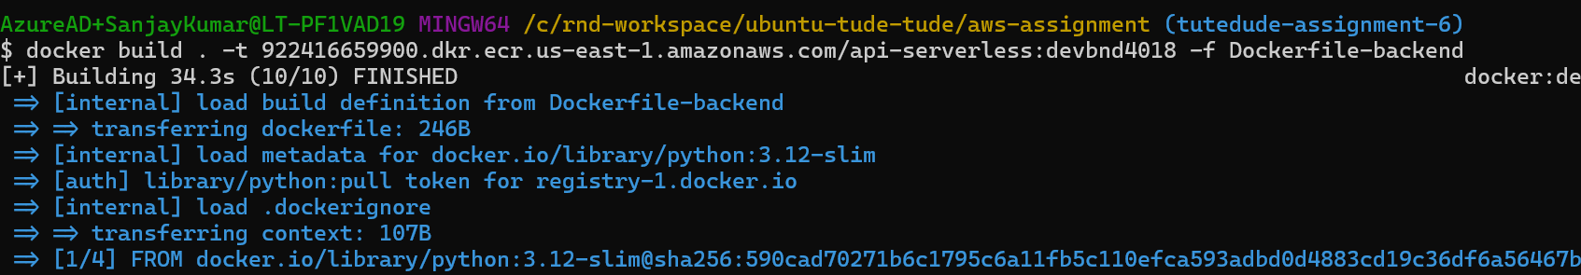
Backend image pushed to ECR
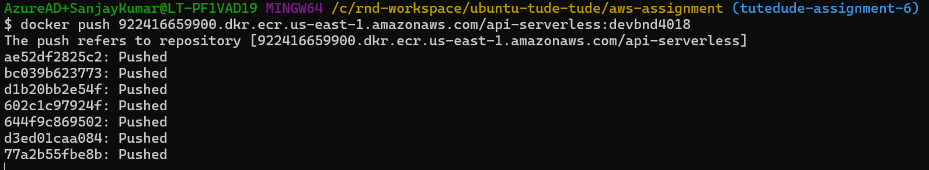

Docker image creation for frontend
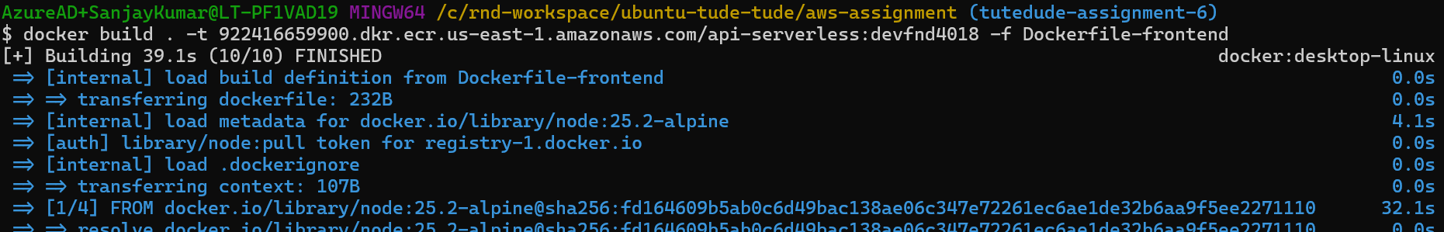
Frontend image pushed to ECR
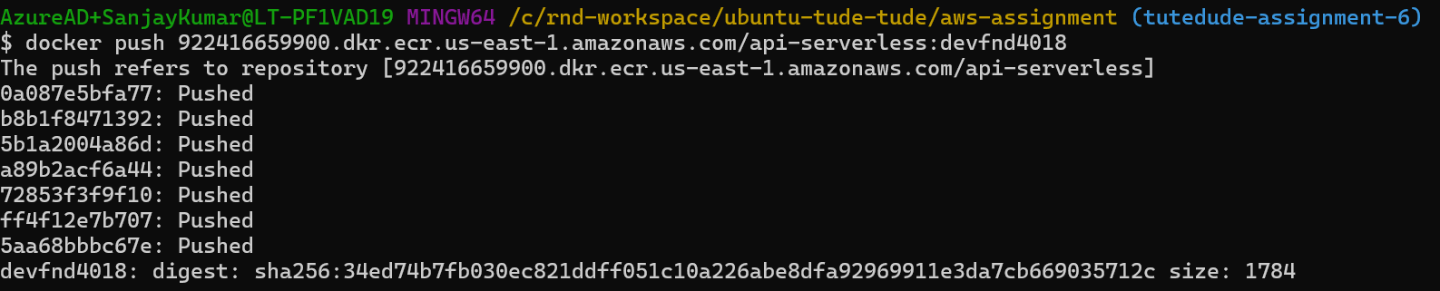

Task execution
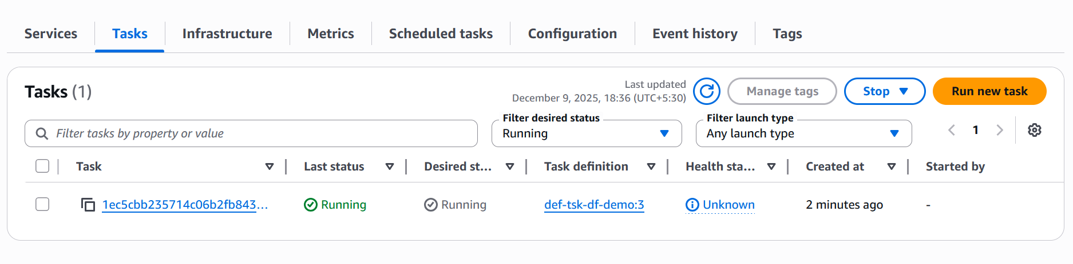

Task Details at the time of execution with public IP 44.223.17.228
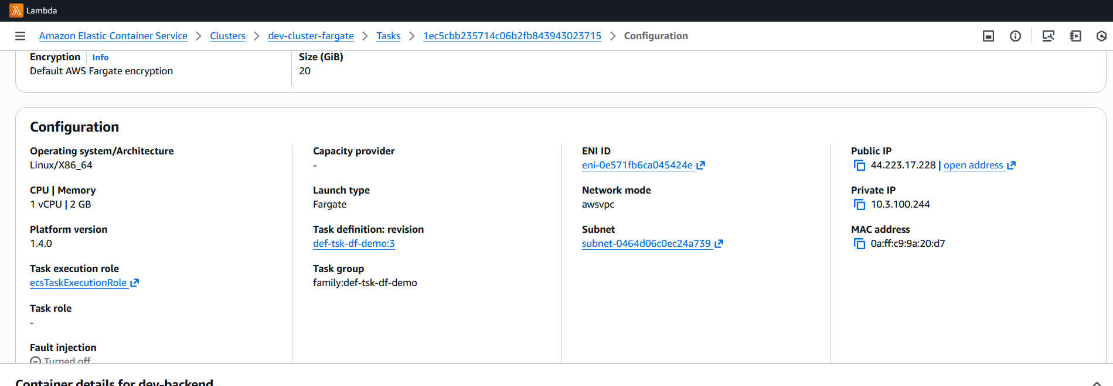

Access the app from browser using public IP:
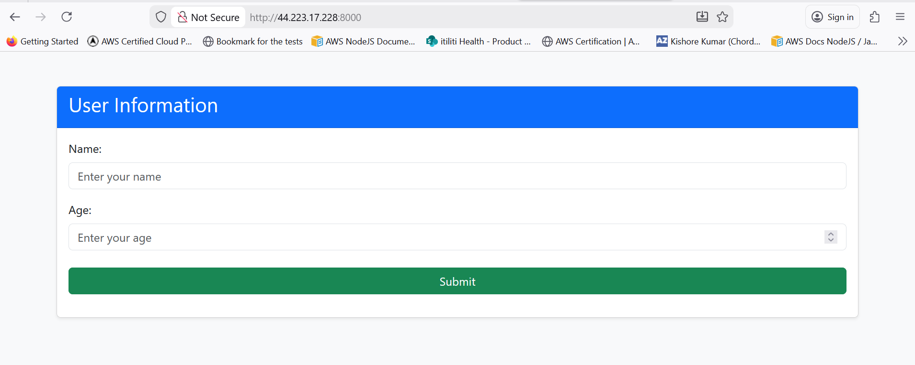

Add an entry in the form
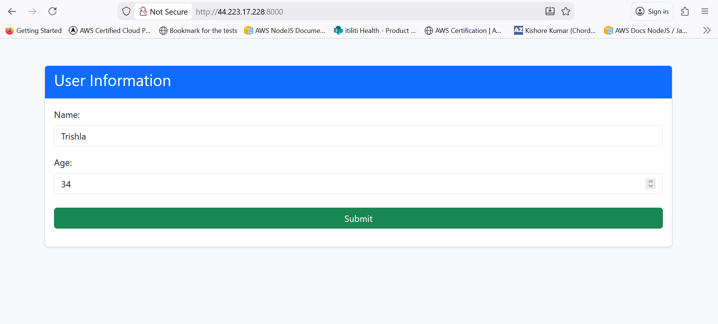

Entry saved successfully
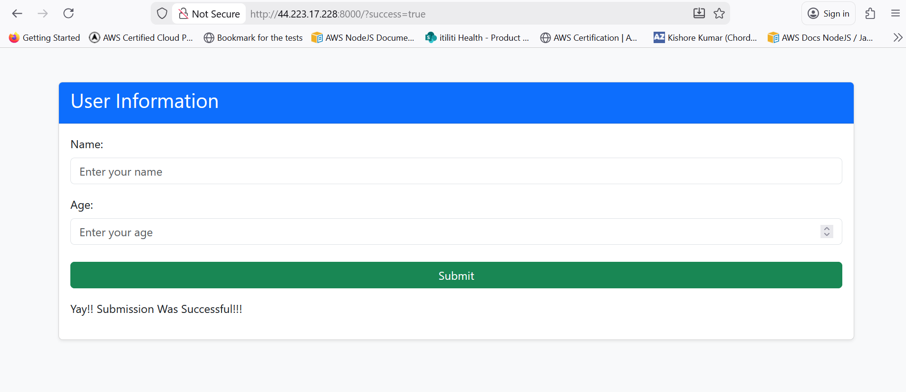

Data reflects in MongoDB Atlas
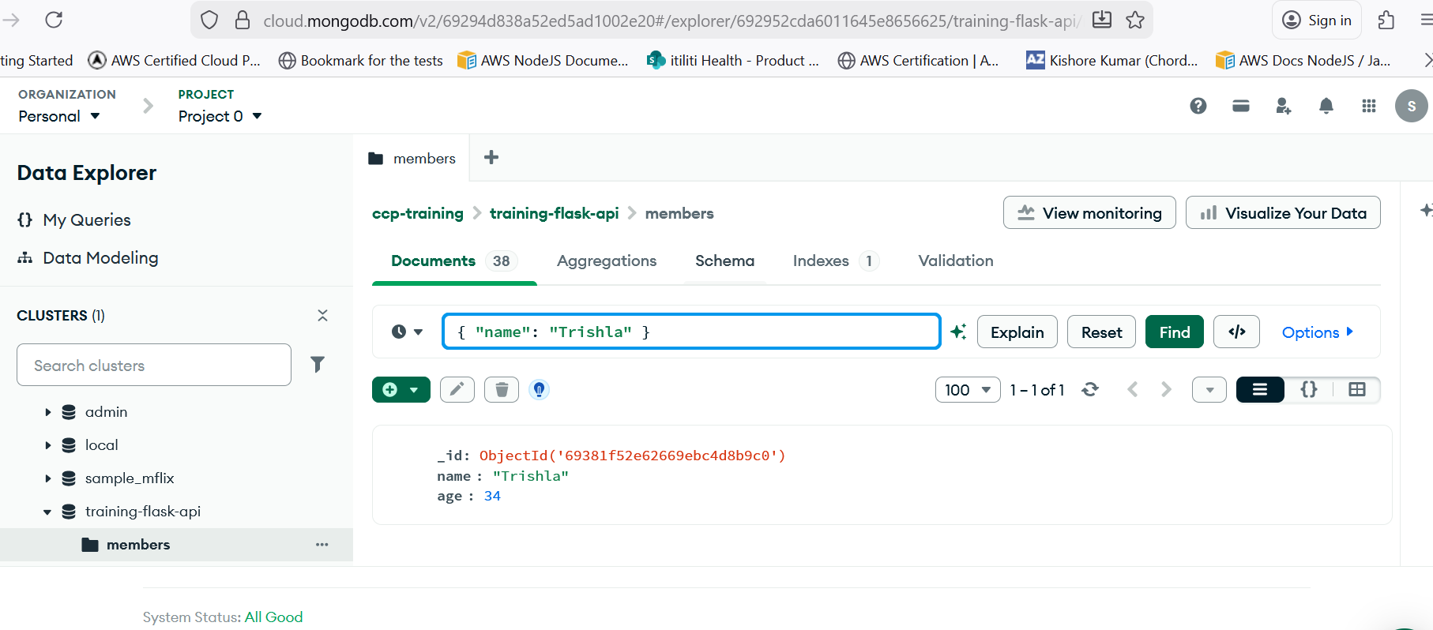

Task definition provided in github repo

