Create a Minikube cluster with profile name “ccpro”
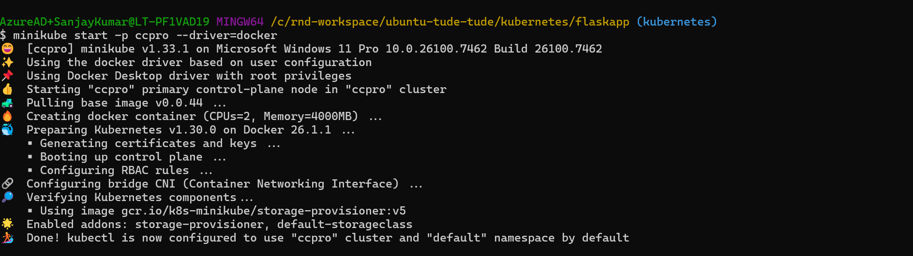

List the available profiles using minikube profile list
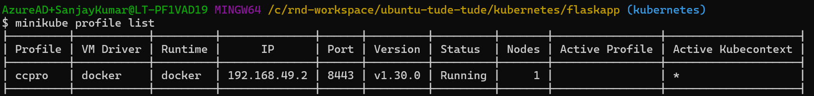

Set “ccpro” as a default profile
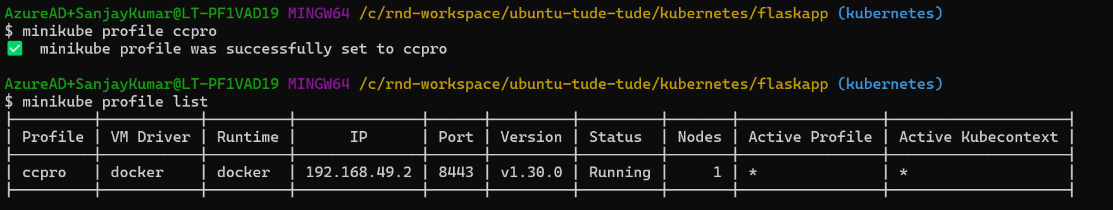

List all the pods of kube-system name space
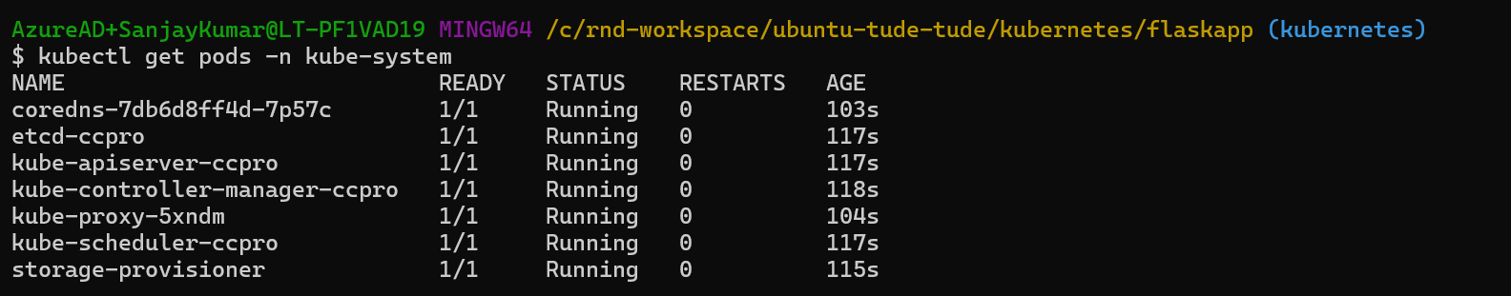

List of all the manifest files to be created in cluster
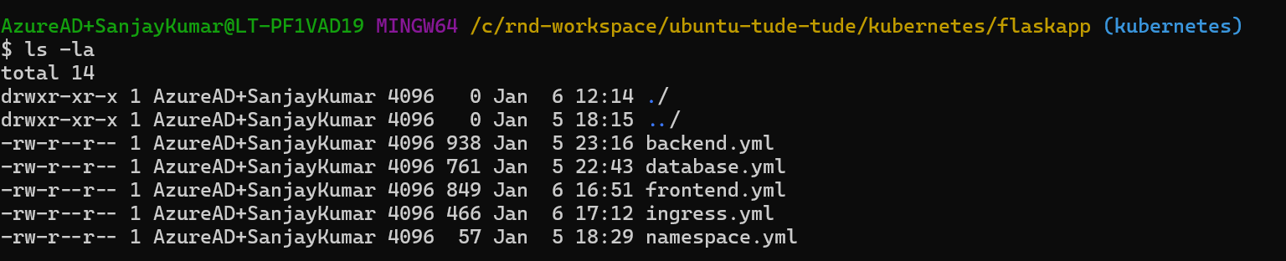

Create the namespace using namespace.yml and list the updated list of name spaces
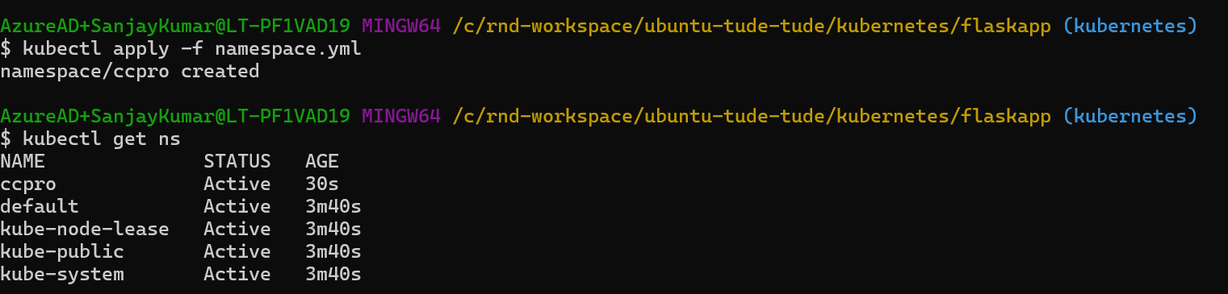

Create the deployments and services for database (mongo), backend (Flask app) and front end (node js)
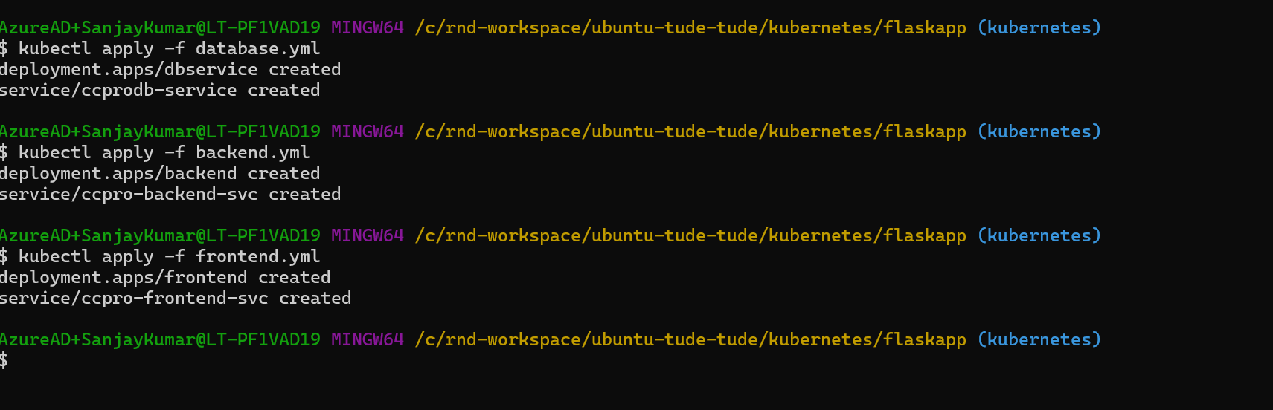

List of Pods and services
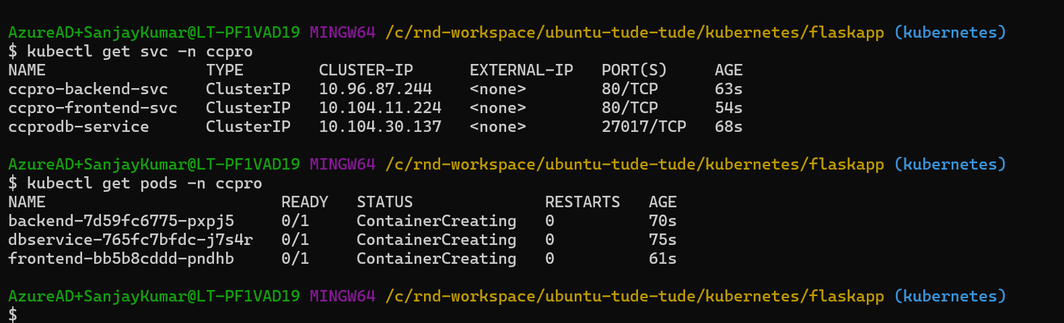

List of Pods and services with status running
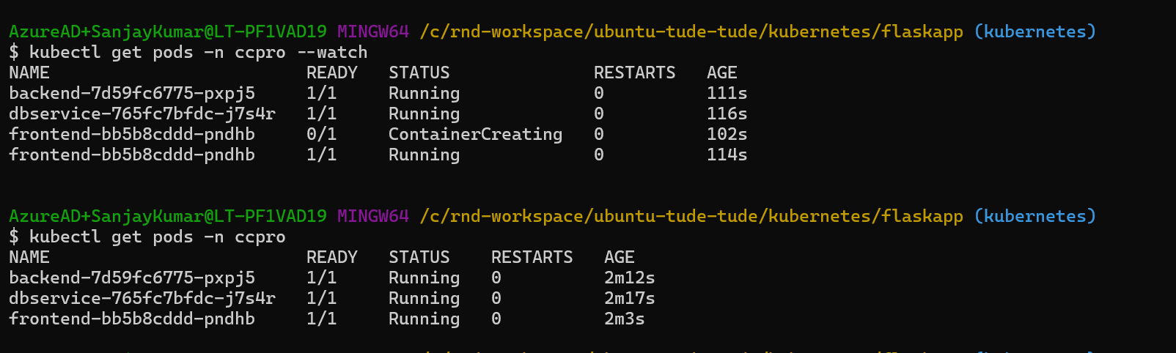

Expose the service using port forwarding:
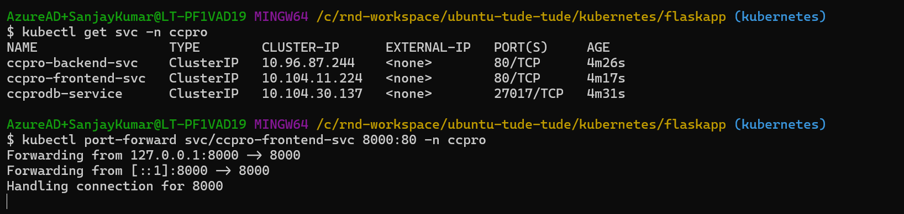

App is accessible using the port forwarded
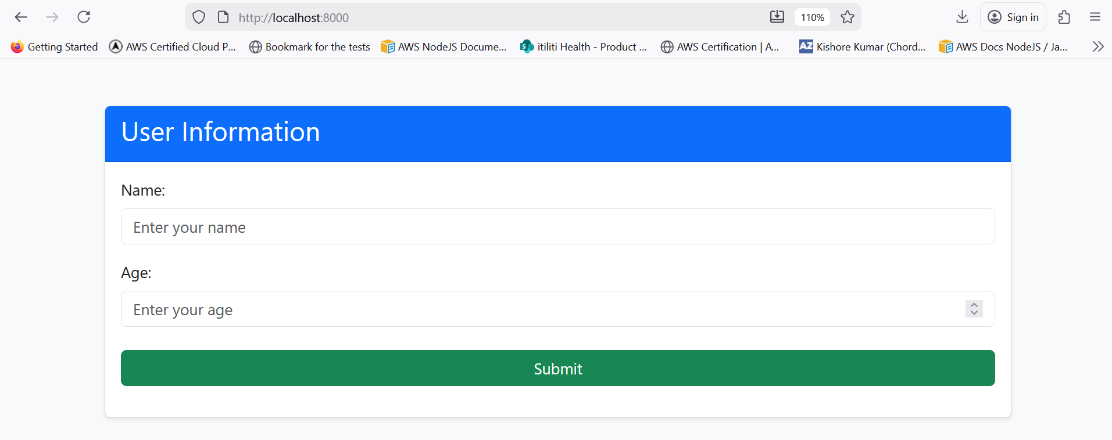

Insert data
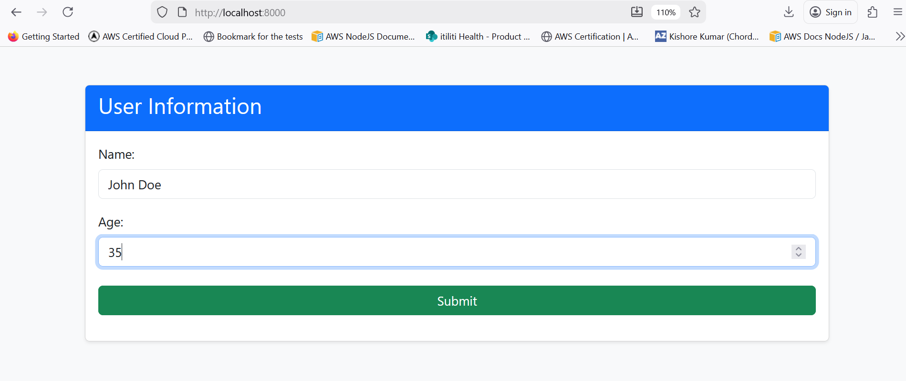

Save data
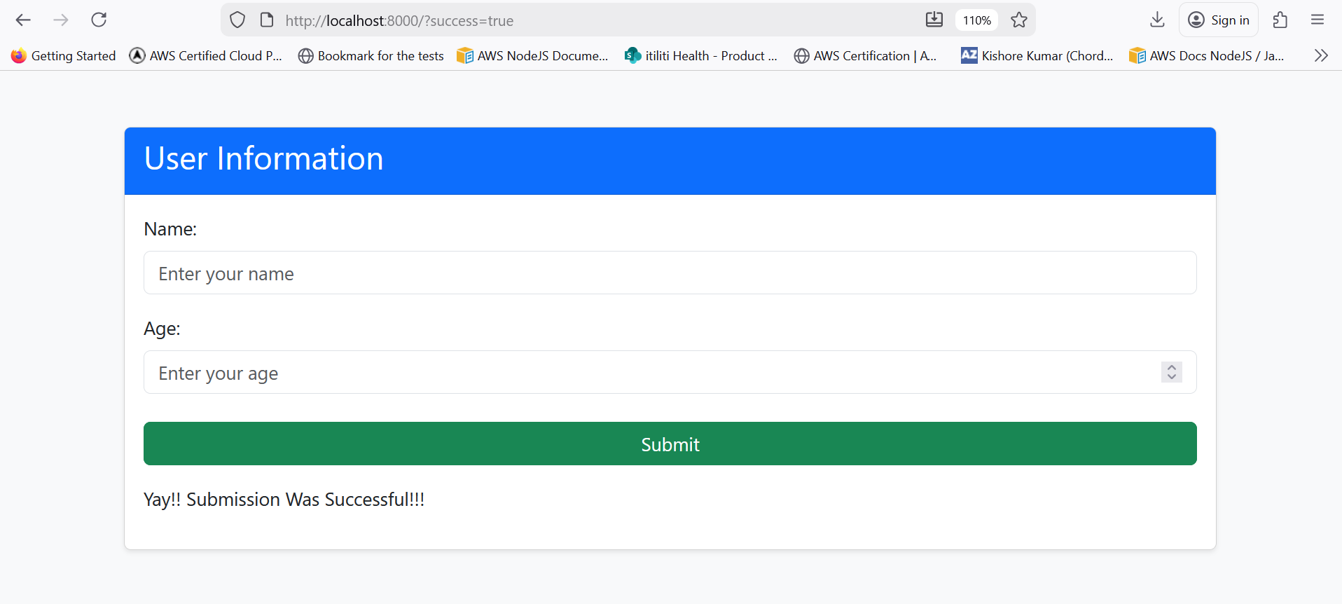

Data is successfully added to MongoDB
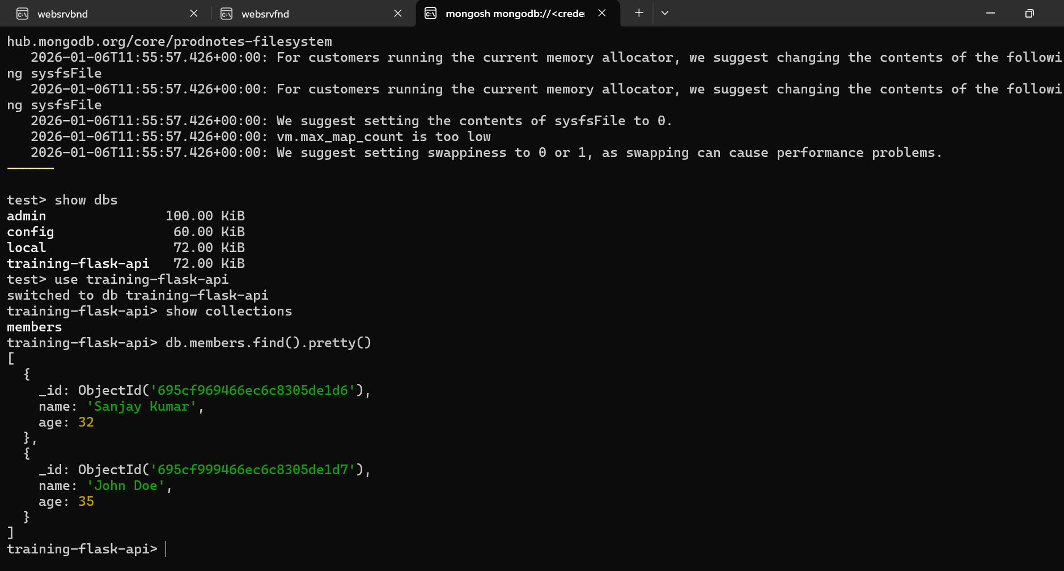

Ingress.
Enabled Ingress using the following command
$> Kubectl addons enable ingress -p ccpro
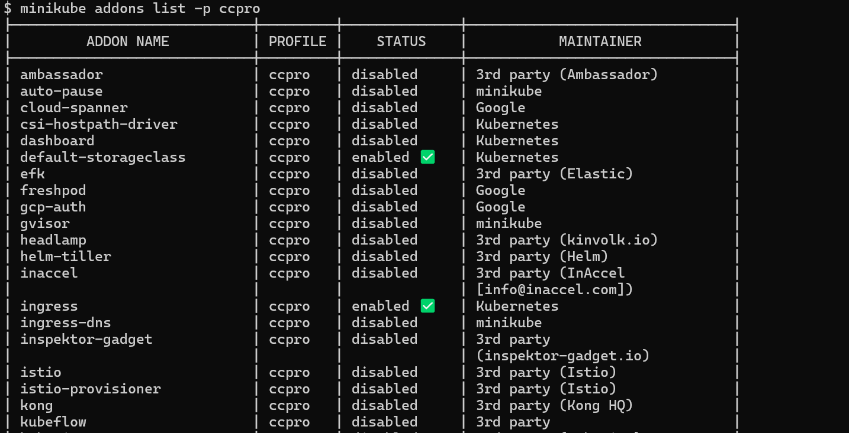

After that
- Apply the ingress manifest file
$ Kubectl apply -f ingress.yml
- Start MiniKube Tunnel
$ minikube tunnel
- Update the host file /c/windows/system32/drivers/etc/host
127.0.0.1 flaskapp.io

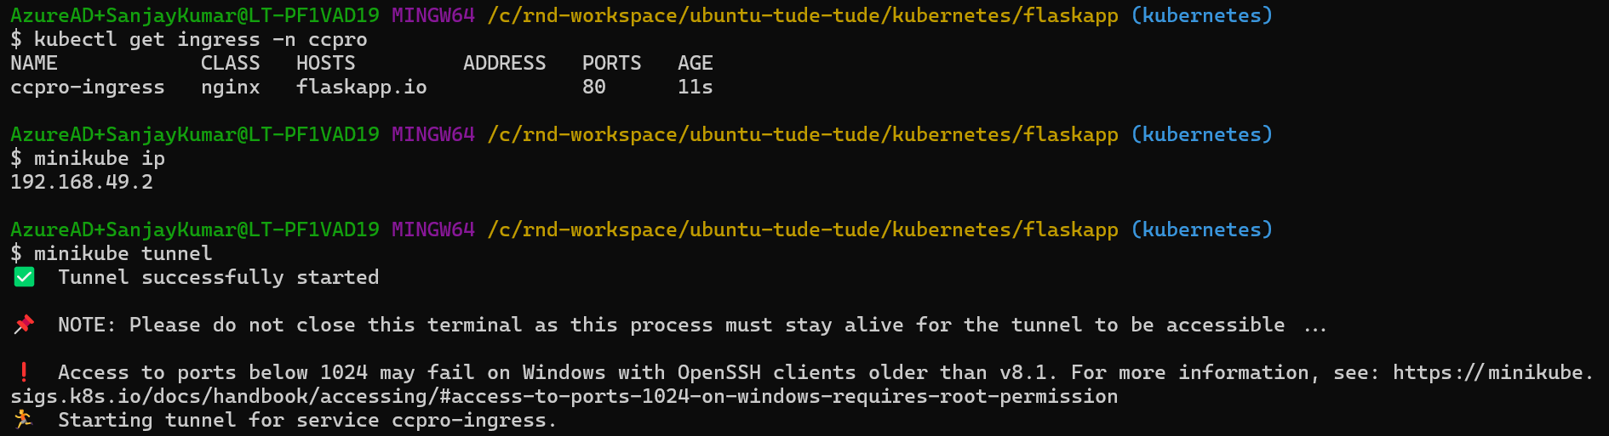
App can now be accessed using the flasapp.io
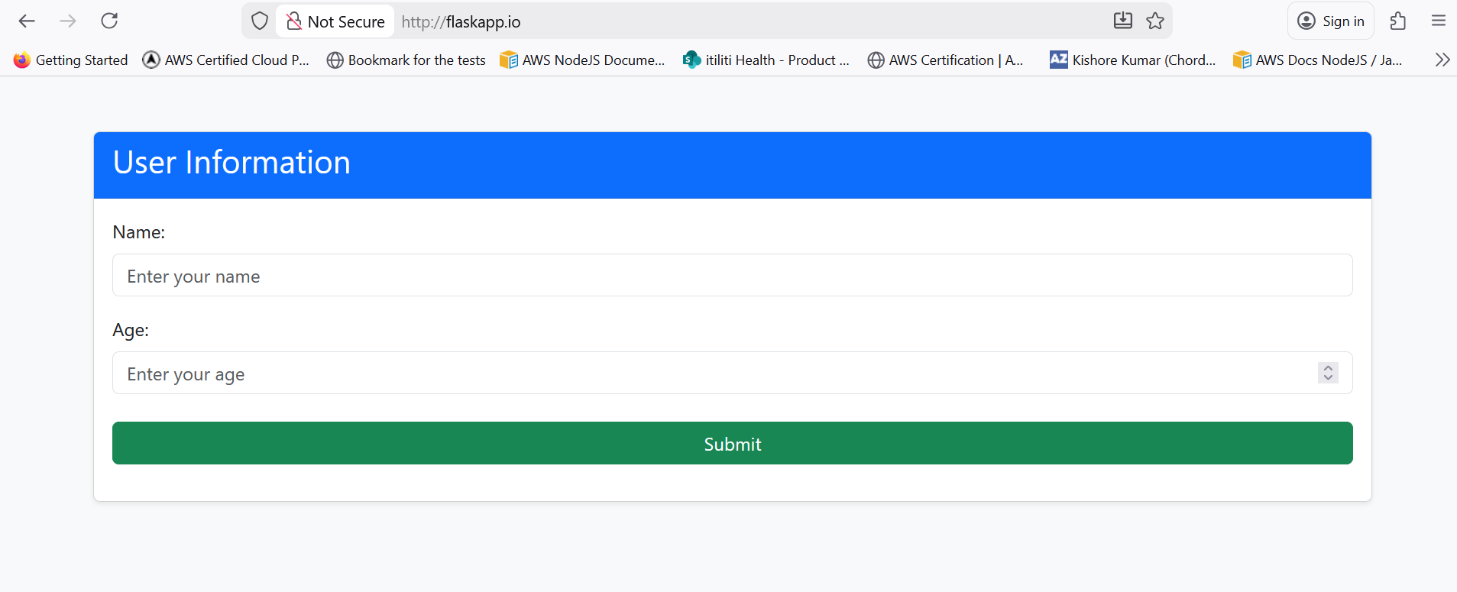

Try to add the data:

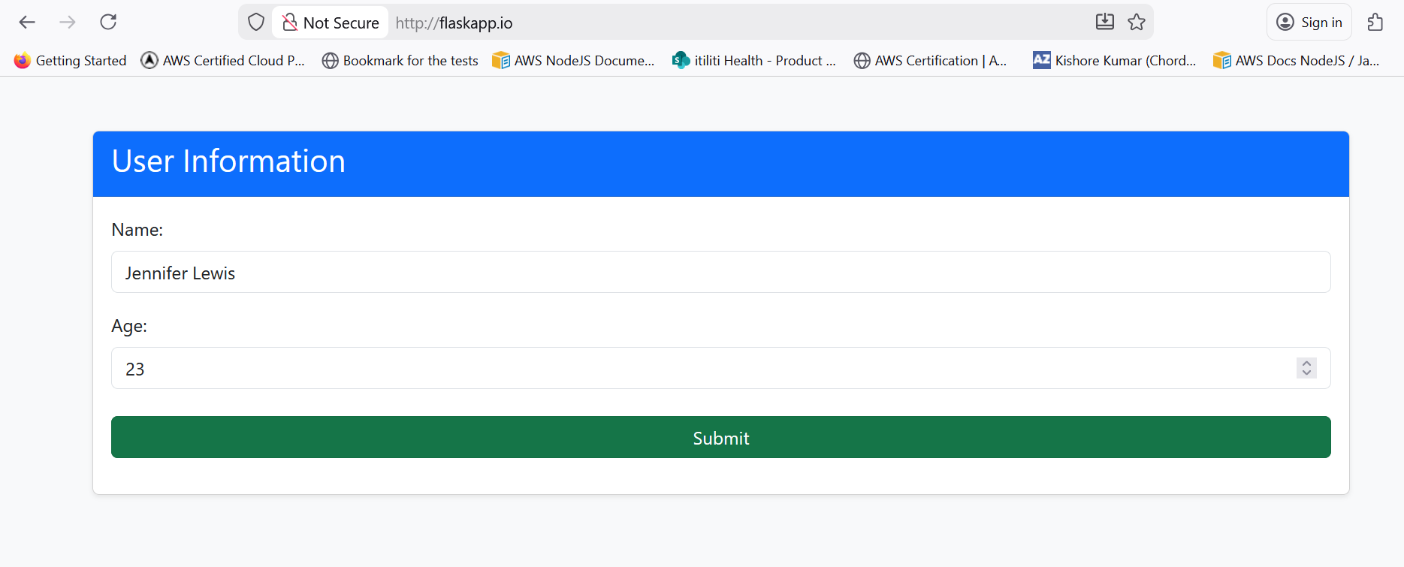
Confirmation
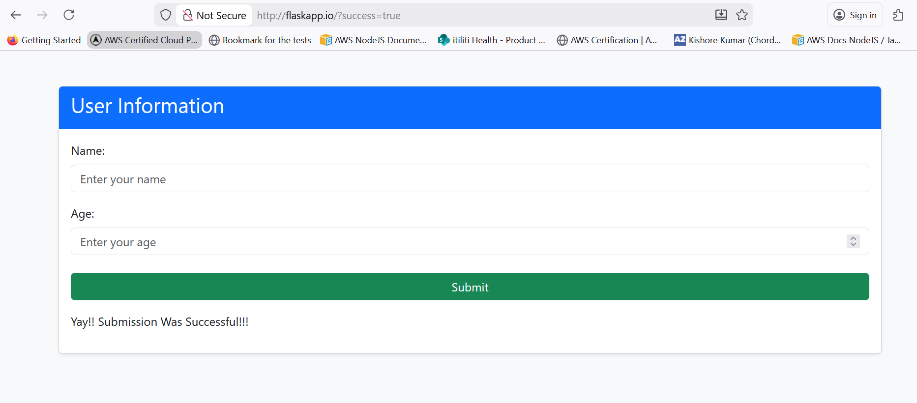
Let’s check the data in the mongodb
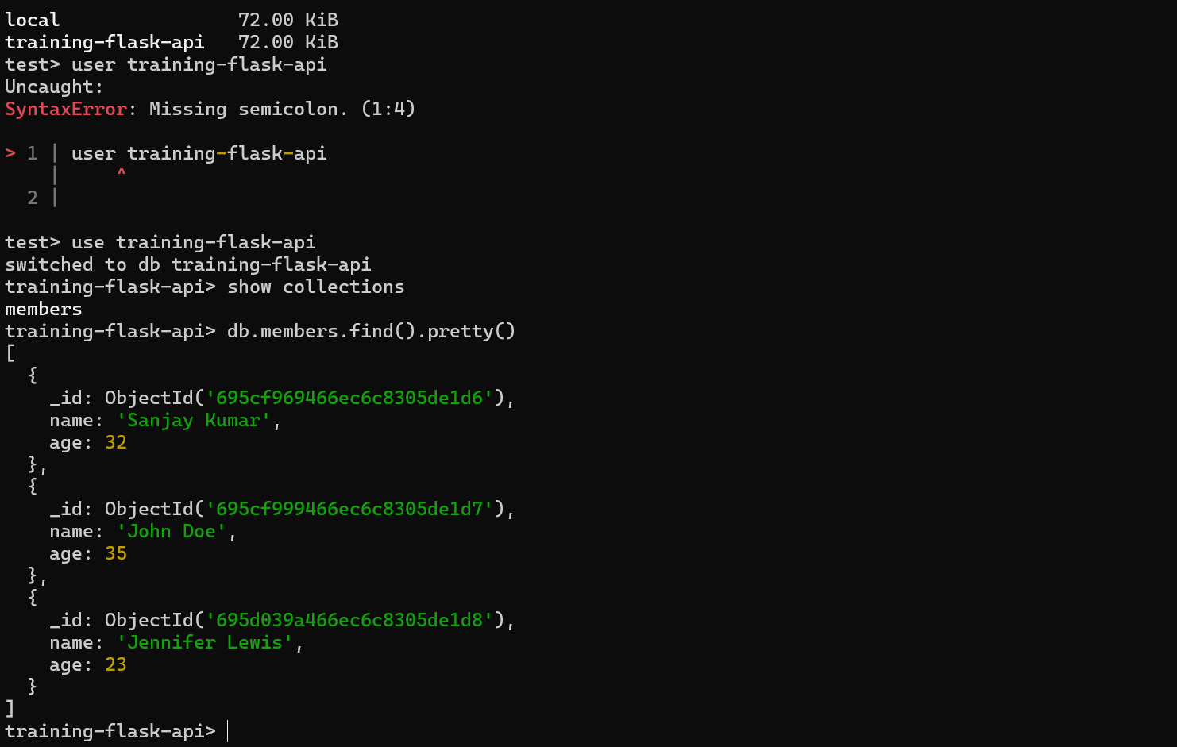

Data is successfully persisted from
Front end app -> Back end -> database.

Set up completed successfully

