1. Creating and Renaming Files/Directories
Create a directory named test_dir using mkdir.
Inside test_dir, create an empty file called example.txt.
Rename example.txt to renamed_example.txt using mv
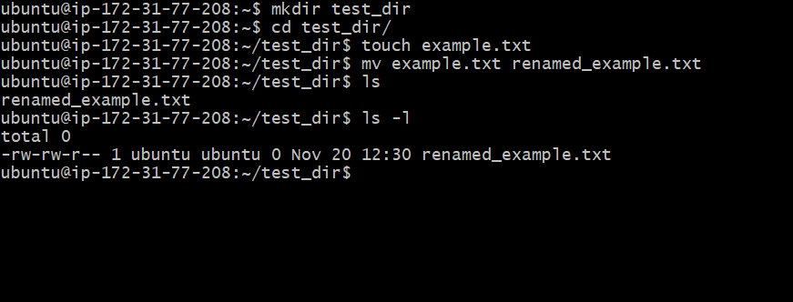

Mkdir command is used for creating a new directory.
mkdir test_dir
it may throw an error if the directory already exists.
Use mkdir -p test_dir to execute the command if directory may exists. Command executes without any error in case the directory already exists.
mv command is used for renaming the files.
Command is $ mv <new-file-name > <source-file-name>
$ mv example.txt to renamed_example.txt

2. Viewing File Contents
Use cat to display the contents of /etc/passwd.
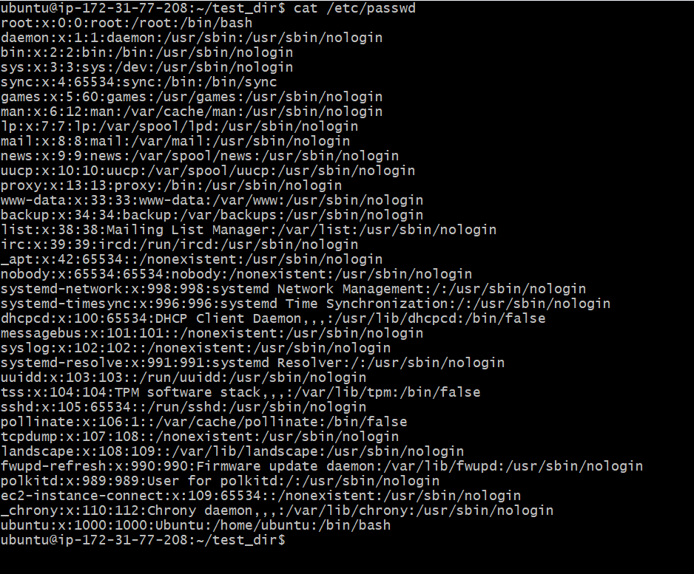

Display only the first 5 lines of /etc/passwd using head.
Command is: head -n 5 /etc/passwd
head command is used to show the content from the top of the file.
-n flag signifies the number of lines to be shown in output
/etc/password is the source file to read from.
By default, if -n flag is not used, it shows 10 lines
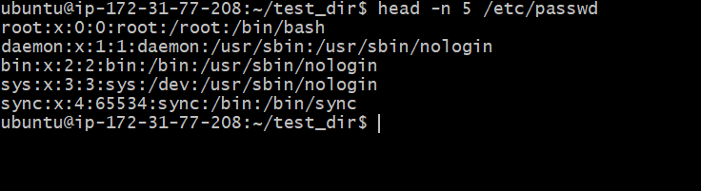

Display only the last 5 lines of /etc/passwd using tail.
Command is: tail -n 5 /etc/passwd
tail is a command to show the content from the bottom of the file.
-n flag signifies the number of lines to be shown in output
/etc/password is the source file to read from.
By default, if -n flag is not used, it shows 10 lines
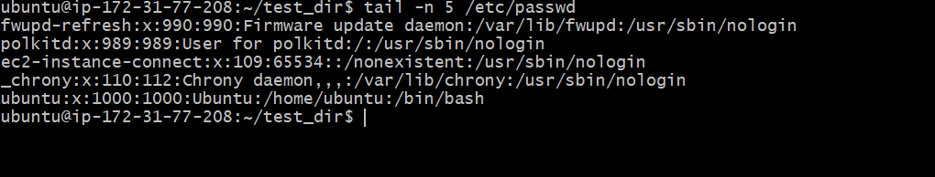

3.Searching for Patterns
Use grep to find all lines containing the word "root" in /etc/passwd.
Command is : $ cat /etc/passwd | grep root
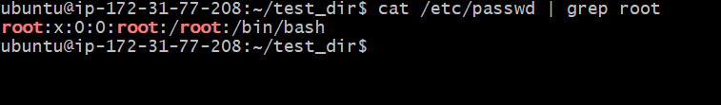

4. Zipping and Unzipping
Compress the test_dir directory into a file named test_dir.zip using zip.
Unzip test_dir.zip into a new directory named unzipped_dir.
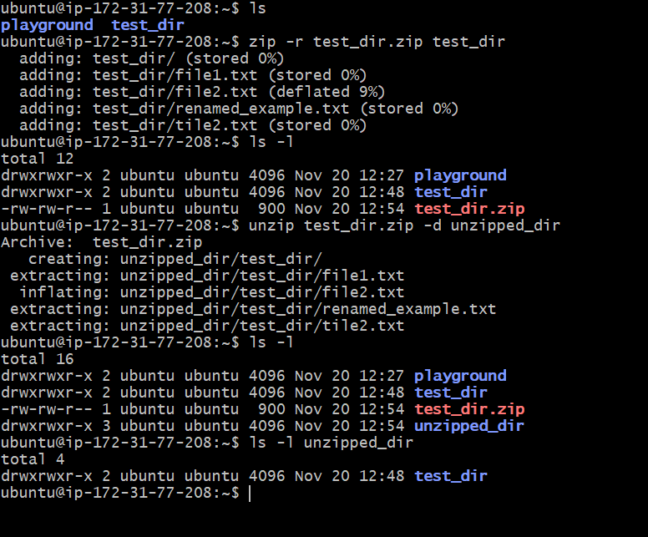
5. Downloading Files
Use wget to download a file from a URL (e.g., https://example.com/sample.txt).
Wget it used to download the output from a URL into a file.
-O flag can be used to name the file of your choice.
Comnad is: $ wget -O dockerfile.txt https://raw.githubusercontent.com/sanjay2028/demobackend/refs/heads/main/Dockerfile
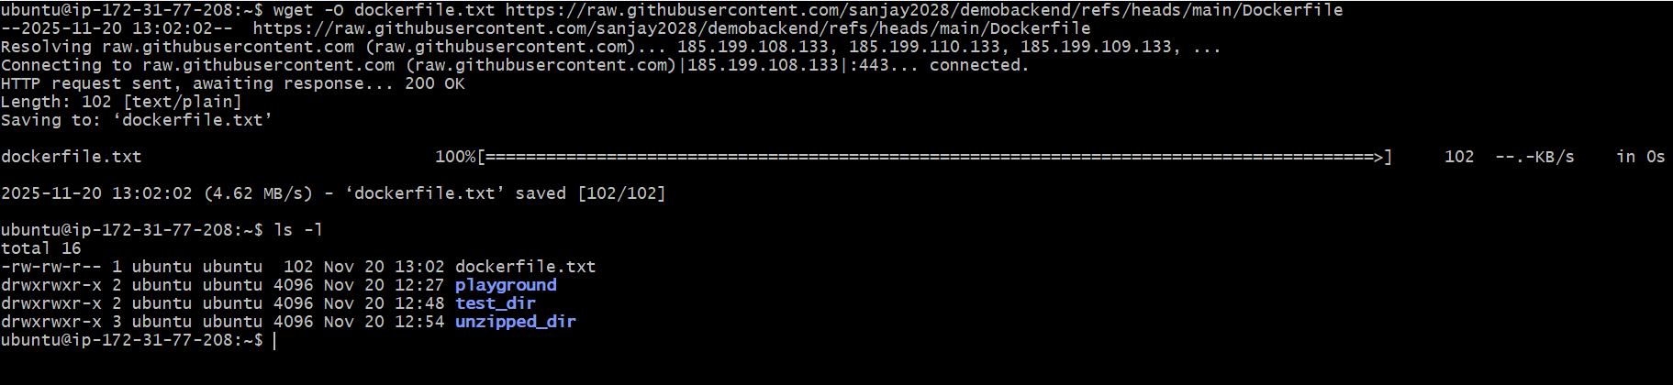

6. Changing Permissions
Create a file named secure.txt and change its permissions to read-only for everyone using chmod.
chmod command is used for changing updating the file permission.
444 sets the permission to read only for all i.e. owner, groups, and others.
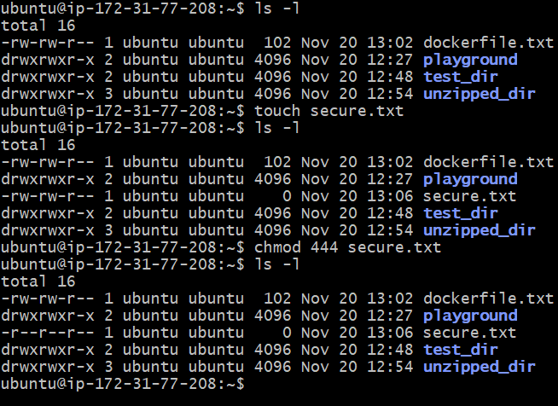
7. Working with Environment Variables
Use export to set a new environment variable called MY_VAR with the value "Hello, Linux!".
Linux export command is used for setting environment variables in the Run Time.
Command is: $ export MY_VAR=”Hello Linux!”
After the command is executed successfully, you can retrieve or print the value on the screen using $ symbol followed by your variable name. For example:
$ echo $MY_VAR
