Ex.No.6 — Implementation of Clustering Techniques
Aim
To implement clustering techniques for iris data set.
Program and output:
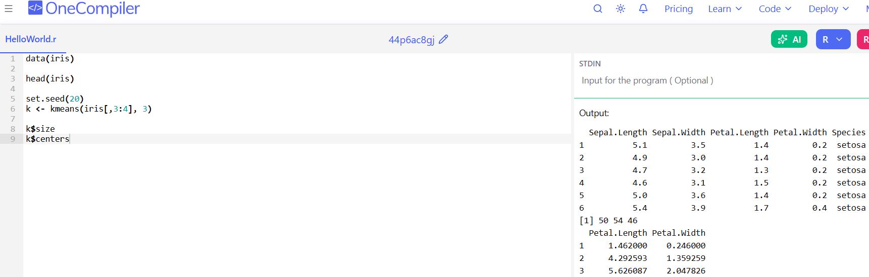

Algorithm / Procedure
Step 1
Start the R program.
Step 2
Load the iris dataset.
Step 3
Select petal length and petal width features.
Step 4
Choose the number of clusters as K = 3.
Step 5
Initialize random centroids.
Step 6
Apply K-Means clustering algorithm.
Step 7
Assign data points to nearest cluster.
Step 8
Recalculate cluster centroids.
Step 9
Repeat clustering until stable clusters are formed.
Step 10
Display cluster results and tables.
Step 11
Stop the program.

Ex.No.5a — Implement SVM Classification Techniques
Aim
To implement Support Vector Machine (SVM) to find optimum hyper plane (line in 2D, 3D hyper plane) which maximize the margin between two classes.
Program:
# Load package
library(e1071)

# Load iris dataset
data(iris)

# Plot dataset
plot(iris)

# Scatter plots
plot(iris$Sepal.Length,
iris$Sepal.Width,
col = iris$Species)

plot(iris$Petal.Length,
iris$Petal.Width,
col = iris$Species)

# Split data
s <- sample(150, 100)

train <- iris[s, c("Petal.Length",
"Petal.Width",
"Species")]

test <- iris[-s, c("Petal.Length",
"Petal.Width",
"Species")]

# Train SVM model
svmfit <- svm(Species ~ .,
data = train,
kernel = "linear")

# SVM classification plot
plot(svmfit, train)

# Prediction
p <- predict(svmfit, test)

# Accuracy table
table(p, test$Species)

# Accuracy value
mean(p == test$Species)

output:
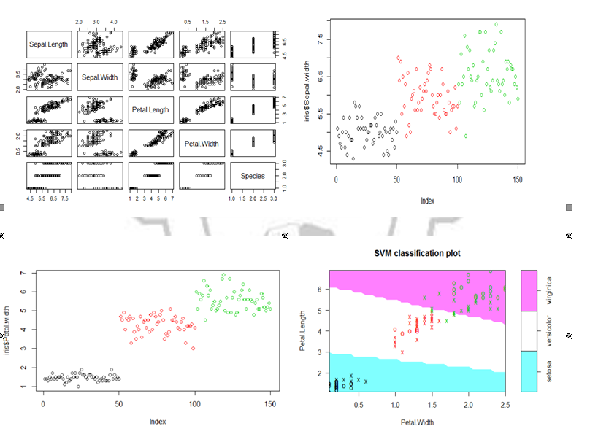
Ex.No.5a — SVM Classification Technique
Algorithm / Procedure
Step 1
Start the R program.
Step 2
Load the iris dataset.
Step 3
Split the dataset into training and testing data.
Step 4
Select important features for classification.
Step 5
Create the SVM model using training data.
Step 6
Choose linear kernel for classification.
Step 7
Train the SVM classifier.
Step 8
Predict the class labels for testing data.
Step 9
Compare predicted values with actual values.
Step 10
Calculate classification accuracy.
Step 11
Display the output graph and results.
Step 12
Stop the program.

Ex.No.5b — Implement Decision Tree Classification Techniques
Aim
To implement a decision tree used for representing a decision situation visually and showing all those factors within the analysis that are considered relevant to the decision.
Program:
# Load packages
library(MASS)
library(rpart)

# Load dataset
head(birthwt)

# Histogram
hist(birthwt$bwt)

# Convert columns to factor
cols <- c("low","race","smoke","ht","ui")
birthwt[cols] <- lapply(birthwt[cols], as.factor)

# Split data
set.seed(1)
train <- sample(1:nrow(birthwt),
0.75*nrow(birthwt))

# Decision Tree model
tree <- rpart(low ~ . - bwt,
data = birthwt[train,],
method = "class")

# Plot tree
plot(tree)
text(tree)

# Prediction
p <- predict(tree,
birthwt[-train,],
type = "class")

# Result table
table(p, birthwt[-train,]$low)
Algorithm / Procedure
Step 1
Start the R program.
Step 2
Load the birth weight dataset.
Step 3
Convert required columns into factor type.
Step 4
Split the dataset into training and testing data.
Step 5
Create the Decision Tree model using rpart() function.
Step 6
Select the best attributes for classification.
Step 7
Construct the tree structure.
Step 8
Predict output values using testing data.
Step 9
Compare predicted and actual results.
Step 10
Display the decision tree and output table.
Step 11
Stop the program.
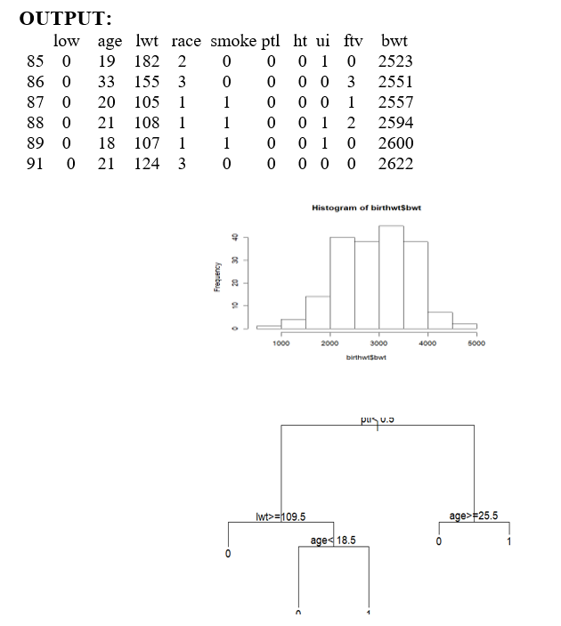
Ex.No.4 — Implement Linear and Logistic Regression
Aim
To implement linear and logistic regression for Sales dataset.

Program Code
1. Simple Linear Regression
dataset = read.csv("data-marketing-budget-12mo.csv",
header = T,
colClasses = c("numeric", "numeric", "numeric"))
head(dataset,5)
# Simple Regression
simple.fit = lm(Sales ~ Spend, data = dataset)
summary(simple.fit)
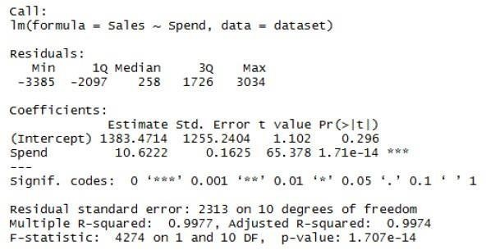

2. Multiple Linear Regression
multi.fit = lm(Sales ~ Spend + Month, data = dataset)
summary(multi.fit)
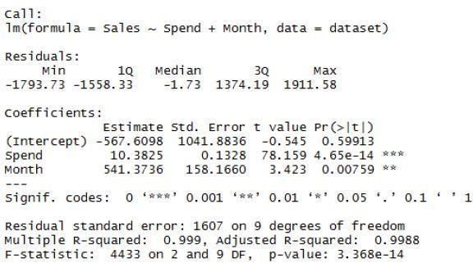

3. Logistic Regression
# selects some column from mtcars
input <- mtcars[, c("am", "cyl", "hp", "wt")]
print(head(input))
input <- mtcars[, c("am", "cyl", "hp", "wt")]
am.data = glm(formula = am ~ cyl + hp + wt,
data = input,
family = binomial)
print(summary(am.data))
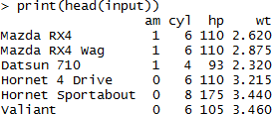
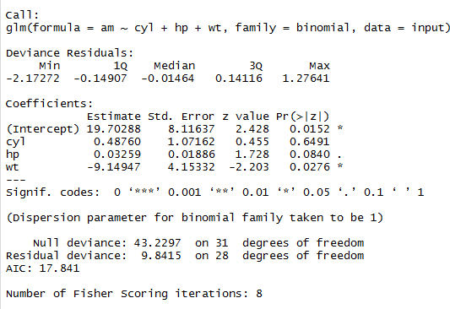
Algorithm / Procedure
Step 1
Start the R program.
Step 2
Load the sales dataset into R.
Step 3
Perform Simple Linear Regression using Sales and Spend.
Step 4
Fit the regression model using lm() function.
Step 5
Display the regression summary and prediction results.
Step 6
Perform Multiple Linear Regression using Sales, Spend, and Month.
Step 7
Fit the multiple regression model.
Step 8
Display the multiple regression output.
Step 9
Load the dataset for Logistic Regression.
Step 10
Apply logistic regression using glm() function.
Step 11
Predict categorical output values.
Step 12
Display the logistic regression result.
Step 13
Stop the program.

Ex.No.7 — Implementation of Visualize Data using Any Plotting Framework
Aim
To implement data visualization to provide an efficient graphical display for summarizing and reasoning about quantitative information.

Program:
# Load Libraries
library(RColorBrewer)
library(corrplot)
library(ggplot2)

# ---------------- 1. HISTOGRAM ----------------
data(VADeaths)

par(mfrow=c(2,3))

hist(VADeaths,
col=brewer.pal(3,"Set3"),
main="Set3 colors")

hist(VADeaths,
col=brewer.pal(3,"Set2"),
main="Set2 colors")

hist(VADeaths,
col=brewer.pal(3,"Set1"),
main="Set1 colors")

hist(VADeaths,
col=brewer.pal(8,"Set3"),
main="Set3 8 colors")

hist(VADeaths,
col=brewer.pal(8,"Greys"),
main="Greys colors")

hist(VADeaths,
col=brewer.pal(8,"Greens"),
main="Greens colors")

# ---------------- 2. LINE CHART ----------------
data(AirPassengers)

plot(AirPassengers,
type="l",
main="Line Chart")

# ---------------- 3. BAR CHART ----------------
data(iris)

barplot(iris$Sepal.Length,
col="red",
main="Bar Chart")

# ---------------- 4. BOX PLOT ----------------
par(mfrow=c(2,2))

boxplot(iris$Sepal.Length,
col="red")

boxplot(iris$Sepal.Length ~ iris$Species,
col="orange")

boxplot(iris$Sepal.Length ~ iris$Species,
col=heat.colors(3))

boxplot(iris$Petal.Length ~ iris$Species,
col=topo.colors(3))

# ---------------- 5. SCATTER PLOT ----------------
plot(iris$Sepal.Length,
iris$Sepal.Width,
main="Scatter Plot")

plot(iris$Petal.Length,
iris$Petal.Width,
col=iris$Species)

# ---------------- 6. HEAT MAP ----------------
x <- matrix(rnorm(100),10)

heatmap(x)

# ---------------- 7. CORRELOGRAM ----------------
corr_matrix <- cor(mtcars)

corrplot(corr_matrix)

corrplot(corr_matrix,
method="number",
type="lower")

# ---------------- 8. AREA CHART ----------------
ggplot(airquality,
aes(Day, Wind)) +
geom_area() +
labs(title="Area Chart")
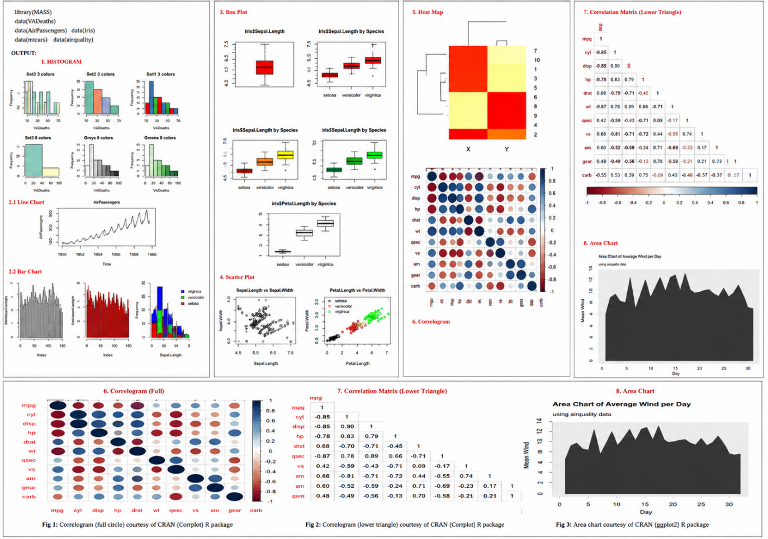
Algorithm / Procedure
Step 1
Start the R program.
Step 2
Load the required datasets and libraries.
Step 3
Create Histogram for frequency distribution.
Step 4
Create Line Chart to show trends over time.
Step 5
Create Bar Chart for comparing values.
Step 6
Create Box Plot to show data spread.
Step 7
Create Scatter Plot to show relationship between variables.
Step 8
Create Heat Map for visualizing data intensity.
Step 9
Create Correlogram for correlation analysis.
Step 10
Create Area Chart for continuous data visualization.
Step 11
Display all visualization outputs.
Step 12
Stop the program.

Ex.No.8 — Implement an application that stores big data in MongoDB using R
Aim
To implement an application that stores big data in MongoDB using R.
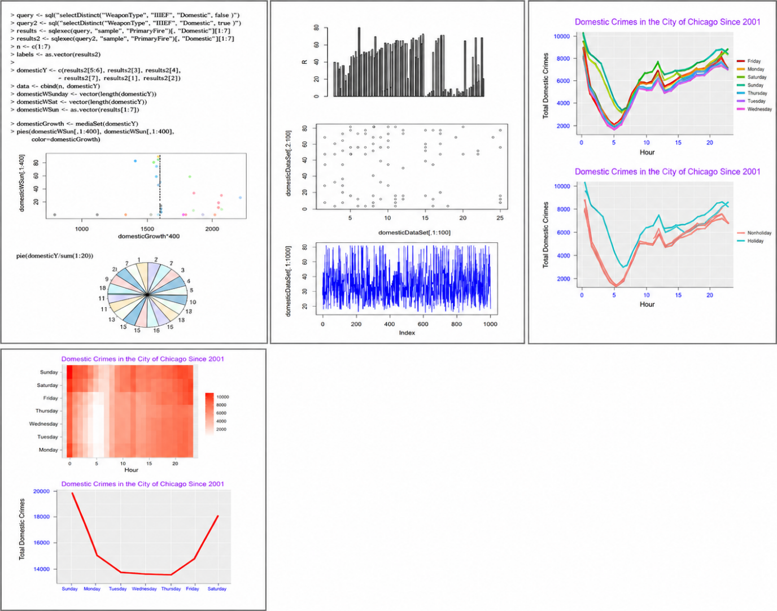
Algorithm / Procedure
Step 1
Start the R program.
Step 2
Install and load MongoDB related libraries.
Step 3
Load the crime dataset into R.
Step 4
Create connection between R and MongoDB.
Step 5
Create database and collection.
Step 6
Insert crime dataset into MongoDB collection.
Step 7
Retrieve records from MongoDB using queries.
Step 8
Perform filtering and aggregation operations.
Step 9
Analyze domestic crime data.
Step 10
Create plots and graphs for visualization.
Step 11
Display MongoDB query results and charts.
Step 12
Stop the program.
Program:
# Libraries
library(ggplot2)

# Sample Data
x <- 1:24
y <- sample(2000:10000,24)

# 1. Bar Plot
barplot(y,
col="grey",
main="Bar Plot")

# 2. Scatter Plot
plot(x, y,
main="Scatter Plot")

# 3. Line Plot
plot(y,
type="l",
col="blue",
main="Line Plot")

# 4. Pie Chart
pie(c(10,20,30,40),
col=rainbow(4))

# 5. Heat Map
m <- matrix(rnorm(100),10)

heatmap(m)

# 6. Domestic Crime Line Graph
df <- data.frame(Hour=x,
Crimes=y)

ggplot(df,
aes(Hour, Crimes)) +
geom_line(color="red",
size=1.5) +
ggtitle("Domestic Crimes in Chicago")

# 7. Weekend vs Weekday Graph
df$Type <- ifelse(df$Hour>12,
"Weekend",
"Weekday")

ggplot(df,
aes(Hour, Crimes,
color=Type)) +
geom_line(size=1.5)

# 8. Heatmap Style Plot
ggplot(df,
aes(Hour, Type,
fill=Crimes)) +
geom_tile()

Ex.No.3 — Implement a MR program that process a weather dataset
Aim
To implement a MR (MapReduce) program that processes a weather dataset.
Program:
1. Mapper.java
import java.io.*;
import org.apache.hadoop.io.*;
import org.apache.hadoop.mapreduce.Mapper;
public class Mapper1 extends Mapper<LongWritable,Text,Text,IntWritable>
{
public void map(LongWritable k, Text v, Context c)
throws IOException, InterruptedException
{
String s = v.toString();
c.write(
new Text(s.substring(15,19)),
new IntWritable(
Integer.parseInt(s.substring(87,92).trim()))
);
}
}

2. Reducer.java
import java.io.*;
import org.apache.hadoop.io.*;
import org.apache.hadoop.mapreduce.Reducer;
public class Reducer1 extends Reducer<Text,IntWritable,Text,IntWritable>
{
public void reduce(Text k,
Iterable<IntWritable> v,
Context c)
throws IOException, InterruptedException
{
int sum=0,count=0;
for(IntWritable i:v)
{
sum += i.get();
count++;
}
c.write(k,new IntWritable(sum/count));
}
}

3. Driver.java
import org.apache.hadoop.conf.*;
import org.apache.hadoop.fs.*;
import org.apache.hadoop.io.*;
import org.apache.hadoop.mapreduce.Job;
import org.apache.hadoop.mapreduce.lib.input.*;
import org.apache.hadoop.mapreduce.lib.output.*;
public class Driver
{
public static void main(String[] a)
throws Exception
{
Job j = Job.getInstance(new Configuration(),"Avg");
j.setJarByClass(Driver.class);
j.setMapperClass(Mapper1.class);
j.setReducerClass(Reducer1.class);
j.setOutputKeyClass(Text.class);
j.setOutputValueClass(IntWritable.class);
FileInputFormat.addInputPath(j,new Path(a[0]));
FileOutputFormat.setOutputPath(j,new Path(a[1]));
System.exit(j.waitForCompletion(true)?0:1);
}
}
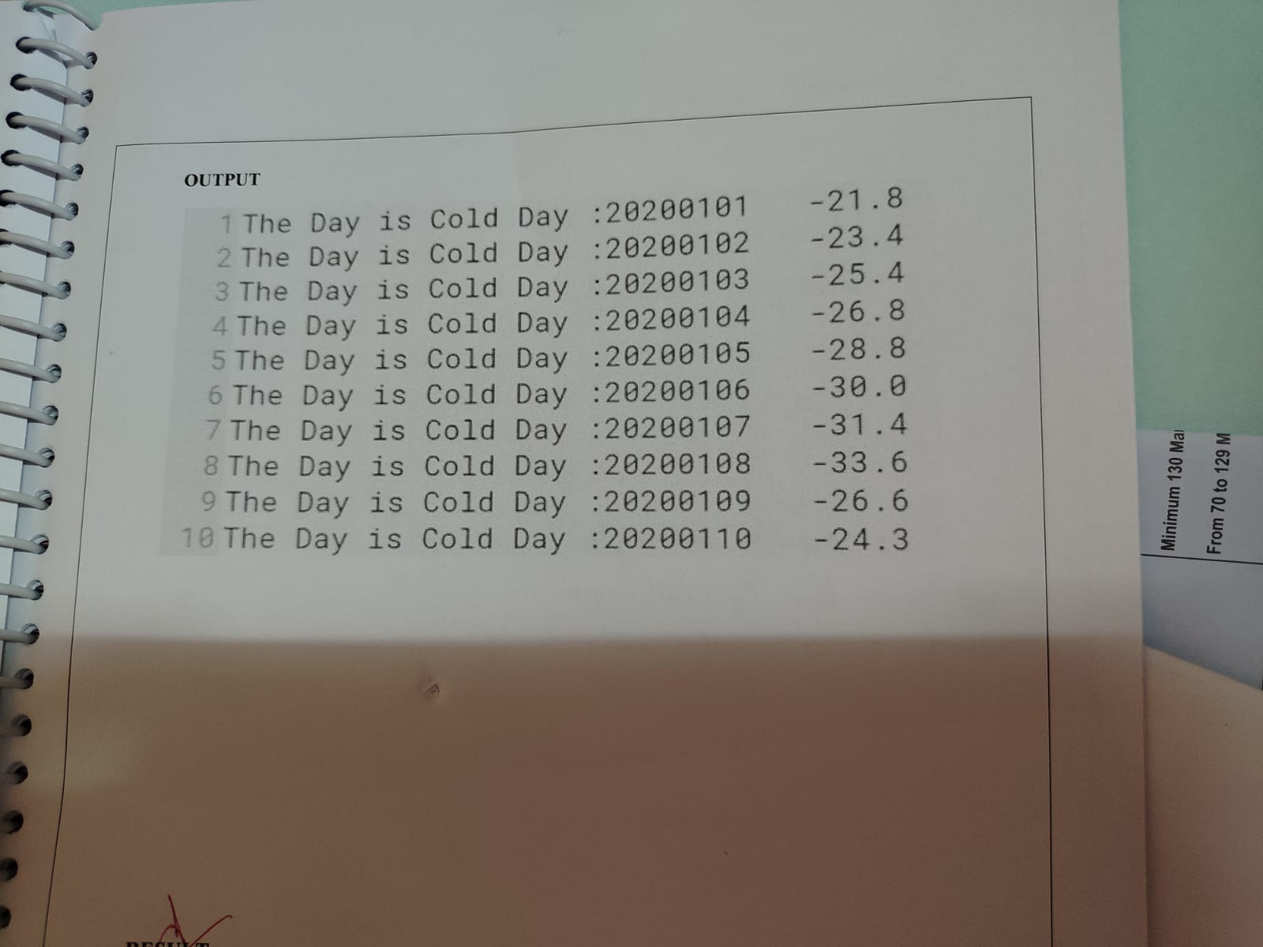

Algorithm / Procedure
Step 1
Start the Hadoop MapReduce program.
Step 2
Load the weather dataset into HDFS.
Step 3
Create the Mapper class to read weather records.
Step 4
Extract year and temperature values from the dataset.
Step 5
Check whether the temperature value is valid.
Step 6
Send year and temperature as key-value pairs to Reducer.
Step 7
Reducer receives all temperature values of the same year.
Step 8
Calculate the average temperature for each year.
Step 9
Store the final output in Hadoop output folder.
Step 10
Stop the program.

