1. **POST​/product​/add-product**

PAYLOAD:

{

"productDesc": "Keyboard",

"price": 500,

"quantity": 5

}

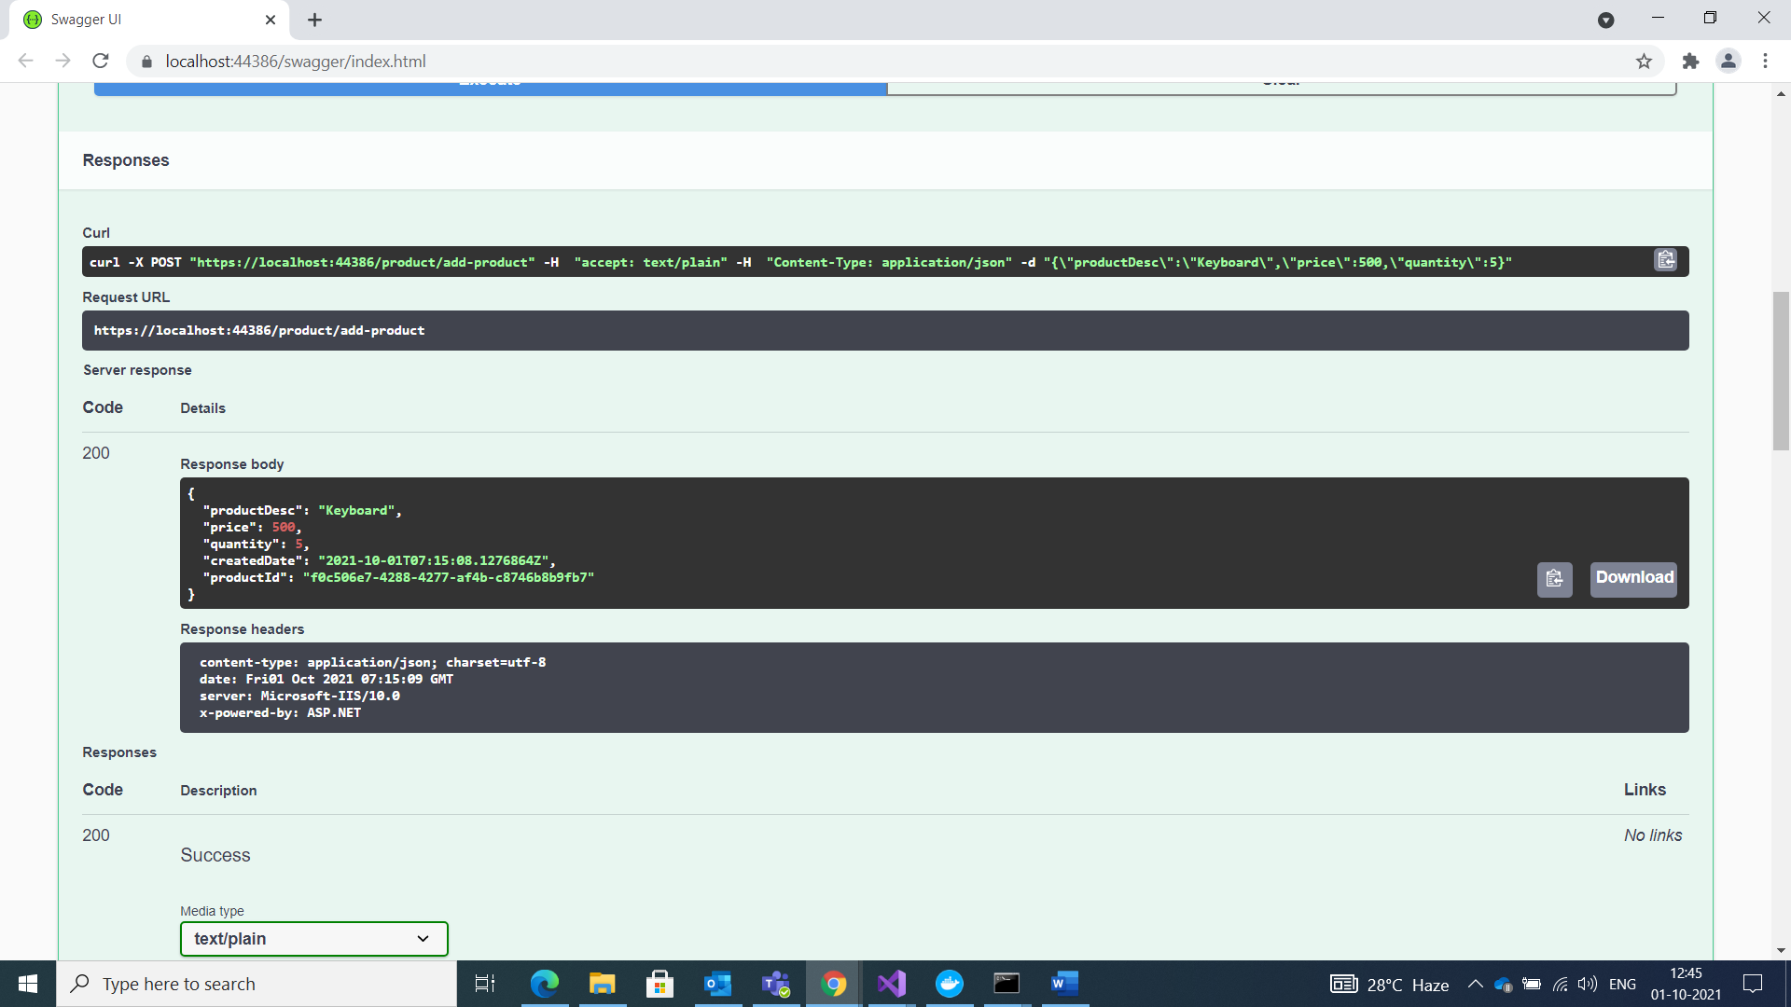

1. **GET​/get-product​/{id}**
2. 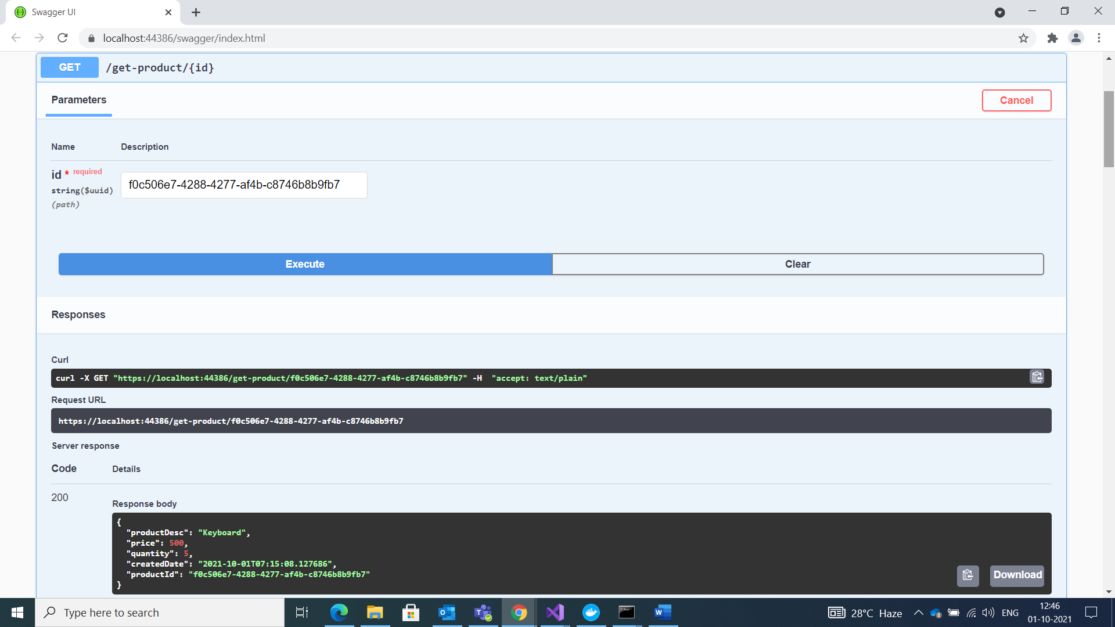
3. **POST​/product​/product-list**

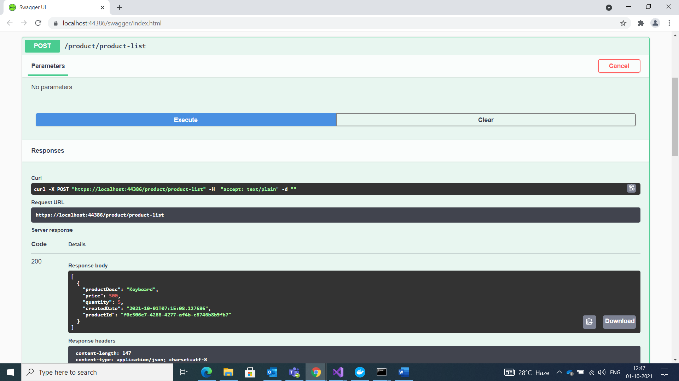

**PUT​/product​/update-product**

