PAHADI BAZAAR
Website Requirements & Developer Plan
PHASE 1 | Responsive Website • Customer Login • Admin Login Foundation
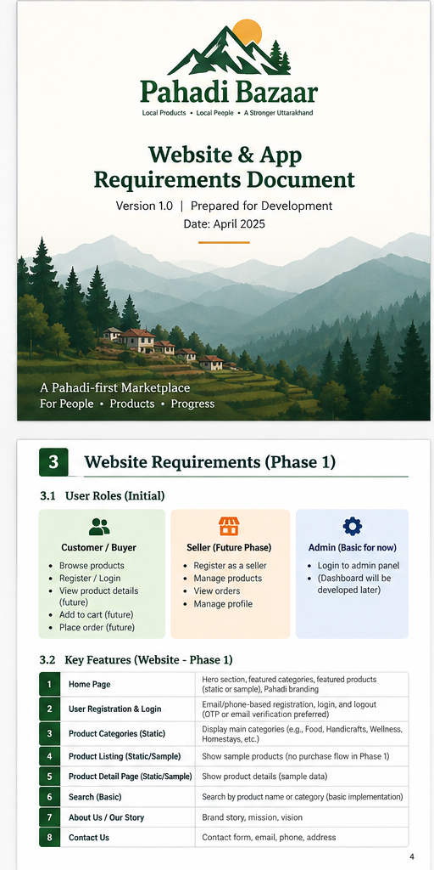
A Pahadi-first marketplace for local products, local people and a stronger Uttarakhand.
Version 1.0 | 30 October 2026 | Prepared for product and engineering planning

1. Document purpose and scope
This document defines the Phase 1 requirements for the Pahadi Bazaar website. The immediate deliverable is a responsive customer-facing website with product discovery, customer registration/login and a basic admin authentication entry point. The full custom admin dashboard, seller portal and mobile applications are deferred to later phases.
Scope boundary
Build the website first. Do not build Android/iOS apps or the full custom admin dashboard in Phase 1. Include a protected /admin/login route; after successful login it can show a Phase 2 placeholder. Use restricted Django Admin or controlled catalogue data entry for interim internal product management.

1.1 Agreed startup decisions
Decision | Agreed direction
Brand | Pahadi Bazaar (working name; trademark/domain availability not yet checked)
Business model | Multi-vendor marketplace
Initial geography | Uttarakhand-wide seller discovery; delivery availability subject to serviceable pincodes
Delivery model | Hybrid: seller-managed and platform-arranged; automation can be phased
Phase 1 platform | Responsive website; mobile apps later
Development approach | Small team / self-funded
Frontend | Next.js + React + TypeScript
Backend | Django + Django REST Framework
Database | PostgreSQL

1.2 Product phases
Phase | Included | Deferred
Phase 1 – Website | Public website, product catalogue, customer account, basic admin login foundation, SEO and responsive UI | Native apps, seller portal, full custom admin dashboard, advanced logistics automation
Phase 2 – Operations | Custom admin dashboard, seller onboarding, product approvals, inventory and order operations | Native apps unless separately prioritised
Phase 3 – Expansion | Customer mobile app, seller app/portal enhancements, promotions, analytics and possible other-state expansion | Unapproved features

2. Goals, users and success measures

2.1 Phase 1 goals
- Establish a recognisable Pahadi Bazaar web presence with a clear Uttarakhand identity.
- Allow customers to browse products by category, Kumaon/Garhwal origin and seller.
- Allow customers to register, sign in, sign out and manage basic profile information.
- Provide secure admin authentication without building the full custom dashboard.
- Create reusable APIs and a maintainable codebase for future admin tools and mobile apps.
- Make product pages indexable by search engines and shareable through social media and WhatsApp.

2.2 Initial user roles
Role | Phase 1 access | Later access
Guest visitor | Browse homepage, products, categories, regions and public pages | Same, plus checkout if enabled
Registered customer | Register, login, logout, view/update basic profile | Cart, checkout, orders, reviews, wishlist
Admin/staff | Protected admin login; placeholder or restricted Django Admin | Custom dashboard for catalogue, sellers, orders, finance and support
Seller | No self-service portal; onboarding handled manually | Seller registration, verification, products, stock and orders

2.3 Initial success measures
Measure | Initial definition
Responsive experience | Core pages usable from 360px mobile width through desktop
Catalogue quality | Published products have approved image, price, unit, description and origin
Authentication | Registration/login/logout and protected-route tests pass
Security | No critical/high unresolved vulnerabilities at release
SEO | Unique page metadata, sitemap and indexable product/category pages
Reliability | Uptime monitoring and automated database backups configured

3. Website sitemap and navigation
Page / route | Purpose | Access
/ | Homepage: brand story, regions, categories and featured products | Public
/shop | All published products with search, sorting and filters | Public
/category/[slug] | Products within a category | Public
/product/[slug] | Product details, seller and origin information | Public
/region/kumaon | Kumaon landing page and products | Public
/region/garhwal | Garhwal landing page and products | Public
/sellers/[slug] | Public seller profile/storefront, if approved for Phase 1 | Public
/about and /contact | Brand story and enquiry form | Public
/faq | Common customer questions | Public
/privacy, /terms, /shipping, /refunds | Legal and customer policy pages | Public
/register and /login | Customer authentication | Public
/account | Basic customer profile | Customer
/admin/login | Basic admin/staff login entry point | Admin/staff
/admin | Phase 1 placeholder or restricted Django Admin entry | Admin/staff

Header recommendation: Logo | Shop | Kumaon | Garhwal | About | Contact | Search | Login/Account. On mobile, collapse navigation into a menu and keep search easy to reach.

4. Functional requirements – Phase 1

4.1 Homepage
- Display logo, navigation and search.
- Show a clear hero message and primary 'Explore products' action.
- Show Shop by Region links for Kumaon and Garhwal.
- Show product categories and a curated featured-products section.
- Show seller/community story content and contact/footer information.
- Homepage sections should be data-driven where practical so a future CMS can manage them.

4.2 Catalogue and discovery
- Show only active and published products.
- Support category and region filters; district filter is recommended when catalogue data is ready.
- Support keyword search by product name and category.
- Support sorting by newest and price ascending/descending.
- Product cards show image, name, price, selling unit/weight, origin and seller name where available.
- Show a clear empty state when no results match.

4.3 Product detail
- Show product name, image gallery, price, selling unit/weight and description.
- Show ingredients/allergens and shelf-life/storage details where applicable.
- Show origin state, region and district plus seller profile information.
- Show availability and delivery note only where verified.
- Do not publish unsupported claims such as organic, chemical-free or homemade.

4.4 Customer registration and login
- Allow registration using name, email and/or mobile number, and password.
- Choose email verification or OTP based on budget and provider.
- Allow login, logout and password reset.
- Validate duplicate email/mobile and enforce password rules.
- Use secure password hashing; never store plain-text passwords.
- Protect account pages and APIs; redirect unauthenticated visitors to login.

4.5 Customer account
- Show basic profile information and allow editing of permitted fields.
- Provide a clear logout action.
- Address book is optional for catalogue-only launch; required if checkout is approved.

4.6 Admin login foundation
- Provide a separate /admin/login route; do not place it prominently in public navigation.
- Only pre-approved staff/admin accounts can authenticate; public signup must never create admin users.
- Enforce role and permission checks on every admin route and API.
- After login, show a Phase 1 'Management dashboard coming in Phase 2' page, or route authorised staff to restricted Django Admin.
- Record login success/failure events and apply rate limiting.

4.7 Content and contact
- Provide About, Contact, FAQ and policy pages.
- Validate contact form fields and send enquiries to a configured business inbox.
- Publish approved business contact details only.
- Privacy, terms, shipping and refund policies must be reviewed before transaction features are enabled.

5. Phase 1 exclusions and future features
Feature | Decision | Notes
Seller registration/dashboard | Later | Manual seller onboarding initially
Custom admin dashboard | Later | Admin login foundation only; restricted Django Admin can support internal work
Android/iOS apps | Later | Reuse backend APIs; no mobile app development in this scope
Cart and checkout | Not included by default | Can be added only after founders approve transactional launch scope
Online payments/settlements | Later unless checkout approved | Requires marketplace payment, tax and settlement design
Courier API integration | Later unless checkout approved | Start with clear delivery notes/serviceability process
Coupons, loyalty, wishlist | Later | Not required for initial release
Reviews and ratings | Later | Add moderation and verified-purchase logic when orders exist
Multi-state catalogue | Architecture-ready only | Initial live data is Uttarakhand; geography should be configurable

Important product decision
This plan assumes a catalogue-first website with customer accounts, not a fully transactional marketplace. If customers must pay and place orders at launch, add cart, checkout, payment gateway, order management, cancellation/refunds, seller fulfilment and tax requirements before estimating the project.

6. UI/UX and visual direction
Design direction: modern, clean and trustworthy, with a subtle Himalayan identity. Avoid a crowded or overly decorative interface.
Element | Recommendation
Primary colour | Forest green – example #174B35
Secondary colour | Warm cream – example #F7F4EA
Accent | Terracotta / muted saffron – example #D99A36
Typography | Readable sans-serif with clear heading hierarchy
Imagery | Authentic product photography and regional context
Layout | Responsive grid, whitespace, accessible contrast and clear actions
Brand voice | Warm, authentic and community-first

6.1 Suggested homepage sequence
- Header: logo, Shop, Kumaon, Garhwal, About, Contact, Search and Login/Account.
- Hero: 'Pahadon ka swaad, ab har ghar' with an 'Explore products' action.
- Shop by Region: Kumaon and Garhwal.
- Shop by Category: sweets, pickles, grains, spices and packaged foods.
- Featured Products: curated product cards.
- Meet Local Sellers: short profiles and origin highlights.
- Our Story: why Pahadi Bazaar exists.
- Footer: contact, FAQs, policies and social links.

6.2 Visual reference
Generated concept board for visual direction only; not a final approved design or production screenshot.
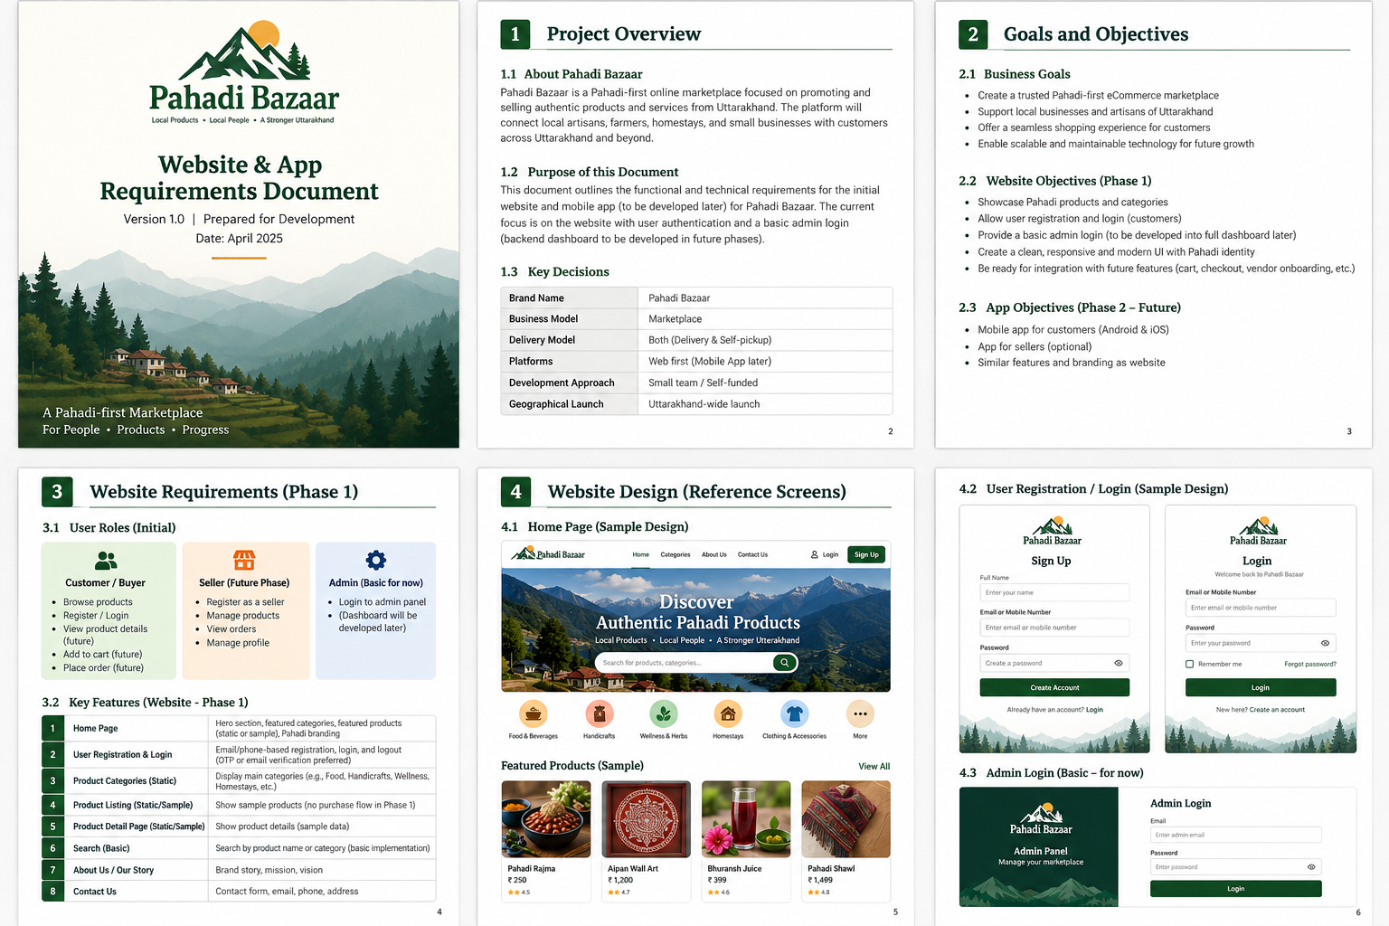

7. Technical implementation plan
Layer | Recommended technology | Implementation notes
Frontend | Next.js + React + TypeScript | SEO-friendly public pages and responsive components
UI system | Tailwind CSS or Material UI | Choose one primary system and keep components consistent
Backend | Django + Django REST Framework | Modular monolith; APIs reusable by future app
Database | PostgreSQL | Relational data, constraints and migrations
Authentication | Secure session/cookie or token strategy | Select one approach and implement CSRF/session protections correctly
Images | S3-compatible object storage | Store object keys/URLs in database; validate uploads
Hosting | Managed hosting or AWS | Separate staging and production
Monitoring | Error tracking, uptime checks and structured logs | Never log passwords, OTPs or secrets
Source control | GitHub | Pull requests, review and protected main branch

7.1 Suggested repository structure
pahadi-bazaar/
frontend/
customer-web/
backend/
config/
apps/
accounts/
locations/
catalog/
content/
contact/
audit/
documentation/
BRD/
SRS/
database/
API/
deployment/
README.md

7.2 Backend modules
Django app | Responsibility
accounts | Customer accounts, staff roles, authentication and profile
locations | State, region, district and pincode master data
catalog | Categories, products, images, origin and publish status
content | Homepage sections, banners and static content (or config-driven initially)
contact | Contact enquiries and spam controls
audit | Admin login events and sensitive action logs

7.3 Initial data entities
Entity | Important fields
User | id, name, email, mobile, password_hash, role, is_active, verified_at, created_at
State | id, name, code, is_active
Region | id, state_id, name (Kumaon/Garhwal), slug
District | id, region_id, name, slug, is_active
Category | id, name, slug, description, image, is_active, sort_order
Product | id, category_id, seller_reference, name, slug, description, price, unit, weight, origin_district_id, status
ProductImage | id, product_id, image_url, alt_text, sort_order
SellerPublicProfile | id, display_name, district_id, description, public_verification_status
ContactEnquiry | id, name, email/mobile, subject, message, status, created_at
AdminAuditEvent | id, actor_user_id, event_type, metadata, created_at

Seller onboarding, seller documents, inventory, orders, payments and settlements are intentionally deferred. Seller attribution can be a simple approved public profile/reference in Phase 1.

8. API outline
Method | Endpoint | Purpose | Access
GET | /api/v1/categories | List active categories | Public
GET | /api/v1/regions | List regions and districts | Public
GET | /api/v1/products | List/search/filter published products | Public
GET | /api/v1/products/{slug} | Product detail | Public
POST | /api/v1/auth/register | Create customer account | Public + throttled
POST | /api/v1/auth/login | Customer login | Public + throttled
POST | /api/v1/auth/logout | End customer session | Customer
POST | /api/v1/auth/password-reset | Request password reset | Public + throttled
GET | /api/v1/me | Current customer profile | Customer
PATCH | /api/v1/me | Update allowed profile fields | Customer
POST | /api/v1/contact | Submit contact enquiry | Public + spam-protected
POST | /api/v1/admin/auth/login | Admin/staff login | Staff authentication only
POST | /api/v1/admin/auth/logout | Admin logout | Admin/staff

Use API versioning from the start. Return consistent validation errors and pagination metadata. Never expose unpublished products or private seller/admin fields through public APIs.

9. Non-functional requirements and security
- Responsive layout: support mobile, tablet and desktop.
- Accessibility: semantic HTML, keyboard navigation, visible focus, form labels and sufficient colour contrast.
- SEO: unique titles/descriptions, canonical URLs, sitemap.xml, robots.txt, Open Graph metadata and suitable product structured data.
- Performance: optimise images, lazy-load below-the-fold media, cache public catalogue responses and monitor Core Web Vitals.
- Security: HTTPS, secure password hashing, rate limiting, input validation, CSRF protection for cookie-based auth, secure cookies and least privilege.
- Admin security: no public staff signup, strong password policy, MFA recommended, rate limits and audit logging.
- Privacy: collect only necessary customer data; publish privacy notice and define retention/deletion procedures.
- Backups: automated database backups and a tested restore procedure.
- Reliability: error monitoring, health checks, staging environment and rollback plan.
- Maintainability: typed frontend code, documented APIs, migrations, automated tests and code review.

10. Acceptance criteria
Area | Definition of done
Homepage | Loads on mobile/desktop; navigation and primary links work; no broken images.
Catalogue | Only published products appear; search and filters return correct results.
Product detail | Shows approved product data, price/unit, origin and seller attribution where available.
Customer registration | Valid user can register; invalid/duplicate inputs are handled; password is not stored in plain text.
Customer login | Valid user can log in; invalid credentials are rejected; logout ends session.
Protected account | Guest cannot access account page or profile API.
Admin login | Only approved staff can authenticate; customer accounts cannot access admin routes/APIs.
Admin placeholder | Successful admin login leads to agreed Phase 1 placeholder or restricted Django Admin.
Contact form | Valid enquiry is recorded and delivered to configured inbox; spam protection is active.
SEO/performance | Metadata and sitemap are present; performance baseline is recorded.
Release | UAT signed off; backups/monitoring configured; no critical/high open defects.

11. Developer execution plan
Sprint | Duration | Work items | Deliverable
Sprint 0 | 3–5 days | Scope confirmation, repo setup, environments, architecture, UI kit and data model | Project foundation
Sprint 1 | 1 week | Homepage, header/footer, responsive layout and static content pages | Public website shell
Sprint 2 | 1 week | Categories, region pages, product listing, product detail and search | Catalogue experience
Sprint 3 | 1 week | Customer registration, login, logout, reset and protected profile | Customer authentication
Sprint 4 | 3–5 days | Admin login, role checks, audit events and placeholder/Django Admin decision | Admin auth foundation
Sprint 5 | 1 week | SEO, accessibility, performance, security, analytics and automated tests | Release candidate
Sprint 6 | 3–5 days | UAT, bug fixes, production deployment, monitoring and handover | Phase 1 launch

Indicative duration: approximately 6–8 weeks for a small experienced team, depending on final scope, content readiness and review turnaround. A catalogue-only website is substantially smaller than a transactional marketplace with checkout and fulfilment.

12. Testing checklist
- Test Chrome, Edge, Firefox and Safari where available.
- Test mobile widths including 360px, 390px and 430px.
- Test slow network, image loading and empty states.
- Test search with partial words, no results and special characters.
- Test unpublished/inactive product visibility.
- Test duplicate registration, invalid email/mobile and weak passwords.
- Test login/logout, password reset and session expiry.
- Test that customer accounts cannot access admin routes or APIs.
- Test admin throttling and inactive staff accounts.
- Test contact form validation and spam controls.
- Run dependency/security checks and verify backup restoration.
- Complete founder/user acceptance testing before production.

13. Environments, deployment and handover
Environment | Purpose | Rules
Local | Developer workstations | Local environment variables; test data only
Staging | QA and founder review | Production-like config; non-production credentials
Production | Live customer website | HTTPS, restricted access, backups, monitoring and approved releases

13.1 Handover items
- GitHub repository access and README setup instructions.
- Environment variable template (.env.example) with no secrets.
- Database ERD and migration history.
- API documentation (OpenAPI/Swagger).
- Admin/staff account creation procedure.
- Deployment and rollback guide.
- Backup and restore instructions.
- Test report and known-issues list.
- Third-party service inventory, billing owner and renewal dates.

14. Decisions to confirm before development
Decision | Recommended default | Why it matters
Catalogue-only or checkout? | Catalogue + customer accounts | Checkout adds payment, order, refund, shipping and tax complexity.
Customer verification | Email verification initially | Controls cost; SMS OTP can be added if needed.
Product data source | Controlled data import / restricted Django Admin | Custom admin dashboard is deferred.
Seller visibility | Show approved seller name and district only | Do not expose private seller contact details.
Delivery messaging | Show availability only where verified | Avoid promising unsupported delivery.
Brand/domain | Pahadi Bazaar as working name | Trademark/domain checks remain pending.
Checkout launch | Separate approval gate | Requires compliance, settlement and fulfilment design.

15. Key risks and mitigations
Risk | Mitigation
Scope creep | Freeze Phase 1 scope; move app, seller portal and full admin dashboard to later phases.
No catalogue owner | Assign one person to approve product data and images.
Unverified product claims | Use evidence-based descriptions and moderation.
Admin access compromise | MFA, throttling, least privilege, audit logs and no public staff signup.
Poor SEO/performance | Use server-rendered product pages, optimised images and performance checks.
Checkout added too early | Require a separate scope and compliance approval.

16. Recommended Phase 1 release
Recommended release
Launch Pahadi Bazaar as a responsive, SEO-friendly catalogue marketplace with Kumaon/Garhwal discovery, product details, customer registration/login, basic account profile and a protected admin login foundation. Use restricted Django Admin or controlled data import for internal catalogue updates until the custom admin dashboard is built. Keep cart, payment, seller self-service and order fulfilment out of scope unless founders explicitly approve a transactional launch.

This approach validates the brand, catalogue and customer interest while keeping the first software release manageable for a small self-funded team.

Appendix A – Phase 1 release checklist
- Brand name and visual identity approved (subject to legal clearance).
- Homepage, shop, category, region and product pages approved.
- Initial approved catalogue loaded.
- Customer registration/login tested.
- Admin authentication and permissions tested.
- Privacy, terms and contact information reviewed.
- Mobile responsiveness and accessibility checked.
- SEO metadata and sitemap checked.
- Staging UAT signed off.
- Production backups, monitoring and rollback plan ready.

Appendix B – Pahadi Bazaar Brand Colour & UI Design System
This appendix defines the approved working colour direction for the Pahadi Bazaar website and future mobile applications. It is based on the light Himalayan visual reference: warm cream surfaces, forest-green branding, soft sage sections and restrained saffron accents. Use these shared design tokens consistently across the customer website, future seller/admin dashboards and mobile apps.

B1. Core brand palette
Colour swatch | Name / HEX | Recommended use
 | Forest Green  #174B35 | Primary brand colour; main headings, primary buttons, links and key icons
 | Deep Green  #103B2B | Footer, dark panels, button hover and strong contrast areas
 | Warm Cream  #F7F4EA | Main page background and warm section backgrounds
 | Soft Sage  #E8EFE6 | Secondary sections, soft feature panels and subtle chips
 | Mountain Mist  #F1F4F0 | Subtle background panels and alternate content surfaces
 | Muted Saffron  #D99A36 | Small highlights, badges, decorative accents and selected states
 | Terracotta  #B96F4B | Secondary accent for editorial details and occasional category accents
 | Earth Brown  #594638 | Primary body text and warm dark text

B2. Semantic UI colours
UI token | HEX | Usage
Page background | #F7F4EA | Main website/app canvas
Header background | #FFFFFF | Top navigation; use a subtle bottom border
Footer background | #103B2B | Footer and dark brand sections
Heading text | #174B35 | H1, H2, H3 and section titles
Body text | #594638 | Paragraphs, descriptions and labels
Secondary text | #737B73 | Helper text, metadata and captions
Primary button | #174B35 | Main actions with white text
Primary button hover | #103B2B | Hover/pressed state
Secondary surface | #E8EFE6 | Soft sage section or secondary card surface
Alternate surface | #F1F4F0 | Subtle panels and alternating sections
Card background | #FFFFFF | Product cards and content cards
Border / divider | #E5E0D3 | Input borders, card borders and dividers
Accent | #D99A36 | Small highlights, icons and promotional markers
Secondary accent | #B96F4B | Warm editorial accent; use sparingly
Success | #367A52 | Success messages and positive status
Error | #B54747 | Validation errors and destructive status

B3. Component styling rules
Component | Background | Text / border | Guidance
Site header | #FFFFFF | Text #174B35; border #E5E0D3 | Clean white header; logo and active nav in forest green.
Main page | #F7F4EA | Body text #594638 | Warm light background; avoid large dark blocks.
Section panel | #E8EFE6 | Heading #174B35 | Use for regional/category callouts.
Product card | #FFFFFF | Border #E5E0D3 | Rounded corners, restrained shadow, clear product image.
Primary button | #174B35 | White text | Use for key actions such as Explore, Sign in and Add to cart later.
Secondary button | #E8EFE6 | Text #174B35 | Use for less prominent actions.
Text input | #FFFFFF | Text #594638; border #E5E0D3 | Focus border #174B35; visible focus ring.
Footer | #103B2B | White / cream text | Use clear contrast for links and legal information.
Badge / highlight | #D99A36 | Dark text where needed | Use sparingly; never rely on colour alone to communicate status.
Error message | #FCEDEC | Text #B54747 | Pair colour with a clear error icon/message.
Success message | #EAF3EC | Text #367A52 | Pair colour with a clear success label/icon.

B4. Typography rules
Element | Style recommendation | Colour
H1 / page title | Aptos Display or another clean sans-serif; 32–40 px desktop, 26–32 px mobile; bold | #174B35
H2 / section title | 24–30 px desktop, 20–24 px mobile; semibold/bold | #174B35
H3 / card title | 18–22 px; semibold | #103B2B
Body text | 16 px desktop/mobile where practical; line-height 1.5–1.7 | #594638
Small metadata | 12–14 px; normal weight | #737B73
Links | 16 px; medium weight; underline on hover/focus | #174B35
Button labels | 14–16 px; semibold | #FFFFFF on primary

Typography note: choose one primary font family for the website and reuse a visually compatible font in the mobile app. Prioritise readability and support for English and Hindi text.

B5. CSS design tokens
:root {
/* Pahadi Bazaar brand */
--pb-forest: #174B35;
--pb-deep-green: #103B2B;
--pb-cream: #F7F4EA;
--pb-sage: #E8EFE6;
--pb-mist: #F1F4F0;
--pb-saffron: #D99A36;
--pb-terracotta: #B96F4B;
--pb-earth: #594638;
/* Semantic UI tokens */
--color-page-bg: var(--pb-cream);
--color-header-bg: #FFFFFF;
--color-footer-bg: var(--pb-deep-green);
--color-heading: var(--pb-forest);
--color-text: var(--pb-earth);
--color-text-muted: #737B73;
--color-primary: var(--pb-forest);
--color-primary-hover: var(--pb-deep-green);
--color-secondary-bg: var(--pb-sage);
--color-surface-muted: var(--pb-mist);
--color-card-bg: #FFFFFF;
--color-border: #E5E0D3;
--color-success: #367A52;
--color-error: #B54747;
/* Shape and spacing */
--radius-card: 14px;
--radius-button: 10px;
--content-max-width: 1200px;
}

B6. Usage and accessibility guidance
- Use Warm Cream (#F7F4EA) as the primary page background and white for cards, forms and the header.
- Use Forest Green (#174B35) for brand identity, headings, links and primary actions.
- Reserve Deep Green (#103B2B) for the footer, hover states and occasional strong brand panels.
- Use Soft Sage (#E8EFE6) and Mountain Mist (#F1F4F0) to create visual separation without introducing heavy colours.
- Use Muted Saffron (#D99A36) and Terracotta (#B96F4B) sparingly; they are accents, not large background colours.
- Do not use light accent colours for small text on white or cream backgrounds. Check contrast for all text and interactive controls.
- Always provide visible keyboard focus states and labels; do not communicate success/error/status using colour alone.
- Keep the same HEX values and semantic token names across website and future React Native app. Map the JSON theme values into the app's styling system when mobile development begins.

B7. Design approval status
Status: Proposed working palette for Pahadi Bazaar v1.0. Use this palette consistently for initial website mockups and implementation. The founders should approve the palette after reviewing it in the actual homepage, product listing, login and mobile-responsive screens.

