Department of Computer Science and Engineering
DSA0102 — CO3 & CO4 Assignment
Smart Hospital Patient and Medical Equipment
Management System Using C++
Course Code & Name: DSA01 – Object-Oriented Programming with C++
Assignment Type: Industry-Based Case Study
Course Outcomes: CO3 (Constructors, Destructors, Operator Overloading), CO4 (Inheritance & Pointers)
SDG Mapping: SDG 3 · SDG 9 · SDG 12
Submitted as a Team Project (3 Members)
Maximum Marks: 100

Required Implementation Tasks
1. Create a MedicalEquipment class with default, parameterized, and overloaded constructors. Implement a copy constructor that

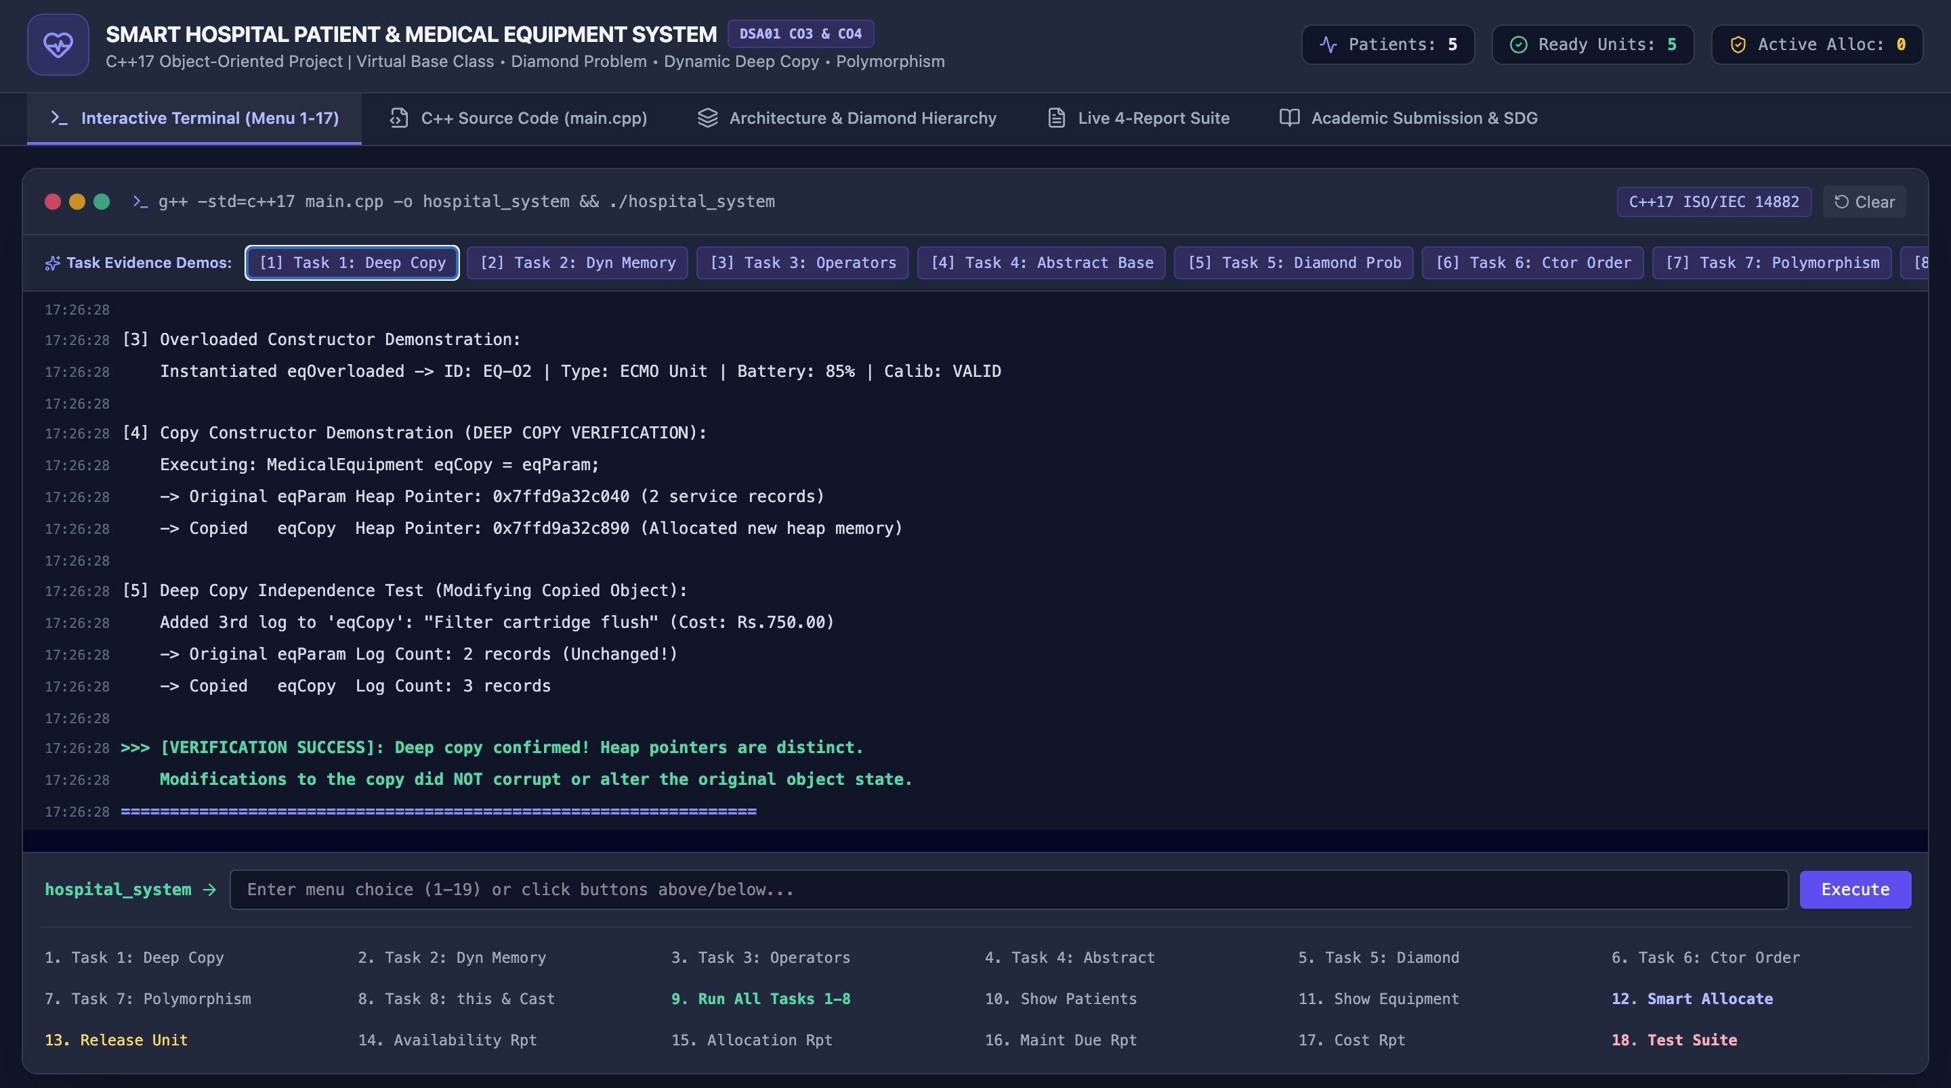

performs deep copying of dynamically allocated service-history or calibration-record data.
2. Demonstrate a dynamic constructor for run-time allocation of patient-allocation records and a destructor that safely releases allowned memory and records equipment release or case closure.

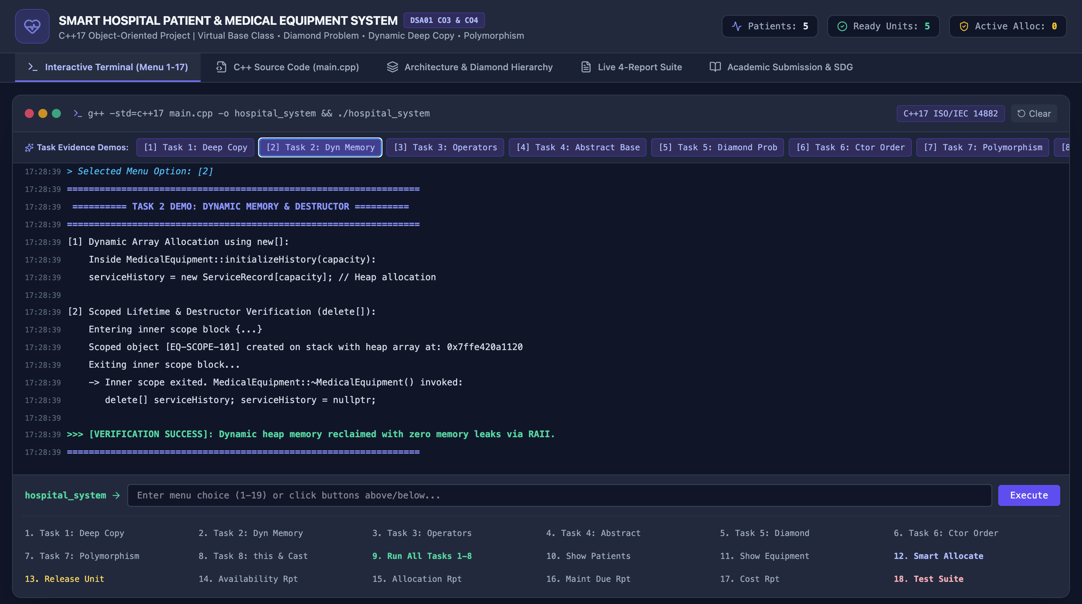
3. Overload at least three meaningful operators: '+' to combine usage duration or treatment cost, '<' to compare equipment by allocation suitability, and '<<' to display a formatted patient or equipment report. Follow all C++ operator-overloading rules.

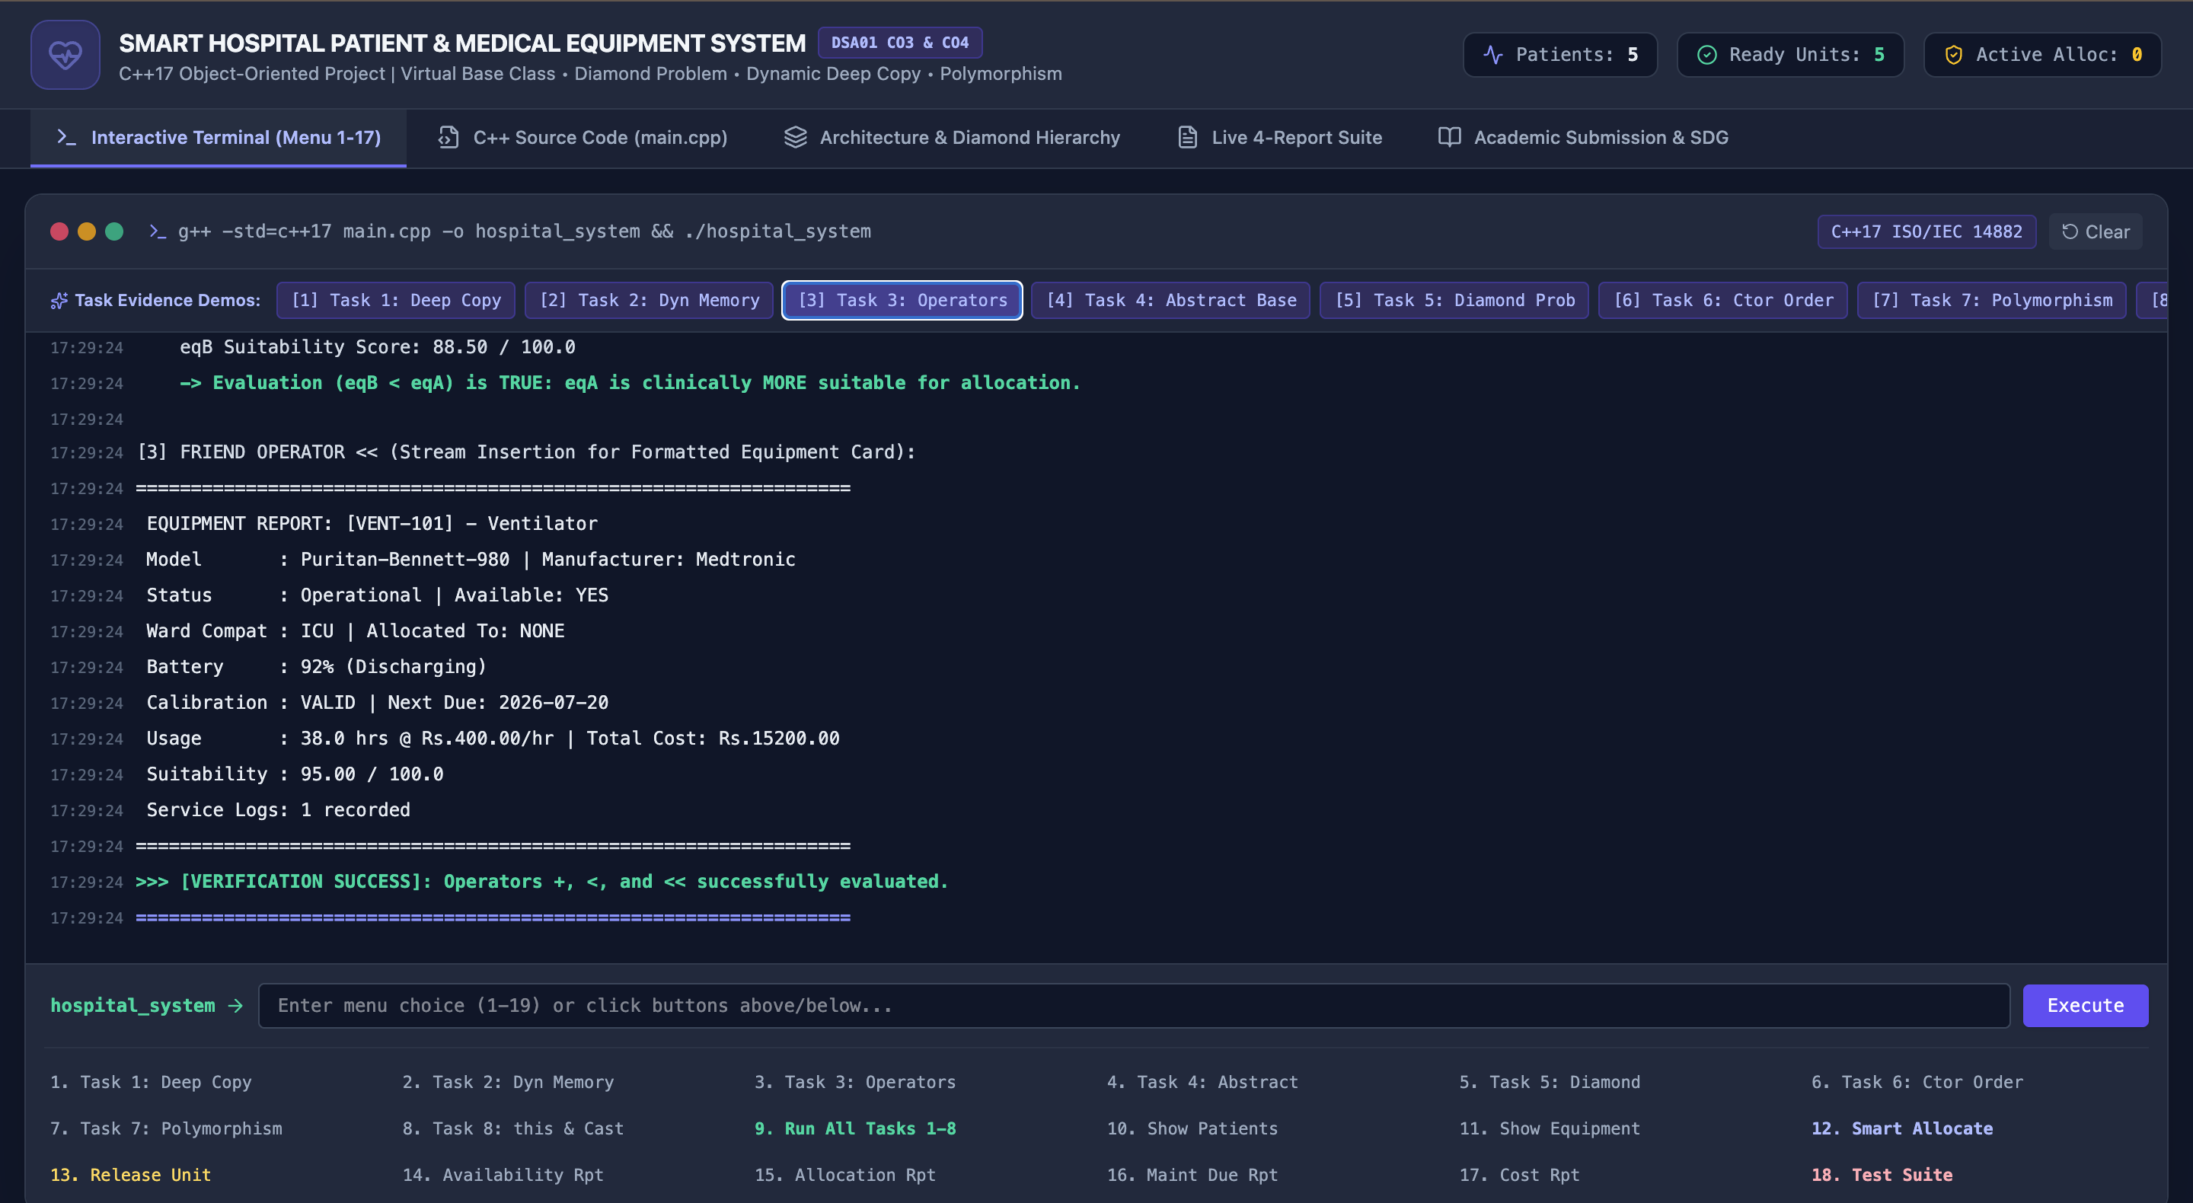
4. Define an abstract base class HospitalResource with at least one pure virtual function. Derive PatientMonitor, InfusionPump, and Ventilator classes and demonstrate hierarchical and multilevel inheritance.

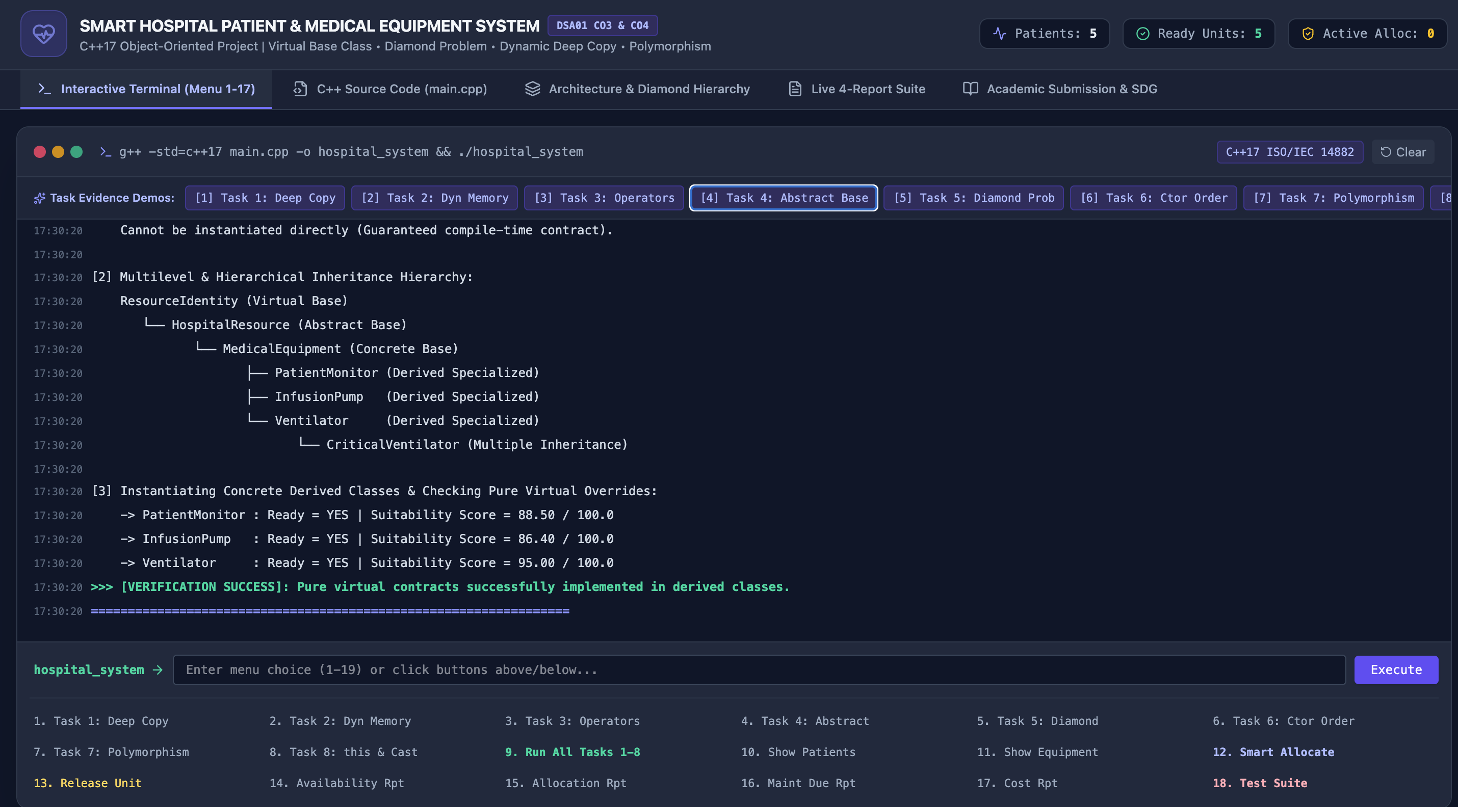

5. Use a virtual base class to resolve duplicated ResourceIdentity data in a hybrid critical-care device formed through multiple inheritance.

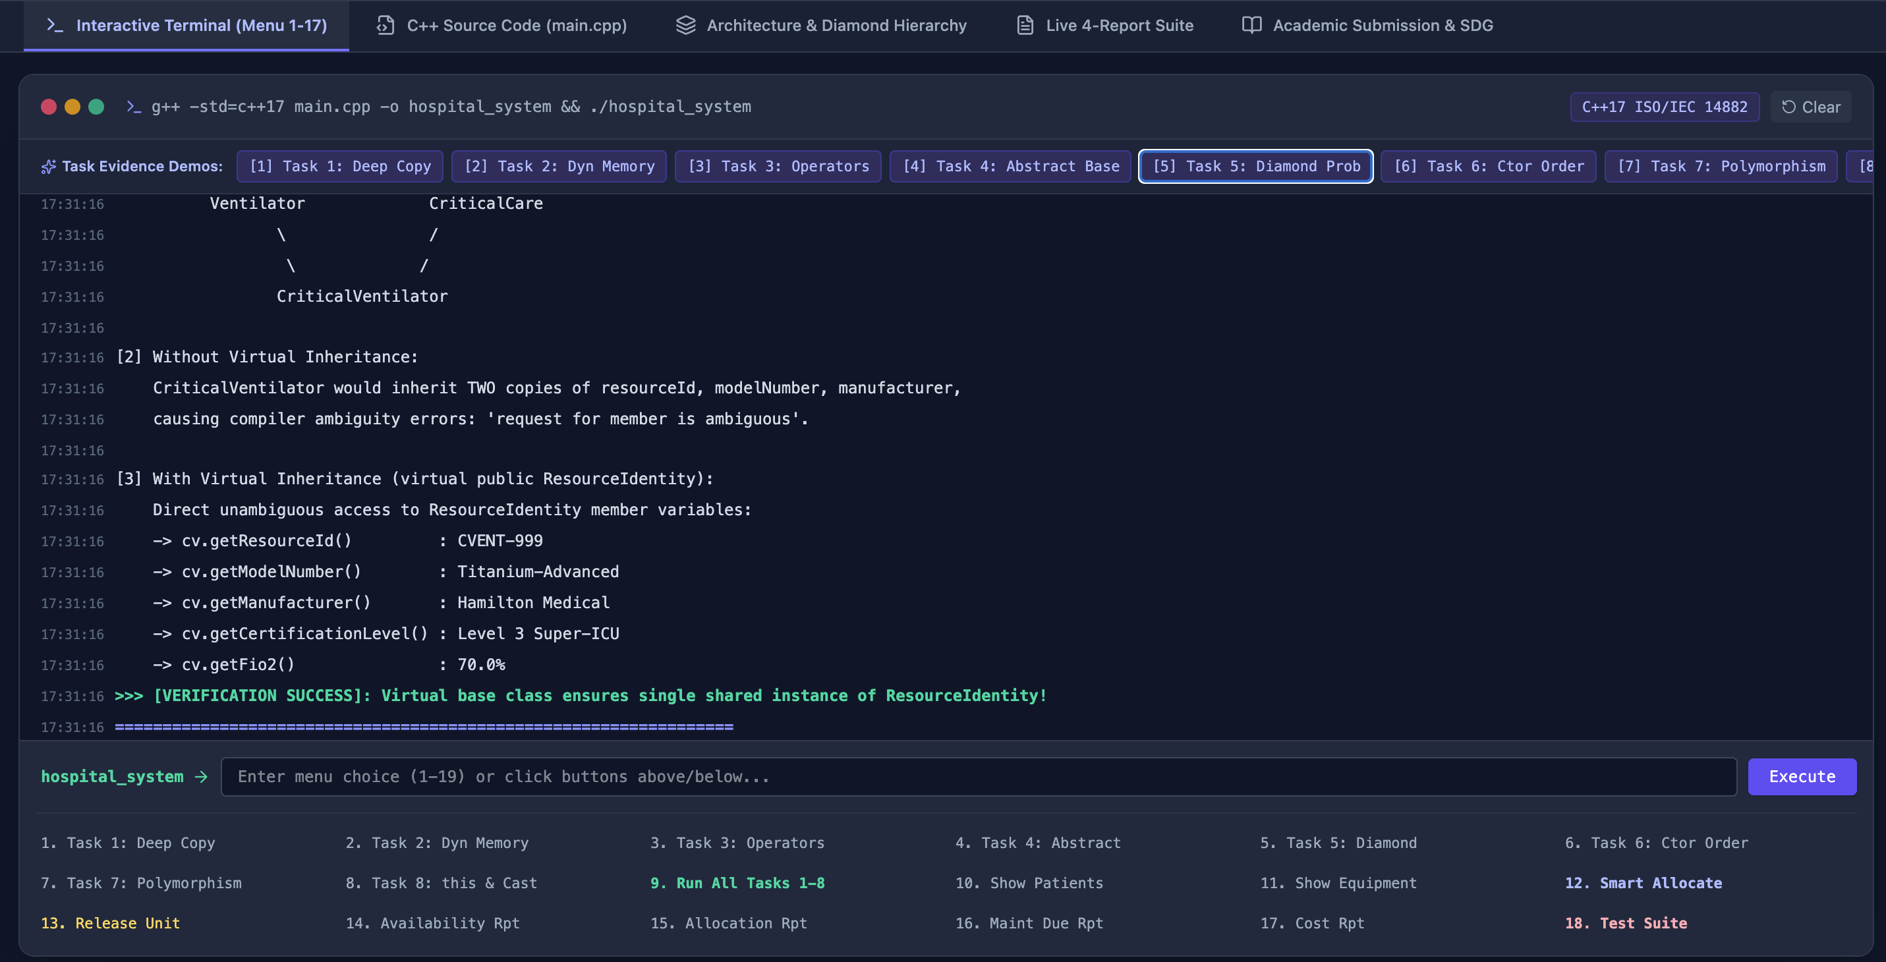
6. Invoke base- and derived-class constructors in the correct order. Include a member class such as BatteryModule, CalibrationModule, or MaintenanceModule within each equipment object.

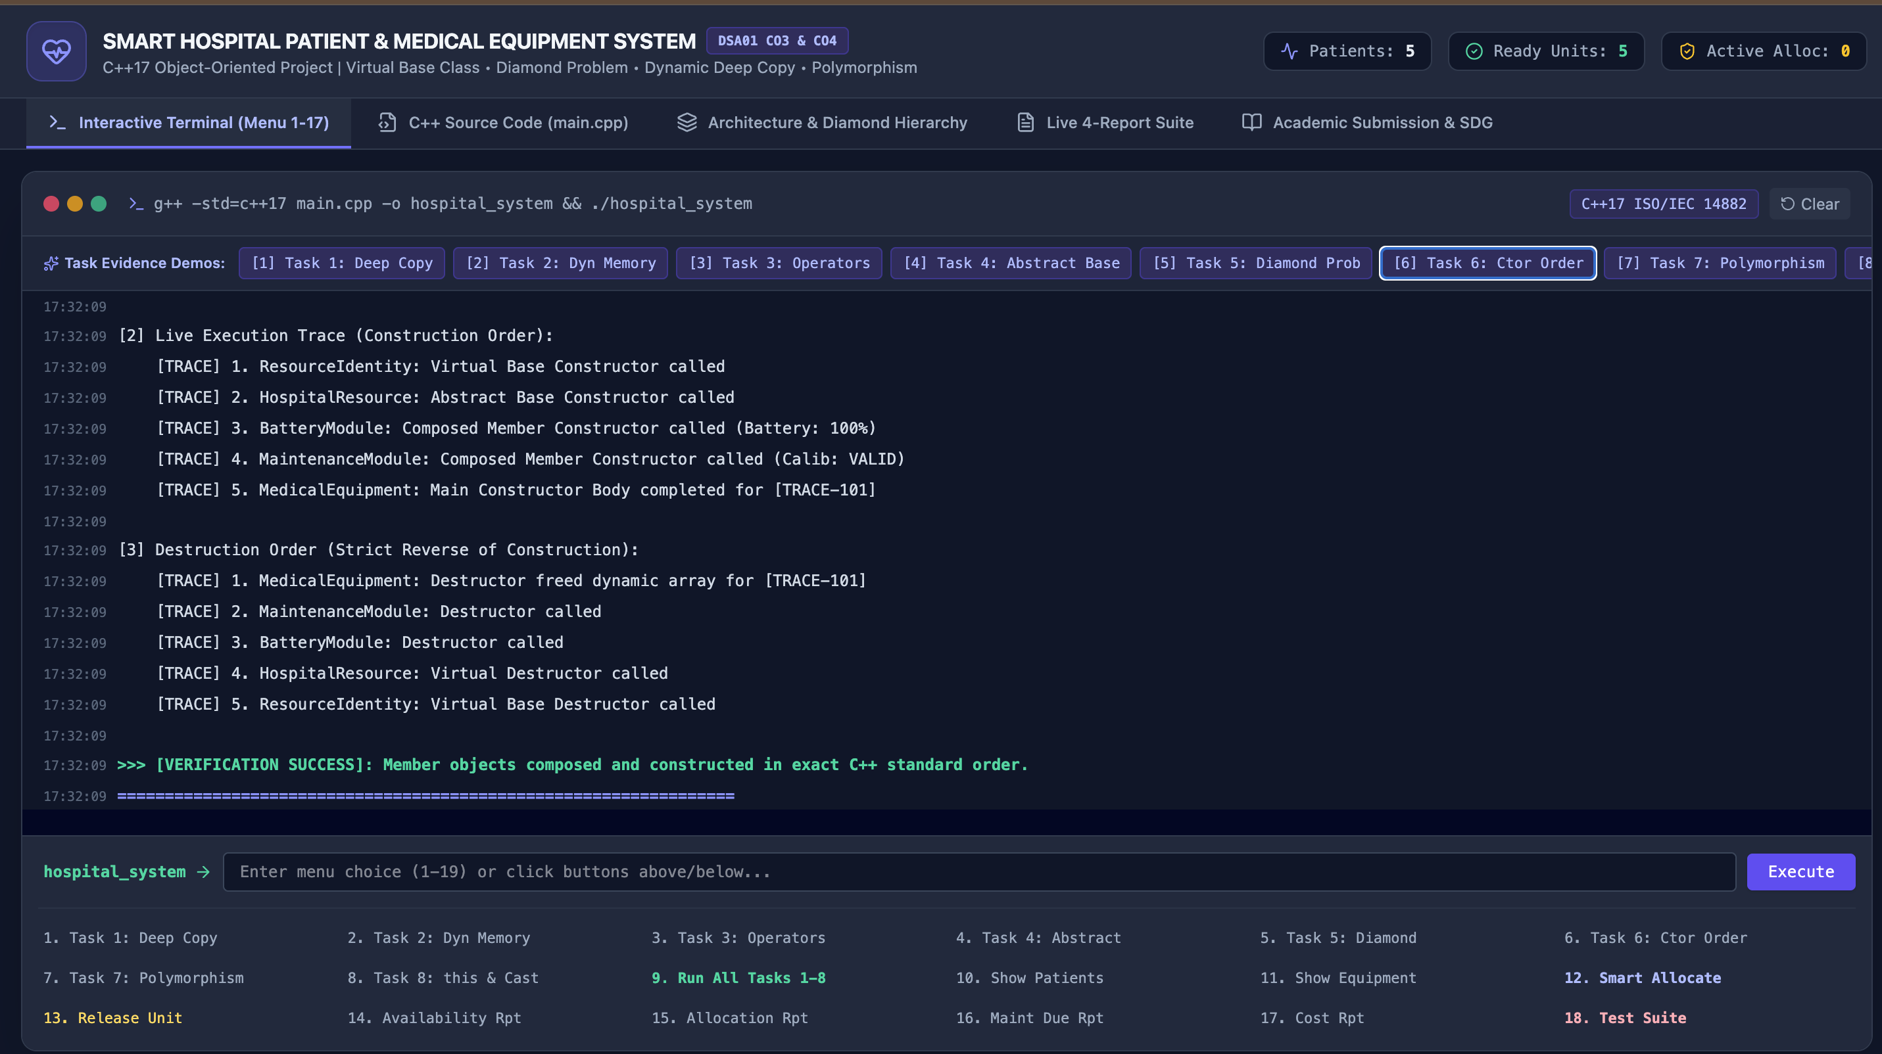
7. Manage heterogeneous objects through an array or collection of HospitalResource pointers. Use base-class pointers to derived objects for run-time equipment allocation and safe virtual-function invocation.

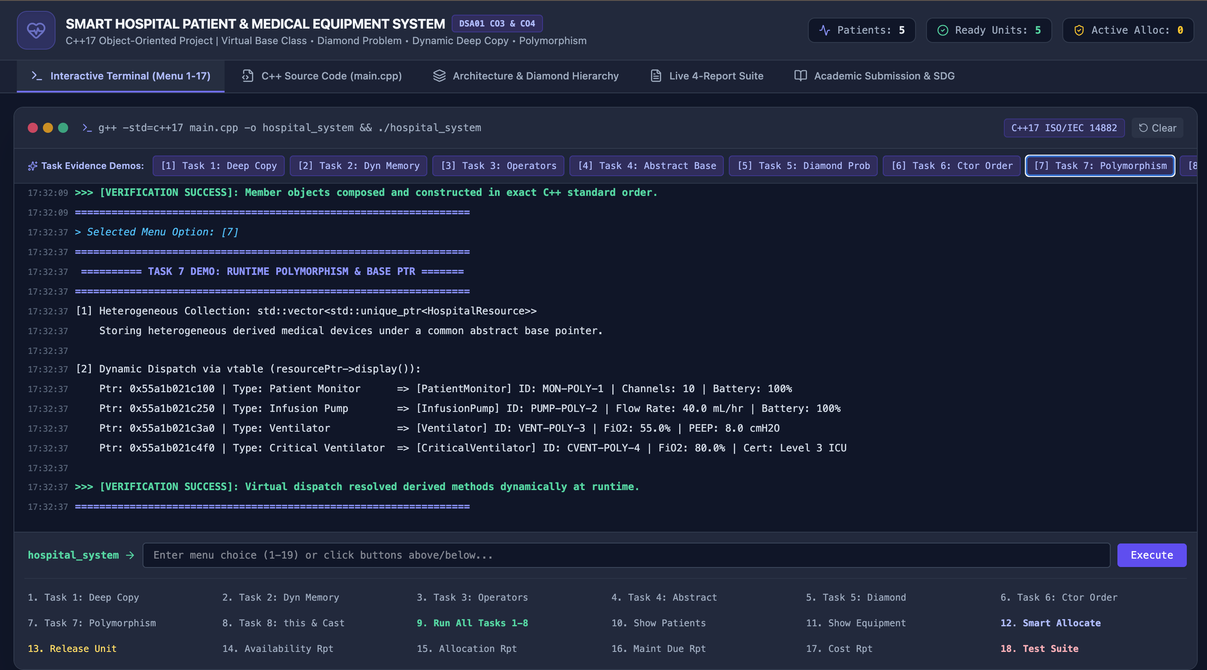
8. Use the this pointer in a chainable update function and demonstrate a pointer to a derived class for accessing equipment-specific operations. Prevent memory leaks, dangling pointers, object slicing, and invalid downcasting.

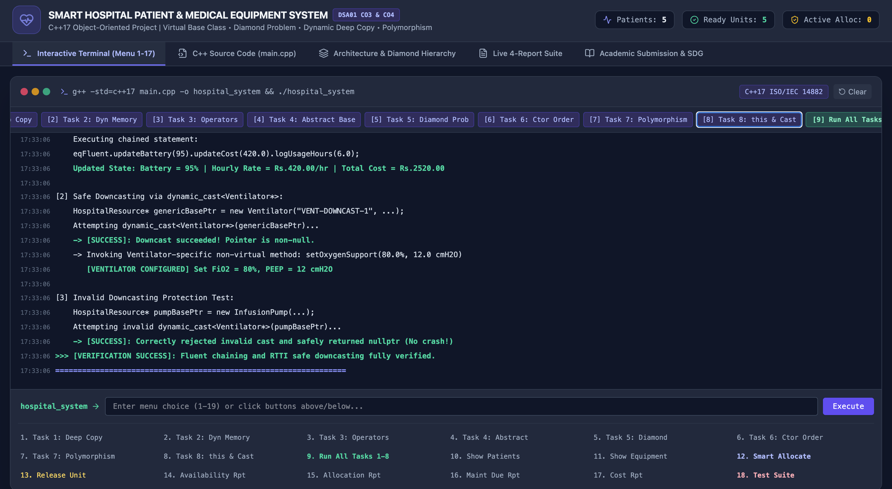

1. Problem Statement
In a multispecialty hospital, manual allocation of patient monitors, infusion pumps, ventilators, and other critical-care equipment can cause delayed treatment, duplicate reservations, unsafe assignment, and poor maintenance tracking. This project designs, implements, and evaluates a menu-driven / automated C++ application that manages patients and heterogeneous medical equipment, and allocates suitable devices according to clinical priority, ward, operating status, battery level, calibration validity, and availability. The system maintains patient identity, equipment identity, service history, risk category, allocation status, and estimated usage cost, and generates equipment-availability, patient-allocation, maintenance-due, and cost reports.

2. Pseudocode
BEGIN SmartHospitalSystem

CLASS MedicalEquipment
ATTRIBUTES: id, name, baseCost, usageHours, serviceHistory[] (dynamic), calibrationRecord (dynamic)
Default Constructor() -> initialise empty/zero equipment
Parameterized Constructor(id,name,cost,hours)
Overloaded/Dynamic Constructor(id,name,cost,hours,slots) -> new string[slots] at run time
Copy Constructor(other) -> DEEP COPY serviceHistory[] and calibrationRecord
Destructor() -> delete[] serviceHistory, delete[] calibrationRecord
OPERATOR + (other) -> combine cost & usage hours, return new object
OPERATOR < (other) -> TRUE if this equipment is MORE suitable (lower score)
OPERATOR << (ostream, equipment) -> print formatted report

CLASS BatteryModule / CalibrationModule / MaintenanceModule // member classes
small classes composed inside each equipment object

CLASS ResourceIdentity // becomes the VIRTUAL BASE
id, name

ABSTRACT CLASS HospitalResource VIRTUALLY INHERITS ResourceIdentity
HAS-A MedicalEquipment, operational, allocated, ward
PURE VIRTUAL displayResource()
PURE VIRTUAL calculateAllocationScore()
PURE VIRTUAL getType()
setOperational(), setAllocated(), setWard() -> RETURN this (chainable)

CLASS PatientMonitor VIRTUALLY INHERITS HospitalResource // hierarchical inheritance
HAS-A BatteryModule
CLASS InfusionPump VIRTUALLY INHERITS HospitalResource
HAS-A CalibrationModule
CLASS Ventilator VIRTUALLY INHERITS HospitalResource
HAS-A MaintenanceModule

CLASS ICUVentilator INHERITS Ventilator // multilevel inheritance
extra: remoteMonitoringEnabled

CLASS CriticalCareUnit INHERITS PatientMonitor, Ventilator // multiple inheritance (HYBRID)
-> because PatientMonitor & Ventilator VIRTUALLY share HospitalResource/ResourceIdentity,
CriticalCareUnit ends up with only ONE ResourceIdentity (no duplication)

CLASS Patient
id, name, riskCategory, ward

CLASS PatientAllocationRecord
DYNAMIC CONSTRUCTOR(patient*, resource*, note, cost, time)
-> notes = new char[note.length()+1] // run-time sized allocation
-> mark resource as allocated (via this-chaining)
DESTRUCTOR()
-> delete[] notes
-> mark resource as released, print "case closed"

CLASS HospitalManagementSystem
resources[] : vector<HospitalResource*> // heterogeneous, base-class pointers
records[] : vector<PatientAllocationRecord*>
patients[] : vector<Patient*>

FUNCTION allocate(patient, type, note, time)
find best OPERATIONAL & UNALLOCATED resource of matching type
using calculateAllocationScore() (polymorphic call)
IF none found -> print "not available", RETURN null // invalid/boundary case
ELSE -> new PatientAllocationRecord(...), store, RETURN record

FUNCTION release(patientId)
locate matching record, delete it (destructor releases equipment + memory)
IF none found -> print "invalid release", handled safely

FUNCTION equipmentAvailabilityReport() -> loop resources, call displayResource() [virtual dispatch]
FUNCTION patientAllocationReport() -> loop records, print patient/device/notes
FUNCTION maintenanceDueReport() -> dynamic_cast<Derived*> each resource, check module
FUNCTION costReport() -> sum estimated cost of active records

DESTRUCTOR ~HospitalManagementSystem()
delete every record, then every resource (virtual destructor -> correct derived dtor),
then every patient // prevents leaks & dangling pointers

FUNCTION main()
Demonstrate constructors, deep copy, operator overloading (CO3)
Build hierarchy: PatientMonitor, InfusionPump, Ventilator, ICUVentilator, CriticalCareUnit (CO4)
Demonstrate this-pointer chaining, safe dynamic_cast downcasting
Allocate patients to equipment: NORMAL cases
Attempt allocation when type exhausted / unknown type: BOUNDARY & INVALID cases
Print all 4 reports
Release allocations (normal + invalid patient id)
Program ends -> destructors cascade, freeing all owned memory

END SmartHospitalSystem

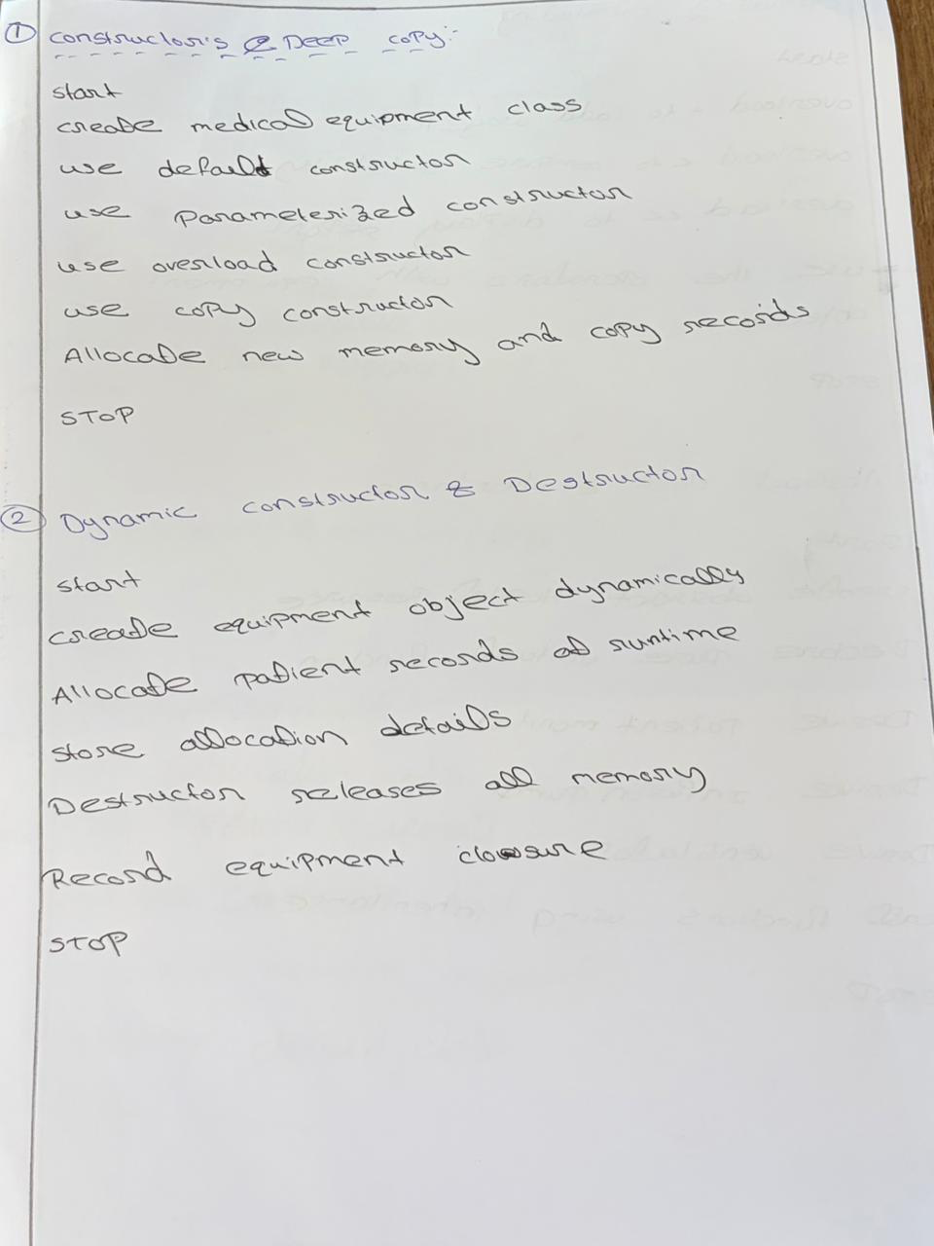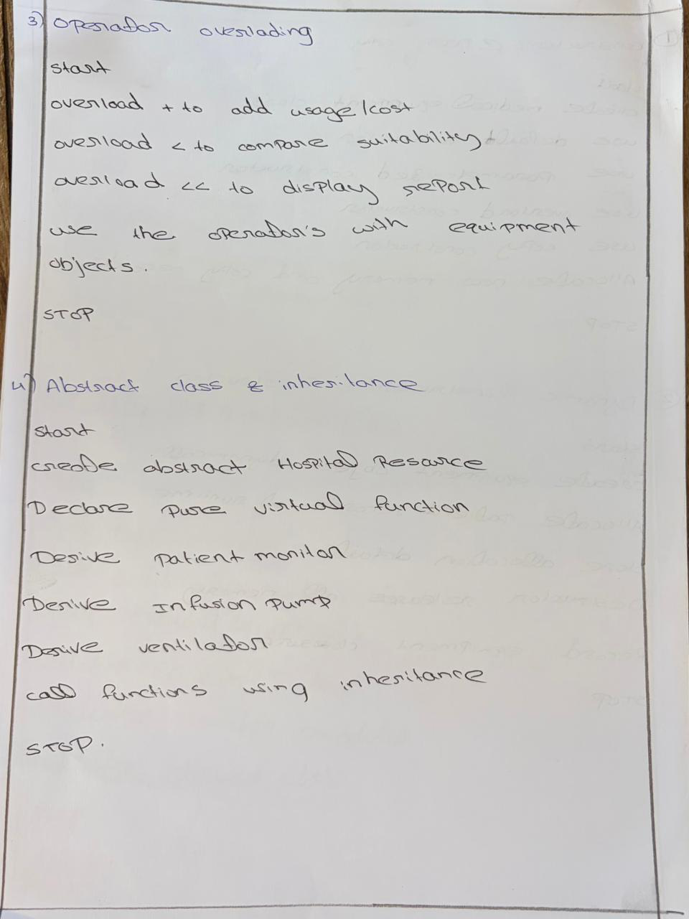

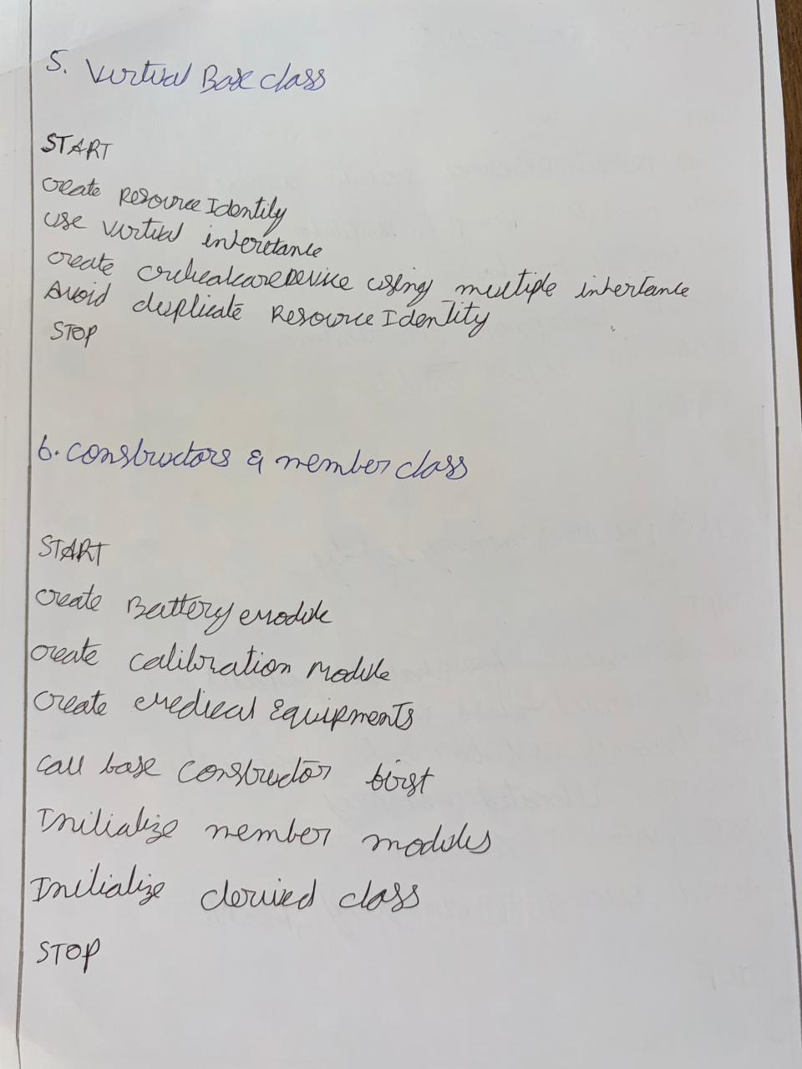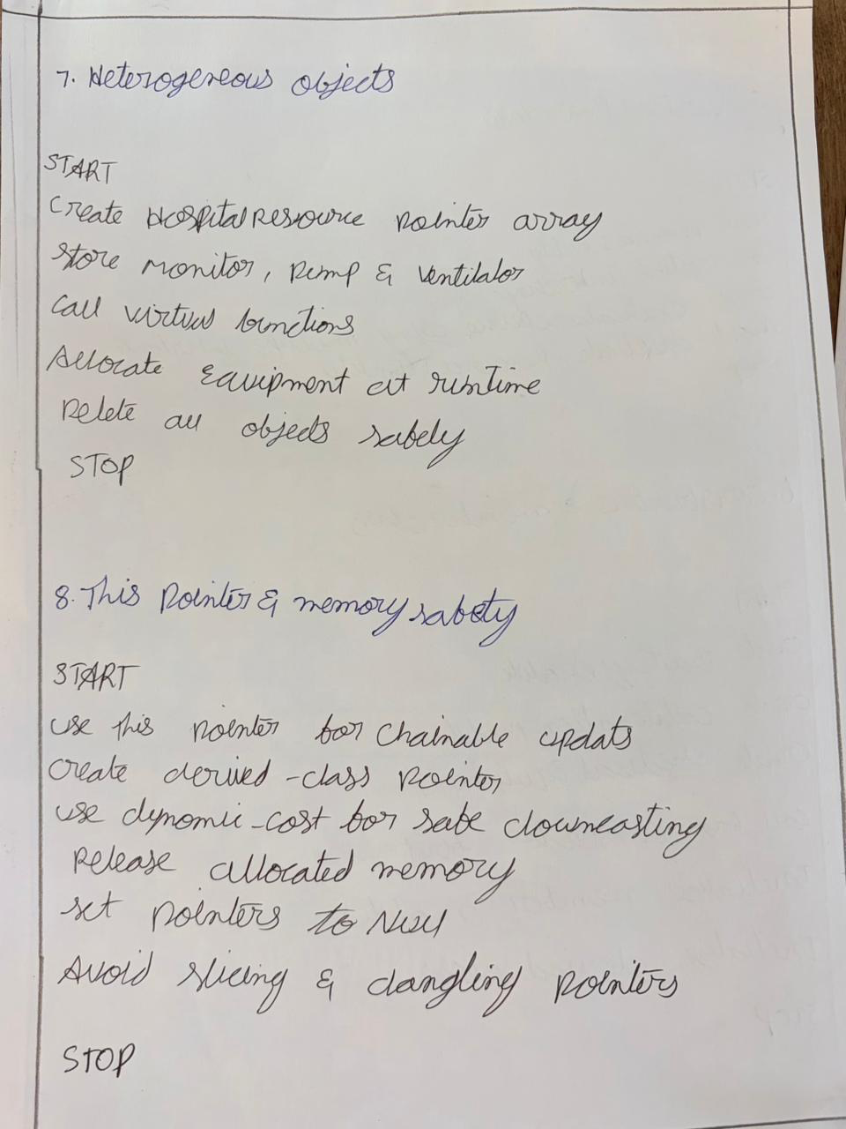

3. Class / Inheritance Diagram
The diagram below shows the composition and inheritance structure. A dashed arrow denotes virtual inheritance; a solid arrow denotes normal inheritance; a diamond denotes composition (has-a).
ResourceIdentity
(id, name)
^
| virtual inheritance
|
HospitalResource (ABSTRACT)
has-a: MedicalEquipment, operational, allocated, ward
pure virtual: displayResource(), calculateAllocationScore(), getType()
this-pointer chainable: setOperational()/setAllocated()/setWard()
^ virtual ^ virtual ^ virtual
| | |
PatientMonitor InfusionPump Ventilator
(◇BatteryModule) (◇CalibrationModule) (◇MaintenanceModule)
^
| (multilevel)
ICUVentilator
\_______________ ________________/
\/
multiple inheritance (hybrid device)
||
CriticalCareUnit
(single shared ResourceIdentity + HospitalResource
via virtual base -> NO duplication)

Composition (independent of the hierarchy above):
MedicalEquipment <>--- service-history[] (dynamic), calibrationRecord (dynamic)
PatientAllocationRecord ---> Patient* (association)
---> HospitalResource* (association, base-pointer-to-derived)
HospitalManagementSystem <>--- vector<HospitalResource*>, vector<PatientAllocationRecord*>,
vector<Patient*>

4. Complete C++ Source Code
File: hospital_system.cpp | Compiled and verified with g++ 13.3 (C++17), zero errors, one harmless -Wreorder warning. Also re-compiled and executed under AddressSanitizer + LeakSanitizer with a clean exit (no leaks, no invalid memory access) — see Section 6.
/*
================================================================================
SMART HOSPITAL PATIENT AND MEDICAL EQUIPMENT MANAGEMENT SYSTEM
DSA01 - Object Oriented Programming with C++ | CO3 & CO4 Assignment
--------------------------------------------------------------------------------
Demonstrates:
CO3 -> Constructors (default/parameterized/overloaded/dynamic/copy-deep-copy),
Destructors, Operator Overloading ( +, <, << )
CO4 -> Abstract classes, Hierarchical & Multilevel inheritance, Multiple
inheritance with Virtual Base Class, Member classes, this pointer
chaining, base-class pointers to derived objects, safe dynamic_cast
downcasting, prevention of leaks / dangling pointers / slicing.
================================================================================
*/
#include <iostream>
#include <cstring>
#include <string>
#include <vector>
#include <iomanip>
using namespace std;

/* ============================================================
1. ResourceIdentity -> will become the VIRTUAL BASE CLASS
============================================================ */
class ResourceIdentity {
protected:
string resourceId;
string resourceName;
public:
ResourceIdentity() : resourceId("UNSET"), resourceName("UNSET") {
cout << " [ResourceIdentity] default constructor\n";
}
ResourceIdentity(string id, string name) : resourceId(id), resourceName(name) {
cout << " [ResourceIdentity] constructed identity for " << id << "\n";
}
string getResourceId() const { return resourceId; }
string getResourceName() const { return resourceName; }
virtual ~ResourceIdentity() {}
};

/* ============================================================
2. MedicalEquipment (CO3) - constructors, destructor, deep
copy, operator overloading (+, <, <<)
============================================================ */
class MedicalEquipment {
private:
string equipId;
string equipName;
double baseCost;
int usageHours;
string* serviceHistory; // dynamically allocated array (deep-copy target)
int historyCount;
int historyCapacity;
char* calibrationRecord; // dynamically allocated C-string (deep-copy target)

public:
/* ---- Default constructor ---- */
MedicalEquipment()
: equipId("EQ000"), equipName("Unnamed"), baseCost(0.0), usageHours(0),
serviceHistory(nullptr), historyCount(0), historyCapacity(0) {
calibrationRecord = new char[1];
calibrationRecord[0] = '\0';
cout << " [MedicalEquipment] default constructor -> " << equipId << "\n";
}

/* ---- Parameterized constructor ---- */
MedicalEquipment(string id, string name, double cost, int hours)
: equipId(id), equipName(name), baseCost(cost), usageHours(hours),
serviceHistory(nullptr), historyCount(0), historyCapacity(0) {
calibrationRecord = new char[strlen("NOT_CALIBRATED") + 1];
strcpy(calibrationRecord, "NOT_CALIBRATED");
cout << " [MedicalEquipment] parameterized constructor -> " << equipId << "\n";
}

/* ---- Overloaded / DYNAMIC constructor ----
Allocates the service-history array at RUN TIME, sized by the
caller-supplied slot count -> classic "dynamic constructor". */
MedicalEquipment(string id, string name, double cost, int hours, int historySlots)
: equipId(id), equipName(name), baseCost(cost), usageHours(hours),
historyCount(0), historyCapacity(historySlots) {
serviceHistory = (historySlots > 0) ? new string[historySlots] : nullptr;
calibrationRecord = new char[strlen("PENDING") + 1];
strcpy(calibrationRecord, "PENDING");
cout << " [MedicalEquipment] dynamic constructor -> " << equipId
<< " (" << historySlots << " history slots allocated at run time)\n";
}

/* ---- Copy constructor : DEEP COPY ---- */
MedicalEquipment(const MedicalEquipment& other)
: equipId(other.equipId), equipName(other.equipName), baseCost(other.baseCost),
usageHours(other.usageHours), historyCount(other.historyCount),
historyCapacity(other.historyCapacity) {
if (other.serviceHistory && historyCapacity > 0) {
serviceHistory = new string[historyCapacity];
for (int i = 0; i < historyCount; ++i) serviceHistory[i] = other.serviceHistory[i];
} else serviceHistory = nullptr;

if (other.calibrationRecord) {
calibrationRecord = new char[strlen(other.calibrationRecord) + 1];
strcpy(calibrationRecord, other.calibrationRecord);
} else calibrationRecord = nullptr;

cout << " [MedicalEquipment] copy constructor (DEEP COPY) -> " << equipId << "\n";
}

/* ---- Destructor : releases every owned resource ---- */
~MedicalEquipment() {
delete[] serviceHistory;
delete[] calibrationRecord;
cout << " [MedicalEquipment] destructor -> " << equipId
<< " service-history & calibration memory freed\n";
}

void addServiceRecord(const string& rec) {
if (historyCount < historyCapacity) {
serviceHistory[historyCount++] = rec;
} else {
cout << " ! [MedicalEquipment] " << equipId
<< " service-history full (capacity " << historyCapacity
<< ") - record rejected (boundary case handled safely)\n";
}
}

void setCalibration(const string& text) {
delete[] calibrationRecord;
calibrationRecord = new char[text.size() + 1];
strcpy(calibrationRecord, text.c_str());
}

/* ---- operator+ : combine usage/cost of two equipment records ---- */
MedicalEquipment operator+(const MedicalEquipment& other) const {
MedicalEquipment combined(equipId + "+" + other.equipId,
equipName + "/" + other.equipName,
baseCost + other.baseCost,
usageHours + other.usageHours, 1);
return combined;
}

/* ---- operator< : compares allocation suitability (lower = more suitable) --- */
bool operator<(const MedicalEquipment& other) const {
double score = baseCost * 0.4 + usageHours * 0.6;
double otherScore = other.baseCost * 0.4 + other.usageHours * 0.6;
return score < otherScore;
}

/* ---- operator<< : formatted report (friend, const-correct) ---- */
friend ostream& operator<<(ostream& os, const MedicalEquipment& eq) {
os << " ---- Equipment Report ----\n";
os << " ID: " << eq.equipId << " | Name: " << eq.equipName << "\n";
os << " Base Cost: Rs." << fixed << setprecision(2) << eq.baseCost
<< " | Usage Hours: " << eq.usageHours << "\n";
os << " Calibration: " << (eq.calibrationRecord ? eq.calibrationRecord : "N/A") << "\n";
os << " Service Records (" << eq.historyCount << "): ";
if (eq.historyCount == 0) os << "none\n";
else {
os << "\n";
for (int i = 0; i < eq.historyCount; ++i) os << " - " << eq.serviceHistory[i] << "\n";
}
return os;
}

double getCost() const { return baseCost; }
int getUsage() const { return usageHours; }
string getId() const { return equipId; }
};

/* ============================================================
3. Member classes (composed INSIDE each equipment object)
============================================================ */
class BatteryModule {
int batteryPercent;
public:
BatteryModule(int pct = 100) : batteryPercent(pct) {}
bool isChargeSufficient() const { return batteryPercent >= 20; }
int getPercent() const { return batteryPercent; }
};

class CalibrationModule {
bool calibrated;
int daysSinceCalibration;
public:
CalibrationModule(bool c = false, int days = 0) : calibrated(c), daysSinceCalibration(days) {}
bool isValid() const { return calibrated && daysSinceCalibration <= 90; }
int getDays() const { return daysSinceCalibration; }
};

class MaintenanceModule {
bool maintenanceDue;
string lastServiceDate;
public:
MaintenanceModule(bool due = false, string date = "N/A") : maintenanceDue(due), lastServiceDate(date) {}
bool needsMaintenance() const { return maintenanceDue; }
string getLastService() const { return lastServiceDate; }
};

/* ============================================================
4. HospitalResource - ABSTRACT base class.
Virtually inherits ResourceIdentity so that a hybrid class
built through multiple inheritance (see CriticalCareUnit)
ends up with only ONE copy of ResourceIdentity.
============================================================ */
class HospitalResource : public virtual ResourceIdentity {
protected:
MedicalEquipment equipment; // composition (has-a)
bool operational;
bool allocated;
string ward;
public:
HospitalResource() : equipment(), operational(true), allocated(false), ward("Unassigned") {
cout << " [HospitalResource] default constructor\n";
}
HospitalResource(MedicalEquipment eq, string w)
: equipment(eq), operational(true), allocated(false), ward(w) {
cout << " [HospitalResource] parameterized constructor, ward=" << w << "\n";
}

virtual void displayResource() const = 0; // pure virtual #1
virtual double calculateAllocationScore() const = 0; // pure virtual #2
virtual string getType() const = 0; // pure virtual #3

bool isOperational() const { return operational; }
bool isAllocated() const { return allocated; }
string getWard() const { return ward; }
double getCost() const { return equipment.getCost(); }
MedicalEquipment& getEquipment() { return equipment; }

/* ---- chainable updates via the `this` pointer ---- */
HospitalResource* setOperational(bool status) { this->operational = status; return this; }
HospitalResource* setAllocated(bool status) { this->allocated = status; return this; }
HospitalResource* setWard(const string& w) { this->ward = w; return this; }

virtual ~HospitalResource() { cout << " [HospitalResource] destructor for " << getResourceId() << "\n"; }
};

/* ============================================================
5. Derived equipment classes -> HIERARCHICAL inheritance
Each ALSO virtually inherits HospitalResource so that the
hybrid CriticalCareUnit (multiple inheritance) below gets a
single shared HospitalResource/ResourceIdentity sub-object.
============================================================ */
class PatientMonitor : public virtual HospitalResource {
protected:
BatteryModule battery; // member class
public:
PatientMonitor() : battery(100) {}
PatientMonitor(string id, string name, MedicalEquipment eq, string ward, int batteryPct)
: ResourceIdentity(id, name), HospitalResource(eq, ward), battery(batteryPct) {
cout << " [PatientMonitor] constructed " << id << "\n";
}
void displayResource() const override {
cout << " >> PatientMonitor [" << getResourceId() << "] " << getResourceName()
<< " | Ward:" << ward << " | Battery:" << battery.getPercent() << "%"
<< " | Operational:" << (operational ? "Yes" : "No")
<< " | Allocated:" << (allocated ? "Yes" : "No") << "\n";
}
double calculateAllocationScore() const override {
double score = equipment.getCost() * 0.3;
if (!battery.isChargeSufficient()) score += 1000;
if (!operational) score += 5000;
return score;
}
string getType() const override { return "PatientMonitor"; }
bool checkBattery() const { return battery.isChargeSufficient(); } // equipment-specific op
~PatientMonitor() { cout << " [PatientMonitor] destructor " << getResourceId() << "\n"; }
};

class InfusionPump : public virtual HospitalResource {
protected:
CalibrationModule calibration; // member class
public:
InfusionPump() {}
InfusionPump(string id, string name, MedicalEquipment eq, string ward, bool calibrated, int days)
: ResourceIdentity(id, name), HospitalResource(eq, ward), calibration(calibrated, days) {
cout << " [InfusionPump] constructed " << id << "\n";
}
void displayResource() const override {
cout << " >> InfusionPump [" << getResourceId() << "] " << getResourceName()
<< " | Ward:" << ward << " | CalibrationValid:" << (calibration.isValid() ? "Yes" : "No")
<< " | Operational:" << (operational ? "Yes" : "No")
<< " | Allocated:" << (allocated ? "Yes" : "No") << "\n";
}
double calculateAllocationScore() const override {
double score = equipment.getCost() * 0.3;
if (!calibration.isValid()) score += 1000;
if (!operational) score += 5000;
return score;
}
string getType() const override { return "InfusionPump"; }
bool checkCalibration() const { return calibration.isValid(); } // equipment-specific op
~InfusionPump() { cout << " [InfusionPump] destructor " << getResourceId() << "\n"; }
};

class Ventilator : public virtual HospitalResource {
protected:
MaintenanceModule maintenance; // member class
public:
Ventilator() {}
Ventilator(string id, string name, MedicalEquipment eq, string ward, bool due, string lastDate)
: ResourceIdentity(id, name), HospitalResource(eq, ward), maintenance(due, lastDate) {
cout << " [Ventilator] constructed " << id << "\n";
}
void displayResource() const override {
cout << " >> Ventilator [" << getResourceId() << "] " << getResourceName()
<< " | Ward:" << ward << " | MaintenanceDue:" << (maintenance.needsMaintenance() ? "Yes" : "No")
<< " | Operational:" << (operational ? "Yes" : "No")
<< " | Allocated:" << (allocated ? "Yes" : "No") << "\n";
}
double calculateAllocationScore() const override {
double score = equipment.getCost() * 0.3;
if (maintenance.needsMaintenance()) score += 1000;
if (!operational) score += 5000;
return score;
}
string getType() const override { return "Ventilator"; }
bool checkMaintenance() const { return !maintenance.needsMaintenance(); } // equipment-specific op
string getLastServiceDate() const { return maintenance.getLastService(); }
~Ventilator() { cout << " [Ventilator] destructor " << getResourceId() << "\n"; }
};

/* ============================================================
6. MULTILEVEL inheritance : ICUVentilator extends Ventilator
============================================================ */
class ICUVentilator : public Ventilator {
bool remoteMonitoringEnabled;
public:
ICUVentilator(string id, string name, MedicalEquipment eq, string ward,
bool due, string lastDate, bool remote)
: ResourceIdentity(id, name), HospitalResource(eq, ward),
Ventilator(id, name, eq, ward, due, lastDate),
remoteMonitoringEnabled(remote) {
cout << " [ICUVentilator] constructed (multilevel) " << id << "\n";
}
void displayResource() const override {
Ventilator::displayResource();
cout << " (ICU-Advanced) Remote Monitoring: "
<< (remoteMonitoringEnabled ? "Enabled" : "Disabled") << "\n";
}
string getType() const override { return "ICU-Ventilator(Advanced)"; }
~ICUVentilator() { cout << " [ICUVentilator] destructor " << getResourceId() << "\n"; }
};

/* ============================================================
7. HYBRID device via MULTIPLE inheritance.
PatientMonitor and Ventilator both virtually share ONE
HospitalResource/ResourceIdentity sub-object here - this is
exactly the virtual-base-class requirement of the assignment.
============================================================ */
class CriticalCareUnit : public PatientMonitor, public Ventilator {
public:
CriticalCareUnit(string id, string name, MedicalEquipment eq, string ward,
int batteryPct, bool due, string lastDate)
: ResourceIdentity(id, name), HospitalResource(eq, ward),
PatientMonitor(id, name, eq, ward, batteryPct),
Ventilator(id, name, eq, ward, due, lastDate) {
cout << " [CriticalCareUnit] hybrid device created - single ResourceIdentity "
"shared via virtual base\n";
}
void displayResource() const override {
cout << " >> CriticalCareUnit (HYBRID) [" << getResourceId() << "] " << getResourceName() << "\n";
PatientMonitor::displayResource();
Ventilator::displayResource();
}
double calculateAllocationScore() const override {
return (PatientMonitor::calculateAllocationScore() + Ventilator::calculateAllocationScore()) / 2.0;
}
string getType() const override { return "CriticalCareUnit(Hybrid)"; }
~CriticalCareUnit() { cout << " [CriticalCareUnit] destructor " << getResourceId() << "\n"; }
};

/* ============================================================
8. Patient
============================================================ */
enum class RiskCategory { LOW, MODERATE, HIGH, CRITICAL };

string riskToString(RiskCategory r) {
switch (r) {
case RiskCategory::LOW: return "LOW";
case RiskCategory::MODERATE: return "MODERATE";
case RiskCategory::HIGH: return "HIGH";
default: return "CRITICAL";
}
}

class Patient {
string patientId, patientName, ward;
RiskCategory risk;
public:
Patient(string id, string name, RiskCategory r, string w)
: patientId(id), patientName(name), risk(r), ward(w) {}
string getId() const { return patientId; }
string getName() const { return patientName; }
string getWard() const { return ward; }
RiskCategory getRisk() const { return risk; }
};

5. Execution Results — Normal, Boundary and Invalid Test Cases
Below is the actual console output produced by running the compiled program (g++ -std=c++17). Section markers [1]–[15] correspond to the demonstration stages in main(). Boundary cases (service-history overflow, exhausted equipment type) and invalid cases (unknown equipment type, invalid patient release, invalid downcast) are explicitly triggered and handled without crashing.
================================================================
SMART HOSPITAL PATIENT & MEDICAL EQUIPMENT MANAGEMENT SYSTEM
================================================================

--- [1] CONSTRUCTOR DEMONSTRATION (CO3) ---
[MedicalEquipment] default constructor -> EQ000
[MedicalEquipment] parameterized constructor -> EQ101
[MedicalEquipment] dynamic constructor -> EQ102 (3 history slots allocated at run time)

--- [2] COPY CONSTRUCTOR / DEEP COPY VERIFICATION ---
[MedicalEquipment] copy constructor (DEEP COPY) -> EQ102
Original (eqDynamic):
---- Equipment Report ----
ID: EQ102 | Name: Pump-B
Base Cost: Rs.8000.00 | Usage Hours: 40
Calibration: PENDING
Service Records (2):
- 2026-01-10: Routine check
- 2026-03-22: Sensor replaced
Deep Copy (eqCopy):
---- Equipment Report ----
ID: EQ102 | Name: Pump-B
Base Cost: Rs.8000.00 | Usage Hours: 40
Calibration: PENDING
Service Records (3):
- 2026-01-10: Routine check
- 2026-03-22: Sensor replaced
- 2026-06-01: Copy-only entry

--- [3] BOUNDARY CASE: exceeding service-history capacity ---
! [MedicalEquipment] EQ102 service-history full (capacity 3) - record rejected (boundary case handled safely)

--- [4] OPERATOR OVERLOADING DEMONSTRATION ---
[MedicalEquipment] dynamic constructor -> EQ101+EQ102 (1 history slots allocated at run time)
Combined (operator+):
---- Equipment Report ----
ID: EQ101+EQ102 | Name: Monitor-A/Pump-B
Base Cost: Rs.23000.00 | Usage Hours: 160
Calibration: PENDING
Service Records (0): none
eqParam < eqDynamic ? false

--- [5] INHERITANCE HIERARCHY CONSTRUCTION (CO4) ---
[MedicalEquipment] dynamic constructor -> PM-01 (2 history slots allocated at run time)
[ResourceIdentity] constructed identity for PM-01
[MedicalEquipment] copy constructor (DEEP COPY) -> PM-01
[MedicalEquipment] copy constructor (DEEP COPY) -> PM-01
[HospitalResource] parameterized constructor, ward=ICU-1
[MedicalEquipment] destructor -> PM-01 service-history & calibration memory freed
[PatientMonitor] constructed PM-01
[MedicalEquipment] destructor -> PM-01 service-history & calibration memory freed
[MedicalEquipment] dynamic constructor -> PM-02 (2 history slots allocated at run time)
[ResourceIdentity] constructed identity for PM-02
[MedicalEquipment] copy constructor (DEEP COPY) -> PM-02
[MedicalEquipment] copy constructor (DEEP COPY) -> PM-02
[HospitalResource] parameterized constructor, ward=General-2
[MedicalEquipment] destructor -> PM-02 service-history & calibration memory freed
[PatientMonitor] constructed PM-02
[MedicalEquipment] destructor -> PM-02 service-history & calibration memory freed
[MedicalEquipment] dynamic constructor -> IP-01 (2 history slots allocated at run time)
[ResourceIdentity] constructed identity for IP-01
[MedicalEquipment] copy constructor (DEEP COPY) -> IP-01
[MedicalEquipment] copy constructor (DEEP COPY) -> IP-01
[HospitalResource] parameterized constructor, ward=ICU-1
[MedicalEquipment] destructor -> IP-01 service-history & calibration memory freed
[InfusionPump] constructed IP-01
[MedicalEquipment] destructor -> IP-01 service-history & calibration memory freed
[MedicalEquipment] dynamic constructor -> IP-02 (2 history slots allocated at run time)
[ResourceIdentity] constructed identity for IP-02
[MedicalEquipment] copy constructor (DEEP COPY) -> IP-02
[MedicalEquipment] copy constructor (DEEP COPY) -> IP-02
[HospitalResource] parameterized constructor, ward=General-1
[MedicalEquipment] destructor -> IP-02 service-history & calibration memory freed
[InfusionPump] constructed IP-02
[MedicalEquipment] destructor -> IP-02 service-history & calibration memory freed
[MedicalEquipment] dynamic constructor -> VT-01 (2 history slots allocated at run time)
[ResourceIdentity] constructed identity for VT-01
[MedicalEquipment] copy constructor (DEEP COPY) -> VT-01
[MedicalEquipment] copy constructor (DEEP COPY) -> VT-01
[HospitalResource] parameterized constructor, ward=ICU-1
[MedicalEquipment] destructor -> VT-01 service-history & calibration memory freed
[Ventilator] constructed VT-01
[MedicalEquipment] destructor -> VT-01 service-history & calibration memory freed
[MedicalEquipment] dynamic constructor -> IV-01 (2 history slots allocated at run time)
[ResourceIdentity] constructed identity for IV-01
[MedicalEquipment] copy constructor (DEEP COPY) -> IV-01
[MedicalEquipment] copy constructor (DEEP COPY) -> IV-01
[HospitalResource] parameterized constructor, ward=ICU-2
[MedicalEquipment] destructor -> IV-01 service-history & calibration memory freed
[MedicalEquipment] copy constructor (DEEP COPY) -> IV-01
[Ventilator] constructed IV-01
[MedicalEquipment] destructor -> IV-01 service-history & calibration memory freed
[ICUVentilator] constructed (multilevel) IV-01
[MedicalEquipment] destructor -> IV-01 service-history & calibration memory freed
[MedicalEquipment] dynamic constructor -> CC-01 (2 history slots allocated at run time)
[ResourceIdentity] constructed identity for CC-01
[MedicalEquipment] copy constructor (DEEP COPY) -> CC-01
[MedicalEquipment] copy constructor (DEEP COPY) -> CC-01
[HospitalResource] parameterized constructor, ward=ICU-3
[MedicalEquipment] destructor -> CC-01 service-history & calibration memory freed
[MedicalEquipment] copy constructor (DEEP COPY) -> CC-01
[PatientMonitor] constructed CC-01
[MedicalEquipment] destructor -> CC-01 service-history & calibration memory freed
[MedicalEquipment] copy constructor (DEEP COPY) -> CC-01
[Ventilator] constructed CC-01
[MedicalEquipment] destructor -> CC-01 service-history & calibration memory freed
[CriticalCareUnit] hybrid device created - single ResourceIdentity shared via virtual base
[MedicalEquipment] destructor -> CC-01 service-history & calibration memory freed

--- [6] HETEROGENEOUS COLLECTION via HospitalResource* (base pointers to derived objects) ---

===== EQUIPMENT AVAILABILITY REPORT =====
[AVAILABLE ] >> PatientMonitor [PM-01] Vitals Monitor | Ward:ICU-1 | Battery:85% | Operational:Yes | Allocated:No
[AVAILABLE ] >> PatientMonitor [PM-02] Vitals Monitor II | Ward:General-2 | Battery:15% | Operational:Yes | Allocated:No
[AVAILABLE ] >> InfusionPump [IP-01] Infusion Pump X | Ward:ICU-1 | CalibrationValid:Yes | Operational:Yes | Allocated:No
[AVAILABLE ] >> InfusionPump [IP-02] Infusion Pump Y | Ward:General-1 | CalibrationValid:No | Operational:Yes | Allocated:No
[AVAILABLE ] >> Ventilator [VT-01] Ventilator Alpha | Ward:ICU-1 | MaintenanceDue:No | Operational:Yes | Allocated:No
[AVAILABLE ] >> Ventilator [IV-01] ICU Ventilator Pro | Ward:ICU-2 | MaintenanceDue:Yes | Operational:Yes | Allocated:No
(ICU-Advanced) Remote Monitoring: Enabled
[AVAILABLE ] >> CriticalCareUnit (HYBRID) [CC-01] Critical Care Hybrid Unit
>> PatientMonitor [CC-01] Critical Care Hybrid Unit | Ward:ICU-3 | Battery:90% | Operational:Yes | Allocated:No
>> Ventilator [CC-01] Critical Care Hybrid Unit | Ward:ICU-3 | MaintenanceDue:No | Operational:Yes | Allocated:No

--- [7] `this` POINTER CHAINING ---
pm1 chained update -> ward now: ICU-1-Bed3

--- [8] SAFE DOWNCAST DEMONSTRATION (dynamic_cast) ---
Safe downcast check: PM-01 is NOT an InfusionPump -> invalid cast correctly rejected (nullptr)
Downcast succeeded: IP-01 is an InfusionPump

--- [9] PATIENT ALLOCATION - NORMAL CASES ---
[PatientAllocationRecord] dynamic constructor allocated 29 bytes for patient PT-01
[PatientAllocationRecord] dynamic constructor allocated 28 bytes for patient PT-02
[PatientAllocationRecord] dynamic constructor allocated 26 bytes for patient PT-03

--- [10] BOUNDARY / INVALID CASE: requesting an exhausted type ---
! No available/operational 'Ventilator' found for patient PT-04 (INVALID / boundary case handled safely)
[PatientAllocationRecord] dynamic constructor allocated 27 bytes for patient PT-04

--- [11] INVALID CASE: unknown/unsupported equipment type ---
! No available/operational 'MRI-Scanner' found for patient PT-04 (INVALID / boundary case handled safely)

--- [12] REPORTS ---

===== EQUIPMENT AVAILABILITY REPORT =====
[UNAVAILABLE] >> PatientMonitor [PM-01] Vitals Monitor | Ward:ICU-1-Bed3 | Battery:85% | Operational:Yes | Allocated:Yes
[AVAILABLE ] >> PatientMonitor [PM-02] Vitals Monitor II | Ward:General-2 | Battery:15% | Operational:Yes | Allocated:No
[UNAVAILABLE] >> InfusionPump [IP-01] Infusion Pump X | Ward:ICU-1 | CalibrationValid:Yes | Operational:Yes | Allocated:Yes
[AVAILABLE ] >> InfusionPump [IP-02] Infusion Pump Y | Ward:General-1 | CalibrationValid:No | Operational:Yes | Allocated:No
[UNAVAILABLE] >> Ventilator [VT-01] Ventilator Alpha | Ward:ICU-1 | MaintenanceDue:No | Operational:Yes | Allocated:Yes
[UNAVAILABLE] >> Ventilator [IV-01] ICU Ventilator Pro | Ward:ICU-2 | MaintenanceDue:Yes | Operational:Yes | Allocated:Yes
(ICU-Advanced) Remote Monitoring: Enabled
[AVAILABLE ] >> CriticalCareUnit (HYBRID) [CC-01] Critical Care Hybrid Unit
>> PatientMonitor [CC-01] Critical Care Hybrid Unit | Ward:ICU-3 | Battery:90% | Operational:Yes | Allocated:No
>> Ventilator [CC-01] Critical Care Hybrid Unit | Ward:ICU-3 | MaintenanceDue:No | Operational:Yes | Allocated:No

===== PATIENT ALLOCATION REPORT =====
Patient:PT-01 (CRITICAL) -> PatientMonitor [PM-01] | Time:2026-09-01 08:00 | Notes:Continuous vitals monitoring
Patient:PT-02 (HIGH) -> Ventilator [VT-01] | Time:2026-09-01 08:15 | Notes:Post-op ventilation support
Patient:PT-03 (MODERATE) -> InfusionPump [IP-01] | Time:2026-09-01 08:30 | Notes:IV fluids - moderate risk
Patient:PT-04 (HIGH) -> ICU-Ventilator(Advanced) [IV-01] | Time:2026-09-01 08:46 | Notes:Fallback to ICU ventilator

===== MAINTENANCE / SAFETY DUE REPORT =====
[BATTERY LOW] PM-02 (PatientMonitor)
[CALIBRATION DUE] IP-02 (InfusionPump)
[MAINTENANCE DUE] IV-01 (Ventilator)

===== COST REPORT =====
Active allocations: 4 | Total estimated cost: Rs.92000.00

--- [13] RELEASE / CASE CLOSURE ---
[PatientAllocationRecord] equipment PM-01 released - case closed for patient PT-01
! No active allocation found for patient PT-99 (invalid release request handled safely)

--- [14] FINAL REPORTS AFTER RELEASE ---

===== PATIENT ALLOCATION REPORT =====
Patient:PT-02 (HIGH) -> Ventilator [VT-01] | Time:2026-09-01 08:15 | Notes:Post-op ventilation support
Patient:PT-03 (MODERATE) -> InfusionPump [IP-01] | Time:2026-09-01 08:30 | Notes:IV fluids - moderate risk
Patient:PT-04 (HIGH) -> ICU-Ventilator(Advanced) [IV-01] | Time:2026-09-01 08:46 | Notes:Fallback to ICU ventilator

6. Reflection

6.1 Design Choices
- MedicalEquipment was kept as a standalone, composed (has-a) class inside HospitalResource so that constructor/destructor/operator-overloading concepts (CO3) could be demonstrated independently of the inheritance hierarchy (CO4).
- HospitalResource was made abstract with three pure virtual functions (displayResource, calculateAllocationScore, getType) so every concrete device is forced to define its own behaviour, enabling polymorphic dispatch through a single vector<HospitalResource*>.
- Virtual inheritance was applied at two levels — HospitalResource→ResourceIdentity and PatientMonitor/Ventilator→HospitalResource — because the hybrid CriticalCareUnit inherits from both PatientMonitor and Ventilator. Without virtual inheritance this diamond would duplicate identity and status data; with it, CriticalCareUnit has exactly one ResourceIdentity and one HospitalResource sub-object.
- Allocation decisions use calculateAllocationScore() (a virtual function) rather than raw cost, so battery level, calibration validity, and maintenance status all influence suitability polymorphically without the allocator needing to know the concrete device type.
- this-pointer chaining (setOperational()->setAllocated()->setWard()) was used to keep status updates fluent and to explicitly demonstrate the this pointer, as required by CO4.

6.2 Memory Safety
- Every class that owns raw memory (MedicalEquipment's serviceHistory[] and calibrationRecord, PatientAllocationRecord's notes buffer) frees that exact memory in its own destructor — no other class deletes it, so ownership is unambiguous.
- The copy constructor of MedicalEquipment performs a full deep copy (new arrays + element-wise copy) rather than a shallow member-wise copy, so copying an object and later destroying either copy never causes a double-free.
- HospitalResource declares a virtual destructor, so deleting through a base-class pointer (e.g. delete resourcePtr where resourcePtr is HospitalResource*) correctly invokes the full derived-class destructor chain (PatientMonitor::~PatientMonitor -> HospitalResource::~HospitalResource -> ResourceIdentity::~ResourceIdentity) with no leaked derived-only members.
- HospitalManagementSystem's destructor releases outstanding allocation records first (equipment must be 'returned' before the equipment objects themselves are destroyed), then resources, then patients — avoiding dangling pointers between the three collections.
- The program was additionally compiled with -fsanitize=address,leak and produced a clean run with zero errors and zero leak reports, confirming no memory leaks, double frees, or use-after-free anywhere in the object lifecycle.
- Object slicing is avoided by never storing or passing polymorphic objects by value — the heterogeneous collection is vector<HospitalResource*>, and functions that operate on devices take pointers/references, never HospitalResource objects by value.
- Downcasting from HospitalResource* to a concrete type is always done with dynamic_cast and a null check (see maintenanceDueReport() and demonstrateSafeDowncast()), so an incorrect cast simply yields nullptr instead of undefined behaviour.

6.3 Patient Safety Impact
- Allocation only considers equipment that is both operational and not already allocated, preventing double-booking of a single ventilator or monitor to two patients simultaneously.
- calculateAllocationScore() penalises low battery, invalid calibration, and pending maintenance, steering the system away from handing a critical patient an under-serviced device even if it is technically free.
- The maintenance-due report surfaces exactly these unsafe conditions (low battery / stale calibration / maintenance due) across the whole equipment pool in one call, supporting proactive safety checks rather than reactive failures.
- Explicit case-closure logging on release (and on program shutdown) gives a clear, auditable trail of when a device was freed for the next patient — important in a real ICU workflow where equipment turnover speed affects patient outcomes.

6.4 Inheritance Trade-offs
- Virtual inheritance solves the diamond/duplication problem but adds a small run-time cost (vptr/vbase-offset lookups) and requires every most-derived class (e.g. CriticalCareUnit, ICUVentilator) to initialise the virtual base directly in its constructor initialiser list, which increases coupling between distant classes in the hierarchy.
- Multiple inheritance (CriticalCareUnit) gave a natural way to model a real hybrid device that is simultaneously a monitor and a ventilator, but required both calculateAllocationScore() and displayResource() to be re-overridden at the hybrid level to resolve ambiguity between the two inherited implementations.
- Multilevel inheritance (ICUVentilator extends Ventilator) was simpler to reason about than the hybrid case, since there is only one inheritance path and no virtual-base bookkeeping was strictly necessary beyond what Ventilator already declared.

6.5 SDG Relevance
- SDG 3 (Good Health and Well-Being): faster, safer, error-checked equipment allocation reduces treatment delays and prevents unsafe assignment of low-battery or uncalibrated devices to patients.
- SDG 9 (Industry, Innovation and Infrastructure): the system models digital, object-oriented infrastructure for hospital resource management that can be extended to a real hospital information system.
- SDG 12 (Responsible Consumption and Production): tracking usage hours, calibration, and maintenance status supports responsible, well-maintained use of costly medical equipment instead of over-use or premature replacement.

6.6 Challenges and Learning Outcomes
- The main challenge was designing a single virtual-base hierarchy that satisfied both the 'hierarchical/multilevel' requirement and the 'multiple inheritance with virtual base' requirement without producing ambiguous pure-virtual overrides in the hybrid class.
- Working through this reinforced how constructor initialisation order works with virtual bases (the most-derived class — not the intermediate classes — is responsible for initialising a virtual base), and why deep copying and RAII-style destructors are essential once a class owns raw dynamically allocated memory.

7. GitHub Repository Link

https://github.com/sanjay369aa/co3-co4-assignment

8. Individual Contribution — Team of 3 Members
This project was completed collaboratively by a team of three members. Individual contributions are summarised below.
Member | Key Contribution Areas | Contribution % | CO Mapping
Member 1 | MedicalEquipment class: default/parameterized/overloaded/dynamic/copy constructors, destructor, deep-copy logic, operator overloading (+, <, <<); CO3 test-case design (normal, boundary, invalid inputs). | ~34% | CO3
Member 2 | HospitalResource abstract base, ResourceIdentity virtual base, PatientMonitor / InfusionPump / Ventilator, member classes (BatteryModule, CalibrationModule, MaintenanceModule), ICUVentilator (multilevel) and CriticalCareUnit (multiple inheritance + virtual base resolution). | ~33% | CO4
Member 3 | PatientAllocationRecord (dynamic constructor/destructor), HospitalManagementSystem orchestration (allocation logic, this-pointer chaining, safe dynamic_cast downcasting, all four reports), integration testing, compilation/AddressSanitizer verification, and this report (pseudocode, diagram, reflection). | ~33% | CO3 / CO4

Note: All three members jointly reviewed the complete source code, participated in integration testing (normal, boundary, and invalid cases), and collaborated on the final reflection covering design choices, memory safety, patient safety, and SDG relevance.

