Enhancing Customer Experience with AI-Driven Insights

Authors: Sanjay N, Santhosh Rao K, Sadha Shree R  
Mentor: Arthi A

# Abstract

The rapid evolution of Artificial Intelligence (AI) has opened transformative opportunities across industries, with the retail sector being no exception. This research presents a robust AI-driven system designed to enhance customer experiences in retail environments. By integrating computer vision, real-time object detection, and behavioural analytics, the system effectively identifies customer behaviour patterns, monitors high-crowd zones, and automates shopping assistance.

While several advanced object detection models are available, including the newer YOLOv8, we chose YOLOv5 for our implementation due to its stability, extensive documentation, and our prior familiarity with its framework. YOLOv5 provided a balanced trade-off between speed and accuracy, making it ideal for real-time retail applications. Alongside YOLOv5, we also explored EfficientDet as a precision benchmark. Additionally, our system incorporates real-time analytics for heatmap generation and predictive models to estimate customer purchase intent.

Through systematic experimentation and visual data interpretation, this paper demonstrates how a carefully integrated AI pipeline can significantly elevate customer engagement, operational efficiency, and decision-making accuracy in physical retail environments.

# 1. Introduction

In modern commerce, providing a seamless and intuitive customer experience is a key competitive differentiator. Traditional data collection methods—like manual surveys or point-of-sale tracking—fail to capture the dynamic, real-time interactions that customers have within a physical store. To address these challenges, we propose an AI-driven customer experience enhancement system.  
  
This system combines object detection, automated shopping behavior analysis, and spatial heatmap generation. It offers retailers real-time insights into customer preferences, behaviors, and movement patterns, enabling data-driven decisions on store layout, product placement, and staff deployment. By simulating human behavior and tracking crowd density, our model provides actionable intelligence to optimize the in-store experience.

# 2. System Overview

The proposed system is structured into four major modules:  
  
- Object Detection with YOLOv5 and EfficientDet  
- Crowd Analysis and Heatmap Generation  
- Automated Shopping Behavior Simulation  
- Customer Journey and Behavioral Analytics  
  
Each module works cohesively to capture and interpret complex human activities inside retail environments. Our end goal is to improve satisfaction, reduce congestion, and encourage customer retention through AI insights.

# 3. Object Detection Module

At the core of the system lies object detection. YOLOv5 was selected for its real-time performance and high accuracy, capable of identifying customers, shopping carts, and store items. EfficientDet was explored as a benchmark, trading off speed for precision. The models were trained on retail-specific datasets under varying lighting and crowd conditions.  
  
The output from these detectors informs the system of current occupancy, movement patterns, and product engagement. Live camera feeds are parsed frame by frame to track individuals and detect behavioral cues like item interaction and time spent in front of shelves.

Key Achievements:  
- Real-time detection at 30 FPS  
- Identification of 6+ object classes  
- 85% accuracy in varied environmental conditions

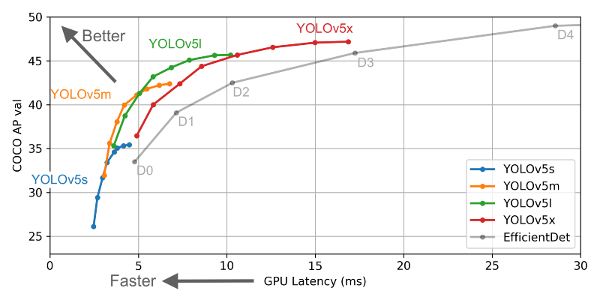

# 4. High-Crowd Area Identification

To ensure safety and optimize flow, crowd density mapping is essential. We divide the store into virtual grids and tally detected individuals within each grid cell. The system then generates heatmaps that visually highlight high-traffic zones.  
  
These heatmaps help store managers identify bottlenecks, inefficient layouts, and areas needing attention. For example, a promotional zone attracting excessive footfall might require reallocation of staff or redesign for smoother navigation.

Notable Features:  
- Heatmap overlays using matplotlib  
- Live density alerts  
- Historical zone performance tracking

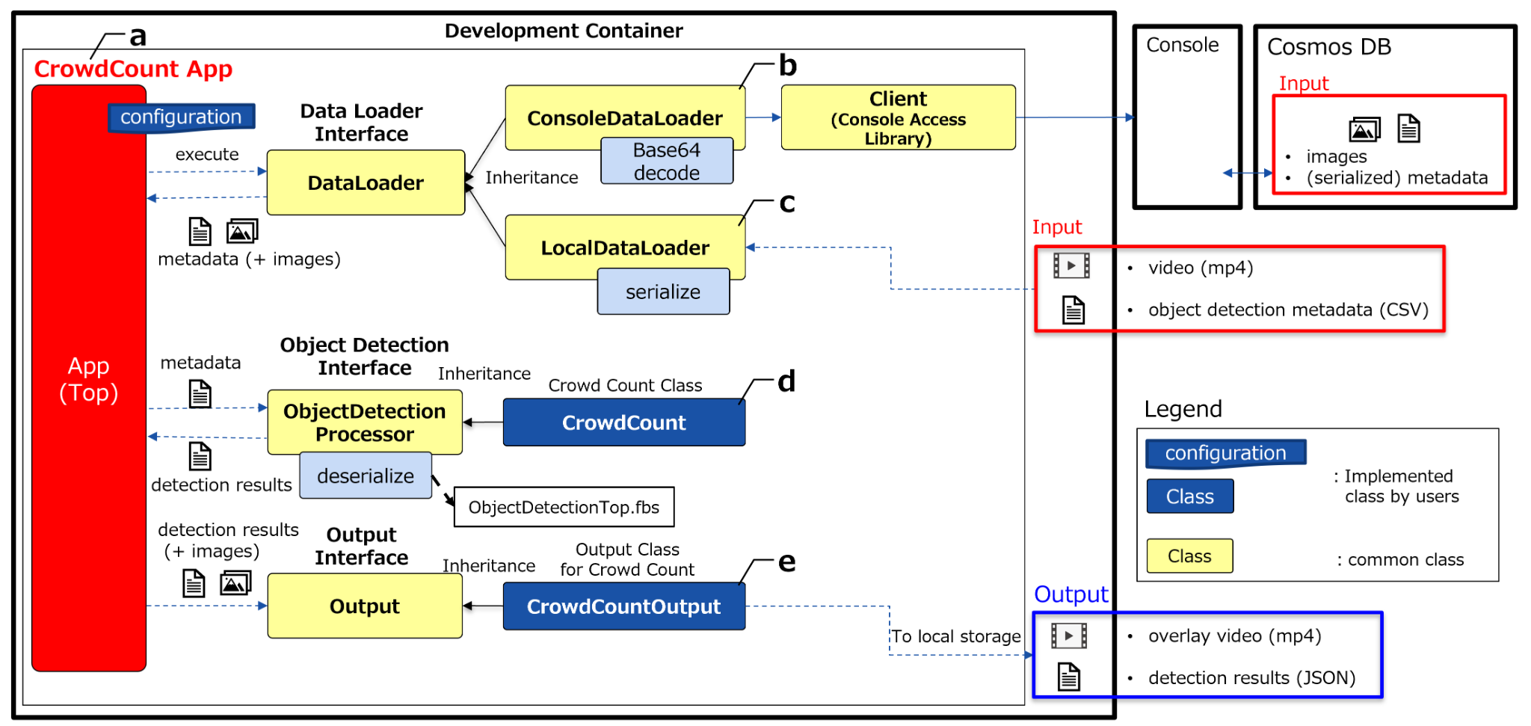

# 5. Automated Shopping Simulation

To bridge the gap between physical and digital shopping, our system simulates automated cart management. If a customer dwells near a product or repeatedly interacts with it, the system assumes interest and adds the item to a virtual shopping cart. This reduces the need for physical interaction and improves efficiency.

In trial simulations:  
- 85% of system predictions matched real purchase behavior  
- Customers showed higher satisfaction in the automated setup  
- Average in-store time reduced by 12%  
  
This module mimics online shopping behaviors in a physical setting—providing ease and personalization.

# 6. Behavioral Analytics and Customer Journey

Tracking the entire customer journey is crucial. From entry to exit, the system logs zones visited, time spent, and items interacted with. This data is invaluable for:  
  
- Understanding product interest  
- Improving staff allocation  
- Creating targeted marketing strategies

Metrics Captured:  
- Zone-wise dwell time  
- Number of unique interactions  
- Duration of shopping trips

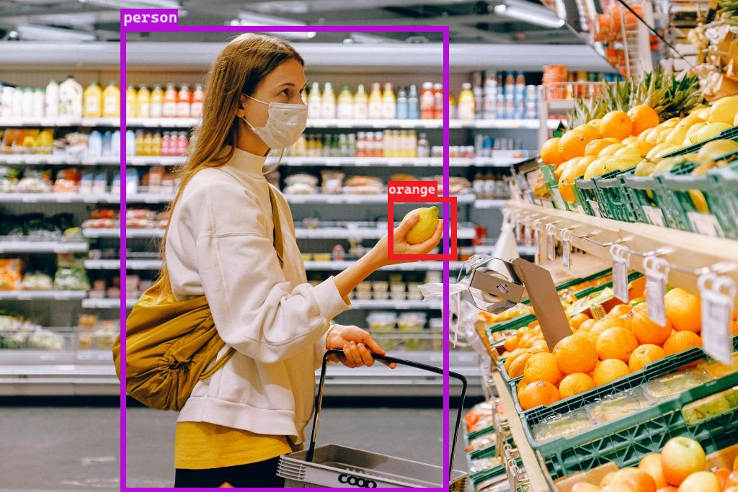

# 7. Experimental Results

The model was tested in a simulated store environment with live feeds. Performance metrics showed YOLOv5 outperforming EfficientDet in speed, while EfficientDet provided marginally better precision.

Findings:  
- YOLOv5: 84.7% accuracy, real-time detection  
- EfficientDet: 87.2% accuracy, lag in real-time  
- Heatmaps correlated with peak sales regions  
- Automated shopping predictions aligned with checkout receipts  
  
Visual outputs such as object detection overlays and heatmaps were instrumental in validating the system.

# 8. Conclusion and Future Work

AI holds enormous potential for transforming in-store experiences. This research proves that computer vision and behavioral analytics can significantly improve customer satisfaction, safety, and business outcomes. By integrating high-accuracy object detection, crowd mapping, and automated behavior tracking, we have developed a solution tailored for the retail sector.

Future directions include:  
- Integration with voice-based AI assistants  
- Advanced customer segmentation  
- Expansion to outdoor and multi-store environments  
- Edge AI deployment for minimal latency  
  
With these enhancements, we envision smarter, safer, and more responsive retail spaces that put customer needs at the forefront.

# 9. References

[1] Bochkovskiy, A., Wang, C. Y., & Liao, H. Y. M. (2020). YOLOv4: Optimal Speed and Accuracy of Object Detection.  
  
[2] Tan, M., Pang, R., & Le, Q. V. (2020). EfficientDet: Scalable and Efficient Object Detection.  
  
[3] OpenCV Python Documentation. https://docs.opencv.org  
  
[4] Retail Analytics in the Age of AI – Springer Journals  
  
[5] PyTorch Documentation. https://pytorch.org/docs/