TASK1:

Task Explanation: Create a simple FreeStyle Job To Install Nginx on your server (tools:jenkins, ubuntu vm)

1.installing nginx in ubuntu through Jenkins

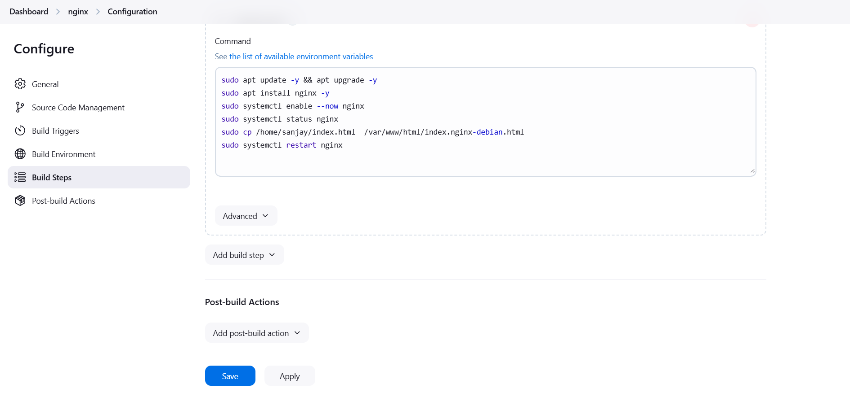

2.output in console:

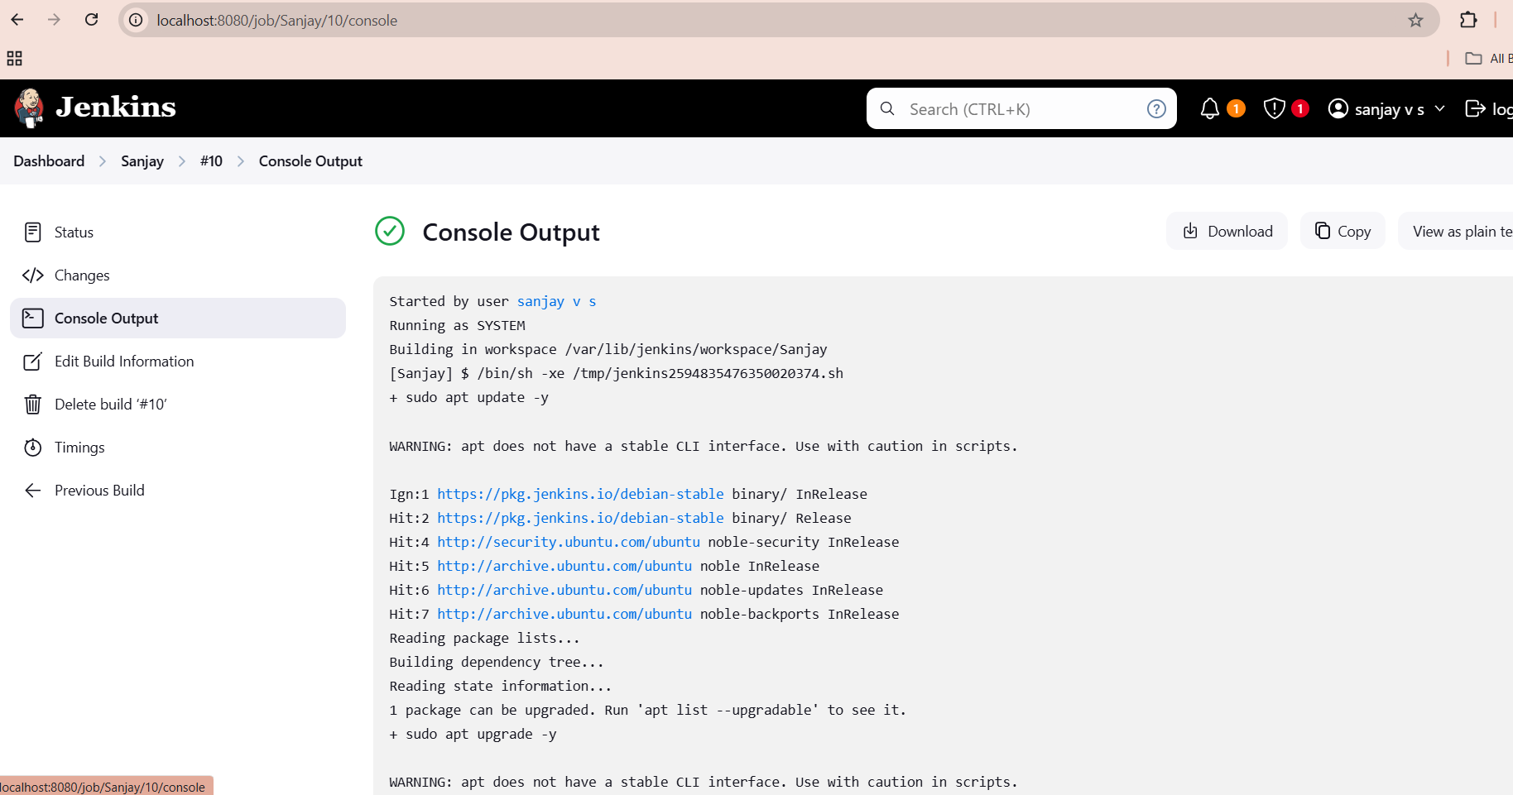

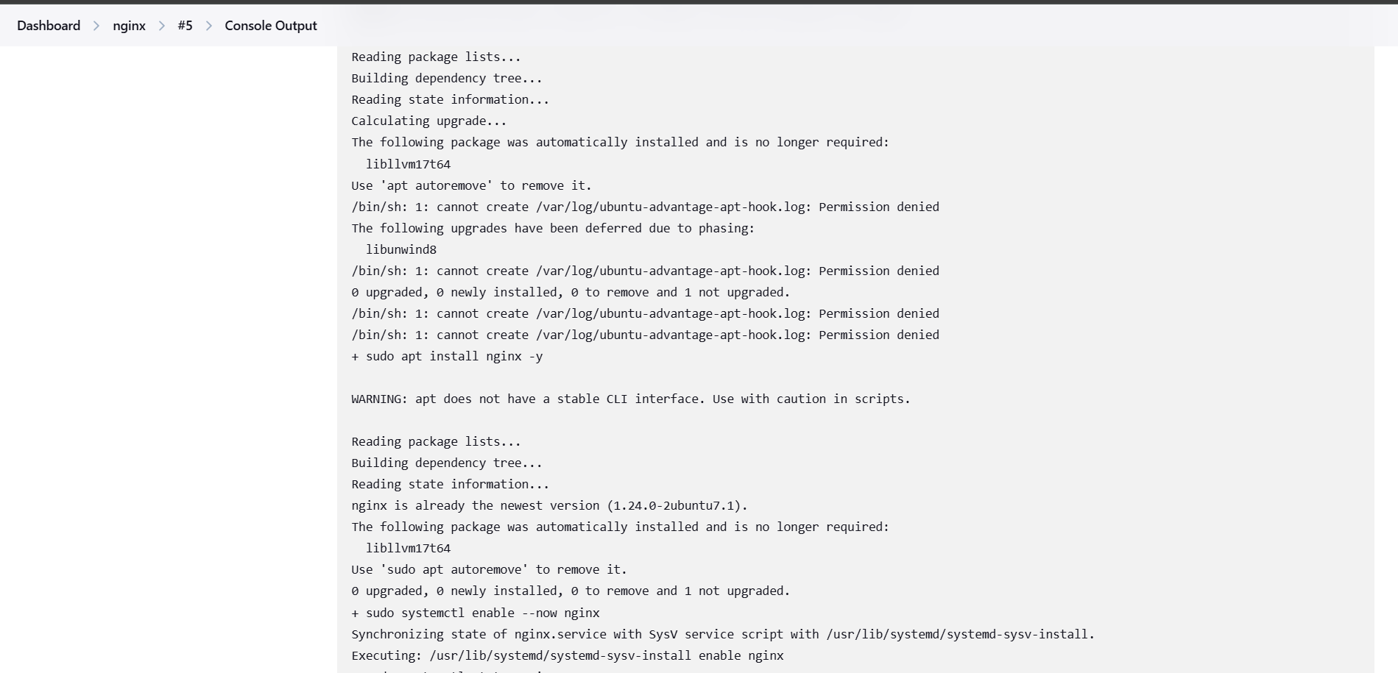

3.output in chrome

