**SANJAY V S**

**22ISR04**

minikube start

Starts a Minikube cluster.

Creates a single-node Kubernetes cluster in a VM or container.

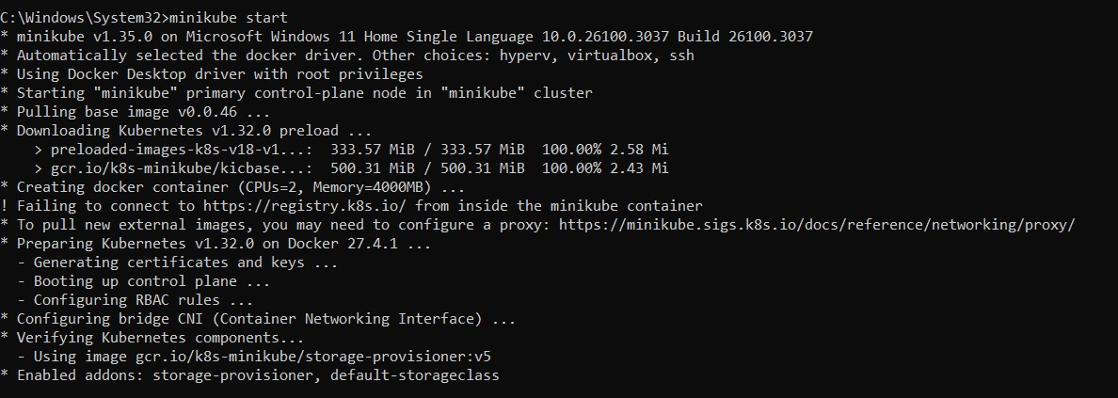

|  |  |
| --- | --- |
| **Command** | **Description** |
| kubectl expose deployment <name> --type=NodePort -port=80 | Creates a service to expose a deployment. |
| kubectl get services | Lists all services. |
| kubectl describe service <service-name> | Shows details about a service. |

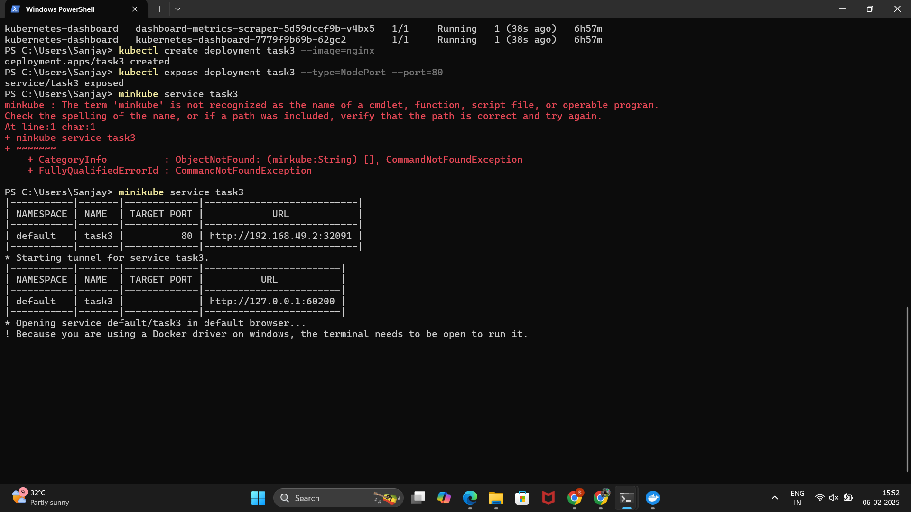

Output in Chrome

