Human Resource Management System (HRMS)

A PROJECT REPORT

*Submitted by*

*Under the course of*

**FULL STACK PYTHON INTERNSHIP**

# GURU NANAK INSTITUTIONS TECHNICAL CAMPUS

*(An Autonomous Institution)*

**Ibrahimpatnam**

*Affiliated to*

**JAWAHARLAL NEHRU TECHNOLOGICAL UNIVERSITY,**

**HYDERABAD**

# TABLE OF CONTENTS

**Title Page No**

ABSTRACT. i

TABLES ii

LIST OF FIGURES ii

LIST OF TABLES iii

1. INTRODUCTION. 1
   1. Project Detail. 1
   2. Purpose 2
   3. Scope. 2
   4. Objective… 2
   5. Technology And Literature Review… 3
2. PROJECT MANAGEMENT… 4
   1. Feasibility Study. 4
      1. Technical Feasibility… 4
      2. Time Schedule Feasibility 4
      3. Operational Feasibility. 4
      4. Implementation Feasibility 4
   2. Project Planning… 5
      1. Project Development Approach 5
      2. Milestones and Deliverables 6
      3. Roles and Responsibilities. 7
      4. Group Dependencies. 8
3. SYSTEM REQUIREMENTS STUDY… 9
   1. Study Of Current System 9
   2. User Characteristics 9
   3. Hardware And Software Requirements 9
   4. Constraints. 9
      1. Regular Policies. 9
      2. Hardware limitations 10
      3. Criticality of the application… 10
   5. Assumptions And Dependencies… 10
4. SYSTEM ANALYSIS… 11
   1. Requirements Of New System 11
      1. User Requirements. 11
      2. System Requirements. 11
5. SYSTEM ARCHITECTURE DESIGN 16
   1. System Architecture Design. 16
   2. Use Case Diagram. 17
   3. Flowchart Diagram… 18
   4. Activity Diagram. 19
   5. Sequence Diagram… 21
6. IMPLEMENTATION PLANNING. 27
   1. Implementation Environment. 27
   2. Program/Modules Specification. 27
   3. Coding Standards. 27
   4. Coding Scenario 28
7. TESTING. 29
   1. Testing Plan 29
   2. Testing Strategy. 30
   3. Testing Methods. 31
   4. Test Cases. 32
8. USER MANUAL. 35
   1. Installation Guide. 35
   2. Screenshots 37
9. LIMITATIONS AND FUTURE ENHANCEMENT 49
   1. Limitations 49
   2. Future Enhancement 49
10. CONCLUSION AND DISCUSSION 50
    1. Conclusion. 50
11. APPENDICES. 51
12. REFERENCES. 52
13. PLAGIARISM REPORT. 52

# ABSTRACT

To maintain the data of all active and inactive employees requires a significant amount of time if we do it without software. Every organization has their own human resources in order to perform the internal and external human resource activities. Among the total human resource activities, managing the human capital i.e. employees is the significant task to any HR. The main function of HR is to recruit, manage and store the employee data which includes their personal information including their job roles, job streams, projects allotted, salaries and many more which allows them to face huge workload. In order to support the HR’s there are some electronic based HR systems called HRMS- human resource management system. Organizations should maintain HRMS software with a huge number of client server applications, service providers as well as control tools. But this application is cost effective one that allows them to manage their employee’s data in a simple manner. This human resource management system will allow the HR’s to manage the timings of employee works, employee information systems, employees recruitment, employees training, employee retention and performance appraisal, employee service and employee attendance. This project belongs to a category of web application that can be accessed through PC with internet connection.

# TABLES LIST OF FIGURES

## Figure Page No.

Fig 5.2 Use Case Diagram… 17

Fig 5.3 Flow Chart Diagram. 18

Fig 5.4(a) Activity Diagram for login. 19

Fig 5.4(b) Activity Diagram of functionality 20

Fig 5.5(a) Sequence Diagram for login. 21

Fig 5.5(b) Sequence Diagram for changing profile… 21

Fig 5.5(c) Sequence Diagram for bulkchange event. 22

Fig 5.5(d) Sequence Diagram for apply leave event. 23

Fig 5.5(e) Sequence Diagram for cancel leave event. 24

Fig 5.5(f) Sequence Diagram for General profile. 25

Fig 5.5(g) Sequence Diagram for sync new employees… 26

Fig 7.1 Testing Plan… 29

Fig 8.1(a) Login form… 37

Fig 8.1(b) Home Screen… 37

Fig 8.2(a) Menu view for admin role. 38

Fig 8.2(b) Menu view for user role. 38

Fig 8.3 Sync Operation… 39

Fig 8.4(a) General tab for User and Admin role. 39

Fig 8.4(b) Personal tab for User and Admin role. 40

Fig 8.4(c) Contact tab for User and Admin role. 40

Fig 8.4(d) Skills tab for User and Admin role. 41

Fig 8.4(e) Job history tab for User and Admin role. 41

Fig 8.4(f) Performance tab for User and Admin role. 42

Fig 8.4(g) Attachment tab for User and Admin role. 42

Fig 8.5 Employee list for Admin role… 43

Fig 8.6 Manage role for Admin role… 43

Fig 8.7 Filter for employee list… 44

Fig 8.8 Upload profile image… 44

Fig 8.9(a) Bulk Change role for Admin… 45

Fig 8.9(b) Second step of Bulk Change… 45

Fig 8.10(a) Leave module… 46

Fig 8.10(b) Apply Leave module… 47

Fig 8.10(c)Manage leave module… 47

Fig 8.10(d)Employee leave module(admin). 48

Fig 8.11 Email notification for leave… 48

# LIST OF TABLES

**Table Page No.**

Table 2.1 Milestones and Deliverables. 7

Table 2.2 Roles and Responsibilities. 7

Table 7.1 Input fields in the personal tab. 33

Table 7.2 Input fields in the Contact tab. 33

Table 7.3 Input fields in the Skills tab. 34

**Chapter 1 : INTRODUCTION**

* 1. **Project Details**

This Project is made using:

1. React.js
2. Django
3. MySQL

#### React.js

React.js is a JavaScript library commonly used in HR management systems for its efficient user interface development. It enables the creation of dynamic and interactive interfaces, improving user experience. Reacts component-based architecture simplifies code organization and maintenance, while its virtual DOM enhances performance by minimizing re-renders. With React, developers can build responsive HR interfaces that seamlessly handle tasks like employee profiles, time tracking, and feedback mechanisms.

#### Django

#### Django is a Python web framework ideal for HR management systems, facilitating streamlined processes like employee onboarding, leave management, and payroll. Its robust architecture ensures security, while its extensibility allows seamless integration with other systems for enhanced functionality.

#### MySQL

#### Reliable relational database system used in HR management systems for efficient storage, retrieval, and management of employee data, ensuring scalability, performance, and security.

#### 

#### Purpose

The Crest HRMS is a Human Resource Management System that was introduced independently due to the following challenges of the previous HRMS:

* + 1. Very high turnaround time when asked for changes.
    2. Slow and buggy.
    3. No value for the money.
    4. Irrelevant features for organization.

#### Scope

The scope of the Crest HRMS is restricted to company employees. Employee has to connect to the company CDS-wifi using direct connection or vpn and after it, HRMS can be accessible. Employee can login HRMS using AD (Active Directory) credentials. The US team can also access Crest HRMS.

#### Objective

The Human Resource Management System (HRMS) aims to manage employee’s information. HRMS is the most important because it provides systematic and accurate information about the employees of the organization.

So HRMS objective are as following: -

1. Manage the recruitment of a workforce.
2. Track development related to employees.
3. It provides reports on period-to-period details of employees.
4. Give training program and information to all new employees.
5. Improving manpower plan and the effective utilization of manpower across the organization.
6. Track leave of employees.
7. Manage Audit logs.

#### Technology And Literature Review

**Technology:**

Frontend: React.js Backend: Django

Database: MySQL

**React.js**

React is an open-source JavaScript library which is used for building user interfaces specifically for single page applications. It's used for handling view layers for web and mobile apps. React also allows us to create reusable UI components.[2]

**Python**

Python is an interpreted, object-oriented, high-level programming language with dynamic semantics. Its high-level built in data structures, combined with dynamic typing and dynamic binding, make it very attractive for Rapid Application Development, as well as for use as a scripting or glue language to connect existing components together. Python's simple, easy to learn syntax emphasizes readability and therefore reduces the cost of program maintenance. Python supports modules and packages, which encourages program modularity and code reuse. The Python interpreter and the extensive standard library are available in source or binary form without charge for all major platforms, and can be freely distributed.[6]

**MySQL**

MySQL is a popular relational database management system (RDBMS) commonly used in HR management systems for efficient data storage and retrieval. Its robust features include ACID compliance, scalability, and high performance, making it suitable for handling large volumes of employee data. MySQL's relational model allows for easy structuring of HR information such as employee profiles, payroll records, and attendance logs. Its compatibility with various programming languages and platforms ensures seamless integration with HR software applications. Overall, MySQL provides a reliable foundation for managing HR data securely and effectively.

## Chapter 2 : PROJECT MANAGEMENT

#### Feasibility Study

The feasibility of software can be tested in four dimensions:

##### Technical Feasibility

Since the project uses reliable tools like open-source technology like

react, Django and MySQL, the system can be implemented efficiently

without any issues. The trio of this technology can efficiently handle data, requests and also create user friendly applications. Hence this project has a good technical feasibility.

##### Time Schedule Feasibility

The project involved to be developed consists of total four different modules hence it is quite tedious to manage but considering that there is sufficient human

resources available, it is feasible to develop the application in the allotted duration. And if the requirement changes, according to it duration will be changed.

##### Operational Feasibility

How the project will work and who will use it, all such concerns arise in this phase. We have to study the existing system’s problem, and is it worth solving or not. This Project will save a lot of time and effort of a user to analyze the employee information and also provide additional functionality. Hence it is operationally feasible.

##### Implementation Feasibility

The requirements mentioned above can be fulfilled using various technologies available. React-.js, MySQL and Django, the implementation of the project is feasible.

#### Project Planning

The project implementation uses the approach of Agile Model. We need to provide a build to the client regularly in some intervals. The client uses checks the application and then suggests changes in the application which is to be delivered in the next development build. And due to this reason, Agile Model is being followed in the project.

##### Project Development Approach

The Agile Model is used for project development. We have selected Agile Model because of its beneficial speed without affecting the quality of product and agile makes the team so much more productive.[3]

#### Agile Model

Agile SDLC model is a combination of iterative and incremental process models with focus on process adaptability and customer satisfaction by rapid delivery of working software products. Agile Methods break the product into small incremental builds. These builds are provided in iterations. Each iteration typically lasts from about one to three weeks. Every iteration involves cross functional teams working simultaneously on various areas like planning, requirements analysis, design, coding, unit testing, and acceptance testing. At the end of the iteration a working product is displayed to the customer and important stakeholders.[3]

#### What is Agile?

Agile models believe that every project needs to be handled differently and the existing methods need to be tailored to best suit the project requirements. In agile the tasks are divided into time boxes (small time frames) to deliver specific features for a release. Iterative approach is taken and working software build is delivered after each iteration. Each build is incremental in terms of features; the final build holds all the features required by the customer.[3]

#### Advantages of using Agile Model

Customer satisfaction by rapid, continuous delivery of useful software. People and interactions are emphasized rather than processes and tools. Customers, developers and testers constantly interact with each other. Working software is delivered frequently (weeks rather than months). Face-to-face conversation is the best form of communication. Close, daily cooperation between business people and developers. Continuous attention to technical excellence and good design.[3]

#### Disadvantages of using Agile Model

In case of some software deliverables, especially the large ones, it is difficult to assess the effort required at the beginning of the software development life cycle.[3]

There is a lack of emphasis on necessary designing and documentation. The project can easily get taken off track if the customer representative is not clear what final outcome that they want.[3]

Only senior programmers are capable of taking the kind of decisions required during the development process. Hence it has no place for newbie programmers, unless combined with experienced resources.[3]

##### Milestones and Deliverables

Milestones are identified in order to complete the entire project in the time duration. Milestones are identified for every sprint of Crest Data Systems.

Table 2.1 Milestones and Deliverables

|  |  |  |
| --- | --- | --- |
| **PHASE** | **DELIVERABLES** | **PURPOSE** |
| System Requirement and Analysis | * Requirement Gathering and analysis. * Functional Specification * Non-functional Specification | It gives an exact understanding of the user’s requirements. |
| System Design | * Use case Diagram * Activity Diagram * Data Flow Diagram | It gives the logical structure that describes the system. |
| Implementation and Testing | * The output obtained for the required functionality after implementing and doing various types of testing. | It makes the system robust and reliable. |

#### Roles and Responsibilities

Table 2.2 Roles and Responsibilities

|  |  |  |  |  |  |
| --- | --- | --- | --- | --- | --- |
| **Name** | **Role** | | | | |
| **Analysis** | **Designing** | **Coding** | **Testing** | **Documentation** |
| **Alli Shiva Kumar** | ✓ | ✓ | ✓ | ✓ | ✓ |
| **Balagoni**  **Shravan** | ✓ | ✓ | ✓ | ✓ | ✓ |

##### Group Dependencies

The members of the project should be dedicated to the project and should in turn help each other in whatever problems concerning the project. They are expected not to have any internal or external communication gaps. They are also expected to share the challenges faced by them during design or development so that the team and mentors can brainstorm over every possible dimension. They should report periodically to the concerned faculty and keep them updated regarding the Project.

## Chapter 3: SYSTEM REQUIREMENTS STUDY

#### Study Of Current System

Before Crest HRMS, Company was using third party’s HRMS.Which was not feasible and was costly too. It was difficult to change existing HRMS.

#### User Characteristics

The users are the normal employees who want to check their leave balance, profile, other employees’ general information. Admin is a special user who has extra rights like accept or reject leave, bulk change functionality, can show all details of any user.

#### Hardware And Software Requirements

##### Hardware Requirements

* + - * Dual Core 2.0 GHZ or latter CPU
      * 4 GB RAM
      * 100GB storage minimum

##### Software Requirements

* + - * Chrome Latest (version: 47.0.2526 or above)

#### Constraints

##### Regular Policies

As, per the Company’s policy any developer has to maintain the Coding Standards and follow the best practices. Also, each and every user should maintain the subversion and commit the modification with appropriate comment so to have track of work and also of the code modification. From the client’s perspective, developers should use well known coding standards.

##### Hardware limitations

The hardware limitation is almost none. System should support Python, React.js.

##### Criticality of the application

Criticality means any occurrence of miss operating of the system or any accidental event in software which can damage the resources of software as well as hardware. As per my knowledge there is no criticality in our application.

#### Assumptions And Dependencies

We assume that the end user has a knowledge of Crest HRMS. So, the end user can get best out of it. Application is dependent only on Google drive API, Client Authentication.

**SYSTEM ANALYSIS**

## Chapter 4: SYSTEM ANALYSIS

#### Requirements Of New System

##### User Requirements

User requirements include minor details, but most importantly users must be aware that the system works properly with full availability, reliability, security and safety. The user responsibility is as follows: User should know how to use the application and should adhere to the guidelines and prescribed standards.

##### System Requirements

#### Functional Requirements

* + - * Collect data from Google Drive and AD credentials.
      * Gather the collected data into events and publish them.
      * Apply leave should execute leave credit or debit accordingly.

#### Non-Functional Requirements

* **Usability**

The UI of the Crest HRMS should be user friendly so that users can navigate easily through it.

#### Accuracy

As we were developing the application, we must make the system that is very accurate in its functions. All the data should keep working properly, keep getting perfect input, process accurately and produce the perfect output. Accuracy is the most important non-functional characteristic or requirement of the system.

#### Reliability

Error handling mechanism must be robust to avoid failure of operation and in case of failure the app reports it to the user without any due harm.

### SYSTEM ANALYSIS

#### Performance

Once the application starts, the user application should complete all tasks without errors.

#### Software Requirements and Specification (SRS) R1. login using AD credentials

**Description**: As an application user, one should be able to login to the application with the AD credentials.

**Input**: Enter username and password.

**Output**: One should be able to login to HRMS using AD credentials else failed.

#### R2. sync employees which allow onboarding & offboarding

**Description (Admin Person):** As an application admin, One should be to sync new joinees and resignees i.e onboarding and offboarding employees into employee directory.

**Input:** Sync up new joinees or resignees.

**Output:** Updated page.

#### R3. view/edit the employee’s general information

**Description (Admin Persona):** As an application admin, One should be able to view and edit any employee’s General information.

**Input:** select employee whom you want to edit info on the employee page.

**Output:** Update employee information or error.

#### R4. view/edit the employee’s contact information

**Description (Admin Person):** As an application admin, one should be able to view and edit any employee’s contact information.

**Input:** select employee whom you want to edit info on the employee page.

**Output:** Update employee information or error.

### SYSTEM ANALYSIS

#### R5. view/edit the employee’s skills

**Description (Admin Person):** As an application admin, One should be able to view and edit any employee’s skills.

**Input:** Add Skills,Primary Technology Vertical,Secondary Technology Vertical of employee.

**Output:** Updated page of skills.

#### R6. employee’s job history information

**Description (Admin Person):** As an application admin, one should be able to view and edit any employee’s job history information from the job history tab.

**Input :** Enter employee job history in Job history tab.

**Output:** Updated page of job profile.

#### R7. employee’s job history information:

**Description (User Persona):** As an application user, one should be able to view and edit only my job history information from the job history tab.

**Input:** Enter employee job history in Job history tab.

**Output:** Updated page of job profile.

#### R8. Upload documents

**Description:** Upload required documents to the google drive.

**Input:** Upload crest letters, Aadhar card, bank acc. page, educational certificate, Visa documents.

**Output:** upload document to google drive or error.

### SYSTEM ANALYSIS

#### R9. Change theme

**Input:** click on change theme icon.

**Output:** toggle them between day theme and night theme.

#### R10. Logout

**Input:** click on logout button.

**Output:** employee logged out from HRMS.

#### R11. Download employee attachments.

**Description:** As an application admin, one should be able to view, upload, delete and download my own as well as other employees’ attachments.

**Input:** click on the download attachment button.

**Output:** get csv file of employee details.

#### R12. Upload profile picture.

**Input:** Select image for profile or remove it.

**Output:** Updated profile picture.

#### R13. Change bulk

**Description:** Change the information of employees in bulk.

**Input:** Select list of employees whose changes are to be done and select change in bulk.

**Output:** Updated employee list.

#### R14. Apply Leave

**Description:** Employee request for a leave.

**Input:** Select range of date or half day leave.

### SYSTEM ANALYSIS

**Output:** Apply leave message.

#### R15. Cancel Leave

**Description:** Employee request for cancel applied leave.

**Input:** Apply for cancellation of leave.

**Output:** Cancellation message.

#### R15. Reject Leave

**Description:** Admin do rejection of employee’s applied leave.

**Input:** Rejection of leave.

**Output:** Rejection message.

## Chapter 5: SYSTEM ARCHITECTURE DESIGN

#### System Architecture Design

Systems design is the process of defining the architecture, modules, interfaces, and data for a system to satisfy specified requirements. Systems design could be seen as the application of systems theory to product development. There is some overlap with the disciplines of systems analysis, systems architecture and systems engineering.[3]

#### Architectural Design

The architectural design of a system emphasizes the design of the systems architecture that describes the structure, behavior and more views of that system and analysis.[3]

#### Logical Design

The logical design of a system pertains to an abstract representation of the data flows, inputs and outputs of the system. This is often conducted via modelling, using an over-abstract (and sometimes graphical) model of the actual system. In the context of systems, designs are included.[3]

#### Physical Design

The physical design relates to the actual input and output processes of the system. This is explained in terms of how data is input into a system, how it is verified/authenticated, how it is processed, and how it is displayed. In physical design, the following requirements about the system are decided.[3]

* Input requirement
* Output requirements
* Storage requirements
* Processing requirements
* System control and backup or recovery

User Interface Design is concerned with how users add information to the system and with how the system presents information back to them. Data Design is concerned with how the data is represented and stored within the system. Finally, Process Design is concerned with how data moves through the system, and with how and where it is validated, secured and/or transformed as it flows into, through and out of the system. At the end of the system design phase, documentation describing the three subtasks is

produced and made available for use in the next phase.[3]

Physical design, in this context, does not refer to the tangible physical design of an information system. To use an analogy, a personal computer's physical design involves input via a keyboard, processing within the CPU, and output via a monitor, printer, etc. It would not concern the actual layout of the tangible hardware, which for a PC would be a monitor, CPU, motherboard, hard drive, modems, video/graphics cards, USB slots, etc. It involves a detailed design of a user and a product database structure processor and a control processor. The H/S personal specification is developed for the proposed system.[3]

#### Use Case Diagram

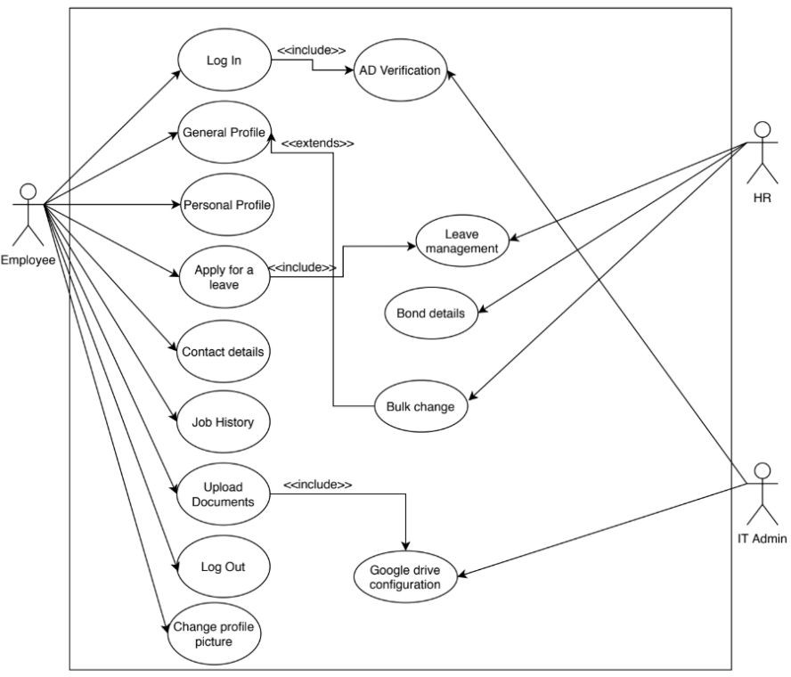

Fig. 5.2 Use Case Diagram

#### Flowchart Diagram

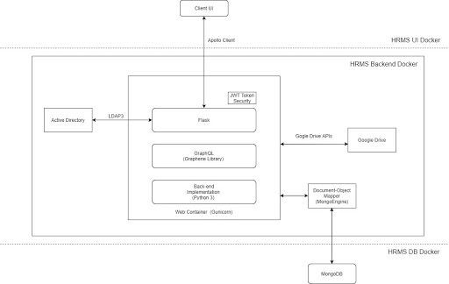

Fig. 5.3 Flowchart Diagram

#### Activity Diagram

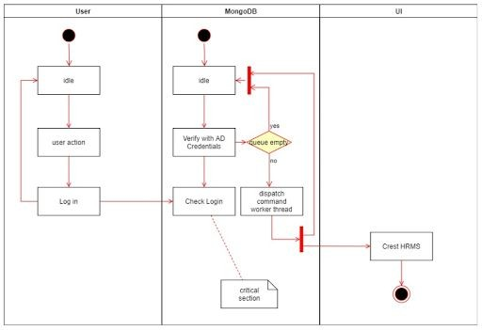

Fig. 5.4(a) Activity Diagram of Login

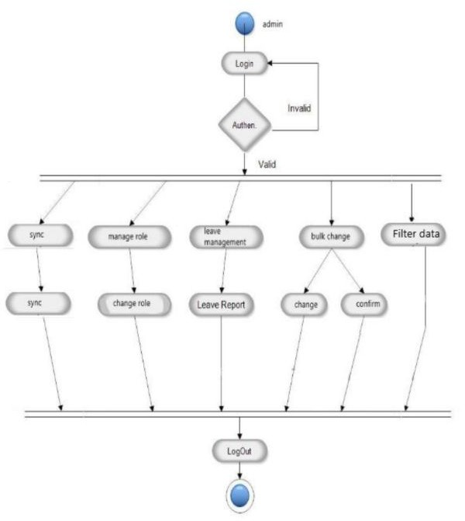

5.4(b) Activity Diagram of functionality

#### Sequence Diagram

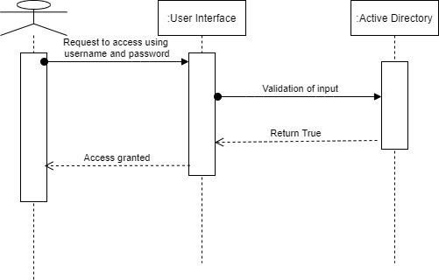

5.5(a) Sequence Diagram of login

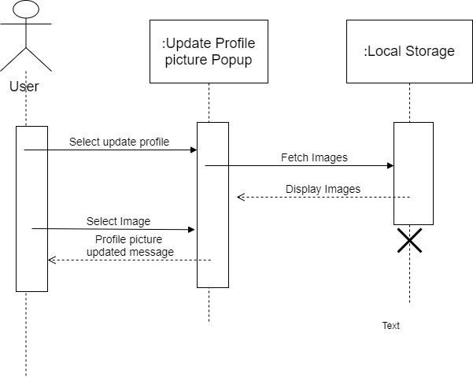

5.5(b) Sequence Diagram for changing profile

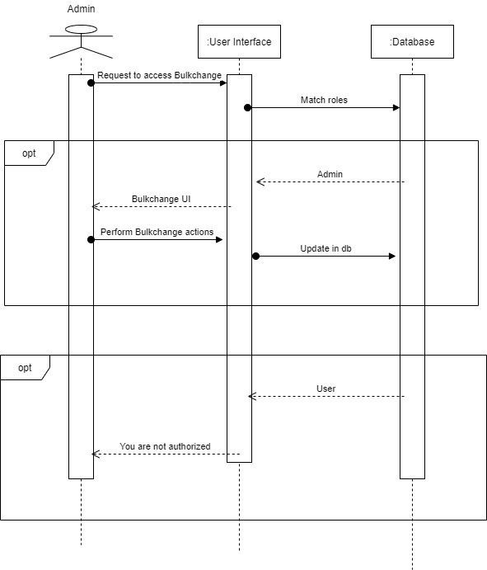

5.5(c) Sequence Diagram for Bulk Change event

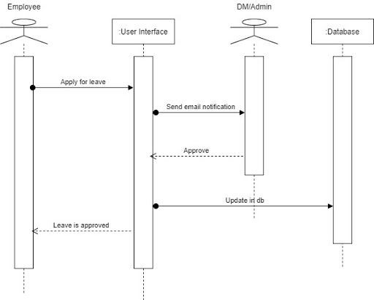

5.5(d) Sequence Diagram for Apply leave event

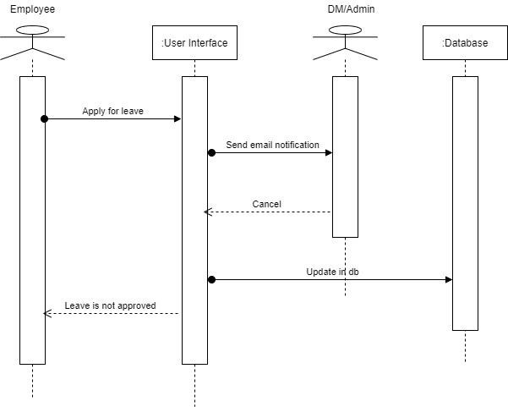

5.5(e) Sequence Diagram for Cancel leave event

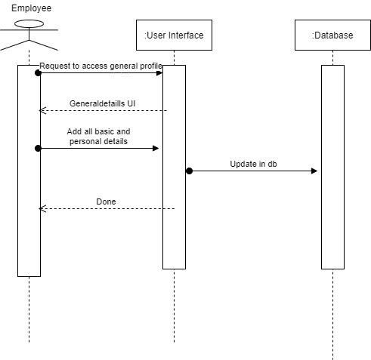

5.5(f) Sequence Diagram for General Profile

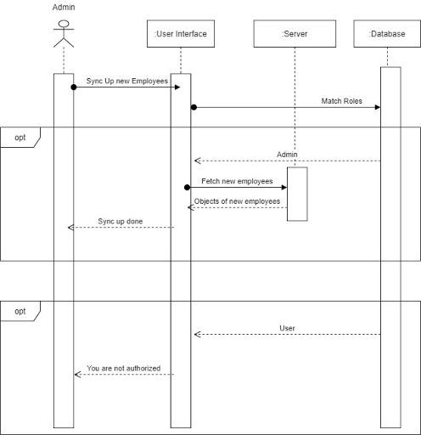

5.5(g) Sequence Diagram for Sync new employees

## Chapter 6 : IMPLEMENTATION PLANNING

Planning is an essential aspect of any successful project. However, it can be difficult to turn goals and strategy into tangible action, and, therefore, projects of all sizes and across all industries have a high tendency to fail. Implementation planning can reduce this chance of failure by helping turn strategy into action.

#### Implementation Environment

The application is a single server multiple client application. Multiple users can log in to use the system.

#### Multi-user vs. Single-user

Single user applications are the application where it is useful to only one user at a time. While in Multi user given application is used by many users at the same time and thus web application is used by many users at the same time. Our system is a multi-user system as we have more than one user who can use the system at the same time.

#### GUI vs. non-GUI

Non-GUI application uses command Prompt for input and output while GUI application has graphics form to interface and other graphics property for various I/O operations and are easy to use Our System is a GUI based and thus easy and effective to use therefore user can easily give input and take Input.

#### Program/Modules Specification

* + - MySQL database Server
    - VS Code
    - OS: Windows

#### Coding Standards

Coding techniques incorporate many facts about software development. Although they usually have no impact on the functionality of the application; they contribute to an improved comprehension of source code. All forms of source code are considered here, including programming, scripting markup, and query languages.[3]

The coding techniques defined are not proposed to form an inflexible set of coding standards. Rather, they are meant to serve as a guide for developing a coding standard for a specific software project. We used sonarlint standards for creating our whole project.[3]

#### Purpose of Coding Standards and Best Practices

To develop reliable and maintainable applications, you must follow coding standards and best practices. The naming conventions, coding standards and best practices described in this document are compiled from our own experience and by referring to various guidelines. There are several standards that exist in the programming industry. None of them are wrong or bad and you may follow any of them. What is more important is, selecting one standard approach and ensuring that everyone is following it.[3]

In this phase of software development, the design is related to a system converted into a machine-readable code that can be compiled and executed. Although the coding phase does not affect the structure of the system, it has a great impact on the internal structure of the module, which affects the testability, under the stability of the system.[3]

## Coding Scenario

We used python Programming and the MySQL query language of API Call. MySQL is used instead of REST. We modularized every functionality so we can reuse those whenever we need.[7]

We have also used Google Drive API, to access the Attachment of employees. We have stored those documents and only the admin can access it.[4]

We have used react.js for front end. We have utilized components very well and also used redux. Redux is a very powerful tool of react.[2]

A major challenge for us was to achieve success when 500 employees use HRMS at a time. We have used Nginx for load balancing. Our HRMS product is also secure in terms of https support.

## Chapter 7: TESTING

#### Testing Plan

The objective of the system testing is to ensure that all individual programs are working as expected, that the programs link together to meet the requirements specified and ensure that the computer system and the associated clerical and other procedures work together. Systems are not designed as entire systems but they are tested as single systems. The analyst must perform both unit and system testing.[3]

<<

Different types of testing methods are available. We have tested our system for different aspects like

Does the application meet the goals for which it has been designed? This was a very important question that stood before us as the application was designed to be implemented on such a large network.[3]

<

To fulfill its goal of being able to run on different systems we went through a series of tests at different

places where this is supposed to be used the most. As we need to make our system efficient enough, we need to test it thoroughly.[3]

<

Finally, we tested the system with real-time data, for which it is actually designed. We are successful in

satisfying our needs as it was designed according to client's requirements. But it is very necessary to maintain this application and so our work is not still over.[3]

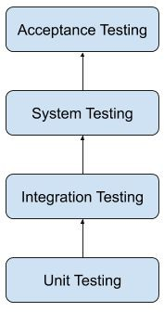

Fig. 7.1 Testing Plan

**TESTING**

## Testing Strategy

Once source code has been generated, the software must be tested to uncover as many errors as possible before delivery to the customer. Our goal is to design a series of test cases that have a high likelihood of finding errors. Software testing techniques provide systematic guidance for designing tests that (1) Exercise the internal logic of software components (2) Exercise the inputs and outputs domains of the program to uncover errors in program function, behavior and performance.[3]

During the early stages of testing, a software engineer performs all tests. However, as the testing process progresses, testing specialists may become involved. Reviews and other activities can and do uncover errors, but they are not sufficient. Every time the program is executed, the customer tests it! Therefore, you have to execute the program before it gets to the customer with the specific intent of finding and removing all errors. In order to find the highest possible number of errors, tests must be conducted systematically and test cases must be designed using disciplined techniques.[3]

#### Testing Objectives

* + - Testing is a process of executing a program with the intention of finding an error.
    - A good test case is one that has a high probability of finding an as-yet undiscovered error.
    - A successful test is one that uncovers an as-yet undiscovered error.

#### Unit Testing

Unit testing is a software development process in which the smallest testable part of an application, called units, are individually scrutinized for proper operation. Unit testing is often automated but it can also be done manually. This testing mode is a component of Extreme Programming (XP), a pragmatic method of software development that takes a meticulous approach to building a product by means of continual testing and revision.[3]

Unit testing involves only those characteristics that are vital to the performance of the unit under test. This encourages developers to modify the source code without immediate concerns about how such changes might affect the functioning of the units or the program as a whole. Once all of the units in a program have been found to be working in the most efficient and error free manner possible, larger components of the program can be evaluated by means of integration testing.[3]

#### System Testing

Now, it’s time for whole System testing. We have found some cosmetic bugs and minor bugs .We have fixed it and tested it again. We worked on each error and exception that we got while testing and most of them are resolved or handled programmatically.[3]

### TESTING

#### Recovery Testing

It is a system test that forces the software to fail in a variety of ways and verifies that recovery is properly performed.[3]

#### Performance Testing

It is designed to test the run-time performance of software within the context of an integrated system performance testing occurs throughout all steps in the testing process.[3]

#### Testing Methods Acceptance Testing

Acceptance testing can be connected by the end user, customer, or client to validate whether or not to

accept the product. Acceptance testing may be performed as part of the hand-off process between any two phases of development. The acceptance test suite is run against the supplied input data or using an acceptance test script to direct the tester. Then the results obtained are compared with the expected results. If there is a correct match for every case, the test suite is said to pass.

#### Alpha & beta testing

The alpha test is conducted at the developer’s site by a customer. The software is used in a natural setting with the developer “looking over shoulder” of the user and recording errors and usage problems. Alpha test is conducted in a controlled environment. The beta testing is conducted at one or more customer sites by the end-user of the software. Unlike alpha testing, the developer is generally not present. Therefore, the beta test is a “live” application of the software in an environment that cannot be controlled by the developer.[3]

#### Black-box testing

Also known as functional testing. Software testing techniques where by the internal working of the item being tested are not known by the tester. For example, in a black box test on software design the tester only knows the inputs and what the expected outcomes should be and not how the program arrives at those outputs. The tester does not ever examine the programming code and does not need any further knowledge of the program other than its specification.[3]

The advantages of this type of testing include:

### TESTING

* The test is unbiased as the designer and the tester are independent of each other.
* The tester does not need knowledge of any specific programming languages.
* The test is done from the point of view of the user, not the designer. Test cases can be designed as soon as the specifications are complete.

The disadvantages of this type of testing include:

* The test can be redundant if the software designer has already run a test case.
* The test cases are difficult to design. Testing every possible input stream is unrealistic because it would take an inordinate amount of time: hence many program paths will go untested.

#### White Box Testing

Also known as glass box, structural, clear box and open box testing. A software testing technique where by explicit knowledge of the internal workings of the item being tested are used to select the test data. Unlike black box testing, white box testing uses specific knowledge of programming code to examine outputs. The test is accurate only if the tester knows what the program is supposed to do. He or she can then see if the program diverges from its intended goal.[3]

#### Test Cases

To minimize the number of errors in software, a rich variety of test design methods have evolved for software. These methods provide the developer with a systematic approach to testing. More importantly, methods provide a mechanism that can help to ensure the completeness of the test and provide the highest likelihood for uncovering errors in software.[3]

An engineering product can be tested in one of the two ways:

* + - Knowing the specified function that product has been designed to perform, tests can be conducted that demonstrate each function is fully operational while at the same time searching for errors in each function:[3]
    - Knowing the internal workings of a product, tests can be conducted to ensure that “all gear mesh “, that is, internal oppression are performed according to specifications and all internal components have been adequately exercised. Here are the test cases that we had made for our application.[3]

### TESTING

Table 7.1 Input fields in the personal tab

|  |  |  |  |  |
| --- | --- | --- | --- | --- |
| **Field Name** | **Field Type** | **Is Field Mandatory?** | **Accessible by User?** | **Accessible by Admin?** |
| Father’s name | Text | No | Yes | Yes |
| Date of Birth | Date | Yes | Yes | Yes |
| Blood Group | Dropdown | Yes | Yes | Yes |
| Personal Email | Email | No | Yes | Yes |
| Gender | Radio Button | Yes | Yes | Yes |
| Marital Status | Dropdown | Yes | Yes | Yes |
| Aadhar Number | Text | Yes | Yes | Yes |
| PAN Number | Text | No | Yes | Yes |

Table 7.2 Input fields in the Contact tab

|  |  |  |  |  |
| --- | --- | --- | --- | --- |
| **Field Name** | **Field Type** | **Is Field Mandatory?** | **Accessible by User?** | **Accessible by Admin?** |
| Present Address | Text | Yes | Yes | Yes |
| City | Text | Yes | Yes | Yes |
| State | Dropdown | Yes | Yes | Yes |

### TESTING

|  |  |  |  |  |
| --- | --- | --- | --- | --- |
| Pincode | Number | Yes | Yes | Yes |
| Contact | Number | Yes | Yes | Yes |
| Emergency Contact | Number | Yes | Yes | Yes |
|  |  |  |  |  |

Table 7.3 Input fields in the Skills

|  |  |  |  |  |
| --- | --- | --- | --- | --- |
| **Field Name** | **Field Type** | **Is Field Mandatory?** | **Accessible by User?** | **Accessible by Admin?** |
| Skills | Dropdown | Yes | No | Yes |
| Primary Technology Vertical | Dropdown | Yes | No | Yes |
| Secondary Technology Vertical | Dropdown | No | No | Yes |

## Chapter 8: USER MANUAL

Installation Guide for React.js, Django, and MySQL:

Pre-requisites:

- Operating System: CentOS 8

- Google Drive account

- Create a directory named "build" in the home directory:

- `cd /home`

- `mkdir build`

- Bamboo plan for production server

- Open port 7000:

- `firewall-cmd --zone=public --add-port=7000/tcp --permanent`

- `firewall-cmd --reload`

Installation Steps:

For React.js:

1. Install Node.js:

- `sudo dnf install nodejs`

2. Run Bamboo build

3. Install npm dependencies:

- From the React.js project directory, run: `npm install`

4. Build the React.js app:

- From the React.js project directory, run: `npm run build`

For Django:

1. Install Python 3:

- `sudo dnf install python3`

2. Install MySQL:

- Create a MongoDB repository file:

- `vi /etc./yum.repos. d/MongoDB. Repo`

- Paste the repository configuration into the file.

- Install MongoDB and start the service:

- `sudo yum install MongoDB-org`

- `systemctl start mongo. service`

- `systemctl enable mongod. service`

3. Install Python dependencies:

- From the Django project directory (`/home/build/HRMS`), run: `pip3 install -r app/requirements.txt`

4. Initialize the database:

- For first-time installation, restore the database:

- From the Django project directory, run: `mongo restore -d HRMS app/database_hrms`

5. Configure settings:

- Update `conf.ini` in the `app` directory for production and Dev/QA settings.

For MySQL:

1. Install MySQL:

- Follow the MySQL installation guide for CentOS 8.

2. Open port 7000:

- `firewall-cmd --zone=public --add-port=7000/tcp --permanent`

- `firewall-cmd --reload`

3. Configure MySQL:

- Follow the MySQL configuration steps for CentOS 8.

Note: Adjust file paths and commands as needed based on your project directory structure and environment settings.

## Snapshots of the application

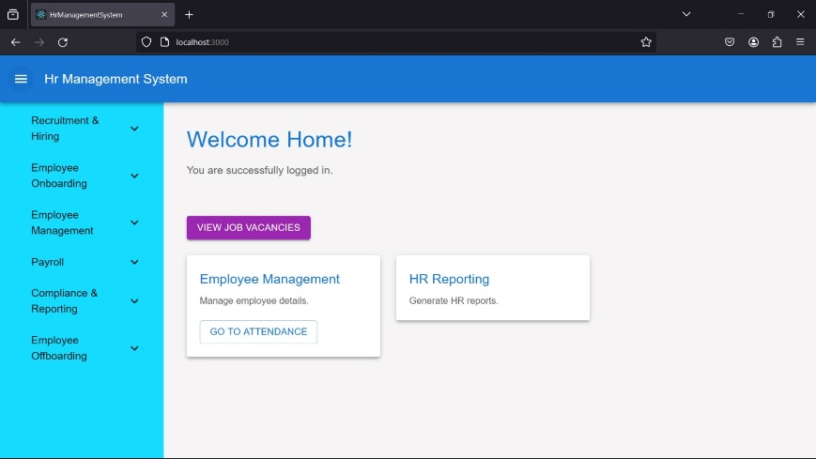

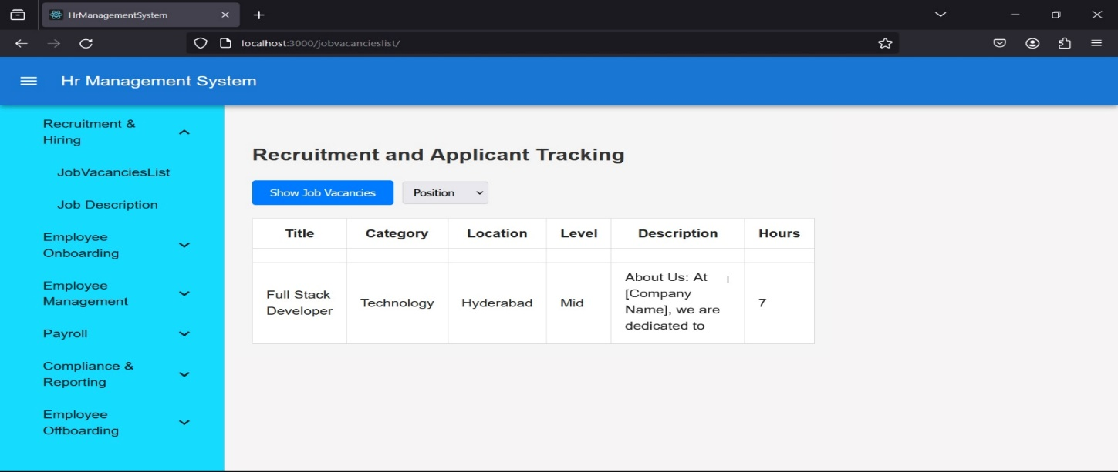

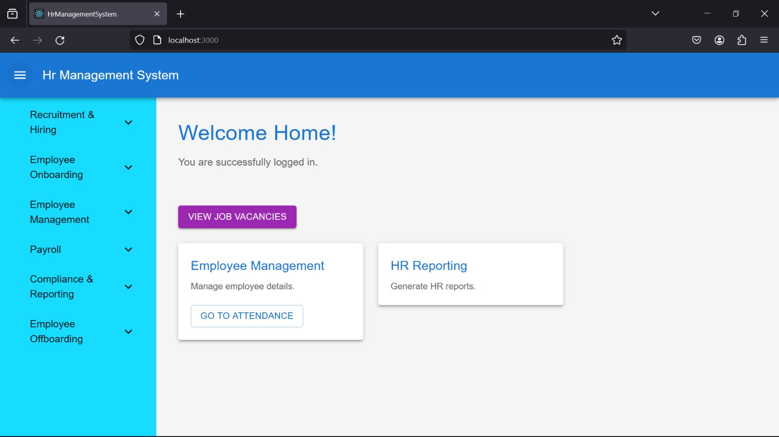

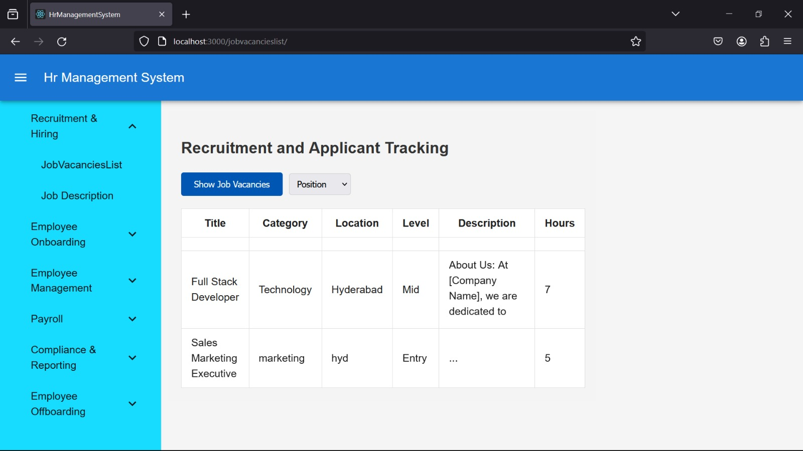

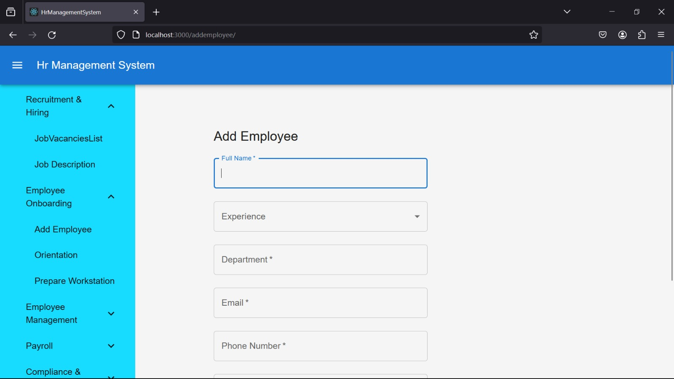

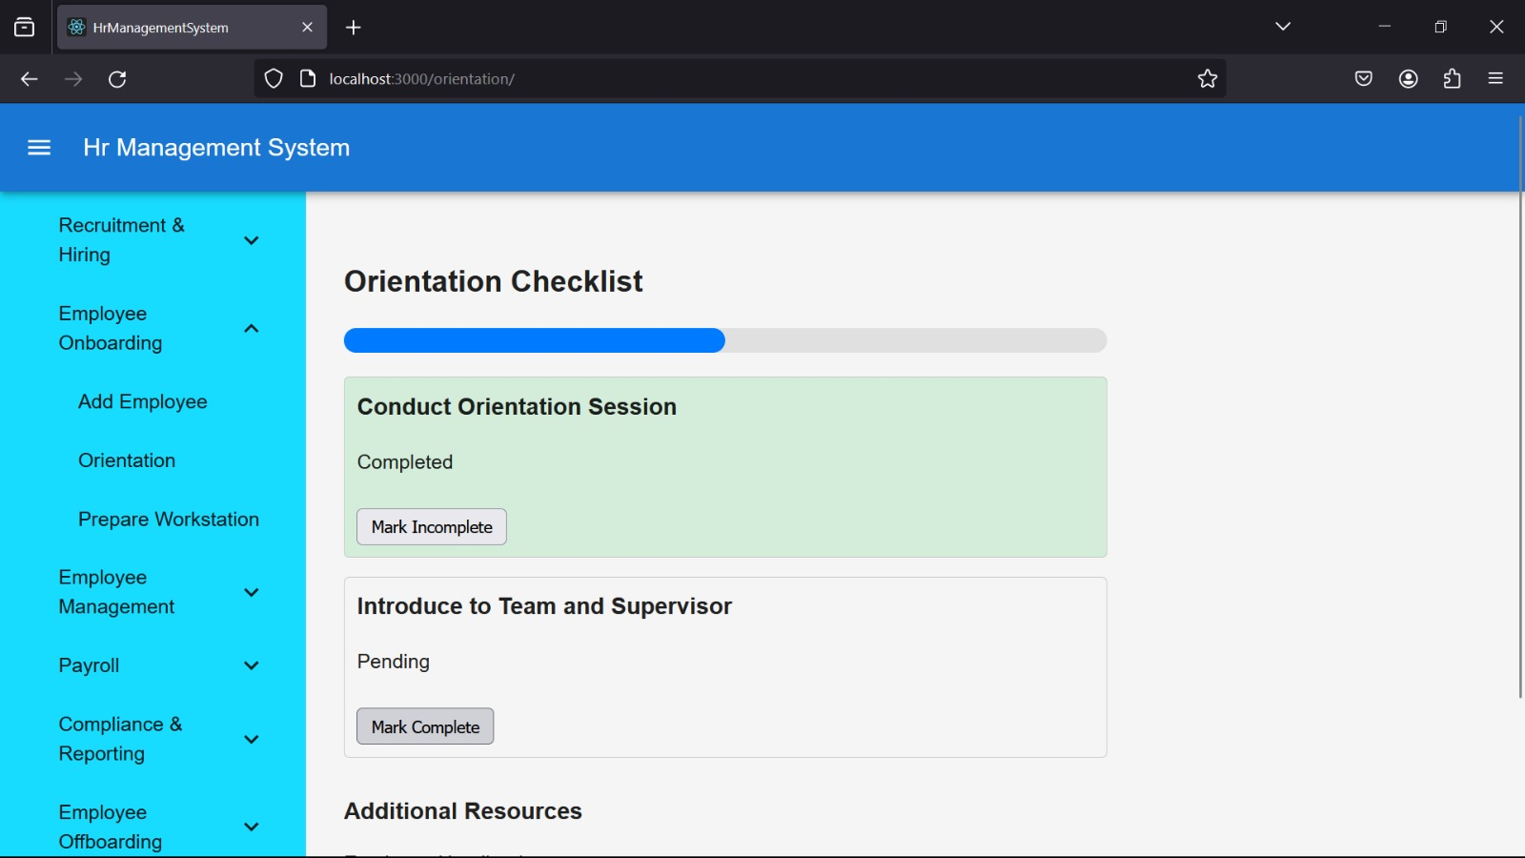

## Chapter 9: LIMITATIONS AND FUTURE ENHANCEMENT

#### Limitations

* + - To get the best out of our product we assume that the end user knows the Crest HRMS.
    - Users must have basic knowledge of Active Directory and must have its credentials.
    - Fast internet connection is expected.
    - Users are expected to have data in plain text format
    - Users are expected to connect in the Crest network.

#### Future Enhancement

* + - Provide Project details in HRMS.
    - Provide the more data encoding formats like PDF Format.
    - Provide the ability to access Crest HRMS outside Crest Network.
    - Give docker facility.

## Chapter 10: CONCLUSION

#### Conclusion

Due to this Human Resource Management System (HRMS) lots of work which was done Manually by the HR and PMO team will be automated. From now on the HR team does not have to maintain an excel sheet (Leave Tracker) for the leaves of all employees. Employees can apply and the DM can approve/reject leaves from HRMS itself and track the leave status. Using the Bulk change module HR and PMO can directly change the grade, designation, department and etc. of many employees in bulk. Most crucial thing is that HRMS is operated and maintained by Crest itself, so it can save money on outsourcing the software and the company can make all required changes according to their needs. Using the feature of filter under employee directory HR and PMO team can filter out employee’s data they require based on skills, previous experience and various other parameters.

# APPENDICES

#### MySQL

* + - * https://mysql.org/

#### React.js

* + - * https://reactjs.org/
      * [https://www.udemy.com/tutorial/react-the-complete-guide-incl-redux/what-is-react/](http://www.udemy.com/tutorial/react-the-complete-guide-incl-redux/what-is-react/)

#### Django

* + - * [The web framework for perfectionists with deadlines | Django (djangoproject.com)](https://www.djangoproject.com/)

# REFERENCES

1. **JavaScript. (2007) The Morden JavaScript Tutorial [Online] [Accessed on January 2020]** https://javascript.info/

#### Redux. (2015) A Predictable State Container For JS App [Online] [Accessed on January 2020]

https://redux.js.org/

#### Quora. (2009) For Solution of Question

**[Online] [Accessed from February to June 2020]**

[www.quora.com](http://www.quora.com/)

#### Stack Overflow. (2008) Coding Related Question Solution [Online] [Accessed from February to June 2020]

https://stackoverflow.com/

1. **GitHub. (2007) GitHub Support Community [Online] [Accessed from February to June 2020]** https://github.community

#### Python. (2001) Python Documentation

**[Online] [Accessed from February to June 2020]**

https://docs.python.org/3/

# PLAGIARISM REPORT

This plagiarism report is generated from the plagiarism checker available at [https://www.duplichecker.com/](http://www.duplichecker.com/). This plagiarism checker has a limit of 1000 words per report.

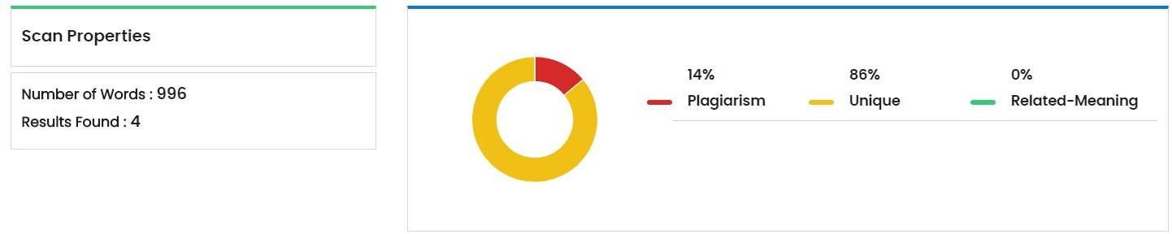

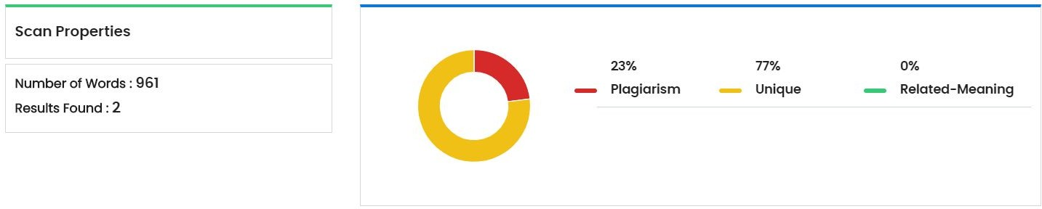

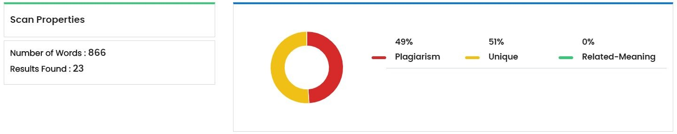

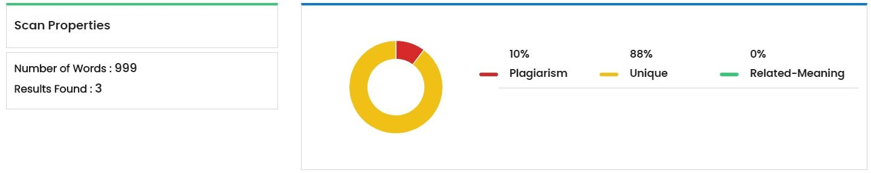

### PLAGIARISM REPORT

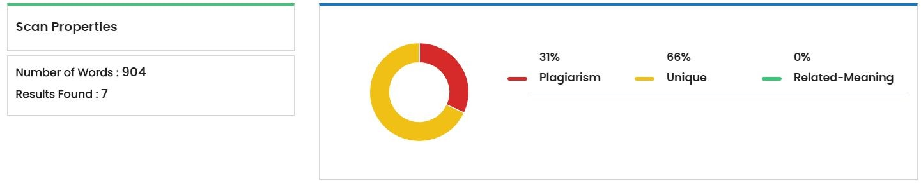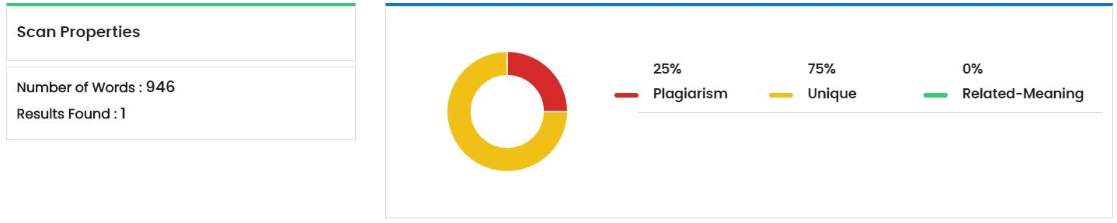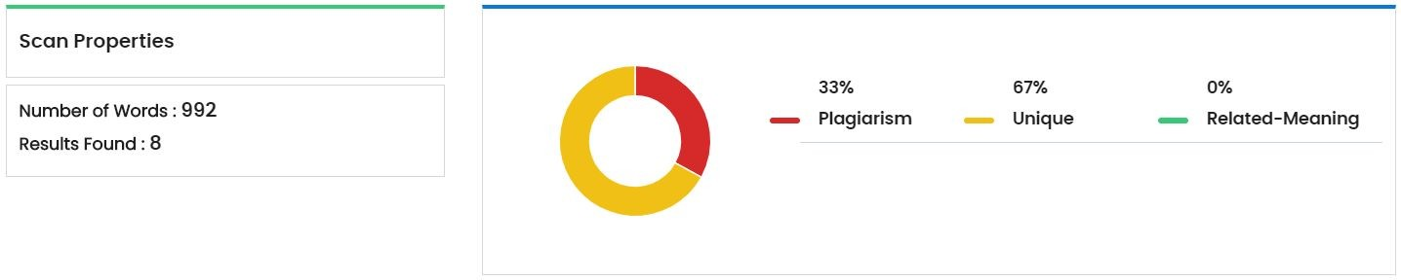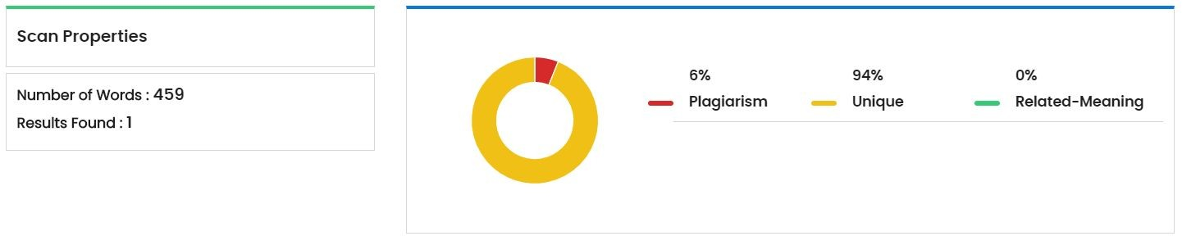

* + **Average plagiarism = 23.875%**