Backend Development Intern Assignment

prerequest: Python,Django framework

step1: create a django project
django-admin startproject projectname

step2: go to the project folder

cd foldername

step4: create a application
python3 manage.py startapp appname

step5: open the settings.py and update the application name in Installed apps

step6: create a template folder and maintain for html documents

step7: create a static folder and maintain for images,css files

step8: update the templates and static folder path in settings.py

step9: create a login in application folder views.py

step10: create a database using models.py

step11: make a update in urls.py for views.py path

step12: create migration
python3 manage.py makemigrations
python3 manage.py migrate
step13: run the project
python3 manage.py runserver

screenshorts:

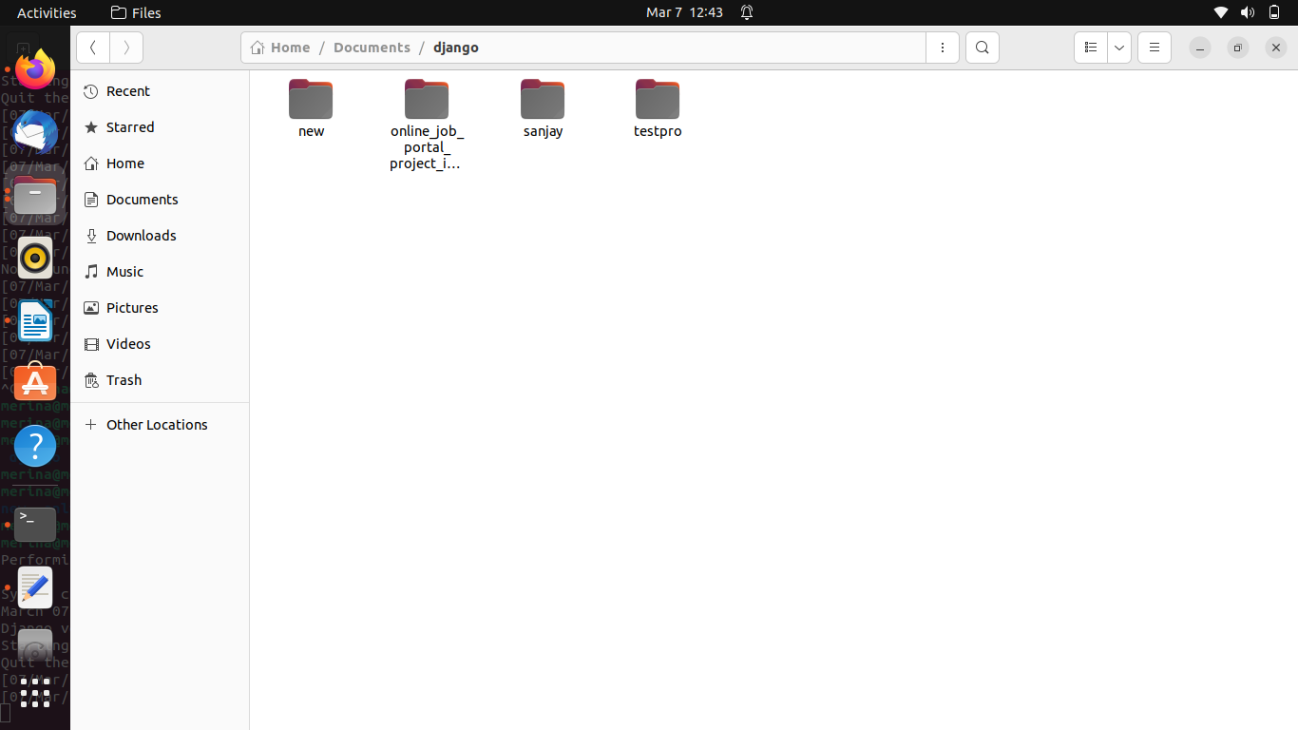

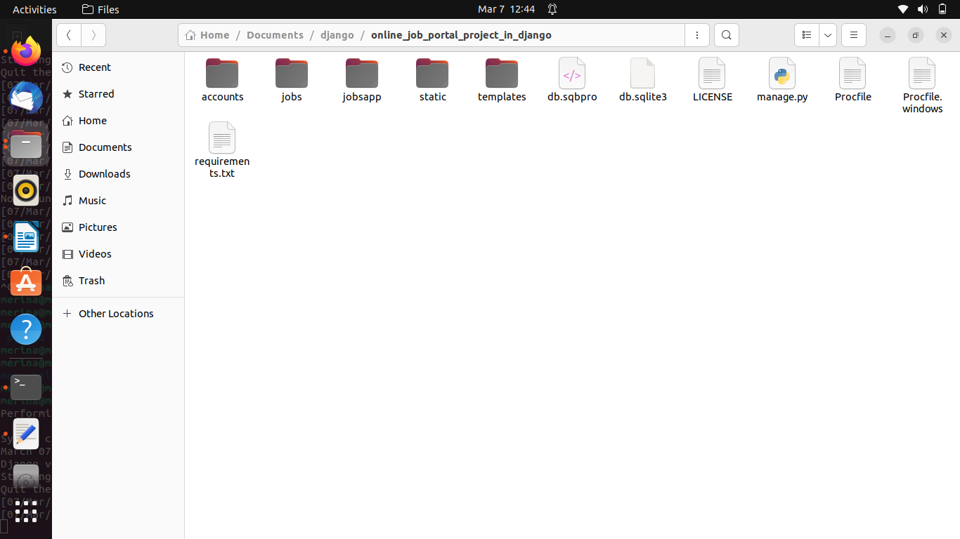

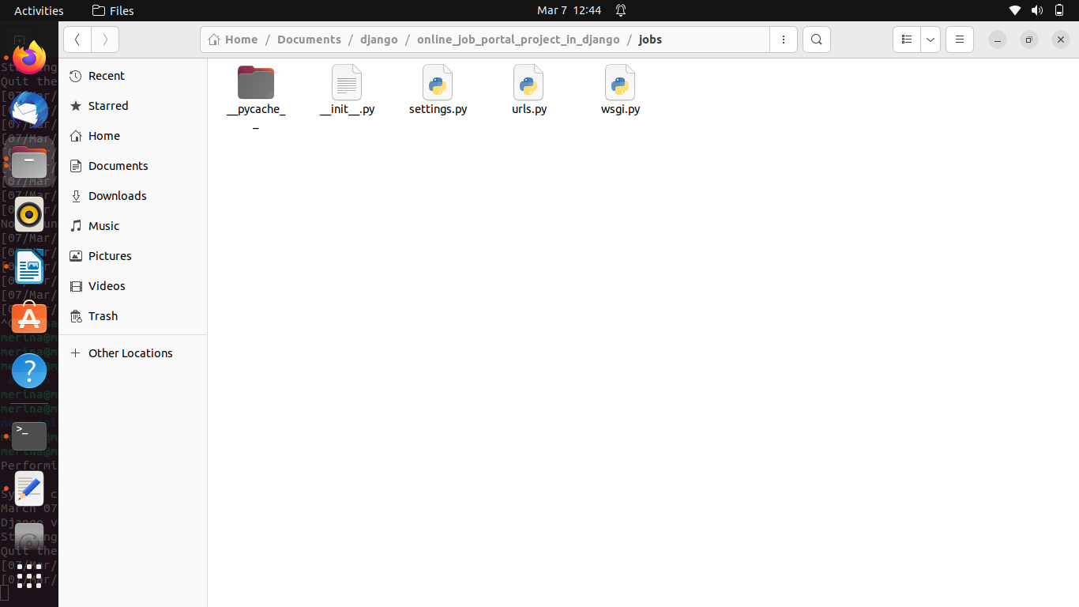

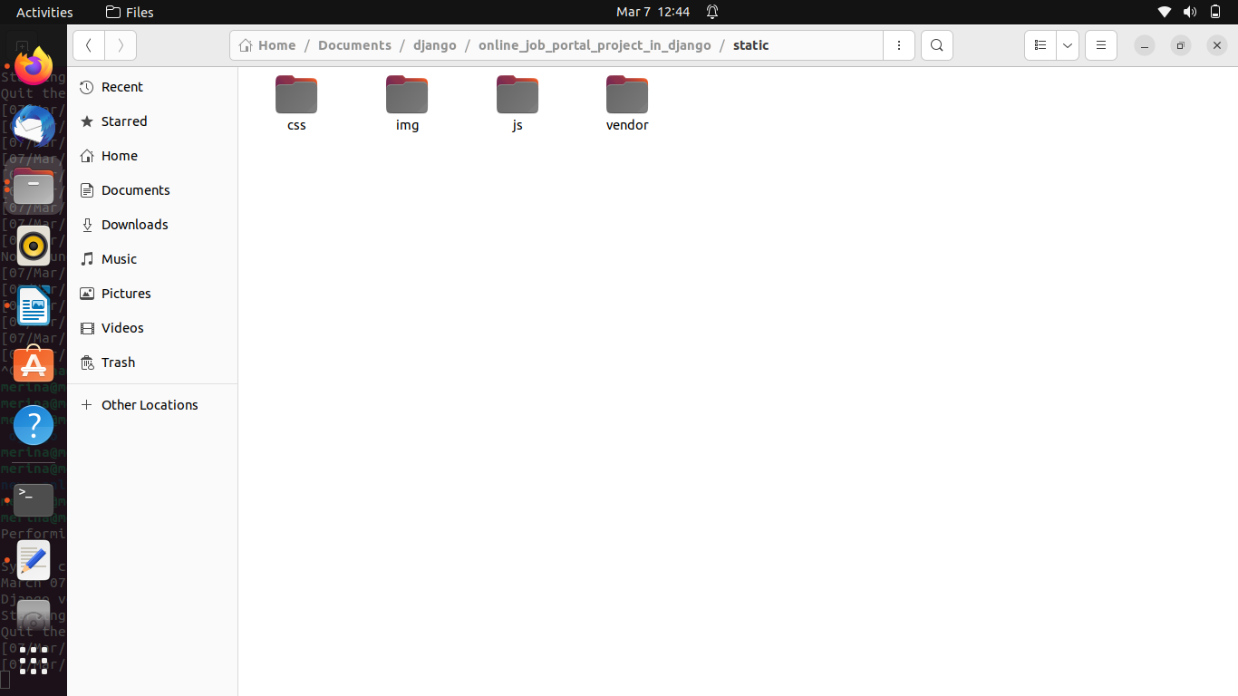

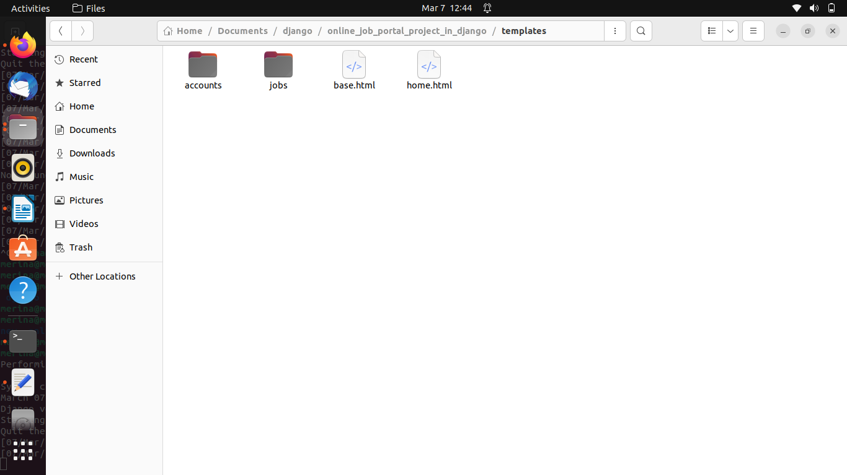

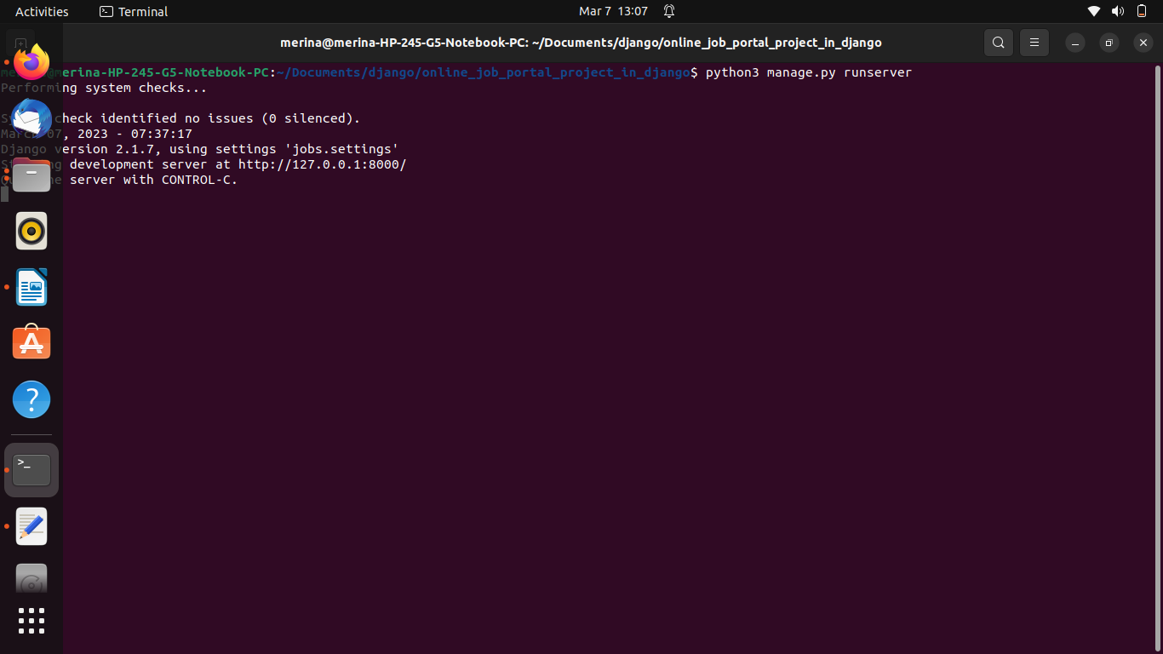

output:

