BCSE307P — Compiler Design Lab
Assessment 9 — Project Review II: Progress Report
Kelvin
An AI-Assisted Domain-Specific Language Compiler for IoT Automation
Submitted by
R. Sanjay Reg. No.: ____________
Settipalli Tejovardhan Reg. No.: ____________
Ashutosh Reg. No.: ____________
Under the guidance of
Faculty: ______________________
Vellore Institute of Technology
October 2026

Abstract
Home and building automation is usually expressed as trigger–action rules, but the people who need these rules are rarely programmers, and natural-language assistants based on large language models can silently produce rules that are wrong. This project presents Kelvin, an AI-assisted compiler for a small domain-specific language (DSL) for IoT automation. A user describes a rule in English or by voice; a free language model (Ollama, Groq or Gemini, with an offline rule-based fallback) drafts DSL code, and a hand-written C++17 compiler verifies it before it can be used. The compiler implements all seven classical phases: a DFA-based lexer, an LL(1) recursive-descent parser, an abstract syntax tree, semantic analysis with satisfiability-based rule-conflict detection, three-address intermediate code, a control-flow-graph optimizer with liveness and available-expressions analysis, and a retargetable back end for C, Arduino, Python and JavaScript. A web studio visualises every phase and runs the optimized code in a smart-home digital twin. On 13 example programs the compiler finishes in under 0.6 ms, the optimizer removes up to 52% of the intermediate code, and all 145 automated tests pass, including equivalence checks across the generated C, Python and JavaScript programs.
Keywords: compiler design, domain-specific language, IoT automation, LL(1) parsing, rule-conflict analysis, dataflow optimization, code generation, large language models, digital twin.
Contents
Abstract 2
1. Introduction 4
1.1 Motivation 4
1.2 Problem Statement 4
1.3 Objectives 4
1.4 Scope of the Language and Compiler 5
1.5 Organisation of the Report 5
2. Related Work 6
2.1 Compiler Construction and Parsing 6
2.2 Program Analysis and Optimization 6
2.3 Domain-Specific Languages 6
2.4 Trigger–Action Programming and IoT Safety 6
2.5 Natural Language to Code 6
2.6 Research Gap 8
3. Proposed Methodology 9
3.1 Architecture 9
3.2 Language Design 9
3.3 Compiler Phases 10
3.4 AI Assistant and Verification Gate 11
3.5 Web Studio and Digital Twin 11
3.6 Tools and Technologies 12
4. Results and Discussion 13
4.1 Test Cases 13
4.2 Sample Outputs 14
4.3 Error Handling 17
4.4 Performance 18
4.5 Novelty 20
4.6 Limitations 20
5. Conclusion and Future Work 22
References 23

(To refresh page numbers after editing, right-click this list in Word and choose Update Field.)

1. Introduction

1.1 Motivation
Smart homes, greenhouses and offices are controlled by small automation rules of the form “if a sensor reads something, switch a device”. Studies of trigger–action platforms show that such rules are written in very large numbers by end users who are not programmers [15], [16], and that these users often misunderstand how their rules behave [17], [18]. Natural-language assistants based on large language models (LLMs) [26], [27] make it easy to write rules, but they do not guarantee that a rule is correct: a model can drop a condition, use an undeclared device, or produce two rules that fight over the same device. In the physical world these mistakes switch off heaters, leave doors unlocked or flood gardens [19], [21].
Compiler technology is the natural answer to this problem. A precisely defined language, a parser and a type checker can reject malformed rules; static analysis can find rules that can never fire or that conflict; and an optimizing back end can turn verified rules into small, predictable code for microcontrollers. This project combines both worlds: the language model is used only as a front-end convenience, and a complete, hand-written compiler is the authority on what is correct.

1.2 Problem Statement
Design and implement an AI-assisted compiler for a domain-specific language for IoT automation. The system must convert a natural-language rule (for example, “If the temperature is above 30 and the door is open, turn on the fan”) into DSL code such as IF temperature > 30 AND door == OPEN THEN turn_on(fan), and compile that code through lexical analysis, parsing, semantic analysis, intermediate representation, optimization and code generation, producing executable code and clear diagnostics.

1.3 Objectives
- Define a small, unambiguous rule language for sensors, devices and actions, with an LL(1) grammar.
- Implement all seven compiler phases by hand in C++17, without parser generators.
- Go beyond type checking with rule analysis: detect impossible, always-true and unreachable conditions and conflicting rules, with example inputs.
- Build an optimizer on basic blocks and a control-flow graph (CFG) using dataflow analysis.
- Generate code for several targets (C, Arduino/ESP32, Python, JavaScript) from one intermediate representation.
- Use free language models to convert English to DSL, and verify every AI answer with the compiler before it is used.
- Provide a web studio that visualises every phase and simulates the compiled rules in a smart-home digital twin.

1.4 Scope of the Language and Compiler
In scope. The language supports numeric sensors (NUMBER) and state sensors (STATE: ON, OFF, OPEN, CLOSED, TRUE, FALSE); device declarations; rules with IF … THEN, any number of ELSE IF branches and an optional ELSE; conditions built from comparisons, AND, OR, NOT, parentheses and arithmetic (+ − × ÷, unary minus); and four built-in actions: turn_on, turn_off, toggle and set_level. Rules are evaluated on a consistent snapshot of sensor values, as in a programmable-logic-controller scan cycle.
Out of scope. Timers and schedules, user-defined functions, loops, variables that persist between evaluations, and direct device drivers. The Arduino target produces pin tables and stub sensor reads that must be connected to real hardware by the user.

1.5 Organisation of the Report
Section 2 reviews related work in compiler construction, domain-specific languages, trigger–action programming, IoT safety and natural-language code generation. Section 3 presents the proposed methodology, the architecture and the tools. Section 4 reports test cases, sample outputs, error handling, performance numbers and limitations. Section 5 concludes and outlines future work.

2. Related Work
This section reviews 30 works in five groups. Table 1 at the end summarises each work and how it relates to this project.

2.1 Compiler Construction and Parsing
The classical compiler pipeline used in this project follows Aho, Lam, Sethi and Ullman [1], which defines the lexical, syntactic, semantic, intermediate-code, optimization and code-generation phases, and the engineering treatment of Cooper and Torczon [2] and Appel [3]. Muchnick [4] describes the optimization passes (constant folding, common sub-expression elimination, copy propagation and dead-code elimination) that our optimizer implements. Knuth's LR theory [5] and the LL-family parser generators ANTLR [6] and LL(*) [7] represent the generator-based approach; we deliberately wrote a recursive-descent parser by hand and instead had the compiler compute FIRST, FOLLOW and the LL(1) table of its own grammar to prove it is conflict-free.

2.2 Program Analysis and Optimization
Allen [8] introduced control-flow analysis on basic blocks, and Kildall [9] gave the lattice framework for iterative dataflow analysis that we use for liveness and available expressions. Cytron et al. [10] introduced static single assignment form, and LLVM [11] showed the value of one intermediate representation shared by many back ends. Our three-address code plays the same role at a much smaller scale: one optimized IR feeds four code generators and the browser's virtual machine.

2.3 Domain-Specific Languages
Mernik, Heering and Sloane [12] give the standard guidance on when and how to build a DSL, van Deursen, Klint and Visser [13] survey DSL design, and Fowler [14] describes external DSLs with their own parser, which is the approach taken here. Our language is an external DSL whose notation is close to the trigger–action rules end users already write.

2.4 Trigger–Action Programming and IoT Safety
Ur et al. showed that end users can write trigger–action rules for smart homes [15] and analysed 200,000 IFTTT recipes [16]. Huang and Cakmak [17] and Brackenbury et al. [18] found that users frequently misinterpret how such rules behave and introduce bugs. On the safety side, Soteria [19] model-checks IoT apps for unsafe states, IoTGuard [20] enforces policies at run time, Ding and Hu [21] study unsafe physical interactions between devices, and Wang et al. [22] chart the attack surface of trigger–action platforms. These works motivate our rule analysis, which detects conflicting and unreachable rules at compile time and explains each warning with a concrete example input.

2.5 Natural Language to Code
Desai et al. [23] synthesise DSL programs from natural language, NL2Bash [24] maps English to shell commands, and Yin and Neubig [25] generate code with a syntax-directed neural model. Large language models [26], [27], [28] made natural-language programming widely available but also showed that generated code is often subtly wrong. Synchromesh [29] constrains decoding with a grammar to improve reliability. Our system uses a small local model (Qwen3 [30]) and adds a compiler-based verification gate: every answer is compiled, failed answers receive one repair attempt with the compiler's own error messages, and a meaning check rejects answers that drop numbers or conditions from the sentence.
Table 1: Summary of related work and its relation to this project
Ref. | Work | Key idea | Use in / gap addressed by this project
[1] | Aho et al., 2006 | Seven-phase compiler model | Structure of our compiler
[2] | Cooper & Torczon, 2011 | Compiler engineering | IR and optimizer design
[3] | Appel, 1998 | Compiler implementation in C | Hand-written front end
[4] | Muchnick, 1997 | Optimization catalogue | Our eight optimization passes
[5] | Knuth, 1965 | LR parsing theory | Grammar analysis background
[6] | Parr & Quong, 1995 | ANTLR LL(k) generator | We avoid generators; prove LL(1) instead
[7] | Parr & Fisher, 2011 | LL(*) parsing | Contrast with our LL(1) grammar
[8] | Allen, 1970 | Control-flow analysis | Basic blocks and CFG
[9] | Kildall, 1973 | Iterative dataflow | Liveness, available expressions
[10] | Cytron et al., 1991 | SSA form | Future work (SSA IR)
[11] | Lattner & Adve, 2004 | One IR, many back ends | One TAC IR for four targets
[12] | Mernik et al., 2005 | When to build a DSL | Language design decisions
[13] | van Deursen et al., 2000 | DSL survey | Notation close to the domain
[14] | Fowler, 2010 | External DSLs | Own lexer and parser
[15] | Ur et al., 2014 | End-user TAP in homes | Target users and rule shape
[16] | Ur et al., 2016 | 200k IFTTT recipes | Realistic rule patterns
[17] | Huang & Cakmak, 2015 | Users' mental models | Need for clear diagnostics
[18] | Brackenbury et al., 2019 | Bugs in TAP rules | Conflict and reachability warnings
[19] | Celik et al., 2018 (Soteria) | Model checking IoT apps | Static analysis at compile time
[20] | Celik et al., 2019 (IoTGuard) | Run-time policy enforcement | We check before deployment
[21] | Ding & Hu, 2018 | Unsafe device interactions | Device conflict detection
[22] | Wang et al., 2019 | TAP attack surface | Local-only design, phone remote key
[23] | Desai et al., 2016 | NL to DSL synthesis | English-to-DSL step
[24] | Lin et al., 2018 (NL2Bash) | NL to commands | Natural-language interface
[25] | Yin & Neubig, 2017 | Syntax-directed generation | Grammar-aware generation
[26] | Brown et al., 2020 | Few-shot LLMs | Prompt with examples
[27] | Chen et al., 2021 | LLMs for code | Generated code can be wrong
[28] | Austin et al., 2021 | LLM program synthesis | Repair with feedback
[29] | Poesia et al., 2022 | Constrained decoding | We verify with a full compiler
[30] | Yang et al., 2025 (Qwen3) | Open LLM | Local model used in the system

2.6 Research Gap
Existing trigger–action platforms accept rules without compiler-level checking; safety analysers work on finished apps rather than on a language with a grammar; and natural-language code generators trust the model's output. No surveyed system combines (a) a small DSL with a provably LL(1) grammar, (b) compile-time detection of conflicting and unreachable rules, (c) an optimizing, retargetable back end for microcontrollers and scripting languages, and (d) an LLM front end whose every answer is verified by the compiler. Kelvin addresses this gap.

3. Proposed Methodology

3.1 Architecture
Figure 1 shows the architecture. An English sentence, typed or spoken, is converted to DSL by the AI assistant. The result passes through a verification gate: it is compiled by iotc, and a meaning check confirms that every number in the sentence appears in the program and every declared sensor is used. The DSL program then flows through the front end (lexer, parser, AST, semantic and rule analysis), the middle end (three-address IR, CFG and dataflow analysis, optimizer) and the back end (code generators and runtimes). A Python web server exposes the compiler to the browser studio, which visualises every phase, and to a digital twin that runs the optimized IR.
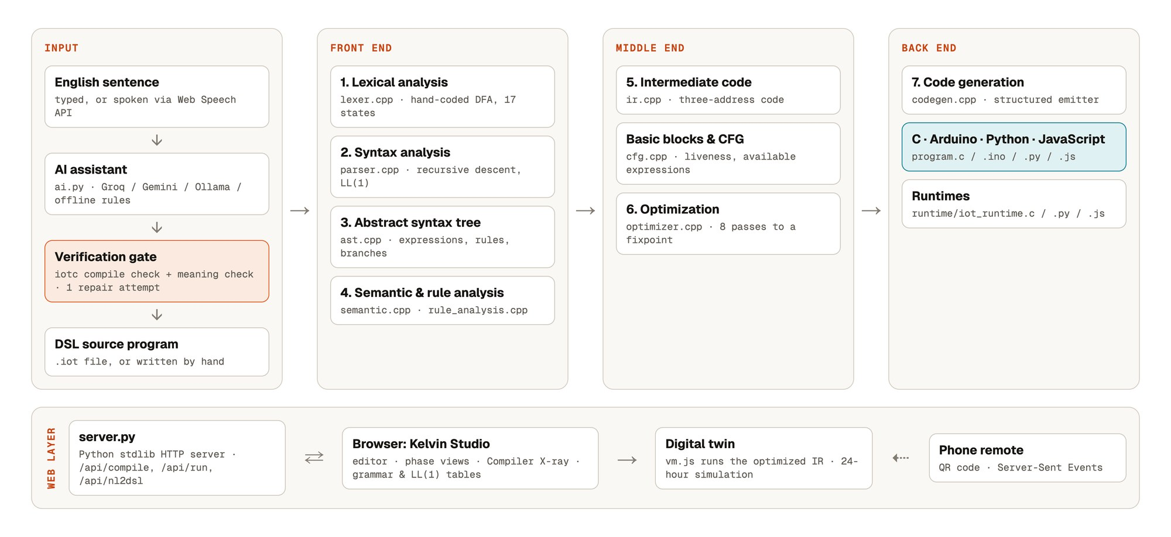
Figure 1: System architecture of Kelvin
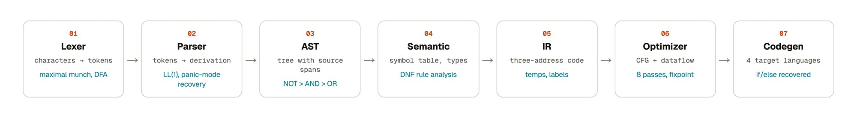
Figure 2: The seven compiler phases and what each produces

3.2 Language Design
The grammar below is written in EBNF. The compiler stores the equivalent BNF grammar (61 productions, 29 nonterminals, 33 terminals) as data, computes FIRST and FOLLOW sets and the LL(1) parse table, and reports 0 conflicts, which proves the grammar is LL(1). Operator precedence, from highest to lowest, is unary minus, * /, + −, comparison, NOT, AND, OR.
program → { declaration | rule } EOF
declaration → SENSOR IDENT ':' ( NUMBER | STATE )
| DEVICE IDENT { ',' IDENT }
rule → IF expr THEN actions { ELSE IF expr THEN actions } [ ELSE actions ]
actions → action { action }
action → IDENT '(' [ expr { ',' expr } ] ')'
expr → and_expr { OR and_expr }
and_expr → not_expr { AND not_expr }
not_expr → NOT not_expr | rel_expr
rel_expr → arith [ relop arith ]
arith → term { ( '+' | '-' ) term }
term → unary { ( '*' | '/' ) unary }
unary → '-' unary | primary
primary → NUMBER_LITERAL | IDENT | ON | OFF | OPEN | CLOSED | TRUE | FALSE | '(' expr ')'
relop → '>' | '<' | '>=' | '<=' | '==' | '!='

3.3 Compiler Phases

Phase 1 — Lexical analysis
The scanner is a hand-coded deterministic finite automaton with 17 states that reads one character at a time and applies the longest-match (maximal munch) rule. Keywords are recognised after an identifier is scanned. Every token records its line and column. Lexical errors, such as an unknown character or = used instead of ==, are reported with a suggested fix, and scanning continues.

Phases 2–3 — Syntax analysis and the abstract syntax tree
A recursive-descent parser implements one C++ function per nonterminal (parseRule, parseExpr, parseAnd, parseRelational, …). One token of lookahead always decides the production. After a syntax error, panic-mode recovery skips to the next IF, SENSOR or DEVICE, so several errors are reported in one run. The AST uses a single expression hierarchy (binary, unary and operand nodes) for both conditions and arithmetic, and every node keeps its source span for error messages and cross-linking in the studio.

Phase 4 — Semantic and rule analysis
The semantic analyser builds a symbol table, checks that each name is declared exactly once, infers types (NUMBER, STATE, BOOL) and checks comparisons, arithmetic and action arguments. Misspelt names produce did-you-mean suggestions using edit distance, and many errors carry machine-applicable quick fixes. Rule analysis then converts each condition to disjunctive normal form and reasons about each conjunction with numeric intervals and sets of states. It reports conditions that can never be true, conditions that are always true, ELSE IF branches made unreachable by earlier branches, and pairs of rules that drive the same device to different states for the same inputs, with an example input that triggers the conflict.

Phase 5 — Intermediate code
The IR is three-address code with temporaries (t1, t2, …), labels and the instructions IF_FALSE … GOTO, GOTO and CALL. Short ELSE IF chains become label sequences. Each instruction stores the source span it came from.

Phase 6 — Optimization
The IR is split into basic blocks and a control-flow graph. Two iterative dataflow analyses are computed [9]: liveness (backward) and available expressions (forward). Eight passes run repeatedly until the code stops changing: constant folding, algebraic simplification, common sub-expression elimination (using available expressions), copy propagation, constant-branch elimination, unreachable-code elimination (CFG reachability), jump optimization and dead-code elimination (using liveness). Every intermediate state is recorded, so the studio can replay the optimizer pass by pass.

Phase 7 — Code generation
A structured emitter recovers if / else blocks from the optimized IR and drives four target back ends through one interface: C (linked with a small runtime), Arduino/ESP32 (setup() and loop() with a pin table), Python and JavaScript, each with its own runtime that prints identical output. The compiler can also translate a program back into plain English.

3.4 AI Assistant and Verification Gate
The AI module uses only free providers, in this order of configuration: Groq, Google Gemini, a local Ollama model (Qwen3 8B in our setup), and a built-in rule-based converter when no model is available. The prompt contains the language reference and the names already declared in the editor. The model's answer is cleaned and compiled. If it has errors, the compiler's error messages are sent back for one repair attempt. A meaning check then rejects answers that compile but lose part of the sentence; we added it after observing the local model translate “above 30 and the door is open” as > 3. If the repaired answer still fails, the rule-based converter is used. The same gate protects the AI fix feature, which is offered only when the targeted error disappears and no new error appears.

3.5 Web Studio and Digital Twin
The studio shows the source editor (live compilation, autocomplete, hover types and quick fixes), a seven-phase status strip and tabs for tokens, the AST graph, the grammar with FIRST/FOLLOW sets and the LL(1) table, symbols, IR (original, optimized, optimizer time machine and CFG), generated code with Build & run, and problems. The Compiler X-ray replays a compilation from traces recorded by the compiler (DFA steps, parser calls and optimizer snapshots). The digital twin executes the optimized IR in a small virtual machine and animates devices on a floor plan; a 24-hour simulation drives sensors along daily curves with simple physics, and a phone can act as a sensor panel through a QR code and Server-Sent Events.
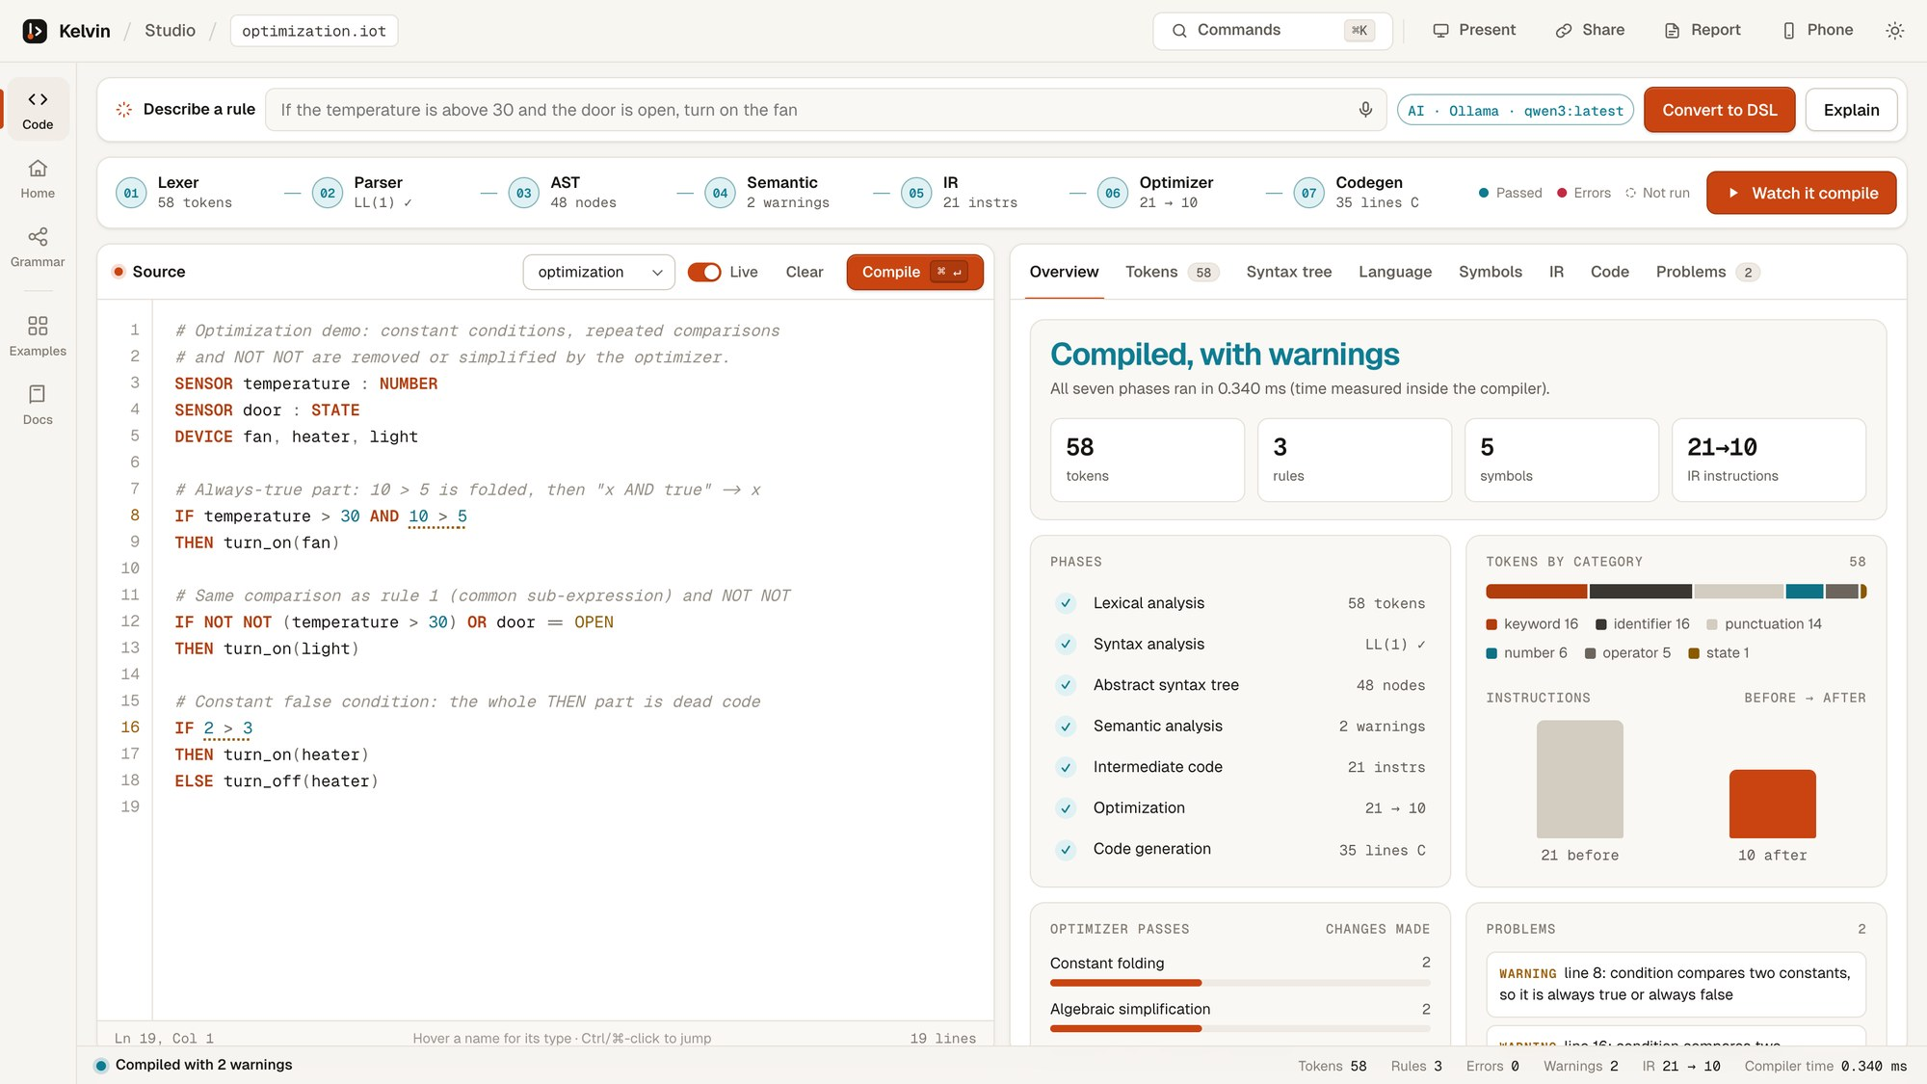
Figure 3: The Kelvin Studio showing the Overview of a compilation (example 07)

3.6 Tools and Technologies
Table 2: Tools and technologies used
Component | Technology | Notes
Compiler (iotc) | C++17, Apple clang 21 / g++ | 4,865 lines in 28 source files; no Lex/Yacc or libraries
Build | GNU Make | make, make run, make remote, make test
Runtimes | C99, Python 3, Node.js | Identical output format for all targets
Web server | Python 3.14 standard library | http.server, JSON API, Server-Sent Events
Front end | HTML, CSS, JavaScript (ES modules) | No frameworks; self-hosted fonts; works offline
AI models | Ollama (Qwen3 8B), Groq, Gemini | Free; offline rule-based fallback
Testing | POSIX shell script, Python unittest | 126 compiler checks + 19 unit tests
Version control | Git, GitHub | Private repository
Hardware used | Apple M3, 16 GB RAM, macOS 27 | All measurements in Section 4

4. Results and Discussion

4.1 Test Cases
The test suite has two parts. tests/run_tests.sh runs 126 checks against the compiler binary, and Python unittest runs 19 tests for the server, the phone remote and the AI module. All 145 tests pass. Table 3 groups the compiler checks; Table 4 lists the example programs used as end-to-end test cases.
Table 3: Compiler test checks by area (all passing)
Area | Checks | What is verified
Examples | 7 | Each bundled example compiles or fails with the expected message
Lexer and parser | 9 | Tokens, positions, precedence, panic-mode recovery
Semantic analysis | 12 | Undeclared names, type mismatches, argument counts, suggestions
IR and optimization | 5 | Three-address code and instruction counts after optimization
Code generation | 6 | Generated C compiles with -Werror and gives correct device states
Arithmetic and ELSE IF | 11 | Arithmetic in conditions and actions; ELSE IF chains
Rule analysis | 10 | Impossible, always-true, unreachable and conflicting rules
CFG and dataflow | 4 | Basic blocks, edges, liveness
Generated C for ELSE IF | 7 | Run-time behaviour of the C output
New examples | 16 | Security, air quality, kitchen and office programs
Grammar, English, fixes, traces | 18 | LL(1) table, back-translation, quick fixes, traces
Cross-target equivalence | 20 | C, Python and JavaScript agree; Arduino sketches compile
JSON | 1 | Machine-readable output is valid
Python unit tests | 19 | Remote access rules, run endpoint, AI meaning check, offline converter

Table 4: Example programs used as test cases
Program | Purpose | Expected result | Result
01 basic | Problem-statement example | Compiles; fan on when hot and open | Pass
02 smart home | Precedence, NOT, set_level | Compiles, 3 rules | Pass
03 greenhouse | NOT with states, levels | Compiles, 2 rules | Pass
04 lexical error | Bad characters, '=' for '==' | 4 lexical errors with fixes | Pass
05 syntax error | Lowercase keyword, missing THEN and ')' | 3 syntax errors, recovery | Pass
06 semantic error | Undeclared, type mismatch, wrong arity | 6 semantic errors | Pass
07 optimization | Constant conditions, CSE, dead code | 21 → 10 instructions, 2 warnings | Pass
08 rule analysis | Impossible, always-true, unreachable, conflict | 4 rule warnings with examples | Pass
09 thermostat | ELSE IF chains, arithmetic | Heater level (22 − t) × 10 | Pass
10 home security | Parentheses, ELSE IF, several actions | Alarm on intrusion, dim porch light | Pass
11 air quality | Arithmetic in actions | Vent level (co2 − 800) / 4 | Pass
12 kitchen safety | OR conditions, safety shut-off | Gas valve shut, sprinkler on fire | Pass
13 office energy | NOT, long AND chains, arithmetic | Lights and AC follow people and time | Pass

4.2 Sample Outputs
The following outputs are produced by the compiler for the problem-statement example (examples/01_basic.iot).
# Input program
SENSOR temperature : NUMBER
SENSOR door : STATE
DEVICE fan
IF temperature > 30 AND door == OPEN
THEN turn_on(fan)
Phase 1 — tokens (first eight of 23):
# LINE:COL TOKEN LEXEME
1 2:1 SENSOR SENSOR
2 2:8 IDENTIFIER temperature
3 2:20 COLON :
4 2:22 TYPE_NUMBER NUMBER
5 3:1 SENSOR SENSOR
6 3:8 IDENTIFIER door
7 3:13 COLON :
8 3:15 TYPE_STATE STATE
Phases 2–3 — abstract syntax tree (rule part):
Rule
├── Condition
│ └── AND
│ ├── Comparison: >
│ │ ├── Identifier: temperature
│ │ └── Number: 30
│ └── Comparison: ==
│ ├── Identifier: door
│ └── State: OPEN
└── Then
└── Action: turn_on
└── Identifier: fan
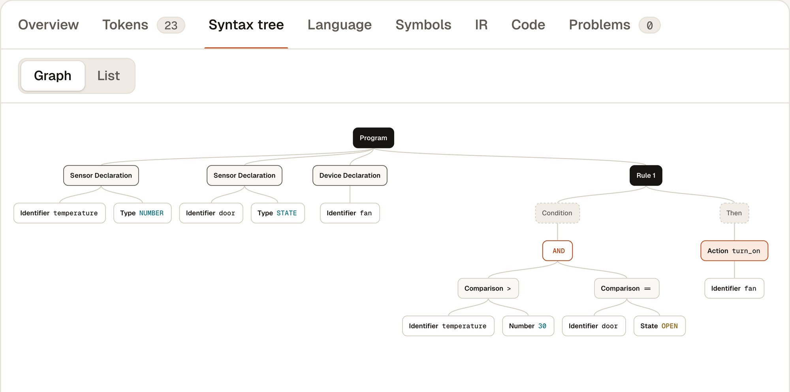
Figure 4: The same syntax tree drawn by the studio
Phases 5–6 — intermediate code before and after optimization for examples/07_optimization.iot, which contains a constant condition, a repeated comparison, a double negation and a dead branch:
BEFORE (21 instructions) AFTER (10 instructions)
# Rule 1 # Rule 1
t1 = temperature > 30 t1 = temperature > 30
t2 = 10 > 5 IF_FALSE t1 GOTO L1
t3 = t1 AND t2 CALL turn_on(fan)
IF_FALSE t3 GOTO L1 L1:
CALL turn_on(fan) # Rule 2
L1: t7 = door == OPEN
# Rule 2 t8 = t1 OR t7
t4 = temperature > 30 IF_FALSE t8 GOTO L2
t5 = NOT t4 CALL turn_on(light)
t6 = NOT t5 L2:
t7 = door == OPEN # Rule 3
t8 = t6 OR t7 CALL turn_off(heater)
IF_FALSE t8 GOTO L2
CALL turn_on(light)
L2:
# Rule 3
t9 = 2 > 3
IF_FALSE t9 GOTO L3
CALL turn_on(heater)
GOTO L4
L3:
CALL turn_off(heater)
L4:
Passes that changed the code: constant folding (2), algebraic simplification (2), common sub-expression elimination (1), copy propagation (5), constant-branch elimination (1), unreachable-code elimination (2), jump optimization (3) and dead-code elimination (1).
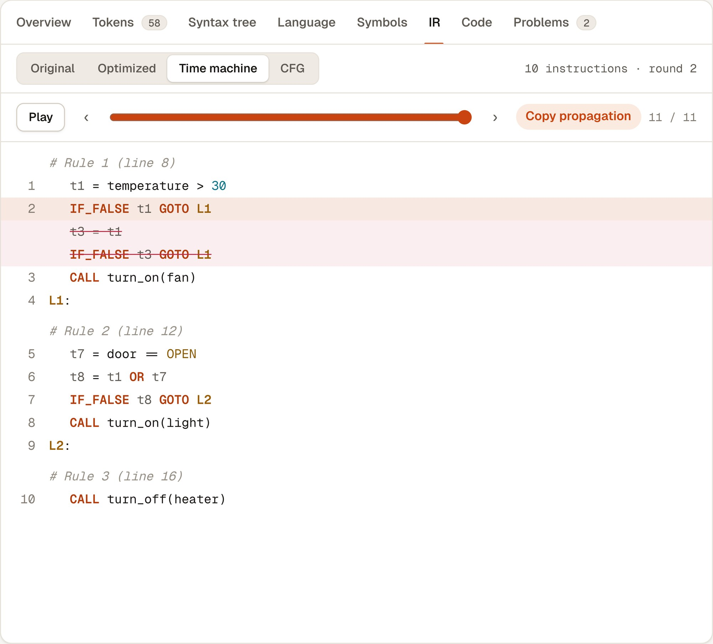
Figure 5: The optimizer time machine replaying each pass (struck-out lines were removed)
Phase 7 — generated C for the basic example:
void evaluate_rules(void)
{
/* Read every sensor once, so all rules see the same snapshot */
double temperature = read_number("temperature");
state_t door = read_state("door");

/* Rule 1 (source line 6) */
bool t1 = temperature > 30;
bool t2 = door == STATE_OPEN;
bool t3 = t1 && t2;
if (t3) {
turn_on(DEV_FAN);
}
}
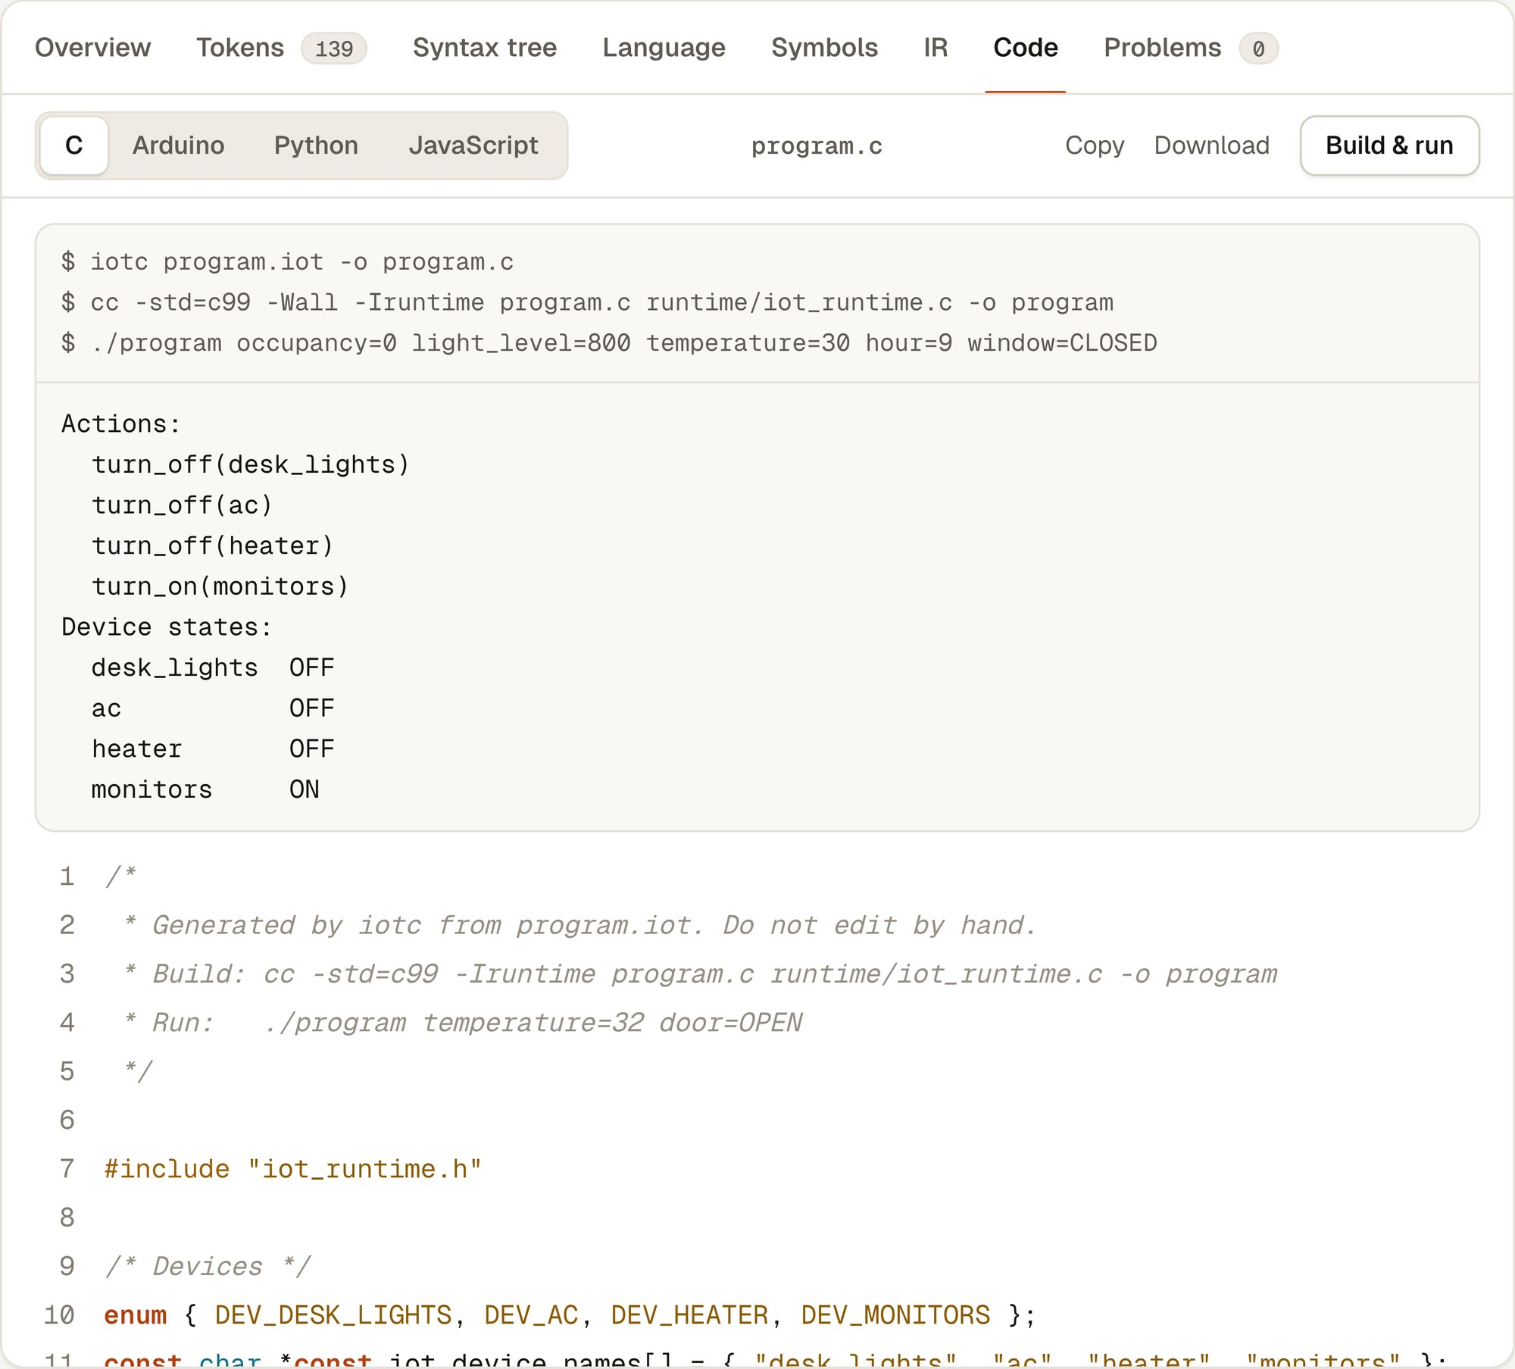
Figure 6: Build & run: the generated C for example 13 compiled with the system C compiler and executed

4.3 Error Handling
Each phase reports its own errors with line and column, continues where it safely can, and attaches quick fixes when the correction is unambiguous. Table 5 lists real messages produced for the error examples, and Figures 7 and 8 show them in the studio.
Table 5: Diagnostics produced by the compiler
Phase | Message (abridged) | Quick fix
Lexical | unexpected character '@' | Remove '@'
Lexical | unexpected '=': assignment is not supported, did you mean '=='? | Replace '=' with '=='
Syntax | expected 'IF', 'SENSOR' or 'DEVICE' … found 'if' (keywords are uppercase) | Change to 'IF'
Syntax | expected 'THEN' after the condition but found 'turn_on' | Insert 'THEN'
Syntax | expected ',' or ')' in the argument list of 'turn_on' but found end of file | Insert ')'
Semantic | 'fan' is not a registered device | Declare 'DEVICE fan'
Semantic | 'temprature' is not a declared sensor (did you mean 'temperature'?) | Change to 'temperature'
Semantic | type mismatch: cannot compare STATE sensor 'door' with number 5 | —
Semantic | 'set_level' expects 2 arguments … but got 1 | —
Rule analysis | this condition can never be true, so its actions never run | —
Rule analysis | this ELSE IF can never run: … an earlier condition is already true | —
Rule analysis | conflict: rule 4 turns 'fan' off while rule 3 turns 'fan' on, e.g. when temperature = 31 and door = OPEN | —

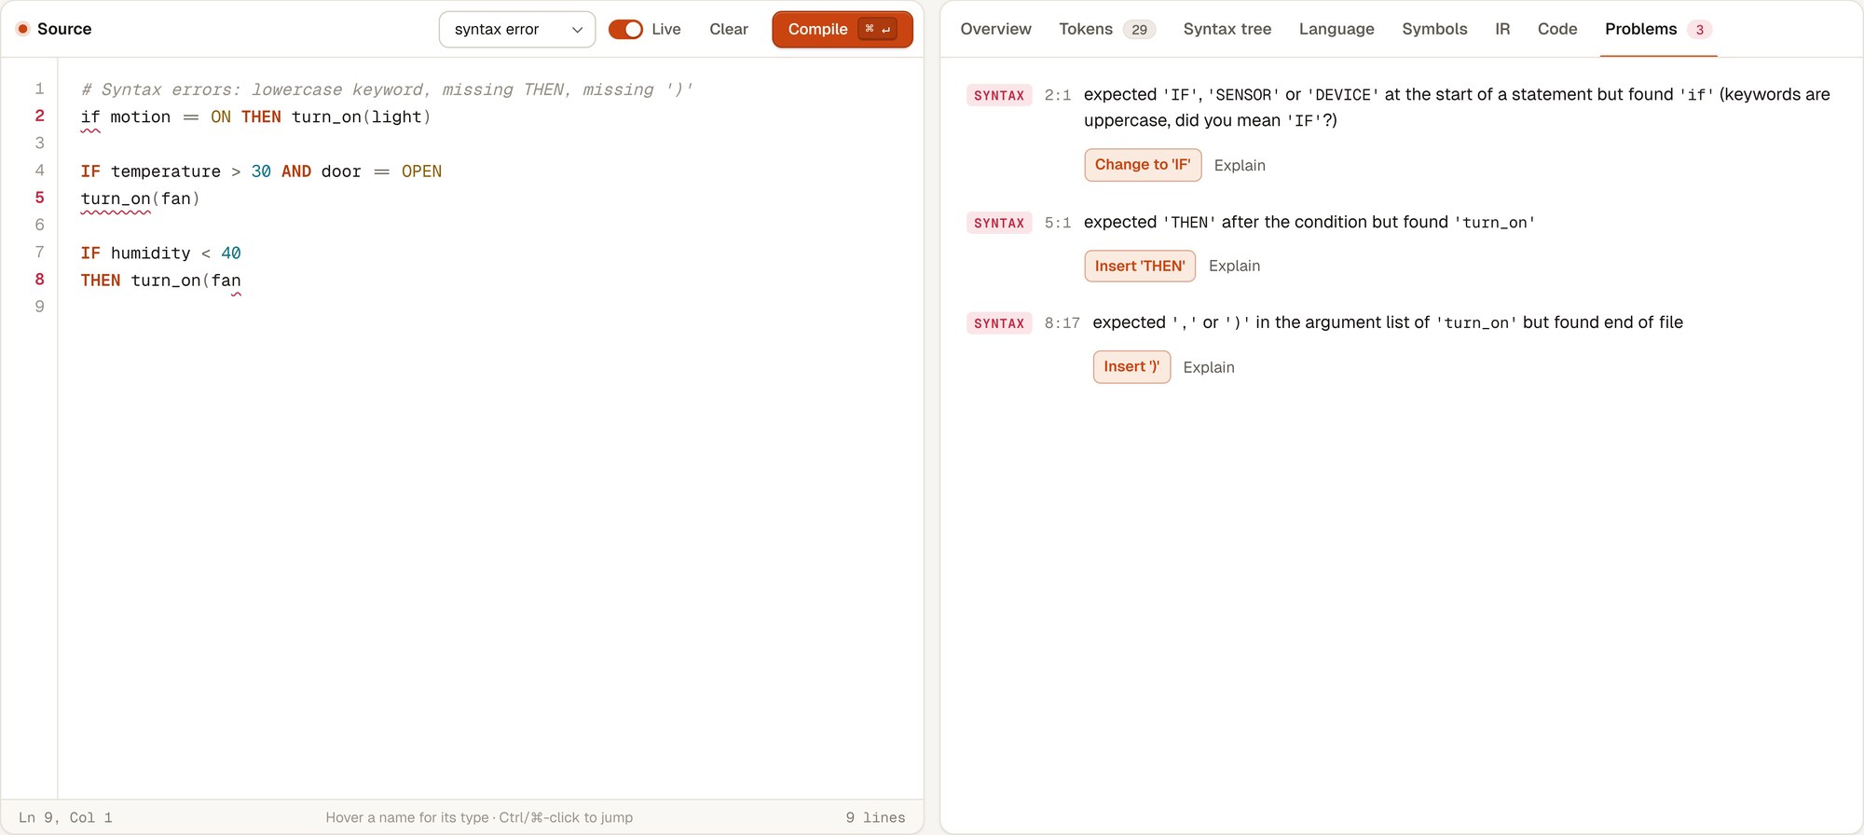
Figure 7: Syntax errors with panic-mode recovery and one-click fixes (example 05)
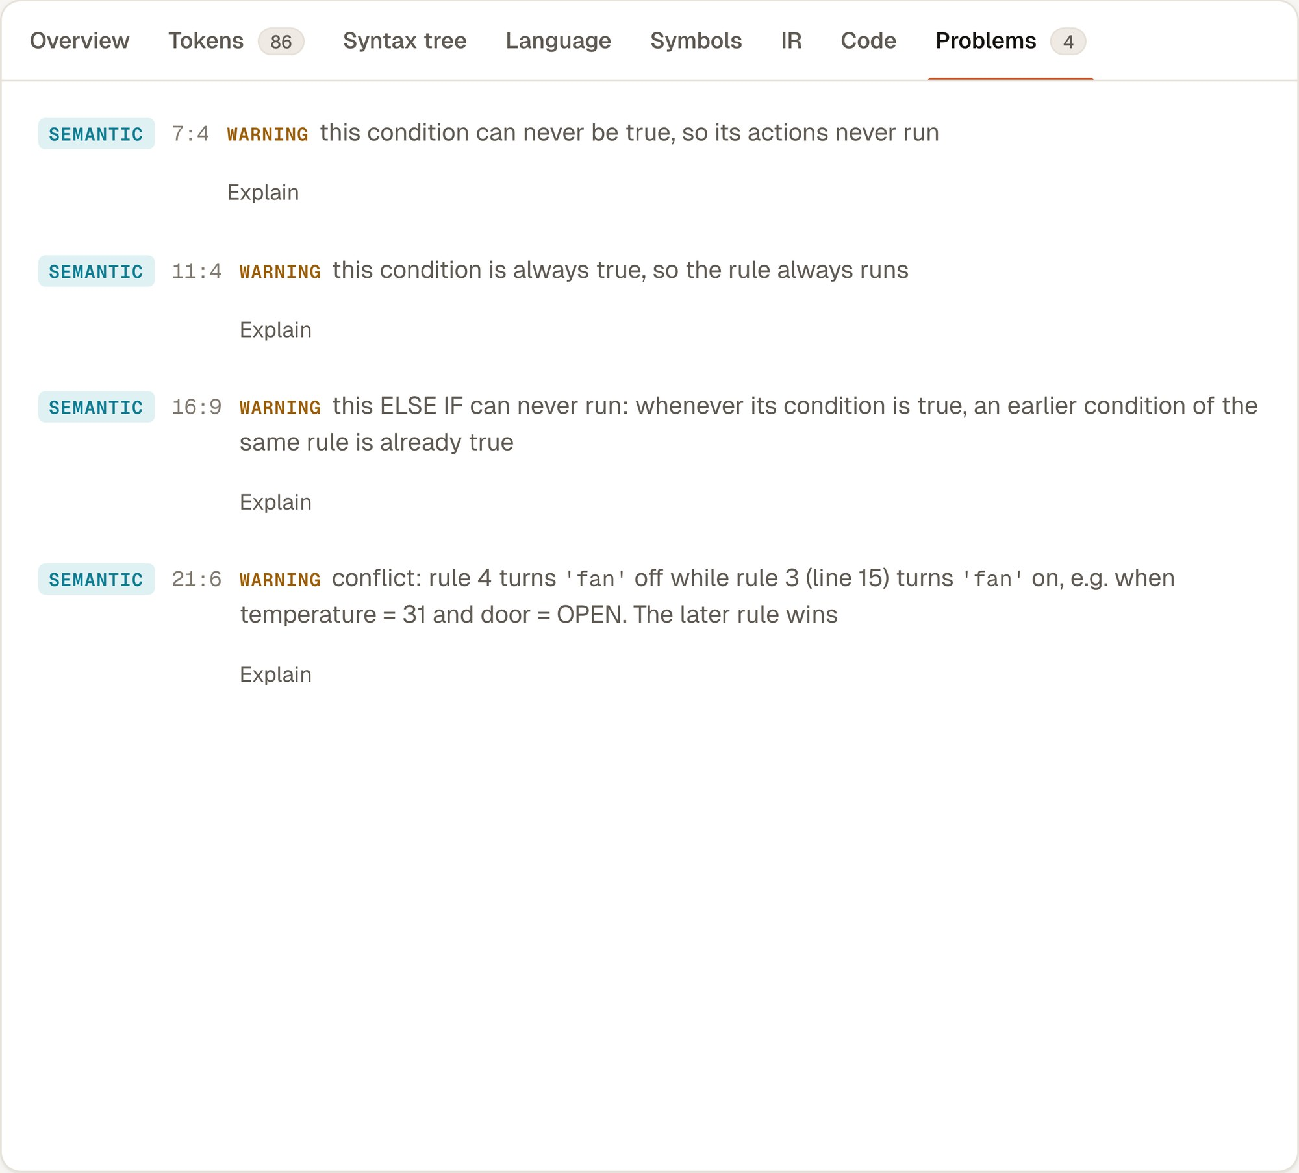
Figure 8: Rule-analysis warnings with example inputs (example 08)

4.4 Performance
All measurements were taken on an Apple M3 laptop (16 GB RAM) with the compiler built at -O2. Compiler time is the time measured inside iotc for all seven phases; end-to-end includes starting the process and writing the JSON output. Each value is the median of 30 runs.
Table 6: Compiler performance on the example programs
Program | Lines | Tokens | Rules | IR before → after | Compiler time (ms) | End-to-end (ms)
basic | 7 | 23 | 1 | 6 → 6 | 0.118 | 2.46
smart home | 20 | 87 | 3 | 27 → 26 | 0.317 | 2.83
greenhouse | 13 | 52 | 2 | 15 → 15 | 0.168 | 2.43
lexical error | 4 | 12 | 0 | — (errors) | 0.023 | 2.00
syntax error | 8 | 29 | 0 | — (errors) | 0.045 | 2.08
semantic error | 14 | 45 | 3 | — (errors) | 0.032 | 2.11
optimization | 18 | 58 | 3 | 21 → 10 | 0.225 | 2.62
rule analysis | 26 | 86 | 6 | 33 → 32 | 0.388 | 2.94
thermostat | 23 | 96 | 2 | 33 → 33 | 0.230 | 2.66
home security | 25 | 102 | 3 | 34 → 31 | 0.325 | 2.82
air quality | 28 | 118 | 3 | 42 → 40 | 0.365 | 2.93
kitchen safety | 25 | 98 | 3 | 34 → 32 | 0.342 | 3.02
office energy | 29 | 139 | 4 | 52 → 51 | 0.567 | 4.13

The compiler processes every example in under 0.6 ms, and the cost grows roughly linearly with the number of tokens. Programs with errors finish fastest because later phases are skipped. The optimizer removes 52% of the code in the optimization example and 1–3 instructions (mostly repeated comparisons) in realistic programs; programs that are already minimal are left unchanged, as expected.
AI conversion. With the local Qwen3 8B model, converting one sentence took 2.5–2.7 s once the model was loaded (10.4 s for the first request, which includes loading the model). The offline rule-based converter took under 1 ms. In every measured case the final answer compiled without errors.
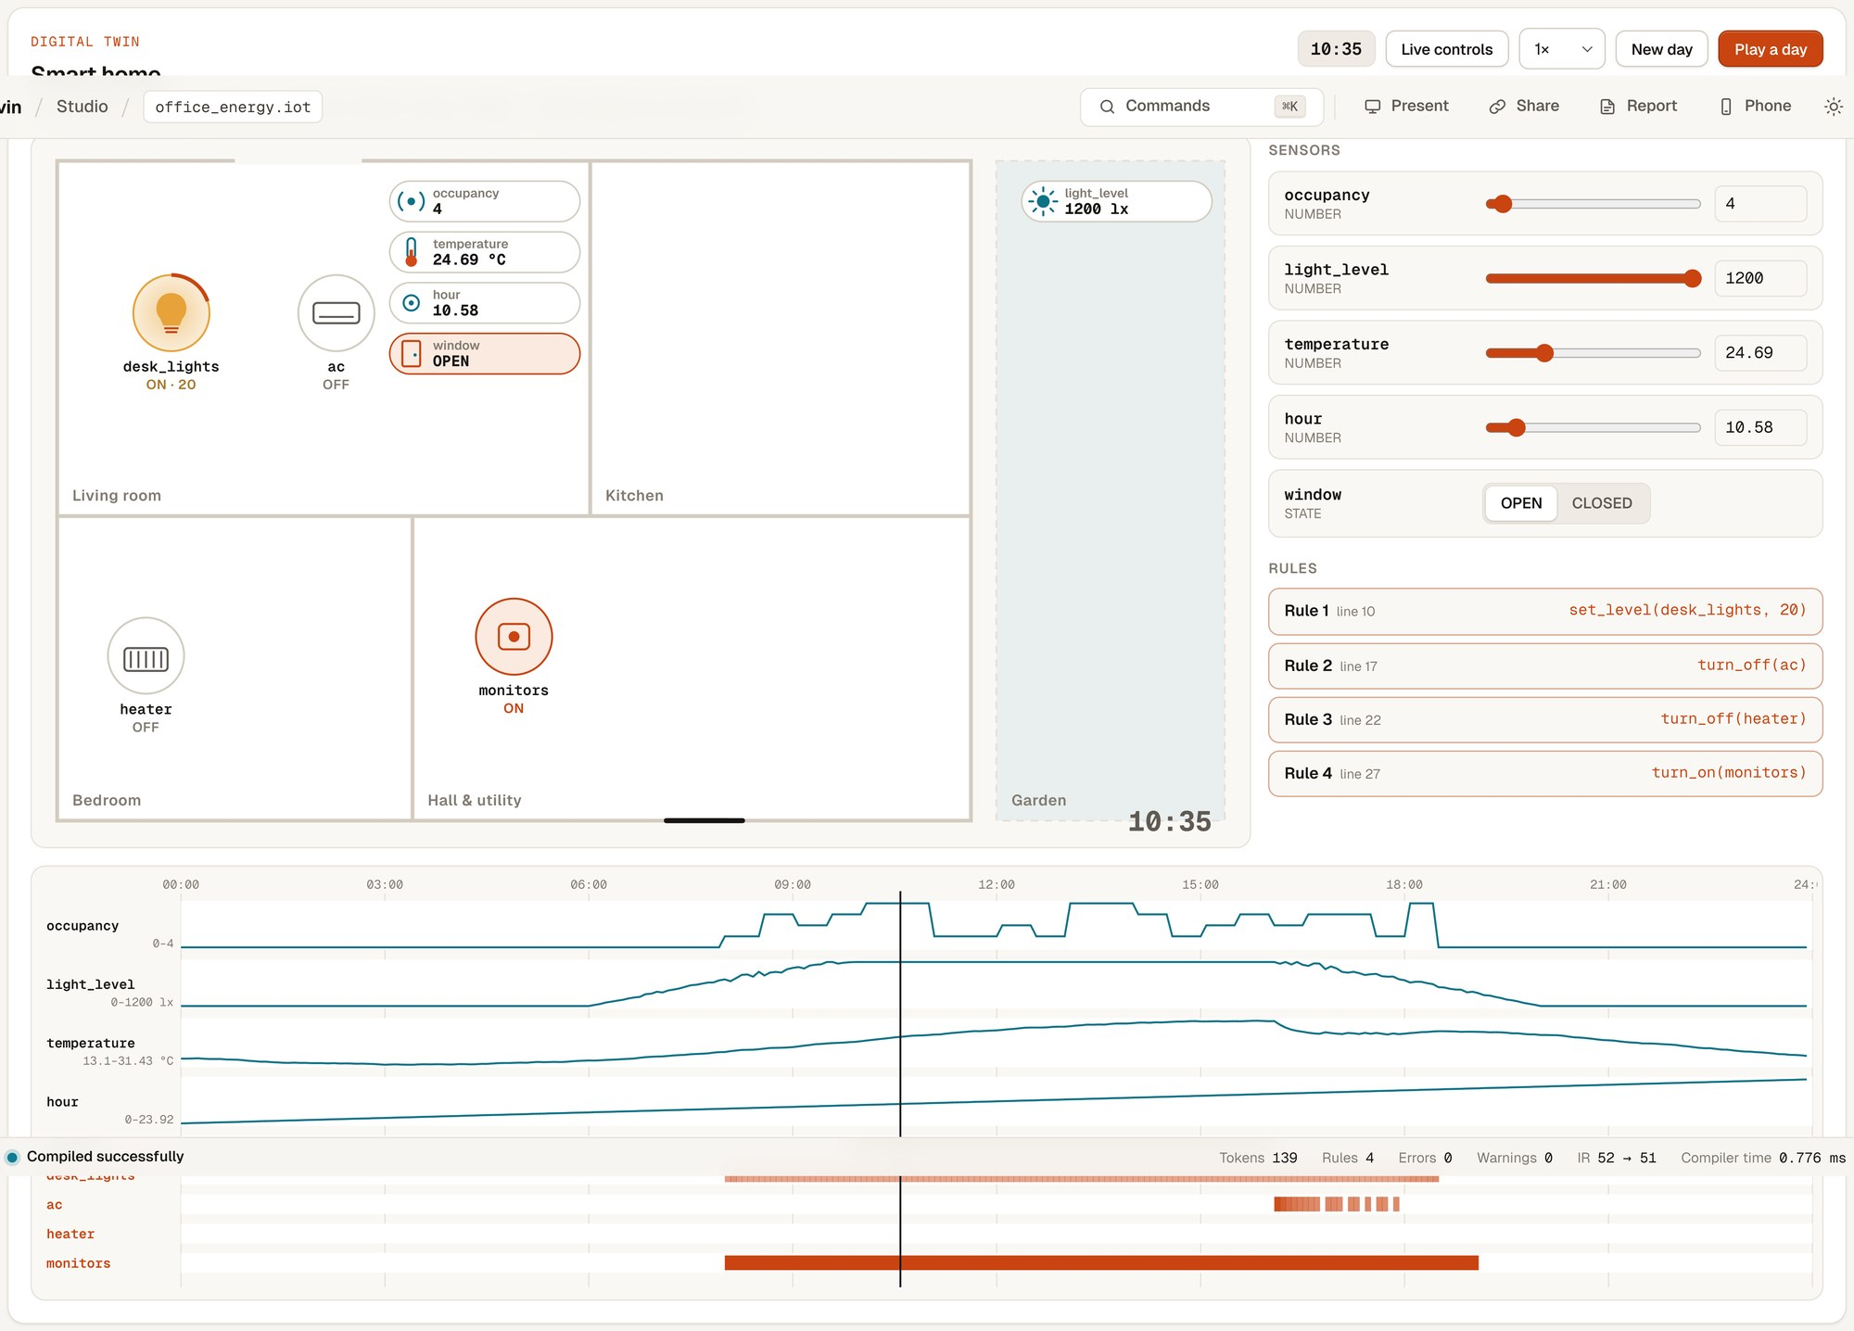
Figure 9: Digital twin running example 13 during a simulated day (10:55): lights dimmed by daylight, monitors on

4.5 Novelty
- Compiler-verified AI: language-model output is never trusted; it must compile, pass a meaning check and, if needed, survive one compiler-guided repair.
- Compile-time rule-conflict analysis with concrete example inputs, which ordinary compilers and trigger–action platforms do not provide.
- A self-verifying grammar: the compiler computes FIRST/FOLLOW and the LL(1) table of its own grammar and reports zero conflicts.
- One IR, four targets (C, Arduino, Python, JavaScript), with tests proving identical behaviour across targets.
- Explainable compilation: the Compiler X-ray replays the real lexer DFA, parser call stack and optimizer passes, and a digital twin runs the optimized IR.

4.6 Limitations
- The language has no timers, schedules, persistent variables or user-defined functions, so rules such as “turn off the light 10 minutes after motion stops” cannot be expressed.
- Rule analysis is exact for comparisons against constants but treats arithmetic between sensors conservatively, so some conflicts involving expressions such as temperature - outside > 5 are not reported.
- The Arduino target generates stub sensor reads that must be connected to real pins; it has been compiled against a stub header but not deployed on hardware.
- Small local language models are slow on a laptop (several seconds per sentence) and can misread complex sentences; the meaning check catches missing numbers and unused sensors but not every misinterpretation.
- The digital twin uses simplified physics and is meant for demonstration, not for engineering-grade simulation.

5. Conclusion and Future Work
This project delivered a complete, working AI-assisted compiler for an IoT automation DSL. All seven phases are implemented by hand in C++17: a DFA lexer, an LL(1) recursive-descent parser with error recovery, an AST with source spans, semantic analysis with satisfiability-based rule analysis, three-address IR, a CFG-based optimizer driven by liveness and available-expressions analysis, and a retargetable back end for four languages. Natural-language rules are drafted by free language models but accepted only after the compiler verifies them. The implementation is supported by 145 passing automated tests, compiles realistic programs in well under a millisecond, and is demonstrated through a web studio, a compiler X-ray and a smart-home digital twin.
Future work.
- Add timers, schedules and state that persists between evaluations, with matching analyses for timing conflicts.
- Extend rule analysis to linear arithmetic between sensors using an SMT solver, and move the IR to SSA form [10].
- Deploy the Arduino/ESP32 output on real hardware with MQTT integration, and add a Home Assistant target.
- Use grammar-constrained decoding [29] so the language model can only produce syntactically valid DSL, and evaluate conversion accuracy on a larger set of English rules.
- Conduct a user study with non-programmers, following the methodology of [15] and [18].

References
[1] A. V. Aho, M. S. Lam, R. Sethi, and J. D. Ullman, Compilers: Principles, Techniques, and Tools, 2nd ed. Boston, MA, USA: Addison-Wesley, 2006.
[2] K. D. Cooper and L. Torczon, Engineering a Compiler, 2nd ed. Burlington, MA, USA: Morgan Kaufmann, 2011.
[3] A. W. Appel, Modern Compiler Implementation in C. Cambridge, U.K.: Cambridge University Press, 1998.
[4] S. S. Muchnick, Advanced Compiler Design and Implementation. San Francisco, CA, USA: Morgan Kaufmann, 1997.
[5] D. E. Knuth, “On the translation of languages from left to right,” Information and Control, vol. 8, no. 6, pp. 607–639, 1965.
[6] T. J. Parr and R. W. Quong, “ANTLR: A predicated-LL(k) parser generator,” Software: Practice and Experience, vol. 25, no. 7, pp. 789–810, 1995.
[7] T. Parr and K. Fisher, “LL(): The foundation of the ANTLR parser generator,” in Proc. 32nd ACM SIGPLAN Conf. Programming Language Design and Implementation (PLDI)*, 2011, pp. 425–436.
[8] F. E. Allen, “Control flow analysis,” ACM SIGPLAN Notices, vol. 5, no. 7, pp. 1–19, 1970.
[9] G. A. Kildall, “A unified approach to global program optimization,” in Proc. 1st ACM Symp. Principles of Programming Languages (POPL), 1973, pp. 194–206.
[10] R. Cytron, J. Ferrante, B. K. Rosen, M. N. Wegman, and F. K. Zadeck, “Efficiently computing static single assignment form and the control dependence graph,” ACM Trans. Programming Languages and Systems, vol. 13, no. 4, pp. 451–490, 1991.
[11] C. Lattner and V. Adve, “LLVM: A compilation framework for lifelong program analysis & transformation,” in Proc. Int. Symp. Code Generation and Optimization (CGO), 2004, pp. 75–86.
[12] M. Mernik, J. Heering, and A. M. Sloane, “When and how to develop domain-specific languages,” ACM Computing Surveys, vol. 37, no. 4, pp. 316–344, 2005.
[13] A. van Deursen, P. Klint, and J. Visser, “Domain-specific languages: An annotated bibliography,” ACM SIGPLAN Notices, vol. 35, no. 6, pp. 26–36, 2000.
[14] M. Fowler, Domain-Specific Languages. Upper Saddle River, NJ, USA: Addison-Wesley, 2010.
[15] B. Ur, E. McManus, M. Pak Yong Ho, and M. L. Littman, “Practical trigger-action programming in the smart home,” in Proc. SIGCHI Conf. Human Factors in Computing Systems (CHI), 2014, pp. 803–812.
[16] B. Ur, M. Pak Yong Ho, S. Brawner, J. Lee, S. Mennicken, N. Picard, D. Schulze, and M. L. Littman, “Trigger-action programming in the wild: An analysis of 200,000 IFTTT recipes,” in Proc. CHI Conf. Human Factors in Computing Systems, 2016, pp. 3227–3231.
[17] J. Huang and M. Cakmak, “Supporting mental model accuracy in trigger-action programming,” in Proc. ACM Int. Joint Conf. Pervasive and Ubiquitous Computing (UbiComp), 2015, pp. 215–225.
[18] W. Brackenbury, A. Deora, J. Ritchey, J. Vallee, W. He, G. Wang, M. L. Littman, and B. Ur, “How users interpret bugs in trigger-action programming,” in Proc. CHI Conf. Human Factors in Computing Systems, 2019, pp. 1–12.
[19] Z. B. Celik, P. McDaniel, and G. Tan, “Soteria: Automated IoT safety and security analysis,” in Proc. USENIX Annual Technical Conf. (ATC), 2018, pp. 147–158.
[20] Z. B. Celik, G. Tan, and P. McDaniel, “IoTGuard: Dynamic enforcement of security and safety policy in commodity IoT,” in Proc. Network and Distributed System Security Symp. (NDSS), 2019.
[21] W. Ding and H. Hu, “On the safety of IoT device physical interaction control,” in Proc. ACM SIGSAC Conf. Computer and Communications Security (CCS), 2018, pp. 832–846.
[22] Q. Wang, P. Datta, W. Yang, S. Liu, A. Bates, and C. A. Gunter, “Charting the attack surface of trigger-action IoT platforms,” in Proc. ACM SIGSAC Conf. Computer and Communications Security (CCS), 2019, pp. 1439–1453.
[23] A. Desai, S. Gulwani, V. Hingorani, N. Jain, A. Karkare, M. Marron, S. R, and S. Roy, “Program synthesis using natural language,” in Proc. 38th Int. Conf. Software Engineering (ICSE), 2016, pp. 345–356.
[24] X. V. Lin, C. Wang, L. Zettlemoyer, and M. D. Ernst, “NL2Bash: A corpus and semantic parser for natural language interface to the Linux operating system,” in Proc. 11th Int. Conf. Language Resources and Evaluation (LREC), 2018.
[25] P. Yin and G. Neubig, “A syntactic neural model for general-purpose code generation,” in Proc. 55th Annual Meeting of the Association for Computational Linguistics (ACL), 2017, pp. 440–450.
[26] T. B. Brown et al., “Language models are few-shot learners,” in Advances in Neural Information Processing Systems (NeurIPS), vol. 33, 2020, pp. 1877–1901.
[27] M. Chen et al., “Evaluating large language models trained on code,” arXiv preprint arXiv:2107.03374, 2021.
[28] J. Austin et al., “Program synthesis with large language models,” arXiv preprint arXiv:2108.07732, 2021.
[29] G. Poesia, O. Polozov, V. Le, A. Tiwari, G. Soares, C. Meek, and S. Gulwani, “Synchromesh: Reliable code generation from pre-trained language models,” in Proc. Int. Conf. Learning Representations (ICLR), 2022.
[30] A. Yang et al., “Qwen3 technical report,” arXiv preprint arXiv:2505.09388, 2025.

