Date: 11.08.2026
Domain: RL-Based Autonomous Intersection Navigation for Advanced Driver Assistance Systems (ADAS)
- Project Type: Simulation-based Reinforcement Learning
Simulation Platform: MetaDrive
Primary Focus: Dynamic intersection navigation, safety, decision-making, collision avoidance
- Objectives
The main objective of this project is to develop a Reinforcement Learning-based autonomous navigation system capable of making safe and intelligent driving decisions at road intersections.
Specific objectives
- Develop a simulation-based ADAS environment for autonomous vehicle research.
- Model dynamic and interactive intersection scenarios involving multiple road users.
- Integrate vehicle-state and simulated perception sensors such as camera and LiDAR.
- Construct an observation space suitable for Reinforcement Learning.
- Develop a reward function that encourages:
  - Collision avoidance
  - Lane adherence
- Train an RL agent to make steering/throttle/braking decisions.
- Evaluate the trained agent under randomized traffic and intersection scenarios.

- Measure safety and driving performance using quantitative metrics such as:
  - Collision rate
  - Route completion
  - Average speed
  - Time to complete intersection
- Current implementation boundary:
The development of the project is completed upto 4 stages:
Project
↓
MetaDrive
↓
Simulator Interface
↓
MetaDrive Adapter
↓
MetaDrive Environment Initialization
The sensor → RL → training → evaluation portion is the next development stage
- Dataset
For this project, the INTERACTION Dataset is a particularly relevant reference dataset because the project focuses on interactive intersection navigation.
The dataset contains naturalistic trajectories of traffic participants in highly interactive driving scenarios. It includes scenarios such as:
- Signalized intersections
- Unsignalized intersections
- Roundabouts
- Merging
- Lane changing
It also provides HD semantic maps and vehicle/pedestrian trajectory files.
This makes it useful for:
- Scenario analysis
- Traffic behavior modeling
- Reinforcement Learning research
- Decision-making
- Planning verification
- Driving scenario generation
The dataset's official website specifically lists reinforcement learning, decision-making/planning, and scenario generation among its intended applications.
Download / Access
Official dataset:
INTERACTION Dataset — Official Website
Dataset details and format:
INTERACTION Dataset — Details & Format

The architecture is:
Real-world INTERACTION Dataset
│
▼
Scenario / Behavior Analysis
│
▼
Scenario Design
│
▼
MetaDrive
│
▼
Synthetic Dynamic Training
│
▼
RL Agent
This is a strong approach because we can use real-world trajectory information to make the simulated scenarios more realistic, while MetaDrive provides the environment in which the RL agent can actually interact and learn.

5.Workflow of the Project:
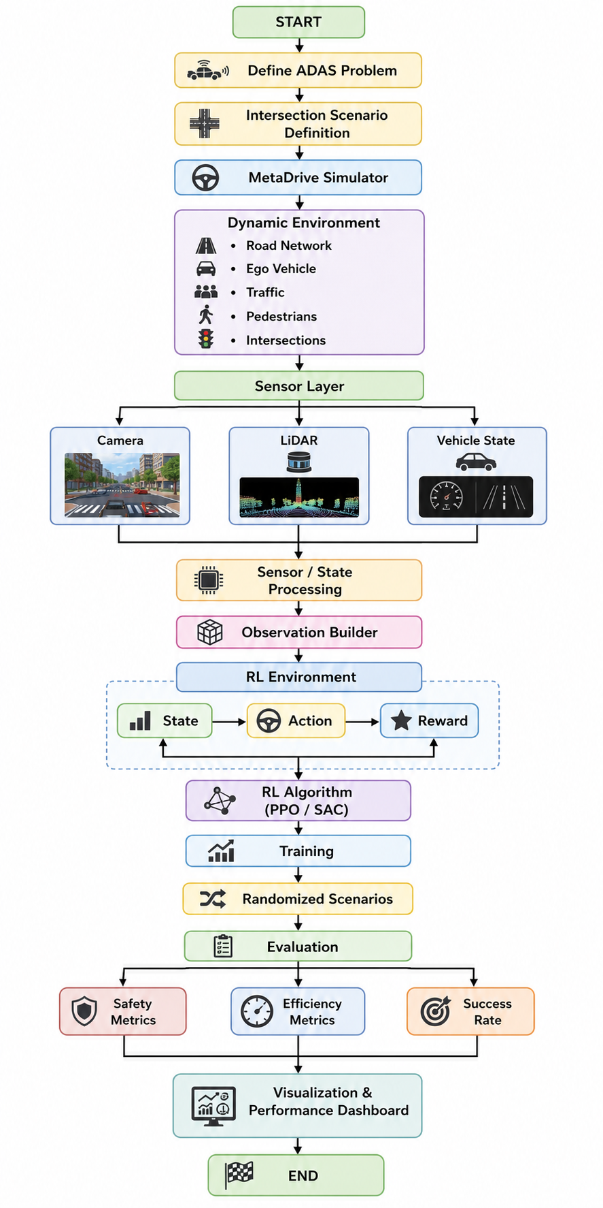
6. Methodology Overview
The complete methodology can therefore be summarized as:
INTERACTION Dataset
│
▼
Scenario / Behavior Analysis
│
▼
MetaDrive Simulation
│
▼
Dynamic Traffic Scenarios
│
▼
Sensor + Vehicle-State Data
│
▼
Observation Processing
│
▼
RL Environment
│
▼
Training
│
▼
Randomized Evaluation
│
▼
Safety + Performance Metrics
│
▼
ADAS Intersection Navigation Policy
Current Progress: The project foundation, Python environments, simulator abstraction, MetaDrive integration, and simulator initialization have been completed. Sensor integration, RL environment construction, agent training, dynamic scenario generation, and quantitative evaluation are the subsequent development stages.

Team Members Name Roll Number
- N.Karthik 2420030511
- V.Sanjay 2420030385
- Ch.Srikar Reddy 2420030509

