Link - https://leetcode.com/problems/set-matrix-zeroes/description/

Given an m x n integer matrix matrix, if an element is 0, set its entire row and column to 0's.

You must do it in place.

Example 1:
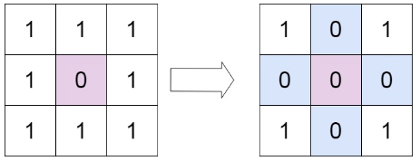

Input: matrix = [[1,1,1],[1,0,1],[1,1,1]]
Output: [[1,0,1],[0,0,0],[1,0,1]]

Example 2:
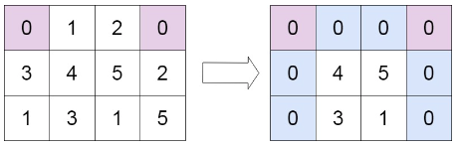

Input: matrix = [[0,1,2,0],[3,4,5,2],[1,3,1,5]]
Output: [[0,0,0,0],[0,4,5,0],[0,3,1,0]]
Constraints:
- m == matrix.length
- n == matrix[0].length
- 1 <= m, n <= 200
- -2³¹ <= matrix[i][j] <= 2³¹ – 1
Follow up:
- A straightforward solution using O(mn) space is probably a bad idea.
- A simple improvement uses O(m + n) space, but still not the best solution.
- Could you devise a constant space solution?

