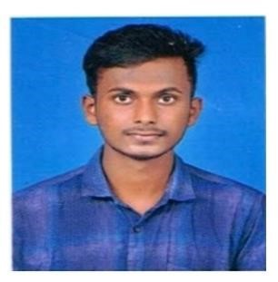 **SANJAY G**

**E-Mail Id**: sanjaysanjay2407@gmail.com

**Mobile Number:** 9751600684

**Address:**  3/9 Mariyyamkovil Street,

Ranganathapuram,

Agarakottalam (PO),

Sankarapuram (TK),

Kallakurichi (DT), 606213.

**Career Objective:**

To enhance myself with new technologies and will research on new technologies in a way which would be helpful for the upliftment of the company and also my professional growth.

**Academic Qualification:**

|  |  |  |  |  |
| --- | --- | --- | --- | --- |
| **Course** | **Name of Institution** | **University/**  **Board** | **Percentage/**  **CGPA** | **Year Of Completion** |
| B.E -  (EEE) | Muthayammal  Engineering College (Autonomous) Rasipuram. | Anna University | 7.70  (pursuing) | 2022  (pursuing) |
| D.EEE | Muthayammal  Polytechnic Institution Rasipuram. | DOTE | 81% | 2019 |
| SSLC | AKT Matric  Higher Secondary  School  Kallakurichi. | State Board | 59% | 2016 |

**Projects:**

**1. Automatic Water controller by using Arduino**

* The main objective of this is project is to save water and to save power
* It instructs the consumer to know about the current water level
* The motor pump automatically turned on when the tank is empty➢ It displays the water level and function of motor on a lcd display **Professional Proficiency:**

**Certified Course**

* I had completed PCB design course And JAVA Full Stack Developer

**Workshop**

* I had attended “Automation using Arduino with IOT” in Muthayammal Engineering College **Paper Presentation**
* I had presented NANO LEAVES and its application” in Erode Sengunthar Engineering College

**Programming Language**

* JAVA Full Stack Developer

**Internships**

* I had completed “Smart solutions using Arduino” in Tagore College of Engineering and Technology

**Sports Achievements**

* DISTRICT LEVEL Competition in Hockey 1st Place,
* STATE LEVEL Competition in Hockey Participation, ➢ DIVISION LEVEL Competition in Hockey 2nd Place, ➢ ZONE LEVEL Competition in Hockey 3rd Place.

**Personal Proficiency:**

* Quick Learner
* Adaptability
* Leadership Skills

**Personal Dossier:**

**Date Of Birth :** 24/07/2001

**Father’s Name :** Mr. Govindasamy P

**Mother’s Name :** Mrs. Selvamani G

**Languages Known :** Tamil, English (Read-Write-Speak)

Telugu (Speak). **Blood Group :** A +ve.

**Declaration:**

I hereby declare that all the details furnished above are true to the best of my Knowledge.

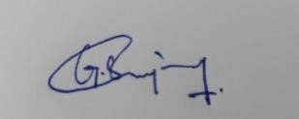

DATE: (SANJAY G)

PLACE: Rasipuram