Atlanta Population

1. use db.zipcodes.find() to filter results to only the results where city is ATLANTA and state is GA.

2. use db.zipcodes.aggregate with $match to do the same as above.

3. use $group to count the number of zip codes in Atlanta.

4. use $group to find the total population in Atlanta.

Q1

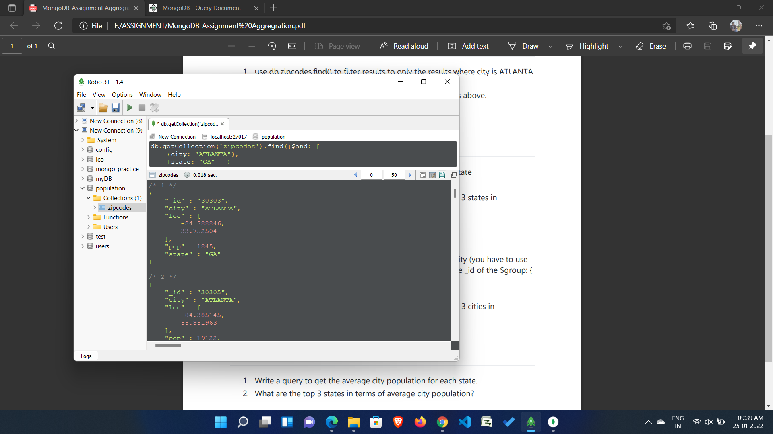

Q2

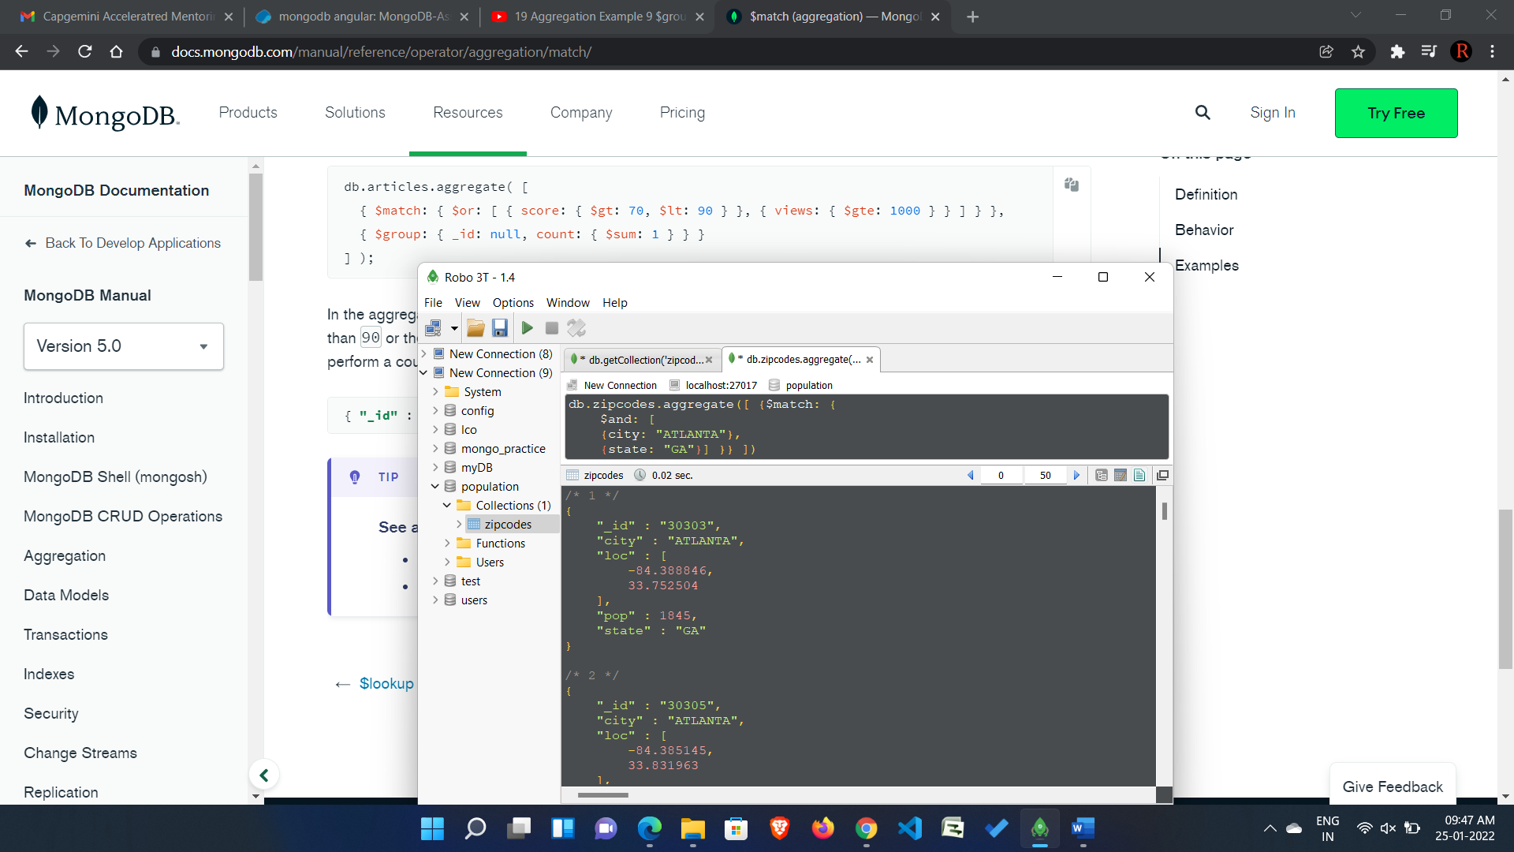

Q3

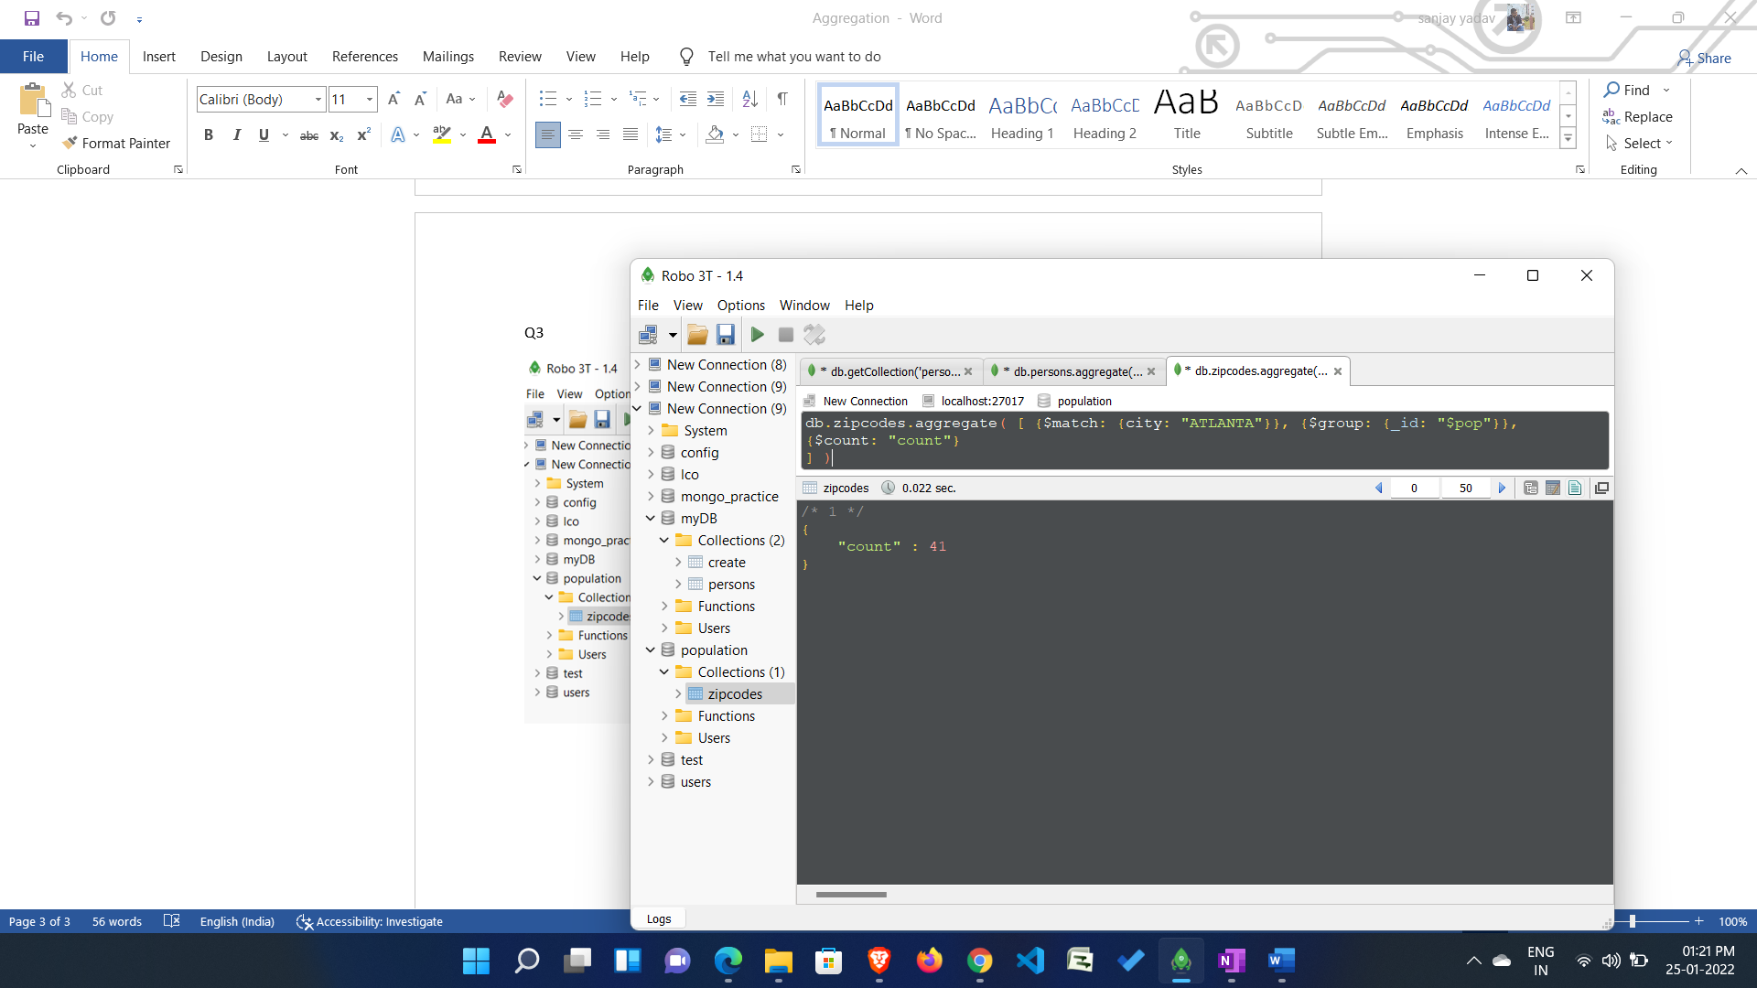

db.zipcodes.aggregate( [ {$match: {city: "ATLANTA"}}, {$group: {_id: "$pop"}},

{$count: "count"}

] )

Q4

db.zipcodes.aggregate([

{$match: {city: "ATLANTA"}},

{$group: {

_id: "$pop",

totalPop: {$sum: "$pop"}

} }

])

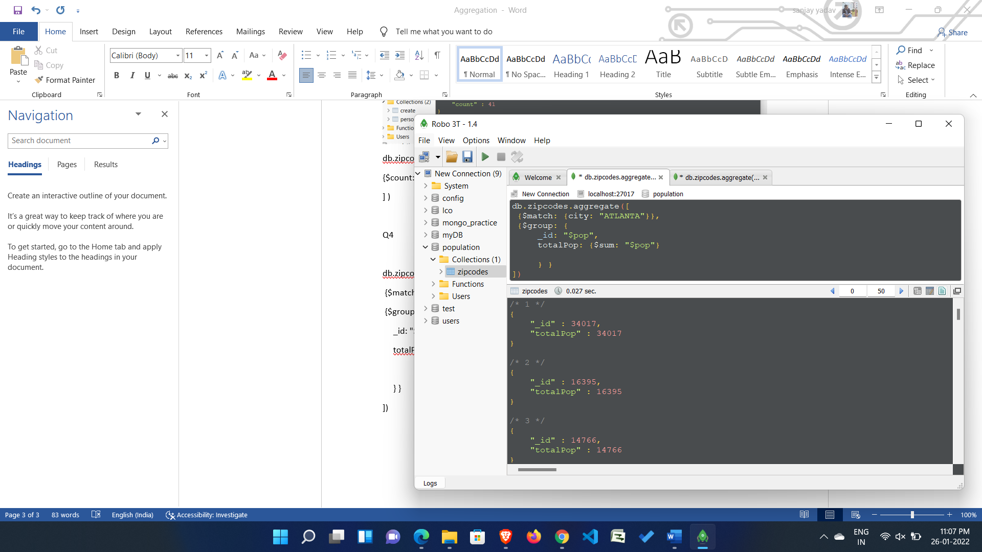

Populations By State 1. use aggregate to calculate the total population for each state 2. sort the results by population, highest first 3. limit the results to just the first 3 results. What are the top 3 states in population?

Q1

db.zipcodes.aggregate([

{ $group: {

_id: { state: "$state", pop:"$pop" },

} },

{$sort: {"_id.state": 1}},

//{$group: {_id: "$_id.state"}, totalPop: {$sum: "$_id.pop"}}

{

$group: {

_id: "$_id.state",

totPop: {$sum: "$_id.pop"}

}

}

]);

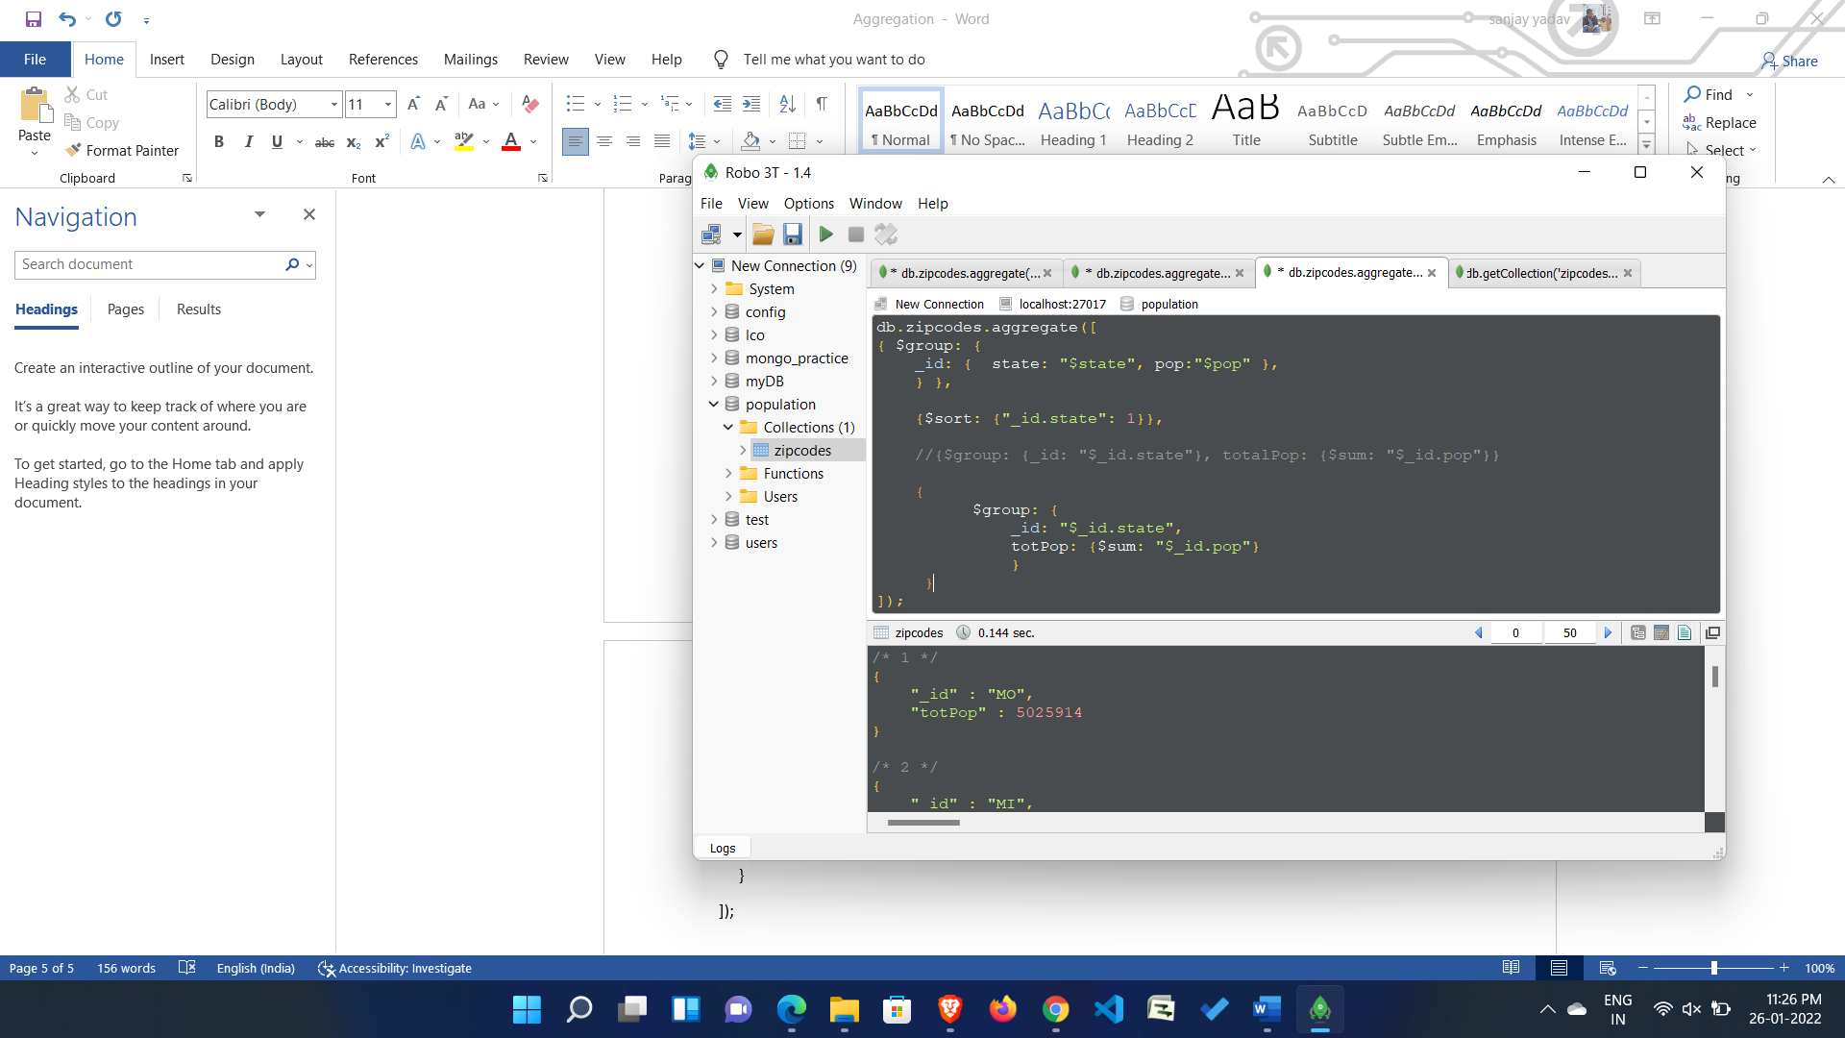

Q2

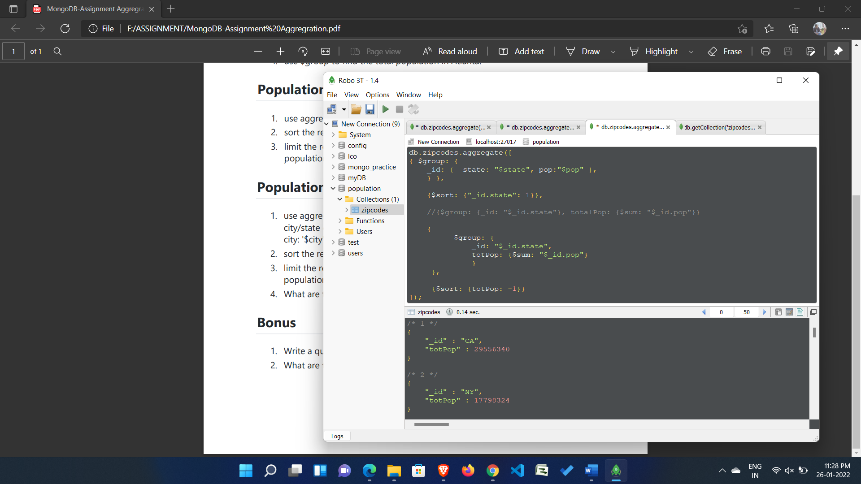

Q3

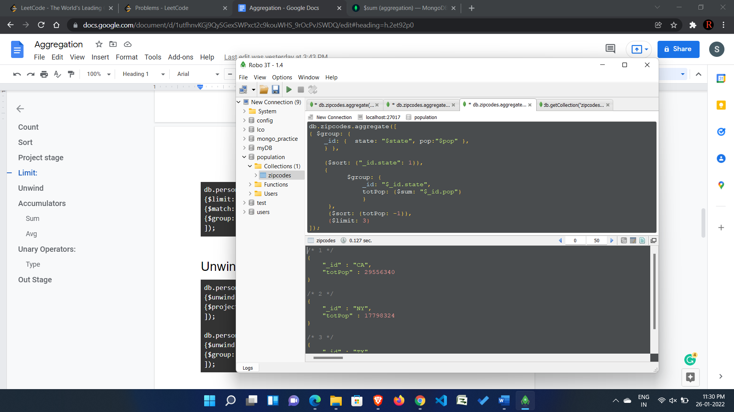

Populations by City 1. use aggregate to calculate the total population for each city (you have to use city/state combination). You can use a combination for the _id of the $group: { city: '$city', state: '$state' } 2. sort the results by population, highest first 3. limit the results to just the first 3 results. What are the top 3 cities in population? 4. What are the top 3 cities in population in Texas?

