About Google:

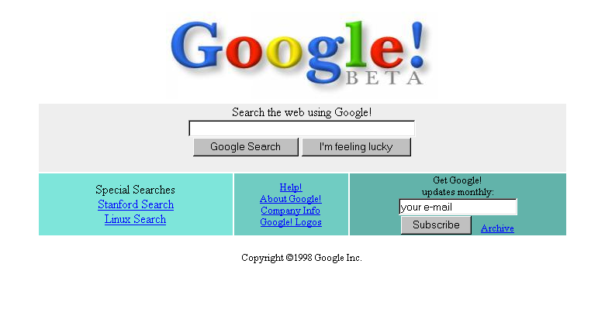

**How Google Start:-  
(1990)**

1. [Google](https://en.wikipedia.org/wiki/Google) began in March 1995 as a research project by [Larry Page](https://en.wikipedia.org/wiki/Larry_Page) and [Sergey Brin](https://en.wikipedia.org/wiki/Sergey_Brin), Ph.D. students at [Stanford University](https://en.wikipedia.org/wiki/Stanford_University)
2. In his research project, nicknamed "BackRub"
3. Page's [web crawler](https://en.wikipedia.org/wiki/Web_crawler) began exploring the web in March 1996, with Page's own Stanford home page serving as the only starting point.[[3]](https://en.wikipedia.org/wiki/History_of_Google#cite_note-wiredbirth-3) To convert the backlink data that it gathered for a given web page into a measure of importance
4. Brin and Page developed the [PageRank](https://en.wikipedia.org/wiki/PageRank" \o "PageRank) algorithm.[[3]](https://en.wikipedia.org/wiki/History_of_Google#cite_note-wiredbirth-3) While analyzing BackRub's output—which, for a given URL, consisted of a list of backlinks ranked by importance—the pair realized that a search engine based on PageRank would produce better results than existing techniques (existing search engines at the time essentially ranked results according to how many times the search term appeared on a page).
5. A small search engine called "[RankDex](https://en.wikipedia.org/wiki/RankDex" \o "RankDex)" from IDD Information Services (a subsidiary of [Dow Jones](https://en.wikipedia.org/wiki/Dow_Jones_%26_Company)) designed by [Robin Li](https://en.wikipedia.org/wiki/Robin_Li) was, since 1996, already exploring a similar strategy for site-scoring and page ranking.[[10]](https://en.wikipedia.org/wiki/History_of_Google#cite_note-10) The technology in RankDex was patented[[11]](https://en.wikipedia.org/wiki/History_of_Google" \l "cite_note-11) and used later when Li founded [Baidu](https://en.wikipedia.org/wiki/Baidu" \o "Baidu) in China.
6. Originally the search engine used Stanford's website with the domain *google.stanford.edu*The domain *google.com* was registered on September 15, 1997. They formally incorporated their company, *Google*, on September 4, 1998 at a friend's ([Susan Wojcicki](https://en.wikipedia.org/wiki/Susan_Wojcicki)) garage in [Menlo Park, California](https://en.wikipedia.org/wiki/Menlo_Park,_California).  
   The first patent filed under the name "Google Inc." was filed on August 31, 1999.
7. Both Brin and Page had been against using advertising pop-ups in a search engine, or an "advertising funded search engines" model, and they wrote a research paper in 1998 on the topic while still students. They changed their minds early on and allowed simple text ads.
8. By the end of 1998, Google had an index of about 60 million pages. The home page was still marked "[BETA](https://en.wikipedia.org/wiki/Beta_test)"

**2000**

1. The Google search engine attracted a loyal following among the growing number of Internet users, who liked its simple design.[[22]](https://en.wikipedia.org/wiki/History_of_Google#cite_note-simpledesign-22) In 2000, Google began selling [advertisements](https://en.wikipedia.org/wiki/Advertising" \o "Advertising)associated with search [keywords](https://en.wikipedia.org/wiki/Keyword_(internet_search)).[[2]](https://en.wikipedia.org/wiki/History_of_Google#cite_note-milestones-2) The ads were text-based to maintain an uncluttered page design and to maximize page loading speed.
2. Google's declared [code of conduct](https://en.wikipedia.org/wiki/Code_of_conduct) is "[Don't be evil](https://en.wikipedia.org/wiki/Don%27t_be_evil)", a phrase which they went so far
3. The first funding for Google as a company was secured in August 1998 in the form of a US$100,000 contribution from [Andy Bechtolsheim](https://en.wikipedia.org/wiki/Andy_Bechtolsheim), co-founder of [Sun Microsystems](https://en.wikipedia.org/wiki/Sun_Microsystems)
4. Google has been ranked No.1 in Fortune's latest annual list of '100 Best Companies to Work For.  
   Why:-
   1. Google is such a great workplace, is because the company believes that treating people well is more important than making a lot of money.
   2. 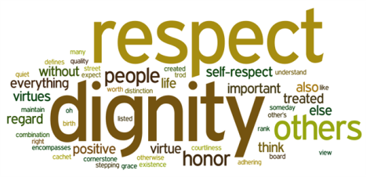  
       there is no magic formula or rocket science to it. It's all about treating people with respect, supporting their creative endeavors, and working hard to adhere to their motto of Don't be evil. And, its efforts are paying off.

* 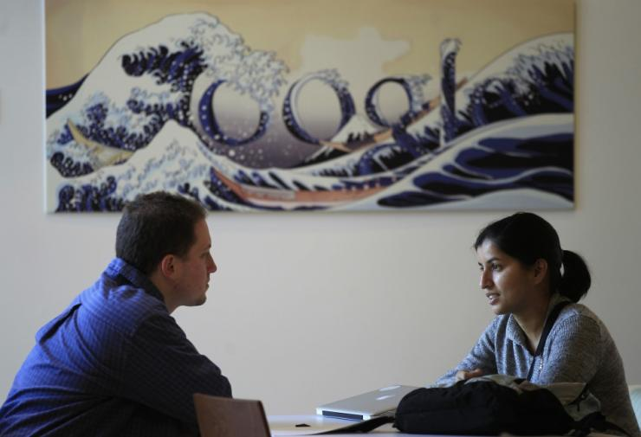  
  Google thinks of employees' ideas as very important. No wonder, there are many internal e-mail lists dedicated to the discussion of particular ideas, issues and complaints. For instance, on the "Google Ideas" Web site, Googlers regularly submit their thoughts on product improvements or provide suggestions about how to make things better around Google. These ideas are rated on a scale of 0 to 5 (Dangerous or harmful if implemented) to 5 (Great idea! Make it so) and the management pays close attention to them. Employee's suggestions and opinions are equally important to Google and they are a key-driver in the company's product development process. Generally, before a product is released in the market, the employees get to play around with it and provide feedback and suggestions to the product engineers and managers. Examples of products that have gone through this process include Google News, Gmail, Froogle, Google Local, Google Toolbar and Google+
*   
  Google offers a unique program called "The 20% project". This program for Google engineers, encourages them to dedicate 20% of their time on a project outside their typical work responsibilities that would potentially benefit the company. The project encourages innovation by allowing the engineers to spend time on Google-related projects that they wish to pursue in the future. By enabling employees to recharge their creative energies, Google provides a unique opportunity for employees to move into new areas of work while also broadening their knowledge base
* 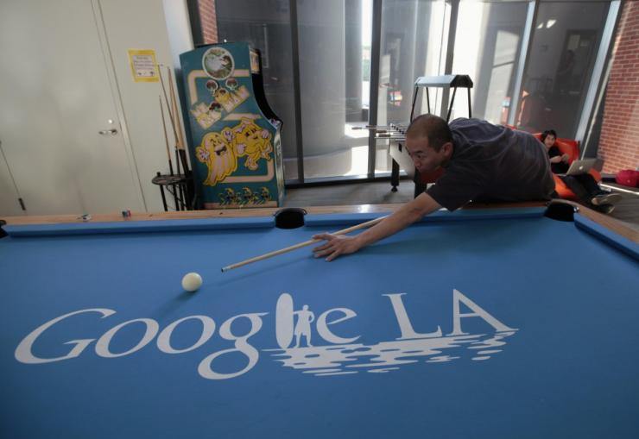  
  Google encourages its employees to speak out their mind and ask their leaders, even Google founders, questions through the TGIF get-together. TGIF is a weekly, company-wide get-together started by Google co-founders, Larry Page and Sergey Brin. Its main purpose is to break the ice between new employees and also is a platform for senior leaders to update others about Google and Google-related events that have transpired over the previous week. However, the most interesting part of TGIF is the Q&A session. In this session, any employee can ask any question to even the most senior members of the management team. No question is off-limits, no matter how outrageous they are. Questions from past sessions include, "What are Google's growth rate projections?" and "When is Google relocating to Mars?" The TGIF are webcast to Google offices around the globe and archived for those who cannot make it to the meeting.