Task 1:

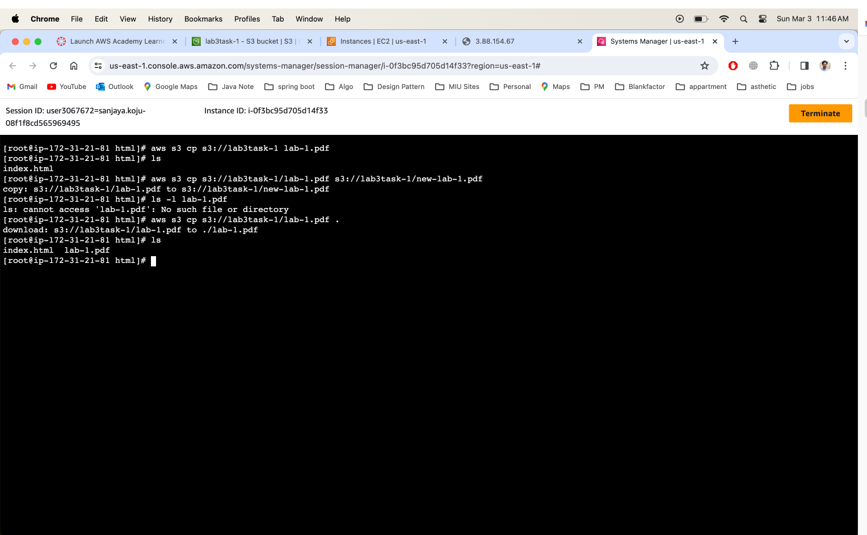

Task 2:

SNS: Policy

{

"Version": "2012-10-17",

"Id": "s3-object-topic",

"Statement": [

{

"Sid": "Statement1",

"Effect": "Allow",

"Principal": {

"Service": "s3.amazonaws.com"

},

"Action": "SNS:Publish",

"Resource": "arn:aws:sns:us-east-1:339712977636:s3-object-topic",

"Condition": {

"StringEquals": {

"AWS:SourceAccount": "339712977636"

},

"ArnLike": {

"Aws:SourceArn": "arn:aws:s3:::lab3task-1"

}

}

}

]

}

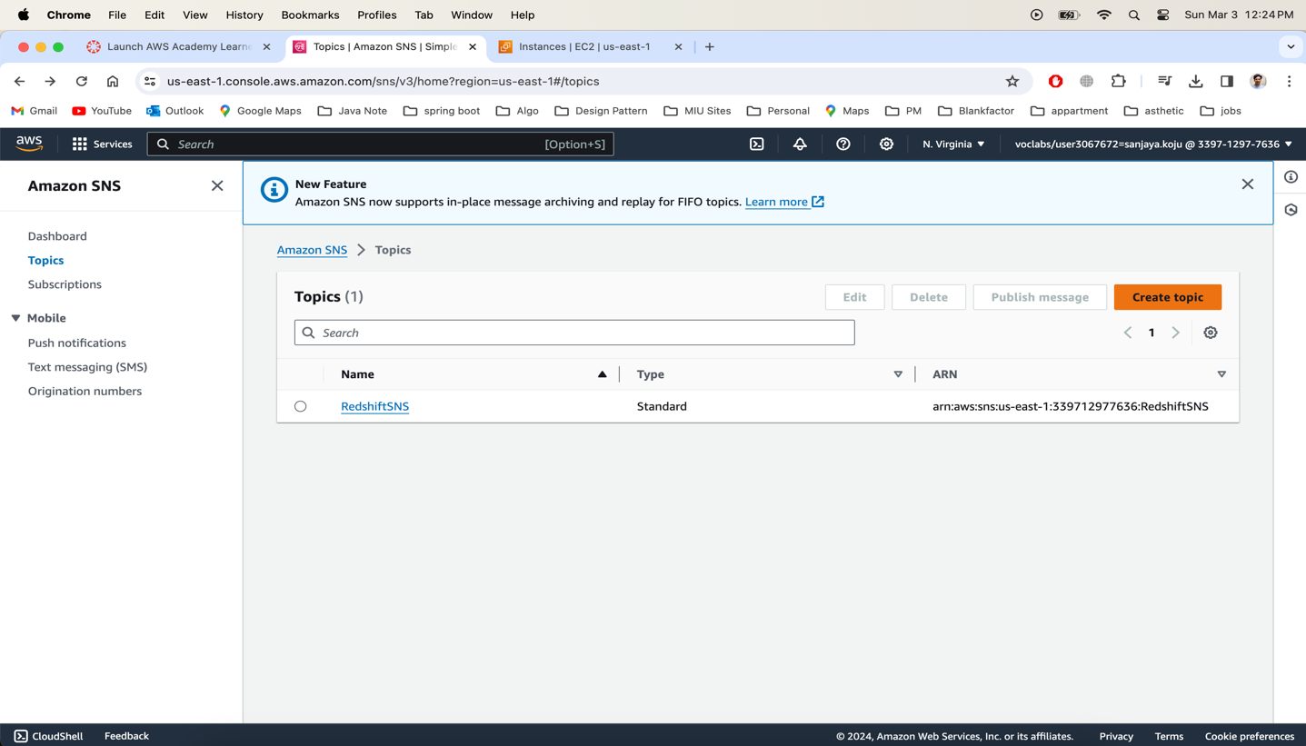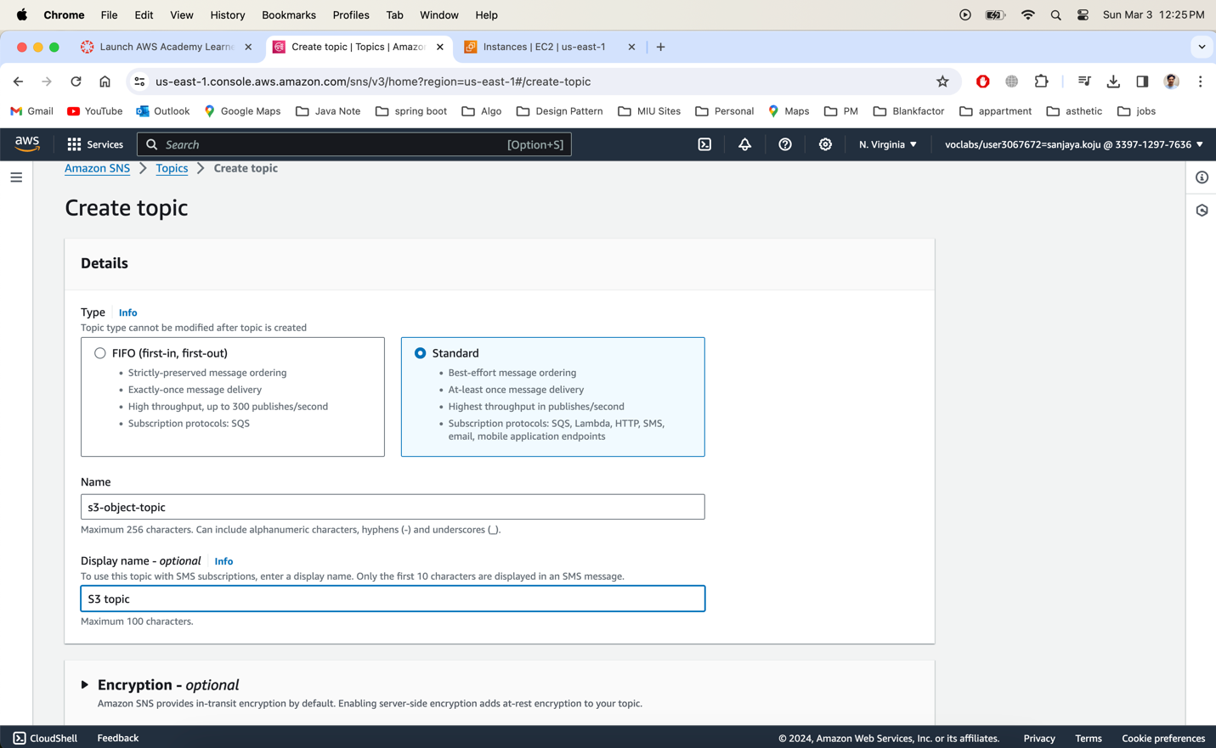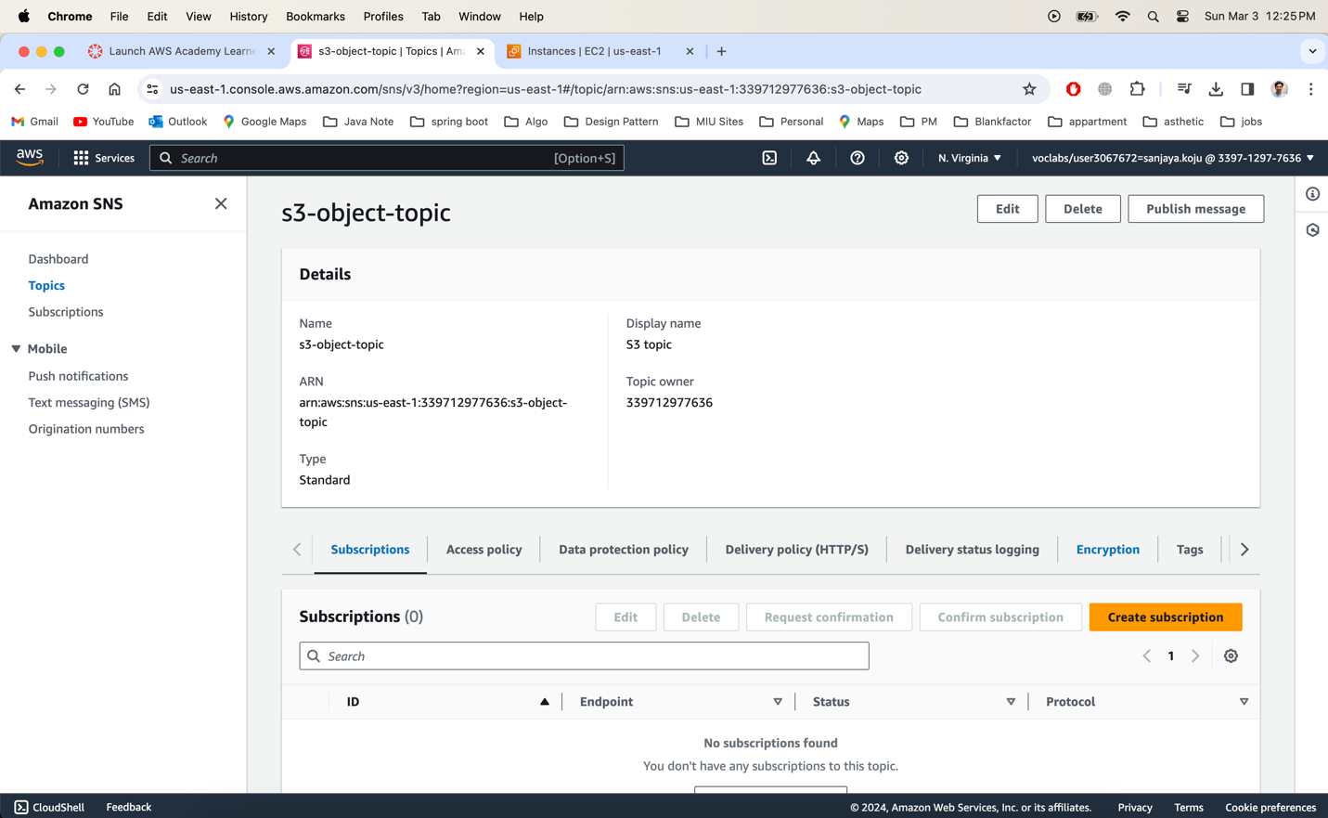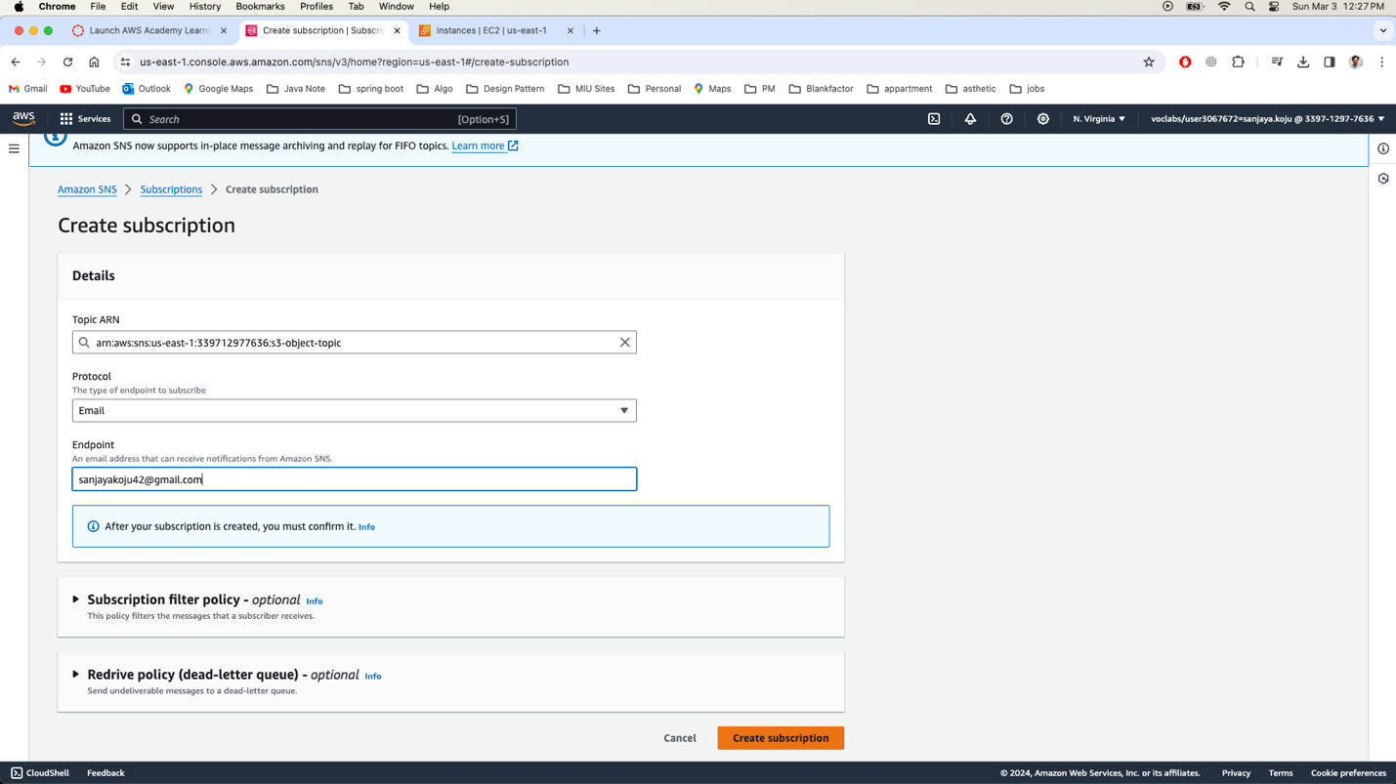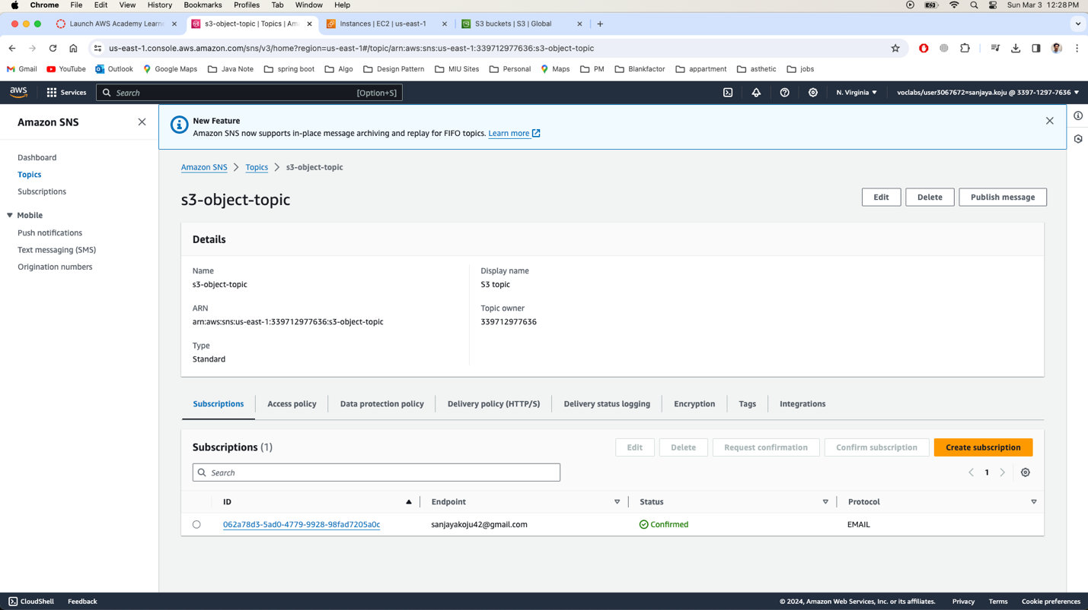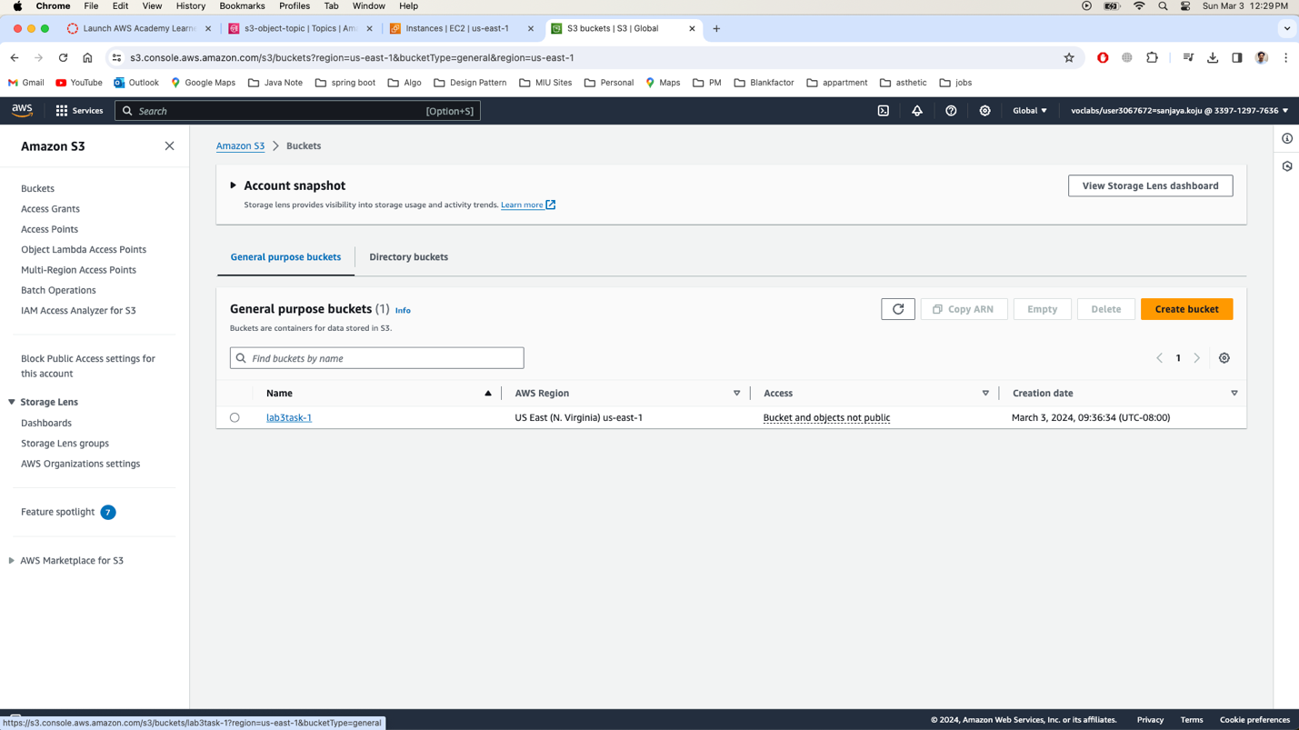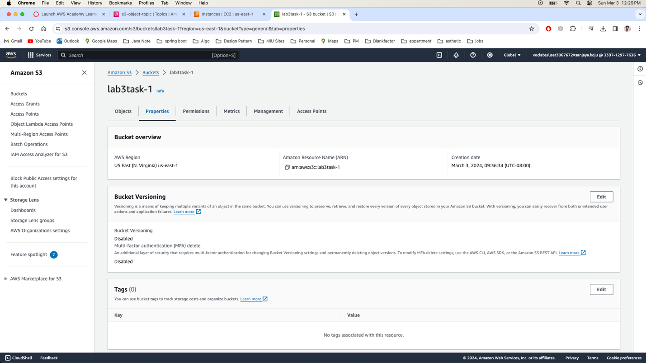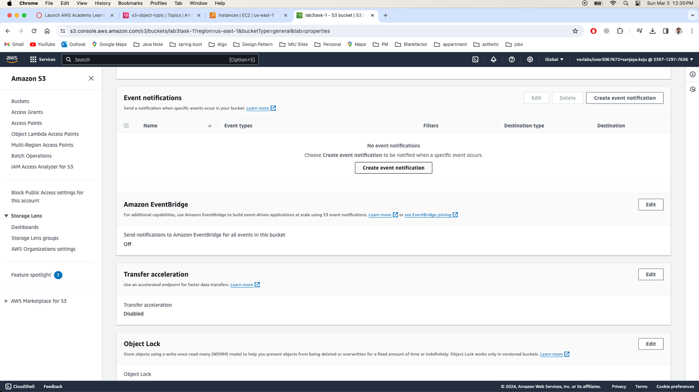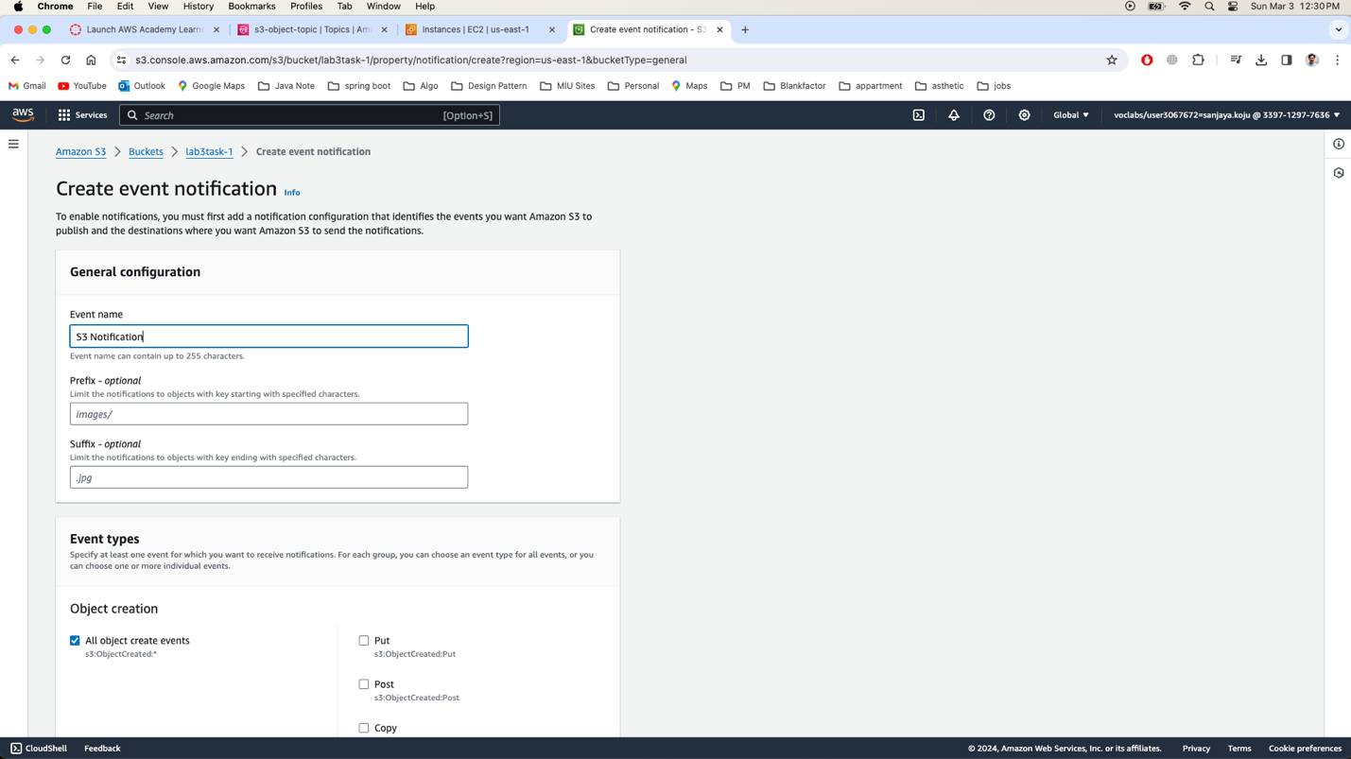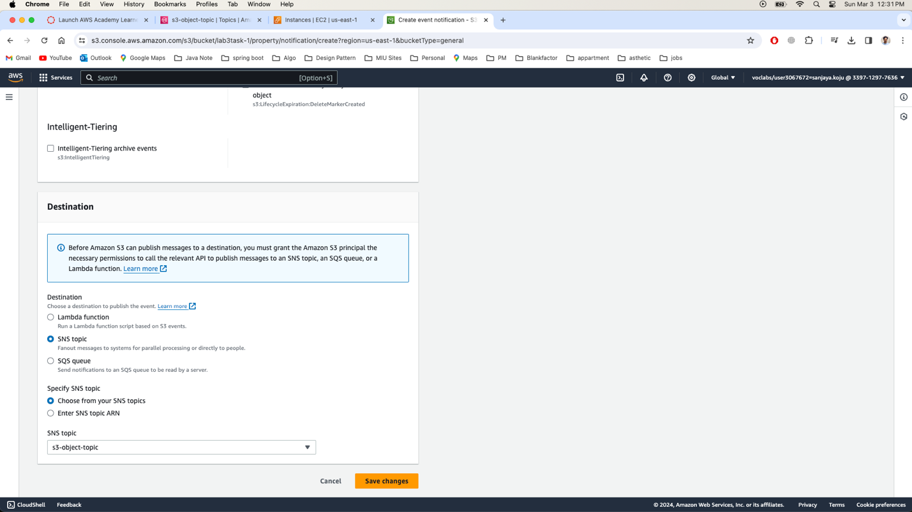

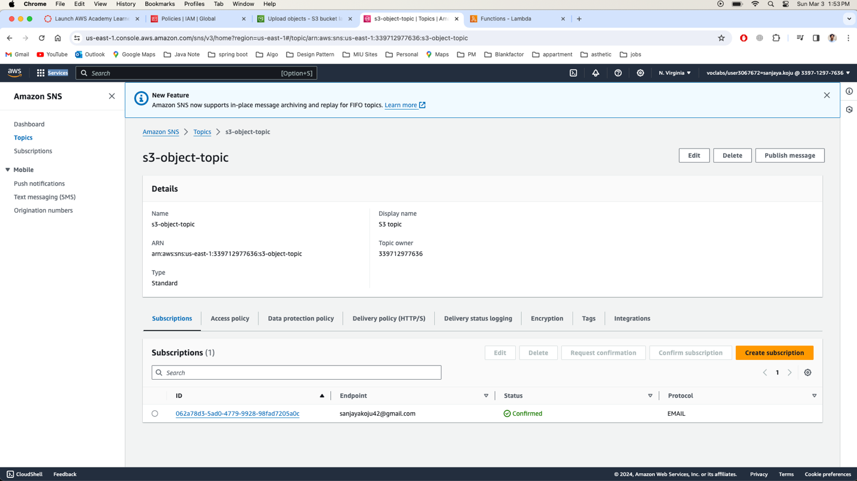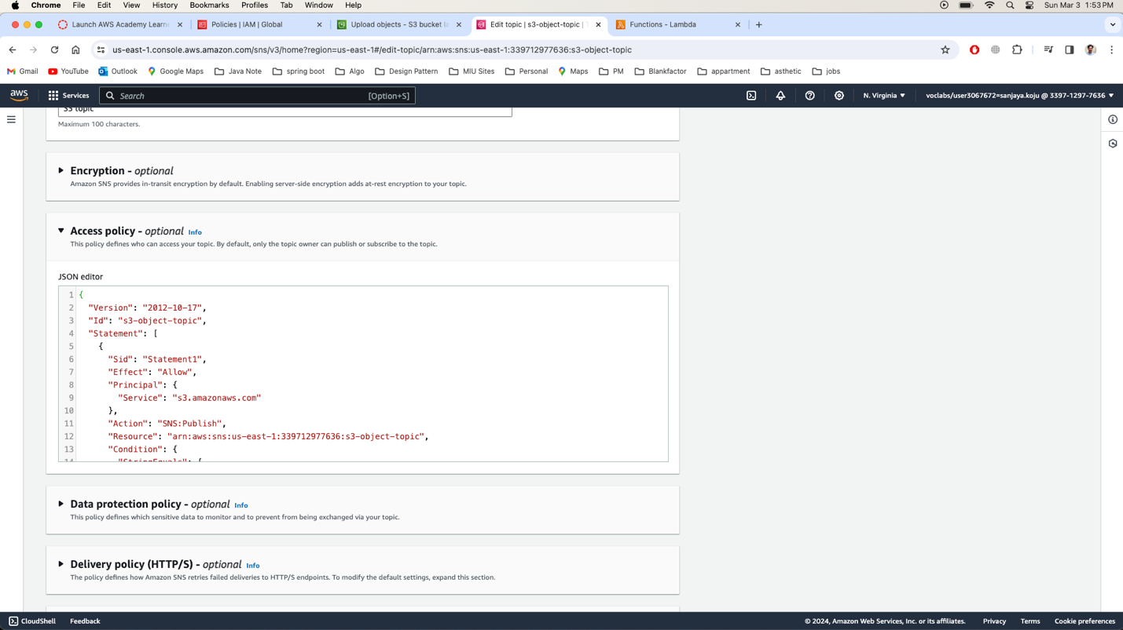

Task 3:

