**FPP Lesson-13 Setup and Usage Instructions for MySql**

**MySql Database System: Installation**.

1. From Sakai, go to Resources\DemoCode\lesson13. Download mysql-noinstall-5.1.63-win32.zip and copy it to the top level of either C drive or D drive into your manchine.
2. To install, unzip the zip archive into your C drive (or D drive). The result will be a directory in your C drive (or D drive) named mysql-noinstall-5.1.63-win32.
3. Change the name of the folder that was just created in C drive (or D drive) in the following way: Right click and rename it from mysql-noinstall-5.1.63-win32 to mysql.  
     
   IMPORTANT: In order for the scripts for the course to work properly, you *must* change the name of this directory in this way.

After this simple installation and name change, you should see a directory structure like this (if you installed on C drive):

C:

- mysql

bin

data

Docs

Embedded

include

lib

mysql-test

scripts

share

sql-bench

**MySql Database System:**  **Loading Data for the Course**.

1. In the Resources\DemoCode\lesson13\setup folder in Sakai, you will find zip files called c-drive and d-drive. If you installed mysql on C: drive, download   
   c-drive.zip; otherwise download d-drive.zip. (For this demo, I will assume you are using C drive).
2. Unzipping c-drive.zip, look inside c-drive folder and find a directory called *database_manage from* *c-drive\mysql_scripts*. This directory contains database scripts for the course. See the screenshot below for the better understanding.

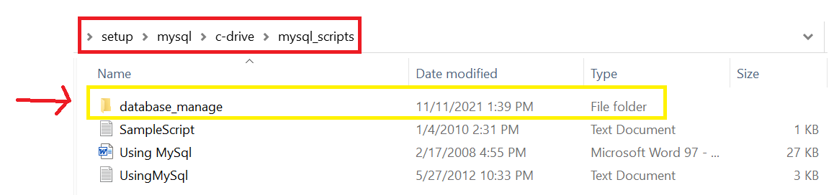  
  
*Copy the database_manage directory into your C:\mysql directory.* Scripts are designed to find the executables and utilities in the mysql package if you place database_manage at this top level within the mysql directory.

After copying, your directory structure should look something like this:

1. *Test the installation.* Inside mysql\database_manage, double click the startMySql.bat file. This should start the MySql DBMS server. A console window should come up that looks like the following:



1. *Load the data.* After your server has started, load the tables for this course.
   1. Double-click the file create fpp tables.bat in mysql\database_manage. This script loads two tables: Person and Address.
2. *Verifying the data.* The data for the course project has now been loaded. You can check that two databases have been added by running the MySql client:  
     
   Double-click mysql client.bat. At the prompt, type   
    show databases;

You should see something similar to the following  
  
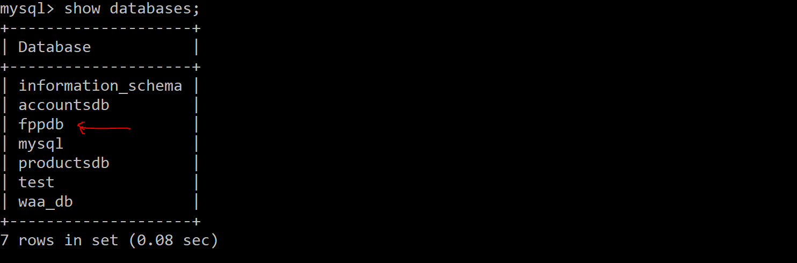

1. When you have finished work on the MySql server, stop it by double-clicking the file stopMySql.bat in mysql\database_manage.

**Note: By default, user name is *root* and password is the empty string (i.e. just blank).**

1. Go to your Eclipse IDE. Click File\Import.

Click Browse, just click "Select Folder", where you download the JdbcPractice project from lesson13.

After Importing the JdbcPractice project, You will see something red colored exclamatory symbol like this :

The red marking on JdbcPractice indicates that you need to add a jar file to that project – we do that next.

Right click on JdbcPractice project and select Properties. Pick Java Build Path. You will see:

Select Libraries. You will probably see my-sql-connector marked in red. Click the Edit button at the right

Then navigate to your jars folder in the DemoCode\lesson13 folder and select the mysql-connector-jar file that you see there.  
  
The red marking should disappear. Click Apply and Close. JdbcPractice project should be free of red marks.

