**JUnit Test in Java**

**// StringFunction.java with two methods**

**public** **class** StringFunction {

**public** String StringJoin(String str1, String str2)

{

**if** (str1.length() == 0 && str2.length()==0)

**return** "Empty";

**else**

**return** str1 + str2;

}

**public** **int** Multiply(**int** x, **int** y){

**return**(x * y);

}

}

**// RecSum.java**

**public** **class** RecSum {

**public** **static** **void** main(String[] args) {

// if your input is 5 ==> 1+2+3+4+5

Scanner in = **new** Scanner(System.***in***);

System.***out***.print("Type a Number: ");

**int** n = in.nextInt();

RecSum r1 = **new** RecSum();

System.***out***.println("Sum = " + r1.Sum(n));

}

**public** **int** Sum(**int** n)

{

**if** (n == 1) //base case

**return** 1;

**else**

**return** Sum(n-1) + n; //general case

}

}

// Test Case

**import** **static** org.junit.Assert.*;

**import** org.junit.Test;

**public** **class** StringFunctionTest {

@Test

**public** **void** test() {

StringFunction sf = **new** StringFunction();

String Ooutput = sf.StringJoin("Renuka", "Mohanraj");

String Eoutput = "RenukaMohanra";

*assertEquals*(Ooutput,Eoutput);

}

@Test

**public** **void** test2()

{

StringFunction sf = **new** StringFunction();

**int** ao =sf.Multiply(10, 20);

**int** eo = 200;

*assertEquals*(ao,eo);

}

@Test

**public** **void** test3(){

RecSum rs = **new** RecSum();

**int** eo = 10;

**int** op = rs.Sum(4);

*assertEquals*(eo,op);

}

}

**To run the above code follow to perform JUnit test follow the steps given below**

Step 1:

Right click on the your project ->Properties

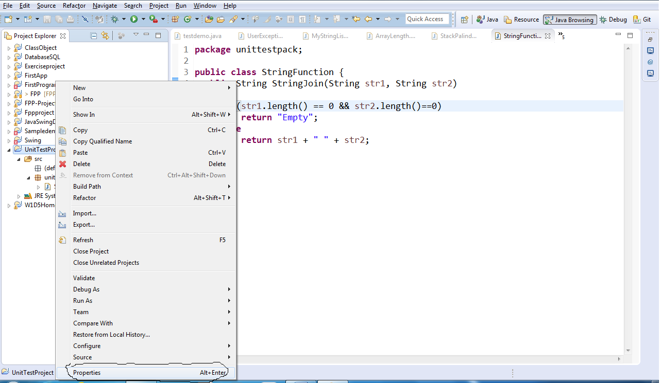

Step 2 :

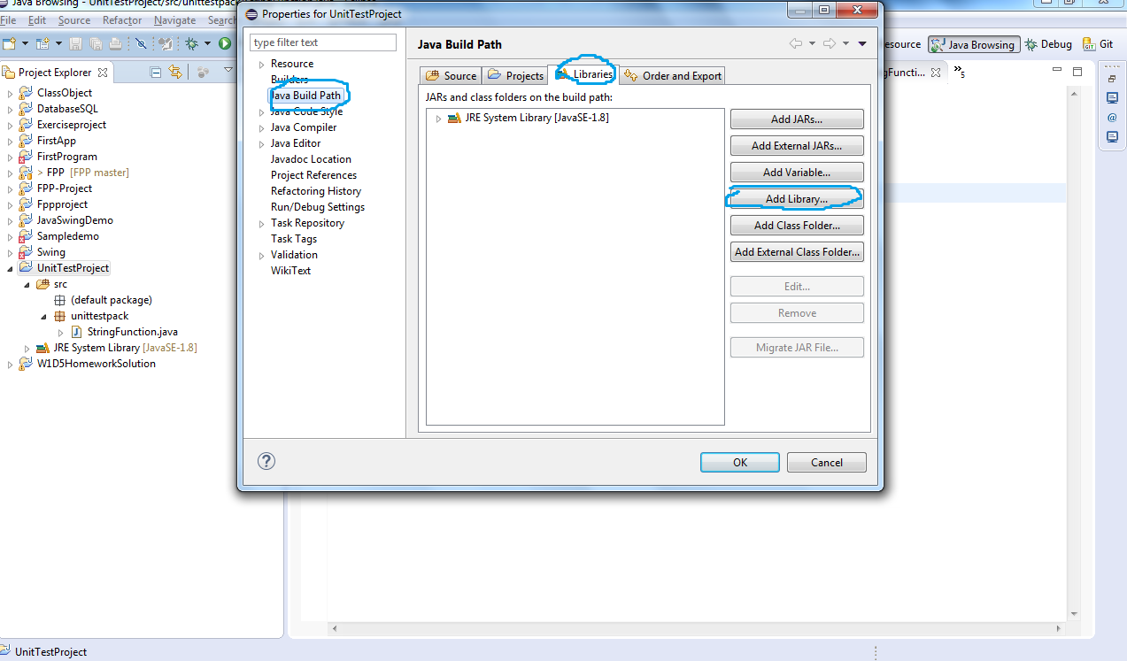

Step 1 and Step 2 does not work, follow the highlighted options from the below screenshot.

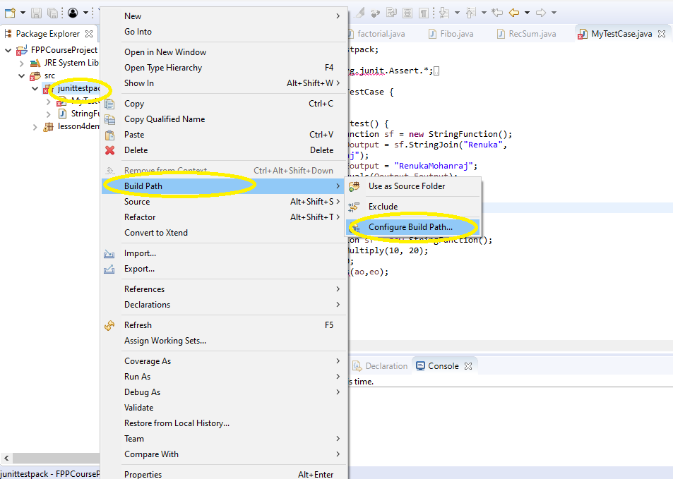

Step 3 : You need to add junit-4.8.1.jar to the "classpath". select Classpath, and click Add External Jars…

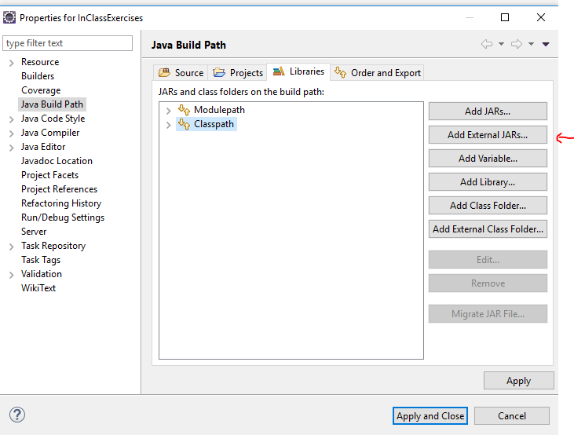

Step : 4

* Download the Junit jar file from Resources/DemoCode/lesson4/ junit-4.8.1.jar. Navigate the junit-4.8.1.jar path from your pc, then click open.

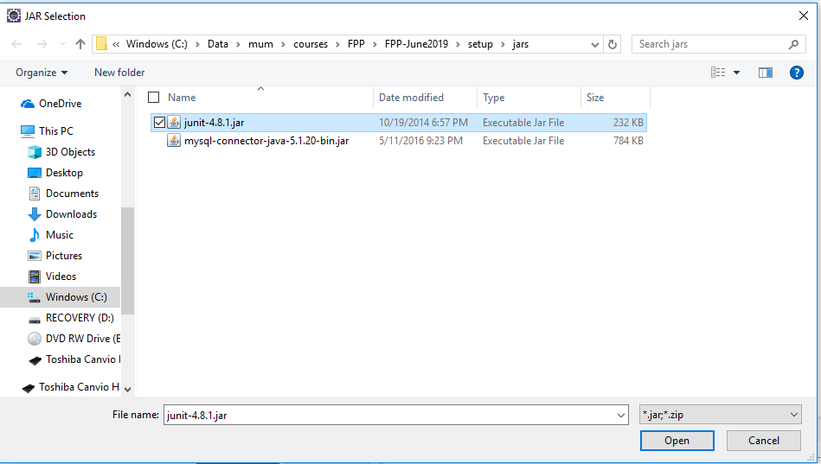

Step 5: Right click on your project, select New 🡪 Junit Test Case. If you not found click New🡪 other🡪Junit Test Case.

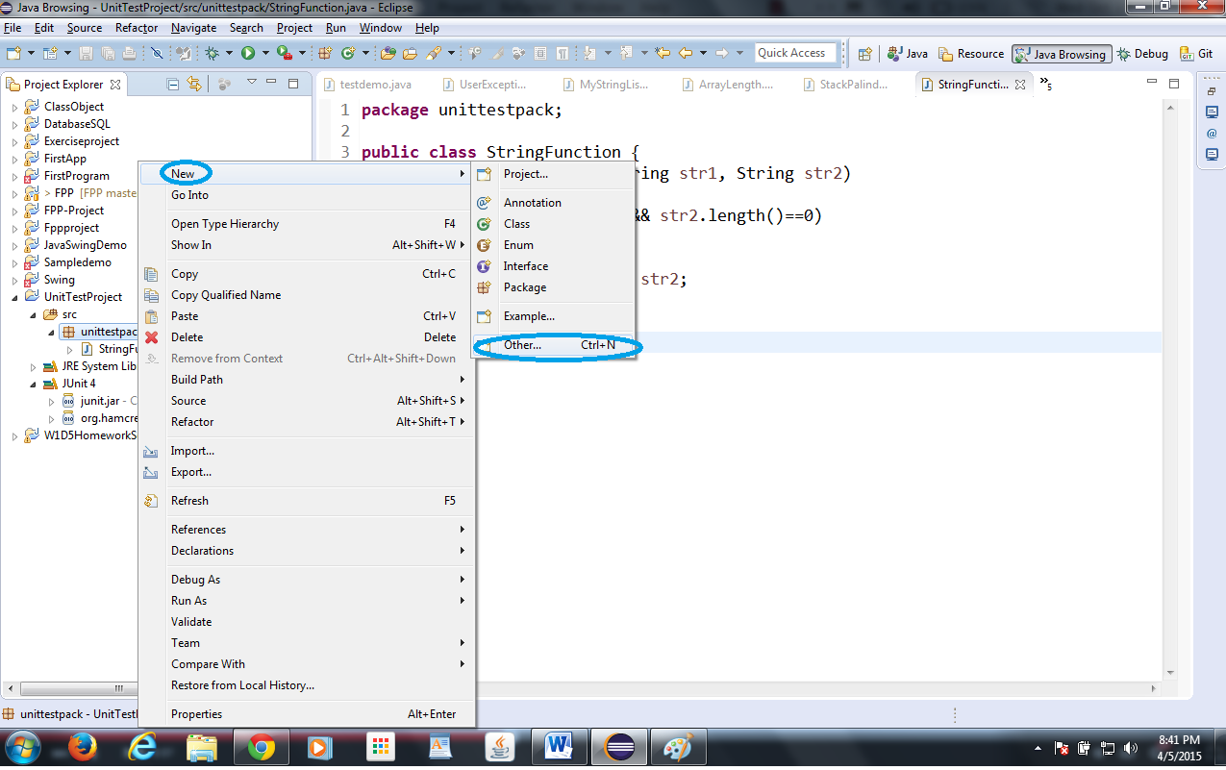

Step 6:

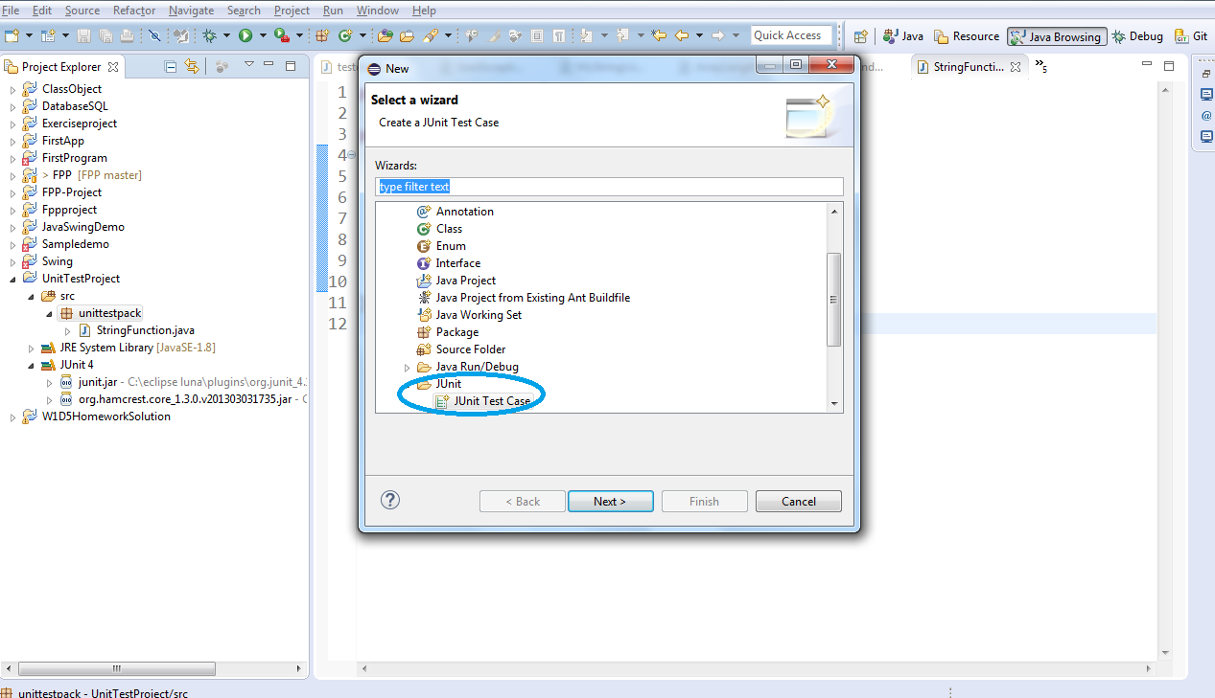

Step 7

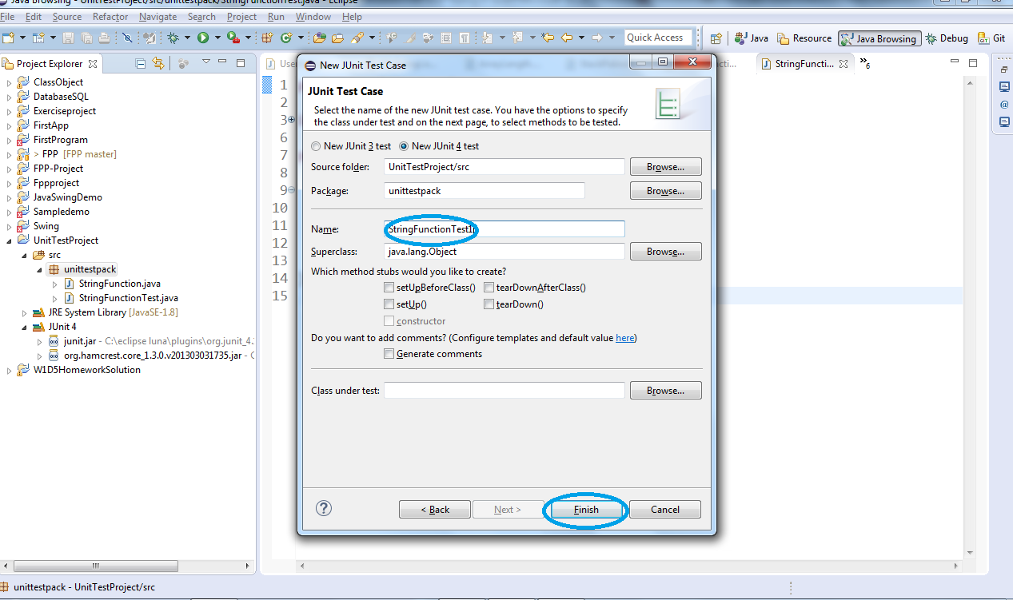

Step 8: Write the test case

