**STUDENT MANAGEMENT SYSTEM**

**CANDIDATE SFID:97231**

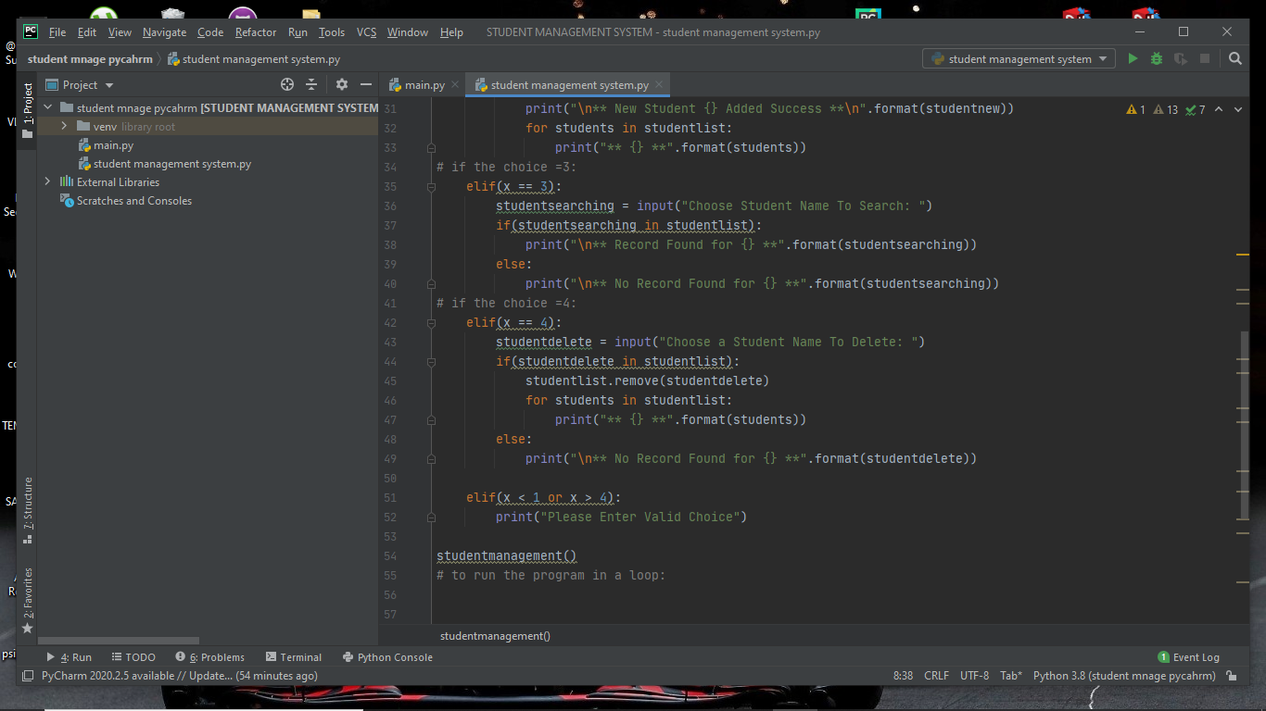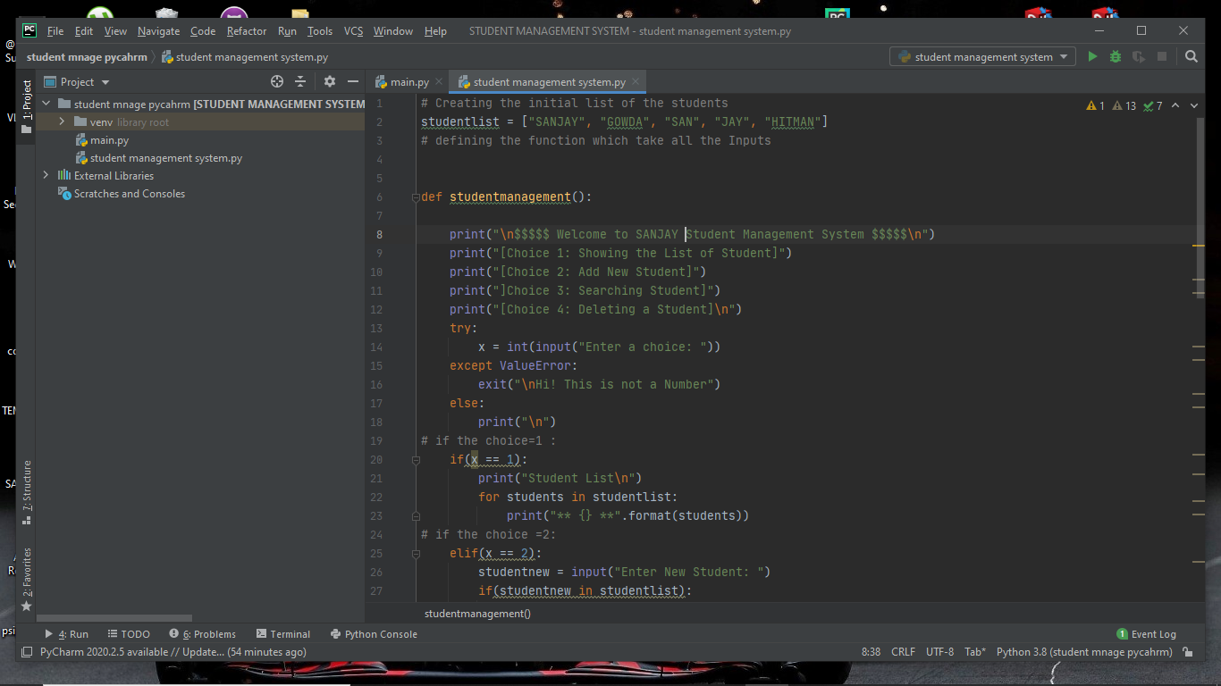

**Screenshot of the Program coded in PYcharm IDE**

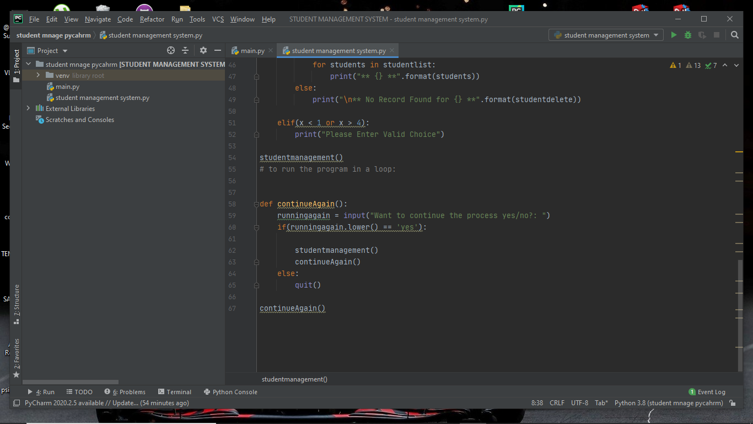

**Screenshot of the Program coded in PYcharm IDE**

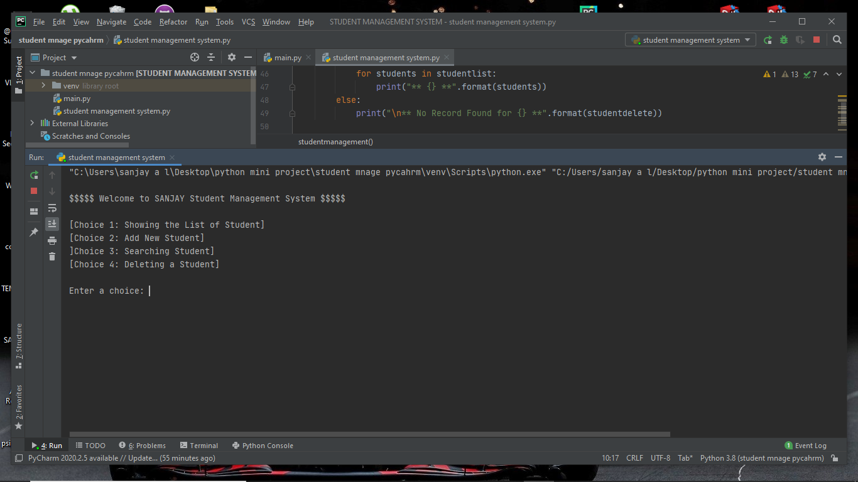

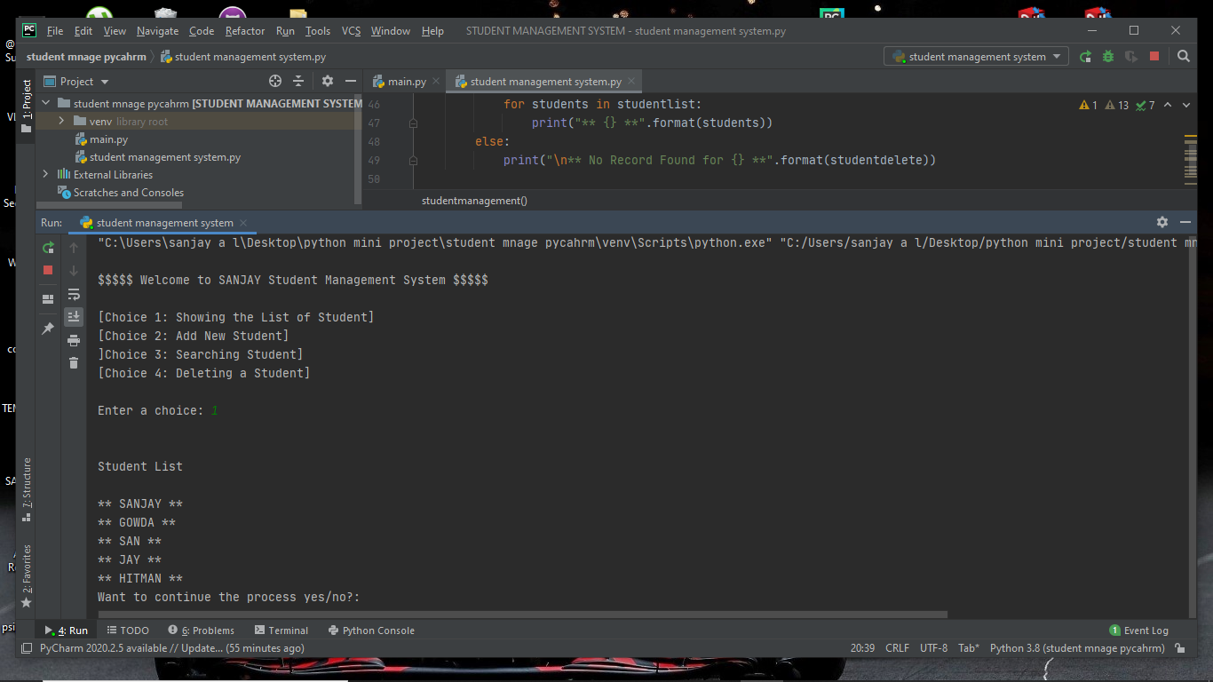

**Screenshot of Input and Output for CHOICE 1**

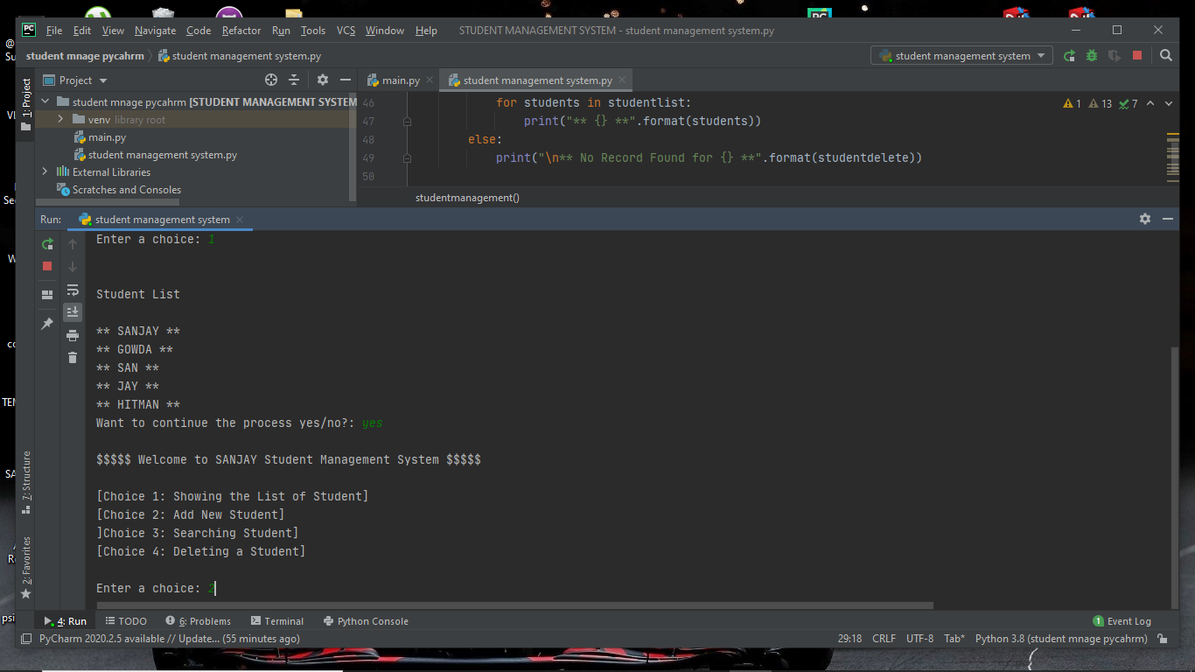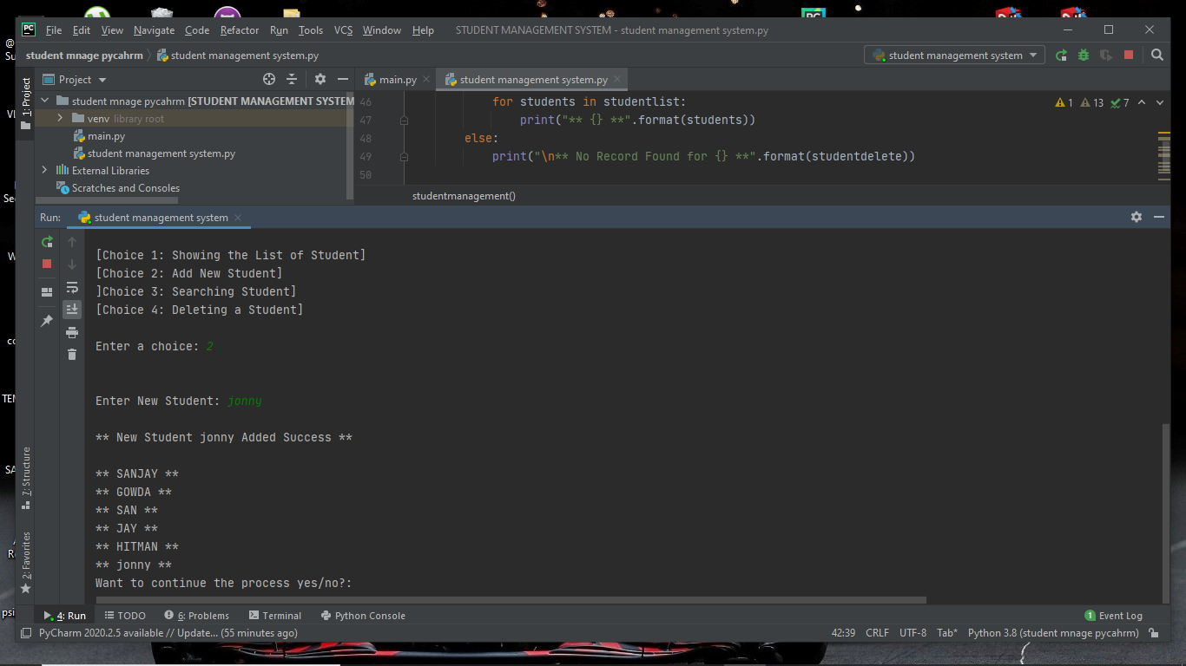

**Screenshot of Input and Output for CHOICE 2**

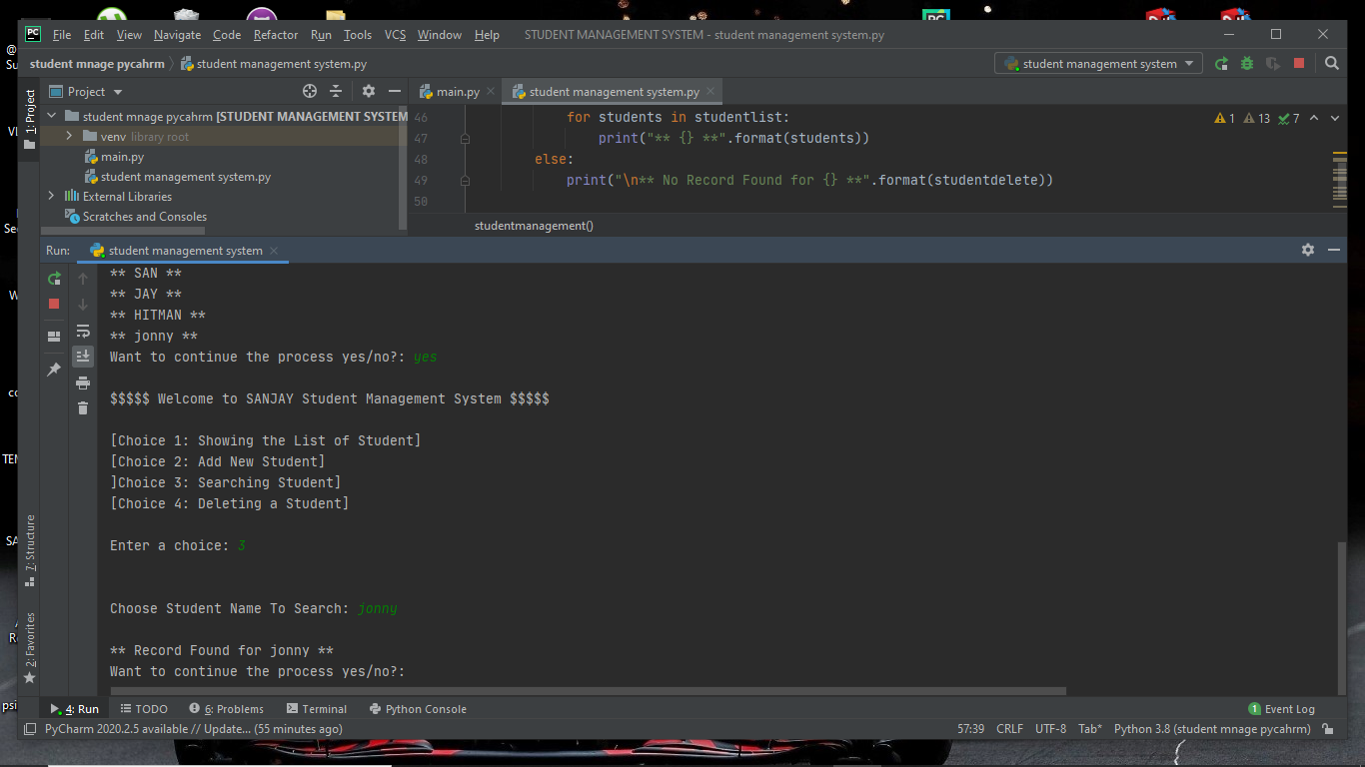

**Screenshot of Input and Output for CHOICE 3**

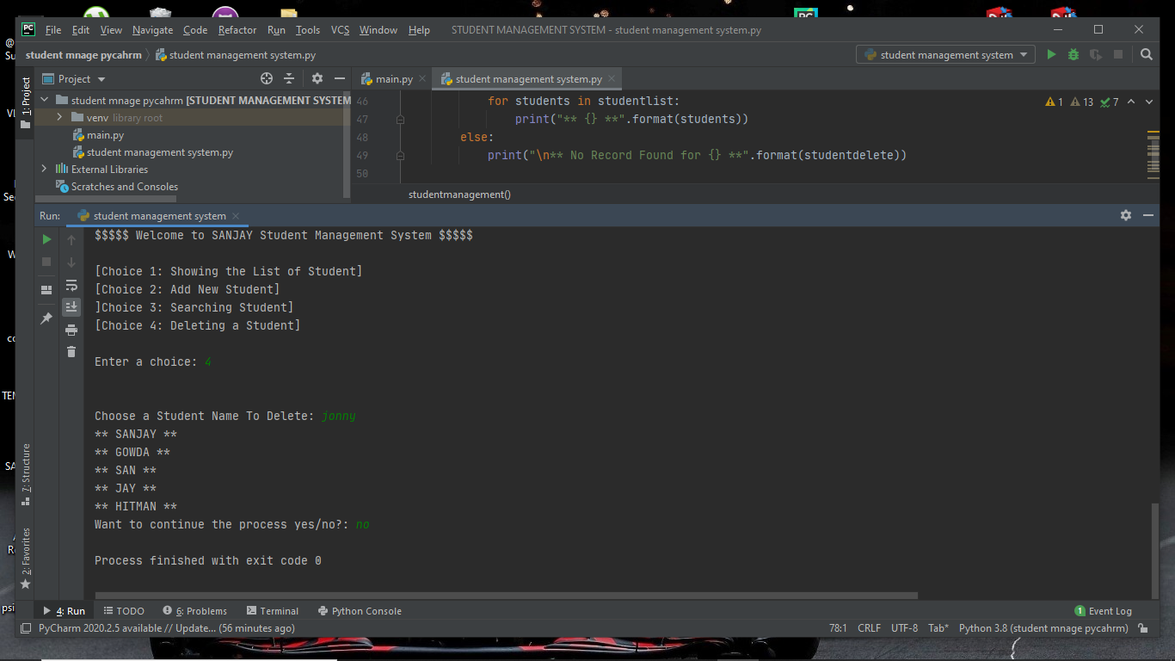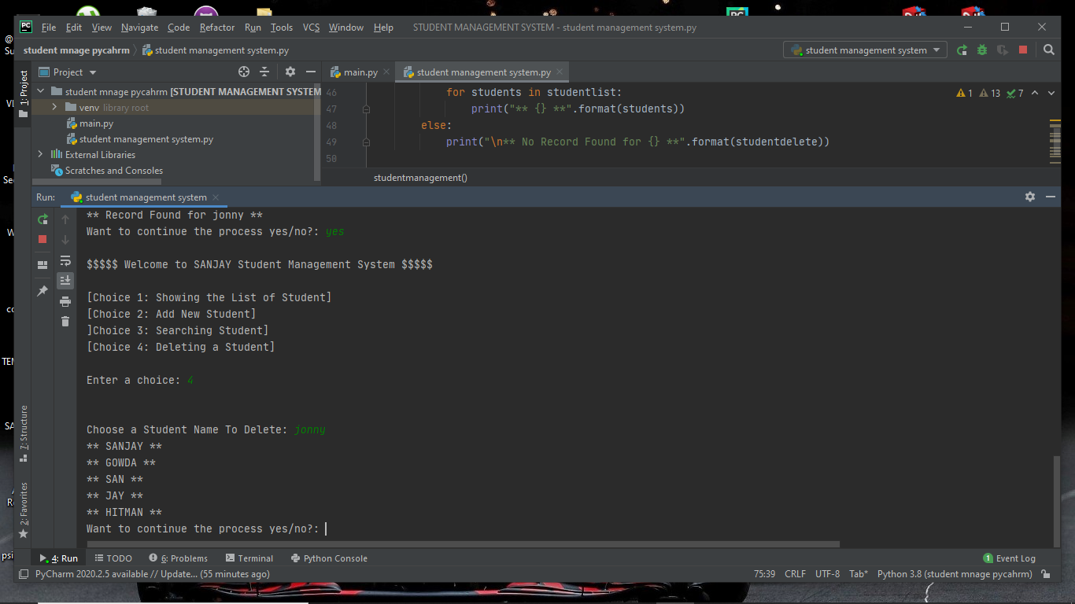

**Screenshot of Input and Output for CHOICE 4**