Practical 1: Simulating the Action Potential with Hodgkin-Huxley Kinetics

Physiology PHOL0009

UCL, Department of Neuroscience, Physiology & Pharmacology 2020

Tutors: *Padraig Gleeson, Brendan Bicknell, Harsha Gurnani*

A brief introduction to computational neuroscience

Computational neuroscience uses mathematical analyses and computer simulations to study the behaviour of single neurons and neuronal networks. The two most important mathematical concepts that are used to model single neurons are the cable equation and the Hodgkin-Huxley equations. The cable equation describes the spatio-temporal

evolution of the voltage in neurites (it was originally developed to model trans-Atlantic cables):

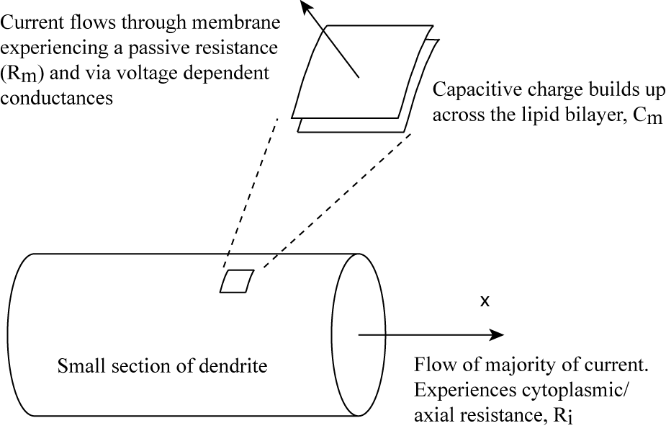

where Ri is the axial resistance, Cm the membrane capacitance and Rm the membrane resistance (ignoring for the moment voltage dependent conductances). For most neurons with complex dendritic geometries, the cable equation cannot be solved analytically and the change of the voltage as a function of space and time is calculated numerically by discretising the equation. This involves breaking up the neuron into a number of iso-potential compartments that can be represented by an equivalent circuit diagram.

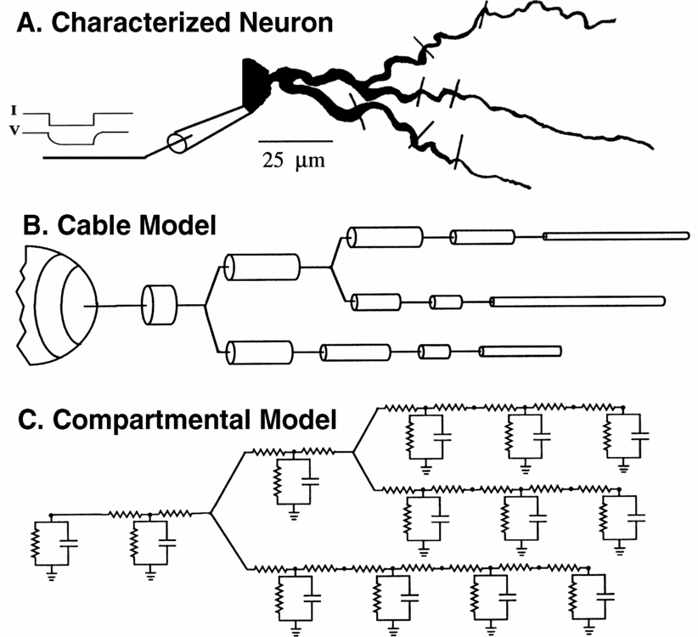

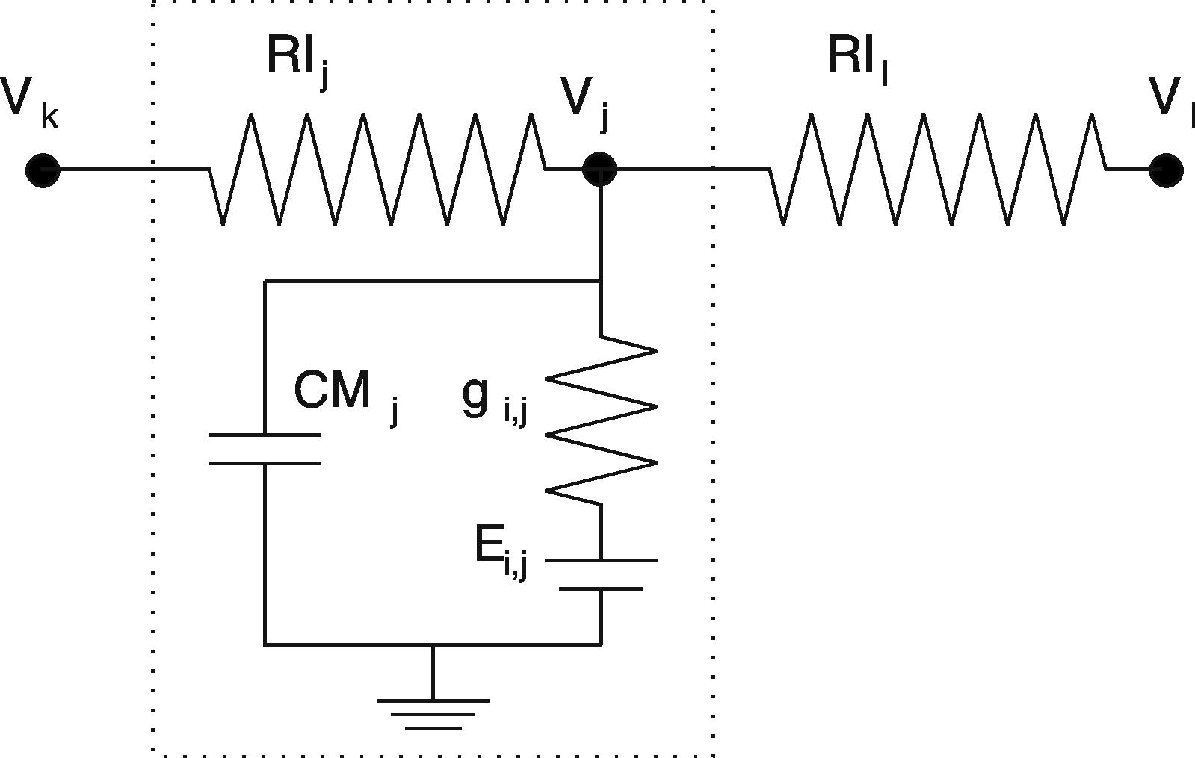

In the diagram above, Vj is the voltage inside compartment j, CMj is the membrane capacitance, and gi,j and Ei,j are the conductances and reversal potentials of the different currents across the membrane. Compartment j is connected to its neighbours k and l by axial resistances RIj and RIl.

Consider now a single compartment. The change of voltage, V(t) inside this is determined by the following currents:

* the capacitive current across the membrane
* the leak (passive, or non voltage dependent) currents
* synaptic currents
* voltage or ligand gated channel currents
* injected currents

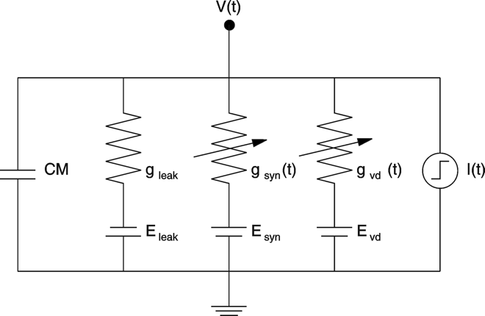

The evolution in time of the voltage in a single compartment with no synaptic input can be expressed as:

Leak currents, synaptic currents and voltage or ligand gated channel currents are commonly described by the product of a conductance (reciprocal of the resistance) gi and a driving force (V – Ei), where Ei is the reversal potential that depends on the internal and external concentrations of ions flowing through the channel (Ohm’s law):



While the conductance of a leak current is independent of membrane potential, the conductances of voltage gated channels are functions of time and voltage and can be described according to the Hodgkin-Huxley formalism by the product of a maximum conductance gmax and activation (m or n) and (optional) inactivation variables (h) that can be raised to powers p and q, respectively:

Examples of these types of conductances as described by Hodgkin and Huxley in the squid giant axon are:

The precise dynamics of the activation and inactivation variables depend on the microscopic changes in the structure of the porous membrane proteins with altered cross membrane voltages. The temporal evolution of the activation and inactivation variables x = {n, m, h} can be described by:



where x = {n, m, h} is the steady state (constant voltage) activation or inactivation and x is the activation or inactivation time constant (a measure of the time to reach a steady state). Both of these parameters are voltage dependent; in the case of x the voltage dependence is usually sigmoidal and can be described by an equation of the form (constant k and Vh):

The implementation of compartmental models has been facilitated greatly by the existence of neural simulators like GENESIS ([www.genesis-sim.org](http://www.genesis-sim.org)) and NEURON ([www.neuron.yale.edu](http://www.neuron.yale.edu)). NEURON provides an extensive graphical interface that will be used in this practical, an interpreted higher level programming language (*hoc* files) for the description of neuronal morphology and design of the simulated experiments, and a compiled lower level programming language (*mod* files) that can be used to implement channel mechanism and intracellular processes. The NEURON code, documentation and a library of models can be downloaded from the NEURON website. An excellent tutorial by Andrew Gillies and David Sterratt is available under [www.anc.ed.ac.uk/school/neuron](http://www.anc.ed.ac.uk/school/neuron). The NEURON Book is also a good introduction to the platform.

This tutorial was originally developed by Volker Steuber and is based on material from M. Nelson and J. Rinzel, Chapter 4: The Hodgkin-Huxley model in The Book of GENESIS, eds. J. M. Bower and D. Beeman (1998).

References

A quantitative description of membrane current and its application to conduction and excitation in nerve. A. L. Hodgkin and A. F. Huxley, Journal of Physiology. 117 (4): 500–544 (1952)

Methods in Neuronal Modeling: from Ions to Networks, C. Koch and I. Segev editors, MIT Press (1998).

Computational Neuroscience: Realistic Modeling for Experimentalists, E. De Schutter editor, CRC Press (2000).

The Book of GENESIS: Exploring Realistic Neural Models with the General Neural Simulation System, 2nd edition, J. M. Bower and D. Beeman editors, TELOS Springer Verlag (1998).

The NEURON Book, N. T. Carnevale and M. L. Hines editors, Cambridge University Press (2005).

### [Principles of Computational Modelling in Neuroscience](http://www.amazon.co.uk/Principles-Computational-Modelling-Neuroscience-Sterratt/dp/0521877954/ref=sr_1_1?ie=UTF8&qid=1350305785&sr=8-1), D. Sterratt, B. Graham, A. Gillies and D. Willshaw, Cambridge University Press (2011).

Current and Voltage clamp experiments

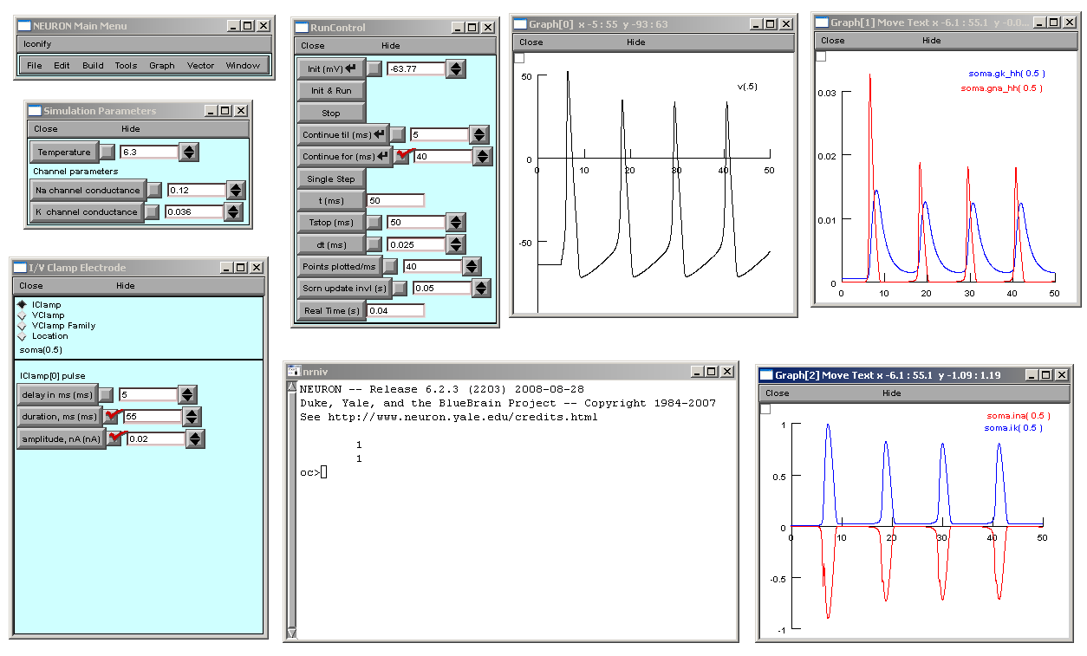

The practical simulates current clamp and voltage clamp experiments similar to the ones used by Hodgkin and Huxley for the characterisation of the voltage dependent sodium and potassium currents in the squid giant axon.

**Installation option 1 (recommended) (Using NEURON via Desktop@UCL Anywhere or** [**https://my.desktop.ucl.ac.uk**](https://my.desktop.ucl.ac.uk)**):**

In order to start the practical, extract the contents of the zip file **NRN.zip** into a folder named N:\Development\NRN in your N:\ drive.

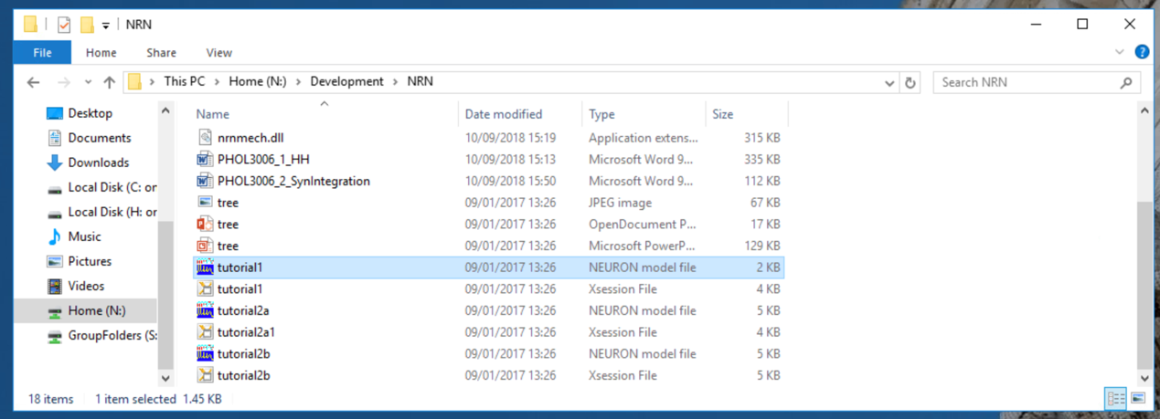

**Make sure you extract the contents of the zip, not just open the zip file and click on the files from there.** Open the NRN directory in the file explorer, and double click on tutorial1.hoc (the file extension .hoc may be hidden), and the windows shown above should appear. Alternatively, open NEURON 7.4 by searching for nrngui at the Start menu. In the NEURON menu (top left window above) go to File -> load hoc and browse to the NRN folder and open tutorial1.hoc.

**Installation option 2 (install NEURON on your own laptop):**

Save the NEURON files in a folder named NRN on your Desktop. Download the current standard distribution of NEURON (version 7.7, behaviour of the practical is identical to 7.4) from [www.neuron.yale.edu/neuron/download](http://www.neuron.yale.edu/neuron/download). Once this is installed, you have to compile the *mod* files which describe the dynamics of the voltage gated channels. In order to do this, go to the Windows Start menu, select **NEURON 7.7** and click on the link to *mknrndll*. Click on *Choose directory* and select the Desktop and then the directory that contains all your NEURON *hoc* and *mod* files. Click on *Make nrnmech.dll* to start the compilation. The compiler opens a separate window; hit return to exit this.

**Mac or Linux users:** open a command line terminal, go to the directory containing the practical files and run the command *nrnivmodl*. Mac users may need Xcode (or <https://github.com/kennethreitz/osx-gcc-installer>), Linux users may need dev packages for ncurses & readline.

**Running the tutorial scripts**

Open *tutorial1.hoc* in NRN (Mac/Linux users: type *nrngui* *tutorial1.hoc* in a command line terminal). NEURON should open 7 different windows (see above):

* *NEURON Main Menu*
* *Run Control*
* *Simulation Parameters*
* *I/V Clamp Electrode*
* *Graph[0] (membrane potential)*
* *Graph[1] (channel conductances)*
* *Graph[2] (channel currents)*

There will also be a command line window (with title nrniv or sh) where you can type in commands to view and set parameters of the simulation. You may have to reposition the windows if the screen display is not big enough. In NEURON's Main Menu, select Window -> Window Manager, click on *move* and reposition the blue windows.

A single compartment, (10 μm long, 3.18 μm diameter, 100 μm2 surface area) is being simulated containing a passive leak current (reversal potential -54.3mV) and sodium and potassium active conductances. To get a feel for the simulation environment go to the I/V Clamp Electrode window, select IClamp (current clamp mode). The parameters for the current pulse to be injected to the compartment are shown. To run the simulation click Init & Run on the RunControl Window. The membrane potential, the conductance and current through the Na and K channels are plotted in various windows, which can be resized as appropriate.

First work in the IClamp mode: Try altering the parameters for the IClamp. A greater amplitude of injection should lead to a higher firing rate. Try reducing the conductance densities of each of the channels to zero (in the Simulation Parameters window) and see what happens. Note that when you change a value through the GUI (Graphical User Interface) you need to press return to ensure the change. Also, typing psection() in the command line interface (nrniv) shows a summary of the parameters for the currently accesses section. Some of the parameters that can be seen there are:

gnabar_hh Na+ max conductance density 0.12 S/cm2

gkbar_hh K+ max conductance density 0.036 S/cm2

gl_hh Leak conductance density 0.0003 S/cm2

el_hh Reversal potential leak conductance -54.3 mV

nai [Na+] inside 10 mM

nao [Na+] outside 140 mM

ki [K+] inside 54.4 mM

ko [K+] outside 2.5 mM

Next, switch to voltage clamp mode by clicking on the VClamp button in the I/V Clamp Electrode window. In each voltage clamp experiment, a variable current is injected into the compartment in order to keep the voltage successively at three constant levels: a conditioning level, a testing level and a return level. Click on the VClamp.igraph button at the bottom of the I/V Clamp Electrode window in order to display this clamp current.

In the first voltage clamp experiment, step the voltage from resting potential (in this case, -63.77 mV) to a testing level of -10 mV for 30 ms. In order to do this, change the testing level amplitude to -10 mV and hit return (the appearance of a red tick mark will always tell you that have changed a parameter from its default value). Click on Init & Run in the RunControl window to run the simulation.

To see the clamp current you have to adjust the axes of the VClamp[0] Graph window. Right click into this window, select View…-> Set View, accept the X Size and change the Y Size for example to [–3 3] (the current is given in nA). Note: the View…-> View = Plot function is also useful for automatically resizing the axes to fit a graph. You will notice four distinct currents during the course of the simulation:

1. A very brief positive spike at the onset of the voltage change. This is the capacitive current that is related to charging the membrane capacitance.
2. A negative peak that represents the extra current needing to be injected to counteract the inward current through the fast sodium channels and hold the voltage constant.
3. A sustained positive (outward) current in response to the increased potassium conductance.
4. A smaller transient current after the voltage clamp returns to resting membrane potential. There is an instantaneous change in the driving force the current through the potassium channels experiences, and the gates in channels gradually close at this membrane potential.

Keep in mind that the clamp current and the clamp voltage displayed in Graph[0] are the only two variables that were accessible to Hodgkin and Huxley in their experiments, the variables that are shown in the other windows are not directly observable and only accessible in our simulation.

In order to study the K current alone, Hodgkin and Huxley replaced Na ions in the external solution with an impermeant cation, thus eliminating the contribution of the ion flow through the Na channels to the measured currents. You can replicate this in the simulation by setting the Na channel conductance in the Simulation Parameters window to 0. Run the simulation again by clicking on Init & Run, and notice that the negative peak in the clamp current disappears. When looking more carefully at the time courses of the K current and conductance (in the VClamp[0] Graph window and in Graph[1] and Graph[2] windows), you will notice that they start with a slow rise and speed up before settling down into the steady state value. In order to reproduce this shape, Hodgkin and Huxley had to raise the K activation variable n to the fourth power:

You can display the temporal evolution of the K activation variable n in a State Graph window. Go to NEURON Main Menu – Graph – State Axis. When the window opens, right click on it and choose Plot What. Double click on soma and then on n_hh, which represents the K activation variable. The Na activation and inactivation variables are represented by m_hh and h_hh, respectively (add these to the window with the n plot). To display all activation and inactivation variables in the same window, change the colour of the traces by right clicking and choosing the Color/Brush option, selecting a colour and clicking on the trace in the window (if you have trouble setting the colour, right click and select Crosshairs, and then right click again and reselect Color/Brush). Tip for write up/essay: you can use screenshots of these plot windows for figures in you write up. Ensure numbers on axes will be legible in final figure. They will have to be further annotated in Word, etc. to add labels for axes & traces. If you really want to make your own graphs, right click, select Pick Vector, click on the trace to save, go to the main menu, select Vector -> Save to file, and the file saved can be imported into Excel.

Set the Na conductance back to its default value of 0.12 S/cm2, and repeat the voltage clamp experiments with the K channel conductance set to 0, comparing the behaviours of the activation/inactivation variables and conductances. Do this for a few different testing voltages (e.g. 10 mV, -10 mV, -30 mV, -50 mV). You can overlay the plots by right clicking into a graph and selecting Keep Lines.

Exercises

1. What are the key differences between the Na current and the K current?

2. In voltage clamp mode, generate plots of the steady state conductance (gna, gk) and activation and inactivation variable values (m, h, n) and the steady state values of current (ina, ik) against clamp voltage (“Testing Level”), for the Na and the K channel at the end the testing phase, i.e. at 40ms (you should note the values in an Excel spreadsheet and generate the graphs that way). Select clamp voltages of -120mV, -100, ... 80mV. You can read out values from the graphs by right clicking and using the crosshair function (move the crosshair along the graph to the value you want to measure, it will be displayed in the title bar of the window). Pay attention for any changes in sign of the values. Adjusting the axes to suit the graph using View…-> View = Plot is also useful. Explain how the shapes of the conductance plots follow from the activation/inactivation plots. What can the graphs tell you about the reversal potentials for Na and K? Explain the shapes of the current graphs in terms of these.

3. In voltage clamp mode, examine the effect of hyperpolarizing conditioning voltages prior to the testing voltage step (try different conditioning voltages between resting potential and -120 mV; use a testing voltage of 0 mV and change the conditioning level duration to 15ms). What is the effect of preconditioning voltages on the Na and the K conductance? In the context of the HH model, explain the mechanism responsible for this effect.

4. Switch to current clamp mode by clicking on IClamp in the I/V Clamp Electrode window. Find the minimum (positive) current (the rheobase current) for eliciting a single action potential (use a delay of 5 ms and a pulse duration of 25 ms). How “sharp” is the threshold phenomenon? Can you find a value of injected current that elicits a half-height action potential?

5. What is the minimum current that elicits repetitive firing, i.e. generates trains of action potentials (use a delay of 5 ms, a pulse duration of 200 ms and set the simulation time (Tstop in the RunControl window) to 205 ms)? How sharp is the transition from single spike generation to repetitive firing? Can you find a value of injected current that generates exactly two action potentials?

6. By counting the number of spikes generated in a 200 ms time window, construct a plot of spike count versus injected current. How much does a 10-fold increase in injected current from the repetitive firing current increase the firing rate? What happens for a 100-fold increase? Why does this happen?

7. In problem 4 we saw that single action potentials can be generated by small sustained levels of current injection. Single action potentials can also be elicited by transient current pulses, even when the duration of the current pulse is shorter than the action potential. What is the effect of pulse duration on threshold current for eliciting a single action potential? Generate a plot of threshold current vs. pulse duration for pulse widths between 0.1 ms and 5 ms. Is there a simple relationship between pulse width and threshold current? Use a simulation time step of 0.0125 ms for this study (change the value of dt in the RunControl window).

8. All of the previously used current injection pulses have been depolarizing. What happens for hyperpolarizing current injections (set the pulse amplitude to –0.01 nA and the pulse duration to 5 ms)? What is the threshold, in terms of current magnitude and pulse duration, for eliciting this so called anode break excitation? What mechanisms in the model are responsible for this behaviour? Look at the time course of the activation and inactivation variables n, m and h.

Information on write up:

Max length ~4 pages A4 (excluding figures), 2000 words (excluding legends, but keep legends brief & to the point). Figures properly numbered/labelled/with legends/referenced in main text/standalone/descriptive only (look at published papers).