A Free Operating System For A Free Community
What Is Fedora?
Fedora is an operating system and a development platform based on the Linux kernel that is free to use, free to modify, free and legal to redistribute, and free from potentially damaging software patent encumbrances.
Fedora is built from the latest technologies from the free software world, and assembled by a community of users and developers who are passionate about providing and maintaining the best free software distribution in the world.
What Is the Fedora Project?
The Fedora Project is a Red Hat and community supported open source project. Our goal is the rapid progress of free and open source software and content. The Fedora Project makes use of public forums, open processes, rapid innovation, meritocracy, and transparency in pursuit of the best operating system and platform that free software can provide.

Fedora Project
http://fedoraproject.org

Getting Support
Fedora Project wiki and mailing lists
https://fedoraproject.org/wiki/Communicate
Official Documentation
http://docs.fedoraproject.org
IRC channel
#fedora @ irc.freenode.net
Community forums
http://ask.fedoraproject.org
http://fedoraforum.org
Looking to join the Fedora community?
Are you interested in contributing to Fedora? There are many ways you can become active in the project.
Whether you are a People Person, Designer, OS Developer, Packager or Administrator – we have a place for you. Just head to the following page and get started today!
http://join.fedoraproject.org



http://fedoraproject.org



Fedora and the Infinity Logo are
registered trademarks of Red Hat, Inc.
Use Fedora everyday!
Fedora comes in both multiboot Live media and installable DVD formats, for a wide range of devices and architectures: 32-bit, 64-bit and ARM machines. A plethora of the latest open source software for day to day use is available in the Fedora repositories: office/productivity tools, internet tools, graphics tools, audio/video recording and editing tools, 3D printing and a lot more! It's all there!
Multiple desktops to choose from..

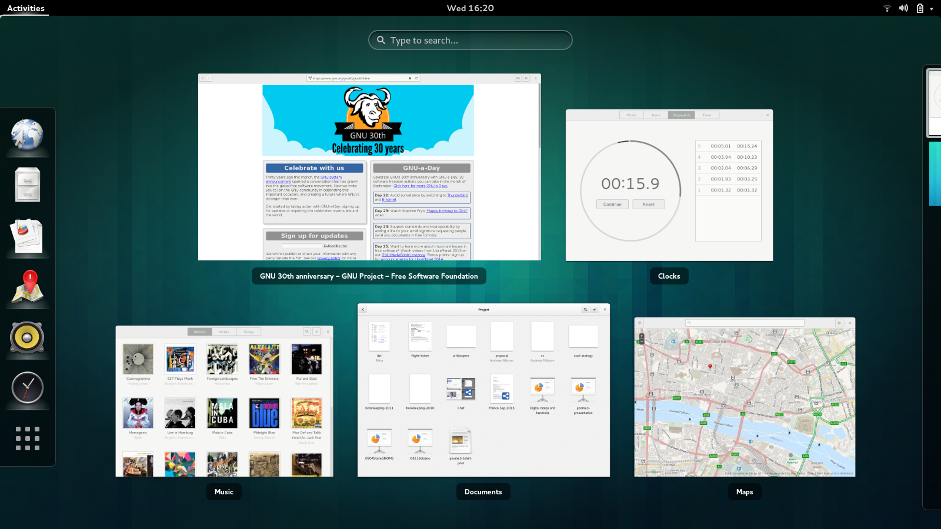
Fedora 20 provides a wide selection of desktops that you can choose from. Latest versions of KDE (4.11), Gnome (3.10), LXDE, XFCE, Sugar(0.100), Mate and even the newest release of Enlightenment, E17 are available in Fedora 20. Each of these is available for as a separate spin or can be installed directly from the repositories.
You can download Live media, try each of them out and then only install whichever desktop best fits your needs.
Internet tools..
The latest version of the popular open source Firefox web browser is available on most Fedora 20 spins. For instant messaging, users can choose from Empathy, Pidgin or Kopete among others.
A number of microblogging clients make it really simple to keep up with your social networks.
A new software installer..

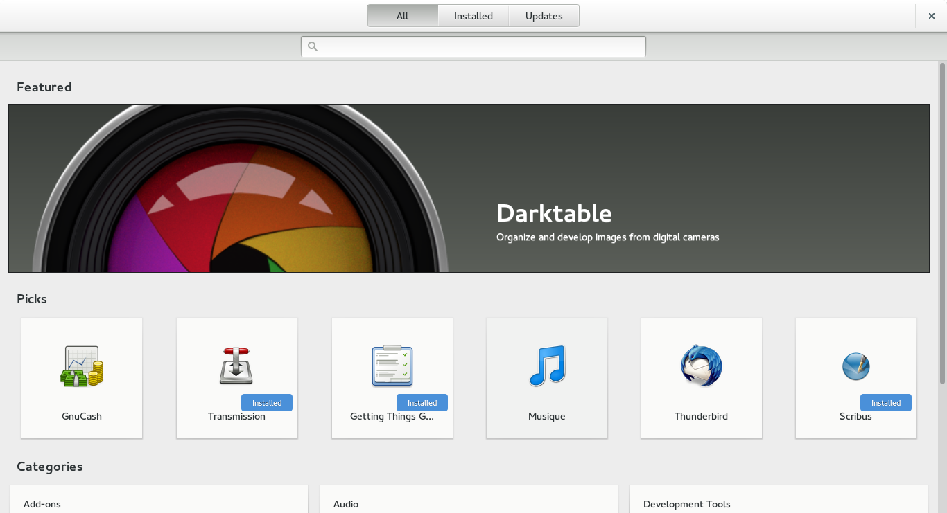
Fedora 20 provides a first look at Gnome-software, a new application installer. Gnome-software focuses on applications rather than packages. It provides a simple, clean interface where you can surf available applications in the repositories and install them with a single click.
Edit and share your photos easily!
Tools range from advanced photograph editors, such as DarkTable, or simple to use photograph managers such as DigiKam or Shotwell. Importing photos from your devices and sharing them with your friends just takes a minute!
Office/Productivity tools:
Fedora ships with LibreOffice, a multi platform and multi lingual open source office suite. It has everything you need for productivity in your business, studies and everyday tasks.
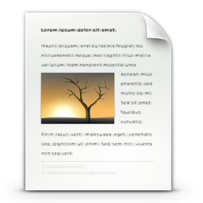
- LibreOffice Writer
(Word processor)
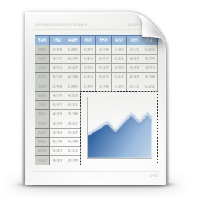
- LibreOffice Calc
(Spreadsheet application)
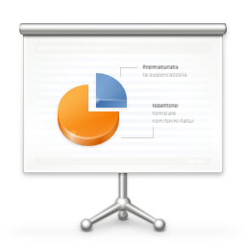
- LibreOffice Impress
(Slide show designer)

Graphics, music and movies? Yes!
Many, many open source movie and music players are available for you to choose from. Not only can you view them, you can create them yourself with the help of some of the best audio/video editing software available! Curious? Install Blender and see if you can create a cool 3D animation or play with Audacious if you're a musician and see what you can come up with.
If you're into graphics, Gimp and Inkscape will cover most of what you'd need. For a complete set of tools, simply install the Fedora Design Spin.
Games galore!
We love playing games! Fedora brings games for all game lovers. You can either play old arcade style games, or newer FPS games. If you're into strategy games, we have them too. Try 0ad, Battle for Wesnoth or the classic Nethack.
What are these Spins?
We have plenty of specialized versions of Fedora to cover the specific needs of a user, or a user group. Depending on what software you use most, you can pick up one of these specific package sets: Security, Design, Robotics, Electronics Lab, Games or the Fedora Jam spin.
Getting Fedora
Obtaining Fedora is easy. You can either download it from our website, or use torrents. If you're low on bandwidth, you can request media from the Fedora free media program. A number of online vendors also sell Fedora media at nominal prices.
http://get.fedoraproject.org

