CHAPTER - 3
PARTICIPATED GAMES - THROWBALL

Throwball is a non-contact ball sport played between two teams on a rectangular court divided by a net. Each team generally consists of seven players. The objective of the game is to throw the ball over the net in such a way that the opposing team is unable to catch or return it properly.
Throwball is widely played in schools and colleges because it improves physical fitness, coordination, teamwork, and communication skills.
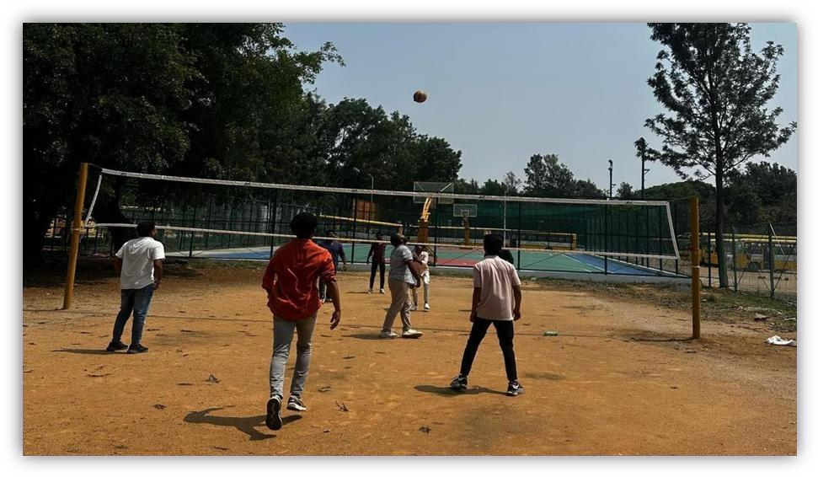
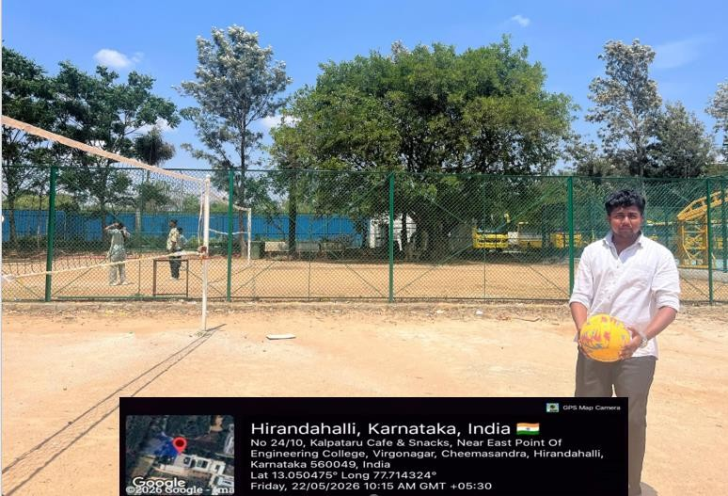

Dept. of CSE 2025-26 7

