VISVESVARAYA TECHNOLOGICAL UNIVERSITY

Jnana Sangama, Belgavi-590018


A Report on

PHYSICAL EDUCATION (SPORTS AND ATHLETICS) (BPEK459)
Submitted in partial fulfillment of the requirement for award of degree
Of
BACHELOR OF ENGINEERING
In
COMPUTER SCIENCE AND ENGINEERING
By

SHREYAS [1EP23CS408]

Under the guidance of Mrs. Madhushree R Professor

Dept. of CSE, EPCET

2025-26



Department of Computer Science and Engineering
Approved by AICTE New Delhi | Affiliated to VTU, Belagavi, Virgo Nagar, Bengaluru-560049

CERTIFICATE

Certified that the “PHYSICAL EDUCATION (SPORTS AND ATHLETICS) – (BPEK459)”

report carried out by Mr. SHREYAS M bearing USN 1EP23CS408 a bonafide student of East Point College of Engineering & Technology in partial fulfillment for the degree of BACHELOR OF ENGINEERING in COMPUTER SCIENCE AND ENGINEERING (6th semester) of the Visvesvaraya Technological University, Belgaum during the year 2025- 2026. It is certified that all corrections suggestions indicated for Internal Assessment have been incorporated in the report deposited in the departmental library. The report has been approved as it satisfies the academic requirements.

Mrs. Madhushree  Professor |  | Dr. I.Manimozhi  Professor & HOD
Dept. of CSE |  | Dept. of CSE
EPCET, Bengaluru |  | EPCET, Bengaluru

ACKNOWLEDGEMENT

Any achievement, be it scholastic or otherwise does not depend solely on the individual efforts but on the guidance, encouragement and cooperation of intellectuals, elders and friends. I would like to take this opportunity to thank them all. We would like to express our sincere thanks to the management of EPCET for providing necessary infrastructure and creating good environment. We express our gratitude to Dr. Pradipkumar Dixit , Principal, and EPCET who has always been a great source of inspiration.

We would like to express our sincere thanks to Dr.I.Manimozhi, Professor and Head of the Department of Computer Science and Engineering, EPCET for his valuable suggestions and encouragement to do our best in this sports activity.

We would like to express our gratitude towards our Guide Mrs. Madhushree R , Assistant Professor, Department of Computer Science for his valuable guidance and constant supervision in participating the sports activity successfully.

We would like to extend our thanks to all the faculty members of Computer Science department for their valuable motivation during the sports activity.
Finally, we would like to thank our parents and friends for their support and encouragement in successful participation of the sports activity.

SHREYAS [1EP23CS408]

 | CONTENTS
Chapter No. | Description | Page No.
1 | Sports Ethics | 1-4
 | 1.1 Introduction
 | 1.2 What Is Sports Ethics?
 | 1.3 Sports Ethics: Standards
 | 1.4 Responsibility for Observance of Sports Ethics
2 | Moral value in sports and Games | 5-6
3 | Participated Games – “Throwball” | 7-8
4 | Benefit of Playing Throwball | 9
5 | Conclusion | 10

CHAPTER - 1
SPORT ETHICS

1.1 INTRODUCTION
It is now being increasingly realized that sports contribute to the physical, psychological and emotional well-being of an individual. Sports play a significant role in healthy social development and interaction. It helps people learn how to set and achieve goals through discipline and hard work. It nurtures the development of decision-making and leadership abilities, while teaching people to manage both success and failure. Today, it has become one of the most popular activities being organized at regular intervals. Sports is a human activity that contributes to the holistic development of individuals. It is recognized as an individual activity which offers the opportunity for self-knowledge, self-expression and fulfilment of personal achievement; skill acquisition and demonstration of ability; enjoyment, good health and well-being. Sports also engages us in a collective effort to pursue human excellence. It provides us an opportunity for social interaction. It is a source of pleasure, but more than that, sports inspire, bring cultures together, and can bridge social divides. Sports can enrich society and foster friendships between nations Sports is primarily a competitive activity where winning is the be all and end all. It is in this context that ethics occupy a critical place. In the present chapter we shall discuss various dimensions of sports ethics.

1.2. WHAT IS SPORTS ETHICS?
Ethics is much more than playing within the rules, as it covers notions such as friendship, respect for others and the sporting spirit. Institutions and adults must be the guarantors of the right to play sport and games. Before discussing various dimensions of sports ethics, it is important to understand the meaning of ethics. Ethics, morals and values are used interchangeably in everyday language, though these terms are not synonyms. The concept of ethics is technically understood as a branch of philosophy that defines what is good for the individual and society and establishes the nature of obligations, or duties, that people

owe themselves and to one another. But without going into the complexities of this concept, it is relevant to understand ethics as the practice of making principled choices between right and wrong: a code of conduct that guides human behaviour, a set of standards that guides our conduct. It is generally viewed as the system or set of rules, norms or laws by which attitudes and actions are determined to be either “right or wrong”. The fundamental problem of ethics is determining what constitutes proper conduct. It is defined as the code of conduct for promoting and ensuring healthy sporting practices.

The codes of sports ethics documented by the Olympic Committee and other international and national sports bodies, governments, sports federations and associations, sports sponsoring concerns and specialized research institutions provide a comprehensive view of sports ethics. These clearly suggest that sports ethics is a set of standards that guide the conduct of all concerned with sports — the sports persons, trainers, referees, managers, administrators, parents, teachers, journalists, doctors and pharmacists, nutritional expert, sports sponsoring concerns, top level sportspersons who serve as models and even spectators.

SPORTS ETHICS: STANDARDS
What are sport ethics or standards? Commonly described as six pillars of fair play, Standards are integral elements of all sports activities, sports policy and management, and apply to all levels of ability and commitment, including recreational as well as competitive sports. These are: trustworthiness, respect, responsibility, fairness, caring and citizenship.

    - Trustworthiness

- Always pursue victory with honour.
- Demonstrate and demand integrity.
- Observe and enforce the spirit and letter of the rules.
- Do not engage in or tolerate dishonesty, cheating, or dishonourable conduct.

    - Respect

- Treat the traditions of the sports and other participants with respect.

- Do not engage in or tolerate disrespectful conduct, including verbal abuse of opponents and officials, taunting and inappropriate celebrations
- Win with grace and lose with dignity.

    - Responsibility

- Be a positive role model on and off the field.
- Safeguard your health. Know what you’re putting in your body. Just because a substance is legal or natural doesn’t mean it’s permitted or safe in health context.
- Take responsibilityand educate yourself about issues of anti-doping. It’s up to you to comply with anti-doping policies.

    - Fairness

- Adhere to high standards of fair play.
- Ensure that teams and athletes playbythe rules and treat others fairly.
- Anything that gives an unfair advantage violates the spirit as well as the integrity of the sport.

    - Caring

- Demonstrate concern for others. Never engage in careless behaviour that could injure yourself or others.
- Help the team byencouraging your teammates.
- Never tolerate unhealthy or dangerous conduct by your teammates. Encourage your teammates to make healthy choices and be prepared to report any dangerous behaviour.

RESPONSIBILITY FOR OBSERVANCE OF SPORTS ETHICS

The responsibility to ensure observance of sports ethics belongs to all those who are directly or indirectly, associated with sports and especially those who influence and encourage the involvement and participation in sports. These include:

- Governments at all levels, including the agencies working with governments.

- Sports-related organizations including sports federations and governing bodies, sports sponsoring concerns, physical education associations, coaching agencies and institutes, medical and pharmacological professions and mass media.

- The commercial sector, including sports goods manufacturers and retailers, sponsoring concerns and marketing agencies;

- Individuals including parents, teachers, coaches, referees, officials, sports leaders, physical education expert, administrators, journalists, doctors and pharmacists and those role models who have achieved levels of sporting excellence and fame; those who work on a voluntary or on a professional basis. Each of these institutions and individuals have a responsibility and a role to play. This code of sports ethics is
addressed to each one of them. This can be effective if all involved in sports are ready to take on the responsibility identified in the code.

CHAPTER - 2
MORAL VALUES IN SPORTS AND GAMES

We all have dreams. But in order to make dreams come into reality, it takes an awful lot of determination, dedication, self-discipline, and effort - Jesse Owens Morality is a human effort to define what is right and what is wrong about our actions and thoughts. Morality as it relates to our behaviour works on three levels. In the opinion of renowned thinker, scholar and writer C.S. Lewis, it -(1) ensures fair play and harmony between individuals;
(2) helps to make us good people in order to have a good society; and (3) keeps us in a good relationship with the power that created us (qtd. in. “Morality”).

Religion, sociology, philosophy, anthropology and more than these one’s own conscience are some of the areas from which we receive such standard norms of morality. Hence, it is a symbol of goodness. Morality is reflected through moral values which make us civilized and cultured and guide us to lead an excellent life without harming others. These moral values can be very practically imbued in the minds of the sportspersons through their games. Since the development of multiple modern civilizations throughout the world, sports and games play a vital role to curb the behaviour of the young generations.

The first chapter a player learns in the field of sports is this that winning is not everything, but the necessary element of sports is to participate with sport spirit which is above any medal. It develops a sense of fair competition in the players. Unfair competition yields unfair result which in one way or the other makes the players feel that they are not real winners. So, this idea of fair competition teaches the players to be unbiased and fair in their private and social life in order to be a good person. Sports and Games do not only make the players physically strong but they also sharpen their mental capacity.

When a player wins, he enjoys the moment but when he is defeated in a game, he learns from it his shortcomings and improves upon them so that he may not repeat them again. When he overcomes his adversity, he learns that life is not always.

Honesty is inculcated in the minds of players when they see and find that the dishonesty only results in doom and destruction of their careers. One of the best forms of honesty is to be honest to one’s own self and players learn this in sports ground. They work honestly in the fields to perform well in their games. They know the importance of consistently working in the sports ground and they never ran away from here. A player who does not play honestly is looked down upon by their teammates who someway or other want to get rid of such a player. Endurance is another quality which is developed by sports and games.

Good players learn to accept victory and defeat equally because they know it well that these are the two sides of the same coin. When a player wins, he enjoys the moment but when he is defeated in a game, he learns from it his shortcomings and improves upon them so that he may not repeat them again. When he overcomes his adversity, he learns that life is not always easy and it’s best to stay with difficult tasks and conquer them rather than take the easy way out.

Sports and games do not only teach us to be fit physically but they make us solid in every sphere of life. Parents now have shifted from the popular saying that a baby is spoiled when he/she will play a game and they are willing to send their kids to join various kinds of games not only in hope of getting success in terms of winning medals at various competitive levels but because of their faith that sports activities are able to frame the character of their kids in a positive direction and more than this help them to be a good human being.

CHAPTER - 3
PARTICIPATED GAMES - THROWBALL

Throwball is a non-contact ball sport played between two teams on a rectangular court divided by a net. Each team generally consists of seven players. The objective of the game is to throw the ball over the net in such a way that the opposing team is unable to catch or return it properly.
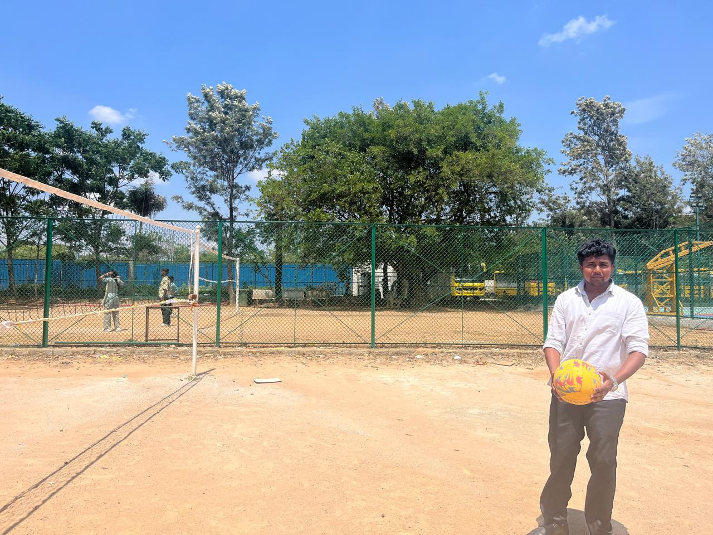
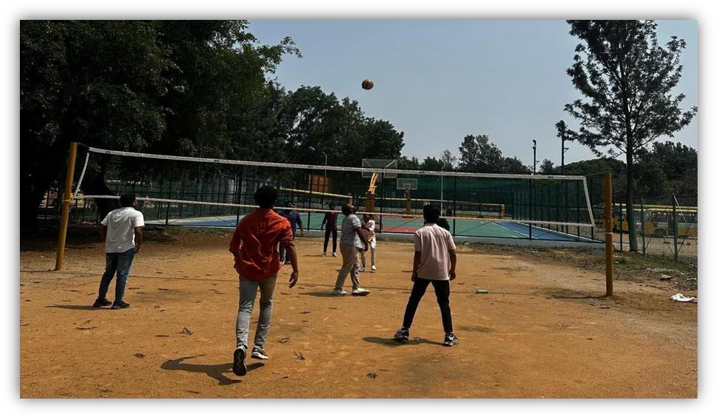
Throwball is widely played in schools and colleges because it improves physical fitness, coordination, teamwork, and communication skills.

The game starts with a serve from one side of the court. Players must catch the ball with both hands and throw it back within a few seconds. The ball should not touch the ground on the player’s side. Points are scored when the opponent fails to catch the ball, throws it outside the boundary, or commits a fault.

Throwball requires quick reflexes, concentration, agility, and proper coordination among teammates. Players develop leadership qualities and team spirit while participating in the game. The sport also improves confidence and promotes discipline among students.

The rules of throwball are simple and easy to understand, making it suitable for players of all age groups. It is a fast-paced game that provides both entertainment and physical exercise. Today, throwball is gaining popularity as an important recreational and competitive sport in educational institutions.

BENEFITS OF PLAYING THROWBALL.

Physical health:

  - Playing throwball strengthens various muscle groups, including arms, legs, core, and back.
  - Improves cardiovascular health.

  - Stretching and jumping involved in the game help improve overall flexibility.

  - Improves hand-eye coordination.

Social benefits:

  - Promotes sportsmanship and respecting opponents.

  - The quick movements and changes in direction required in throwball enhance coordination, balance, and agility.
  - Encourages social interaction and bonding.

Mental benefits:

  - Reduces stress and anxiety.

  - Enhances focus and concentration.

  - Throwball is a team sport that fosters teamwork, communication, and social interaction, building relationships and a sense of community.
  - Develops strategic thinking abilities.

CHAPTER – 5
CONCLUSION

Throwball is an excellent team sport that promotes physical fitness, mental strength, and social interaction among players. It helps students develop discipline, coordination, leadership qualities, and teamwork. The sport encourages active participation and creates a healthy competitive spirit among individuals. Throwball is simple to learn, enjoyable to play, and suitable for all age groups. By participating in throwball activities, students can improve their overall personality and maintain a healthy lifestyle. The growing popularity of throwball in schools and colleges highlights its importance as both a recreational and competitive sport.

Several organizations and entities work to make sport accessible to all by creating infrastructure, accessibility, specific activities for persons with disabilities, or including people with disabilities in unadapted activities and modalities. However, to date, it is necessary to analyze and elaborate the European social access and social inclusion of people with disabilities in sport. With each raid, tackle, and victory, throwball reaffirms its status as not just a sport, but a timeless tradition cherished by generations past, present, and future.

