In the Hindu epic Mahabharat, Nakul was fourth of the five Pandav brothers. Nakul and Sahadeva were twins born to Madri, who had invoked the Ashwini Kumaras. Nakul and his brother Sahadeva, are both called as Ashvineya(आश्विनेय), as they were born from Ashvins
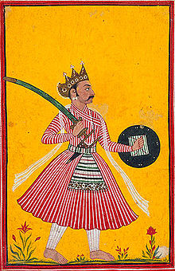
The story of the birth of two small Pandavas is completely different. Pandu's first wife Kunti had given birth to three brave sons Yudhishthra, Bhima and Arjuna. At the same time, Gandhari gave birth to hundred sons. Children from both families were growing up according to time.

Whereas, Pandu's second wife Madri was still far from the joy of becoming a mother.

Perhaps no one had time to understand Madri's grief and so she was becoming lonely. According to chapter 123 of 'Sambhav Parva' of Mahabharata Adi festival, Pandu children had lost their ability to originate.

Kunti had given birth to three sons through the mantra of progeny, but Madri had a problem as it was. Being a daughter, Pandu was completely focused on Kunti and her children. After a long time, Pandu found that the beauty of Madri is now diminishing, she is getting filled with bitterness. He wanted to know the reason for this from Madri.

Madri said, "How can I be happy? It is just you, your three sons and your second wife. I have neither you nor children! Pandu tried to convince Madri but he knew that Madri's anger is justified.

After a long debate, Madri told Pandu that Kunti didi knows the mantra of procreation, you should ask them to teach me that mantra too so that I too can become a mother. This task was difficult for Pandu but there was no way left to calm Madri's anger.

When Pandu told Kunti his wish for Madri, he said that I have received this mantra as a blessing. Which I cannot share with anyone, but I can help Madri. She then took Madri to a forest cave.

Also said, 'I will use the mantra. You can call any god you want, and you can have children of virtue.
NAKUL is hidden in the village!! Find him by changing the look!!

Nakula desired Drupada to be the general of the Pandava army, but Yudhishthira and Arjuna opted for Dhristadyumna.

