

**Software Design Document**

**Version <1.0>**

**Ajay Singh Pal**

**Akash Jain**

**03/26/2015**

**Revision History**

|  |  |  |  |
| --- | --- | --- | --- |
| **Date** | **Version** | **Description** | **Author** |
| 03/26/2015 | <1.0> | Initial version of document | Ajay Singh Pal & Akash Jain |
|  |  |  |  |
|  |  |  |  |

**Reviewed By**

|  |  |  |  |
| --- | --- | --- | --- |
| **Date** | **Version** | **Description** | **Reviewer** |
|  | <1.0> |  | Deepika Gupta |

Contents

Purpose 3

Visuals Flow 4

# Purpose

This document is a generic Technical Design Document for the Jumbune project. This software design document defines and describes the use of each view, the architectural constraints of the system, and the functional requirements with a significant impact on the architecture. Here we are listing all the visuals and their flow.

# Visuals Flow

1



* When User clicks on ***Define Cluster*** button (1), user will be navigating to a new page (1.1)

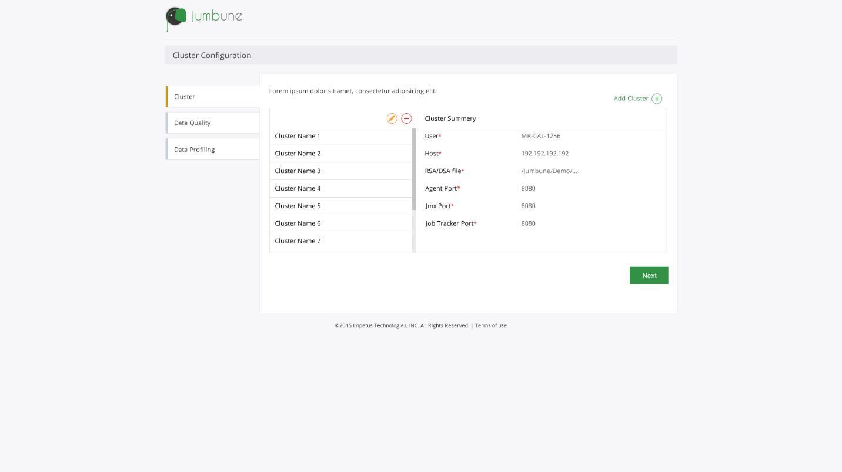

1.3

1.2

1.1

* On the page user can see the list of all defined clusters.
* He can add new cluster configuration by clicking on ***Add Cluster*** button.
* User can select one or more than one cluster.
* When user selects a cluster Edit and Delete buttons will be enabled.
* If user selects more than one cluster then only delete button will be enabled.
* User can see the respective cluster information in ***Cluster Summary*** tab.
* If user clicks on ***Add Cluster*** (1.2) than he will redirected to Define cluster page (1.4).
* On clicking on ***Next*** (1.3) user will be redirected to Define Data Quality page (1.5).

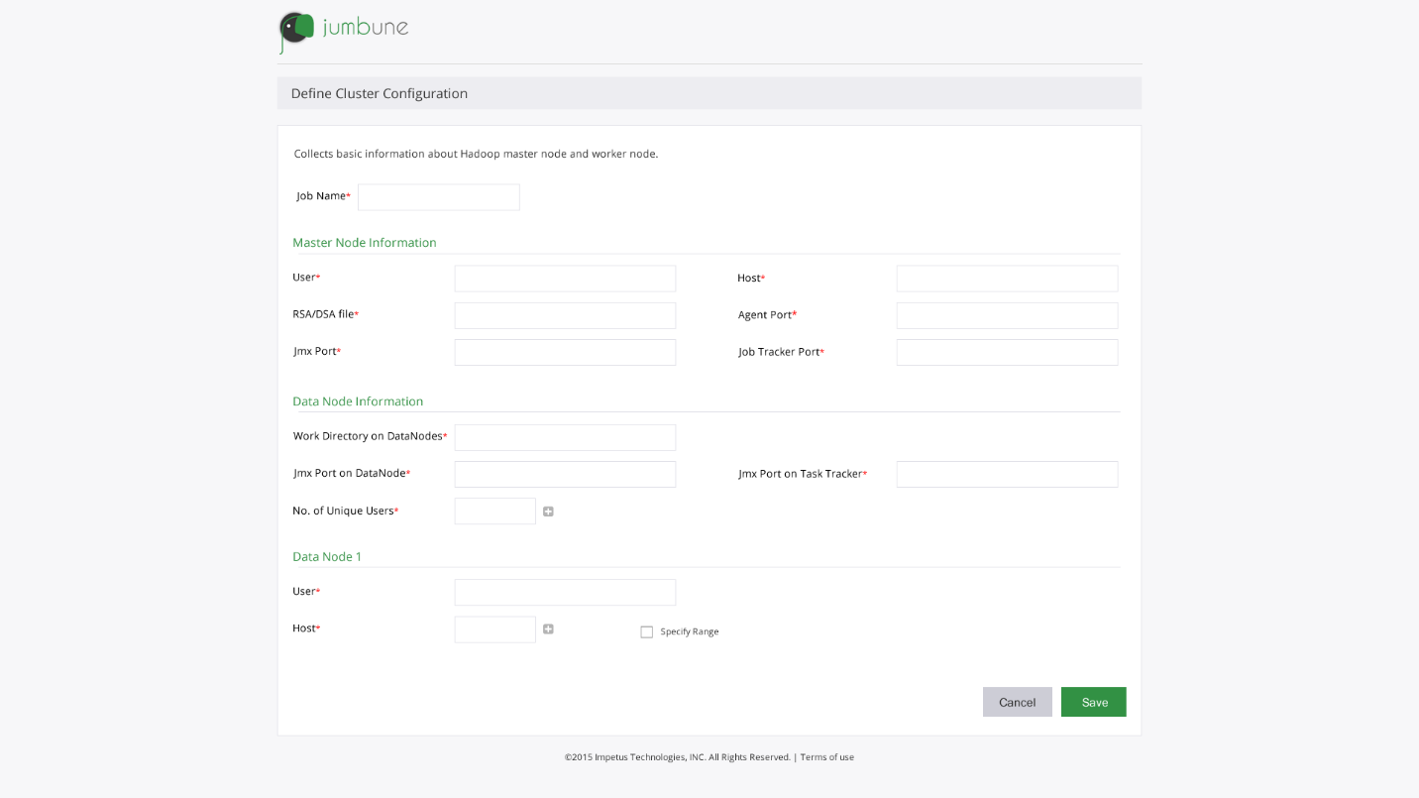

1.4

* After clicking on ***Save*** button cluster configuration will be saved.

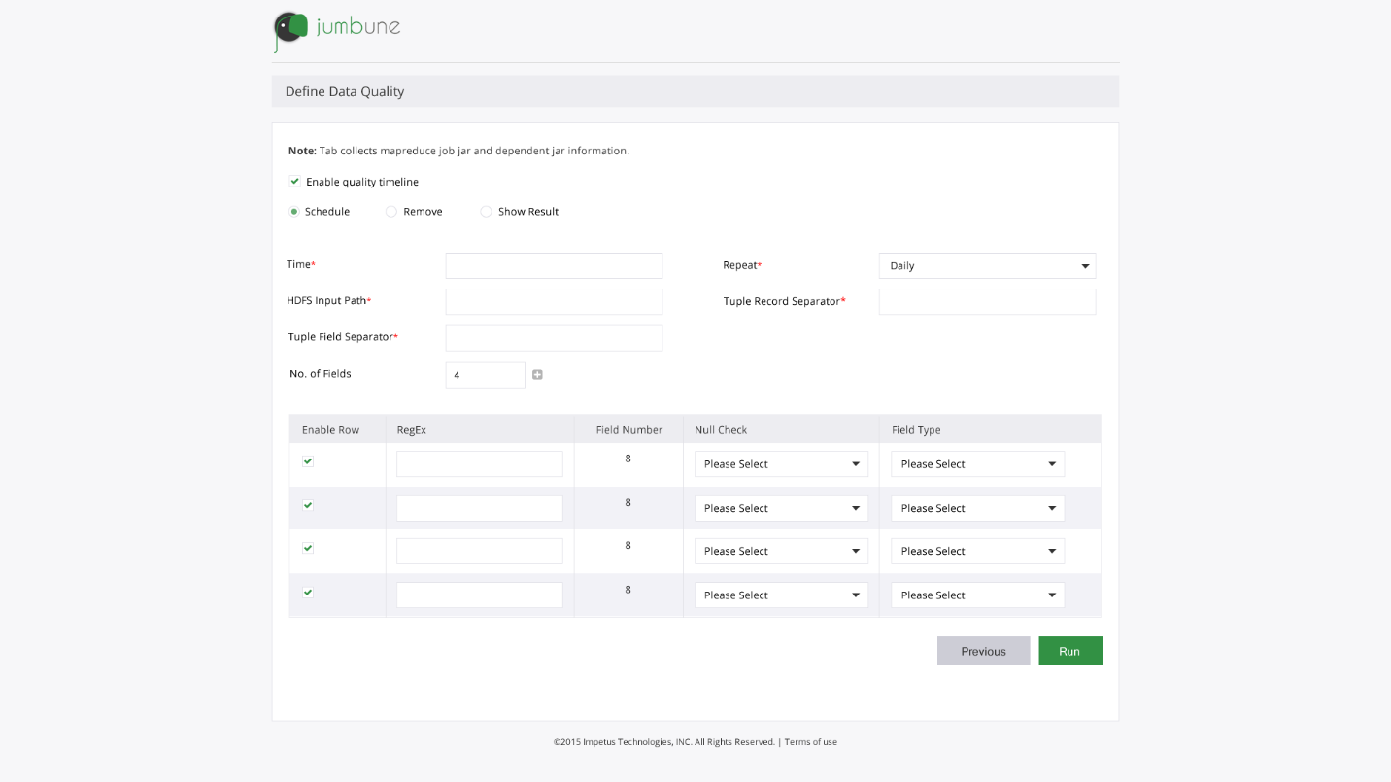

1.5