**Assignment1-Ansible**

**Deploying three (3) Virtual Machines**

Deployed three VM’s with OS as ubuntu using Amazon EC2 instances in Aws portal and naming them as VM1 and VM2 VM3 respectively and generating keypair in order to access the other vm’s from the server

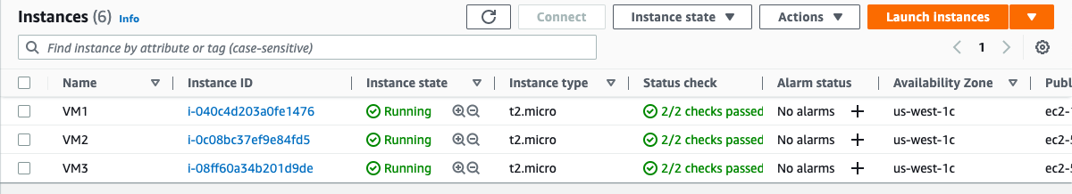

**Installing Ansible on the server**

1. cd .ssh
2. sudo apt-get update && apt-get upgrade
3. sudo apt install ansible
4. ansible –version

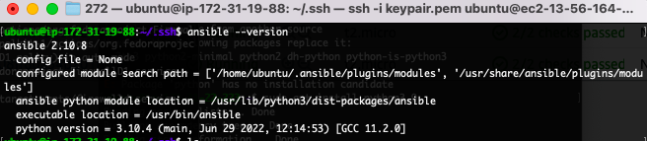

**Uploading the keypair.pem file into the server for further connections with the remaining VM’s**

scp -i desktop/sanjay/272/keypair.pem -r desktop/sanjay/272/keypair.pem ubuntu@ ec2-13-56-164-60.us-west-1.compute.amazonaws.com:/home/ubuntu/.ssh/keypair.pem

**Generating a hosts file**

It contains the details of the two VM’s into which we need to install apache and send the message

Hosts file

[apache]

vm2 ansible_host=54.183.237.185 ansible_ssh_private_key_file=keypair.pem

vm3 ansible_host=54.193.128.181 ansible_ssh_private_key_file=keypair.pem

[all:vars]

ansible_python_interpreter=/usr/bin/python3

**Generating an index file to display message**

Index.html

<head>

<h1>

Hello World from SJSU

</h1>

</head>

**Creating a playbook for deploying the Apache server on the VM’s**

Install.yml

- hosts: apache

become: true

tasks:

- name: install apache2

apt: name=apache2 update_cache=yes state=latest

- name: Copy your index file

template:

src: "index.html"

dest: "/var/www/html/index.html"

**Running the playbook**

ansible-playbook -i hosts install.yml

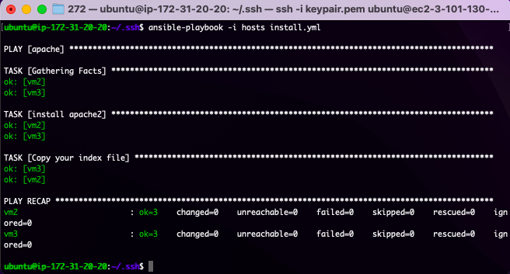

**Output**

We will be fetching the output from the local port from the amazon ec2 instance with the help of public IP provided in the console. We have enable the HTTP and HTTPS in the security groups so the vm will always be listening in the 80 port

**Output from VM2**

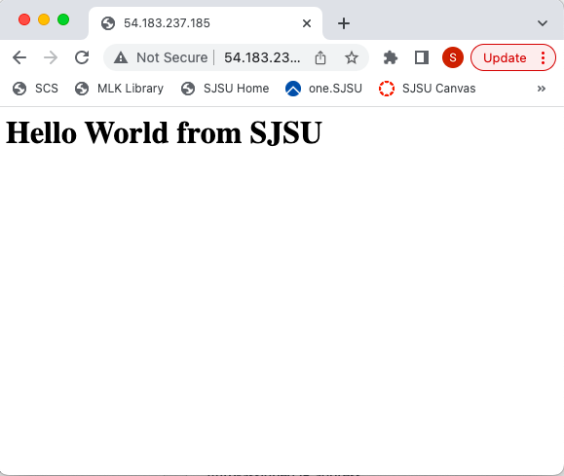

**Output from VM3**

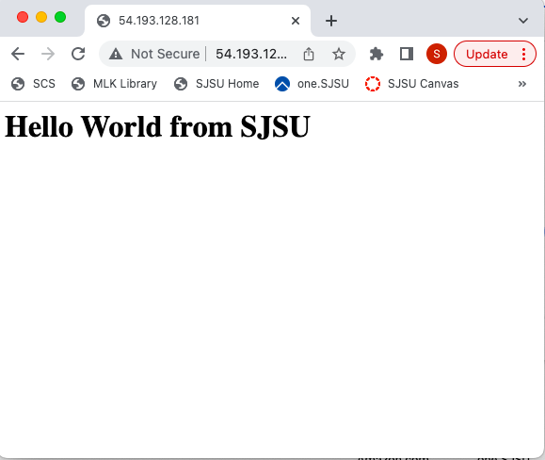

**Creating a playbook for Un deploying the Apache server on VM’s**

Uninstall.yml

- hosts: apache

become: true

tasks:

- name: uninstall apache2

apt: name=apache2 autoremove=yes state=absent

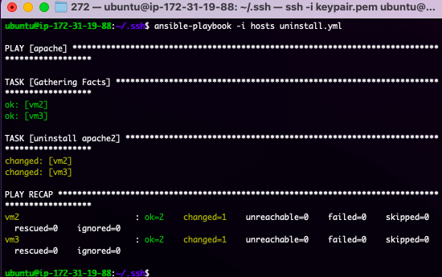

**VM’s after Un deploying Apache server**

**VM2**

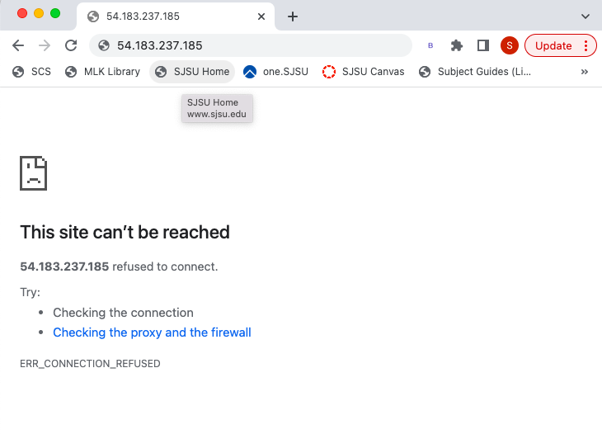

**VM3**

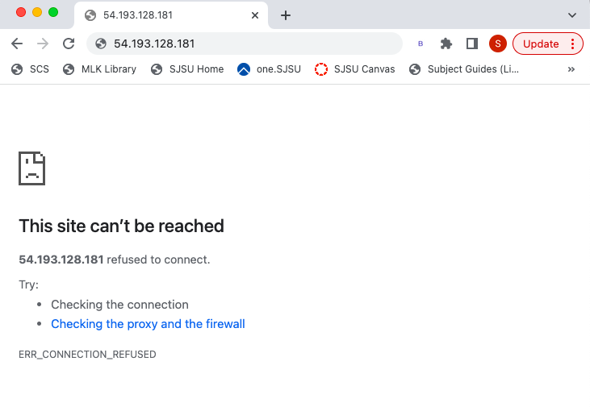

GitHub link for scripts:

<https://github.com/sanjaybhargavm/CMPE272-Assgnment1-Ansible.git>