**HW 2 - Twitter Service**

**Team Name: Spartans**

**Team Members:**

Sanjay Bhargav Madamanchi

Abdul Vahed Shaik

Chirudeep Gorle

Jayanth Vishal Reddy Godi

Sai Pragna Kancheti

Problem Statement:

1.Develop a simple twitter service that implement any Twitter API to to programmatically create, retrieve and delete a Tweet in the Twitter Sandbox environment. e.g.,  ads-api-sandbox.twitter.com  [https://developer.twitter.com/en/docs/ads/general/overview/ads-api-sandbox.htmlLinks to an external site.](https://developer.twitter.com/en/docs/ads/general/overview/ads-api-sandbox.html)

2.Develop a simple Web UI that  implements your service and demonstrates the functions.

The twitter documentation is here:

[https://developer.twitter.com/en/docs/ads/general/guides/getting-started Links to an external site.](https://developer.twitter.com/en/docs/ads/general/guides/getting-started)   <https://developer.twitter.com/en/docs/developer-utilities/twitter-libraries>

Solution:

Creating a developer account in order to get the keys required for the API features to work for creating fetching and deleting tweets

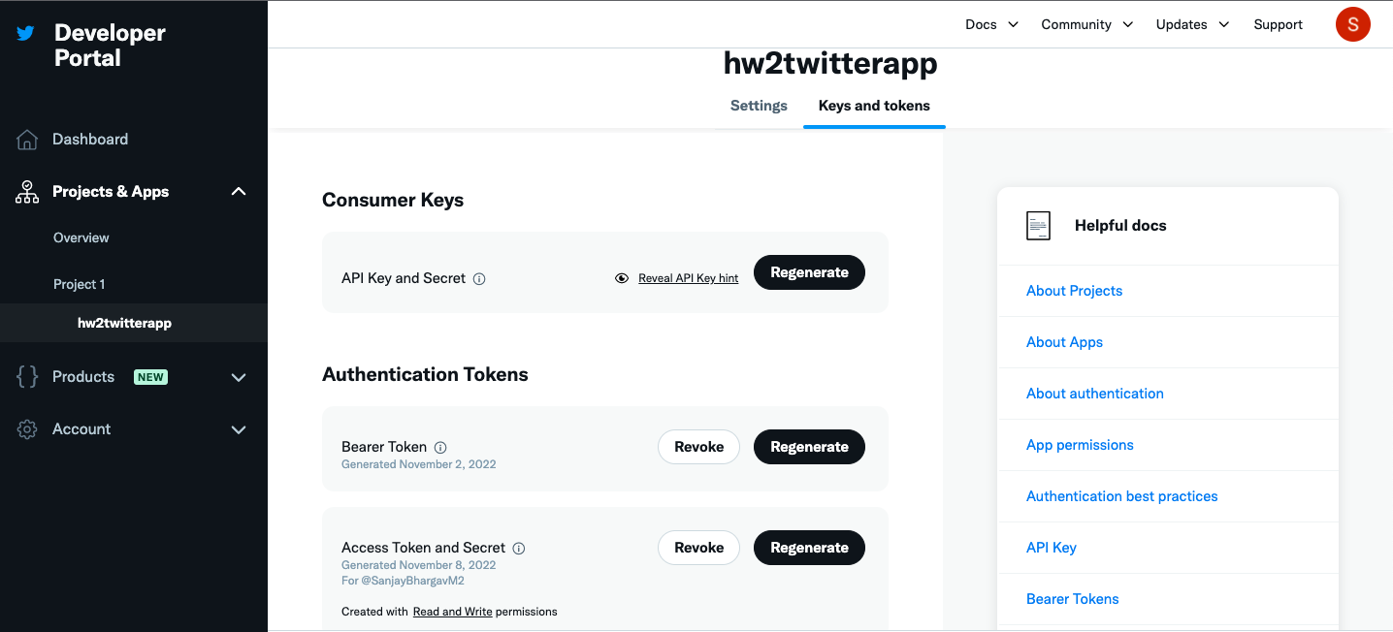

Home page : The home page for twitter service API in order to perform operations

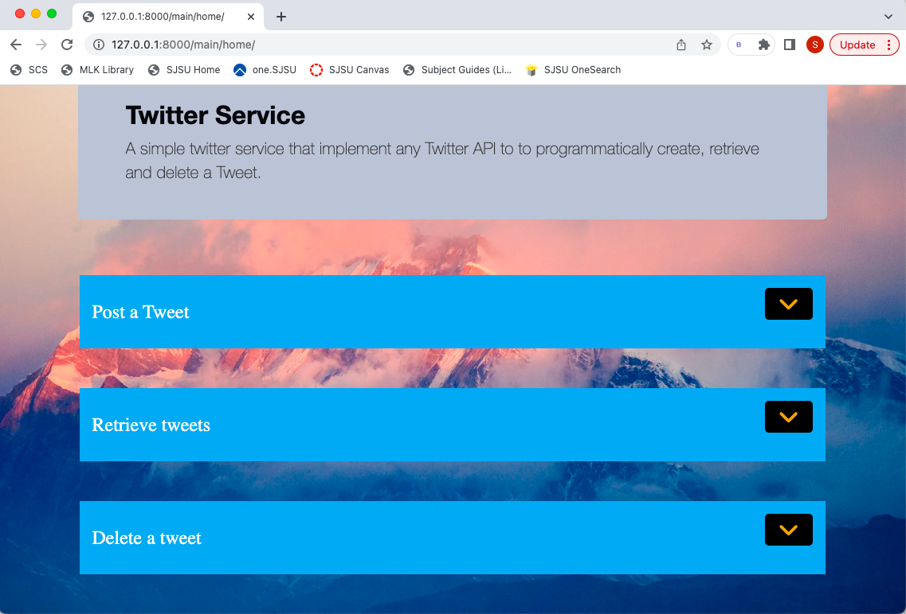

Posting a Tweet:

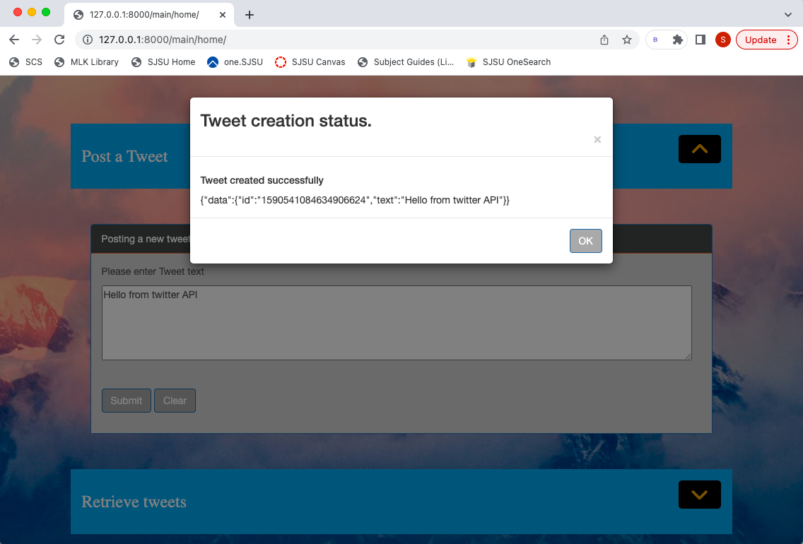

Retrieve a Tweet: In order to retrieve a tweet we need to provide the username of the user we are trying to fetch

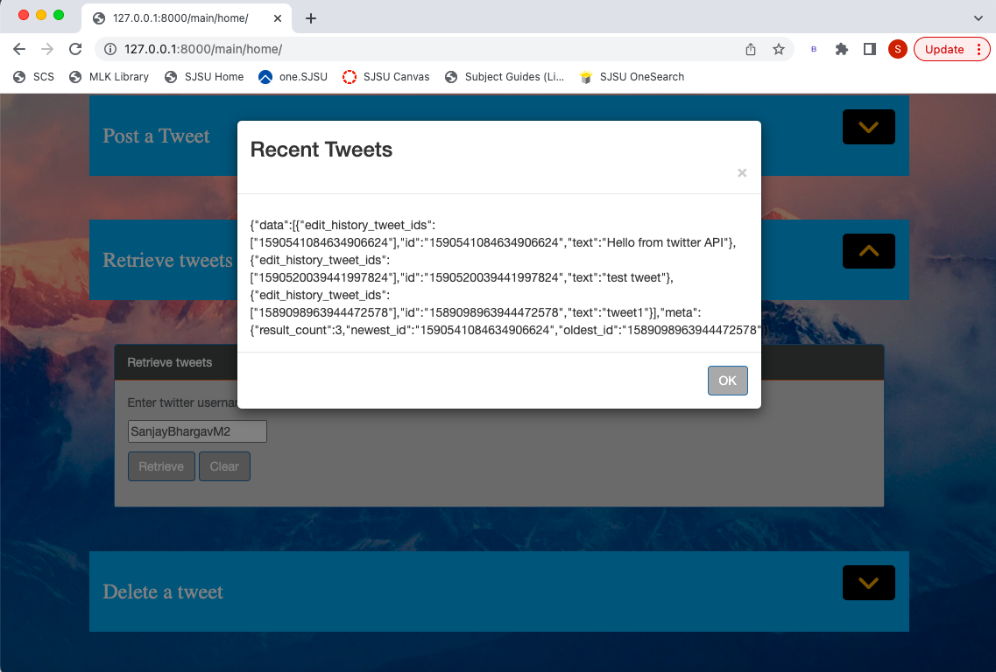

Deleting a Tweet: For deleting a tweet we are providing the id of the tweet we need to delete

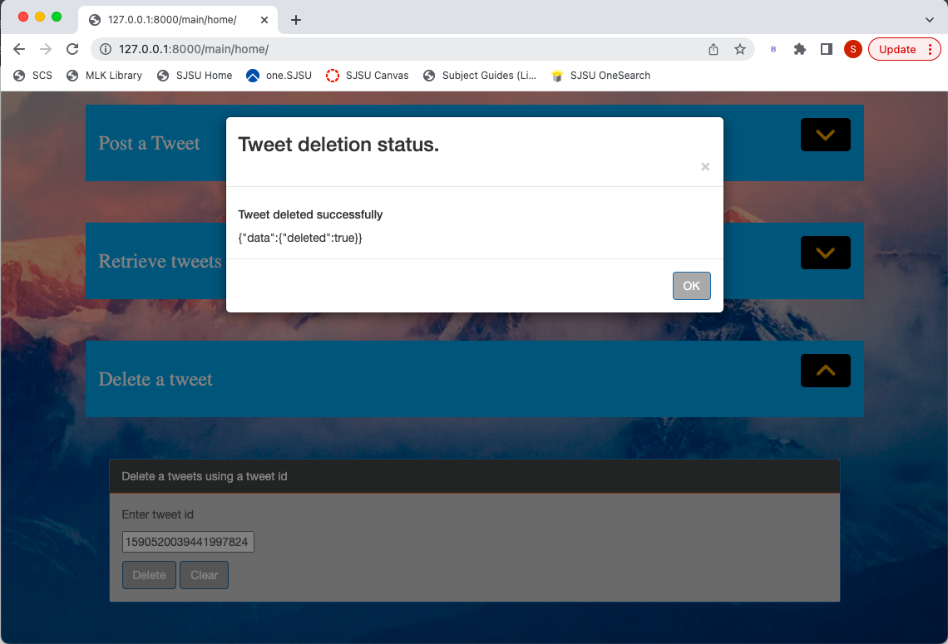

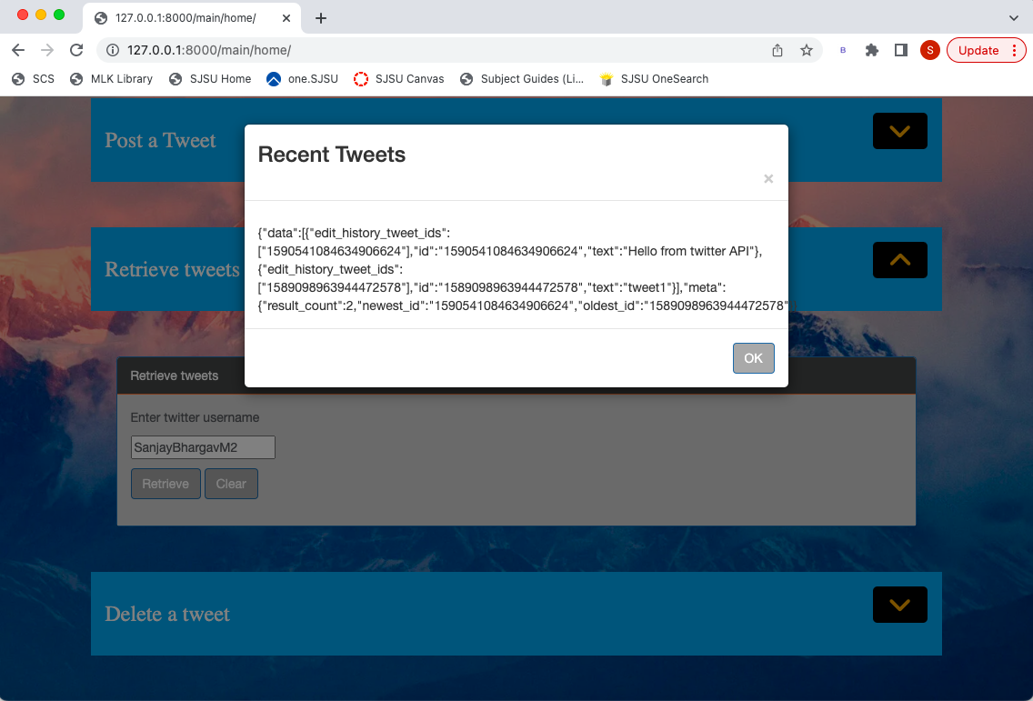

Code: <https://github.com/sanjaybhargavm/CMPE272-HW2-TwitterService.git>