<https://rws7-dev-ed.lightning.force.com/lightning/setup/NavigationMenus/home>

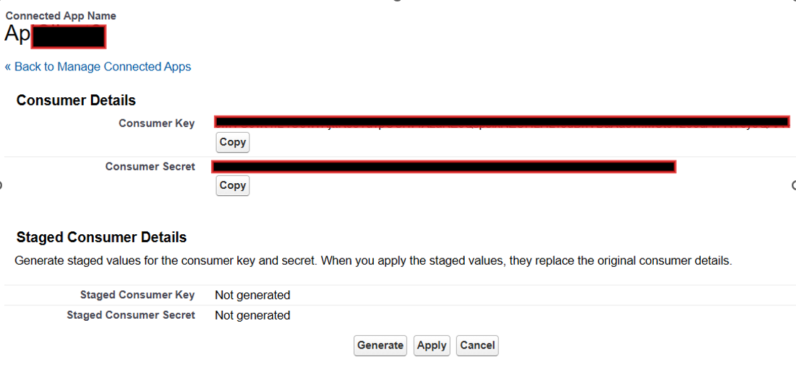

<https://rws7-dev-ed.my.salesforce.com/p/setup/custent/CustomObjectsPage?setupid=CustomObjects&retURL=%2Fui%2Fsetup%2FSetup%3Fsetupid%3DDevTools>

Create Object in the object manager

Visitor Tracking

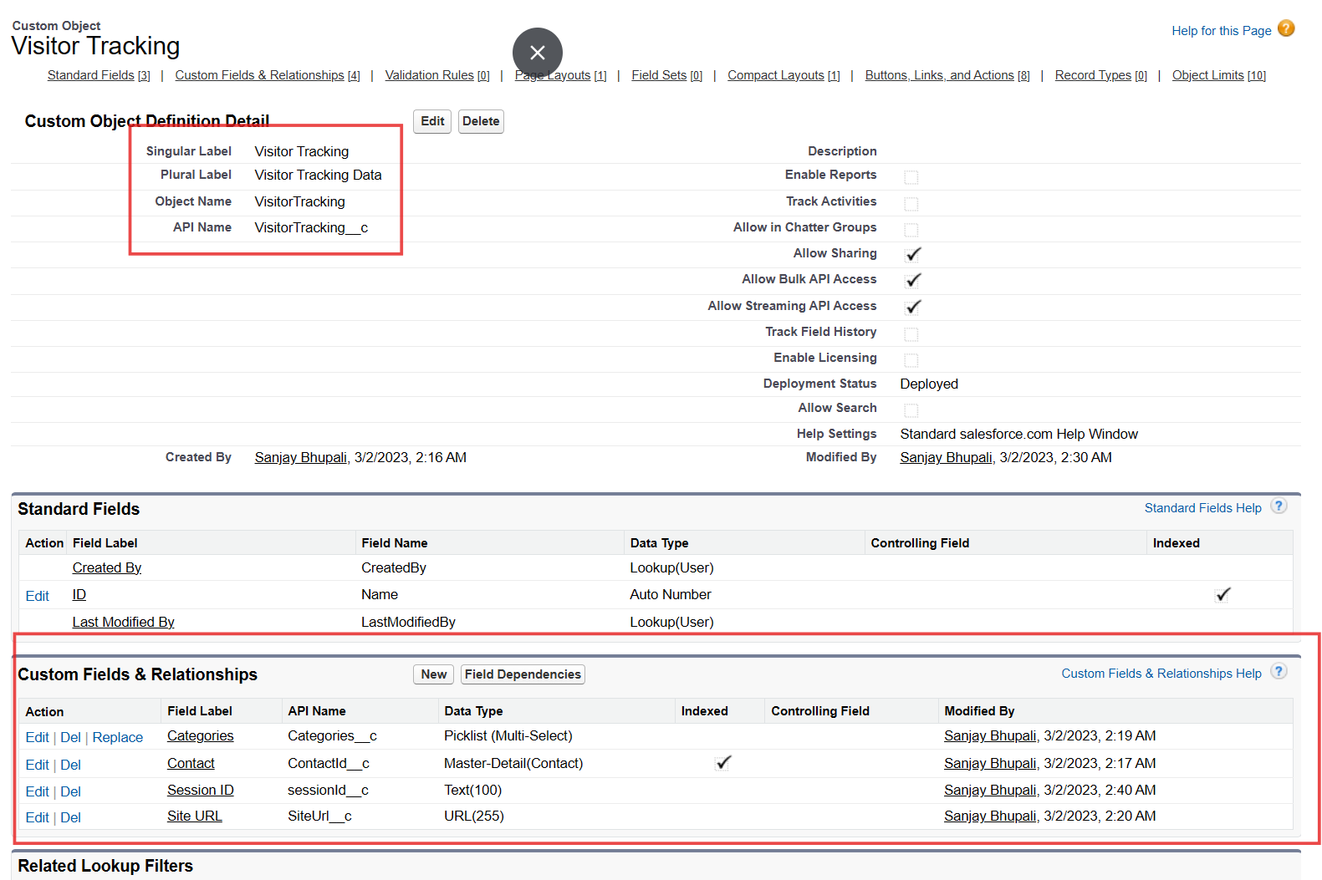

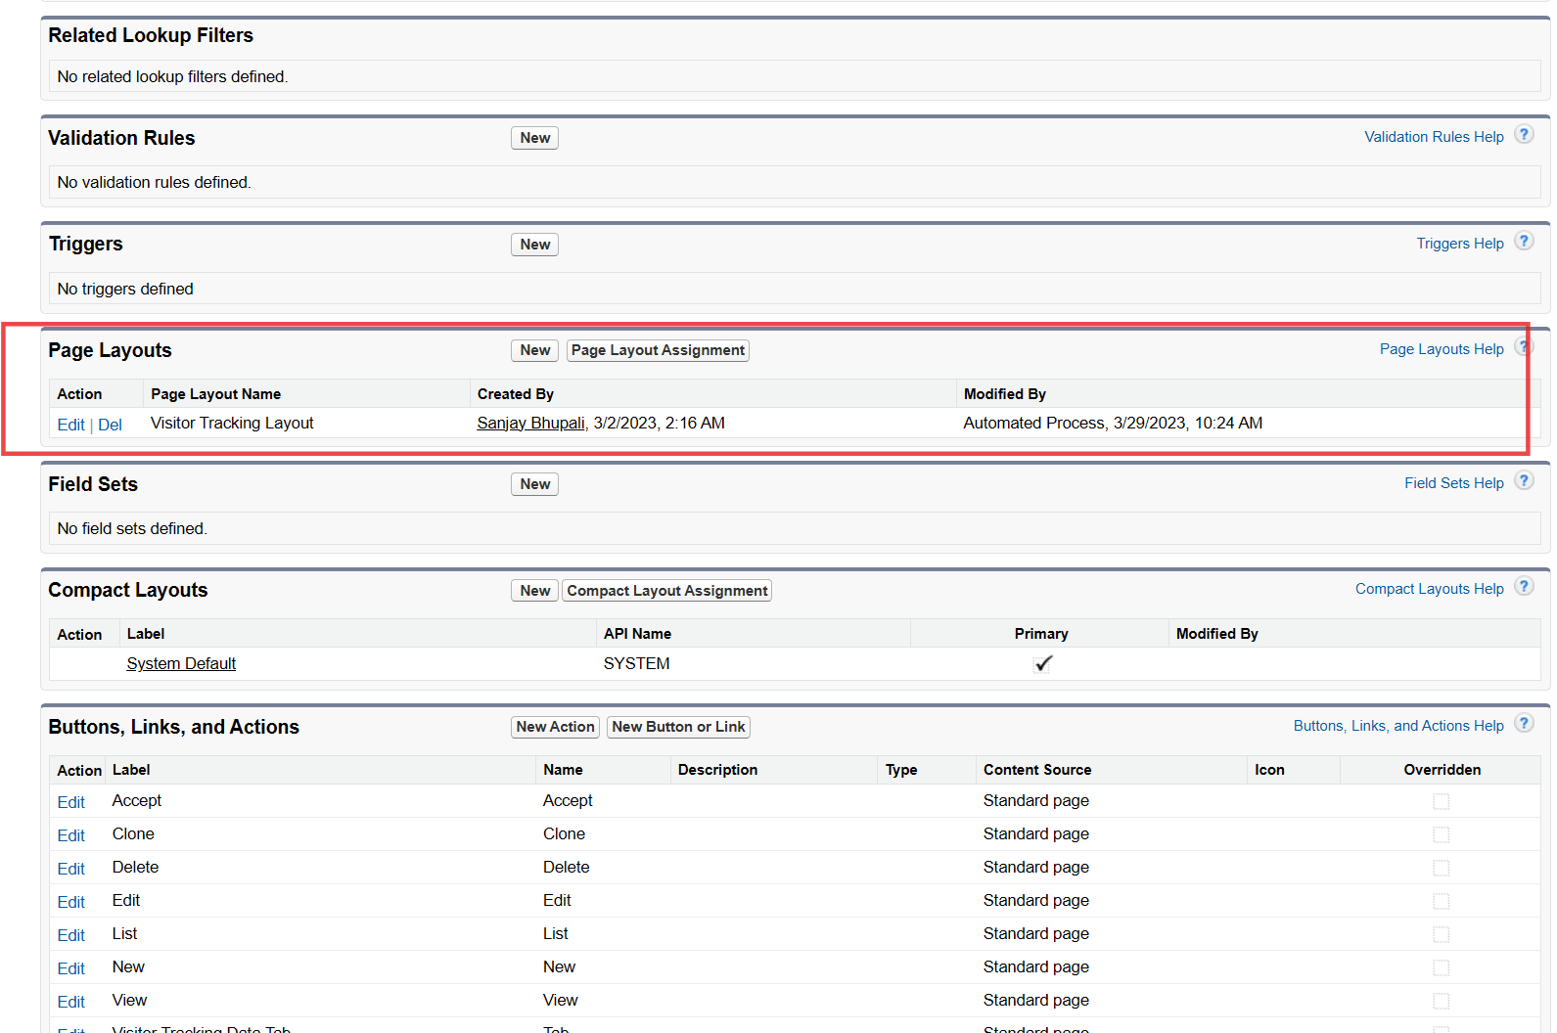

Visitor Tracking Layout

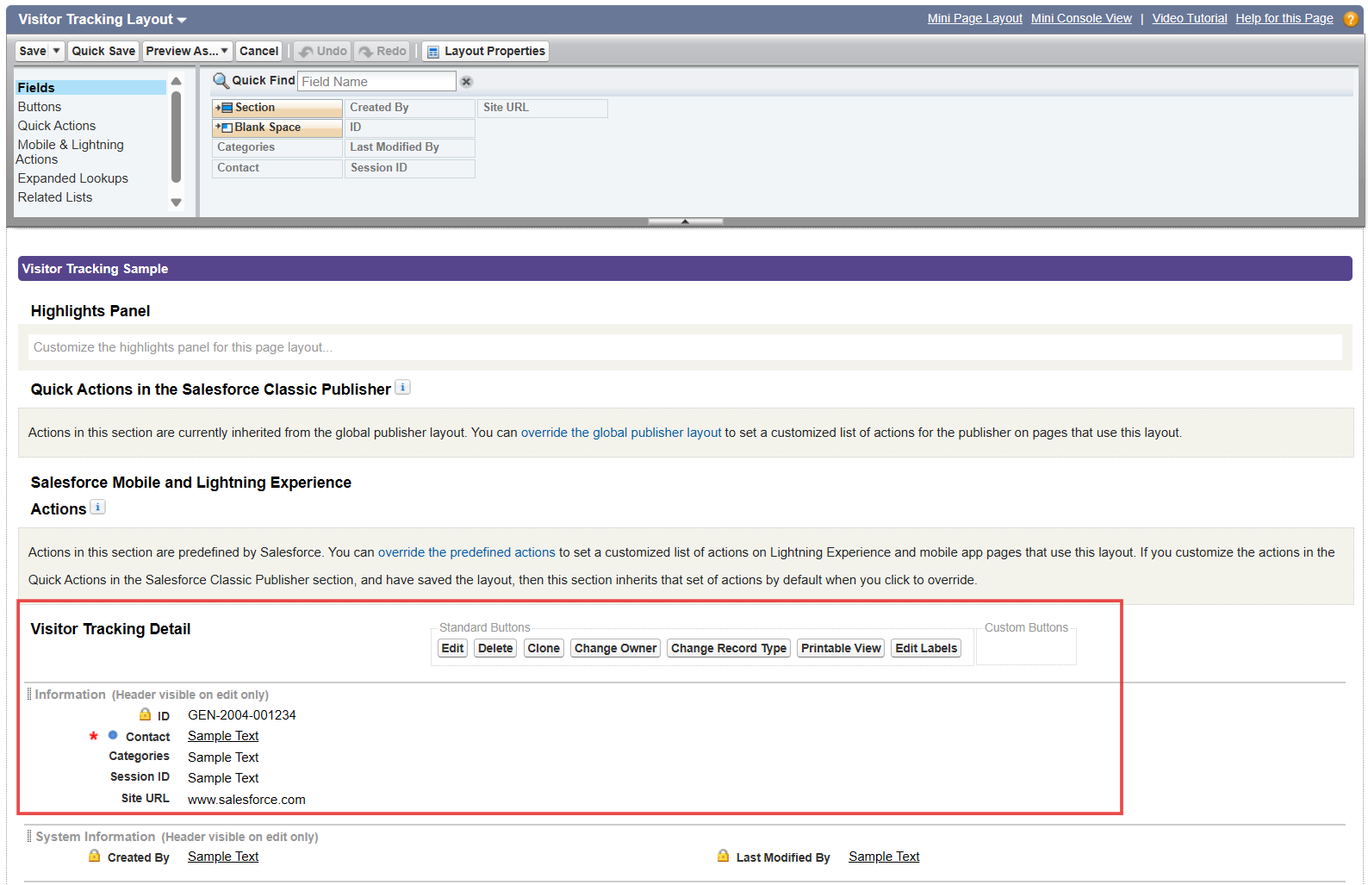

Categories

Contact

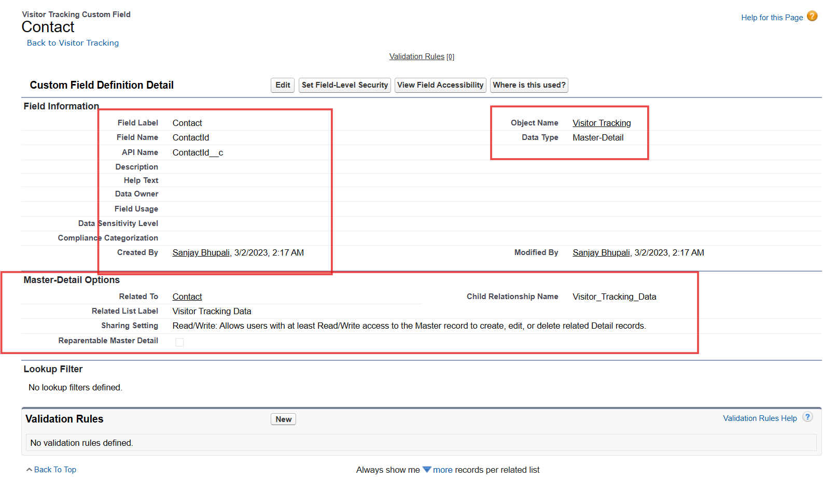

Contact fields

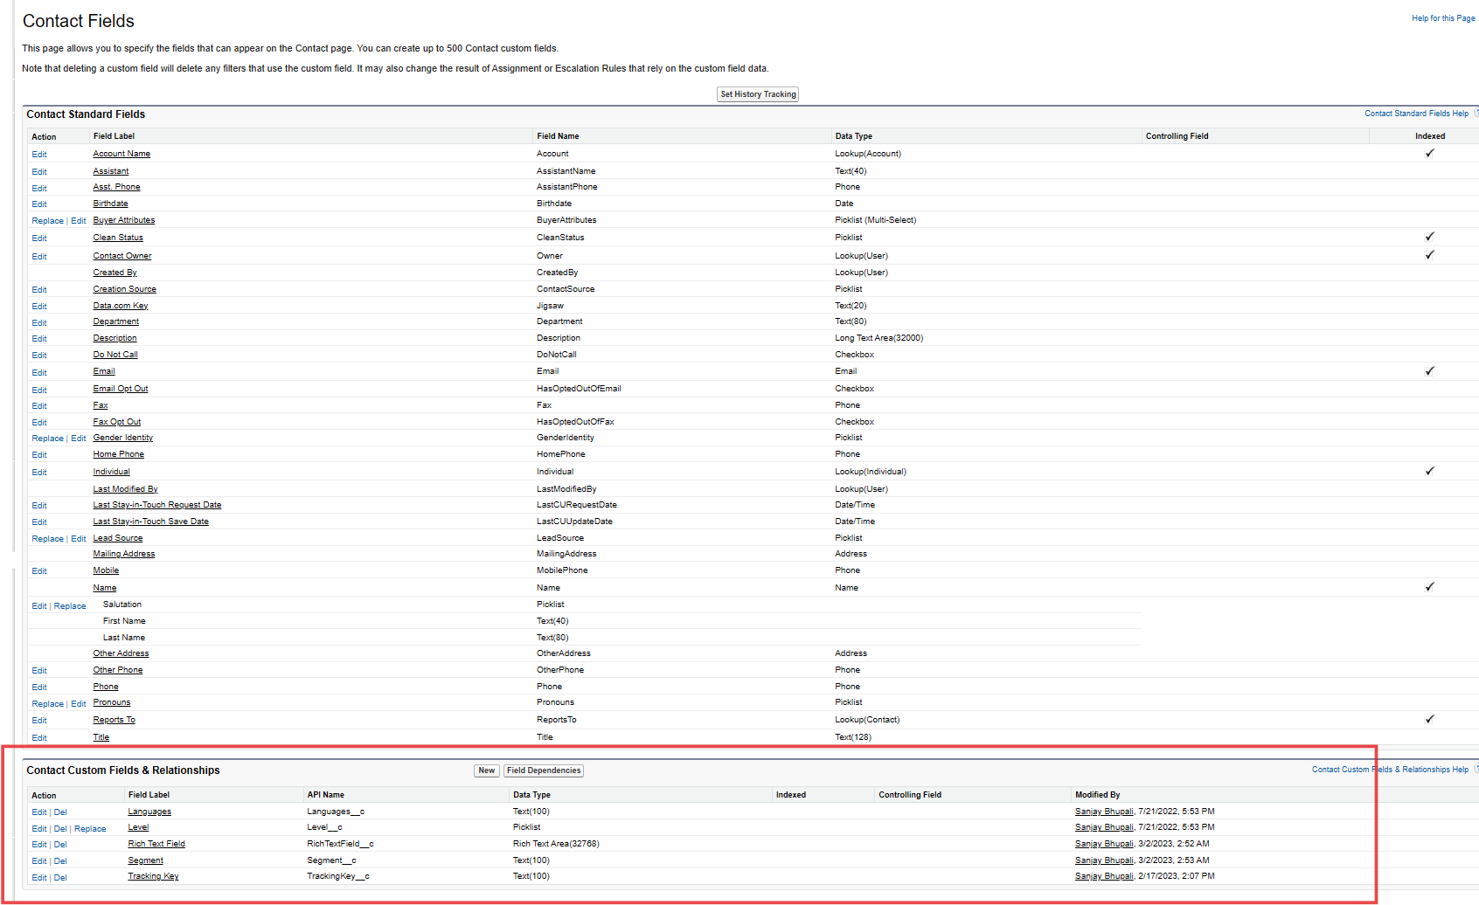

Contact form – Custom fields

Language

Segment

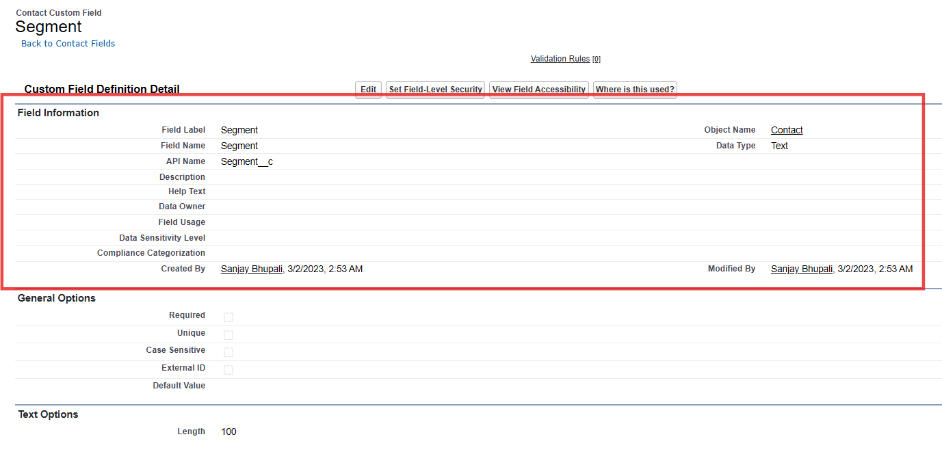

Tracking Key

Rich Text Field

Contact Page Layouts

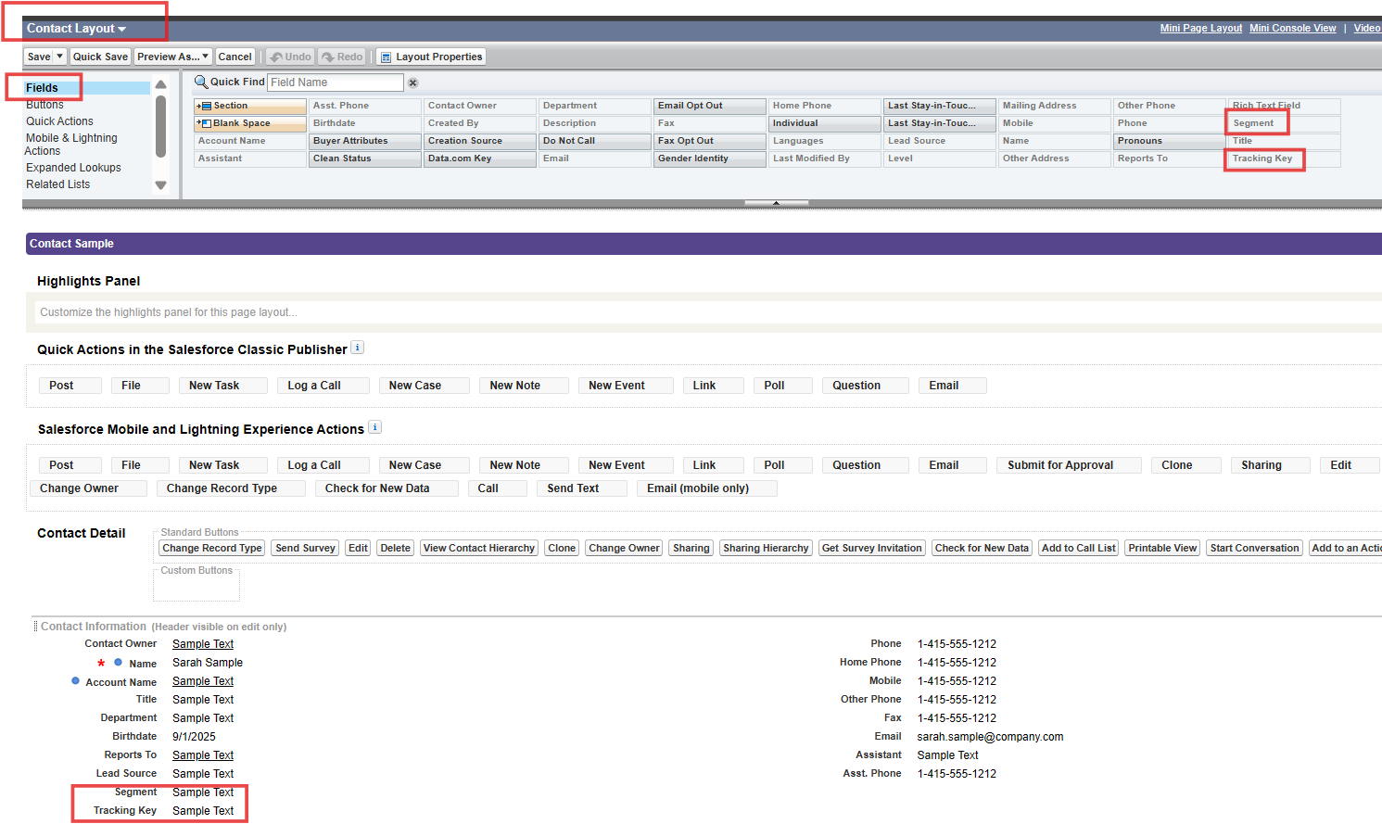

Process Builder

<https://rws7-dev-ed.lightning.force.com/lightning/setup/ProcessAutomation/home>

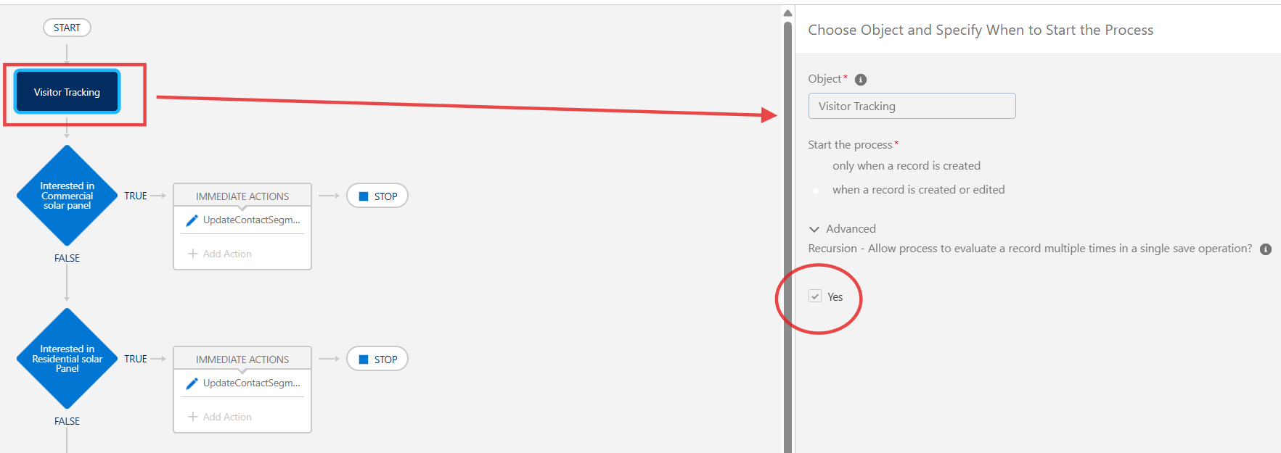

Final workflow

