SIMATS ENGINEERING ASSESSMENT TOOL 1
COURSE NAME: COMPUTER NETWORKS
COURSE CODE: CSA07
COURSE OUTCOME COVERED
CO4:
Design network topologies star, mesh, bus, and hybrid using networking devices, transmission media, and cabling standards (BL2,BL6)
Assessment Tool Weightage: 40%
QUESTIONS: 10 Total Marks:50
Annexure A Coding challenge
Code of Conduct:
I __S Sanjay charan (192312373)____________ (Name / Reg No) certify that this submission is my original work and that I have adhered to the guidelines specified for this assessment.
I understand that any violation of academic integrity rules will result in disciplinary action.
Signature of the student:charan

Annexure A
Coding challenge
- Write a Python script that generates a star topology diagram (ASCII or graphical) given n hosts and a central switch. The script must print each host label, the switch name, and the connecting Cat6 UTP cable length.
A .

PROGRAM CODE :
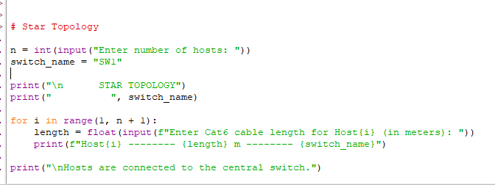

OUTPUT :
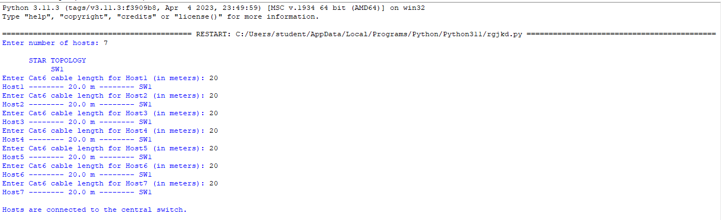

- Code a function `validate_segment(length_m)` that returns True if the UTP segment is within IEEE 802.3 limits (≤100 m) and False with an error message otherwise. Include at least 3 test cases.
A .

PROGRAM CODE :

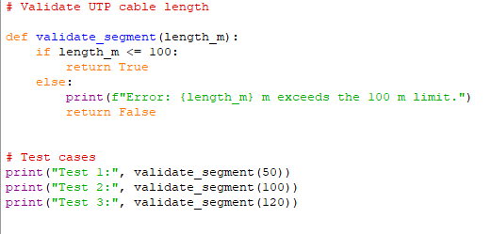

OUTPUT :

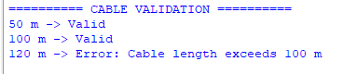

- Write a script that simulates CSMA/CD on a star topology with 4 hosts. Log every collision detection event and the back-off interval to a file named `csma_log.txt`.

A .
PROGRAM CODE :
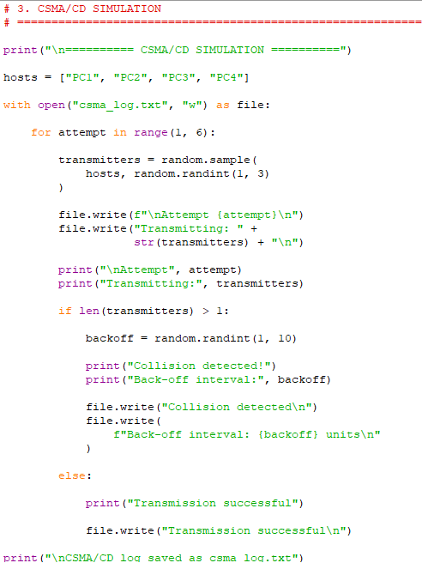

OUTPUT
: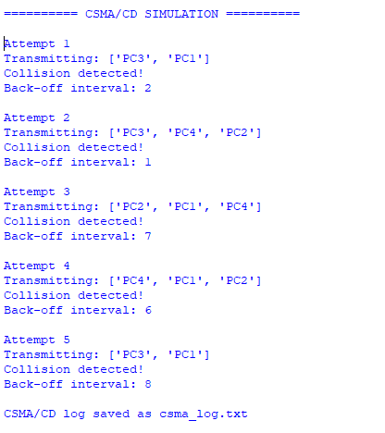

- Using Python's `socket` library, write a client-server program that models two hosts communicating through a star switch. Demonstrate message forwarding by printing the switch's MAC address table after each frame transmission.
A .
PROGRAM CODE :
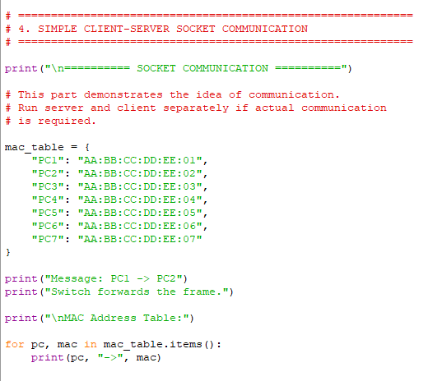

OUTPUT :
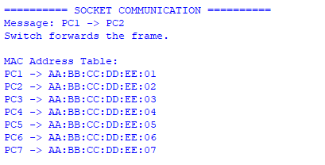

- Create a class `StarSwitch` with methods `add_port(host_id)`, `remove_port(host_id)`, and `broadcast(frame)`. Broadcast must send a frame to all ports except the source and log each delivery.
A .
PROGRAM CODE:
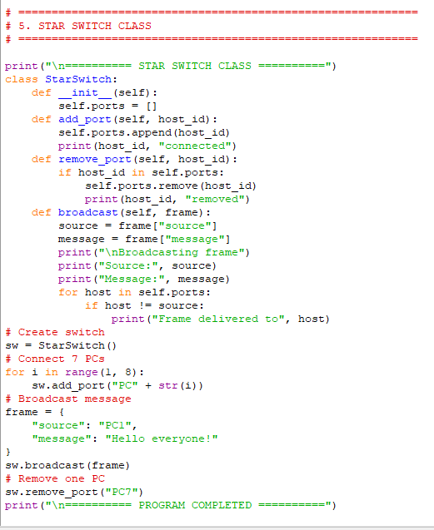

OUTPUT :
