**DAA PROJECT REPORT**

**TEAM MEMBERS :**

Sanjay Chari

PES1201700278

Section : G

Vishnu S. Murali

PES1201701624

Section : G

**ABSTRACT :**

The main functionality of the project is converting an epsilon NFA, taken as input from the user, to a DFA, which accepts the same language as the epsilon NFA.

**HIGH LEVEL ALGORITHM :**

Algorithm Closure(A,i,m,n)

State <- A[i]

Closure <- []

k<-0

cstate <- State[n-1]

Closure[k] <- cstate

k <- k+1

while cstate is not ‘-‘

State <- A[cstate]

Cstate <- State[n-1]

Closure[k] <- cstate

k <- k+1

return Closure

Algorithm NFA_TO_DFA(A,m,n)

State <- A[0]

K<-0

States <- []

B <- []

While state not in states

States[k] <- state

K <- k+1

Transition <- []

for i <- 0 to n

transition.append(closure(A[i]))

state<-closure(A[i])

B.append(transition)

Return B

**TEST RESULTS :**

**INPUT TO PROGRAM :**

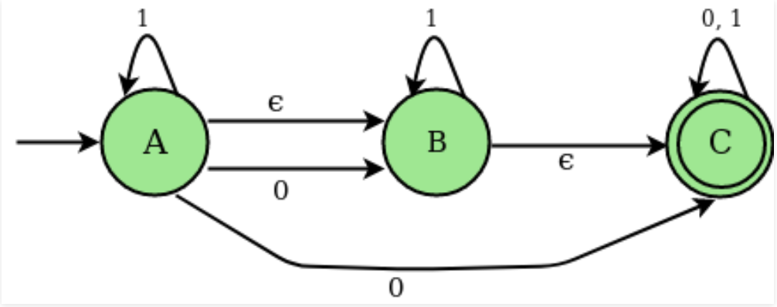

**OUTPUT OF PROGRAM :**

