Project-Github-Link: https://github.com/sunnysavita10/ecomm-prod-assistant

These are all the commands that you need to run on your command prompt

- Write Python in your terminal
- If you have Python, then no need to install it
- uv --version
- If you are not able to get the version
- Pip install uv
- import shutil
- print(shutil.which("uv"))

- 6. Uv init <my-project-name>
- 7. uv pip list

- 8. uv python list
- uv venv env --python cpython-3.10.18-windows-x86_64-none
- uv venv <your-env-namne> --python <your-python-version>
- Note: Please use either 3.10, 3.11, or 3.12
- Command Prompt (CMD) .\<your-env-nanme>\Scripts\activate.bat
- Git Bash ya WSL terminal, or MAC Terminal:
  - source <your-env-nanme>/Scripts/activate

18. If your git is asking for a login to publish the repo, execute the command below
  - git config --global user.name "Your Name"
  - git config --global user.email "your-email@example.com"
19. UV add <package_name>
20. Uv add -r requirements.txt
21. Streamlit run <give your streamlit python filename>
22. Install the live server extension in VS Code for testing the HTML

For accessing the DataStax, here is a link: https://accounts.datastax.com/session-service/v1/login

Vectordb Comparison: https://superlinked.com/vector-db-comparison

Once you log in to the DataStax Vector page, you will get the following page

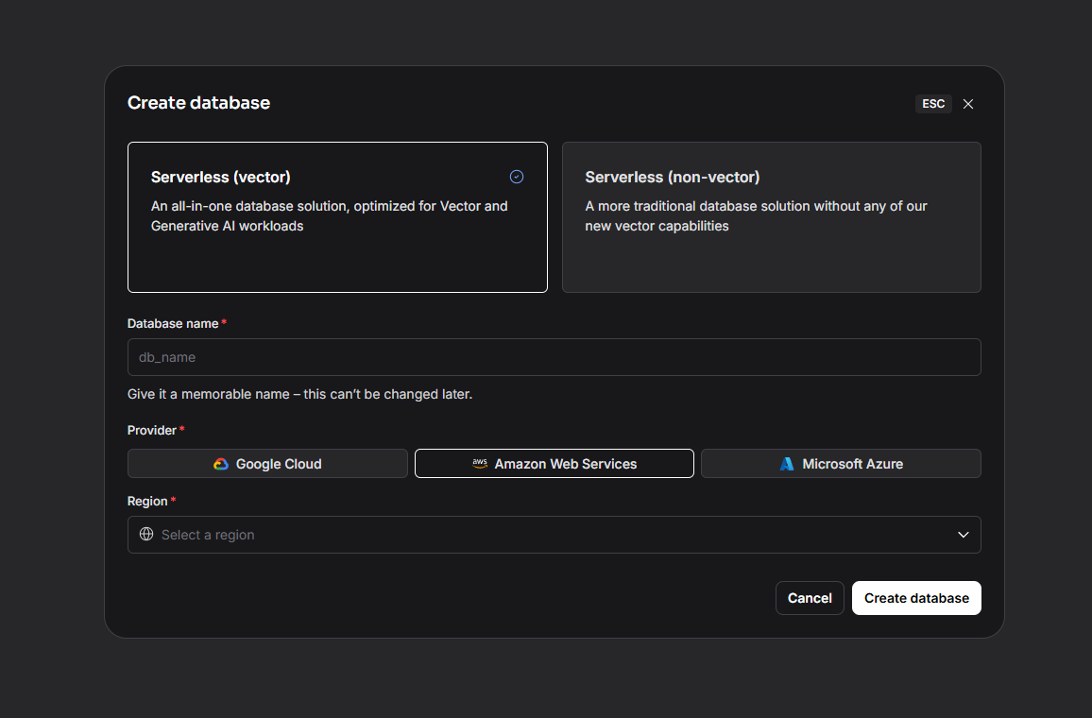

For running the streamlit UI, the command is:

streamlit run <file_path_of_streamlit_python_file>

For installing your prod_assistant as a package use the .toml file

For install the package through the toml file here is a command

Uv pip install -e .

Or mention -e . in th requirements.txt and run the command

uv pip install -r requirements.txt

(NOTE: Same thing we can do with the setup.py file and we have already done it in the previous project)

Command for executing the fastapi:
uvicorn prod_assistant.router.main:app --reload --port 8000

Command for running the streamlit app
Stream run <your_file_name.py>

Step to the run the application:

- First run the mcp server:

D:\complete_content_new\llmops-batch\ecomm-prod-assistant\prod_assistant\mcp_servers\product_search_server.py

- If you want to test your application you can in two ways

First: with client.py file
Second: from agentic workflow

Note: use the latest workflow:
D:\complete_content_new\llmops-batch\ecomm-prod-assistant\prod_assistant\workflow\agentic_workflow_with_mcp_websearch.py

Note: please use your system path not mine

- Now after testing run the application from api and test it via ui your application will be running on this url
http://127.0.0.1:8000/
uvicorn prod_assistant.router.main:app --reload --port 8000

docker ps # running containers check karne ke liye
docker stop <container_id>
docker rm <container_id>
docker images # images list check karne ke liye
docker rmi <image_id>

Build Docker Image
Use this command: docker build -t prod-assistant .

Run Docker Container
docker run -d -p 8080:8080 --name <container_custon_name> <give image name which you have created using dockerfile>

Use this command:
docker run -d -p 8000:8000 --name product-assistant prod-assistant

${{ secrets.AWS_ACCESS_KEY_ID }}
${{ secrets.AWS_SECRET_ACCESS_KEY }}
${{ secrets.AWS_REGION }}
${{ secrets.ECR_REGISTRY }}
${{ secrets.ECR_REPOSITORY }}
${{ secrets.EKS_CLUSTER_NAME }}
${{ secrets.GROQ_API_KEY }}
${{ secrets.GOOGLE_API_KEY }}
${{ secrets.ASTRA_DB_API_ENDPOINT }}
${{ secrets.ASTRA_DB_APPLICATION_TOKEN }}
${{ secrets.ASTRA_DB_KEYSPACE }}

Keep the scerates without the double quote

Link for downloading the aws CLI: https://docs.aws.amazon.com/cli/latest/userguide/getting-started-install.html

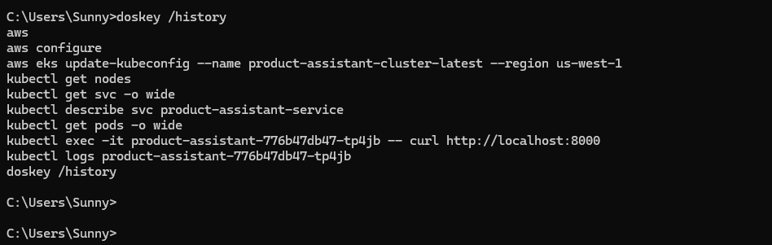

Once deployment is done then after for getting all the details through your CLI you need to execute some important commands

Aws eks update-kubeconfig –name <eks-cluster-name> –region <write_aws_region>

Kubectl get nodes
Kubectl get svc -o wide
aws
aws configure

aws eks update-kubeconfig --name product-assistant-cluster-latest --region us-west-1

kubectl get nodes
kubectl get svc -o wide
kubectl describe svc product-assistant-service
kubectl get pods -o wide

kubectl logs <write_your_pod_id>

doskey /history

