Project Github: https://github.com/sunnysavita10/automated-research-report-generation

Command for UV:

- uv –version
- If uv is not there then install the uv
- pip install uv
- Once you got the uv
- Write this command- uv init <project_name>
- Open the project in VS Code

You can also take an alternative approach
- First, create a new folder
- Open it inside VS Code
- Over the VS Code terminal, write this command: uv init

To create a virtual environment, follow the command below
You can simply write-> uv venv for creating a virtual environment

It will create a virtual env with the default name .venv (this will be the name of the env)

If you want to create with a custom name, follow the command below
uv python list
uv venv <your-env-namne> --python <your-python-version>

Activate the environment
.venv\Scripts\activate.bat

Note: If it is a custom env then copy the path from that folder

uv add -r requirements.txt

uv add ipykernel

Website for getting Tavilay API key for search the web
https://app.tavily.com/home

#26-0ct-2025
##steps for running the application
- Install the requirements.txt and update your virtual env
uv pip install -r requirements.txt

- commad for running the api
uvicorn research_and_analyst.api.main:app --reload
uvicorn research_and_analyst.api.main:app --host 0.0.0.0 --port 8000

TO check the record in the user.db install this extension in vscode: SQLite Viewer

#1st of NOV
Installation link for the Azure CLI: https://learn.microsoft.com/en-us/cli/azure/install-azure-cli-windows?view=azure-cli-latest&pivots=msi
Verify the installation of Azure CLI by writing below in your terminal

az –version

Deployment command:

Microsoft Azure Portal: https://azure.microsoft.com/en-us/get-started/azure-portal

az login
or
az login --username <your_mail>
It will give you the error
Error in the red character
It will ask to set up the subscription

az login --tenant <KEEP_YOUR_TENANT_ID> <you will get it from console open the subscription, and copy from there the name of the tenant on the console is Parent management group>
az login --tenant <KEEP_YOUR_TENANT_ID> --use-device-code
az account set --subscription <KEEP_YOUR_SUBSCRIPTION_ID>

az account list --output table
az account list
az account show
az group list
az login

If nothing is working, run this
az logout
az account clear
rmdir /s /q "%USERPROFILE%\.azure"
az login --use-device-code
az account list -o table

bash ./azure-deploy-jenkins.sh
bash ./build-and-push-docker-image.
Sh

Stage 1 of the deployment:
- Setup the azure account
- Setup the azure cli
- Create a file and write the config inside

Stage 2 of the deployment:
- Run the shell script
- Set up the Azure resource
- Set up the Jenkins server
- Build the image
- Push it to the ACR
- Deploy it to the container

##2nd NOV

If az is not coming in your vs terminal then do this
- Write where az on your cmd
- Then you will get the path of az
- Then open the vs code
- Open command pallet (view>command pallet)(shortcur is ctrl+shift+p)
- Then type there: Preferences: Open Settings (JSON)
- {
"python-envs.pythonProjects": [],
"terminal.integrated.env.windows": {
"PATH": "C:\\Program Files\\Microsoft SDKs\\Azure\\CLI2\\wbin;${env:PATH}"
}
}
IMP NOTE: PATH should be your path from cmd

Follow the steps below for deploying your application:
Jenkins→ open source self-hosted CI/CD tool
- azure-deploy-jenkins.sh
- Dockerfile.jenkins
- These are the two files that are required for us to set up Jenkins over Azure

What is this .sh→ sh stand for shell script
In .sh file we write all the command which we want to execute over the terminal
Terminal→azure cli
Why bez we have configure az login

Make sure your docker engine is running
Run the .sh file: bash <path-of-your-sh-file>

After running this file you will get two things:
- URL: url of your jenkins which is running under the container over the azure
- Password for login:
- If you will do it first time then copy the one time password from terminal and paste it over the jenkins UI
- Then setup the plugins
- It will atleast 5 - 10 mints
- If you will do it second time then
- Use username: admin
- And password you will over the terminal

If you are getting error: subscription id is not there then check with this command

az login --tenant <KEEP_YOUR_TENANT_ID> <you will get it from console open the subscription, and copy from there the name of the tenant on the console is Parent management group>

az login --tenant <KEEP_YOUR_TENANT_ID> --use-device-code

az account set --subscription <KEEP_YOUR_SUBSCRIPTION_ID>

az provider register --namespace Microsoft.ContainerRegistry
az provider register -n Microsoft.Storage --subscription <subscription_id>

az account list --output table
az account list
az account show

After completing everything you will get a image of custom jenkins under this location:
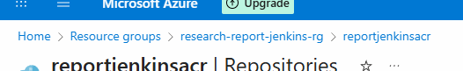
After reaching to this location open service/repository

After open the jenkins tick mark this check box:
Where you will get it:
You will get under settings<it is gear icon at right top>/security

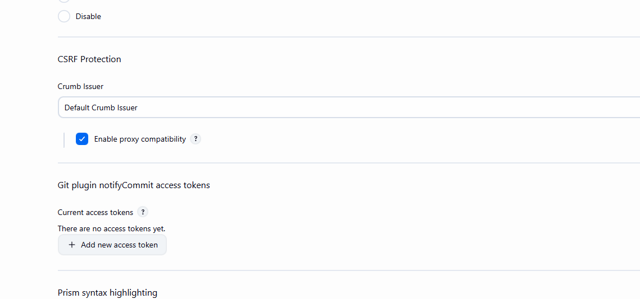

Now the next step setup the infra:

So command is:

bash setup-app-infrastructure.sh

After this you will get a secrate for making connection between jenkins and azure

Below is the secrate

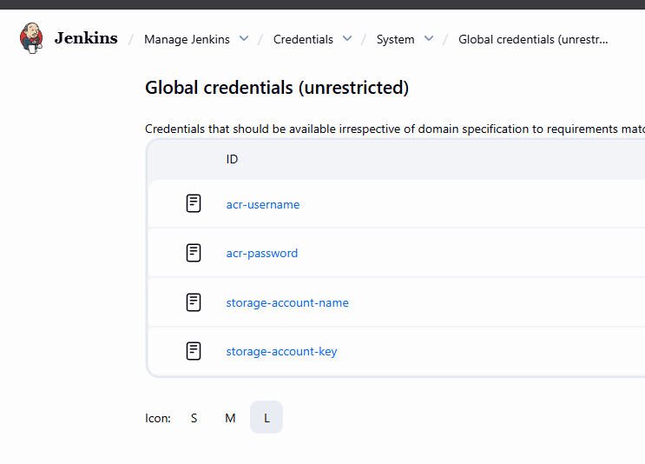

You will get a key and a value both over the terminal

Add it at the appropriate location

Add few more credentials:

You will get those credentials using these commands

az ad sp create-for-rbac \
--name "jenkins-research-report-sp" \
--role Contributor \
--scopes /subscriptions/$(az account show --query id -o tsv)

Use of this command: It will create a Service Principle in azure with role based access

After running you will get a json:

azure-client-id: appId
azure-tenant-id: tenant
azure-client-secret: password
azure-subscription-id: az account show --query id -o tsv

Openai-api-key
Google-api-key
Groq-api-key
Tavily-api-key
Llm-provider

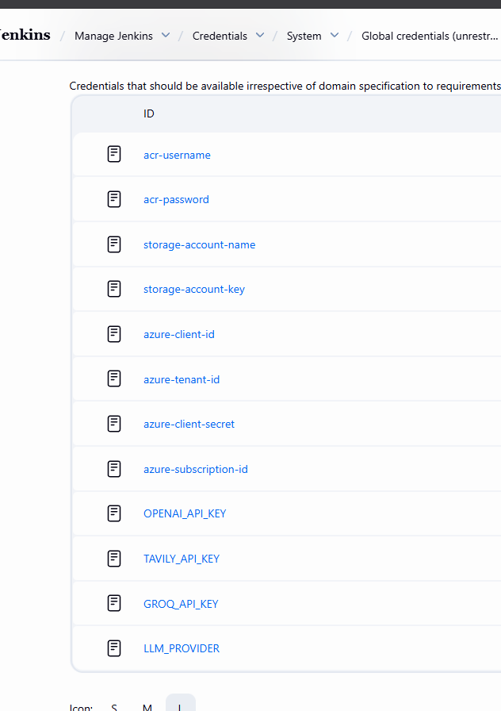
Configure these keys in the Jenkins global variable

The next setup would be to

Build the Docker image from our application and push to it to ACR hub
Below is the command
build-amd-push-docker-image.sh

configure the Jenkins pipeline:
new-item/pipeline
Now follow the video for further configuration

Then add the
Add the webhook in the github:

