Github Link of the project: https://github.com/sunnysavita10/Finetuning-on-aws

Step 1: Create IAM Roles
We’ll create two roles:
• SageMakerLLMRole
• LambdaInvokeLLMRole
You can write custom name

A. Create SageMaker role

a. Go to AWS Console → IAM → Roles → Create Role
b. Choose AWS Service → SageMaker
c. Attach policies:
AmazonS3FullAccess
AmazonSageMakerFullAccess
CloudWatchFullAccess

B. Create Lambda role
a. Go to AWS Console → IAM → Roles → Create Role
b. Choose AWS Service → Lambda
c. Attach policies:
AmazonSageMakerFullAccess
AmazonDynamoDBFullAccess
AmazonS3FullAccess
CloudWatchLogsFullAccess

STEP 2 — Create S3 Buckets for Dataset & Model Artifacts

- First bucket for dataset storage
- Second bucket for model artifacts (after training, SageMaker will save the model)
1. AWS Console → S3 → “Create bucket”
2. Bucket name: llm-finetune-dataset-<yourname>
3. Region = same as your SageMaker region (e.g., ap-south-1)
4. Create a bucket

Why have we created this bucket for keeping the training files

B. Create Second Bucket (for model artifacts)
1. AWS Console → S3 → “Create bucket”
2. Bucket name: llm-model-artifacts-<yourname>
3. Region = same as above
4. Create a bucket

C. Verify and Note the paths
s3://llm-finetune-dataset-sunny/datasets/
s3://llm-model-artifacts-sunny/models/

STEP 3 — Create SageMaker Notebook Instance

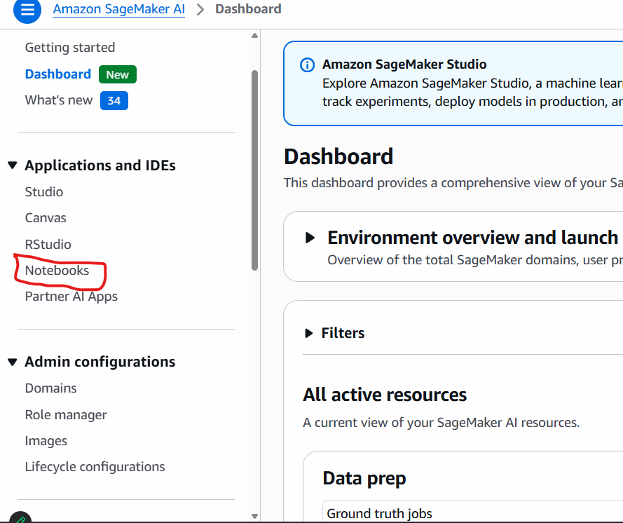

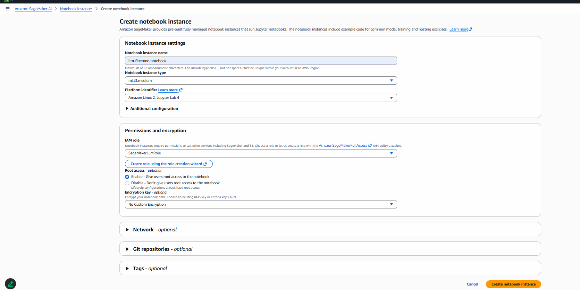

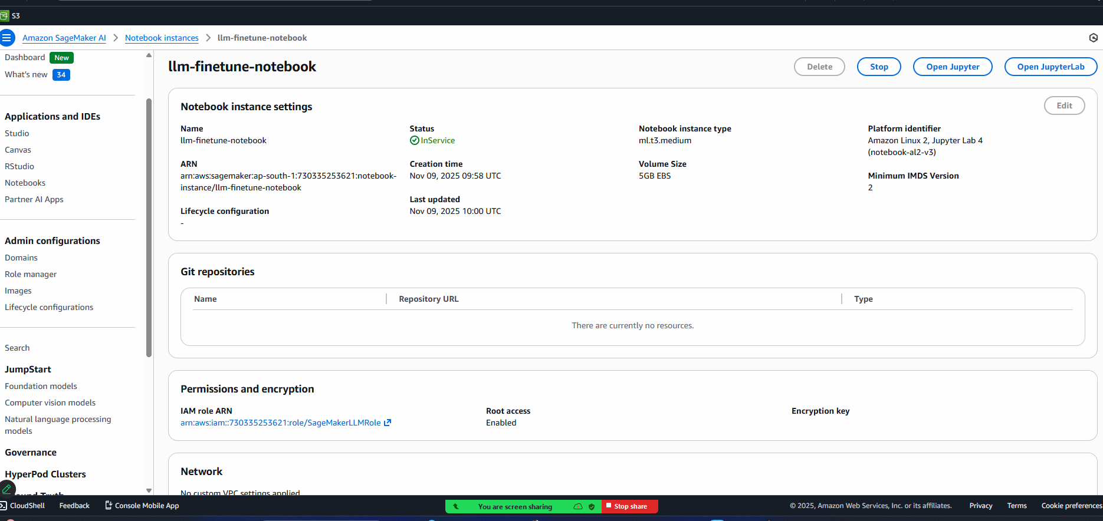

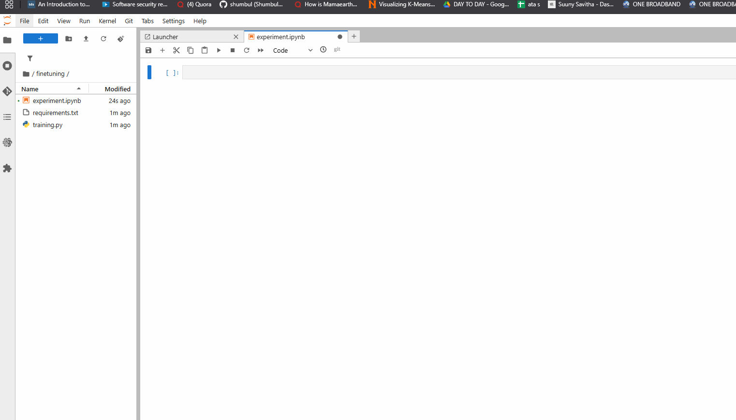

Keep the necessary requirements in the requirements.txt
Then install with the below command:
Pip install -r requirements.txt

Note: please check with your requirements.txt path

- ls
- pwd
- cd /home
- ls
- cd ec2-user/
- ls
- cd SageMaker/
- ls
- cd Finetuning-on-aws/
- ls
- git status
- Clear
- Activate the env:
source /home/ec2-user/anaconda3/bin/activate python3
- pip install --upgrade pip setuptools wheel
- pip install --upgrade cmake
- sudo yum install -y gcc gcc-c++ make
- pip install cmake==3.27.0 pyarrow==16.1.0 --no-cache-dir
- pip install -r ./finetuning/requirements.txt
- pip cache purge

Open the page below to increase the quota

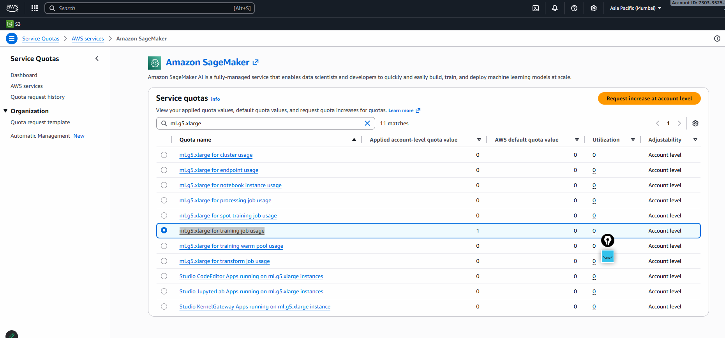

Create AWS Lambda Function
Go to Lambda → Create function
Name: invoke-llm-lambda
Runtime: Python 3.10
Select Existing Role: LambdaInvokeLLMRole

Add the env variable in the lambda
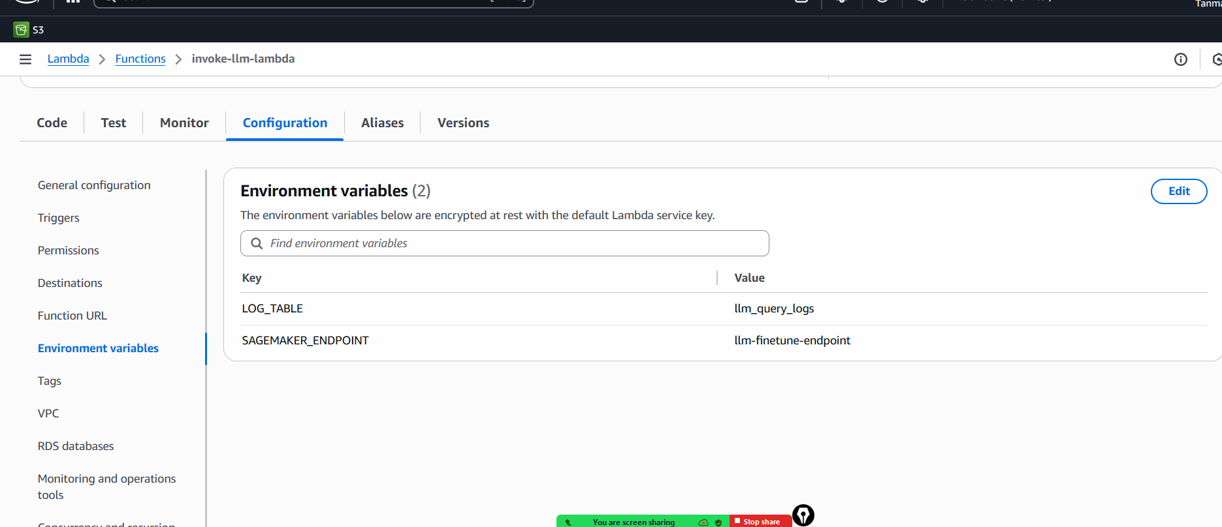

Paste handler:
import json, os, time, boto3

runtime = boto3.client("sagemaker-runtime")
dynamo = boto3.resource("dynamodb").Table(os.environ["LOG_TABLE"])
ENDPOINT = os.environ["SAGEMAKER_ENDPOINT"]

def lambda_handler(event, context):
body = json.loads(event.get("body", "{}"))
text = body.get("inputs", "")

resp = runtime.invoke_endpoint(
EndpointName=ENDPOINT,
ContentType="application/json",
Body=json.dumps({"inputs": text})
)
result = json.loads(resp["Body"].read().decode())

log_item = {
"id": f"{int(time.time()*1000)}#{context.aws_request_id}",
"prompt": text,
"response": result,
"timestamp": int(time.time())
}
dynamo.put_item(Item=log_item)

return {
"statusCode": 200,
"body": json.dumps({"result": result})
}

Create DynamoDB Table (for logs)
Go to DynamoDB → Create table
- Table name: llm_queries
- Partition key: id (String)
- Sort key: (optional)

Deploy-test with the sample
{
"body": "{\"inputs\": \"Summarize the text about heart disease\"}"
}

Create API Gateway (REST)
- Go to API Gateway → Create API → REST API → Build
  - Name: LLMInferenceAPI
- Create resource /predict
- Create method POST
  - Integration type: Lambda Function
  - Choose invoke-llm-lambda
- Deploy API → stage: prod

Now create a UI for the inferencing and RAG appp
Create a virtual env and install the requirementS_inference.txt

- uv python list
- uv venv env --python cpython-3.11.13-windows-x86_64-none
- env/Scripts/activate
- source env/Scripts/activate→ for bash terminal
- uv pip install -r requirements_inference.txt

Then after creating a app will run it via these below commands
- streamlit run inference_app.py

Command for running Streamlit on a different port:
streamlit run rag_app_ui.py --server.port 8502

Env variables:
GROQ_API_KEY=""
GOOGLE_API_KEY=""
TAVILY_API_KEY=""
OPENAI_API_KEY=""
API_URL = "" # Replace with your actual API Gateway endpoint
API_KEY= ""

