# spring-rest-handson

## Hands on 1

## Create a Spring Web Project using Maven :

**Follow Steps below to create a project:**

1. Go to <https://start.spring.io/>
2. Change Group as “com.cognizant”
3. Change Artifact Id as “spring-learn”
4. Select Spring Boot DevTools and Spring Web
5. Create and download the project as zip
6. Extract the zip in root folder to Eclipse Workspace
7. Build the project using ‘mvn clean package -Dhttp.proxyHost=proxy.cognizant.com -Dhttp.proxyPort=6050 -Dhttps.proxyHost=proxy.cognizant.com -Dhttps.proxyPort=6050 -Dhttp.proxyUser=123456’ command in command line
8. Import the project in Eclipse "File > Import > Maven > Existing Maven Projects > Click Browse and select extracted folder > Finish"
9. Include logs to verify if main() method of SpringLearnApplication.
10. Run the SpringLearnApplication class.

**SME to walk through the following aspects related to the project created:**

1. src/main/java - Folder with application code
2. src/main/resources - Folder for application configuration
3. src/test/java - Folder with code for testing the application
4. SpringLearnApplication.java - Walkthrough the main() method.
5. Purpose of @SpringBootApplication annotation
6. pom.xml

**SpringApplication.java:**

package com.cognizant.spring_learn;

import org.springframework.boot.SpringApplication;

import org.springframework.boot.autoconfigure.SpringBootApplication;

@SpringBootApplication

public class SpringLearnApplication {

public static void main(String[] args) {

SpringApplication.run(SpringLearnApplication.class, args);

System.out.println("SpringLearnApplication has started...");

}

}

**Pom.xml:**

<?xml version="1.0" encoding="UTF-8"?>

<project xmlns="http://maven.apache.org/POM/4.0.0" xmlns:xsi="http://www.w3.org/2001/XMLSchema-instance"

xsi:schemaLocation="http://maven.apache.org/POM/4.0.0 https://maven.apache.org/xsd/maven-4.0.0.xsd">

<modelVersion>4.0.0</modelVersion>

<parent>

<groupId>org.springframework.boot</groupId>

<artifactId>spring-boot-starter-parent</artifactId>

<version>3.5.3</version>

<relativePath/>

</parent>

<groupId>com.cognizant</groupId>

<artifactId>spring-learn</artifactId>

<version>0.0.1-SNAPSHOT</version>

<name>spring-learn</name>

<description>Demo project for Spring Boot</description>

<url/>

<licenses>

<license/>

</licenses>

<developers>

<developer/>

</developers>

<scm>

<connection/>

<developerConnection/>

<tag/>

<url/>

</scm>

<properties>

<java.version>17</java.version>

</properties>

<dependencies>

<dependency>

<groupId>org.springframework.boot</groupId>

<artifactId>spring-boot-starter-web</artifactId>

</dependency>

<dependency>

<groupId>org.springframework.boot</groupId>

<artifactId>spring-boot-devtools</artifactId>

<scope>runtime</scope>

<optional>true</optional>

</dependency>

<dependency>

<groupId>org.springframework.boot</groupId>

<artifactId>spring-boot-starter-test</artifactId>

<scope>test</scope>

</dependency>

</dependencies>

<build>

<plugins>

<plugin>

<groupId>org.springframework.boot</groupId>

<artifactId>spring-boot-maven-plugin</artifactId>

</plugin>

</plugins>

</build>

</project>

## Output:

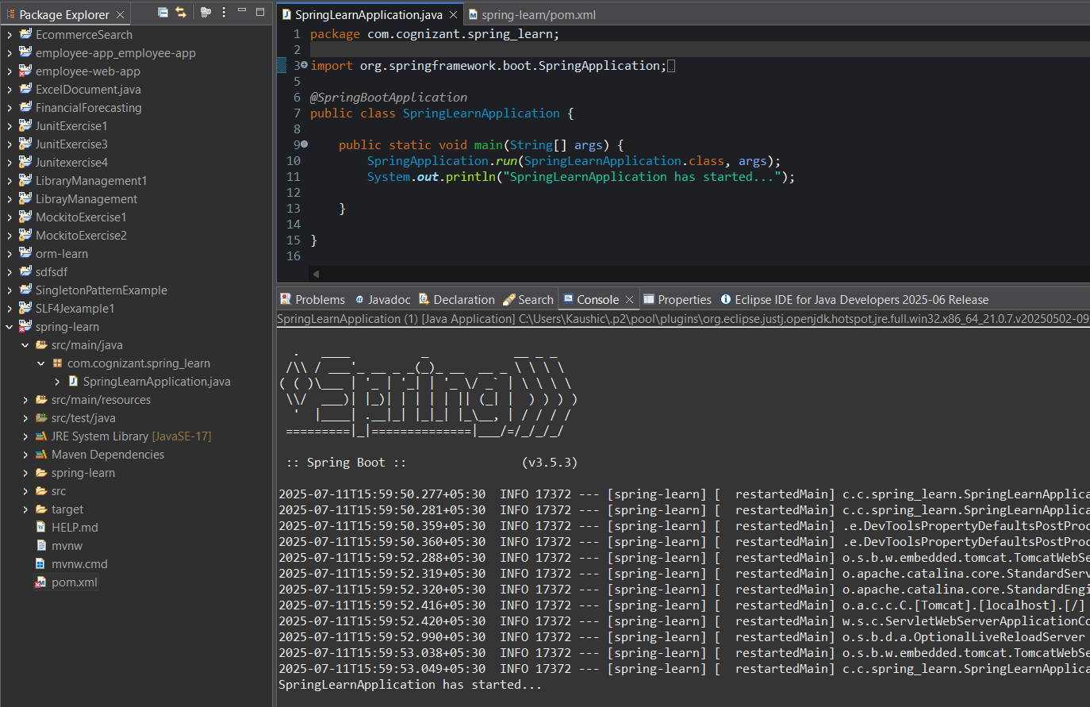

## **Hands on 4**

## **Spring Core – Load Country from Spring Configuration XML** :

An airlines website is going to support booking on four countries. There will be a drop down on the home page of this website to select the respective country. It is also important to store the two-character ISO code of each country. 

|  |  |
| --- | --- |
| **Code** | **Name** |
| US | United States |
| DE | Germany |
| IN | India |
| JP | Japan |

Above data has to be stored in spring configuration file. Write a program to read this configuration file and display the details.  
  
Steps to implement

* Pick any one of your choice country to configure in Spring XML configuration named country.xml.
* Create a bean tag in spring configuration for country and set the property and values

    <bean id="country" class="com.cognizant.springlearn.Country">

        <property name="code" value="IN" />

        <property name="name" value="India" />

    </bean>

* Create Country class with following aspects:
  + Instance variables for code and name
  + Implement empty parameter constructor with inclusion of debug log within the constructor with log message as “Inside Country Constructor.”
  + Generate getters and setters with inclusion of debug with relevant message within each setter and getter method.
  + Generate toString() method
* Create a method displayCountry() in SpringLearnApplication.java, which will read the country bean from spring configuration file and display the country details. ClassPathXmlApplicationContext, ApplicationContext and context.getBean(“beanId”, Country.class). Refer sample code for displayCountry() method below.

ApplicationContext context = new ClassPathXmlApplicationContext("country.xml");

Country country = (Country) context.getBean("country", Country.class);

LOGGER.debug("Country : {}", country.toString());

* Invoke displayCountry() method in main() method of SpringLearnApplication.java.
* Execute main() method and check the logs to find out which constructors and methods were invoked.

SME to provide more detailing about the following aspects:

* bean tag, id attribute, class attribute, property tag, name attribute, value attribute
* ApplicationContext, ClassPathXmlApplicationContext
* What exactly happens when context.getBean() is invoked

## Code:

**Country.java:**

package com.cognizant.spring_learn;

public class Country {

private String code;

private String name;

public Country() {}

public String getCode() {

return code;

}

public void setCode(String code) {

this.code = code;

}

public String getName() {

return name;

}

public void setName(String name) {

this.name = name;

}

*@Override*

public String toString() {

return name + " (" + code + ")";

}

}

**CountryController.java:**

package com.cognizant.spring_learn;

import java.util.List;

import org.springframework.context.ApplicationContext;

import org.springframework.context.support.ClassPathXmlApplicationContext;

import org.springframework.web.bind.annotation.*;

import org.springframework.stereotype.Controller;

import org.springframework.ui.Model;

import org.springframework.web.bind.annotation.ResponseBody;

@Controller

public class CountryController {

private final List<Country> countryList;

public CountryController() {

ApplicationContext context = new ClassPathXmlApplicationContext("country-list.xml");

this.countryList = context.getBean("countryList", CountryList.class).getCountryList();

}

@GetMapping("/countries")

@ResponseBody

public List<Country> getCountries() {

return countryList;

}

@PostMapping("/select")

@ResponseBody

public String selectCountry(@RequestParam("countryCode") String code) {

Country selected = countryList.stream()

.filter(c -> c.getCode().equals(code))

.findFirst()

.orElse(null);

if (selected != null) {

return "<h2>You selected: " + selected.getName() + " (" + selected.getCode() + ")</h2><br><a href='/'>Back</a>";

} else {

return "<h2>Country not found</h2>";

}

}

}

**CountryList.java:**

package com.cognizant.spring_learn;

import java.util.List;

public class CountryList {

private List<Country> countryList;

public List<Country> getCountryList() {

return countryList;

}

public void setCountryList(List<Country> countryList) {

this.countryList = countryList;

}

}

**Country-list.xml:**

<?xml version="1.0" encoding="UTF-8"?>

<beans xmlns="http://www.springframework.org/schema/beans"

xmlns:xsi="http://www.w3.org/2001/XMLSchema-instance"

xsi:schemaLocation="http://www.springframework.org/schema/beans

https://www.springframework.org/schema/beans/spring-beans.xsd">

<bean id="countryUS" class="com.cognizant.spring_learn.Country">

<property name="code" value="US" />

<property name="name" value="United States" />

</bean>

<bean id="countryDE" class="com.cognizant.spring_learn.Country">

<property name="code" value="DE" />

<property name="name" value="Germany" />

</bean>

<bean id="countryIN" class="com.cognizant.spring_learn.Country">

<property name="code" value="IN" />

<property name="name" value="India" />

</bean>

<bean id="countryJP" class="com.cognizant.spring_learn.Country">

<property name="code" value="JP" />

<property name="name" value="Japan" />

</bean>

<bean id="countryList" class="com.cognizant.spring_learn.CountryList">

<property name="countryList">

<list>

<ref bean="countryUS" />

<ref bean="countryDE" />

<ref bean="countryIN" />

<ref bean="countryJP" />

</list>

</property>

</bean>

</beans>

**Index.html:**

<!DOCTYPE html>

<html>

<head>

<title>Airlines - Country Selection</title>

<script>

async function loadCountries() {

const response = await fetch('/countries');

const countries = await response.json();

const select = document.getElementById('countryCode');

countries.forEach(country => {

let option = document.createElement('option');

option.value = country.code;

option.innerText = country.name;

select.appendChild(option);

});

}

window.onload = loadCountries;

</script>

</head>

<body>

<h2>Select Your Country</h2>

<form action="/select" method="post">

<select id="countryCode" name="countryCode">

<option value="">-- Select Country --</option>

</select>

<button type="submit">Submit</button>

</form>

</body>

</html>

**SpringLearnApplication.java:**

package com.cognizant.spring_learn;

import org.springframework.boot.SpringApplication;

import org.springframework.boot.autoconfigure.SpringBootApplication;

@SpringBootApplication

public class SpringLearnApplication {

public static void main(String[] args) {

SpringApplication.run(SpringLearnApplication.class, args);

}

}

## Output:

