# 2-Spring-Rest-Handson

## 1.Write a REST service in the spring learn application created earlier, that returns the text "Hello World!!" using Spring Web Framework. Refer details below:

Method: GET  
URL: /hello  
Controller: com.cognizant.spring-learn.controller.HelloController  
Method Signature: public String sayHello()  
Method Implementation: return hard coded string "Hello World!!"  
Sample Request: http://localhost:8083/hello  
Sample Response: Hello World!!

**HelloController.java:**

package com.cognizant.spring_learn.controller;

import org.slf4j.Logger;

import org.slf4j.LoggerFactory;

import org.springframework.web.bind.annotation.GetMapping;

import org.springframework.web.bind.annotation.RestController;

*@RestController*

public class HelloController {

private static final Logger ***LOGGER*** = LoggerFactory.*getLogger*(HelloController.class);

*@GetMapping*("/hello")

public String sayHello() {

***LOGGER***.info("START - sayHello()");

String message = "Hello World!!";

***LOGGER***.info("END - sayHello()");

return message;

}

}

## Output:

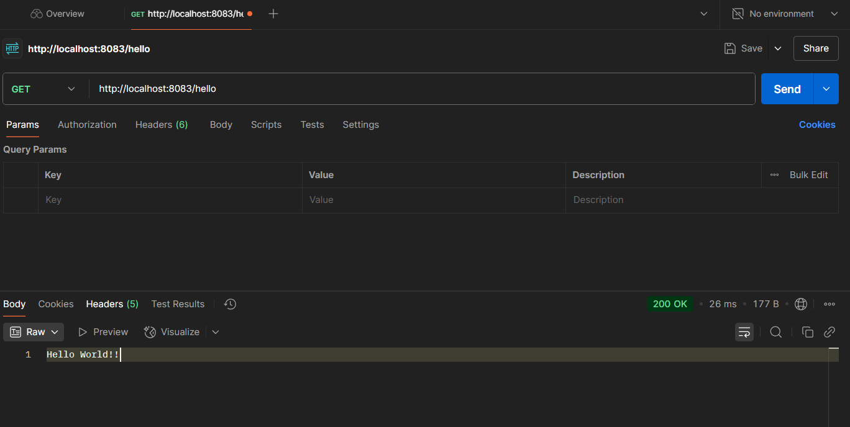

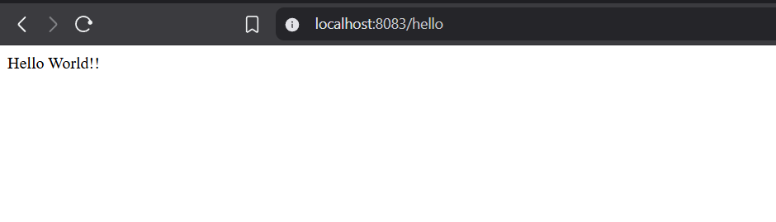

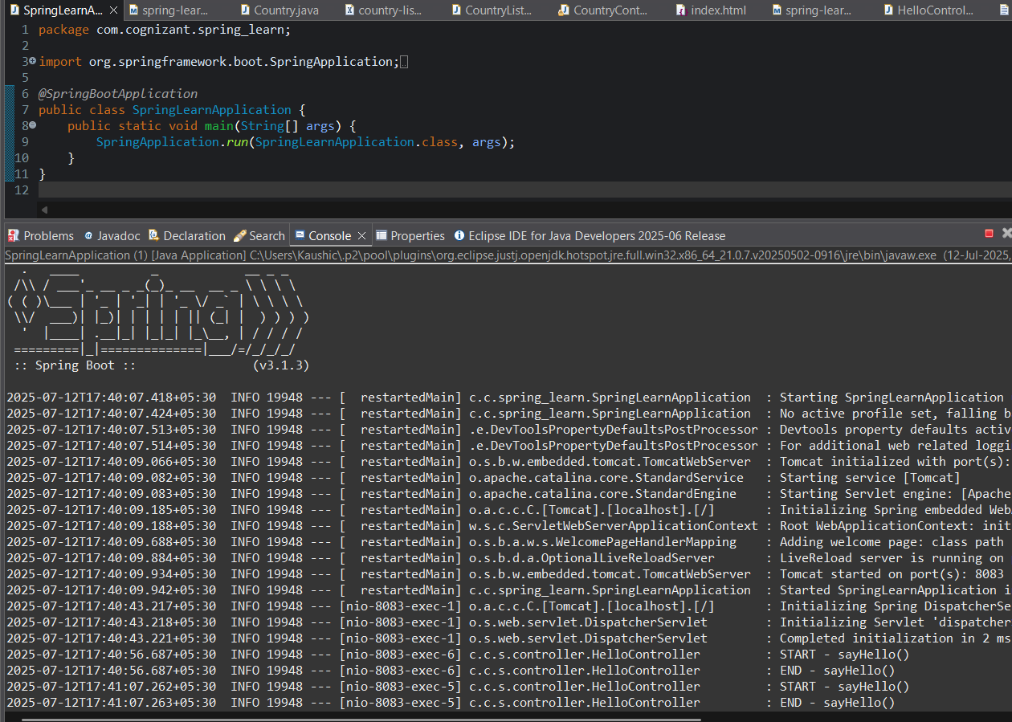

## **REST - Country Web Service** : Write a REST service that returns India country details in the earlier created spring learn application.

**URL**: /country  
**Controller**: com.cognizant.spring-learn.controller.CountryController  
**Method Annotation**: @RequestMapping  
**Method Name**: getCountryIndia()  
**Method Implementation**: Load India bean from spring xml configuration and return  
**Sample Request**: <http://localhost:8083/country>

**Country.java:**

package com.cognizant.spring_learn;

public class Country {

private String code;

private String name;

public Country() {}

public Country(String code, String name) {

this.code = code;

this.name = name;

}

public String getCode() {

return code;

}

public void setCode(String code) {

this.code = code;

}

public String getName() {

return name;

}

public void setName(String name) {

this.name = name;

} }

**CountryController.java:**

package com.cognizant.spring_learn;

import com.cognizant.spring_learn.Country;

import org.slf4j.Logger;

import org.slf4j.LoggerFactory;

import org.springframework.context.ApplicationContext;

import org.springframework.context.support.ClassPathXmlApplicationContext;

import org.springframework.web.bind.annotation.RequestMapping;

import org.springframework.web.bind.annotation.RestController;

*@RestController*

public class CountryController {

private static final Logger ***LOGGER*** = LoggerFactory.*getLogger*(CountryController.class);

*@RequestMapping*("/country")

public Country getCountryIndia() {

***LOGGER***.info("START - getCountryIndia()");

ApplicationContext context = new ClassPathXmlApplicationContext("country.xml");

Country country = (Country) context.getBean("in");

***LOGGER***.info("END - getCountryIndia()");

return country;

} }

**Country.xml:**

<?xml version="1.0" encoding="UTF-8"?>

<beans xmlns="http://www.springframework.org/schema/beans"

xmlns:xsi="http://www.w3.org/2001/XMLSchema-instance"

xsi:schemaLocation="http://www.springframework.org/schema/beans

http://www.springframework.org/schema/beans/spring-beans.xsd">

<bean id="in" class="com.cognizant.spring_learn.Country">

<property name="code" value="IN"/>

<property name="name" value="India"/>

</bean>

</beans>

## Output:

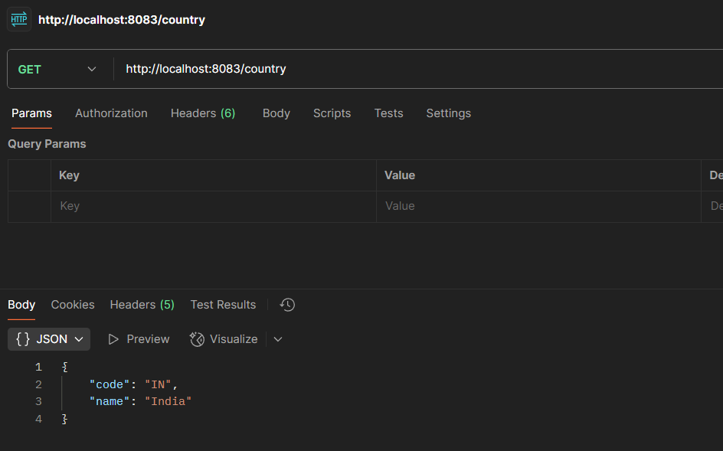

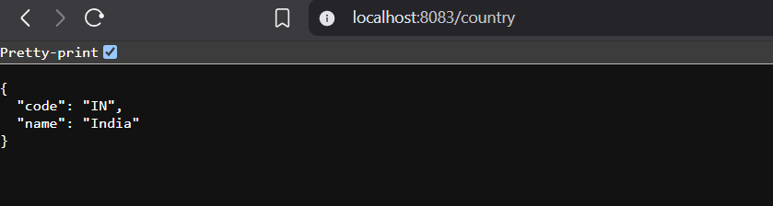

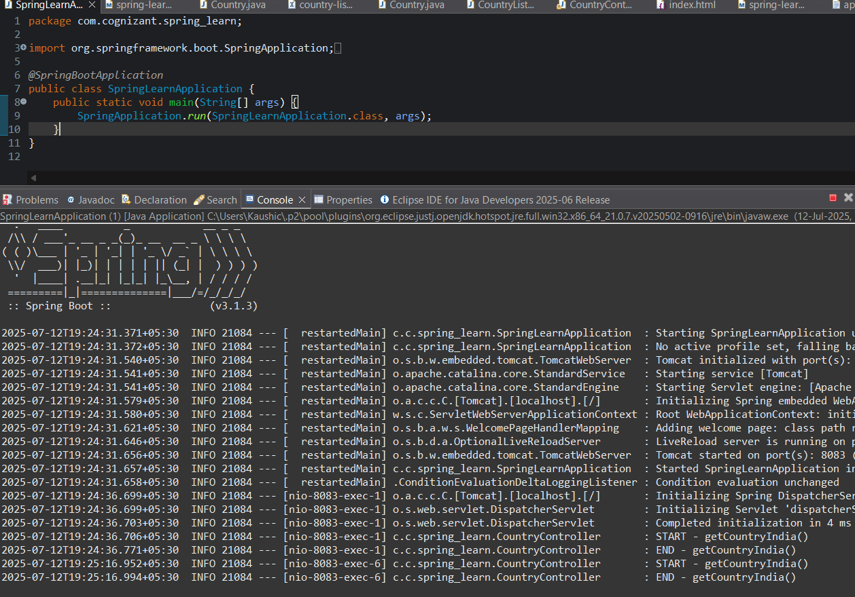

## REST - Get country based on country code :

Write a REST service that returns a specific country based on country code. The country code should be case insensitive.  
  
**Controller**: com.cognizant.spring-learn.controller.CountryController  
**Method Annotation:** @GetMapping("/countries/{code}")  
**Method Name**: getCountry(String code)  
**Method Implemetation**: Invoke countryService.getCountry(code)   
**Service Method:**com.cognizant.spring-learn.service.CountryService.getCountry(String code)

**CountryController.java:**

package com.cognizant.spring_learn.controller;

import com.cognizant.spring_learn.Country;

import com.cognizant.spring_learn.service.CountryService;

import org.slf4j.Logger;

import org.slf4j.LoggerFactory;

import org.springframework.beans.factory.annotation.Autowired;

import org.springframework.web.bind.annotation.*;

*@RestController*

public class CountryController {

private static final Logger ***LOGGER*** = LoggerFactory.*getLogger*(CountryController.class);

*@Autowired*

private CountryService countryService;

*@GetMapping*("/country/{code}")

public Country getCountry(*@PathVariable* String code) {

***LOGGER***.info("START - getCountry({})", code);

Country country = countryService.getCountry(code);

***LOGGER***.info("END - getCountry({})", code);

return country;

}

}

**CountryService.java:**

package com.cognizant.spring_learn.service;

import com.cognizant.spring_learn.Country;

import org.springframework.context.ApplicationContext;

import org.springframework.context.support.ClassPathXmlApplicationContext;

import org.springframework.stereotype.Service;

import java.util.List;

*@Service*

public class CountryService {

public Country getCountry(String code) {

ApplicationContext context = new ClassPathXmlApplicationContext("country.xml");

List<Country> countryList = context.getBean("countryList", List.class);

return countryList.stream()

.filter(c -> c.getCode().equalsIgnoreCase(code))

.findFirst()

.orElse(null); // or throw custom exception if not found

}

}

**Country.xml:**

<?xml version="1.0" encoding="UTF-8"?>

<beans xmlns="http://www.springframework.org/schema/beans"

xmlns:xsi="http://www.w3.org/2001/XMLSchema-instance"

xsi:schemaLocation="http://www.springframework.org/schema/beans

http://www.springframework.org/schema/beans/spring-beans.xsd">

<bean id="countryList" class="java.util.ArrayList">

<constructor-arg>

<list>

<bean class="com.cognizant.spring_learn.Country">

<property name="code" value="IN"/>

<property name="name" value="India"/>

</bean>

<bean class="com.cognizant.spring_learn.Country">

<property name="code" value="US"/>

<property name="name" value="United States"/>

</bean>

<bean class="com.cognizant.spring_learn.Country">

<property name="code" value="CN"/>

<property name="name" value="China"/>

</bean>

</list>

</constructor-arg>

</bean>

</beans>

## Output:

