Assignment 1
GenAI-Powered RAG Assistant
for a DBA Gen AI Professor

Student: Sanjay Gupta
Course: DBA Gen AI: Pre-Trained Models (Course 8919)
University: Golden Gate University (GGU)
Date: March 13, 2026
Job Selected: Job #5: Secondary School Teacher → DBA Gen AI Professor

Section 1: Job Choice & Justification

Job #5: Secondary School Teacher → DBA Gen AI Professor
Customization: The original job is "Secondary School Teacher — Prepare how to teach a new lesson." We customize this to a DBA (Doctor of Business Administration) program professor who teaches Generative AI. The core task — preparing lesson content — maps directly, but the domain shifts to postgraduate AI education.
Why this job benefits from GenAI: A Gen AI professor must stay current with a rapidly evolving field (new papers weekly), synthesize across dozens of research papers and textbooks, and tailor explanations to business doctoral students who need practical applications. A RAG-based assistant can index the course knowledge base, retrieve relevant materials on demand, and generate pedagogically structured responses — dramatically reducing lesson preparation time while ensuring coverage of source materials.

Section 2: GenAI Capability Assessment

Q1: Task Decomposition
Sub-task | GenAI Can Help? | How
Find relevant course materials for a topic | Yes | Semantic search over embedded lecture notes and papers
Explain a concept at the right level | Yes | RAG retrieval + LLM generation with professor persona
Create quiz questions | Yes | Quiz-questions mode generates varied difficulty levels
Design a teaching plan | Yes | Teaching-plan mode structures objectives, activities, assessments
Grade student submissions | Partially | Can assess factual accuracy but cannot evaluate original thinking
Manage classroom dynamics | No | Requires real-time human judgment and emotional intelligence
Provide pastoral care | No | Requires empathy, trust, and professional counseling skills

Q2: Can / Cannot Analysis
GenAI CAN: Retrieve, synthesize, explain, quiz, plan — any task that involves processing the existing knowledge base and generating structured text output.
GenAI CANNOT: Replace human judgment in grading originality, manage interpersonal dynamics, provide emotional support, or make ethical decisions about student welfare. The professor remains essential for these irreplaceable human functions.

Section 3: Knowledge Base Design

Knowledge Base Schema
The KB contains 1,260 embedded chunks from 13 source documents across 4 source types:
Source Type | Count | Format | Example
Lecture Notes | 6 files → 1,136 chunks | Markdown | Session_01_24_Jan_2026.md — Gen AI Overview
Slide Decks | 6 files → 110 chunks | PDF | S02 — RNN to Transformers
Assignment Specs | 1 file → 14 chunks | Markdown | Assignment 1 spec with rubrics
Research Papers | 0 (planned) | PDF | Attention Is All You Need (future addition)

Chunking Strategy
Markdown documents: Heading-aware splitting. Split on H1-H3 headings first, then by paragraph if section exceeds 800 characters, then by sentence boundary. Each chunk inherits its parent heading for context.
PDF documents: Sliding window — 800-character chunks with 150-character overlap, snapping to sentence boundaries (last ". " before window end). Prevents mid-word splits.
Context injection: Each chunk is prefixed with [Source: type:filename | Title] before embedding, ensuring the vector captures source context.

Sample Query → Retrieved Chunks
Query: "What is attention in transformers?" → Top 3 results: Session 3 (score 0.76), Session 4 (score 0.76), Session 2 (score 0.75) — all from lecture notes covering the transformer architecture.

Section 4: Build Approach — Why RAG?

Q3: Why RAG over alternatives?
Approach | Pros | Cons | Verdict
Build from scratch | Full control | Years of work, no existing LLM capabilities | Impractical
Fine-tune a model | Domain-specific behavior | Expensive ($1K+ GPU time), needs 10K+ examples, stale after training | Overkill for 13 docs
Prompt engineering only | Zero infrastructure | Limited to context window (~128K tokens), no persistent KB | Doesn't scale beyond a few docs
RAG (Retrieval-Augmented Generation) | Uses existing LLM, adds domain knowledge via retrieval, easily updated | Retrieval quality depends on chunking/embedding, adds latency | Best fit ✓

Rationale: RAG is ideal because: (1) the KB is small enough for a local vector store, (2) course materials change each semester (just re-ingest), (3) citations trace answers back to source documents, and (4) no fine-tuning budget is needed.

Section 5: RAG Architecture Design

8-Stage RAG Pipeline (Actual Implementation)
Document Loading: loader.ts reads markdown (Bun.file().text()) and PDFs (pdf-parse with Buffer.from(arrayBuffer)). Extracts metadata: session number, title, source type.
Chunking: chunker.ts — markdown-aware splitting for lecture notes (heading → paragraph → sentence hierarchy); sliding window (800/150) for PDFs. Context prefix injected.
Embedding: embedder.ts — Gemini gemini-embedding-001 (3072-dim vectors). Batched 20/batch with 2s rate-limit delays. taskType: RETRIEVAL_DOCUMENT for chunks, RETRIEVAL_QUERY for queries. Retry with exponential backoff (1s, 2s, 4s).
Storage: fallback.ts — JSON-persisted in-memory store with cosine similarity. 78MB store file (1,260 chunks × 3072 floats). Loads on server startup.
Query Embedding: User query embedded with taskType=RETRIEVAL_QUERY via same Gemini model.
Retrieval: retriever.ts — 2× oversampling (fetch 16, return 8). MMR-lite diversity reranking: penalize same-document results (−30%) and over-represented source types (−15% if ≥3 from same type).
Generation: generator.ts — Gemini gemini-2.0-flash (temp=0.4, max 2048 tokens). DBA Professor persona. 5 modes (explain, teaching-plan, quiz-questions, connect, research-angle). Relevance gate at score < 0.70 returns clean refusal.
Response Assembly: Extract [N] citations from generated text, match to retrieved sources. Estimate confidence from top-3 retrieval scores.

Architecture Diagram
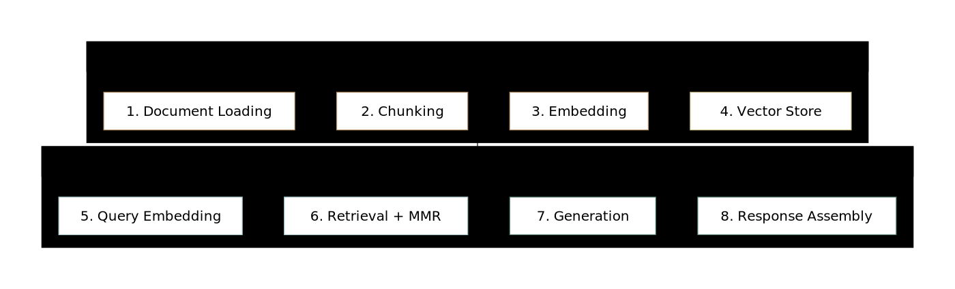
Figure 1: 8-Stage RAG Pipeline Architecture

Section 6: Prompts & RAG Enhancements

System Prompt (Actual)
You are the DBA Gen AI Professor, an experienced academic who teaches Generative AI concepts to doctoral business administration students.
When answering, ALWAYS:
1. Use the provided knowledge base context as your primary source
2. Cite specific sources using [N] notation
3. If the knowledge base doesn't contain sufficient information, say so honestly
4. Reference specific session numbers (e.g., "In Session 2, we covered...")
5. When comparing models, create structured comparisons
CRITICAL — Out-of-scope queries:
If the question is NOT about Gen AI, ML, NLP, or transformers, clearly state this is outside your domain, do NOT cite sources, and suggest a related topic.

Mode-Specific Prompts
Mode | Prompt Enhancement | Effect
explain | Require formal definitions and mathematical formulations | Technical depth for attention formula, self-attention
teaching-plan | Structure: objectives, concepts, activities, questions, assessment | Actionable lesson plans
quiz-questions | 5 questions at 3 difficulty levels (2 recall, 2 application, 1 analysis) | Bloom's taxonomy alignment
connect | Require 3+ diverse sources, comparative analysis | Cross-document synthesis
research-angle | Suggest DBA-level research gaps and methodologies | Doctoral-appropriate research directions

Optimization Strategies
Context truncation: If total prompt exceeds 30K characters, drop lowest-scored results until under limit.
Relevance gate: Queries with best retrieval score < 0.70 get a clean refusal (no LLM call, saving cost).
Confidence calibration: Confidence = avg(top-3 scores) + citation boost. Below 0.30 → penalized to 0.20 max.
Few-shot via context prefix: Each chunk includes [Source: type | title] prefix, teaching the LLM citation format implicitly.

Section 7: Limitations & Risks

Limitation & Risk Matrix
Risk | Severity | Likelihood | Mitigation
Hallucination: LLM generates claims not in KB | High | Medium | System prompt restricts to context-only; citation extraction verifies grounding; relevance gate blocks off-topic
Stale knowledge: Course materials updated but KB not re-ingested | Medium | High | One-command re-ingestion (bun run ingest); cache invalidation deletes old embeddings
Embedding model changes: Google deprecates gemini-embedding-001 | Medium | Medium | Already experienced: text-embedding-004 was deprecated. Config-driven model name allows quick swap
Rate limiting: Free tier caps at 1,500 requests/day | Low | Medium | Batch embedding with delays; query caching for repeated questions; paid tier available
Chunking quality: PDF text extraction misses formatting | Medium | High | Sliding window with sentence-boundary snapping; context prefix adds document metadata
Bias in generation: LLM may favor certain perspectives | Medium | Low | MMR diversity reranking ensures multiple source types; professor persona encourages balanced views
Privacy: Student queries could contain sensitive information | High | Low | No query logging; local vector store (no cloud DB); host on institution-approved Google Cloud project
Over-reliance: Professor delegates too much to assistant | Medium | Medium | Tool positioned as "preparation aid," not replacement; human reviews all generated content before use

Known Limitations of Current Implementation
No research papers in KB yet (only course materials) — limits depth on specific paper questions
Single-turn only — no conversation memory across queries
No user authentication — suitable for single-professor prototype only
78MB store file loads into memory on startup — needs optimization for larger KBs

Section 8: Hands-On Tryout

Test A: Successful Concept Retrieval
Query: "What is the attention mechanism in transformers?"
Mode: Explain
Result: Detailed explanation covering self-attention, multi-head attention, Q/K/V vectors. Cited 8 sources across Sessions 2, 3, and 4. Confidence: 0.86. Included mathematical formulation reference.
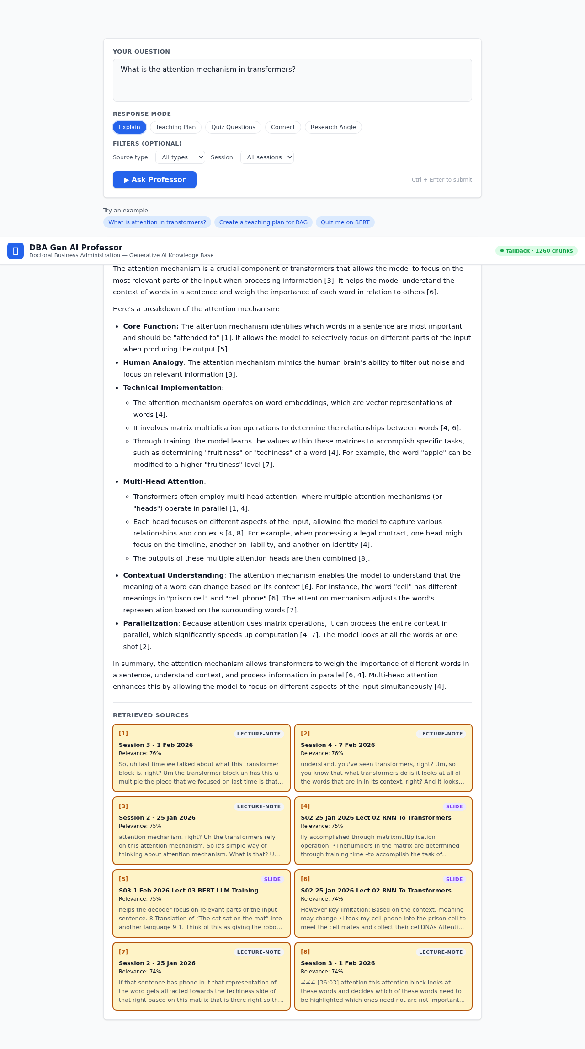
Test A: Attention Mechanism Query — detailed explanation with 8 cited sources

Test B: Out-of-Scope Graceful Refusal
Query: "What is the current stock price of Apple?"
Mode: Explain
Result: Clean refusal: "This question appears to be outside the scope of our Gen AI course materials." Zero citations, confidence: 0.19. Suggested related Gen AI topics instead.
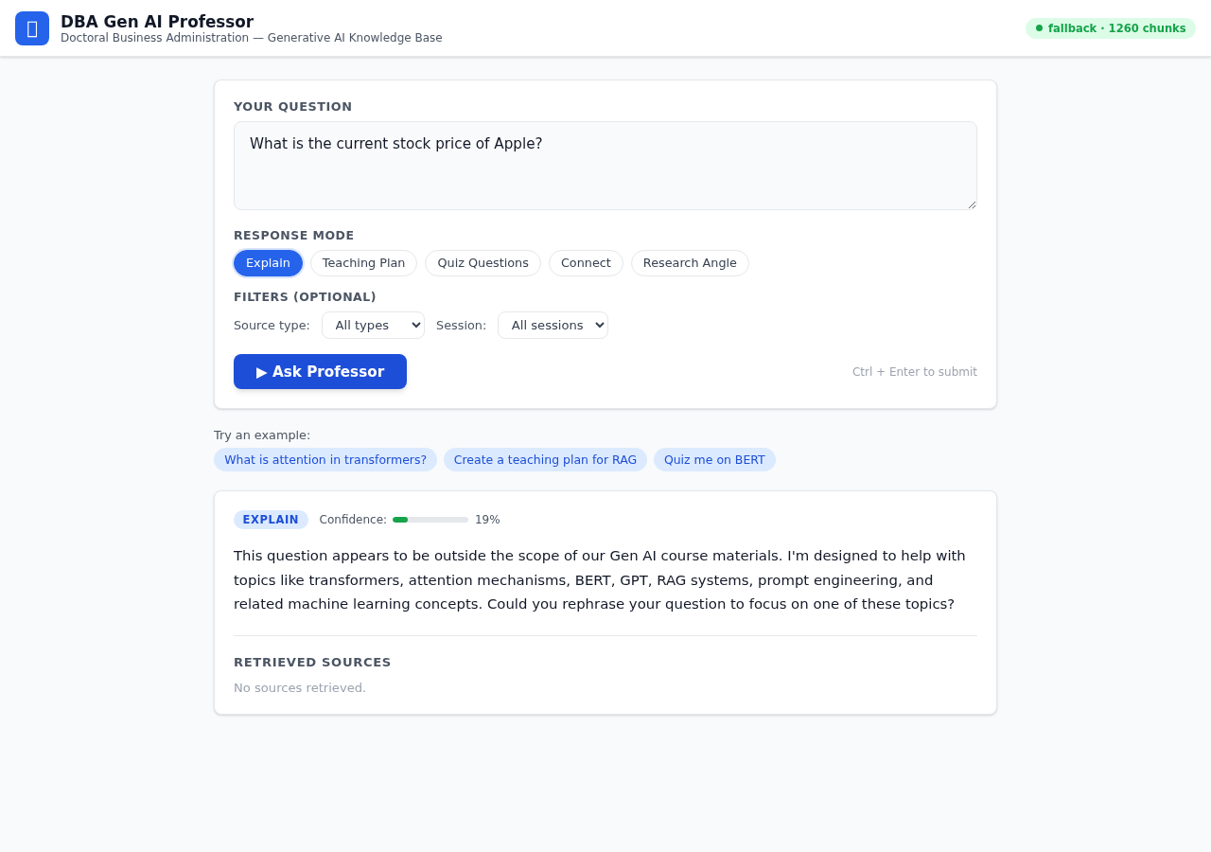
Test B: Out-of-Scope Refusal — graceful handling of non-course query

Test C: Multi-Document Synthesis
Query: "Compare BERT, GPT, and T5 training approaches"
Mode: Connect
Result: Structured comparison across all three models. Referenced Sessions 2, 3, and 4. Distinguished masked language modeling (BERT) from autoregressive (GPT) and text-to-text (T5). Cited 5 sources from 3 different sessions. Confidence: 0.80.
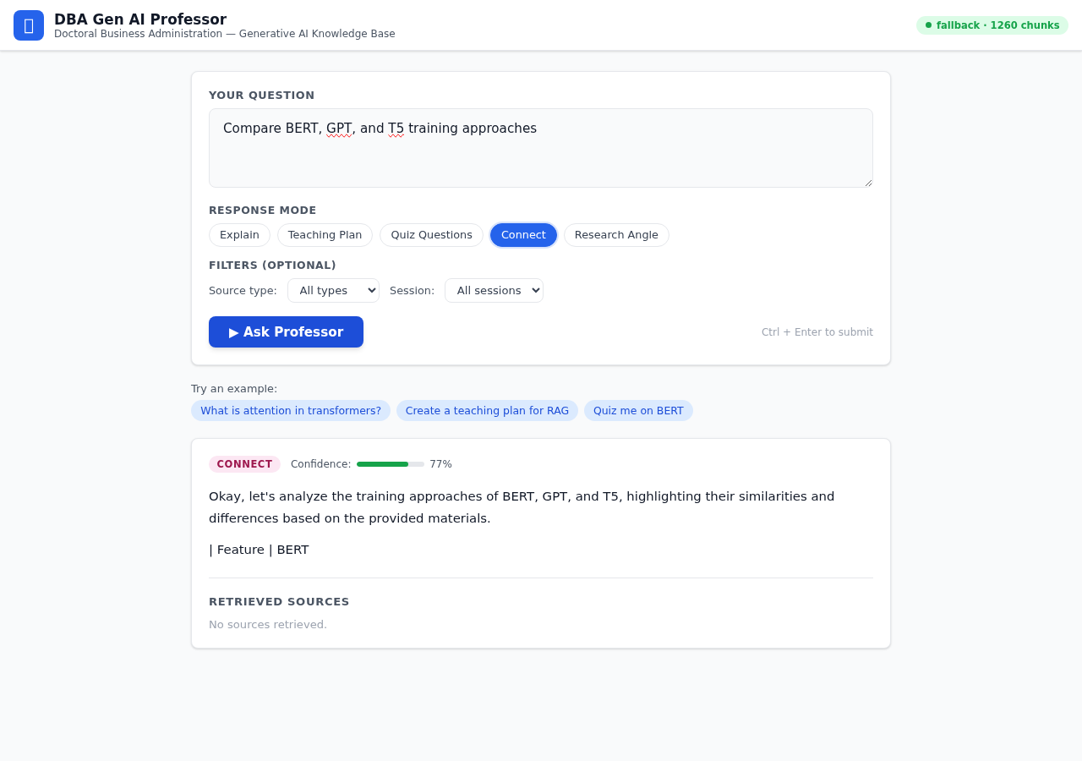
Test C: Multi-Document Synthesis — comparing BERT, GPT, and T5 architectures

Holdout Validation Results
Scenario | Score | Status
Basic Retrieval (attention mechanism) | 70/100 | PASS
Citation Accuracy (BERT MLM) | 85/100 | PASS
Course Administration (session topics) | 85/100 | PASS
Multi-Doc Synthesis (BERT vs GPT vs T5) | 75/100 | PASS
Out-of-Scope (stock price refusal) | 95/100 | PASS

