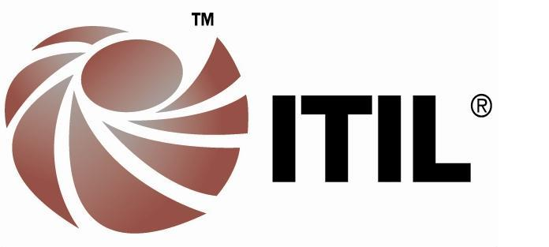

Tarun Kumar

Contact No.: +91 9891305367, E-mail: tarunbit2001@gmail.com
Address: 2S-104, AWHO Township, Greater Noida, UP – 201310
Self-motivated leader with strong implementation skills with 12+ years of Core IT Infrastructure experience. Managed key company operation activities – Service Delivery management for 250+ Business Critical Applications and Infrastructure Project Management.

Key technologies worked on
Web server: Apache, IIS
App Server: Jboss (4.X – 7.X), Jboss EAP, Wild Fly (8.X to 10.X)
Back-End: SQL Server (2005-2012), Oracle (9i-12 C), MySQL, DB2
Middleware: Oracle Tuxedo (8i – 12c), Web Methods
Products: SAP (ECC, WM, LES, MM) Oracle Tuxedo, Microsoft SharePoint (2007/2010/2013), Microsoft Project Server, Microsoft Workflow Manager, Enterprise Printing Solution (Unispool, Opentext Output Management)
Operating System: HP UX, RHEL, Solaris, Windows, AIX
Backup Solutions: Veritas NetBackup, Tivoli Storage Manager
Monitoring: HP Operation Manager, HP Business Solution Manager, Dynatrace Deep-Dive, Dynatrace DCRUM, HP SiteScope
Virtualization S/W: VMware ESX, Windows Hyper V
Load Balancing: BIG IP F5

PROFESSIONAL EXPERIENCE
ST Microelectronics – Oct 2007 – Till Date
Projects & Programs - Infrastructure – World Wide Data Center July’16-now

- Responsible for multiple Infrastructure Projects for Company’s ONLY Business Data Center
- Participating in Business IT alignment for Infrastructure (BITA) service to define next yrs priorities inline to Business priorities
- Engaging teams (Internal/External) for timely delivery of Infra layer which includes database, webservers & application servers.
- Institutionalize Project Management Practices in the team.
  - Prepare Business case for Infra initiative & send for CIO approval
  - CAPEX management for Infra initiatives (2-3 m$ annually)
- Setup of Infrastructure as per RTO, RPO needs based on Application criticality & co-ordinate the drill to verify the same
- Engaged in architecture, Solution Definition and Build and Hand them over to Operations – Cutting across all Infrastructure components such as Servers, Storage, Databases, Network, Firewalls, Load Balancers, Facilities, Applications, Platforms etc.

Service delivery – Business Applications Infrastructure – World Wide Data Center Apr’12-Jun’16
- Accountable for providing quality Business Applications Infra service to four solution groups covering 250+ applications that they require and providing full spectrum of cutting edge infra services and solutions of the highest quality - that generate value to the business
- Accountable for migration / setup and evolution for applications infra layer under delivery scope
- Lead external assessment of data center by an external agency (Infosys) to identify gaps in technology & applied processes. Later cementing those gaps by leading a list of ~100 actions.
- Ensuring timely delivery of Infra components (middleware, database, app servers & other products) to business application
- Accountable for Business IT communication is case of disaster recovery around business applications
- Accountable for smooth transition service from build to Service operations along with audit of release to production checklist, seek evidences for disaster recovery drill execution & ensure suitable entry to DR recovery document if App is H or VH & putting them into the right restart sequence in Disaster recovery doc.
- Release Deployment: Managed >20 big consolidation release deployment programs around companies MOST critical services like Logistics, warehouse management & Finance.
- Change Management: Chaired Infrastructure Change Advisory Board for 1.5 years and prime accountable for all the infra changes in Business Application data center of company.
- Problem Management: Lead problem management for ~4 years to ensure timely RCAs & related actions are done. Also mastered 8D methodology.
- Leading application recovery in case of disasters
- Accountable for running customer satisfaction surveys with all solution groups and customers with 50% participation from recipients and managing the service improvement plans.
- Process Definition: Participation to ICT process workgroups to define processes (change management & release to production)

Technical Lead for 24*7 Production Operations – World Wide Data Center Jul’10-Apr’12
- Accountable & responsible for managing deployment of 250+ Business applications hosted in WWDC
- Accountable ITIL process compliance while ensuring a tight control on quality/timeline of release deployment.
- Responsible for monitoring and continually improving standards of performance and quality within the team operations.
- Worked closely with Service managers _ Infra , Solution groups / Infra Project Management Team for requirement gathering and resource planning
- Accountable for SOX Compliance during release deployment for Financial application
- Accountable for 24X7 on-call availability of duty persons across various technologies domain

System Engineer – Production Operation – World Wide Data Center Oct’07-Jul’10

- Monitoring Business Critical Apps and Server in 24*7 environment and ensuring the 99.99% availability of application to end users.
- Ensuring that majority of issues coming to L1 browser are fixed and invoking the L2/L3 team in time so minimize the impact on business and manufacturing.
- Ensuring that repetitive incidents are analysed and problem tickets open for l2 and l3 team to fix the issues permanently.
- Undertook major activities of L1 under L1 role:
  - Migrated around 90 TWS 7.0 installation to TWS 8.2
  - Took handover and managed tools like Hermes / Unispool as L3 team. Managed them and migrated to new version
  - Took Handover of HP3K Server (Problem mgmt./ Patching for HP3K / PR/PO for software annual maintenance)
- Enhancing the Monitoring and operating procedure for the L1 team and asking L2 team to update the procedure wherever required

KEY RECOGNITIONS / CERTIFICATIONS
- PMI-PMP Certified Professional (2017 & renew in 2020)
- ITIL V3 Certified Intermediate level (All 5 modules 2015-17)
- HP UX, CISCO, Sun microsystems Certifications for managing the servers & switches
- 2 times recipient of CIO award for my contribution to World Wide Data Center Evolution Program
- Recipient of CFO award “SUPERFLIS” (One of the most prestigious awards for IT)
ACADEMIA
Master of Computer Application | 2007-10 | Sikkim Manipal University
Bachelor of Information Technology | 2001-05 | NSIC, (IGNOU) New Delhi
Higher National Diploma in Computing | 2001-03 | Edexcel, UK
PERSONAL DETAILS

- Date of Birth 24 Dec, 1983
- Marital Status Married with 1 son (of 18 months)

