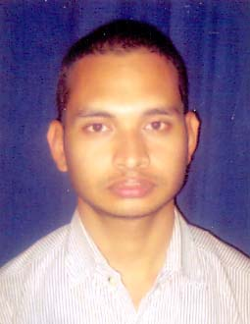
R E S U M E
MR. LALATENDU BIKRAM PRATAP
E-mail: lalatendu_bikram@rediffmail.com
Mob No- 07894256835
OBJECTIVES :
- My career objectives is to become a part of dynamic, growth- oriented organization where I can use my Mechanical skills and where my performance is rewarded and have exposure to a competitive environment responsibilities.
STRENGTH :
  - Positive attitude and enthusiastic team work.

  - Ability to handle crunch situation and adapt to any environment.

  - Strong desires to work in various platforms according to requirements and eagerness.
EDUCATIONAL QUALIFICATION :
- Matriculation under H.S.C., Orissa in the year 2000 with 61.46 %
TECHNICAL QUALIFICATION :
- Diploma in Mechanical Engineering under State Council of Technical Education & Vocational Training affiliated to A.I.C.T.E. in the year-2004 with 60.14 %
EXPERIENCE :
- Worked as a Site Engineer at M/s Sterling and Wilson Ltd. In Fire Fighting & Plumbing Dept. from Oct.-2009 to till date.

- Worked as an Operating Executive at Apollo Tyres Ltd. In Production Unit from Aug.2005 to July 2009.
MAIN RESPONSIBILITIES :
1 Study of drawings, planning of execution work.
2 Checking of BOQ as per layouts.
3 Checking the quality for material received & prepare report.
4 Coordination with client’s team, contractors & HO.
5 Preparation & submission of site reports.
6 Checking & certify the contractors Bill.
7 Obtaining mark up drawing from contractors for as built drawing.
PERSONAL PROFILE :
Father’s Name : Mr. Surendra Kumar Pratap
Mother’s Name : Mrs. Rasmi Rekha Pratap
Date of Birth : 18th June 1985
Nationality : Indian
Language known : English, Hindi & Oriya
Permanent Address : C/o- Surendra Kumar Pratap
At- Mukundapur
P.o.- Chandol
Dist- Kendrapara
Pin- 754208
State- Orissa(India)
DECLARATION
I hereby declare that the foregoing information is correct to the best of my knowledge and belief.
Place :BHUBANESWAR,[ODISHA] (Lalatendu Bikram Pratap)
Date :

