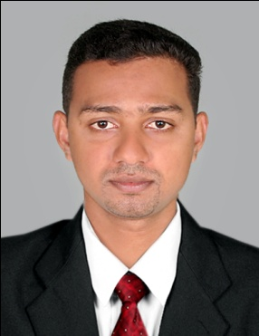**LIJO GEORGE**

**Vandankuzhiyil (H)**

**Marika P O**

**Koothattukulam**

**PIN-686662**

[lijogeorgemarika99@gmail.com](mailto:lijogeorgemarika99@gmail.com)

Mob:00966530424017

**CAREER OBJECTIVES**

Seeking challenging careers that can offer me growth in this competitive environment by implementing the academic knowledge and the sound experience to the fullest practical use to serve the organization and their varied requirement to the level of optimum satisfaction and perfection.

**CAREER OVERVIEW:**

Above 7 years of working experience in the field of ACCOUNTS AND SALES

**1.MEGAMART BANGALORE**

Period: JUNE 2006 to DECEMBER 2007

**JOB PROFILE:**

**Worked as Audit Staff under SSM Chartered Accountant Consultancy**

1. Maintain the cash and the petty cash
2. Maintain the stock register
3. Taking care of the stock audit
4. Taking care of the registers
5. Billing

**2. Arvind Brands Ltd (Megamart)**

Working as a showroom manager

Period: December 2007 to May 2011

JOB PROFILE:

1. Make sure that the store target is achieving
2. Sales cash management
3. Petty cash management
4. Auditing the stock
5. Preparing periodical reports
6. Coordinating company exhibitions and sales
7. Maintain the stock level
8. Take care of the staff

**3 .Worked as a Heavy Driver in Vallarapadam Container Terminal**

Worked as a Container Driver

Period: May 2011 to June 2014

JOB PROFILE

1. Always sure about the safe driving

2. Maintain the vehicle properly

3. Make sure that the required documents are there

4. Safe transfer of goods

5. Make sure that the container is safe

6. Get the received slip for the good transferred

7. Collect the hiring charge and transfer it to the office

**4 .Seder Telecom Riyadh (K.S.A)**

Working in Finance and Administration

Period: June 2014 to till date.

JOB PROFILE:

1. Maintain the cash and the petty cash
2. Make sure that the project in a profitable condition
3. Maintain the cash flows to the sites
4. Control the expenses
5. Check all the expenses and invoices
6. Maintain the stock registers
7. Taking care of the registers
8. Preparing periodical reports
9. General word processing
10. Collation and distribution of minutes, reports and other documents.
11. Dealing with incoming and outgoing mail and general emails.
12. Ordering of equipment, materials and office supplies.

**COMPUTER SKILLS:**

**Operating System:**

MS Dos, Windows2000 Server,XP

**Office package:**

MS-Excel, MS-Word, Power point, MS-Front page, Internet, Email

**Accounting packages:**

Tally, Shopper

**EDUCATIONAL QUALIFICATION:**

1. Plus-Two.( 2000-2002) MG University

2. B.A Economics (2003-2006) M.G.University

**PERSONAL DETAILS:**

Name : Lijo George

Age : 32

Date of Birth : 31-05-1984

Sex : Male

Fathers Name : George

Marital Status : Married

Nationality : Indian

**OTHER DETAILS:**

Language Proficiency : English, Malayalam, Kannada, Hindi and Tamil

Passport Number : H 2713433

D L Number : 38/732/2010

Hobbies : Playing Cricket, Reading

**REFERENCE:**

Available on demand.

**DECLARATION:**

I hereby declare that all information given is true to the best of my knowledge and belief.

**LIJO GEORGE**