**GAURAV ARORA**

**Contact:** +91-9619796907

**E-Mail:** ga.jobs806@gmail.com

**SENIOR LEVEL PROFESSIONAL**

**Service Delivery Management| IT Governance**

***Versatile, high-energy technocrat with a successful background in setting a direction for major systems to establish and transform operational excellence***

***Location Preference: NCR, Bangalore, Mumbai***

|  |  |
| --- | --- |
| **CORE COMPETENCIES**  **IT Service Delivery**  **IT Infrastructure Management**  **IT Governance**  **Change / Problem Management**  **Process Enhancement**  **Transition Management**  **Consultant Management**  **Business Continuity Planning**  **Operations Management**  **Transition & Transformation**  **Strategic Planning**  **Team Building & Leadership** | **PROFILE SUMMARY**   * Results Driven Technology Leader, with over 13 years of experience in large engagements and driving IT strategic vision & transforming Global Service Delivery across APAC, EMEA, North and South America] * Developed strategy, direction, and governance processes utilizing Information Technology Infrastructure Library (ITIL) practices; implemented those processes and simultaneously built the organization with alignment of business strategies, goals and objectives * Transition Expert: drove the transition of various services like Service Desk from Canada & Change Management from San Jose, U.S. to Adobe India; pivotal in the transition of Queue management accounts from EMEA to CSC India * A Strategist & Implementer: directed the implementation of Active Roles Server for a lean process oriented approach which reduced the MTTR by 50% and improved the accuracy by 43% * Led the creation of a central service desk model from a divided service desk model; expanded the IT team in India and Montevideo (through follow the Sun model) which augmented the FPoC from 25% to 63% in 1.5 years; pivotal in the implementation of “Moving things left” concept * Re-oriented IT Service Delivery methodologies to ensure improved focus on functional expertise and delivery of business critical services * An ambassador of change with the excellency successful business process re-structuring, implementation of business solutions in organizations through thought leadership and technical expertise |



**ORGANIZATIONAL EXPERIENCE**

**Mar’15 – April’ 16 I.T.B.D. Pvt. Ltd., as Sr. Manager – Infrastructure / Service Delivery Manager**

**May’13 – Mar’15 Trafigura. Global Services Pvt. Ltd., Mumbai as Manager – IT**

**Mar'09 to May'13 Adobe Systems India, Noida as Service Desk, Incident Management & Change Management**

**Key Result Areas:**

* Providing technological direction monitoring the existing infrastructure,; proposing budgets for purchases and upgrades, administering the backup teams, maintenance teams, L1, L2 & L3 teams and project teams, and presiding over IT infrastructure related projects
* Steering the implementation of a project methodology for the delivery of infrastructure and application project; including templates, processes, and training for increasing the project delivery efficiency of the IT team
* Spearheading the planning of IT Infrastructure Operations, control of operational and capital costs, technology implementation, transition and service delivery
* Creating execution roadmaps for IT infrastructure, purchases and budget controls to reduce overall operational costs of resources, infrastructure and applications as well as create an alignment between business / technology plans and strategic initiatives at the top level
* Developing strategy, direction, and governance processes utilizing Information Technology Infrastructure Library (ITIL) V3 practices; implementing those processes and simultaneously building the organization with alignment of business strategies, goals, and objectives
* Tailoring efficient service management processes through consolidating vendors, documentation & control of IT Policy and IT Asset Management
* Ensuring Service Level Agreement (SLA) adherence, establishing a 24X7 handover mechanism, mandatory escalation metric and delivery support based on Information Technology Infrastructure Library (ITIL);
* Attending service review meetings with service owners and discussing OLAs & scope of new work
* Administering the development of business continuity plans and implementation of disaster recovery infrastructure& plans; adhering to the RPOs and RTOs compliances
* Work with Vendors for training needs, Procurement, Hiring, Consultancy, Development and Infra projects etc.

**Highlights:**

* Augmented the GP from 34 % to 45% over a period of 1 year
* Successfully:
* Managed an established department with revenue $ 2.5 million dollars
* Grew a new department from $1 M to 2.5 Million dollars within a year
* Conceptualized & implemented a 2-year Global IT strategy to move the work from across the globe to India which empowered the L1 and L2 teams based out of India to take more work; increased the overall contribution in IT space increased from 25% to 63% over a period of 1.5 years
* Conceptualized & designed a boot camp program which reduced the time taken to make a resource fully billable / 100% utilized from 6 weeks to 3 weeks
* Reduced the bench cost by 50% month on month basis by initiating a new boot camp program which reduced the training period from 3 months to 1.5 months
* Improved the hiring process by standardizing the interview process in-sync technical team, setting bench marks for perks and remuneration, defining OLAs for approval process and escalation matrix, defining engagement process for candidates before joining and on-boarding of new employees till their confirmation
* Enhanced the knowledge management process which reduced the escalation by 66% and streamlined the on-boarding process of new projects.
* Enhance the Service Catalogue by dividing over all IT services into smaller pieces (e.g. NOC, Patching and maintenance, body shopping for L1, L2 and L3 engineers, process improvement services, Migration to Cloud, Procurement etc.)
* Established a well-defined KRA, KPI and road map for employee’s growth in the organization which reduced the attrition to less than 5% at the organization level leading to reduction of resource replacement cost and enhanced quality output.
* Steered the automation of approval process for all access related tasks which reduced MTTR by 90% and catapulted the customer satisfaction.
* Structured & implemented a new ITSM tool called LANDesk for incident management & Self Service
* Defined OLA for internal departments to set accountability for swift action and cohesive working



**PREVIOUS EXPERIENCE**

**Jul'06 to Dec'08 CSC India Pvt LTD, Noida as Team Lead (Service Desk & Incident Management)**

**Highlights:**

* Maintained an attrition rate of less than 5 %
* Successfully converted a non-performing account to a highly performing account
* Received giraffe award from the Vice president of the company for excellent performance and contribution
* Secured a 100 % SLA for 5 quarters
* Drove the Six Sigma projects for:
* Analysing Root cause and reducing backlogs
* Data processing in the Service Desk department

**Feb '04 to Jan'06 EXL Services.Com, Noida as Technical Support Executive**

**Highlights:**

* Received:
* Employee of the quarter for Best Customer Service
* Employee of the quarter for Best Attendance
* Employee of the month for Best Quality

**Jun’02-Jan’04 Calc Computers, DeraBassi Punjab as Computer Trainer**



**ACADEMIC QUALIFICATION**

* MCA (Computer Sciences) from PTU in 2007
* M.Sc. (Computer Sciences) from PTU in 2003
* PGDCA (IT) from CALC in 2001
* B.Com. from K.U.K Post Graduate College. Ambala in 2001



**TRAININGS & CERTIFICATIONS**

* ITIL®V3 Foundation – Certified
* Lean Six Sigma Green Belt – Certified
* ITIL®V3 ST Intermediate – Certified
* Project Management Professional (PMP) Trained
* M.C.S.E
* Good understanding of .Net, SQL, C#
* Advance Excel & VB programming- Trained
* Management Excellence Workshops and Leadership Trainings



**A Typical Week in My Professional Life**

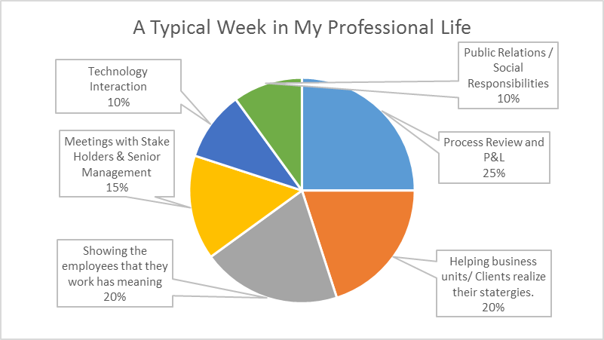



**PERSONAL DETAILS**

**Date of Birth**  20th October 1980

**Languages known**  English, Hindi and Punjabi

**Address**  806/5 East end apartment, Indirapuram, Ghaziabad – 201014