WEEK 1 • PLANNING DOCUMENT
AGRIBUSINESS
DATA ANALYSIS
A structured plan for collecting, cleaning, analysing and forecasting public agricultural data

STUDENT NAME | SANJAY H H
USN | 1MJ24CD041
PROGRAM | CSE – Data Science
SEMESTER | 5th Semester
INSTITUTION | MVJ College of Engineering, Bengaluru
Prepared for the Week 1 Task: Agribusiness Data Analysis Planning
Proposed project schedule: 12 October – 6 December 2026

Executive Summary
This document proposes a structured and reproducible plan for collecting and analysing publicly available agribusiness data, with an emphasis on crop yield, agricultural market prices and resource-use indicators. The analysis will combine official crop statistics with market-price and arrivals records, rainfall information and selected international indicators. The purpose is to describe historical patterns, test whether production and weather indicators move alongside market prices, and compare simple forecasting baselines before making any predictive claims.
The project will begin with a manageable pilot: selected Indian crops and a Karnataka market subset where data completeness can be confirmed. Annual crop statistics will establish production and yield trends; daily or market-day records will be aggregated to weekly and monthly levels for price analysis. Since the supplied crop-statistics table contains area, production and yield—but not prices or farm-level water use—separate data sources are required for pricing and resource-use analysis.
Core principle Use public data, preserve source files, document every transformation, distinguish confirmed records from missing values, and treat forecast outputs as estimates with measurable error—not as guaranteed future prices.

Objectives
- Define a clear research scope and a set of measurable questions for agribusiness trend analysis.
- Identify credible public data sources for crop production, market prices, arrivals, rainfall and selected resource indicators.
- Specify key metrics, units, data frequency and definitions before collecting data.
- Design a repeatable workflow for acquisition, quality checks, cleaning, integration, exploratory analysis and forecasting.
- Create a dated timeline with milestones, outputs and quality checks for the planning task and follow-on analysis.

How this document addresses the Week 1 brief
Assignment requirement | Where addressed
Structured plan and research rationale | Sections 1–2
Public agricultural data sources | Section 2 and References
Crop yield, pricing and resource-use metrics | Section 3
Collection, cleaning and interpretation steps | Section 4
Forecasting methods with a worked example | Section 5
Timeline with milestones and dates | Section 6
Evaluation criteria, readability and limitations | Sections 7–8

1. Research Rationale and Project Scope

1.1 Research rationale
Agricultural outcomes are influenced by multiple connected factors: cultivated area, yield, harvest timing, rainfall, input availability, transport, market arrivals, seasonal demand and price movements. Examining only one dataset can create an incomplete picture. For example, a production increase does not automatically imply a lower retail price because storage, procurement, market access, quality, location and demand can alter the relationship. A joined and documented dataset makes these relationships easier to examine while helping expose data gaps.
A Data Science approach is appropriate because these sources often differ in format, units, geography and time frequency. The project will use descriptive statistics and visualisation first, then establish simple forecasting baselines. More complex models will only be considered if enough consistent observations are available and they outperform the baselines on a holdout period.

1.2 Proposed scope
Dimension | Proposed scope for the pilot
Geography | India for annual production/yield; Karnataka markets for price analysis, limited to markets with adequate records.
Crops | Pilot crops: maize for the worked production example; onion and tomato may be included in market-price analysis if records are sufficiently complete.
Time span | Five annual crop years from 2021–22 to 2025–26 for the supplied crop table; target 36 months of daily/market-day price records if downloadable and consistent.
Analysis unit | Crop × year for production; commodity × market × date for prices/arrivals; state/district × period for rainfall where aligned.
Deliverable | A DOCX planning report, source register, cleaned CSV, analysis notebook/script, charts and a concise findings summary.

Data availability gate The scope is provisional until the first source audit confirms crop/market names, historical depth, geographic coverage, units and missingness. If one crop or market lacks reliable records, document the exclusion and choose the next suitable series rather than silently filling gaps.

1.3 Research questions
1. How did area, production and yield change for selected crops across the available years?
2. Which selected commodity-market series show strong monthly seasonality or large price variability?
3. Are changes in market arrivals and rainfall associated with price movements after aligning records to the same time period?
4. Which simple forecasting baseline performs best on a time-ordered holdout sample, and how large are its errors?
5. What data limitations prevent a reliable claim about farm profitability, water productivity or causal climate effects?

1.4 Expected outputs
The outputs will be a source inventory and data dictionary; read-only raw files plus cleaned data; a quality audit covering missingness, duplicates, units and date coverage; exploratory charts; a baseline forecast comparison using MAE/RMSE; and a concise findings note with limitations and reproducibility details.

2. Public Data Sources and Acquisition Strategy
The source plan prioritises official government or intergovernmental datasets. Each download should be accompanied by its source URL, dataset title, retrieval date, selected filters, units, geographic scope and any relevant footnotes. Record the original file name and do not overwrite source files during cleaning.
Source and link | Data to collect | Frequency / unit | Role and caveat
DA&FW / ES&E – Agricultural Statistics at a Glance 2024  https://desagri.gov.in/document-report-category/agriculture-statistics-at-a-glance/ | Crop area, production, yield; agriculture structure and selected input indicators. Also use the DA&FW crop-wise table supplied for 2021–22 to 2025–26. | Mostly annual; source-specific units. Supplied table: area in lakh ha, production in lakh tonnes, yield in kg/ha. | Primary production source. Mark 2025–26 as third advance estimates, not final actuals.
Open Government Data Platform India – daily mandi prices  https://karnataka.data.gov.in/catalog/current-daily-price-various-commodities-various-markets-mandi | Commodity, variety, market/APMC, date, minimum, maximum and modal wholesale price; arrivals if present in the download. | Daily/market day; preserve source price and arrival units then standardise. | Pricing source generated through AGMARKNET. Availability and completeness may vary by commodity and market.
AGMARKNET portal  https://agmarknet.gov.in/ | Cross-check market profiles, commodity names, price/arrival definitions and market context. | Dynamic market records; daily/market day. | Use as the domain reference for Indian agricultural market information; verify how each exported field is defined.
India Meteorological Department – rainfall information  https://mausam.imd.gov.in/responsive/rainfallinformation.php?msg=M | District/state/subdivision rainfall, monthly or seasonal totals and departure from normal where available. | Daily, weekly, monthly and cumulative views; rainfall in mm or source-specific unit. | Use a location/time key and align rainfall to relevant crop/market periods; historical downloads may need a separate request.
World Bank – Agriculture & Rural Development indicators  https://data.worldbank.org/indicator | Cereal yield, agricultural land, irrigated land, fertilizer consumption, crop/food production indices and agriculture value added. | Generally annual; definitions and latest year vary by indicator. | Provides context indicators; national aggregates should not be treated as district or farm-level measurements.
FAOSTAT – Food and Agriculture data  https://www.fao.org/faostat/ | Comparable crop production, harvested area, yield and selected sustainability/resource indicators. | Annual; country and commodity coverage depends on domain. | Useful for international comparison and cross-checking; definition, release year and unit must be checked in metadata.

2.1 Collection procedure
1. Confirm each source title, agency, geography, date coverage, update date and usage terms.
2. Export CSV/XLSX where possible; retain PDFs only when structured data is unavailable.
3. Record file name, URL, retrieval date, filters and units; keep the original download read-only.
4. Use consistent crop, variety, market, district, state and date identifiers; prefer stable codes when available.
5. Preserve provisional/advance-estimate status for 2025–26 crop statistics.
Important distinction The provided crop-wise statistics table does not contain historical mandi prices. Pricing analysis must be built from a market-price dataset; no price results will be reported until those records are actually collected and verified.

3. Key Indicators, Metrics and Definitions
Metrics are defined before analysis so that calculations are consistent. Every chart and table should show the crop/market, period, unit and source. Where farm-level measurements are unavailable, report a proxy or state that the metric cannot be calculated from the selected data.
Domain | Metric / definition | Unit or calculation | Interpretation
Production | Crop area | ha or lakh ha; retain source unit. | Land devoted to crop; area alone does not measure efficiency.
Production | Crop production | tonnes or lakh tonnes. | Total output; flag provisional/advance estimates.
Productivity | Crop yield | kg/ha. | Output per area; compare the same crop and definition.
Pricing | Modal price | Source unit; convert only with a documented factor. | Observed wholesale mode; not retail or farm-gate price.
Pricing | Price range / spread | Maximum − minimum for the same commodity, market and date. | Within-day range; grades and reporting can differ.
Pricing | Period-over-period change | 100 × (P_t − P_(t−1)) / P_(t−1). | Price movement; undefined if prior price is zero or missing.
Pricing | Price volatility | SD or coefficient of variation of comparable weekly/monthly prices. | Variability; compare consistent periods and units.
Market flow | Market arrivals | Arrival quantity in the source unit. | Market inflow; not equal to total production.
Climate | Rainfall total / anomaly | mm; observed minus long-run normal when defined. | Seasonal context; association is not causation.
Resource use | Fertilizer consumption | Source unit, such as kg/ha. | Input-intensity proxy; national values do not describe a farm.
Resource use | Irrigated agricultural land | % of agricultural land per source definition. | Irrigated share; not the water actually applied.
Sustainability | Water productivity (optional) | Crop output / measured water use. | Use only with credible matched water-use records.

3.1 Derived indicators
Indicator | Formula | Quality check
Year-over-year crop change | 100 × (X_t − X_(t−1)) / X_(t−1) | Denominator must be non-zero; flag provisional years.
Mean price per month | Mean of valid prices within commodity-market-month. | Show observation count; flag sparse months.
Missing rate | Missing cells / expected cells × 100. | Calculate by variable, crop/market and period.
Forecast absolute error | |observed − forecast|. | Keep time order; never train on future data.
MAE | Mean(|observed − forecast|). | Same unit as the target variable.
RMSE | Square root of mean squared error. | More sensitive to large errors than MAE.
MAPE (conditional) | Mean(|observed − forecast| / |observed|) × 100. | Use only where actual values are non-zero and meaningful.

4. Step-by-Step Data Collection, Cleaning and Interpretation
The workflow is designed to be repeatable. Each step produces a small, reviewable deliverable so that data issues are found early rather than after modelling.
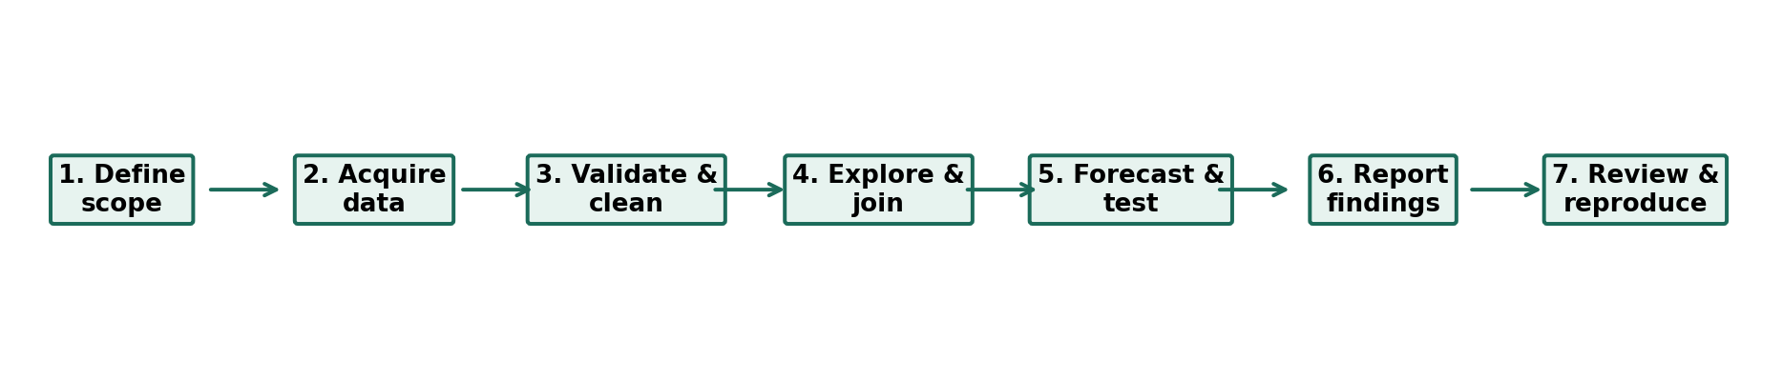
Figure 1. Proposed end-to-end analysis workflow.

Step 1 — Define and record scope
- Record research questions, crops, markets, years, frequency, target variables and exclusions; separate annual yield/production targets from weekly or monthly price targets.

Step 2 — Acquire and preserve raw data
- Download source files into /data/raw and create /data/processed, /outputs and /references folders. Record the URL, retrieval date, filters, version and units in a source register; never edit raw files.

Step 3 — Profile the raw data
- Inspect row/column counts, types, date coverage, unique crop/market labels, units, duplicates and missingness; compare observed with expected market-days while accounting for closures and non-reporting.

Step 4 — Clean and standardise
- Parse dates and standardise crop, variety and market labels through a documented mapping table. Define a valid record key (e.g., commodity × variety × market × date) before removing duplicates.
- Keep blank, unavailable, not applicable and genuine zero distinct. Convert units only with documented factors; flag unusual prices/yields for source review and log every correction. Never impute an absent value without justification.

Step 5 — Integrate sources carefully
- Join using validated identifiers and compatible geography/time. Aggregate price records to weekly/monthly summaries and align rainfall and crop years without silently mixing calendar and agricultural years.

Step 6 — Explore and interpret
- Create descriptive tables, crop-trend lines, monthly price plots, distributions and missingness charts; label each with unit, period and source.
- Compare area, production and yield separately. Explore price-arrival-rainfall associations with sample sizes and confounders; do not interpret correlation as causation.

Step 7 — Forecast, validate and communicate
- Compare naïve, seasonal-naïve (if relevant), moving-average and linear-trend baselines using chronological or rolling-origin validation; calculate MAE/RMSE and use MAPE only when appropriate.
- Document limitations, maintain the data dictionary, save code and produce a one-page findings summary.

5. Analytical Design and Worked Example

5.1 Descriptive analysis using the supplied crop table
The Department of Agriculture & Farmers Welfare crop-wise table supplied for this project reports India-level area, production and yield for 2021–22 through 2025–26. The table states that 2025–26 figures are third advance estimates. This example uses the maize “Total” row; values are not a state-level breakdown.
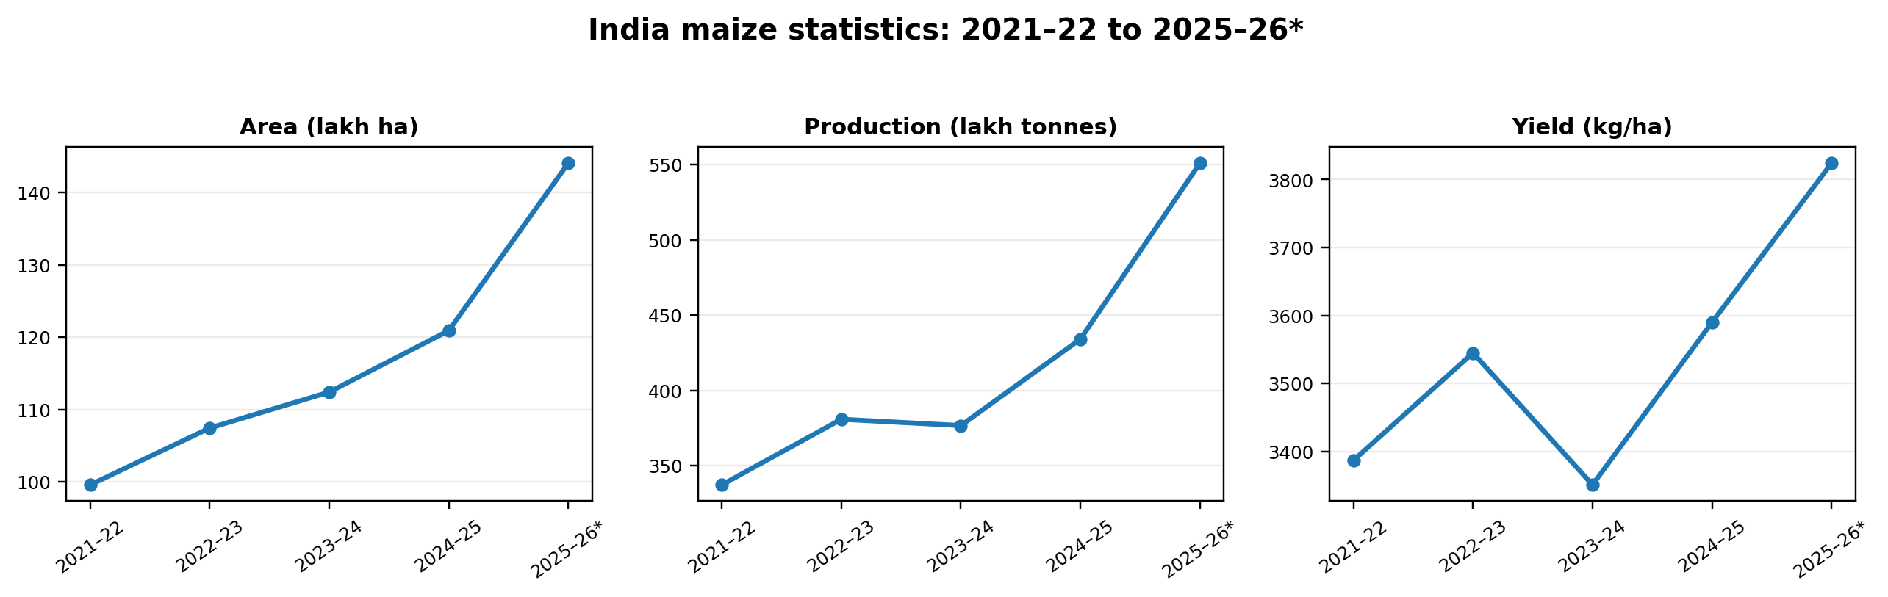
Figure 2. Maize area, production and yield over the five reported crop years. *2025–26 is a third advance estimate.
Indicator | 2021–22 | 2024–25 | 2025–26* | Change 2021–22 to 2025–26*
Area (lakh ha) | 99.58 | 120.91 | 144.08 | +44.7%
Production (lakh tonnes) | 337.30 | 434.09 | 550.93 | +63.3%
Yield (kg/ha) | 3,387 | 3,590 | 3,824 | +12.9%

Interpretation In the supplied series, maize production increased faster than cultivated area across the endpoints, while reported yield also increased. This is a descriptive comparison only; it does not establish the causes, and the latest year is provisional. Seasonal, weather, input and policy factors require separate aligned records.

5.2 One-step-ahead forecast demonstration
To make the forecasting plan concrete, the first four annual maize production observations (2021–22 to 2024–25) are used to forecast 2025–26. The third advance estimate of 550.93 lakh tonnes is then used as the comparison value. This is an illustration of model mechanics, not enough data to declare one method generally superior.
Method | Forecast for 2025–26 (lakh tonnes) | Absolute error (lakh tonnes) | Absolute percentage error
Naïve baseline: last year value | 434.09 | 116.84 | 21.2%
Three-year moving average: mean of 2022–23 to 2024–25 | 397.20 | 153.73 | 27.9%
Linear trend fitted to 2021–22 through 2024–25 | 453.77 | 97.16 | 17.6%
Comparison value: 2025–26 third advance estimate | 550.93 | — | —

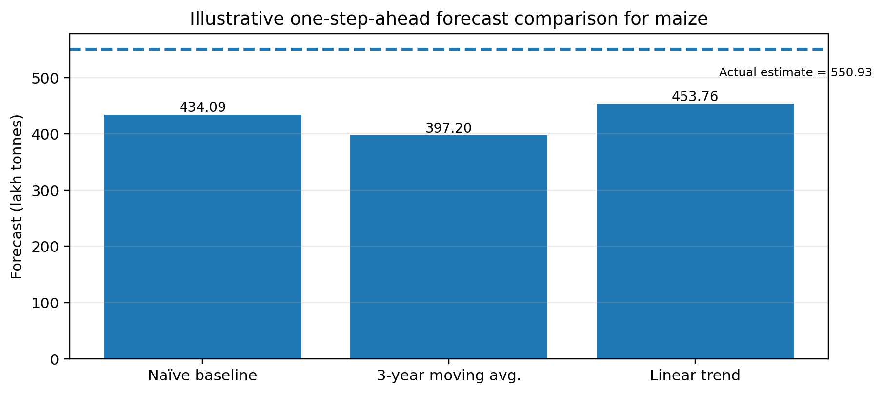
Figure 3. Forecasts from three simple baselines compared with the 2025–26 third advance estimate.

5.3 What the demonstration tells us—and does not tell us
- On this single comparison point, the linear-trend estimate has the smallest absolute error among the three methods. That does not prove it will perform best in future years.
- Only four training observations are available in this example, and 2025–26 is a third advance estimate. Longer historical data and revisions should be used before formal model selection.
- For market prices, model at a weekly or monthly frequency after checking seasonality. Compare naïve and seasonal-naïve baselines with moving average and trend models.
- If enough market-price observations are available, add rainfall, arrivals, month/season, holidays, market and commodity as candidate features. Validate using rolling-origin splits to prevent look-ahead bias.

5.4 Model evaluation plan
Validation design | Procedure | Success condition
Chronological holdout | Train on earlier records, test on later time periods; no random row split for time series. | All test observations occur after training observations.
Rolling-origin checks | Move the forecast origin forward and recompute each forecast using only data available at that point. | Report average and range of MAE/RMSE across folds.
Baseline comparison | Evaluate the same test dates for naïve, seasonal-naïve, moving average and trend models. | Prefer a complex model only if it consistently improves on the relevant baseline.
Residual and bias checks | Plot errors over time and by crop/market/season. | No unexplained systematic under- or over-prediction; document limitations.

6. Timeline, Milestones and Deliverables
The dates below are a proposed working schedule beginning 12 October 2026. The Week 1 planning document is planned for completion by 18 October; follow-on work continues to 8 November. A milestone is complete only when its output is saved and checked. If a source is delayed, record the issue and proceed only with available verified data rather than inventing values. Adjust dates if the platform specifies another deadline.

6.1 Week 1 planning milestones
Date | Task | Output / acceptance check
12 Oct 2026 | Confirm questions, geography, pilot crops, target variables and exclusions. | One-page scope; each question linked to a measurable indicator.
13 Oct 2026 | Review official production, market-price, climate and context sources. | Source register with titles, links, units, coverage and retrieval notes.
14 Oct 2026 | Choose candidate crops/markets based on availability, not preference alone. | Selection table listing completeness and exclusions.
15 Oct 2026 | Define variable names, units, keys, expected frequency and quality rules. | Draft data dictionary and join-key specification.
16 Oct 2026 | Write collection, cleaning, exploratory analysis and forecast procedures. | Method workflow with explicit missing-data/outlier handling.
17 Oct 2026 | Build forecast baseline example, validation plan and evaluation rubric. | Worked example; error metrics; evaluation criteria.
18 Oct 2026 | Check citations, formatting, figures, timeline and completeness against brief. | Final Week 1 DOCX; all requirements traceable to a section.

6.2 Follow-on project schedule
Dates | Phase | Tasks and milestone
19–23 Oct 2026 | Data collection | Download raw crop/price/rainfall records; preserve original files; source register complete.
24–26 Oct 2026 | Data audit and cleaning | Profile duplicates, missingness, units, dates, outliers; produce cleaned files and audit log.
27–30 Oct 2026 | Exploratory data analysis | Trend summaries, price seasonality charts, arrivals/price summaries and climate alignment.
31 Oct–2 Nov 2026 | Forecasting and validation | Build baselines; time-based evaluation; calculate MAE/RMSE; compare against simple benchmarks.
3–5 Nov 2026 | Interpretation | Review evidence, likely explanations, uncertainties, practical relevance and limitations.
6–8 Nov 2026 | Final packaging | Final report, reproducible code/notebook, data dictionary, charts, references and presentation.

7. Quality Assurance, Risks and Limitations
Risk | Potential effect | Mitigation / decision rule
Missing market-day records | False apparent price spikes or incomplete monthly averages. | Report observation counts and missing rate; suppress or flag months below a pre-set coverage threshold; do not fill missing prices with zero.
Provisional crop figures | Trend and forecast target may be revised. | Label advance estimates; update the series when final estimates appear; report version/date.
Different units or definitions | Invalid joins and misleading comparisons. | Use a data dictionary; retain original units; convert only through documented factors; check source metadata.
Geographic mismatch | National rainfall or yields may be wrongly used to explain a local market price. | Align state/district/market level where possible; if not possible, treat the broader indicator as context only.
Outliers and data entry errors | Distorted means or forecasts. | Flag extreme values; compare source pages and adjacent dates; correct only with evidence and preserve a correction log.
Short time series | Unstable forecast rankings and overfitting. | Start with simple baselines; use longer history; state that short-run results are exploratory.
Correlation mistaken for causation | Overstated claims about climate, prices or policy. | Use cautious language; consider alternative factors and confounders; causal claims need an appropriate design.
Unmeasured resource use/costs | Cannot calculate farm water productivity or net profit reliably. | Do not infer from national proxies; seek matching input/water/cost data or list the metric as future work.

7.1 Minimum data-quality checks
- Completeness: report non-missing percentage by field and time period.
- Validity: check numeric ranges, date formats, positive/negative values where prohibited by definitions, and allowed categories.
- Uniqueness: check the chosen record key for duplicate rows and conflicting records.
- Consistency: compare totals and units across sources and note whether the crop year differs from calendar year.
- Timeliness: record the access date, dataset publication/update date and provisional/final status.
- Reproducibility: keep raw and cleaned files separately; version the code; make the transformations rerunnable.

7.2 Privacy and responsible use
The project prioritises public aggregate data. If any dataset includes personal or farm-identifiable information, it will not be used unless lawful access and appropriate safeguards are clear. The report will avoid claiming that a model guarantees prices, crop yields or farmer income; it will present results as decision support with visible uncertainty.

8. Proposed Evaluation Criteria
The following rubric operationalises the Week 1 brief. It is a proposed self-checking rubric, not an official college grading formula. Each criterion receives a rating from 1 (weak) to 5 (excellent); weighted points = rating ÷ 5 × criterion weight.
Criterion | Weight | Rating 1–2: needs improvement | Rating 4–5: strong evidence
Problem definition and scope | 10% | Question vague; crop, geography or period unclear. | Measurable questions, exclusions, scope and success criteria are explicit.
Data-source credibility and citation | 15% | Sources unsupported or hard to trace. | Agency, title, URL, retrieval date, coverage, units and caveats are recorded.
Data cleaning and method transparency | 15% | Cleaning undocumented; missing and zero values confused. | Raw/clean separation, audit log, key validation and transformations are reproducible.
Quantitative depth and interpretation | 20% | Mostly general description; no checked calculations. | Multiple checked metrics, trends, alternative explanations and evidence-led conclusions.
Forecasting and validation | 15% | Methods named without worked examples or evaluation. | Several baselines, transparent errors, time-ordered validation plan and limitations.
Charts and readability | 10% | Charts lack units/source or are hard to read. | Charts show titles, units, periods, source/status and support interpretation.
Practical relevance and limitations | 5% | Recommendations generic; assumptions hidden. | Actions follow evidence; uncertainty and unmeasured factors are separated.
Reproducibility and code/data | 5% | Code/data missing; results cannot be recreated. | Clean run regenerates outputs; schema, environment, logs and outputs are included.
Timeline and deliverables | 5% | Tasks undated or outputs undefined. | Dated milestones include outputs, acceptance checks and contingencies.

8.1 Final submission checklist
- ☐ Objectives, research rationale, scope, official sources and measurable KPIs are defined.
- ☐ Cleaning rules cover missing values, duplicates, outliers, units and valid joins.
- ☐ Forecasts include numerical examples, error calculations, a time-ordered evaluation plan and limitations.
- ☐ Dated milestones, labelled charts, source references, provisional values and hypothetical examples are checked.

9. Expected Deliverables and Conclusion
Deliverable | Contents | Completion evidence
Planning document (DOCX) | Research rationale, scope, sources, indicators, process, forecasting plan, schedule, evaluation and references. | Requirements matrix completed; proofreading and source checks passed.
Source register | Source title, agency, URL, retrieval date, filters, coverage, unit, license/notes. | One row per file or dataset; all downloaded files traceable.
Raw-data archive | Original downloads with unmodified file names and retrieval notes. | Read-only raw directory; source files not overwritten.
Cleaned CSV + data dictionary | Standardised names, units, identifiers, derived variables and definitions. | Schema documented; quality report attached.
Python notebook or script | Acquisition notes (where permitted), cleaning, descriptive analysis, forecast baselines and metrics. | Can be run again using the documented files and dependencies.
Charts and summary | Crop trend, market price/seasonality, missingness and forecast evaluation charts. | Titles, units, sample period and sources visible.
Final findings report | Evidence-based findings, recommendations, risks and limitations. | Every claim links to a table, chart, formula or credible source.

Conclusion
This Week 1 plan defines a practical route from public agricultural information to transparent analysis. It combines official crop statistics with separately collected market-price and rainfall data, predefines meaningful metrics, sets out quality checks and proposes a realistic timeline. A small maize example demonstrates how to calculate changes and compare naïve, moving-average and linear-trend forecasts. The example also shows why model validation, data provenance and provisional-estimate labels are essential. The next stage is to download and audit the candidate market and climate datasets; results must be reported only after those records have been inspected and cleaned. Any planned or simulated price scenario must remain labelled hypothetical and must never be presented as observed market data.

References and public data portals
[1] Department of Agriculture & Farmers Welfare, Economics, Statistics & Evaluation Division. “Agricultural Statistics at a Glance 2024.” https://desagri.gov.in/document-report-category/agriculture-statistics-at-a-glance/ (accessed 11 October 2026).
[2] Department of Agriculture & Farmers Welfare. “All India: Crop-wise Area, Production & Yield,” 2021–22 to 2025–26, supplied project table. Source footnote: 2025–26 figures are third advance estimates; area in lakh ha, production in lakh tonnes, yield in kg/ha.
[3] Open Government Data Platform India. “Current daily price of various commodities from various markets (Mandi).” Dataset generated through AGMARKNET. https://karnataka.data.gov.in/catalog/current-daily-price-various-commodities-various-markets-mandi (accessed 11 October 2026).
[4] Directorate of Marketing & Inspection. AGMARKNET portal. https://agmarknet.gov.in/ (accessed 11 October 2026).
[5] India Meteorological Department. “Rainfall Information.” https://mausam.imd.gov.in/responsive/rainfallinformation.php?msg=M (accessed 11 October 2026).
[6] World Bank. “Agriculture & Rural Development Indicators.” https://data.worldbank.org/indicator (accessed 11 October 2026).
[7] Food and Agriculture Organization of the United Nations. FAOSTAT database. https://www.fao.org/faostat/ (accessed 11 October 2026).
[8] Safeer, S., Gallo, P., & Pulvento, C. (2025). “Agri-farming with computer vision, IoT and blockchain towards climate smart cultivation.” Internet of Things, 34, 101749. https://doi.org/10.1016/j.iot.2025.101749. Included as supporting context for digital agriculture; it is not the source of crop-price data.

APPENDIX A | RESUBMISSION IMPROVEMENTS AND ORIGINAL NUMERICAL ANALYSIS
This appendix makes the analytical evidence explicit so a reviewer can trace each conclusion to source values, formulae, or a clearly labelled scenario. The underlying crop figures come from the supplied Department of Agriculture & Farmers Welfare (DA&FW) All-India Crop-wise Area, Production & Yield table. Values for 2025–26 are Third Advance Estimates and are not labelled as final outturns.

A.1 Feedback-to-evidence map
Evaluator concern | What this version adds | Evidence / where to check
Broad discussion; few concrete numbers | Endpoint changes for maize area, production and yield; year-by-year total food-grain production; formulas and source status. | Appendix A.2 and outputs/endpoint_change_metrics.csv; outputs/foodgrains_yoy_analysis.csv
Forecasting methods too vague | Numerical naïve, three-year moving-average and linear-trend estimates compared against the source-reported 2025–26 maize Third Advance Estimate. | Appendix B; outputs/maize_forecast_holdout_comparison.csv
Timeline too generic | Dated milestones and completion evidence already included in Section 6; the Week 1 plan runs 12–18 Oct 2026 and follow-on work is scheduled through 6 Dec 2026. | Section 6: dates, deliverables and acceptance checks
Evaluation criteria too brief | A nine-criterion rubric includes weights, observable 1/3/5 anchors and a weighted scoring formula. | Appendix D
Analysis not reproducible | A runnable Python script, notebook, 40-row selected CSV, outputs, data-quality audit and README are included in the companion bundle. | Appendix C and the resubmission ZIP
Price/loss numbers could be mistaken for observed facts | Price-spread and supply-chain loss numbers are explicitly labelled hypothetical teaching scenarios; the supplied crop table has no price or measured loss observations. | Appendix B.3 and B.4; matching CSVs have HYPOTHETICAL status labels

A.2 Source-backed maize statistics
Agricultural year | Area (lakh ha) | Production (lakh tonnes) | Yield (kg/ha) | Source status
2021–22 | 99.58 | 337.30 | 3,387 | Reported in supplied source
2022–23 | 107.44 | 380.85 | 3,545 | Reported in supplied source
2023–24 | 112.41 | 376.65 | 3,351 | Reported in supplied source
2024–25 | 120.91 | 434.09 | 3,590 | Reported in supplied source
2025–26 | 144.08 | 550.93 | 3,824 | Third Advance Estimate

Calculated endpoint changes
Endpoint change formula: percentage change = ((2025–26 value ÷ 2021–22 value) − 1) × 100. Values are compared within the same variable and crop.
Indicator | Starting value (2021–22) | Ending value (2025–26*) | Calculated change
Maize area | 99.58 lakh ha | 144.08 lakh ha | +44.69%
Maize production | 337.30 lakh tonnes | 550.93 lakh tonnes | +63.34%
Maize yield | 3,387 kg/ha | 3,824 kg/ha | +12.90%
Total food-grain production | 3,156.16 lakh tonnes | 3,765.63 lakh tonnes | +19.31%

Interpretation boundary Maize production increased faster than cultivated area over these endpoints, while reported yield also increased. This is descriptive, not causal: the data do not isolate the effects of weather, seed, inputs, policy, or reporting revisions. The 2025–26 value is a Third Advance Estimate.

A.3 Total food-grain production year by year
Agricultural year | Production (lakh tonnes) | Year-over-year change
2021–22 | 3,156.16 | Baseline
2022–23 | 3,296.87 | +4.46%
2023–24 | 3,322.98 | +0.79%
2024–25 | 3,577.32 | +7.65%
2025–26* | 3,765.63 | +5.26%

Across four year-to-year intervals, total food-grain production rises by 19.31%, equivalent to a descriptive compound annual growth rate (CAGR) of approximately 4.51%. CAGR is calculated as ((last value ÷ first value)^(1/4) − 1) × 100. It describes the endpoints and does not imply the same rate will continue.

APPENDIX B | DETAILED FORECASTING EXAMPLE AND SCENARIO CALCULATIONS

B.1 One-step-ahead maize comparison
To demonstrate the mechanics of forecasting, the four maize production observations from 2021–22 through 2024–25 are used as the training series. The 2025–26 Third Advance Estimate (550.93 lakh tonnes) is the comparison value. The exercise is deliberately a single holdout demonstration, not a complete validation study.
Method | Calculation | Forecast (lakh tonnes) | Absolute error (lakh tonnes) | Absolute % error
Naïve baseline | Use 2024–25 value | 434.09 | 116.84 | 21.21%
Three-year moving average | (380.85 + 376.65 + 434.09) ÷ 3 | 397.20 | 153.73 | 27.90%
Linear trend (least squares) | Fit straight line to the four training values; extrapolate one step | 453.77 | 97.17 | 17.64%
Comparison value | 2025–26 Third Advance Estimate | 550.93 | — | —

Absolute error = |reference value − forecast|. Absolute percentage error = absolute error ÷ |reference value| × 100. In this one comparison the linear trend has the smallest absolute error, but a single test point cannot establish that it is generally the best method.
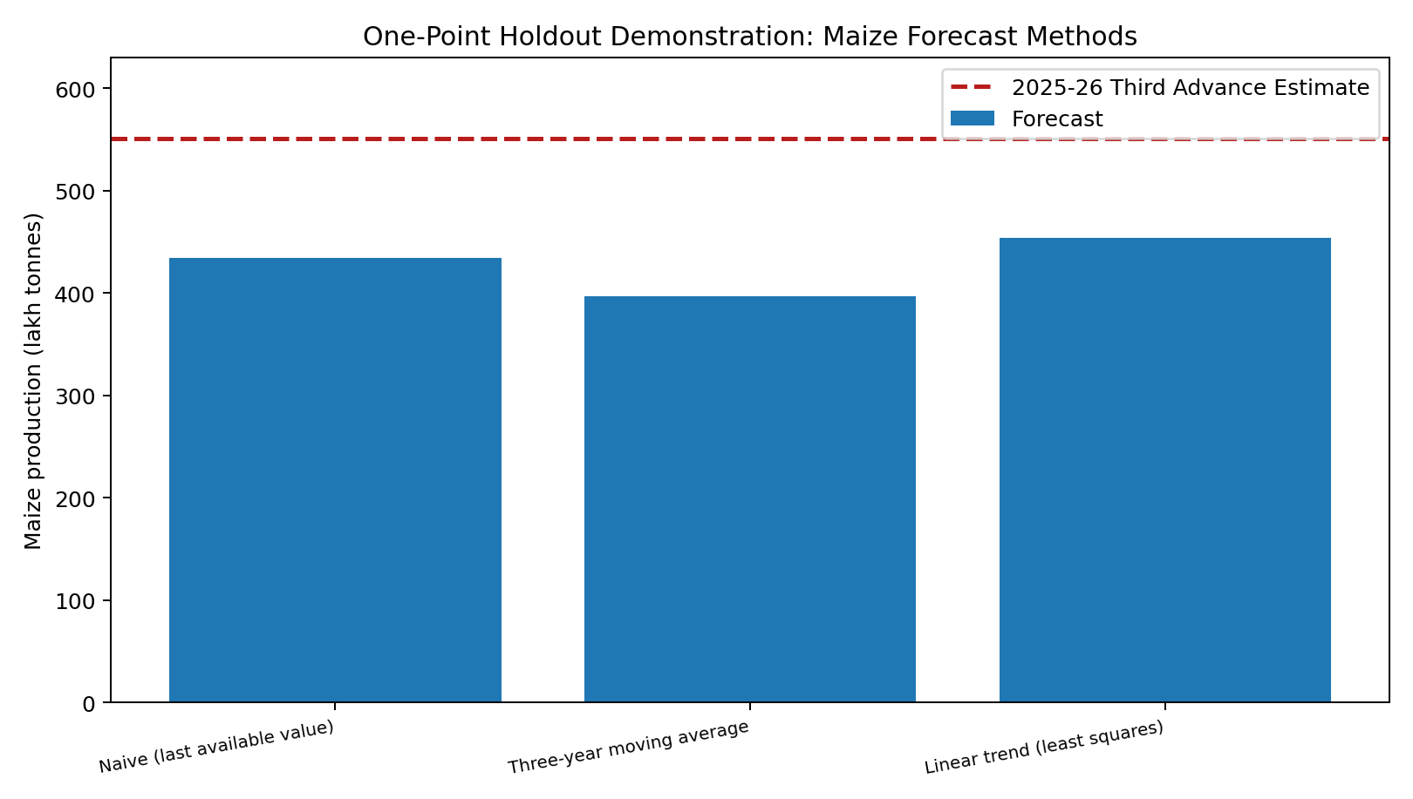
Figure A1. Maize baseline forecasts compared with the 2025–26 Third Advance Estimate; this is one comparison point only.
Important forecasting limitation Five annual observations total provide very little history; only four observations train this example and only one point is used for comparison. These outputs are illustrative and do not validate a reliable predictive model. Use a longer consistent series, rolling-origin validation, and MAE/RMSE across multiple test periods before making reliability claims.

B.2 Forward-only food-grain forecast illustration
Using all five reported total food-grain values, three simple methods produce the values below for 2026–27. There is no observed 2026–27 comparison value in this project dataset, so no error can be calculated and no forecast accuracy is claimed.
Method | Illustrative 2026–27 value (lakh tonnes) | Interpretation
Naïve baseline | 3,765.63 | Repeats the latest reported value
Three-year moving average | 3,555.31 | Averages 2023–24 through 2025–26
Linear trend (least squares) | 3,873.61 | Extends a straight-line fit across five annual observations

B.3 Hypothetical price-spread calculation (not observed market data)
The supplied DA&FW crop-statistics table contains area, production and yield. It does not contain actual farm-gate, wholesale or retail prices. The following invented prices show the calculation only; they must not be reported as measured Indian market prices.
Supply-chain stage | Illustrative price (₹/kg) | Difference from prior stage
Farm-gate | 18.00 | —
Wholesale | 24.00 | +₹6.00/kg versus farm-gate
Retail | 32.00 | +₹8.00/kg versus wholesale
Farm-gate-to-retail spread | ₹14.00/kg | ₹32 − ₹18

A price spread is not the same as the farmer’s profit or the retailer’s net margin. Transport, handling, commissions, grading, storage, spoilage, labour, rent and financing can occur between stages. To calculate a real spread, collect market-date-crop-specific records and align price units and grades.

B.4 Hypothetical post-harvest loss calculation (not observed loss data)
Assume 1,000 kg is harvested and illustrative losses are 2% at collection, 4% during storage, and 2% during transport. Each stage percentage applies to the quantity entering that stage.
Stage | Input (kg) | Assumed loss rate | Loss (kg) | Output (kg)
Harvested quantity | 1,000.00 | — | 0.00 | 1,000.00
Collection | 1,000.00 | 2% | 20.00 | 980.00
Storage | 980.00 | 4% | 39.20 | 940.80
Transport | 940.80 | 2% | 18.82 | 921.98
Total | 1,000.00 | 7.80% net loss | 78.02 | 921.98

Net loss percentage = (starting quantity − final saleable quantity) ÷ starting quantity × 100 = (1,000 − 921.984) ÷ 1,000 × 100 ≈ 7.80%. This is a transparent worked example using assumed rates. Replace the rates with measured, crop-specific weights before drawing real conclusions.

APPENDIX C | REPRODUCIBLE CODE, DATA AND QUALITY CONTROLS
A report is reproducible when another person can rerun the documented steps and regenerate the results from the same source dataset. The companion ZIP contains the script, notebook, selected source-data CSV, source PDF, output tables, charts and instructions.
File / output | Purpose | What to verify
crop_statistics_selected_all_india.csv | Selected data rows covering eight crop/aggregate groups across five agricultural years (40 rows). | Each row has crop, year, area, production, production unit, yield and estimate status.
source_DAandFW_crop_statistics_2025_26.pdf | Source copy supplied for the project. | 2025–26 must be labelled Third Advance Estimate; review units and notes.
analyze_agri_data.py | Loads and validates the CSV; calculates endpoint changes, year-over-year changes, forecast comparisons and hypothetical teaching examples; creates charts and outputs. | Run from the package folder with the listed dependencies.
Agribusiness_Data_Analysis_Reproducible.ipynb | Interactive workflow showing validation, descriptive analysis, forecast calculations and labelled scenarios. | Run cells in order; keep the CSV beside the notebook.
outputs/data_quality_audit.csv | Machine-readable basic checks for row count, unique keys, year coverage, missingness, negative values and unit consistency. | These are structural checks and do not replace checking the transcription against every source row.
outputs/endpoint_change_metrics.csv | Change percentages for area, production and yield for the selected crop groups. | Interpret percent changes within a crop’s consistent unit.
outputs/maize_forecast_holdout_comparison.csv | Naïve, moving-average and trend forecasts with absolute error and absolute percentage error for one holdout value. | Single comparison point only; not a validated forecasting result.
outputs/foodgrains_2026_27_illustrative_forecasts.csv | Three illustrative next-year projections for total food grains. | No actual 2026–27 value; do not describe as validated accuracy.
outputs/hypothetical_price_spread_scenario.csv and outputs/hypothetical_supply_chain_loss_scenario.csv | Transparent price-spread and staged-loss calculation examples. | All values are hypothetical teaching assumptions, not observations.

C.1 How to reproduce the analysis
- Extract the ZIP file into a local folder and open a terminal in the folder containing analyze_agri_data.py.
- Install dependencies: python -m pip install pandas numpy matplotlib
- Run the script: python analyze_agri_data.py
- Open the outputs folder and compare the generated CSVs, text summary and chart files with the report.
- To use the notebook, open Agribusiness_Data_Analysis_Reproducible.ipynb in Jupyter or upload it to a notebook environment, and keep the CSV in its working directory.

C.2 Cleaning and quality rules implemented
- Reject the dataset if required columns are missing, required values are blank, crop-year keys are duplicated, expected years are absent or numeric values are negative.
- Check that production units remain consistent within each crop series. Different crops can have different production units; do not compare their absolute values without unit conversion.
- Retain true zero separately from missing data. Never replace missing price records with zero.
- Preserve the source status for the 2025–26 Third Advance Estimate. It is a provisional estimate and may be revised.
- Keep source/raw files unchanged and write derived tables and charts into the outputs folder.
- For a real price model, do not merge annual national production to local daily prices without documenting geography and time alignment.
Data limitation The attached dataset contains selected national crop statistics only. It does not contain daily mandi prices, observed supply-chain losses, farm costs, or matched farm water use. The project plan identifies public sources for future collection; until those records are added and checked, price/loss/water examples remain hypothetical.

APPENDIX D | MEASURABLE EVALUATION RUBRIC
This is a proposed self-evaluation rubric designed to address the feedback that the evaluation criteria were too brief. It is not presented as MVJ College of Engineering’s official grading scheme. Score each criterion from 1 to 5: 1 = inadequate, 2 = weak, 3 = satisfactory, 4 = strong, 5 = excellent. Ratings 2 and 4 fall between the written anchors for 1/3/5.
Criterion | Weight | Score 1 anchor | Score 3 anchor | Score 5 anchor
Problem definition and scope | 10% | Question vague; crop/geography/period unclear. | Question, main variables and boundaries stated. | Measurable questions, exclusions and success criteria are explicit.
Data-source credibility and citation | 15% | Sources unsupported or hard to trace. | Credible sources linked with basic units and coverage. | Agency/title/URL, retrieval date, coverage, units, revision status and caveats recorded.
Data cleaning and method transparency | 15% | Cleaning undocumented; zeros/missing confused. | Basic missingness, duplicates, units and outliers addressed. | Raw/clean separation, audit log, key validation and every transformation reproducible.
Quantitative depth and interpretation | 20% | Mostly general description; no checked calculations. | Correct formulas and several source-backed comparisons. | Multiple verified metrics, trends, alternative explanations and evidence-led conclusions.
Forecasting and validation | 15% | Names models but gives no worked example or evaluation. | At least two simple baselines with a time-ordered comparison. | Several baselines, transparent errors, proper rolling-origin validation plan and limitations.
Charts and readability | 10% | Charts lack units/source or are hard to read. | Charts titled, labelled and reasonably readable. | Charts fit the question, show units/period/source/status and support the written interpretation.
Practical relevance and limitations | 5% | Recommendations generic; assumptions hidden. | Recommendations generally follow findings; key limits stated. | Actions tied to measured evidence; hypotheses, uncertainty and unmeasured factors clearly separated.
Reproducibility and code/data | 5% | Code or data missing; results cannot be recreated. | Code, selected data and basic run steps provided. | Clean run regenerates outputs; dataset schema, environment, logs and outputs are included.
Timeline and deliverables | 5% | Tasks undated or outputs undefined. | Dated milestones and main outputs identified. | Milestones include named outputs, owners/acceptance checks, buffer and contingency decisions.

Weighted points for one criterion = (rating ÷ 5) × criterion weight. Total self-evaluation score is the sum of weighted points across all criteria. Example: a rating of 4/5 for the 20%-weighted analytical-depth criterion contributes (4 ÷ 5) × 20 = 16 points. This score is a planning aid only, not an official grade prediction.

APPENDIX E | FINAL RESUBMISSION CHECKLIST
- Brief alignment: objective, rationale, official sources, indicators, cleaning workflow, forecasting methods, dated milestones and measurable evaluation criteria are included.
- Evidence: numerical calculations cite the DA&FW table; the 2025–26 series is marked as a Third Advance Estimate; source units and geography are explicit.
- Honest limitations: forecasts are illustrative (not validated), and the price-spread/supply-chain values are hypothetical; no missing real data are invented.
- Reproducibility: ZIP and GitHub repository contain the final DOCX/PDF, source PDF, CSV, Python script, notebook, requirements, generated outputs and README.

