AGRIBUSINESS DATA ANALYSIS
MODEL EVALUATION
AND REPORTING STRATEGY
A reproducible framework for agricultural yield prediction
━━━━━━━━━━━━━━━━━━━━━━━━━━━━━━━━━━━━━━━━
Student Name | SANJAY H H
USN | 1MJ24CD041
Academic Semester | 5th Semester
Programme | CSE - Data Science
Institution | MVJ College of Engineering, Bengaluru
WEEK 5 ASSIGNMENT
Prepared: 02 November 2026

Executive Summary
This report presents a practical, auditable strategy for evaluating a hypothetical agricultural-yield prediction model and communicating its performance to technical and non-technical stakeholders. The proposed pilot target is Kharif maize yield, measured in tonnes per hectare (t/ha), at district-season level. The report defines the prediction target, data requirements, leakage controls, temporal validation design, model metrics, visual reporting, acceptance gates, limitations, and a repeatable reporting process.
A small eight-row synthetic holdout example is used to demonstrate the arithmetic of model evaluation. In that illustration, a candidate prediction series produces MAE 0.125 t/ha and RMSE 0.130 t/ha, compared with 0.300 t/ha and 0.367 t/ha for a constant training-mean baseline. These are demonstration calculations only: no model has been trained and these are not real district results. The small synthetic sample cannot establish generalization, fairness, or operational readiness.
Important interpretation
The evaluation example is synthetic and is included to make the metrics and reporting process transparent. Actual model performance can only be reported after acquiring, harmonizing, training on, and testing genuine district-season data using a locked temporal test set.

Contents at a glance
- 1. Purpose, scope and target definition
- 2. Evaluation questions and dataset design
- 3. Data sources, feature register and leakage controls
- 4. Training, validation and test protocol
- 5. Performance metrics and formulas
- 6. Worked synthetic holdout example
- 7. Visual analysis and interpretation
- 8. Stakeholder reporting and executive summary
- 9. Limitations, risks and model refinement
- 10. Reproducibility, monitoring and governance
- 11. Evaluation rubric, timeline and deliverables
- 12. Conclusion and references

1. Purpose, Scope and Target Definition
Purpose. Define how a predictive model should be evaluated after training, how performance should be compared with simple baselines, and how findings should be communicated responsibly. The work is a model-evaluation strategy, not a claim that a production model has already been developed.

1.1 Pilot scope
Item | Defined pilot choice
Prediction task | Predict Kharif maize yield for a district-season.
Target variable | Harvested maize yield in tonnes per hectare (t/ha).
Observation unit | One district x crop x agricultural season x year record.
Forecast time | A defined within-season cut-off, such as 30 days after sowing; only information available by that date may be used.
Geographic scope | Indian districts for which crop-yield and matching weather records can be harmonized.
Intended users | Agricultural analysts, extension officers and planning teams; not an automatic instruction system for farmers.
Primary decision support | Identify districts where expected yield is materially below a historical local benchmark and where follow-up review may be useful.

1.2 Why define the forecast cut-off?
A model must be evaluated as if it were making a prediction in real time. If the forecast is issued 30 days after sowing, it may use sowing-area estimates, soil information, historical yields, and observed weather up to that cut-off. It must not use final seasonal rainfall, harvested production, final yield, or post-harvest prices because these values would not yet be known. Using future information is target leakage and can make test performance look falsely strong.

1.3 Evaluation questions
- Does the candidate model reduce error compared with a transparent baseline?
- Are errors acceptably small in t/ha for the intended planning use?
- Does the model systematically overpredict or underpredict?
- Are errors concentrated in particular states, yield ranges, irrigation groups or years?
- Does the model remain useful when tested on a later year or on districts not seen during training?
- Are uncertainty estimates and limitations communicated clearly?

2. Dataset Design and Evaluation Inputs
The full evaluation dataset should be assembled as a district-season panel. Each row should have a unique district code, crop code, season, year, target yield, feature values, source references, and the date on which each feature became available. District names alone are not reliable identifiers because boundaries and names can change. A versioned district-code crosswalk is required when historical boundaries differ.

2.1 Target construction
Where production and area use compatible units, yield can be checked as: Yield (tonnes/ha) = Production (tonnes) / Area (ha). If the source provides yield directly, preserve that source field and independently recalculate a validation copy. Do not divide when area is zero, missing, or non-comparable. Record whether area and production are preliminary, advance, revised, or final estimates.

2.2 Proposed features and rationale
Feature group | Candidate variables | Why relevant | Availability / leakage rule
Historical crop performance | Prior-year and multi-year maize yield; rolling mean; yield variability | Captures local productivity baseline and persistence. | Only use completed earlier seasons.
Rainfall | Cumulative rainfall to forecast cut-off; anomaly vs local normal; dry-spell count | Represents water availability and stress exposure. | Use only observed/forecast information available by the issue date; label forecast vs observed.
Temperature | Mean/max temperature to cut-off; hot-day count | Represents heat exposure during crop development. | No full-season temperature if forecast is issued earlier.
Water and land | Irrigated-area share; soil type; soil organic carbon; pH where available | Represents water access and land characteristics. | Check measurement date and spatial scale; avoid post-outcome measurements.
Crop operations | Sowing date/window; area under maize; crop calendar | Captures crop timing and exposure period. | Use only records known by cut-off.
Economic context (optional) | Input-price index or fertilizer availability | May capture cost constraints affecting management. | Use historical values available at prediction time; do not add realized future market prices.

2.3 Proposed data sources
Source | Relevant data | Role in evaluation plan | Access / reference
DA&FW Agricultural Statistics Unit | Area, production and yield estimates at State and National levels; advance and final estimate releases. | Official benchmark and definitions; check estimate status before comparisons. | desagri.gov.in/divisions-cell/agricultural-statistics-division/ [1]
DES District APY portal | State, crop, year and district Area-Production-Yield reports. | Primary candidate source for district-season target construction. | data.desagri.gov.in/website/crops-report-district-level-web [2]
Open Government Data Platform India | District-wise, crop-wise, season-wise and year-wise area and production. | Additional structured extraction and cross-checking. | data.gov.in/catalog/district-wise-season-wise-crop-production-statistics-0 [3]
ICRISAT District-Level Database / TCI | Historical district-level agriculture and allied indicators, including production, environment and infrastructure variables. | Historical feature and target source; harmonize district boundaries and time coverage. | icrisat.org/public/resources/data/district-level-data [4]
India Meteorological Department (IMD) | Gridded rainfall and temperature products. | Weather features aligned to district boundaries and forecast cut-off. | imdpune.gov.in / cmpg/Griddata [5-6]

Data-source caution: each source has its own coverage, units, revision status, spatial resolution and access conditions. Before modelling, create a source register containing the exact dataset name, download date, licence or terms, reference period, unit, granularity, missingness, and version. The official sources listed above identify data portals and dataset families; the final analytical extract must be archived with its own metadata.

3. Evaluation Design and Model Comparison

3.1 Models to compare
Model / reference | Purpose | Strength | Risk / control
Baseline A: district prior-season yield | Uses the latest completed season for the same district and crop where available. | Simple, interpretable benchmark. | May fail for new districts or unusual weather; report coverage and fallback rule.
Baseline B: training-period mean or local median | Predicts a fixed historical value from training data only. | Provides a stable minimum benchmark. | Can hide local differences; never calculate from test targets.
Ridge Regression | Linear model with regularization. | Interpretable coefficient direction; handles correlated predictors better than ordinary least squares. | Scale numeric features and tune alpha within training folds only.
Random Forest Regressor | Ensemble of decision trees. | Captures nonlinear relationships and interactions. | Can overfit small data; limit depth and tune on validation periods.
Histogram Gradient Boosting | Boosted trees for tabular data. | Can model nonlinear effects efficiently. | Requires careful tuning and leakage-safe preprocessing.

3.2 Recommended data split
Use chronological splits, not a random row split. Sort records by agricultural year. As an example only, if enough years are available, assign the earliest 70% of years to training, the next 15% to validation, and the latest 15% to the final test. Keep each year intact across districts so the model is evaluated on genuinely later seasons. The exact year cut-offs must be decided after the actual dataset coverage is inspected.
- Training set: fit imputers, encoders, scalers and model parameters.
- Validation set: compare candidate models, tune hyperparameters, and select the model.
- Final test set: evaluate once after model and thresholds are frozen; do not tune on the test results.
- Rolling-origin validation: repeat the train-to-future test process across multiple cut-off years to measure stability across seasons.
- Spatial robustness: in a separate experiment, hold out selected districts or states to test transfer to locations not represented in training.

3.3 Leakage and integrity checks
- Create a forecast-time feature availability table and timestamp every input.
- Fit imputation, scaling, feature selection and encoding inside each training fold only.
- Do not use final production, final yield, complete-season weather or revised post-harvest values as predictors for an earlier forecast.
- Keep duplicate district-season records in the same split; resolve duplicates before modelling.
- Maintain district boundary crosswalks and document any apportionment across changed boundaries.
- Freeze test-period labels until final evaluation; keep a record of dataset and code versions.

4. Performance Metrics and Correct Interpretation
Let y_i be the observed yield, yhat_i the predicted yield, e_i = yhat_i - y_i the signed error, and n the number of test observations. All yield errors below are expressed in t/ha.
Metric | Formula | Interpretation | Caution
MAE | (1/n) × Σ |y_i − yhat_i| | Average absolute error; easy to explain in t/ha. | Treats all absolute errors equally.
RMSE | sqrt[(1/n) × Σ (y_i − yhat_i)^2] | Penalizes large errors more heavily. | Can be dominated by a few extreme residuals.
R-squared | 1 − SSE/SST | Fraction of test-set variation explained relative to predicting the test mean. | Can be negative; not a measure of absolute error and can be unstable on tiny/low-variance samples.
MAPE | (100/n) × Σ |e_i/y_i| | Percentage error when actual values are safely away from zero. | Undefined or unstable when actual yield is zero or near zero.
WAPE | 100 × Σ|e_i| / Σ|y_i| | Total absolute error relative to total observed yield. | Can conceal subgroup errors; pair with MAE/RMSE by group.
Bias | (1/n) × Σ (yhat_i − y_i) | Negative = average underprediction; positive = average overprediction. | A near-zero average can hide large positive and negative errors.

Metric reporting rule
Always report MAE and RMSE in the target unit, R² with the sample size and baseline, and signed bias. Report MAPE only when all actual values are positive and sufficiently far from zero; otherwise use WAPE alongside MAE/RMSE.

5. Worked Evaluation Example (Synthetic Demonstration)
To demonstrate the calculation process, the following eight observations are synthetic examples labelled SYN-01 to SYN-08. They are not real districts, and the predictions are illustrative numbers rather than outputs from a trained algorithm. The baseline is a constant training-mean prediction of 2.90 t/ha. The candidate column is a hypothetical model-output series chosen to demonstrate metric calculation.
Sample | Actual yield | Baseline pred. | Candidate pred. | Candidate error
SYN-01 | 2.60 | 2.90 | 2.70 | +0.10
SYN-02 | 3.10 | 2.90 | 3.00 | -0.10
SYN-03 | 2.90 | 2.90 | 3.00 | +0.10
SYN-04 | 3.40 | 2.90 | 3.25 | -0.15
SYN-05 | 2.70 | 2.90 | 2.85 | +0.15
SYN-06 | 3.60 | 2.90 | 3.40 | -0.20
SYN-07 | 3.00 | 2.90 | 3.10 | +0.10
SYN-08 | 3.30 | 2.90 | 3.20 | -0.10

5.1 Worked calculation for SYN-01
Observed yield = 2.60 t/ha; candidate prediction = 2.70 t/ha. Signed error = prediction − actual = 2.70 − 2.60 = +0.10 t/ha. Absolute error = 0.10 t/ha. Squared error = 0.10² = 0.0100 (t/ha)². A positive signed error means the candidate overpredicted this one observation by 0.10 t/ha.

5.2 Aggregate metric calculation
Candidate absolute errors are 0.10, 0.10, 0.10, 0.15, 0.15, 0.20, 0.10 and 0.10 t/ha. Their sum is 1.00, so MAE = 1.00 / 8 = 0.125 t/ha. The squared errors sum to 0.135, so RMSE = sqrt(0.135 / 8) = 0.1299 t/ha. The mean actual yield is 3.075 t/ha and SST is 0.835; therefore R² = 1 − 0.135/0.835 = 0.8383. Mean signed error (prediction − actual) = −0.0125 t/ha. MAPE for this all-positive synthetic sample is 4.05%.
Metric | Baseline | Candidate | Candidate interpretation
MAE (t/ha) | 0.300 | 0.125 | Average absolute error is lower in this illustration.
RMSE (t/ha) | 0.367 | 0.130 | Large-error-sensitive metric is lower.
R² | -0.293 | 0.838 | Candidate explains more test variation in this synthetic set.
MAPE (%) | 9.38 | 4.05 | Only meaningful here because all synthetic actuals are nonzero.
Bias (t/ha) | -0.175 | -0.012 | Candidate has slight average underprediction.

In this synthetic example, candidate MAE is 58.3% lower than the baseline MAE, and candidate RMSE is 64.6% lower than baseline RMSE. This arithmetic comparison demonstrates how an evaluation report should be written; it is not evidence that a real model achieved these improvements.
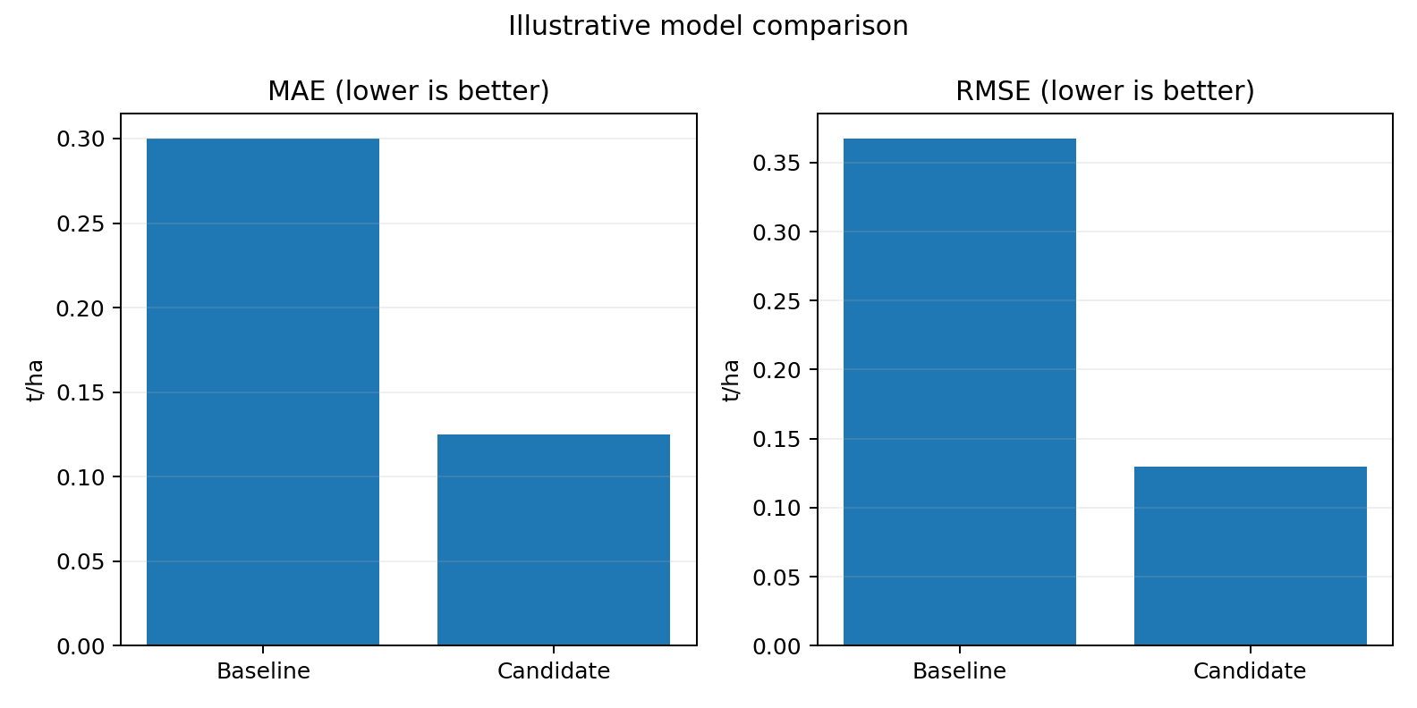
Figure 1. Baseline and candidate metric comparison on the synthetic eight-row example.
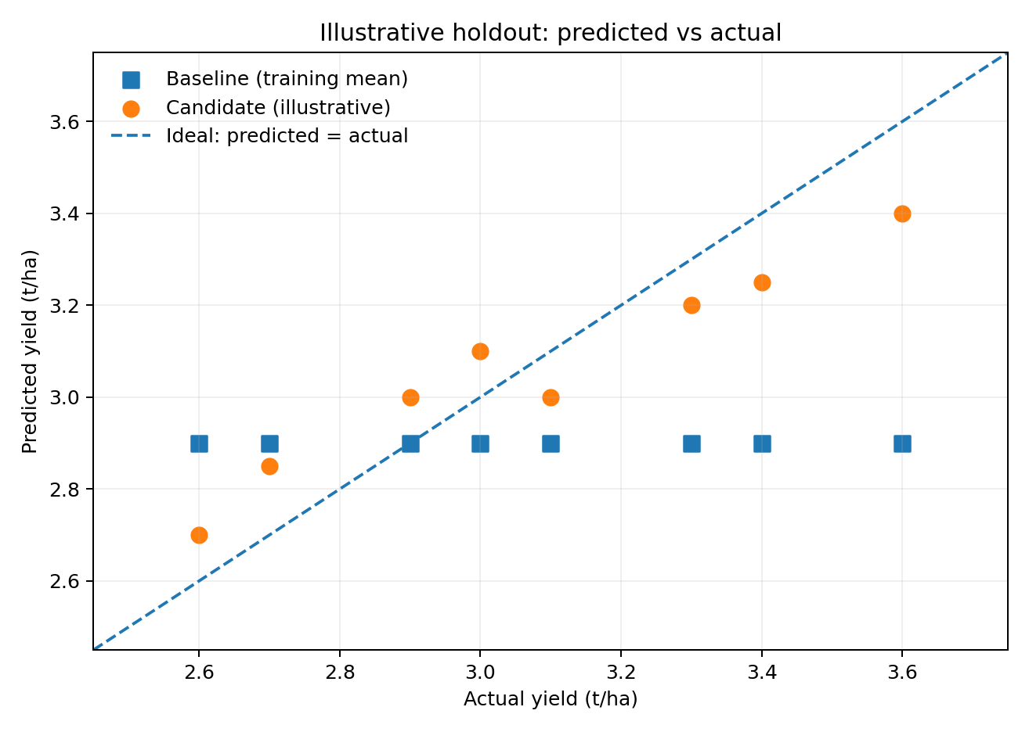
Figure 2. Predicted-versus-actual chart. Points nearer the dashed 1:1 line are closer to the observed value.
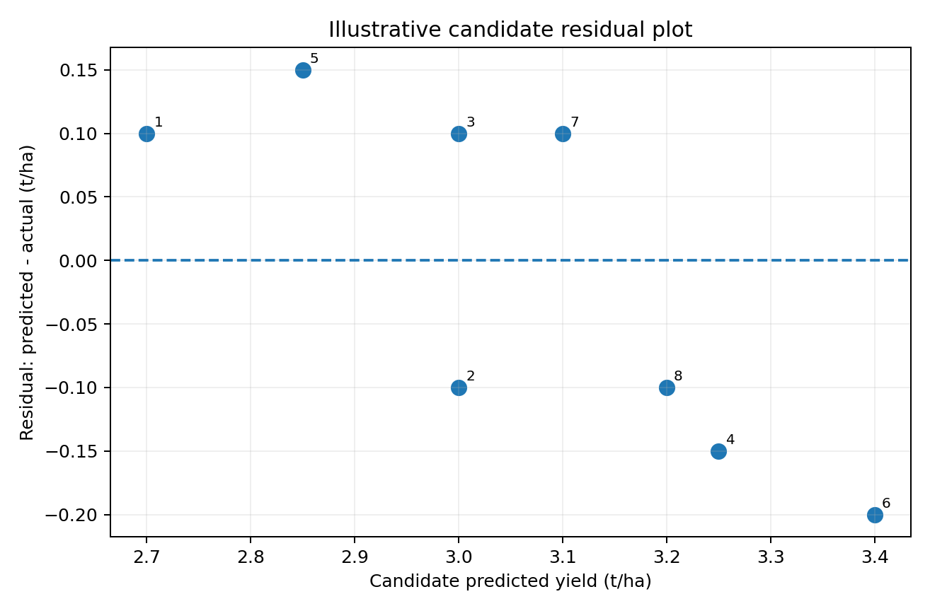
Figure 3. Candidate residuals (prediction minus actual). Residuals should be randomly distributed around zero in a satisfactory model.

6. Visualization and Diagnostic Reporting Plan
Visualization | What to plot | Question answered | Interpretation / action
Predicted vs actual scatter | Actual yield on x-axis; predicted yield on y-axis; 1:1 reference line. | Are predictions close to observed yield? | Systematic points above/below line indicate over/underprediction.
Residual vs predicted plot | Residual (predicted − actual) against predicted yield; zero line. | Do errors change with predicted yield? | Curves or funnel shapes suggest nonlinearity or unequal variance.
Residual histogram / density | Distribution of signed errors. | Are errors centered near zero? | Skew indicates systematic bias; tails show large misses.
Metric comparison chart | MAE and RMSE for each model, same units. | Does the candidate beat the baseline? | Always include a baseline and sample count.
Error by subgroup | MAE/RMSE by state, irrigation group, yield band and year. | Does the model work unevenly? | Flag low-sample groups; do not rank groups with tiny n.
Rolling-fold performance | MAE/RMSE by chronological validation year. | Is performance stable across seasons? | Large swings indicate temporal sensitivity.
Prediction interval coverage | Observed yield vs lower/upper prediction interval. | Are uncertainty ranges calibrated? | An 80% interval should contain about 80% of future observations over many cases.

Chart design requirements: label units on every axis; state the crop, season, year range and sample size; use the same axis scale when comparing models; include the baseline; distinguish actual observations from predictions; add captions that explain the takeaway; and avoid decorative 3-D charts or truncated axes that exaggerate small differences.

7. Stakeholder Reporting Strategy

7.1 One-page executive summary structure
Block | Required content
Decision question | What crop, region, forecast date and planning decision does the model support?
Dataset and evidence | Years, district coverage, sample count, target unit, source versions and missingness.
Headline performance | MAE, RMSE, R², bias and baseline comparison, each with units and test sample count.
Reliability and equity | Results by region, irrigation group, yield band and time period; identify sparse groups.
Practical interpretation | What a typical error means in t/ha; where the model is useful and where it is not.
Limitations and action | Data gaps, uncertainty, whether the model passes proposed gates, next validation steps.

7.2 Example stakeholder summary (synthetic values only)
Illustrative summary - not a real model result
On an eight-row synthetic test example, the candidate prediction series records MAE 0.125 t/ha and RMSE 0.130 t/ha, compared with 0.300 t/ha and 0.367 t/ha for a constant baseline. Average signed bias is −0.013 t/ha. These numbers show how the final summary will be formatted. They do not establish operational performance. A real decision requires multi-year chronological testing, subgroup review and prediction-uncertainty reporting.

7.3 Audience-specific communication
- Extension officers: typical error in t/ha, district coverage, uncertainty band and when to seek field verification.
- Agricultural planners: region-level aggregate performance, year-to-year stability, resource implications and data coverage.
- Technical reviewers: split design, feature list, baselines, hyperparameters, residual diagnostics, confidence intervals and reproducibility files.
- Farmers and local users: communicate forecasts as estimates with uncertainty, not guaranteed harvest outcomes or automatic recommendations.

8. Model Limitations and Refinement Plan
Limitation / risk | Why it matters | Mitigation / next step
Short or inconsistent history | Few annual observations cannot support reliable ML claims. | Acquire a longer district-season panel; compare performance across multiple rolling test years.
Boundary changes | District splits/mergers create false time trends. | Use official district codes and a documented geographic crosswalk; test sensitivity to aggregation.
Weather spatial mismatch | Grid cells and district polygons may not align exactly. | Area-weight climate grids to district polygons; record grid resolution and coverage.
Advance vs final crop estimates | Target values can be revised after initial release. | Store estimate stage and publication date; evaluate against a consistent final target version.
Target leakage | Future information creates artificially low test errors. | Use forecast-time cut-off checks and automated feature availability tests.
Geographic subgroup error | A model may perform poorly in some agro-climatic zones. | Report subgroup metrics, uncertainty and sample counts; avoid deployment for unsupported groups.
Climate and market regime shifts | Relationships can change after extreme seasons or input-price shocks. | Monitor drift and error each season; retrain only after governance review.
False precision | A point estimate hides uncertainty. | Use prediction intervals or quantile models and communicate their empirical coverage.

8.1 Proposed model refinement sequence
- Expand the training panel across districts and multiple seasons after source harmonization.
- Add weather summaries aligned to crop calendars and the stated forecast cut-off.
- Compare a persistence baseline, regularized linear model, Random Forest and gradient boosting.
- Use rolling-origin validation; tune only on training and validation periods.
- Evaluate subgroup errors, bias and prediction intervals, not only overall MAE.
- Run a limited shadow evaluation before any real-world use; require human review and document failure cases.

9. Reproducibility, Monitoring and Governance
A reproducible evaluation requires the same raw data snapshot, cleaning code, feature definitions, model parameters, split boundaries and random seeds to reproduce the reported metrics. The final project folder should contain: (1) source register, (2) raw-data manifest and version, (3) cleaned analytical dataset or secure reference, (4) evaluation CSV, (5) Python script/notebook, (6) metric output, (7) figures, (8) model card, and (9) this report. Personal or restricted farm records should not be uploaded to a public repository.

9.1 Model card minimum fields
Field | Required entry
Model purpose | Kharif maize district-season yield estimate at a declared forecast cut-off.
Target and unit | Yield in t/ha; document how area and production are reconciled.
Intended / excluded uses | Planning support and analyst review; not guaranteed production advice, credit eligibility or insurance adjudication.
Data lineage | Provider, exact dataset, download date, period, geography, licence/terms and version.
Training and evaluation | Chronological split dates, spatial holdout design, baseline, metrics and test sample size.
Known limitations | Data gaps, geographic coverage, estimate revisions, uncertainty and subgroup limitations.
Monitoring owner | Named project role/team responsible for seasonal error review and approval of model changes.

9.2 Monitoring after deployment (if approved)
- At each harvest, append observed yield and compute MAE, RMSE, bias and subgroup metrics.
- Track input-feature drift and missingness; investigate sudden changes in rainfall coverage, district definitions or crop reporting.
- Trigger review if errors exceed pre-agreed thresholds, calibration degrades, or a district group is outside training coverage.
- Keep versioned model releases and a change log; do not silently replace a model during an evaluation period.

10. Proposed Acceptance Gates and Evaluation Rubric
The thresholds below are proposed project governance rules, not official agricultural standards. They should be agreed with domain reviewers before viewing the final test results.
Gate | Proposed rule | Evidence required
G1 - Baseline value | Candidate MAE and RMSE should improve on the selected baseline across at least three chronological test folds. | Fold-wise metric table and relative improvement.
G2 - Bias | Absolute overall bias should be within a domain-agreed tolerance; establish the tolerance before final testing. | Signed bias with units and direction.
G3 - Robustness | No adequately sized region/irrigation subgroup should show unexplained material degradation. | Subgroup table, sample counts and investigation notes.
G4 - Uncertainty | Prediction intervals should demonstrate empirical coverage close to their stated nominal level. | Coverage and average interval width on held-out data.
G5 - Reproducibility | A reviewer should be able to regenerate metrics from the frozen CSV and script. | Versioned inputs, script output and run instructions.
G6 - Operational readiness | Model card, human review, monitoring owner and fallback baseline are documented. | Signed readiness checklist and approval record.

10.1 Report assessment rubric (100 points)
Criterion | Weight | Full-credit evidence
Metric selection and correct calculation | 20 | Correct MAE/RMSE/R²/bias formulas, units and worked example.
Validation design and leakage control | 20 | Chronological split, baseline, rolling validation and feature cut-off.
Visual diagnostics | 15 | Readable predicted-vs-actual, residual, subgroup and metric charts.
Interpretation and stakeholder clarity | 15 | Plain-language error meaning, careful conclusion and useful summary.
Limitations and refinement | 10 | Coverage, uncertainty, subgroup and drift risks with mitigation.
Data provenance and reproducibility | 10 | Source register, versioning, code, outputs and data dictionary.
Structure and presentation | 10 | Clear headings, consistent units, references and professional formatting.

11. Implementation and Reporting Timeline
Date | Task | Deliverable / completion evidence
03-04 Nov 2026 | Confirm target, crop-season definition, forecast cut-off and intended users. | Signed target definition and feature-availability table.
05-07 Nov 2026 | Acquire district APY, historical yield and matching weather data; register versions. | Source register, raw-data manifest and data dictionary.
08-10 Nov 2026 | Clean, harmonize units, reconcile district boundaries and create leakage-safe features. | Quality report, crosswalk, frozen feature table.
11-13 Nov 2026 | Create chronological splits and train baseline plus candidate models. | Split manifest, baseline output and tuned candidate artifact.
14-16 Nov 2026 | Run final holdout evaluation, rolling folds and subgroup diagnostics. | Metrics CSV, residual plots and subgroup error report.
17-18 Nov 2026 | Prepare executive summary, model card and reviewer-ready technical appendix. | Final evaluation report and reproducibility package.

12. Final Deliverables Checklist
- ☐ Defined target, unit, crop/season and forecast issue date.
- ☐ Verified data-source register with download dates and coverage.
- ☐ Feature dictionary with availability cut-off and leakage assessment.
- ☐ Chronological train/validation/test split manifest and rolling-fold design.
- ☐ Baseline and candidate model results on the same held-out records.
- ☐ Metric calculations (MAE, RMSE, R², bias; MAPE/WAPE where appropriate).
- ☐ Predicted-vs-actual, residual, metric comparison and subgroup charts.
- ☐ Plain-language executive summary with test sample size and caveats.
- ☐ Limitations, model card, monitoring plan and proposed acceptance gates.
- ☐ Python script, CSV outputs, README, source list and version notes.

13. Conclusion
A reliable agricultural prediction system must be judged by more than a single accuracy score. It requires a clearly defined prediction target, time-aware data splits, leakage controls, meaningful baselines, multiple complementary metrics, diagnostic visualizations, subgroup analysis and transparent communication of uncertainty. The worked example in this report demonstrates the calculations with synthetic data so the method is auditable. The next real-world step is to assemble a sufficiently long district-season dataset, harmonize geography and weather, train candidate models, and evaluate them on later unseen years. Only after these steps should any statement about real model accuracy or practical readiness be made.

References and Data Portals
[1] Department of Agriculture & Farmers Welfare, Agricultural Statistics Unit. Explains State/National area, production and yield estimates, advance/final estimate stages and validation inputs. https://desagri.gov.in/divisions-cell/agricultural-statistics-division/ (accessed 02 Nov 2026).
[2] Directorate of Economics & Statistics, DA&FW. Area, Production & Yield - District Level Reports portal. https://data.desagri.gov.in/website/crops-report-district-level-web (accessed 02 Nov 2026).
[3] Open Government Data Platform India. District-wise, season-wise crop production statistics: area and production by district, crop, season and year. https://www.data.gov.in/catalog/district-wise-season-wise-crop-production-statistics-0 (accessed 02 Nov 2026).
[4] ICRISAT / TCI. District-Level Database for Indian Agriculture and Allied Sectors. The TCI description reports historical district coverage for 571 districts in 20 states over 1966-2017; verify individual table coverage and boundary harmonization before use. https://www.icrisat.org/public/resources/data/district-level-data and https://tci.cornell.edu/data/ (accessed 02 Nov 2026).
[5] India Meteorological Department, Climate Monitoring and Prediction Group. Daily gridded rainfall data over India; dataset page documents units in mm and archive period. https://www.imdpune.gov.in/cmpg/Griddata/Rainfall_25_NetCDF.html (accessed 02 Nov 2026).
[6] India Meteorological Department, Climate Monitoring and Prediction Group. Daily gridded maximum temperature data; dataset page documents temperature in degrees Celsius and period. https://www.imdpune.gov.in/cmpg/Griddata/Max_1_Bin.html (accessed 02 Nov 2026).

Appendix A - Reproducing the Synthetic Metric Example
The supporting bundle contains hypothetical_holdout_predictions.csv and evaluate_model.py. The example can be reproduced with Python 3 using only the standard library:
python evaluate_model.py hypothetical_holdout_predictions.csv
The script prints MAE, RMSE, R², MAPE and signed bias for the baseline and candidate series. It intentionally does not train a machine-learning model. To evaluate a real model, replace the synthetic prediction columns with predictions from a frozen model on a genuine untouched test set and retain the same metric definitions.

Appendix B - Sample interpretation phrases
- “The model’s MAE is X t/ha on N held-out district-season observations; this is the mean absolute distance between predicted and observed yield.”
- “RMSE is higher than MAE, indicating that larger residuals contribute more heavily to the error summary.”
- “Negative bias means the model underpredicts yield on average; the magnitude should be interpreted alongside subgroup results.”
- “The candidate improves on the chosen baseline in the tested years, but further rolling-year and geographic validation is required before operational use.”

