## FLOW CHART:

### 

## CLASS DIAGRAM

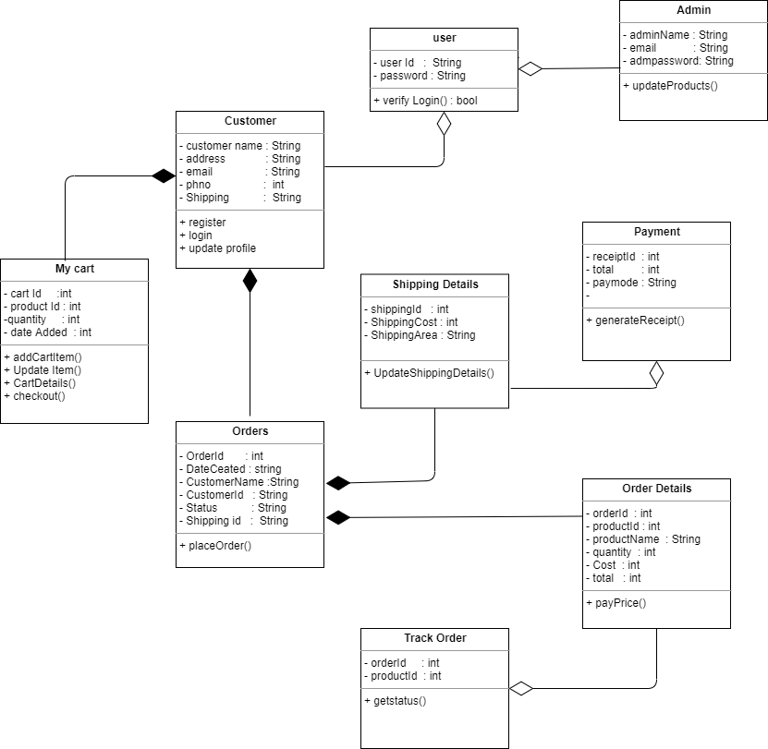

## SEQUENCE DIAGRAM

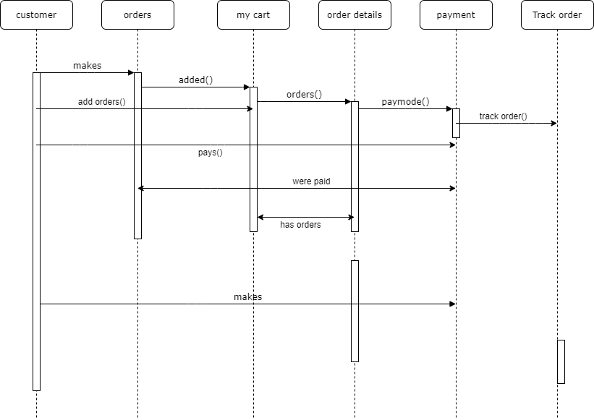

## USECASE DIAGRAM

