Car MPG Case Study

**Amit Patel, Sanjay Jagarlamudi, Murali Parthasarathy**

*MSDS 7333 Quantifying the World, May-20-2017*

**ABSTRACT (Subhead style 1: Arial, Size 12, Bold, ALL CAPS)**

Environment and consumer awareness are driving car OEMs to shift focus on increasing the miles per gallon offered by the vehicle. There are several factors, which affect the MPG of a vehicle. The data collected is from the various sub systems of the car and have a lot of missing values. The missing values are caused by the devices, which transfer the data from the car into a human consumable format. The Paper studies the various options available for data imputation to increase the effectiveness of the MPG data analysis.

**Introduction**

The vehicle mpg is highly dependent on the built of the vehicle and the driving style. Vehicles mpg is drastically reduced in city drives where the driver has to slower speed limits and multiple signal lights. The driver has to accelerate to gain momentum after every slow down or signal light. The MPGs in city drives are affected by driving styles and vehicle attributes. The data set provided has a lot of missing values, which affect the overall statistical capability of the data set. The objective of the study is to find affective ways of data imputation.

**Data Analysis**

|  |  |
| --- | --- |
| **Attribute Name** | **Characteristics** |
| Mpg | Miles Per gallon. This is the reading from the car during the drive |
| Cylinders | The number of cylinders in the car determines the mpg |
| Hp | Horse Power. The horse power generated by the engine |
| Weight | Weight of the car. A heavier car will need more displacement to gain momentum |
| Acceleration | Acceleration is a driving style. It depends on the pressure exerted by the driver on the accelerator gear |
| Weight | The Weight of the vehicle |
| Eng_type | The Engine type , the type of engine could be a V4 or V6 |

Table 1 : Data attributes

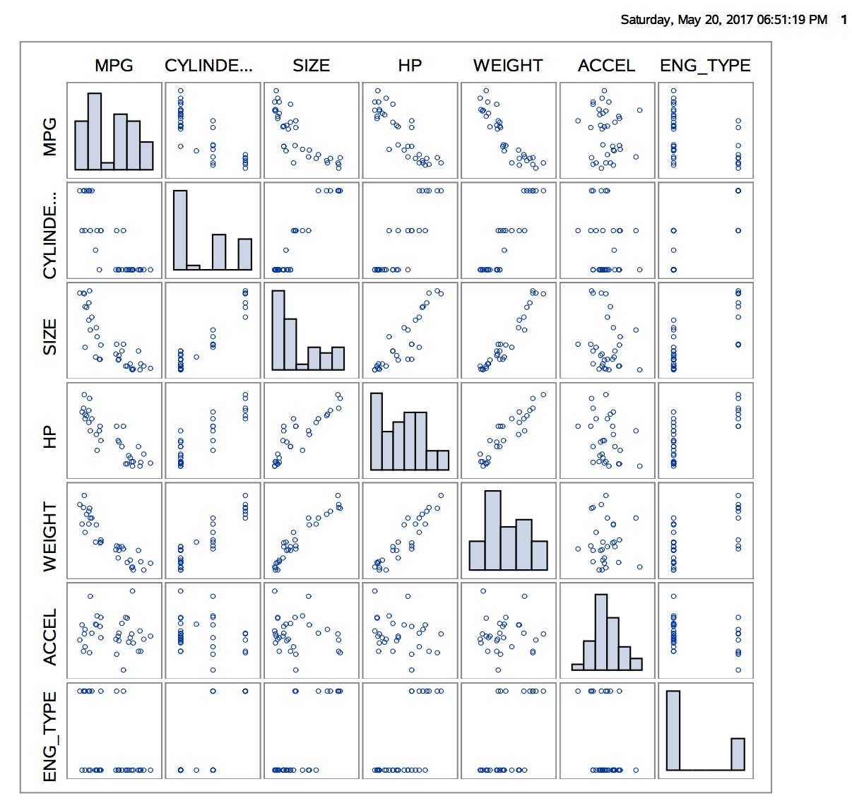

Figure : Scatter Plot

The section below comments a few relationships

|  |  |
| --- | --- |
| **Relationship** | **Comments** |
| Mpg-weight | The mpg decreases as the weight of the vehicle increases. |
| Hp-mpg | The mpg decreases as the vehicle offers higher Horsepower |
| Weight-hp | The horse power increases as the weight of the vehicle increases |

Table 2 : Data correlation

**Missing Values**

The data set has a lot of missing values. A cursory inspection suggests that weight, HP and engine type are missing on some data records. The missing values display a monotonous pattern; the figure below provides insight to the missing value monotonous pattern.

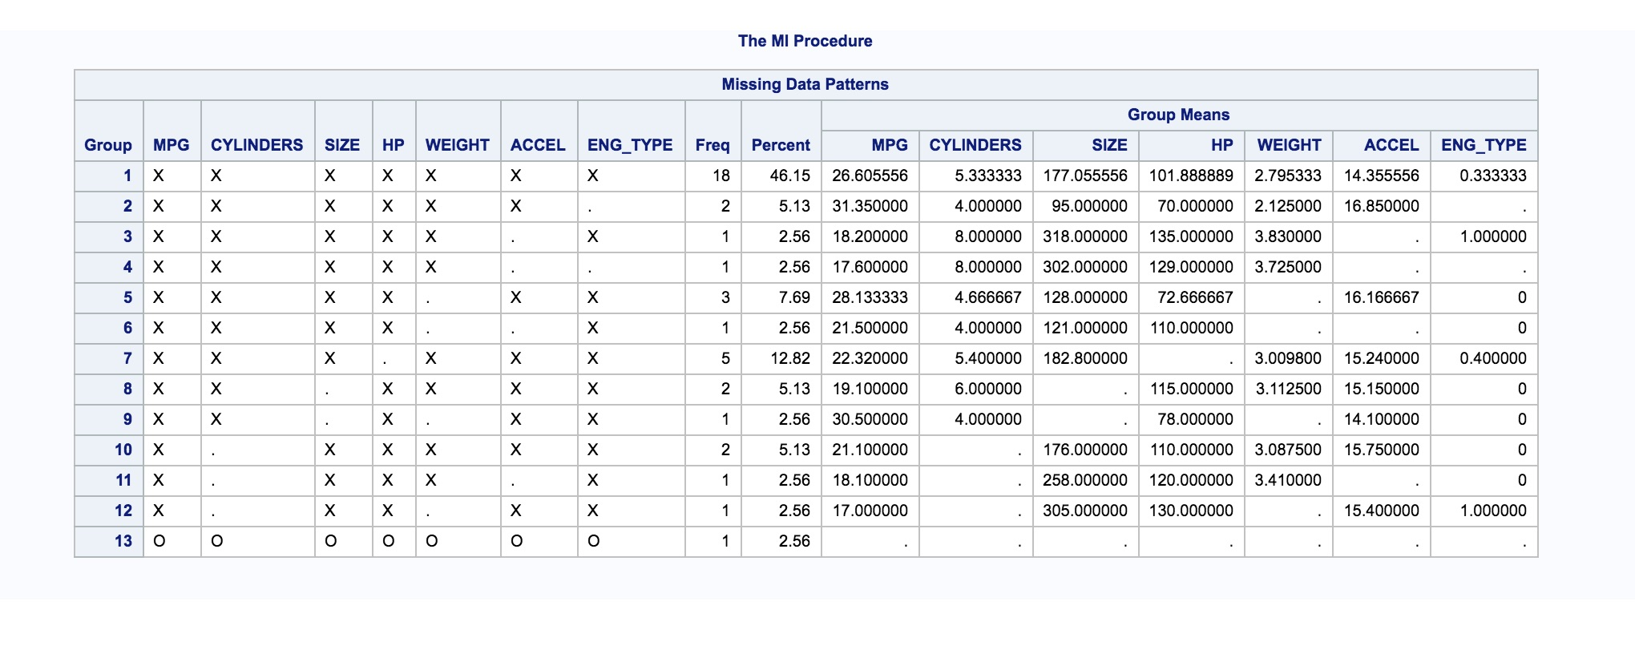

Figure : Missing attribute Pattern

Missing data pattern

There are four data missing mechanisms

Missingness completely at random - The probability of missingness is the same for all variables

Missingness at random - The probability of missingness is not the same for all variables

Missingness depends on observed predictors –The missingness is not at random and depends on the observed values

The data set shows a patterns of missing at random, the probability of missingness is not the same for all the variables.

Imputation Methods

The imputation methods can be categorized as

Simple imputation

Multiple imputations

The methods can be further categorized as approaches, which keep all the data, and approaches will remove records with missing data.

Simple imputation

Complete case Analysis

In the method the records with missing data is completely ignored. This method will have bias as certain good responses with missing values will be ignored

<Fill from 2ds>

The dataset is highly co related but there are certain attributes, which will qualify for simple imputation methods and will not affect the overall predictability of the model.

Single imputation approaches can be done for engine type and weight. The most likely value can be determined from the data available. The approach is not comprehensive and cannot be employed to all the missing attributes.

The multiple imputation technique determines the missing values by taking into account the available data sets have to be employed. The multiple imputation technique takes into account the uncertainty in the data set due to the missing values. The multiple imputation technique is easy to employ.

The only disadvantage of the imputation model is the team now has to consider both the analysis model and imputation model.

Multiple data sets approach

There are two approaches they are

Maximimum likelihood estimation

Multiple imputation

Maximum likelihood estimation

The maximum likelihood estimation does not create multiple data sets like the multiple imputation method. The method estimates the missing value based on the available attributes. This approach fits linear models very well. The approach estimates the values based on a range of values.

<<Add SAS output>>

**Regression Analysis**

The regression analysis on the data set shows only 17 out of the 39 data records are used. The model does not explain the errors completely. The missing values need to be imputed to improve the model.

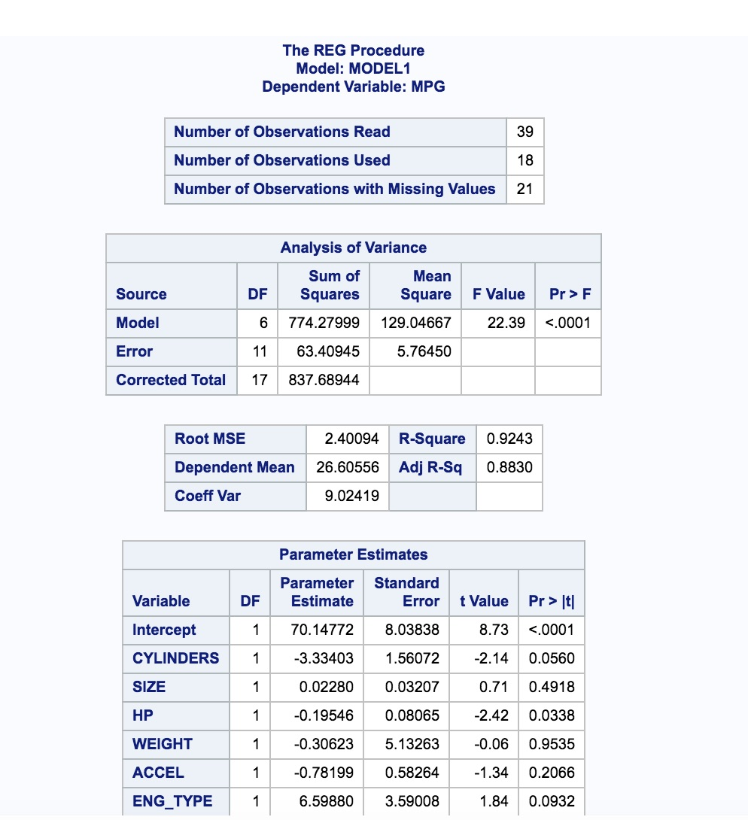

Figure Regression

**Multiple Imputation Details**

## Step 1 – Create the Data Sets

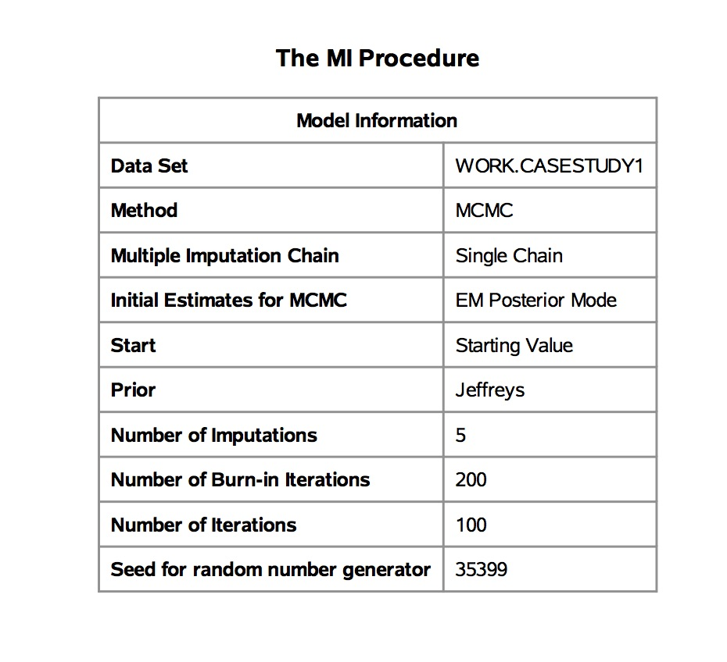

Figure Multiple Imputation Procedures

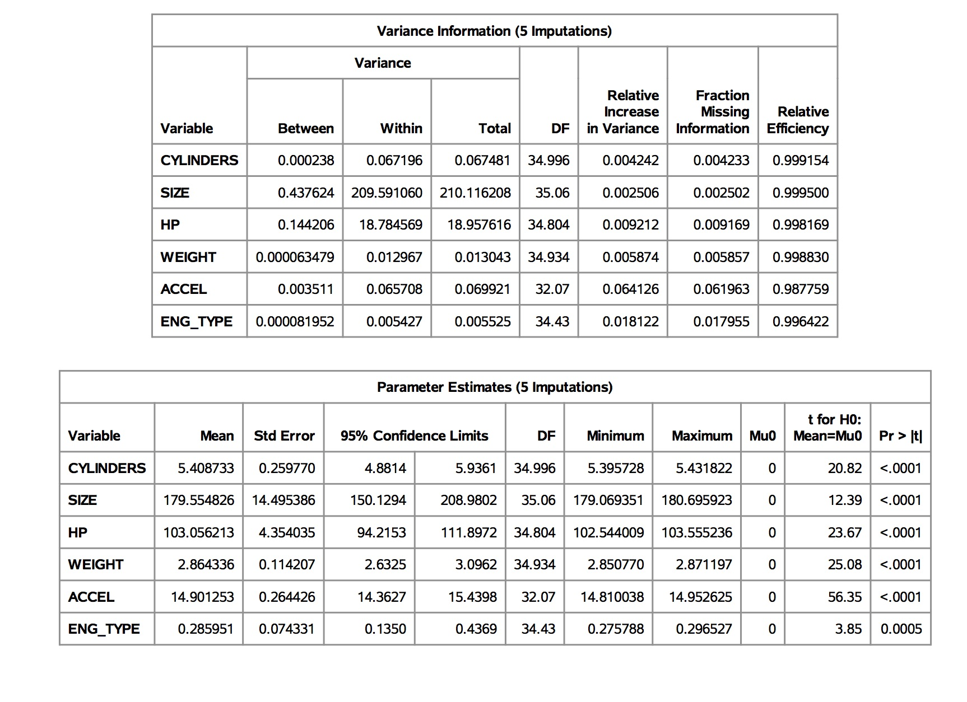

Figure Parameter and Variance Estimation on Imputed value

## Step 2 - Analyze the imputed data set

In this step a regression analysis is done on the imputed data sets.

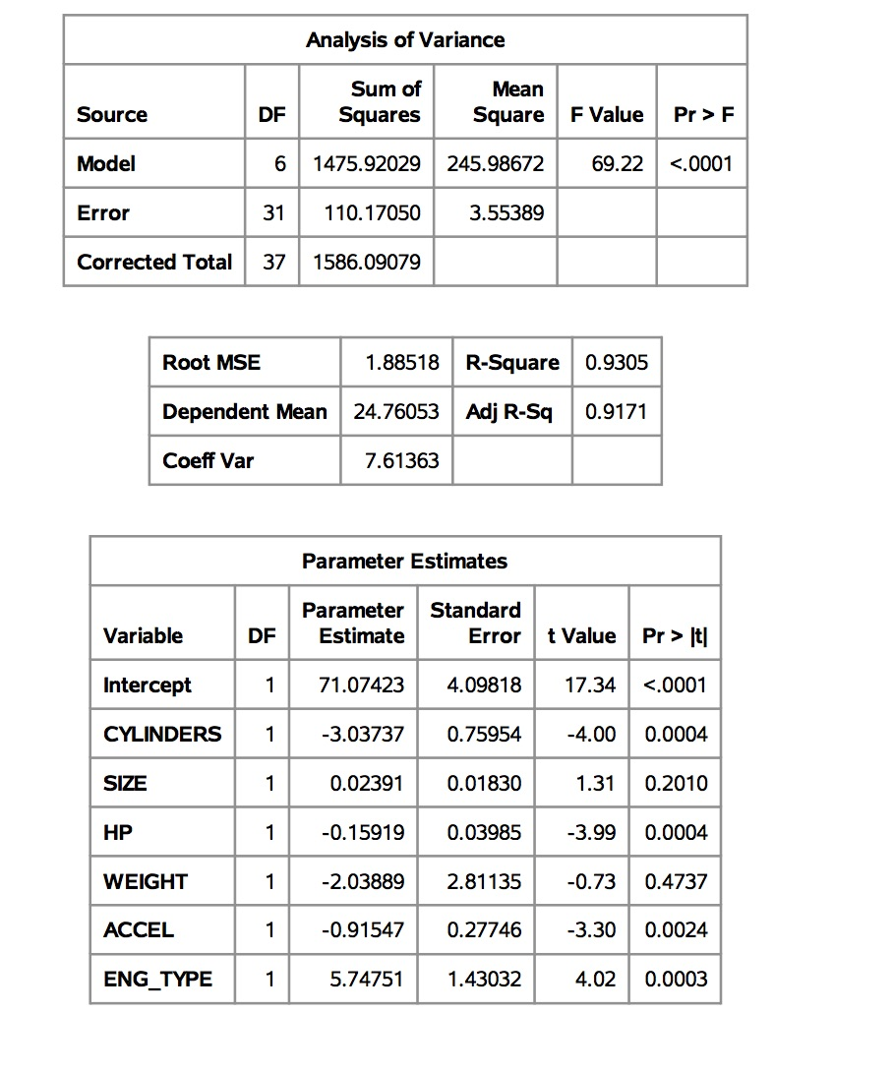

Figure Imputation 1

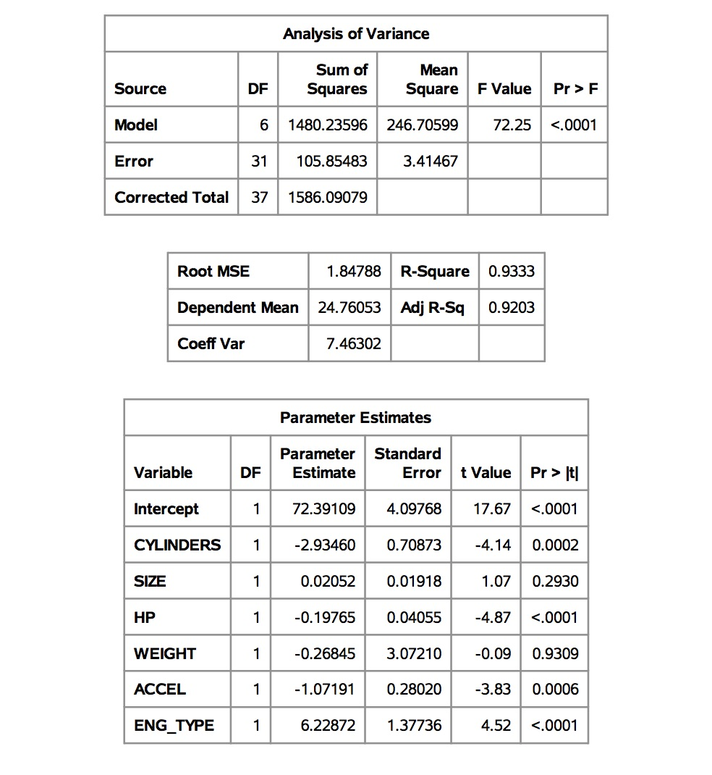

Figure Imputation 2

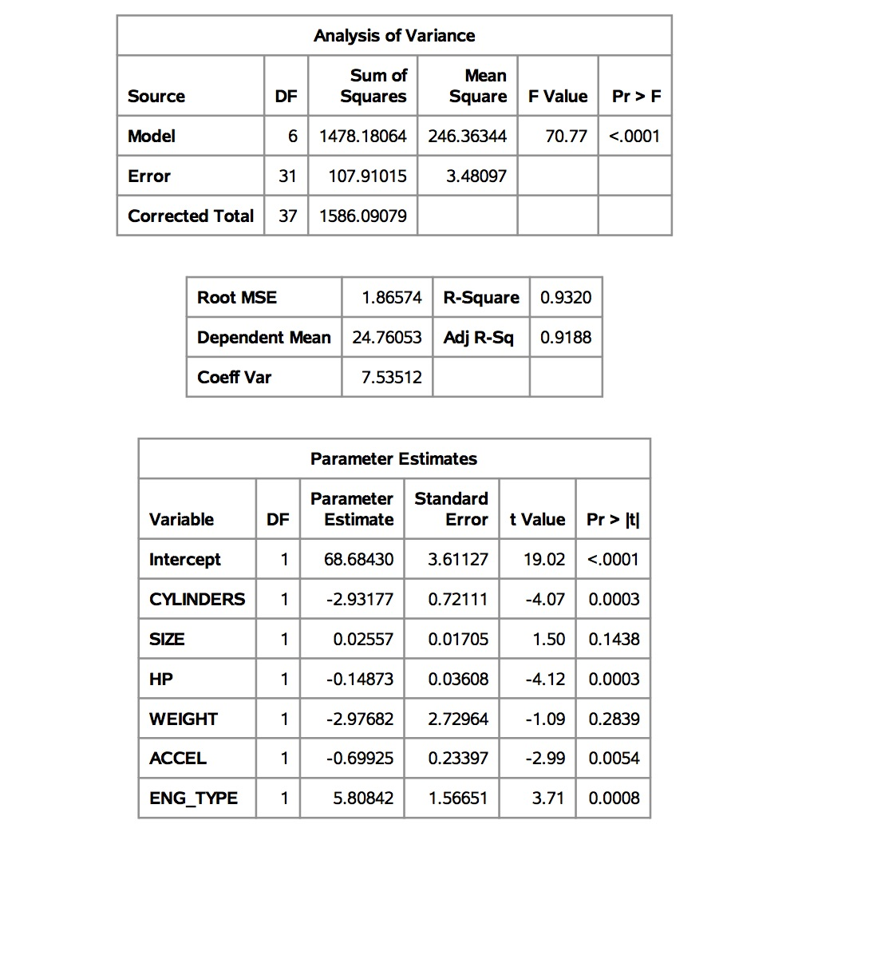

Figure Imputation 3

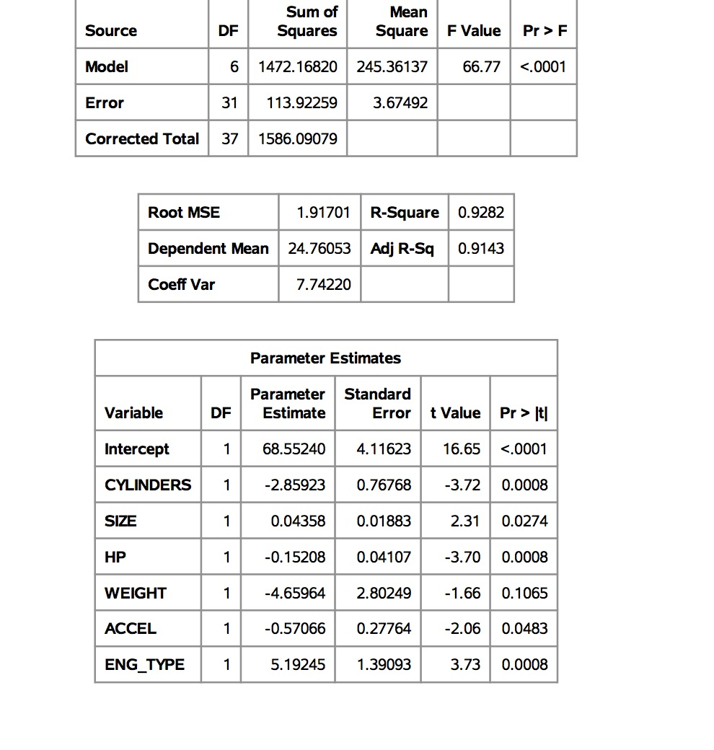

Figure Imputation 4

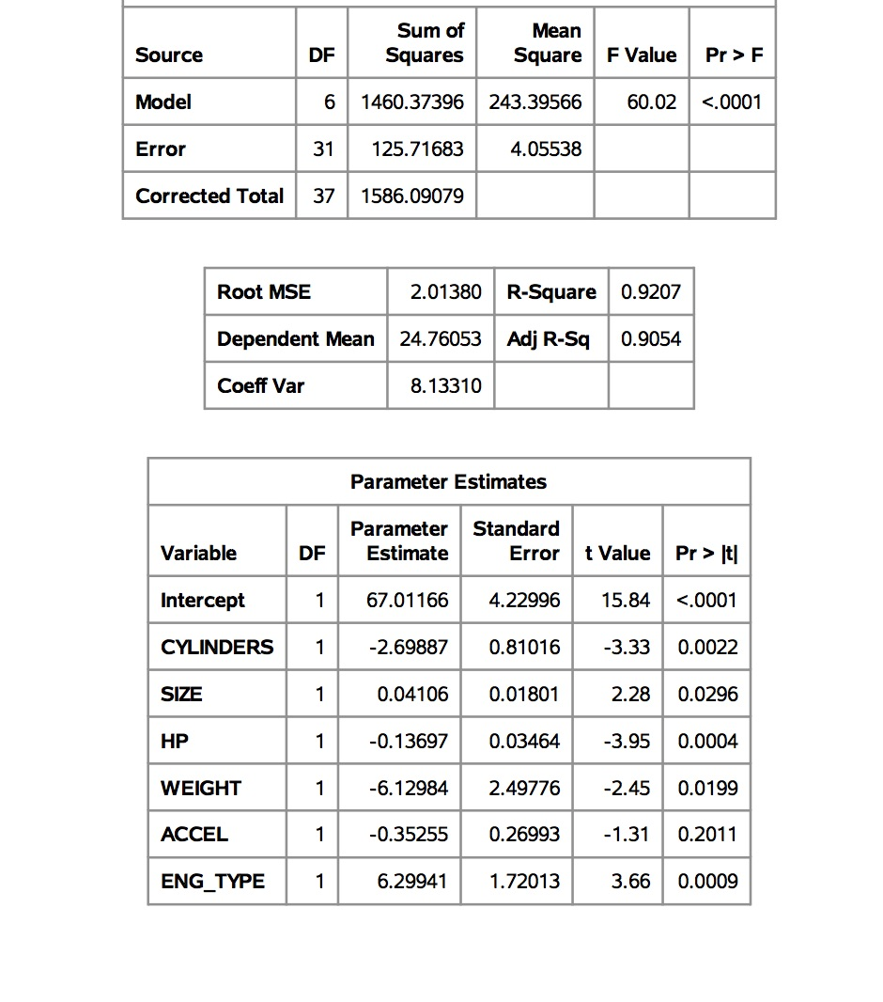

Figure Imputation 5

## Step 3 – Combine Analysis Results

This step averages the results from the multiple analyses.

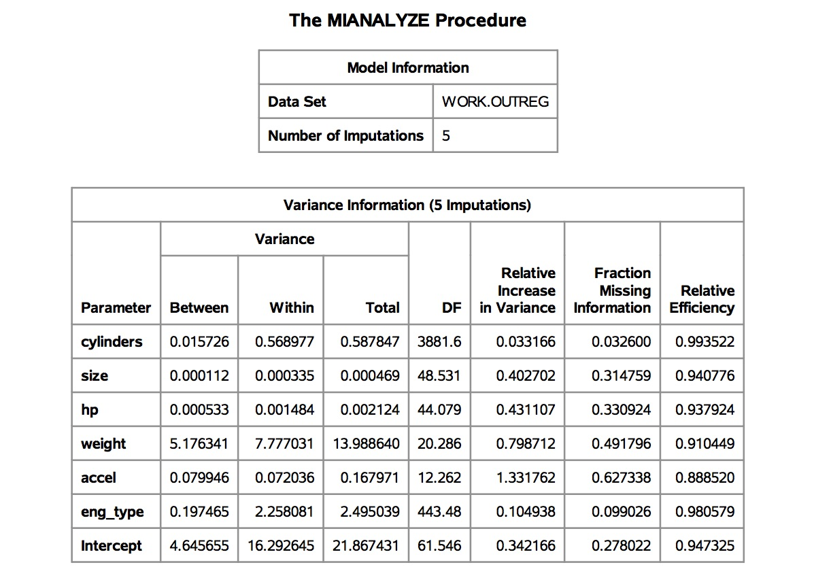

Figure Combined Analysis

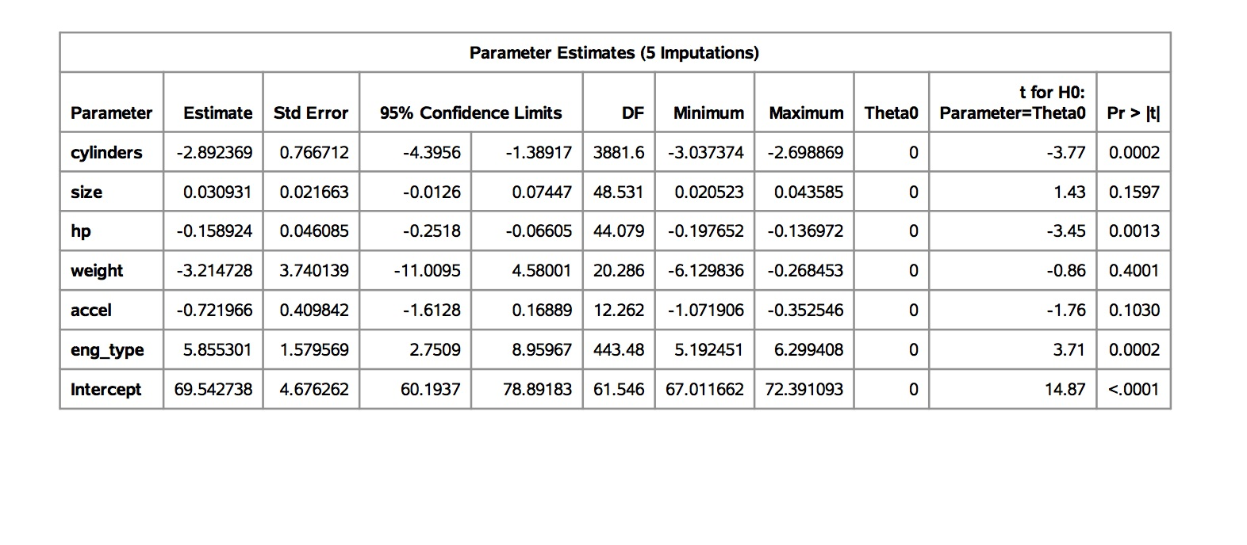

Figure Combined Analysis

**CONCLUSION**

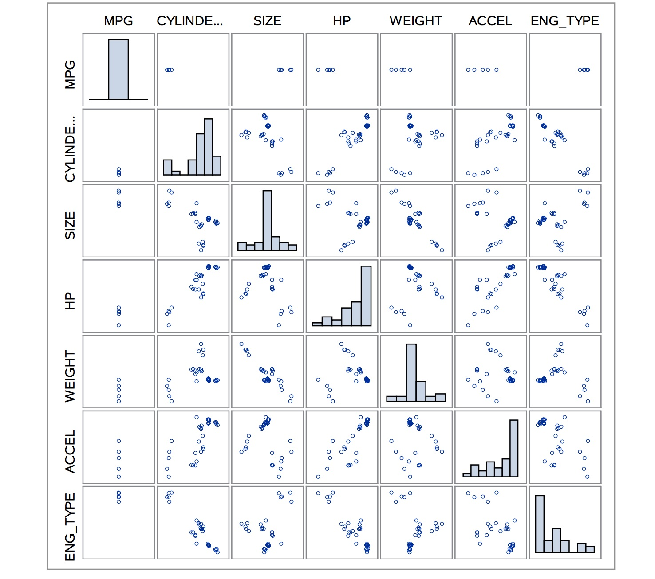

Figure Scatter Plot on Imputed data

The scatter plot on the imputed data shows a vast improvement in the predictably of the data set.

**SAS Code**

proc print data=work.casestudy1;

run;

proc sgscatter data=WORK.casestudy1;

matrix mpg cylinders size hp weight accel eng_type / diagonal = (histogram);

run;

ods select misspattern;

PROC MI data=WORK.casestudy1 nimpute=0;

var mpg cylinders size hp weight accel eng_type;

run;

quit;

title ' Predicting MPG: Initial Analysis';

PROC REG data=WORK.casestudy1;

model mpg= cylinders size hp weight accel eng_type;

run;

quit;

PROC MI data=WORK.casestudy1 nimpute=5

out= miout seed=35399;

var mpg cylinders size hp weight accel eng_type;

run;

title ' PROC Reg imputation output ';

PROC REG data=miout outest= outreg

covout;

model mpg=cylinders size hp weight accel eng_type;

by _imputation_;

run;

PROC MIANALYZE data=outreg;

modeleffects cylinders size hp weight accel eng_type Intercept;

run;

proc sgscatter data=outreg;

matrix mpg cylinders size hp weight accel eng_type / diagonal = (histogram);

run;

**REFERENCES**

Allison P. (2012). Why You Probably Need More Imputations Than You Think. <http://www.statisticalhorizons.com/more-imputations>. Retrieved 11/10/2013.