BUSGO: A WEB-BASED BUS TICKET RESERVATION SYSTEM WITH REAL-TIME SEAT LOCKING AND TRANSACTIONAL BOOKING
A Project Report
Submitted in partial fulfilment of the requirements for the
Award of the degree of
“Master of Computer Applications”
By
[Student Name]
([Registration Number])
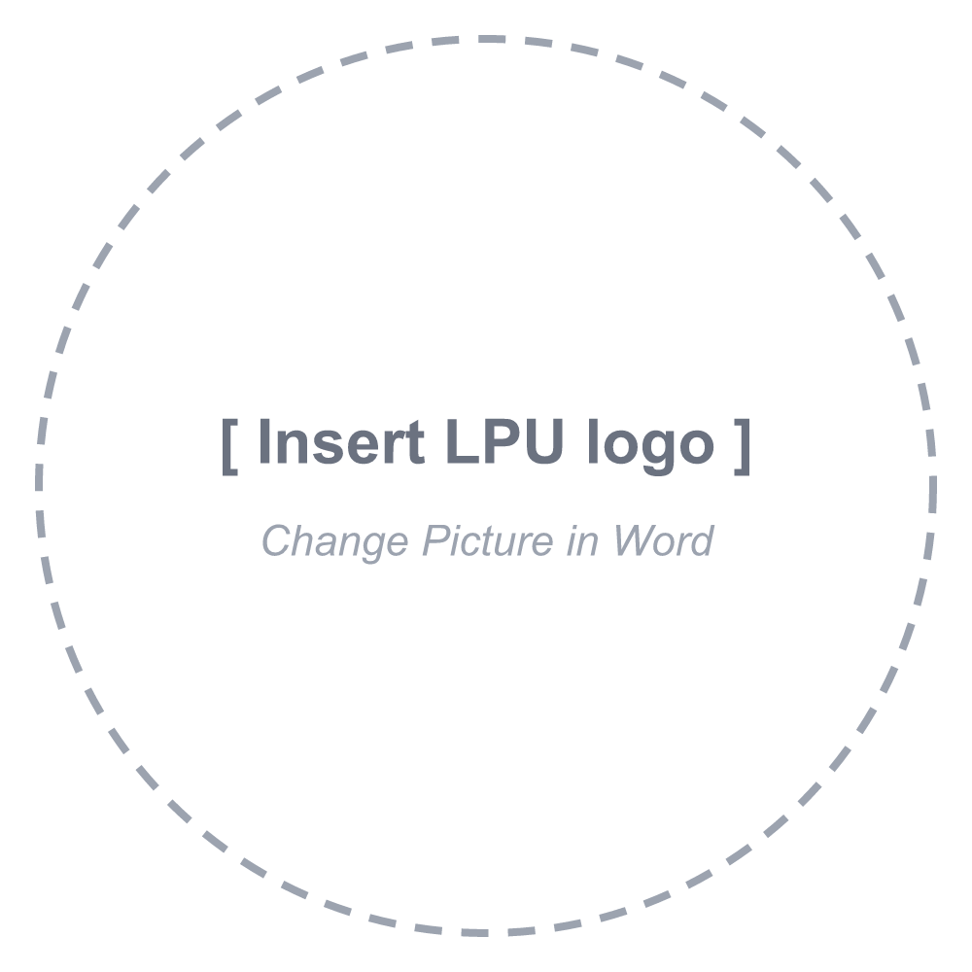
Centre for Distance and Online Education
LOVELY PROFESSIONAL UNIVERSITY
PHAGWARA, PUNJAB
2026

Declaration by the Student
To whom-so-ever it may concern
I, [Student Name], [Registration Number], hereby declare that the work done by me on “BusGo: A Web-Based Bus Ticket Reservation System with Real-Time Seat Locking and Transactional Booking”, is a record of original work for the partial fulfilment of the requirements for the award of the degree, Master of Computer Applications.
[Student Name] ([Registration Number])
Signature of the student
Dated:

Acknowledgement
I express my sincere gratitude to the Centre for Distance and Online Education, Lovely Professional University, for giving me the opportunity to carry out this project as part of the Master of Computer Applications programme. The project allowed me to apply the concepts studied during the programme to a complete, working software system.
I am thankful to my faculty mentors and the course coordinators for the guidelines, timelines and feedback that shaped the direction of this work. Their emphasis on original, industry-relevant work encouraged me to look beyond a basic booking form and to study how real reservation systems keep data consistent when many people use them at the same time.
I also acknowledge the open-source communities behind Node.js, Express, MongoDB, Mongoose, React, Next.js, TypeScript and Tailwind CSS, whose documentation and tools made this project possible.
Finally, I thank my family and friends for their constant encouragement and for patiently testing the application and sharing honest feedback during development.
[Student Name]

Abstract
Intercity bus travel remains one of the most widely used modes of transport in India, and passengers increasingly expect to search, choose a seat and receive a confirmed ticket online. A seat reservation system, however, faces a classic concurrency problem: when two passengers select the same seat at nearly the same moment, a naive implementation can confirm both bookings, producing a double-booked seat, a refund and a dissatisfied customer.
This project presents BusGo, a full-stack web application for online bus ticket reservation that treats seat contention as a first-class design concern. The backend is built with Node.js, Express 5 and TypeScript over MongoDB, accessed through the Mongoose object-document mapper. Each seat on each travel date is represented by a reservation document protected by a unique compound index, and a seat moves through the states AVAILABLE, LOCKED and BOOKED. When a passenger selects seats, the system grants a five-minute hold using conditional, atomic updates inside a multi-document transaction; competing requests receive an immediate conflict response instead of silently overwriting the hold. Booking confirmation and cancellation are likewise executed as ACID transactions so that seat status and booking records can never disagree. Users authenticate with JSON Web Tokens and passwords are stored as bcrypt hashes.
The frontend is a responsive Next.js 16 and React 19 application offering city-based search with bus-type filters, a live seat map refreshed every twenty seconds, a checkout page with a visible countdown for the seat hold, printable tickets and a booking history with filtering and cancellation. A test plan of functional and concurrency scenarios covers rejection of conflicting seat requests, automatic release of expired holds and the return of cancelled seats to the pool. The report concludes with the limitations of the current prototype and a roadmap that includes payment integration, an operator dashboard and real-time seat updates.
Keywords: online bus reservation, seat locking, concurrency control, MongoDB transactions, REST API, Next.js, JSON Web Token.

Table of Contents
Declaration by the Student i
Acknowledgement ii
Abstract iii
Table of Contents iv
List of Tables vii
List of Figures / Charts viii
List of Algorithms ix
List of Abbreviations x
CHAPTER-1: Introduction 1
1.1 Background 1
1.2 Problem Statement 1
1.3 Aim of the Project 2
1.4 Objectives 2
1.5 Scope of the Project 3
1.6 Importance and Applicability 3
1.7 Category, Nature and Relevance of the Project 4
1.8 Organisation of the Report 4
CHAPTER-2: Review of Literature 5
2.1 Introduction 5
2.2 Existing Online Bus Reservation Platforms 5
2.3 Research on Online Bus Ticketing Systems 5
2.4 Concurrency Control and Transactions 6
2.5 Web Application Architecture and API Design 7
2.6 Authentication and Application Security 7
2.7 Summary of Literature 7
2.8 Research Gaps 8
CHAPTER-3: Implementation of Project 10
3.1 Development Methodology 10
3.2 Requirement Analysis 10
3.3 Tools and Technologies 11
3.4 System Architecture 11
3.5 Database Design 12
3.6 Use Case Model 14
3.7 Seat Life Cycle 15
3.8 Module Implementation 16
3.9 REST API Design 20
3.10 Frontend Implementation 20
3.11 Security Measures 22
3.12 Deployment and Configuration 23
CHAPTER-4: Results and Discussions 24
4.1 Overview 24
4.2 Application Screens 24
4.3 Functional Test Cases 28
4.4 Concurrency Test Scenarios 30
4.5 Sample API Responses 30
4.6 Discussion 31
CHAPTER-5: Conclusion and Future Scope 33
5.1 Conclusion 33
5.2 Limitations of the Present Work 33
5.3 Future Scope 34
5.4 Applicability 34
List of Publications / Conference Papers 35
Annexures 36
Annexure - I: Cover Page 36
Annexure - II: Declaration by the Student 36
Annexure - III: Installation and Execution Guide 36
Annexure - IV: Key Source Code Listings 36
References 39

List of Tables
Table 1.1: Classification of the project as per the guidelines 4
Table 2.1: Summary of reviewed literature 7
Table 3.1: Functional requirements 10
Table 3.2: Technology stack 11
Table 3.3: SeatReservation collection 13
Table 3.4: Booking collection 14
Table 3.5: REST API endpoints 20
Table 3.6: Environment configuration 23
Table 4.1: Functional test cases 29
Table 4.2: Concurrency test scenarios 30
Table 4.3: Achievement of objectives 31

List of Figures / Charts
Figure 1.1: Double booking without seat locking compared with BusGo's atomic seat lock 2
Figure 3.1: Three-tier architecture of BusGo 12
Figure 3.2: Entity–relationship diagram of the BusGo database 13
Figure 3.3: Use case diagram 15
Figure 3.4: State diagram of a seat for one travel date 16
Figure 3.5: Sequence diagram for seat locking and booking 19
Figure 3.6: Frontend routes, components and shared client layer 21
Figure 3.7: Flowchart of the passenger booking flow 22
Figure 4.1: Home page with search form and popular routes 24
Figure 4.2: Search results with bus-type filters 25
Figure 4.3: Seat selection page with date strip and seat map 25
Figure 4.4: Checkout page with countdown and passenger form 26
Figure 4.5: Conflict message when a seat is held by another user 26
Figure 4.6: Confirmed ticket with booking number 27
Figure 4.7: My Bookings page with status filter and sort 27
Figure 4.8: Cancellation confirmation dialog 28
Figure 4.9: Login and registration pages 28

List of Algorithms
Algorithm 3.1: Seat locking (lockSeatsService) 17
Algorithm 3.2: Transactional booking (createBookingService) 18
Algorithm 3.3: Booking cancellation (cancelBookingService) 19

List of Abbreviations
Abbreviation | Full form
ACID | Atomicity, Consistency, Isolation, Durability
API | Application Programming Interface
CLI | Command-Line Interface
CORS | Cross-Origin Resource Sharing
CRUD | Create, Read, Update, Delete
CSS | Cascading Style Sheets
DNS | Domain Name System
ER | Entity–Relationship
HS256 | HMAC using SHA-256
HTTP(S) | Hypertext Transfer Protocol (Secure)
ICT | Information and Communication Technology
IETF | Internet Engineering Task Force
IPR | Intellectual Property Rights
ITS | Intelligent Transportation Systems
JSON | JavaScript Object Notation
JWT | JSON Web Token
MCA | Master of Computer Applications
NoSQL | Not only SQL (non-relational database)
ODM | Object–Document Mapper
OWASP | Open Worldwide Application Security Project
REST | Representational State Transfer
RFC | Request for Comments
RSRTC | Rajasthan State Road Transport Corporation
RTC | Road Transport Corporation
SDG | Sustainable Development Goal
SPA | Single-Page Application
SSR | Server-Side Rendering
TLS | Transport Layer Security
TTL | Time To Live
UI / UX | User Interface / User Experience
URL | Uniform Resource Locator
UUID | Universally Unique Identifier

CHAPTER-1: Introduction

1.1 Background
Road transport carries a very large share of India's intercity passenger traffic. State Road Transport Corporations operate extensive networks between district towns, while private operators run air-conditioned seater and sleeper coaches on busy corridors such as Delhi–Jaipur and Delhi–Chandigarh. For a long time, a seat on such a bus was purchased at a counter or through an agent, which meant travelling to the bus stand in advance, depending on the agent's view of availability and accepting whatever seat was offered.
Online aggregators such as redBus¹ and AbhiBus², together with the reservation portals of public operators such as RSRTC³, have changed this experience. Passengers now expect to compare buses by departure time, type and fare, to pick a specific seat from a seat map, and to receive a ticket within seconds. Studies of public-sector reservation systems also show that the efficiency and reliability of the online channel directly influence how much passengers trust and use it⁴.
Behind this simple experience lies a demanding engineering problem. A bus has a fixed number of seats, every seat can be sold only once per journey, and hundreds of users may be looking at the same seat map at the same time. The software must therefore combine a pleasant user interface with strict guarantees about data consistency. This project, BusGo, is a complete web-based reservation system built to study and solve that problem with modern, widely used open-source technologies.

1.2 Problem Statement
Consider two passengers, A and B, who open the seat map of the same bus for the same date. Both see seat A1 as free. Passenger A selects it and starts entering passenger details; a few seconds later passenger B does the same. If the system checks availability and writes the booking as two separate, unprotected steps, both requests can pass the check before either write happens. The result is a lost update: the seat is sold twice, as illustrated in Figure 1.1(a). This is a well-known anomaly in database theory, and it is exactly the situation that transaction isolation and locking were designed to prevent^{5,6}.
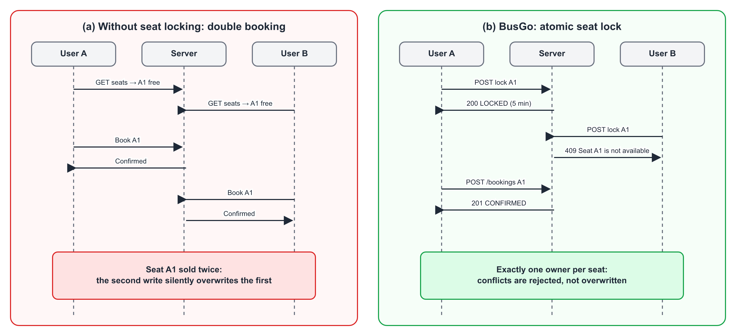
Figure 1.1: Double booking without seat locking compared with BusGo's atomic seat lock
A second, related problem concerns the time a passenger spends at checkout. Entering names, ages and genders for several travellers can take a few minutes. If the seat is not held during this time, another user can take it and the first passenger's effort is wasted at the final step. If the seat is held forever, an abandoned checkout blocks the seat for everyone else. The system therefore needs a temporary hold that expires automatically.
The problem addressed by this project can be stated as follows: to design and implement an online bus ticket reservation system in which a seat can never be confirmed for more than one passenger on the same journey, in which seats being purchased are held fairly for a limited time, and in which the current seat availability is clearly visible to every user.

1.3 Aim of the Project
The aim of the project is to build a secure, responsive and consistent web application that lets passengers search intercity buses, view live seat availability, temporarily lock chosen seats, enter passenger details, confirm a booking and manage or cancel their bookings, while guaranteeing that concurrent requests can never produce a double booking.

1.4 Objectives
- To study existing online bus reservation platforms and the literature on concurrency control, transactions and web application security.
- To design a data model in which every seat on every travel date has exactly one authoritative reservation record.
- To implement a time-limited seat-locking mechanism (five minutes) using atomic, conditional database updates.
- To implement booking confirmation and cancellation as multi-document ACID transactions.
- To provide secure user registration and login using bcrypt password hashing and JSON Web Tokens.
- To develop a responsive, user-friendly frontend with search, a visual seat map, a checkout countdown, printable tickets and booking history.
- To test the system functionally and under conflicting requests, and to document the results, limitations and future enhancements.

1.5 Scope of the Project
The scope of the current version covers the complete passenger journey from search to cancellation:
- Search: routes between cities with case-insensitive matching, an optional bus-type filter (AC/Non-AC, Seater/Sleeper) and pagination.
- Seat selection: a date-specific seat map showing AVAILABLE, LOCKED and BOOKED seats, with up to six seats per booking.
- Seat hold: a five-minute lock per user, extendable by the same user and released automatically on expiry or explicitly on cancel.
- Booking: passenger details for each seat, validation on both client and server, and a unique booking number.
- Account: registration, login, persistent sessions, booking history with status filter and sort order, ticket view and printing, and cancellation.
Online payment, operator and administrator dashboards, dynamic pricing and notifications are outside the scope of this version; they are discussed as future scope in Chapter-5. Routes and buses are loaded through a seed script.

1.6 Importance and Applicability
The techniques implemented here are not limited to buses. Any system that sells a scarce, uniquely identifiable resource for a particular time slot faces the same challenge: railway and airline seats, cinema and event tickets, hotel rooms, doctor appointments, sports-court slots and examination centre seats. The combination of a per-slot reservation record, a unique index, a temporary hold with expiry and transactional confirmation is a reusable pattern for all of these domains. For small and medium bus operators, BusGo also demonstrates that a reliable, self-hosted booking channel can be built entirely from open-source components and deployed on low-cost cloud platforms.

1.7 Category, Nature and Relevance of the Project
Table 1.1 maps the project to the categories and outcomes listed in the project guidelines. The project supports Sustainable Development Goal 9 (industry, innovation and infrastructure) and Goal 11 (sustainable cities and communities)⁷ by making public and shared road transport easier and more transparent to use.
Table 1.1: Classification of the project as per the guidelines
Parameter | Description
Area of specialization | Web technologies and database systems
Project category (MCA) | Web based project (with database design as a major component)
Nature of the project | General project with entrepreneurial potential for small bus operators
Issues addressed | Societal issues (access to transport), business issues (reliable online sales, no double booking)
Novelty | Time-limited, transactional seat locking with a visible countdown and live seat map
Expected outcome | Working prototype; software eligible for copyright registration; base for a research publication

1.8 Organisation of the Report
Chapter-2 reviews existing reservation platforms and the research literature on online ticketing, concurrency control, transactions, web architecture and security, and identifies the gaps addressed by this project. Chapter-3 describes the implementation: requirements, technology stack, architecture, database design, algorithms, REST API, frontend and deployment. Chapter-4 presents the results, including application screens, functional and concurrency test cases and a discussion against the objectives. Chapter-5 concludes the report and outlines the future scope. Publication details, annexures and references follow the final chapter.

CHAPTER-2: Review of Literature

2.1 Introduction
The review is organised along the four areas that shape the design of BusGo: (i) existing online bus reservation platforms and published work on bus ticketing systems, (ii) concurrency control and transaction processing, (iii) web application architecture and API design, and (iv) authentication and application security. Each area contributes either a requirement or a design decision to the project.

2.2 Existing Online Bus Reservation Platforms
Commercial aggregators such as redBus¹ and AbhiBus² list buses from many private and public operators, show a seat layout for each bus and issue an electronic ticket after payment. Their success established the user expectations that any new system must meet: search by origin, destination and date; filters for bus type; a graphical seat map; and an immediately downloadable ticket.
State transport undertakings run their own channels. The Rajasthan State Road Transport Corporation, for example, offers online reservation through its official portal³. Parihar and Sharma analysed the efficiency of RSRTC's online ticket reservation system, which uses ITS and ICT-enabled services, and discussed the factors that limit its effectiveness for passengers⁴. Their work shows that even a functioning online system is judged by how reliable and efficient it appears to the passenger, which motivates both the consistency guarantees and the transparent seat states in BusGo.

2.3 Research on Online Bus Ticketing Systems
Shaikh et al. observed that passengers often have to visit separate websites or applications of different operators, and proposed a single eBus services solution through which tickets can be booked from anywhere, saving time for the traveller⁸. Amrutha, Kavyashree and Shreelatha presented a cloud-based online bus ticket system in which tickets are stored in a cloud database and a separate ticket-checker application is used to authenticate a passenger's ticket⁹. These works confirm the practical value of online booking and of cloud hosting, which BusGo also adopts through a managed cloud database.
The emphasis of these system papers is on convenience, centralisation and ticket verification. The mechanism that prevents two passengers from receiving the same seat when they act at the same moment, and the handling of seats held during an incomplete checkout, are not the central subject of these works. These aspects are therefore studied separately in the database literature reviewed next.

2.4 Concurrency Control and Transactions
Eswaran et al. formalised the notions of a transaction, a consistent schedule and locking. They showed that to obtain a consistent (serialisable) result, a transaction must not acquire new locks after releasing any lock, and they argued that a transaction should lock a logical subset of the database, described by a predicate, rather than physical records⁵. In BusGo, the logical subset of interest is exactly "seat s of bus b on date d", which is why the reservation record is keyed on those three values.
Kung and Robinson proposed optimistic concurrency control, in which transactions proceed without locking, and a validation phase at commit time detects conflicts and backs out the losing transaction¹⁰. Optimistic methods work well when conflicts are rare. Seat selection on a popular bus is the opposite case: many users converge on the same few window seats, so detecting the conflict only at the final step would waste the user's effort. BusGo therefore combines both ideas: a short, explicit hold (a pessimistic lock with a timeout) during checkout, and conditional atomic updates at confirmation time that behave like optimistic validation.
Haerder and Reuter introduced the ACID terminology (atomicity, consistency, isolation, durability) and a taxonomy of recovery techniques that underpins modern transactional systems⁶. Gray and Reuter's textbook treats transaction processing in depth and remains the standard reference for locking, logging and recovery¹¹. Kleppmann discusses how these classical ideas apply to contemporary distributed and document databases, including the lost-update and write-skew anomalies and the use of atomic compare-and-set operations to prevent them¹².
MongoDB, the database used in this project, supports multi-document ACID transactions on replica sets and sharded clusters¹³, and unique indexes that reject a second document with the same key values¹⁴. These two features provide the building blocks required by the literature above: a unique key for the logical seat-on-date object, and transactions for operations that must change several documents together.

2.5 Web Application Architecture and API Design
Fielding defined Representational State Transfer (REST) as an architectural style built on a client–server separation, stateless interactions, a uniform interface and resource identification through URLs¹⁵. Stateless requests allow the API server to scale horizontally, and resource-oriented URLs such as /api/buses/:id/seats make the interface self-explanatory. BusGo's backend follows this style, carrying the user's identity in each request through a bearer token instead of a server-side session.
On the client side, React provides a component model and hooks for managing state and side effects¹⁶, and Next.js adds file-system routing, server rendering and build optimisation on top of React¹⁷. Using TypeScript¹⁸ on both the client and the server gives compile-time checking of data shapes shared across the API boundary, which reduces a whole class of integration errors.

2.6 Authentication and Application Security
JSON Web Tokens, standardised in RFC 7519, are compact, URL-safe tokens that carry claims and are protected by a signature or message authentication code¹⁹. They are well suited to stateless REST APIs because the server can verify the token without a session lookup. Provos and Mazières designed bcrypt, an adaptive password-hashing function whose cost factor can be increased as hardware becomes faster, making brute-force attacks on stolen hashes expensive²⁰. The OWASP Top 10 lists the most critical web application security risks, including broken access control, cryptographic failures, injection and identification and authentication failures²¹; it is used in this project as a checklist for the security measures described in Section 3.11.

2.7 Summary of Literature
Table 2.1 summarises the reviewed works, their objectives, approaches and the contribution each makes to the design of BusGo.
Table 2.1: Summary of reviewed literature
Author(s), Year | Objective | Approach / Tools | Findings and relevance to BusGo
Eswaran et al., 1976⁵ | Define consistency and locking for transactions | Formal model; predicate locks | Lock the logical object (seat on a date); two-phase rule for consistency
Kung & Robinson, 1981¹⁰ | Concurrency control without locks | Optimistic validation at commit | Basis for conditional updates that fail on conflict
Haerder & Reuter, 1983⁶ | Taxonomy of recovery; ACID | Conceptual framework | Booking and cancellation must be atomic and durable
Provos & Mazières, 1999²⁰ | Future-proof password storage | bcrypt adaptive hashing | Passwords stored as bcrypt hashes (cost 12)
Fielding, 2000¹⁵ | Architecture of the Web | REST architectural style | Stateless, resource-oriented API design
Jones et al., 2015¹⁹ | Standard token format for claims | JWT (RFC 7519) | Stateless authentication with signed tokens
Kleppmann, 2017¹² | Reliable data-intensive systems | Survey of databases and anomalies | Use atomic compare-and-set to prevent lost updates
Parihar & Sharma, 2019⁴ | Efficiency of RSRTC online reservation | Analysis of ITS/ICT-enabled system | Reliability and efficiency drive passenger trust
Shaikh et al., 2020⁸ | Single platform for bus booking | Unified eBus services solution | Centralised booking saves passengers time
Amrutha et al., 2023⁹ | Cloud-based bus ticketing | Cloud database; ticket-checker app | Cloud hosting and verifiable ticket records

2.8 Research Gaps
From the review, the following gaps were identified, which together define the need for the proposed work:
- Concurrency is under-addressed in applied ticketing systems. The system papers reviewed focus on convenience, centralisation and ticket verification; the guarantee that a seat cannot be confirmed twice under simultaneous requests is not their central subject, although database theory provides the tools to achieve it.
- Fair temporary holds are rarely described. A practical system must hold seats during checkout but must not let abandoned sessions block inventory. A time-bounded hold with automatic expiry, made visible to the user, connects the classical locking literature to the checkout experience.
- Transparent seat state. Passengers judge a reservation channel by its reliability. Showing whether a seat is free, temporarily held or booked, and refreshing that view regularly, reduces failed attempts and builds trust.
- Modern, typed full-stack reference implementations are scarce. A documented implementation using current, widely adopted tools (TypeScript end-to-end, a document database with transactions and a modern React framework) is useful for learners and small operators alike.
BusGo addresses these gaps through a unique per-seat-per-date reservation record, a five-minute hold implemented with conditional atomic updates, transactional booking and cancellation, a seat map with three visible states and a typed, layered implementation described in the next chapter.

CHAPTER-3: Implementation of Project

3.1 Development Methodology
The project followed an iterative and incremental methodology. Each iteration delivered a working vertical slice that was tested before the next feature was added: (1) data model, seed data and bus search API; (2) authentication; (3) seat availability and seat locking; (4) transactional booking; (5) booking history and cancellation; (6) the Next.js frontend for each of these flows; and (7) refinement, error handling and deployment. Working in slices made it possible to test the riskiest part of the system, concurrent seat locking, early in the project.

3.2 Requirement Analysis

3.2.1 Functional Requirements
Table 3.1: Functional requirements
ID | Requirement
FR-1 | A visitor can register with name, e-mail and password, and log in with e-mail and password.
FR-2 | The system lists the available origin and destination cities.
FR-3 | A visitor can search buses by origin and destination, filter by bus type and page through results.
FR-4 | A visitor can view the seat map of a bus for a chosen date with each seat's status and fare.
FR-5 | A logged-in user can lock up to six seats for five minutes; locks held by other users must be respected.
FR-6 | A user can release their own lock, and expired locks are treated as available.
FR-7 | A user can enter name, age and gender for each locked seat and confirm the booking.
FR-8 | A confirmed booking receives a unique booking number and a total amount.
FR-9 | A user can list their bookings with pagination, a status filter and sort order.
FR-10 | A user can view and print a ticket for any of their bookings.
FR-11 | A user can cancel a confirmed booking, which releases the seats for other passengers.
FR-12 | Only the owner of a booking can view or cancel it.

3.2.2 Non-Functional Requirements
- Consistency: a seat must never be BOOKED by two bookings on the same date.
- Security: passwords hashed; protected endpoints require a valid token; users can access only their own bookings.
- Usability: a responsive interface for desktop and mobile, clear error messages and visible hold time.
- Performance: indexed lookups for seat reservations; paginated search and history.
- Maintainability: layered code (routes, controllers, services, models) and static typing with TypeScript.
- Portability: configuration through environment variables; deployable on standard Node.js cloud hosts.

3.3 Tools and Technologies
Table 3.2: Technology stack
Layer | Technology | Purpose in BusGo
Language | TypeScript 5 | Static typing for backend and frontend¹⁸
Runtime | Node.js | JavaScript runtime for the API server
Web framework | Express 5 | HTTP routing and middleware²²
Database | MongoDB Atlas | Cloud document database with transactions¹³
ODM | Mongoose 9 | Schemas, validation, indexes, sessions²³
Authentication | jsonwebtoken, bcrypt | JWT (HS256, 7-day expiry); bcrypt (cost 12)
Frontend framework | Next.js 16, React 19 | App Router pages and components^{16,17}
Styling | Tailwind CSS 4 | Utility-first responsive styling²⁴
UI libraries | lucide-react, sonner | Icons and toast notifications
Dev tooling | tsx, nodemon, ESLint | Hot reload, TypeScript execution, linting
Hosting | Render (API), MongoDB Atlas | Cloud deployment²⁵
Version control | Git | Source history and collaboration

3.4 System Architecture
BusGo follows a three-tier architecture (Figure 3.1). The presentation tier is a Next.js application running in the browser. It owns routing, rendering, client-side validation and short-lived client state such as the current session and the booking draft. The application tier is an Express server written in TypeScript. Requests pass through JSON parsing and CORS middleware, are dispatched by routers, authenticated by the protect middleware where required, validated and mapped to HTTP status codes by controllers, and finally processed by services that contain all business rules. The data tier is a MongoDB Atlas cluster. Because Atlas clusters run as replica sets, multi-document transactions are available, which the booking and locking services rely on.
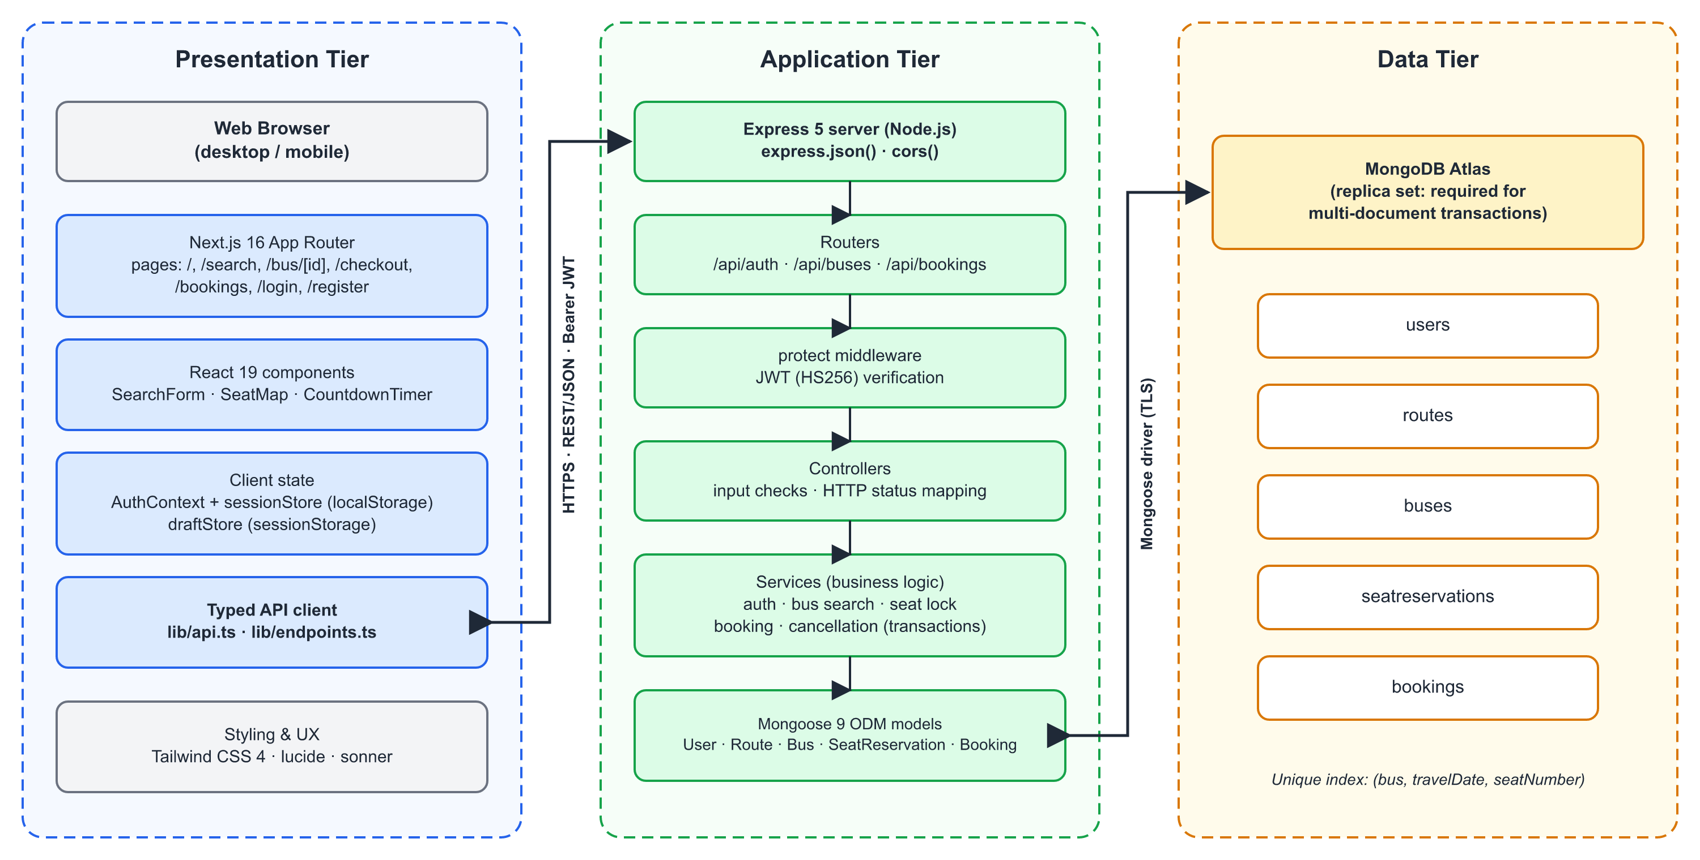
Figure 3.1: Three-tier architecture of BusGo
Separating controllers from services keeps HTTP concerns (reading parameters, choosing a status code) apart from domain logic (whether a seat may be locked). Services can therefore be reasoned about and tested independently of Express, and the same service could be reused from a different interface such as a mobile API or an administrative script.

3.5 Database Design
The data model consists of five collections: users, routes, buses, seatreservations and bookings. Figure 3.2 shows the entities and their relationships. A route connects two cities and records the journey duration and optional intermediate stops. A bus belongs to one route and defines its seat layout as a two-dimensional array in which empty strings represent the aisle, for example ["A1","A2","","A3","A4"]. This layout drives both validation on the server and the drawing of the seat map on the client.
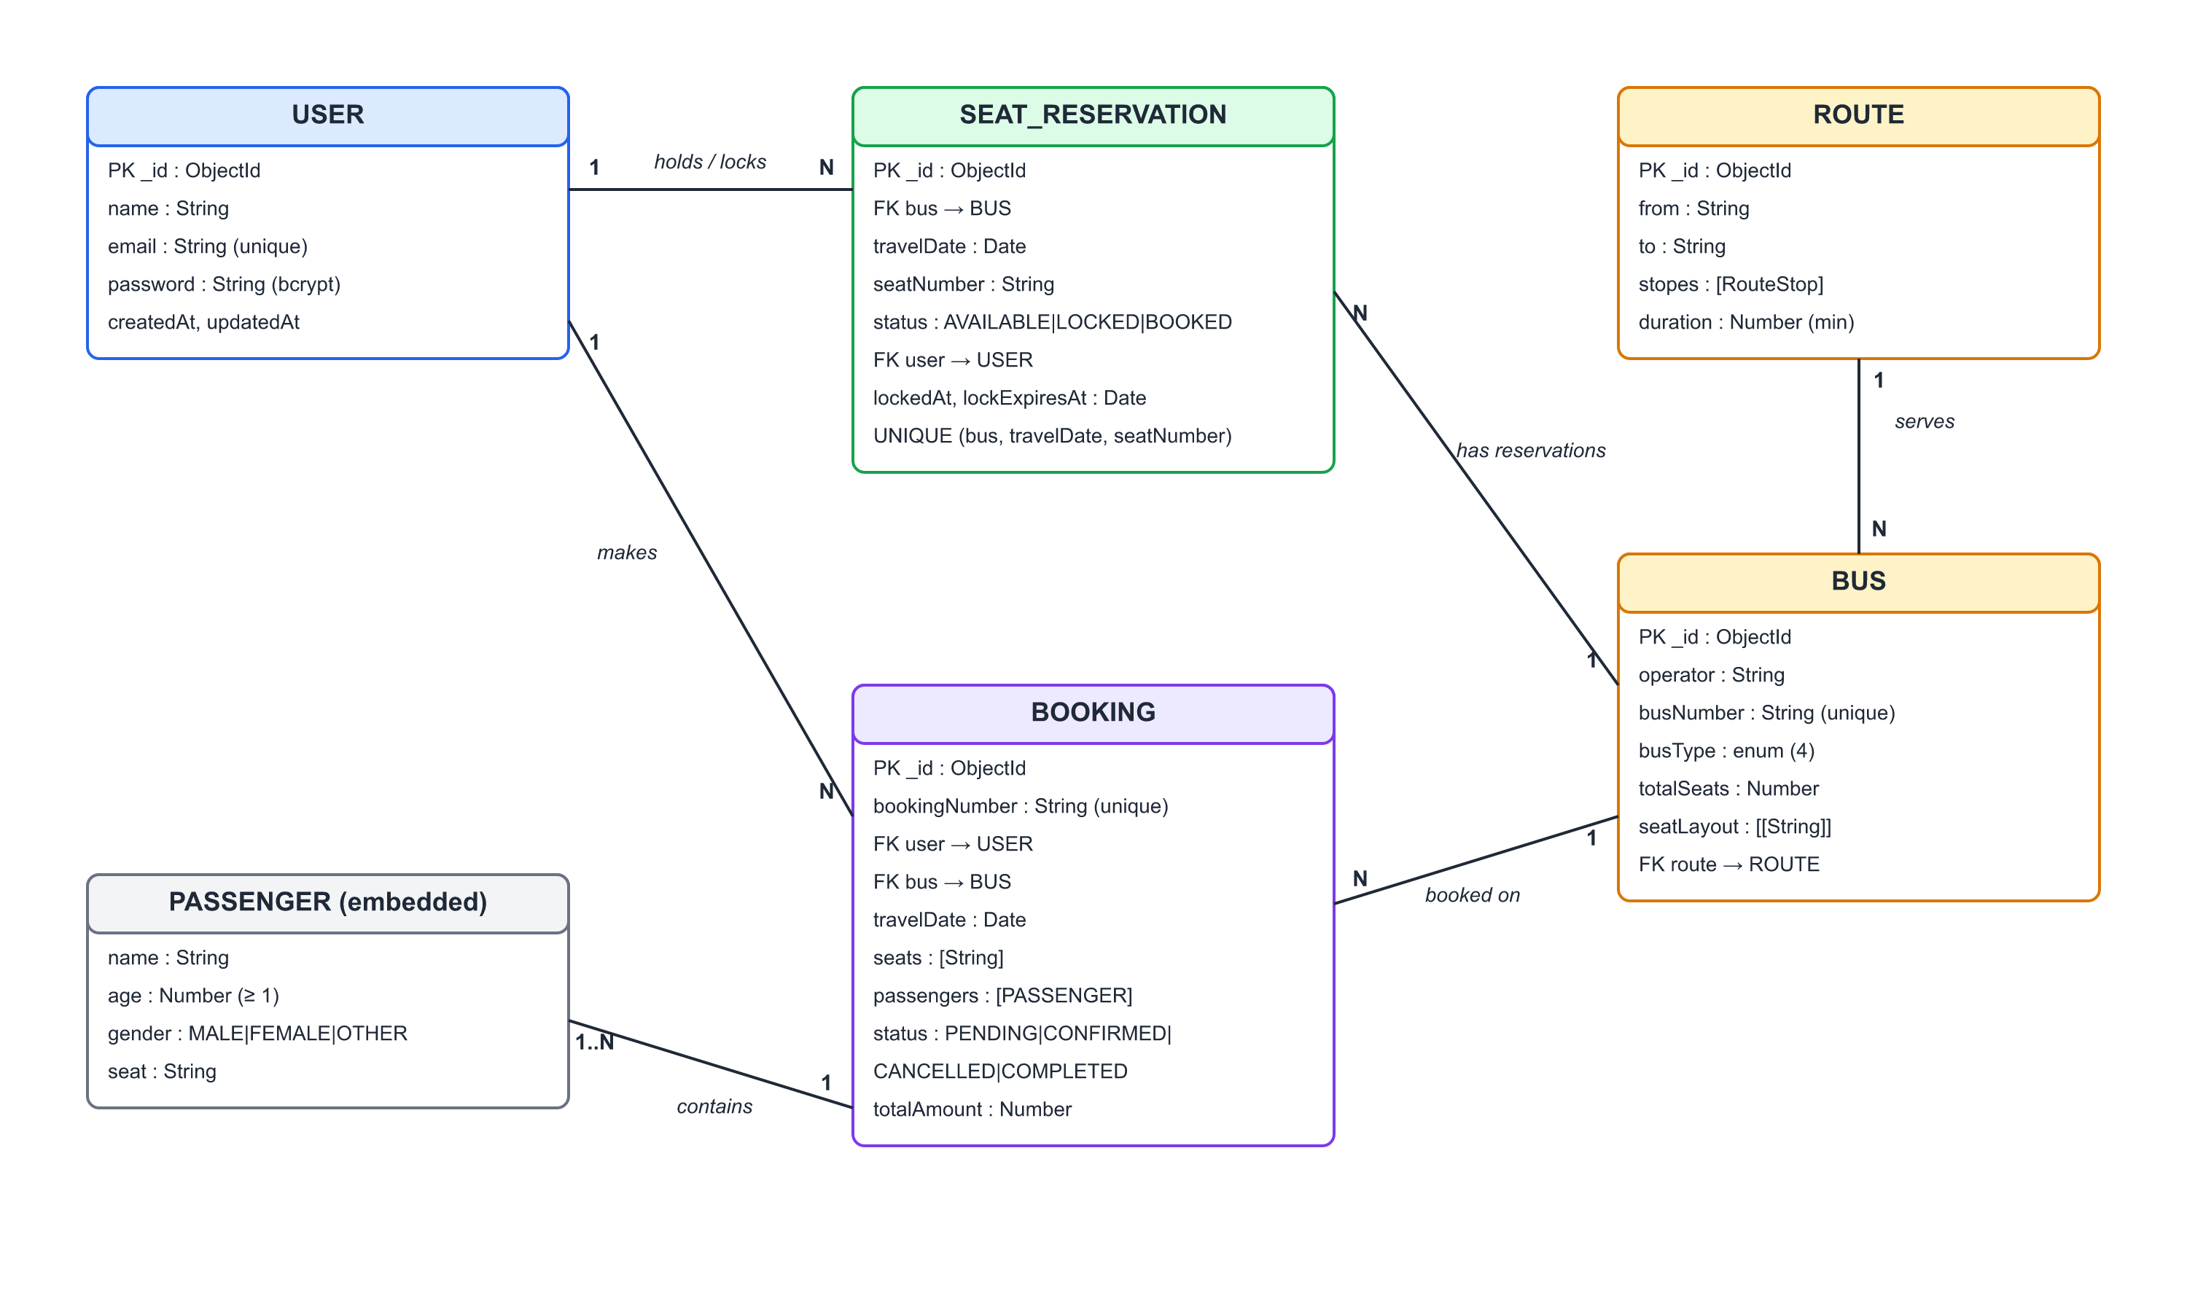
Figure 3.2: Entity–relationship diagram of the BusGo database
The central design decision is the SeatReservation collection. Instead of storing an array of booked seats inside each bus or booking, the system stores one small document per seat per travel date, but only for seats that have ever been locked or booked; a seat with no document is implicitly available. A unique compound index on (bus, travelDate, seatNumber) guarantees that at most one such document can ever exist¹⁴. All concurrent operations on a seat therefore compete for the same single document, and MongoDB's per-document atomicity decides the winner. Table 3.3 and Table 3.4 describe the two most important collections.
Table 3.3: SeatReservation collection
Field | Type | Constraint / Meaning
bus | ObjectId → Bus | Required
travelDate | Date | Required; stored at 00:00 UTC of the travel day
seatNumber | String | Required; must exist in the bus seat layout
status | Enum | AVAILABLE | LOCKED | BOOKED
user | ObjectId → User | Holder of the lock or owner of the booked seat
lockedAt, lockExpiresAt | Date | Set while LOCKED; lock is valid only while now < lockExpiresAt
(bus, travelDate, seatNumber) | Unique index | At most one reservation document per seat per day

Table 3.4: Booking collection
Field | Type | Constraint / Meaning
bookingNumber | String | Unique; format BUS-XXXXXXXX derived from a random UUID
user, bus | ObjectId | Owner of the booking and the booked bus
travelDate | Date | Journey date (UTC midnight)
seats | [String] | At least one seat
passengers | [Passenger] | Embedded: name, age (≥ 1), gender, seat
status | Enum | PENDING | CONFIRMED | CANCELLED | COMPLETED
totalAmount | Number | Fare per seat × number of seats (≥ 0)
createdAt, updatedAt | Date | Automatic timestamps

Passengers are embedded inside the booking rather than stored in a separate collection, because they are always read and written together with the booking and have no meaning on their own. User passwords are excluded from query results by default (select: false) and are hashed in a pre('save') hook with bcrypt at cost factor 12²⁰.

3.6 Use Case Model
Three actors interact with the system (Figure 3.3). A Guest can explore cities, search buses and view seat maps, and can register or log in. A Registered User inherits these capabilities and can additionally lock seats, enter passenger details, confirm bookings, and view, print or cancel their bookings. An Administrator currently manages master data (routes and buses) through an idempotent seed script that uses upserts, so it can be re-run safely.
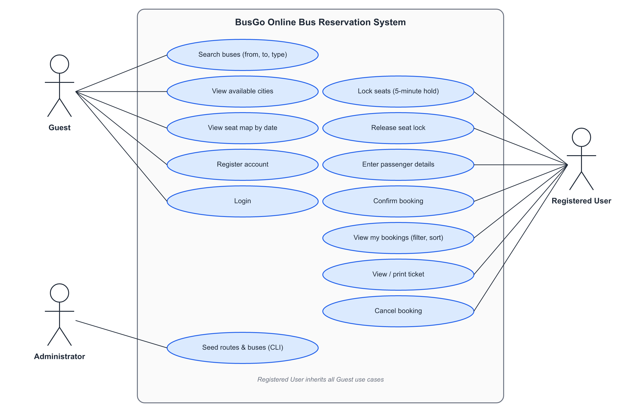
Figure 3.3: Use case diagram

3.7 Seat Life Cycle
Every seat on a given date behaves as a small state machine, shown in Figure 3.4. A seat starts as AVAILABLE (no reservation document). A lock request moves it to LOCKED and records the user and an expiry time five minutes ahead. From LOCKED, the seat returns to AVAILABLE when the user releases it or when the expiry time passes, or it moves to BOOKED when the same user confirms a booking. The same user may lock again while holding the seat, which simply extends the expiry. A booked seat returns to AVAILABLE only through cancellation. Expiry needs no background job: every read treats an expired lock as available, and every write is allowed to take over an expired lock.
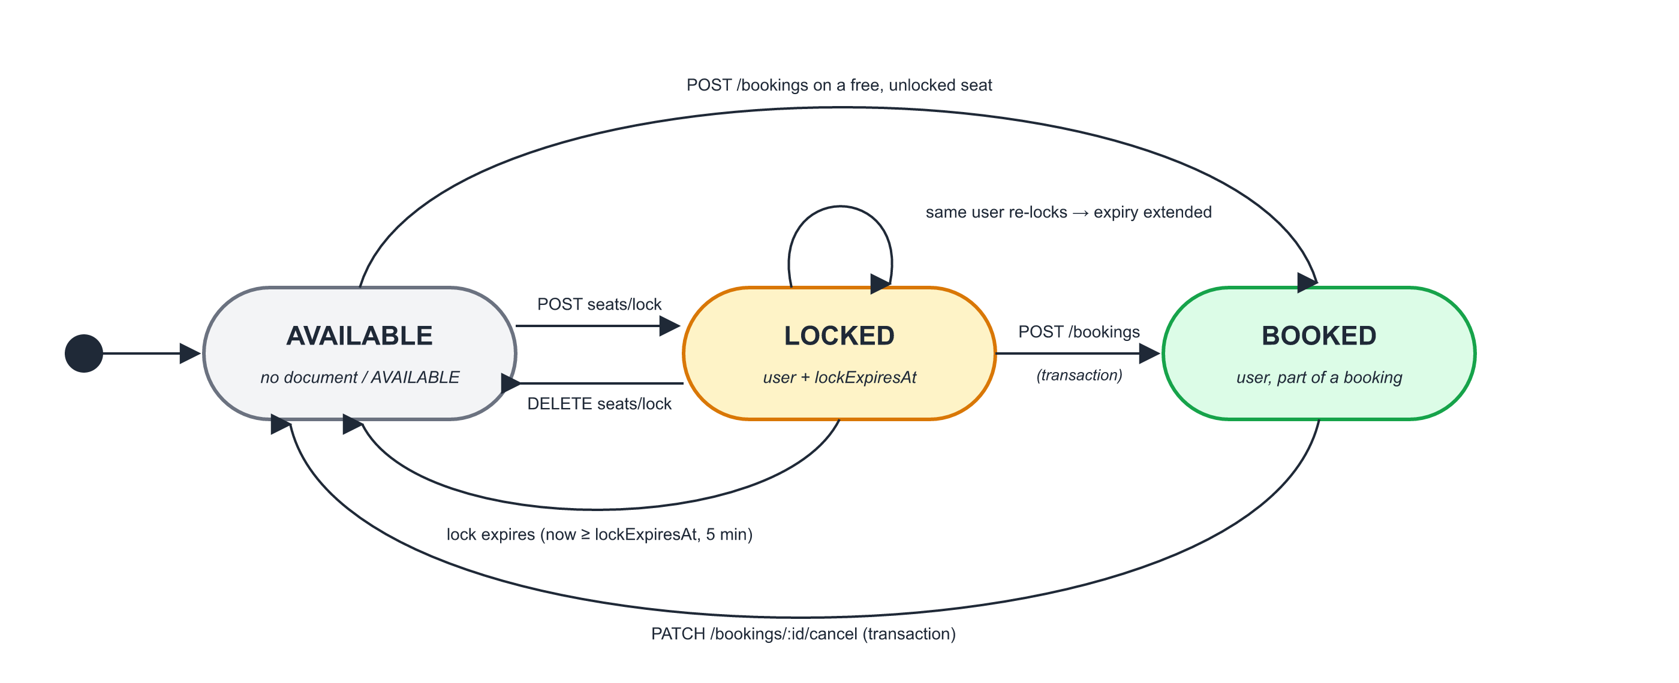
Figure 3.4: State diagram of a seat for one travel date

3.8 Module Implementation

3.8.1 Authentication Module
POST /api/auth/register checks that name, e-mail and password are present, rejects a duplicate e-mail with HTTP 409 and stores the user; the e-mail is normalised to lowercase and the password is hashed by the model hook. POST /api/auth/login loads the user together with the hidden password field and compares it using bcrypt.compare; on failure the same generic message, "Invalid email or password", is returned for both unknown e-mail and wrong password, so that attackers cannot discover which e-mail addresses are registered. On success, a JWT containing the user ID is signed with HS256 and a seven-day expiry¹⁹. The protect middleware reads the Authorization: Bearer header, verifies the signature and algorithm, and attaches req.userId for downstream controllers. GET /api/auth/user returns the current user and is used by the frontend to re-validate a stored session.

3.8.2 Bus Search Module
GET /api/buses/cities returns the distinct origin and destination cities, which populate the search form. GET /api/buses/search first finds matching routes. User input is escaped before being placed in a case-insensitive, anchored regular expression, so that a search for "delhi" matches "Delhi" exactly and special characters cannot alter the pattern. It then finds buses on those routes, optionally filtered by bus type, and returns them with route details and pagination metadata (page, limit, total, totalPages).

3.8.3 Seat Availability Module
GET /api/buses/:id/seats?date=YYYY-MM-DD loads the bus, fetches all reservation documents for that bus and date in a single query, and builds a map from seat number to status. Locks whose expiry time has passed are reported as AVAILABLE. The response contains every seat from the layout with its status and fare, so the client can draw the seat map without further requests.

3.8.4 Seat Locking Module
Seat locking is the heart of the system. Algorithm 3.1 summarises lockSeatsService. After validating the identifiers, the date format and the seat list, the service first deletes expired locks for the requested seats. It then opens a transaction and, for each seat, performs a conditional update: the reservation document is changed to LOCKED only if it is currently AVAILABLE, or LOCKED with an expired timer, or LOCKED by the same user. If no document matched, the service checks whether a document exists. If one exists, it belongs to someone else and the whole transaction is aborted with the message "Seat X is not available", which the controller maps to HTTP 409 Conflict. If none exists, a new LOCKED document is created; the unique index ensures that if two users race to create the first document for the same seat, only one insert can succeed.
Algorithm 3.1: Seat locking (lockSeatsService)
Input: busId, travelDate (YYYY-MM-DD), seats[], userId
Output: lockExpireAt, or an error
1. Validate busId, userId, date format and a non-empty list of unique seats
2. bus ← Bus.findById(busId); if not found → error "Bus not found"
3. if any seat ∉ bus.seatLayout → error "One or more seats do not exist"
4. now ← current time; expiry ← now + 5 minutes
5. delete reservations for these seats where status = LOCKED and lockExpiresAt ≤ now
6. BEGIN TRANSACTION
7. for each seat s in seats do
8. r ← updateOne({bus, date, seat = s, and (status = AVAILABLE
or (status = LOCKED and lockExpiresAt ≤ now)
or (status = LOCKED and user = userId))},
set {status: LOCKED, user: userId, lockedAt: now, lockExpiresAt: expiry})
9. if r.modifiedCount = 0 then
10. if a reservation for s exists then ABORT → error "Seat s is not available"
11. else insert {bus, date, s, LOCKED, userId, now, expiry} (unique index)
12. COMMIT; return {status: LOCKED, lockExpireAt: expiry}

Because all seats are locked inside one transaction, the operation is all-or-nothing: a user who requests seats A1, A2 and A3 either receives all three or none. This avoids the confusing situation in which a group is split across the bus because one of their seats was taken. DELETE /api/buses/:id/seats/lock releases only the LOCKED documents owned by the requesting user, so one user cannot release another user's hold.

3.8.5 Booking Module
POST /api/bookings is handled by createBookingService (Algorithm 3.2). Before any write, the service performs extensive validation. It checks that the user and bus exist and that the date is a real calendar date that is not in the past. It checks that the seats are unique and exist on the bus, and that none is already BOOKED or held by another user with an unexpired lock. Every passenger must have a non-empty name, an integer age of at least one and a valid gender, and each seat must have exactly one passenger. The writes then run inside a transaction. Each seat is moved to BOOKED with the same conditional-update technique used for locking, and the booking document is created with status CONFIRMED. If anything fails, for example because another user took a seat after its lock expired, the transaction is rolled back and no partial booking remains.
Algorithm 3.2: Transactional booking (createBookingService)
Input: userId, busId, travelDate, seats[], passengers[]
1. Validate user, bus, date (valid, not in the past), seats (unique, exist on bus)
2. R ← reservations for (bus, date, seats)
3. if any r ∈ R has status BOOKED → error "Seats already booked"
4. if any r ∈ R is LOCKED by another user and not expired → error
5. Validate passengers: count = |seats|, name, integer age ≥ 1, gender, one per seat
6. amount ← farePerSeat × |seats|; number ← "BUS-" + first 8 chars of UUID
7. BEGIN TRANSACTION
8. for each seat s: conditional updateOne → BOOKED if AVAILABLE, or LOCKED by userId
and not expired, or LOCKED and expired; else insert BOOKED if no document
exists; otherwise ABORT "Seat s is no longer available"
9. create Booking {number, user, bus, date, seats, passengers, amount, CONFIRMED}
10. COMMIT; return booking

The interaction between the user, the frontend, the API, the service layer and the database during locking and booking is shown in the sequence diagram of Figure 3.5.
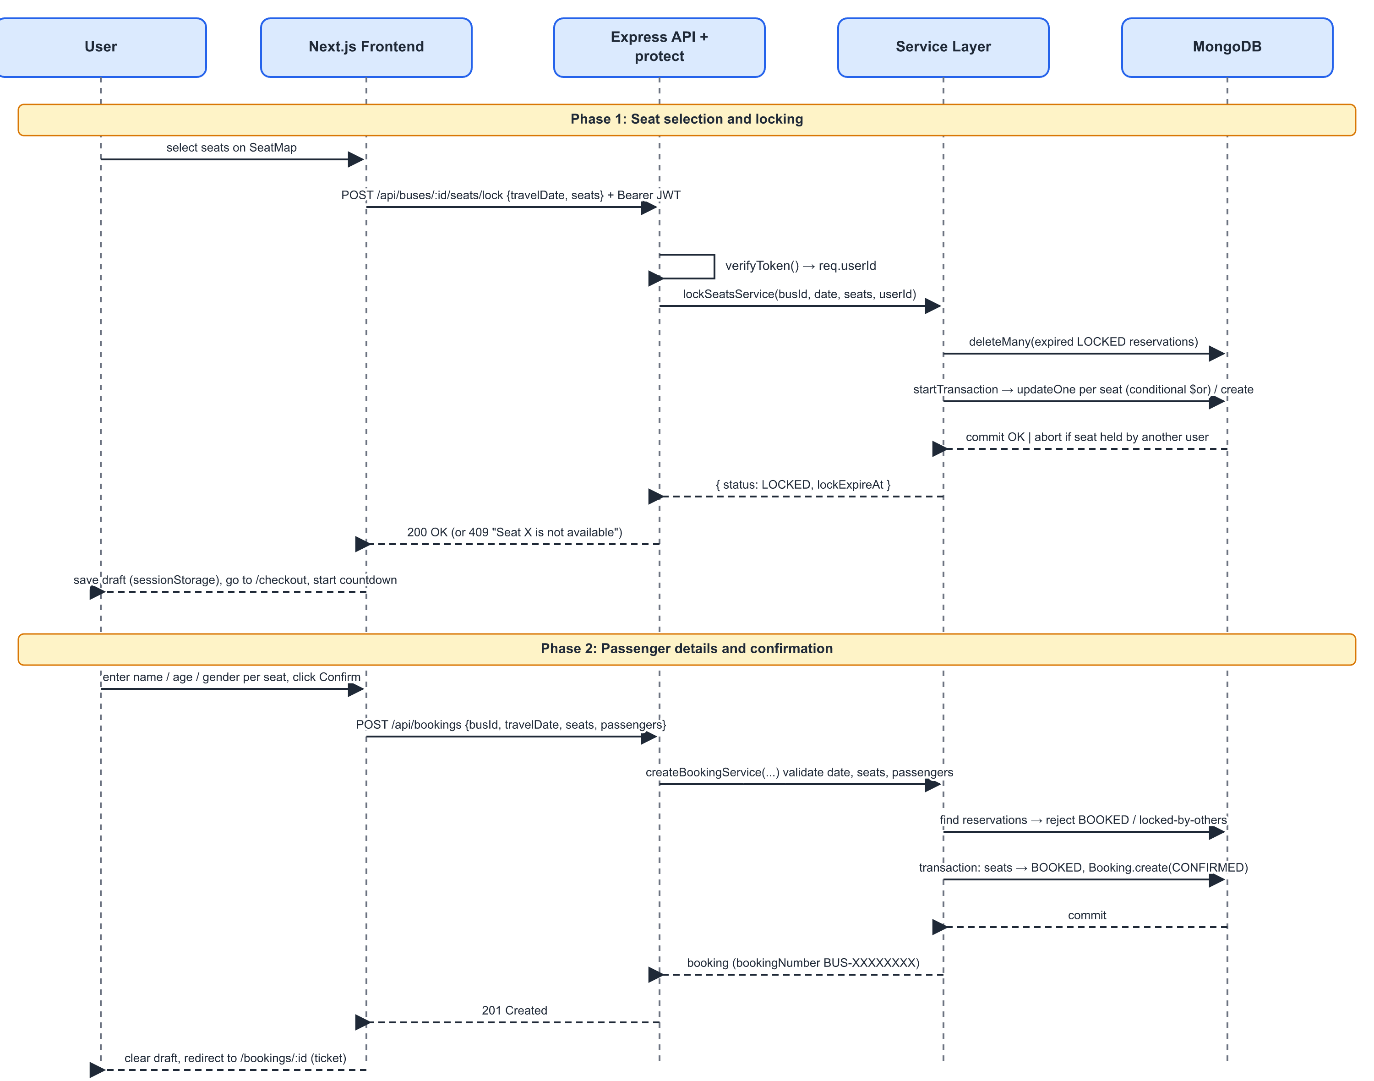
Figure 3.5: Sequence diagram for seat locking and booking

3.8.6 Booking History and Cancellation Module
GET /api/bookings returns only the requesting user's bookings, populated with bus and route details, with page size limited to fifty, an optional status filter and newest-first or oldest-first sorting. GET /api/bookings/:id returns a single booking only if it belongs to the requesting user; an invalid or foreign ID yields 404 rather than revealing that the booking exists. Cancellation (Algorithm 3.3) runs in a transaction that marks the booking CANCELLED and returns its seats to AVAILABLE, so the released seats are immediately visible to other users.
Algorithm 3.3: Booking cancellation (cancelBookingService)
Input: bookingId, userId
1. BEGIN TRANSACTION
2. b ← Booking.findById(bookingId); if none → error "Booking not found"
3. if b.user ≠ userId → error "You are not allowed to cancel this booking"
4. if b.status ∈ {COMPLETED, CANCELLED} → error
5. b.status ← CANCELLED; save b
6. update reservations (b.bus, b.travelDate, seats ∈ b.seats, status = BOOKED)
set {status: AVAILABLE, user: null, lockedAt: null, lockExpiresAt: null}
7. COMMIT; return b

3.9 REST API Design
The API exposes thirteen operations grouped under three resources (Table 3.5). All responses are JSON objects containing a success flag and either a result or a message describing the error.
Table 3.5: REST API endpoints
Method | Endpoint | Auth | Purpose
POST | /api/auth/register | No | Create account; returns JWT and user
POST | /api/auth/login | No | Authenticate; returns JWT and user
GET | /api/auth/user | Yes | Current user profile
GET | /api/buses/cities | No | Distinct origin and destination cities
GET | /api/buses/search | No | Search by from, to, busType; page, limit
GET | /api/buses/:id | No | Bus details with route
GET | /api/buses/:id/seats?date= | No | Seat statuses and fares for a date
POST | /api/buses/:id/seats/lock | Yes | Lock seats for five minutes
DELETE | /api/buses/:id/seats/lock | Yes | Release the caller's locks
POST / GET | /api/bookings | Yes | Create booking / list own bookings
GET | /api/bookings/:id | Yes | Own booking details (ticket)
PATCH | /api/bookings/:id/cancel | Yes | Cancel own booking, release seats

3.10 Frontend Implementation
The frontend uses the Next.js App Router. Each URL corresponds to a folder under app/, and each page delegates to a client component that contains its interactive logic (Figure 3.6). The root layout wraps every page in an AuthProvider and a toast container and renders the navigation bar and footer.
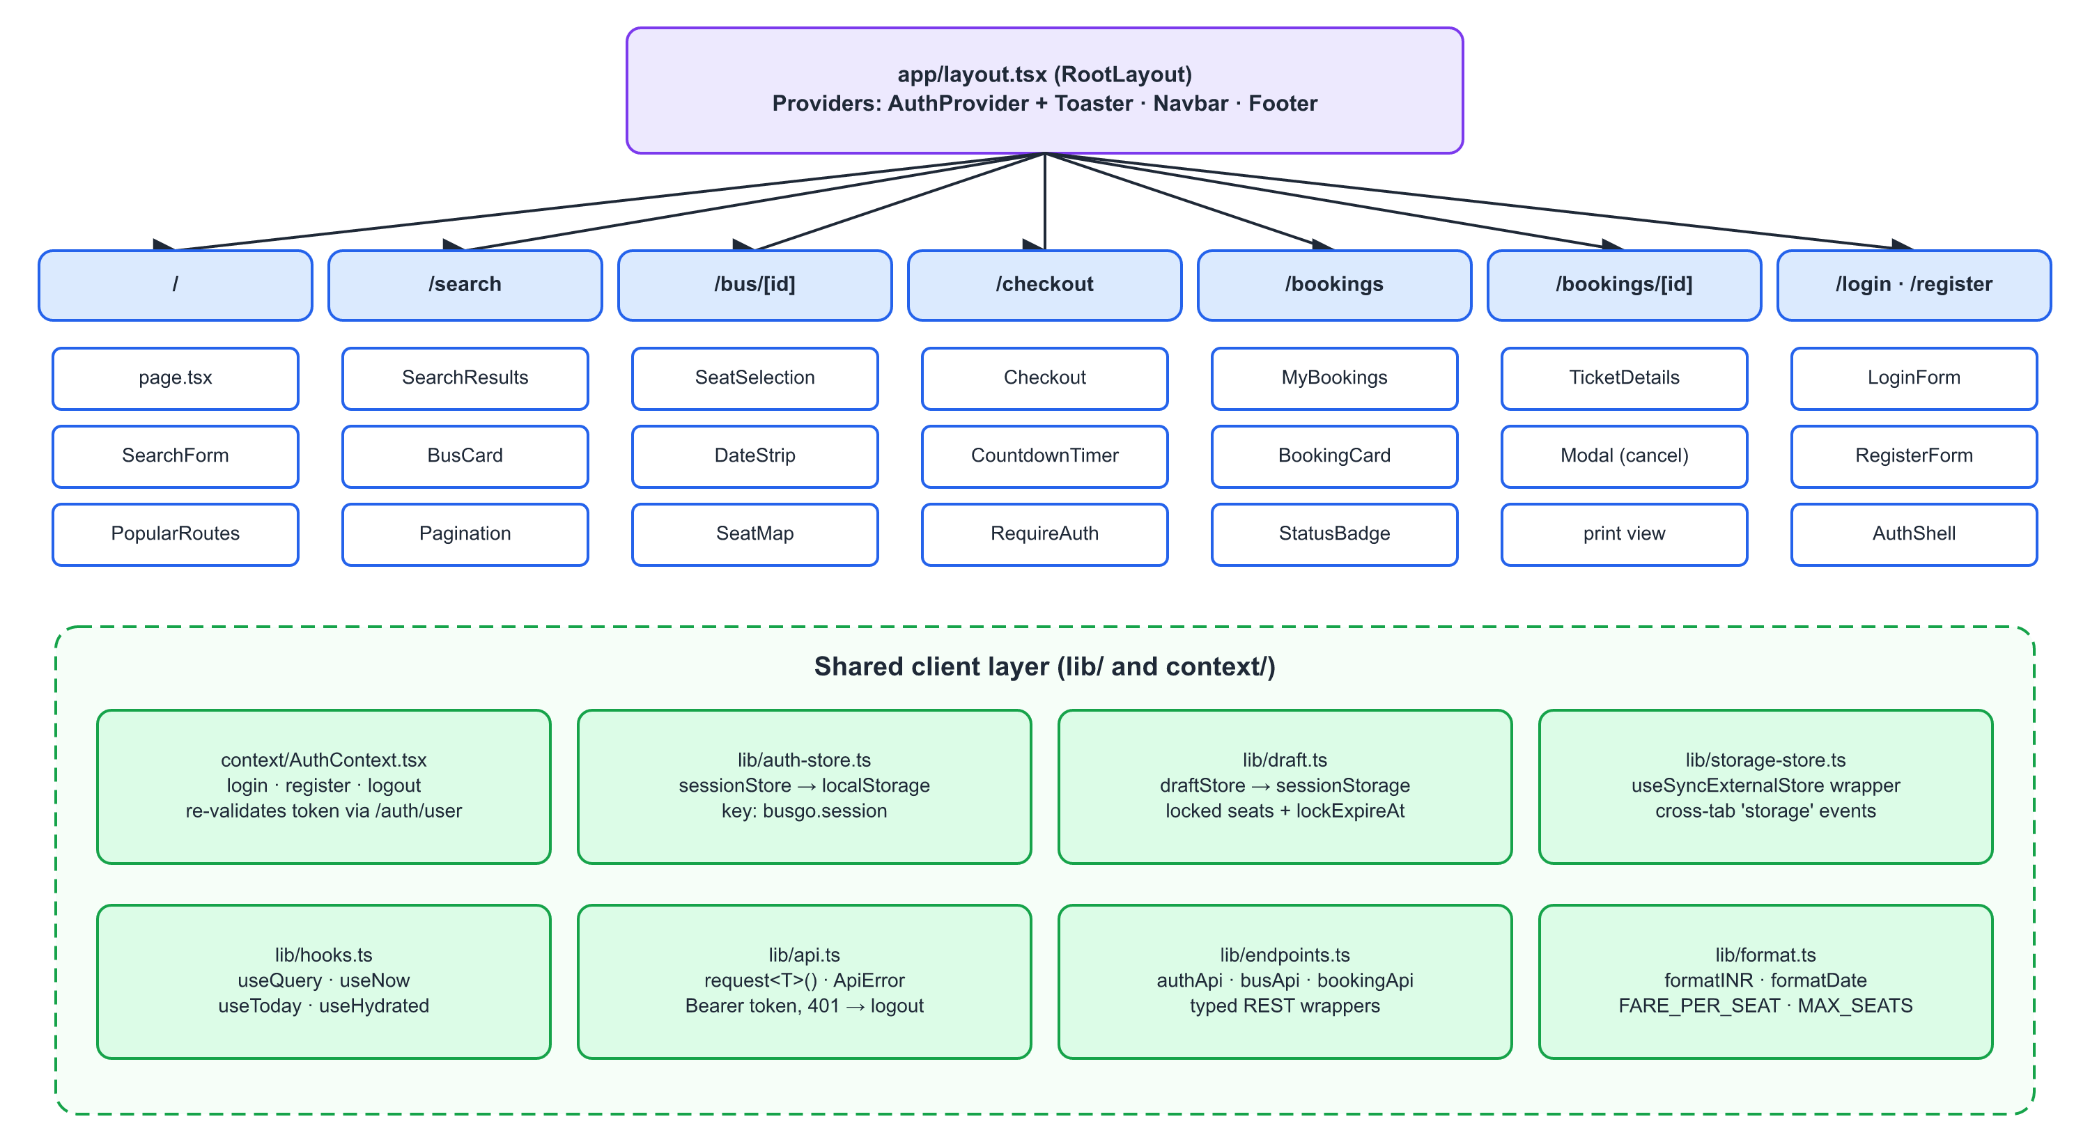
Figure 3.6: Frontend routes, components and shared client layer
API client. All network calls go through a single typed request<T>() function in lib/api.ts. It builds the URL from a configurable base address, attaches the bearer token when a call is marked as authenticated, converts network failures into a friendly message and throws an ApiError carrying the HTTP status. If the server reports that the token is missing or expired, the client clears the stored session automatically. lib/endpoints.ts wraps every API endpoint in a typed function (authApi, busApi, bookingApi), so pages never construct URLs by hand.
State management. Rather than using a third-party state library, the project implements a small storage-backed store on top of React's useSyncExternalStore hook¹⁶. The session (token and user) is kept in localStorage so that it survives browser restarts. The booking draft, which holds the locked seats, fare and lock expiry, is kept in sessionStorage, so it is scoped to the current tab²⁶. The store listens to the browser's storage event, so logging out in one tab is reflected in other tabs.
Seat selection and checkout. The seat-selection page shows a strip of upcoming dates and the seat map. The map is refreshed every twenty seconds while the user decides, so seats taken by others appear without a manual reload. A user may select up to six seats. If they are not logged in, they are redirected to the login page with a return URL that preserves the chosen seats. Pressing Continue sends the lock request. On success, the draft is saved and the checkout page opens with a countdown showing the remaining hold time. When the countdown reaches zero, the form is disabled, the lock is released and the user is invited to choose seats again. Client-side validation mirrors the server rules (name of at least two characters, age 1–120, gender selected) to give instant feedback. The overall user flow is summarised in Figure 3.7.
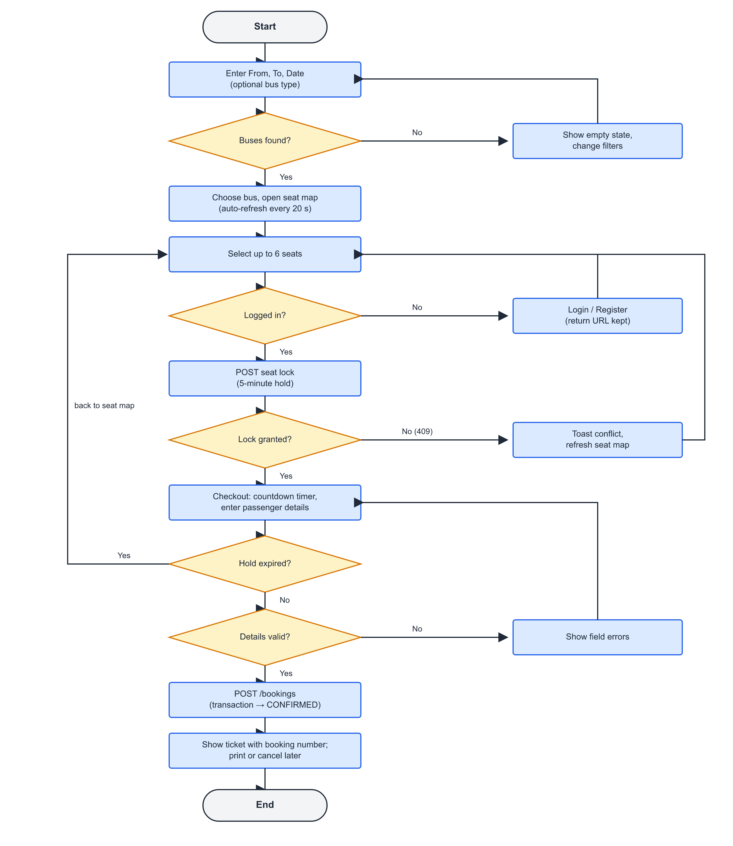
Figure 3.7: Flowchart of the passenger booking flow
Bookings and tickets. The My Bookings page lists bookings six per page with status tabs and a sort toggle. The ticket page shows the booking number, journey, passengers and amount, can be printed using a print-specific style sheet that hides navigation elements, and offers cancellation through a confirmation dialog. All dates are formatted in the Indian locale and amounts in rupees.

3.11 Security Measures
- Passwords hashed with bcrypt (cost 12) and never returned by queries (select: false)²⁰.
- JWTs signed with a secret from the environment; the verification step pins the algorithm to HS256 and checks the payload shape¹⁹.
- Every booking query is filtered by the authenticated user ID, preventing access to other users' bookings (broken access control in OWASP terms)²¹.
- Search input is regex-escaped before use, preventing pattern injection; IDs are validated as ObjectIds before queries.
- Uniform error message for failed logins, avoiding account enumeration.
- Secrets (database URL, JWT secret) are stored in environment files excluded from version control by .gitignore.

3.12 Deployment and Configuration
The backend is compiled with the TypeScript compiler (npm run build) and started with npm start; during development npm run dev uses nodemon and tsx for automatic reloads, and npm run seed loads the sample routes and buses. The API is deployed on Render²⁵ and connects to a MongoDB Atlas cluster through an SRV connection string. The frontend is built with next build and reads the API address from NEXT_PUBLIC_API_URL, so the same build can target a local or a hosted backend. Table 3.6 lists the configuration variables.
Table 3.6: Environment configuration
Variable | Component | Description
PORT | Backend | HTTP port of the API server (default 5000)
DB_URL | Backend | MongoDB Atlas connection string (mongodb+srv)
JWT_SECRET | Backend | Secret key used to sign and verify tokens
NEXT_PUBLIC_API_URL | Frontend | Base URL of the REST API, e.g. http://localhost:8080/api

The seed data contains five routes (Delhi–Jaipur, Delhi–Chandigarh, Delhi–Agra, Jaipur–Delhi and Jaipur–Chandigarh) and one bus per route covering all four bus types, each with a twenty-seat 2+2 layout in five rows (A–E).

CHAPTER-4: Results and Discussions

4.1 Overview
This chapter presents the working application, the results of functional and concurrency testing and a discussion of how far the objectives set in Chapter-1 have been met. The test plan operates at two levels: end-to-end through the web interface, and at the API level by sending requests directly to the endpoints with an HTTP client, which allows conflicting requests from two user accounts to be issued deliberately. The expected results below follow from the behaviour implemented in the code; the Status column is to be completed (✓ / ✗) when each case is executed.

4.2 Application Screens
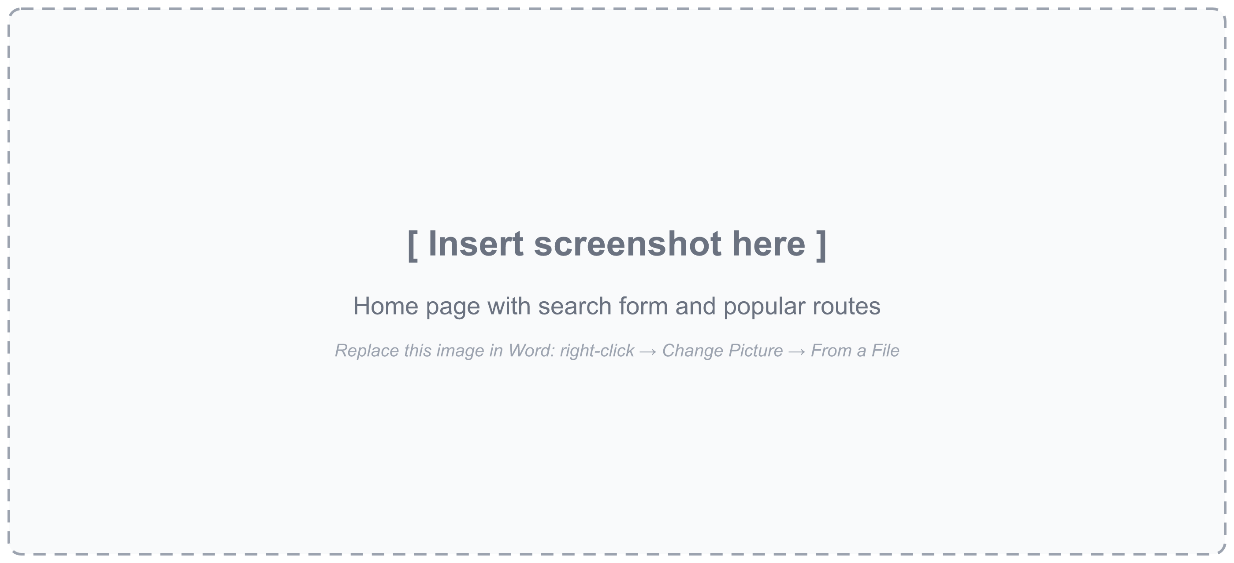
Figure 4.1: Home page with search form and popular routes
The home page presents the search form (from, to, date and optional bus type) prominently, followed by popular routes derived from the available buses and a summary of the service's key features: seat choice, five-minute hold, instant confirmation and free cancellation.
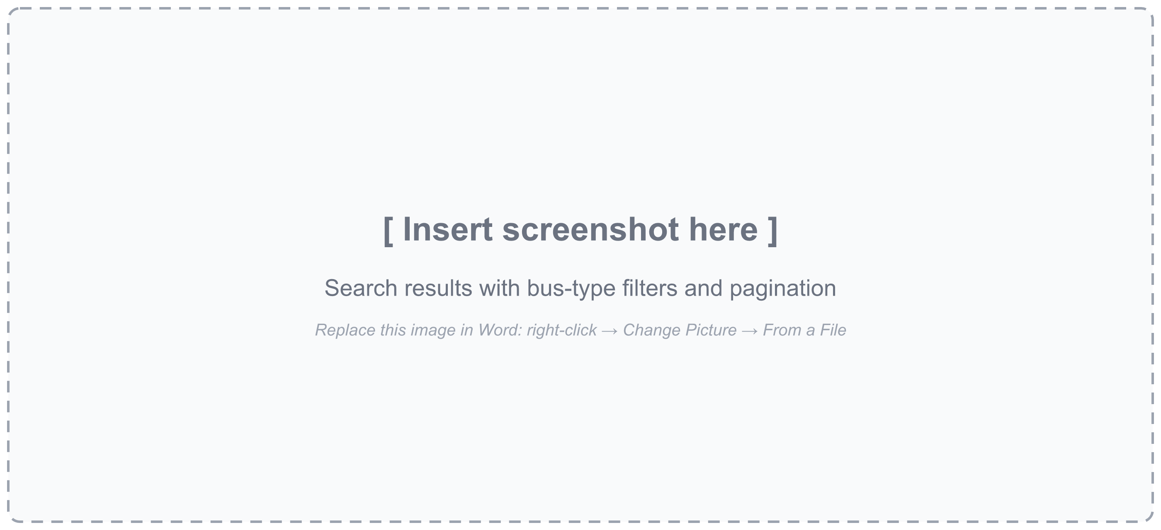
Figure 4.2: Search results with bus-type filters
Search results show each bus with operator, bus number, type, route, duration and fare. Filter chips narrow results by bus type, and results are paginated eight per page. An empty-state message suggests changing the filters when no bus matches.
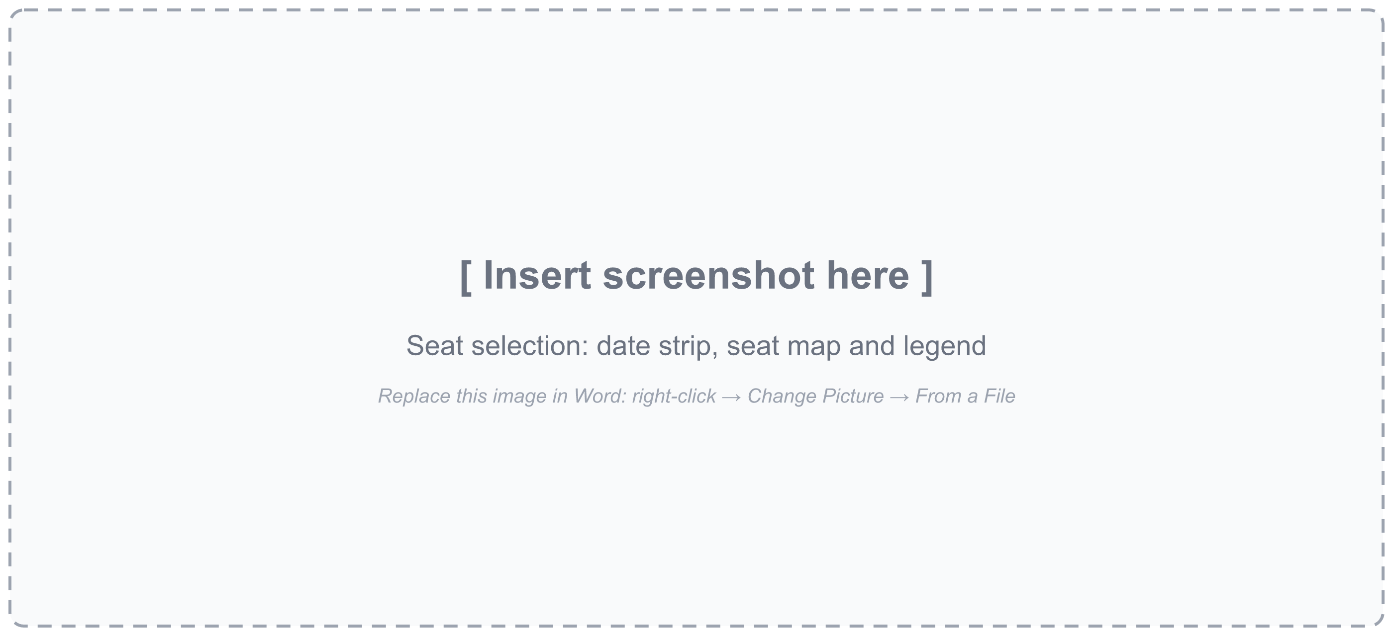
Figure 4.3: Seat selection page with date strip and seat map
The seat map follows the bus's 2+2 layout with an aisle. Seats are colour-coded as available, selected, held by another user, or booked, with a legend. The date strip allows switching the travel date without returning to search, and the summary panel shows the selected seats and the total fare.
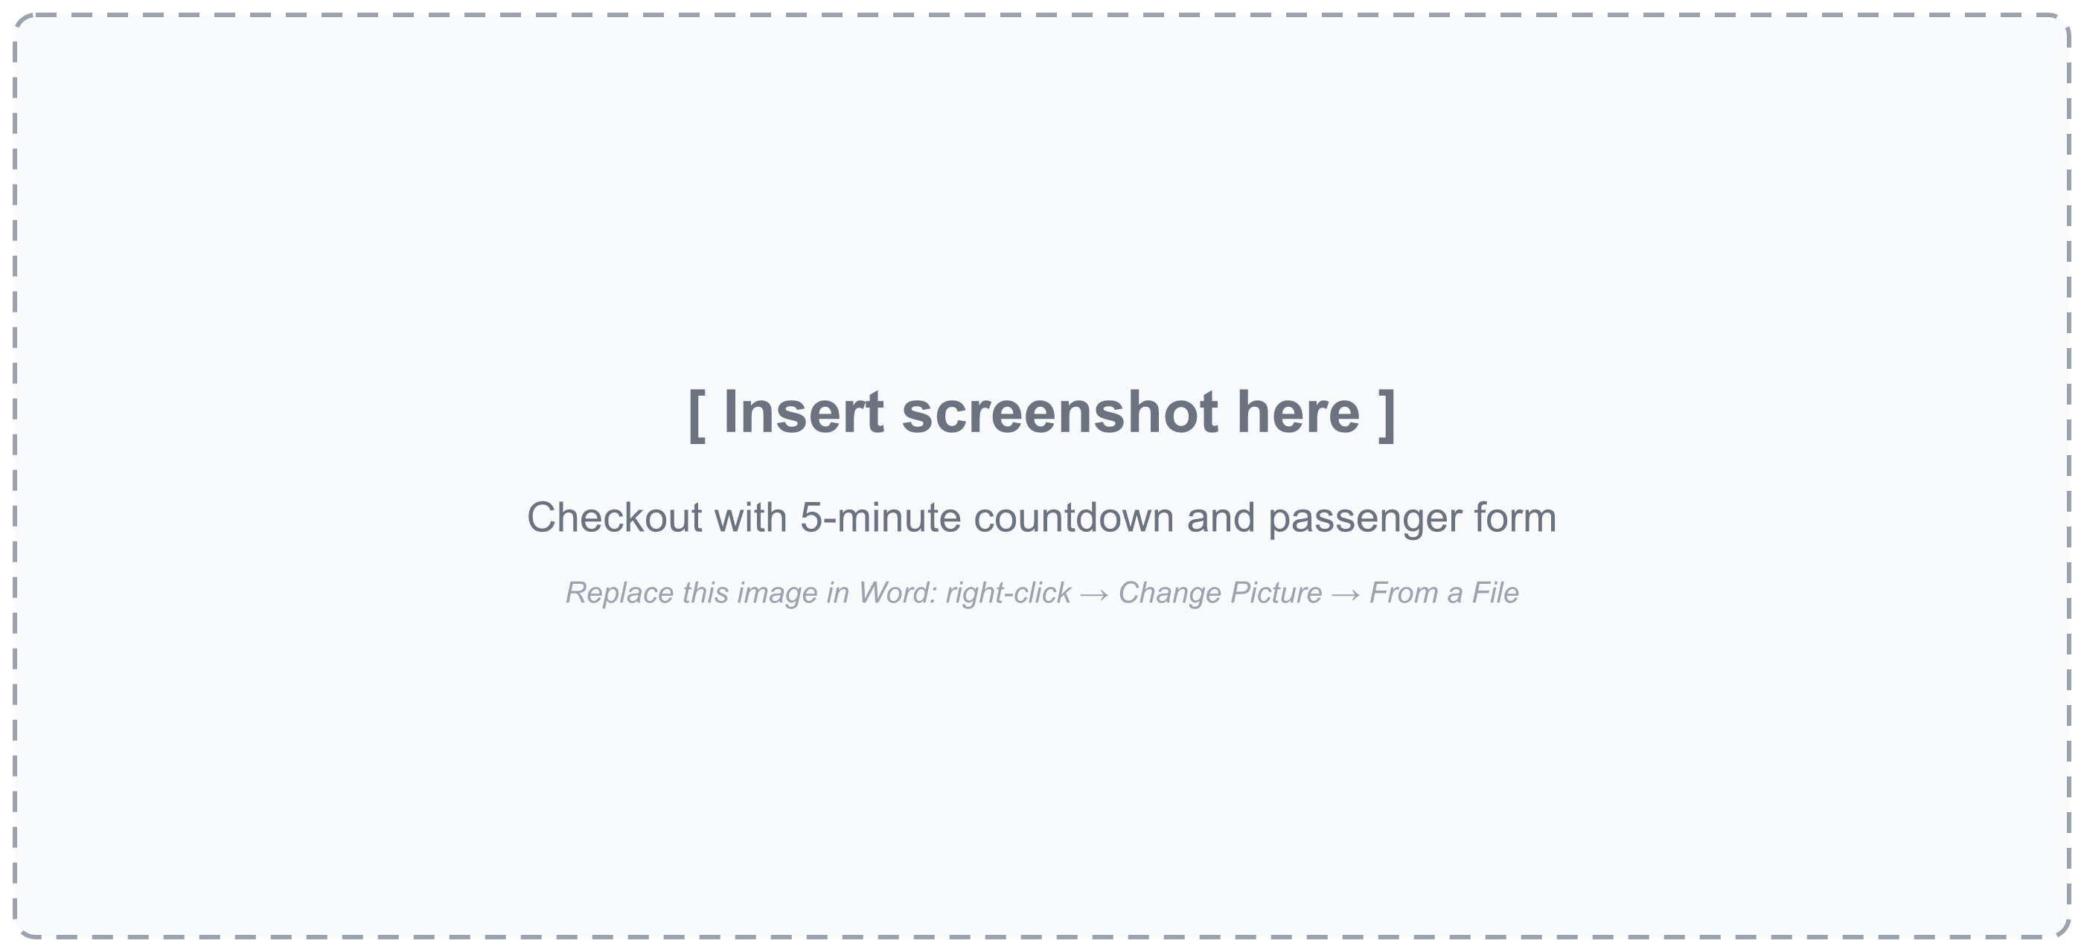
Figure 4.4: Checkout page with countdown and passenger form
After the lock succeeds, the checkout page displays a countdown of the remaining hold time and a form with one card per seat for name, age and gender. Field-level validation messages appear immediately, and the booking summary shows the journey and total amount.
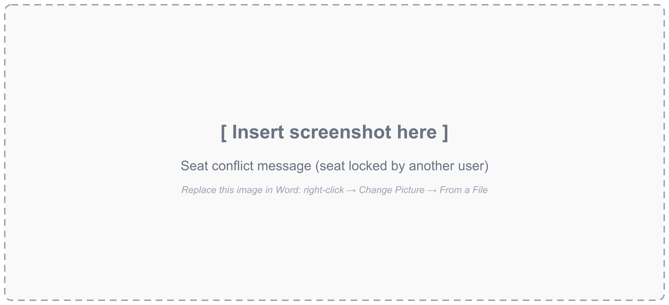
Figure 4.5: Conflict message when a seat is held by another user
If another user has locked a selected seat in the meantime, the lock request fails with HTTP 409. The interface shows an error notification and refreshes the map so that the seat appears as held.
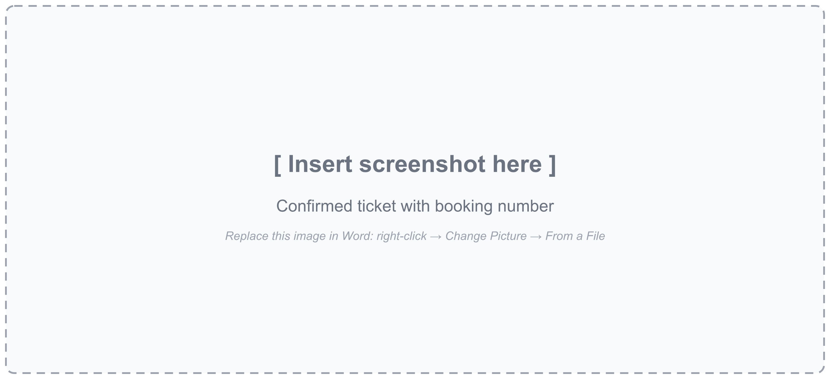
Figure 4.6: Confirmed ticket with booking number
On confirmation, the user lands on the ticket page, which shows the BUS-XXXXXXXX booking number, journey details, passenger list and total paid. The ticket can be printed directly from the browser.
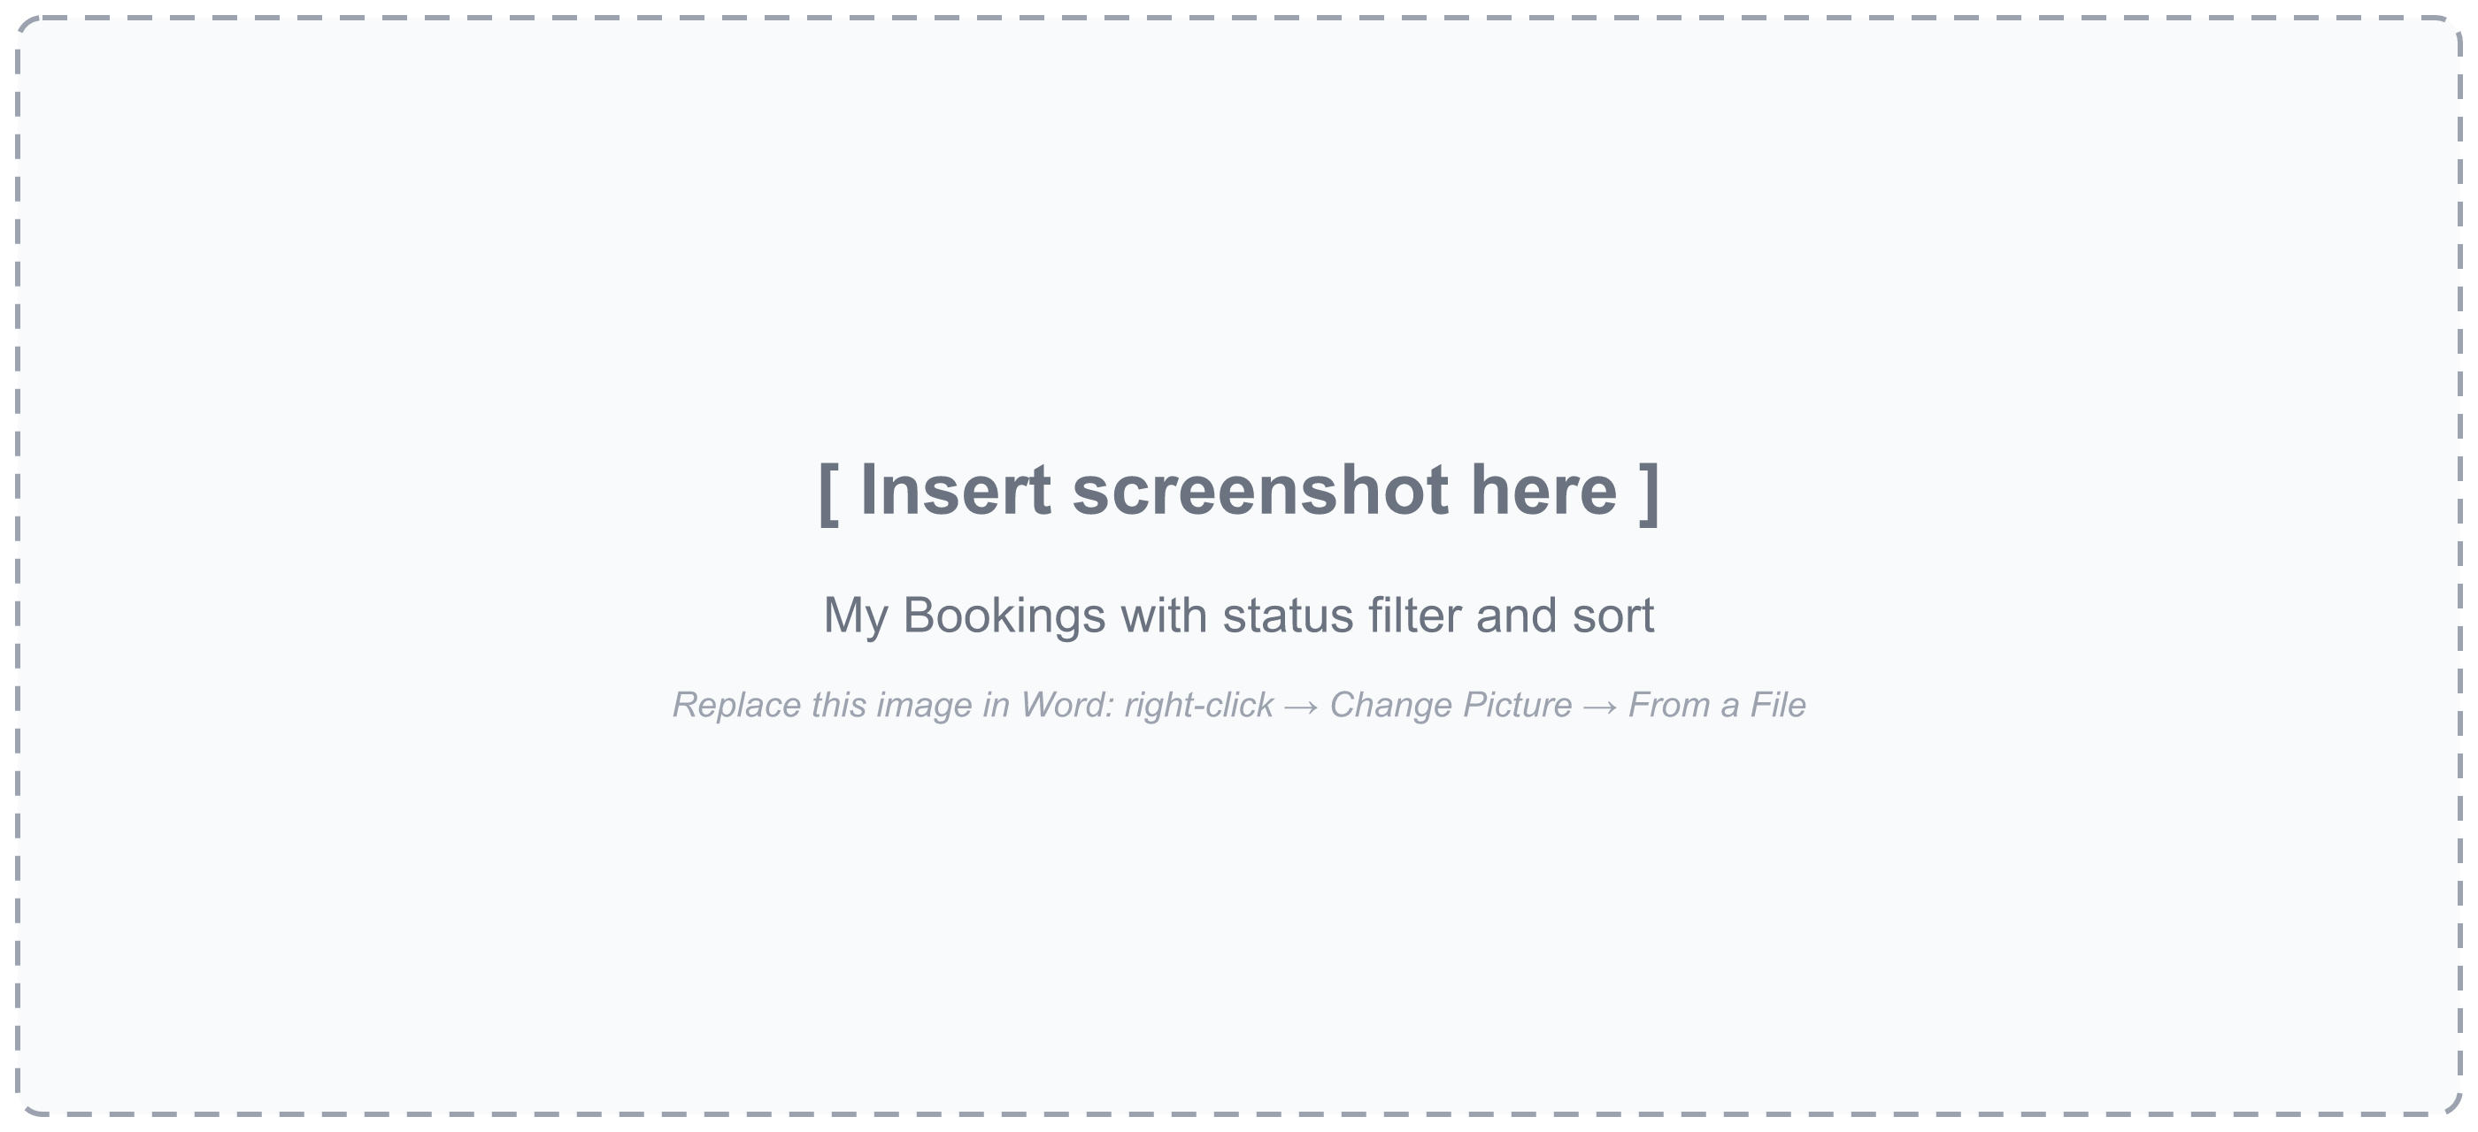
Figure 4.7: My Bookings page with status filter and sort
The booking history groups bookings by status (all, confirmed, cancelled, completed) and can be sorted newest or oldest first, with pagination.
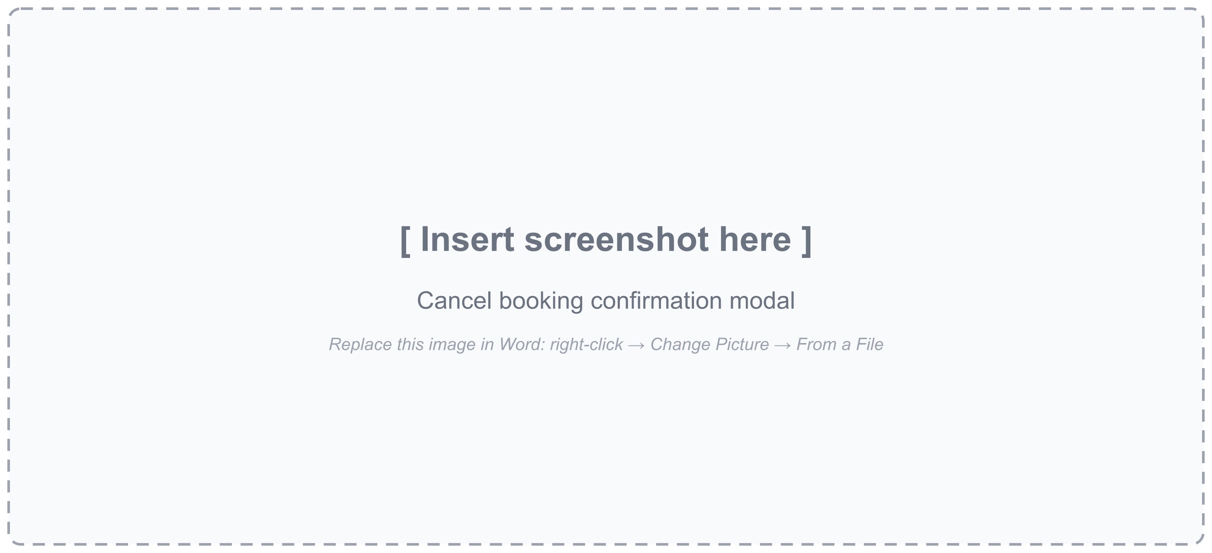
Figure 4.8: Cancellation confirmation dialog
Cancelling asks for confirmation in a modal dialog. After cancellation, the status badge changes to CANCELLED and a notification confirms that the seats were released.
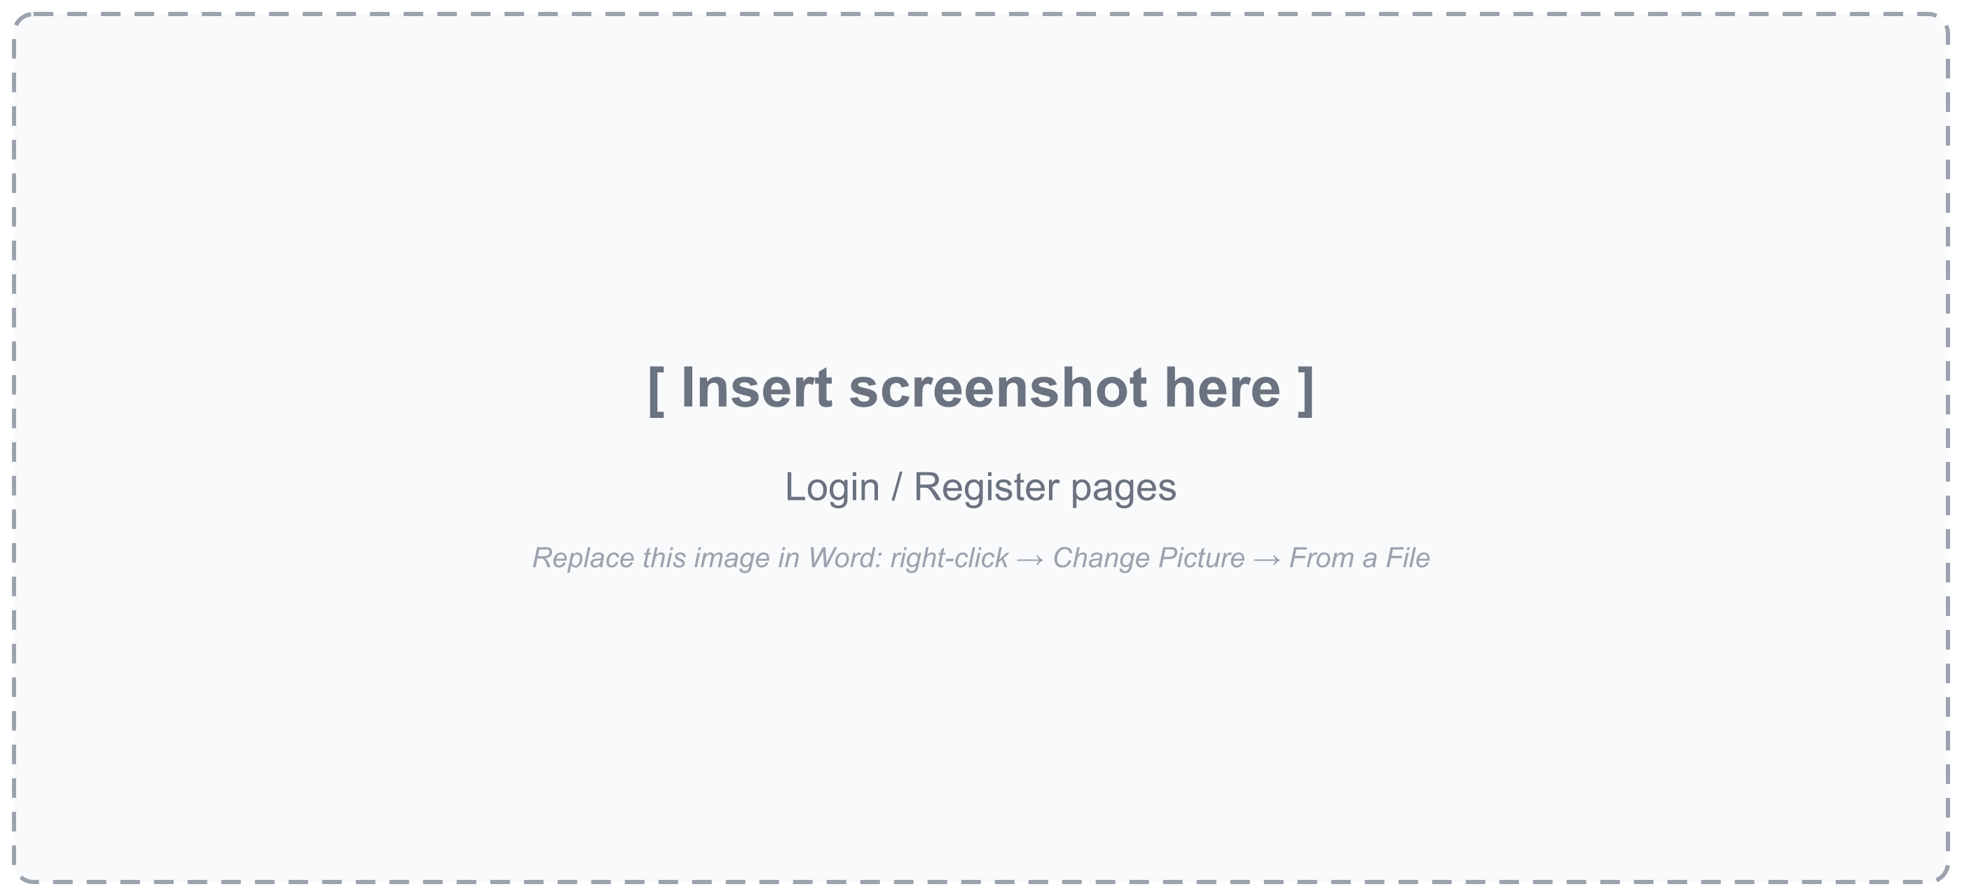
Figure 4.9: Login and registration pages
The login and registration pages share a common layout, with password visibility toggles and inline error messages. After login, the user is returned to the page they came from, including any seats they had selected.

4.3 Functional Test Cases
Table 4.1 lists the functional test cases derived from the requirements in Section 3.2. The expected results correspond to the behaviour implemented in the controllers and services. The Status column records the outcome observed when the test is executed.
Table 4.1: Functional test cases
ID | Scenario | Input / Action | Expected result | Status
TC-01 | Register new user | Valid name, e-mail, password | 201; token and user returned
TC-02 | Register duplicate e-mail | Existing e-mail | 409 "Email already exists"
TC-03 | Register missing field | No password | 400 "All fields are required"
TC-04 | Login wrong password | Valid e-mail, wrong password | 401 "Invalid email or password"
TC-05 | Protected call without token | POST seat lock, no header | 401 "Not authorized, token missing"
TC-06 | Protected call, tampered token | Modified JWT | 401 "Invalid or expired token"; client logs out
TC-07 | Search by cities | from=delhi, to=jaipur | Delhi–Jaipur bus listed (case-insensitive)
TC-08 | Search with type filter | busType=AC_SLEEPER | Only AC sleeper buses
TC-09 | Seat map for a date | GET seats?date=… | 20 seats with status and fare ₹850
TC-10 | Lock free seats | Seats A1, A2 | 200; LOCKED; expiry = now + 5 min
TC-11 | Lock non-existent seat | Seat Z9 | 400 "One or more seats do not exist…"
TC-12 | Lock invalid date | travelDate=2026-02-30 | 400 "Invalid travel date…"
TC-13 | Release own lock | DELETE lock A1, A2 | 200; seats shown AVAILABLE
TC-14 | Book locked seats | 2 seats, 2 valid passengers | 201; CONFIRMED; amount ₹1,700
TC-15 | Passenger count mismatch | 2 seats, 1 passenger | Error; booking rejected
TC-16 | Invalid passenger age | age = 0 | Error "Invalid age…"
TC-17 | Past travel date | Yesterday's date | Error "Travel date cannot be in the past"
TC-18 | List own bookings | status=CONFIRMED, sort=desc | Only own confirmed bookings, newest first
TC-19 | View another user's booking | Foreign booking ID | 404 "Booking not found"
TC-20 | Cancel booking | PATCH cancel | CANCELLED; seats AVAILABLE again
TC-21 | Cancel twice | PATCH cancel again | Error "Booking is already cancelled"
TC-22 | Hold expires at checkout | Wait 5 min on checkout | Form disabled; lock released; reselect

4.4 Concurrency Test Scenarios
The most important property of BusGo is that it behaves correctly when users compete for the same seat. Table 4.2 lists the concurrency scenarios to be executed using two separate user accounts (U1 and U2) on the same bus and date.
Table 4.2: Concurrency test scenarios
ID | Scenario | Expected behaviour | Status
CT-01 | U1 locks A1; U2 then locks A1 | U2 receives 409 "Seat A1 is not available"; U1 keeps the hold
CT-02 | U1 locks A1, A2; U2 locks A2, A3 | U2's request fails as a whole; A3 is not locked for U2 (all-or-nothing)
CT-03 | U1 locks A1 twice | Second lock succeeds and extends the expiry
CT-04 | U1's lock on A1 expires; U2 locks A1 | U2 obtains the lock; U1's later booking for A1 is rejected
CT-05 | U2 tries to book A1 while U1 holds it | Rejected: "Seats locked by another user: A1"
CT-06 | U2 tries to release U1's lock | No effect; only the caller's locks are deleted
CT-07 | U1 cancels booking for A1; U2 locks A1 | A1 shown AVAILABLE and U2's lock succeeds

By design, each seat-on-date is owned by at most one user at any time, and ownership changes only through the defined transitions of Figure 3.4; these scenarios verify that behaviour. Scenario CT-02 is worth highlighting. Because all seats in a request are locked inside a single transaction, the conflict on A2 rolls back the tentative lock on A3, so a group never ends up holding only part of the seats it asked for.

4.5 Sample API Responses
The following responses, derived from the controller code, illustrate the API contract for a successful lock, a conflicting lock and a confirmed booking (identifiers shortened).
POST /api/buses/66f1…/seats/lock → 200 OK
{ "success": true, "message": "Seats locked successfully for 5 minutes",
"data": { "seats": ["A1","A2"], "status": "LOCKED",
"lockExpireAt": "2026-10-27T10:35:00.000Z" } }

POST /api/buses/66f1…/seats/lock → 409 Conflict (seat held by another user)
{ "success": false, "message": "Seat A1 is not available" }

POST /api/bookings → 201 Created
{ "success": true, "message": "Booking created successfully",
"result": { "bookingNumber": "BUS-3F9A2C7E", "status": "CONFIRMED",
"seats": ["A1","A2"], "totalAmount": 1700, … } }

4.6 Discussion
Table 4.3 compares the outcomes with the objectives defined in Section 1.4.
Table 4.3: Achievement of objectives
Objective | Outcome | Status
Study platforms and literature | Chapter-2; gaps identified and mapped to design decisions | Achieved
One authoritative record per seat-on-date | SeatReservation with unique compound index | Achieved
Time-limited seat locking | Five-minute conditional, transactional lock; automatic expiry | Achieved
Transactional booking and cancellation | Mongo sessions with withTransaction for both | Achieved
Secure authentication | bcrypt (cost 12), JWT HS256, ownership checks | Achieved
Responsive frontend | Search, live seat map, countdown, tickets, history | Achieved
Testing and documentation | 22 functional and 7 concurrency scenarios defined; this report | Test plan ready

Hold duration. Five minutes balances two competing needs. It is long enough to enter details for up to six passengers, yet short enough that an abandoned checkout returns seats to the pool quickly. Because expiry is evaluated lazily at read and write time, no scheduler is needed and an expired hold costs nothing until the seat is next requested.
Pessimistic hold with optimistic confirmation. The literature presents locking and optimistic validation as alternatives^{5,10}. BusGo uses both, at different stages. The hold is pessimistic, protecting the user's effort during checkout, while the confirmation step uses conditional updates that fail safely if, for example, the hold expired and another user took the seat. This layered approach keeps the common path fast and the rare conflict path safe.
Polling versus push. The seat map is refreshed every twenty seconds. This is simple and works on any hosting platform, but a seat can appear free for up to twenty seconds after someone else locked it. The consequence is harmless, because the server still rejects the conflicting lock, but it can cause an avoidable failed attempt. Push-based updates are discussed as future scope.
Embedding versus referencing. Embedding passengers inside bookings means a ticket is read with a single query, which suits the access pattern. Keeping seat reservations in a separate collection rather than embedding them in the bus document avoids contention on a single large document and allows the unique index that the whole consistency argument depends on.

CHAPTER-5: Conclusion and Future Scope

5.1 Conclusion
This project designed, implemented and tested BusGo, a full-stack online bus ticket reservation system. The design described in Chapter-3 and the test plan of Chapter-4 target one central goal: a seat on a given date can never be confirmed for more than one passenger. Conflicting lock requests are rejected with a clear message, expired holds are reclaimed without any background process, and cancelled seats return to the pool immediately.
The key design insight of the work is that data consistency should be designed into the data model rather than added through application checks alone. Modelling each seat-on-date as a single document with a unique index, and changing it only through conditional updates inside transactions, turns the abstract guarantees discussed in the literature into a small amount of understandable code. On the client side, making the hold visible through a countdown and keeping the seat map fresh turned the same guarantees into a better user experience. The project also showed that a modern, fully typed stack of Express, MongoDB, Next.js and TypeScript can deliver a production-style system with modest infrastructure.

5.2 Limitations of the Present Work
- No payment gateway. A booking is confirmed directly after passenger details are entered; no money is collected.
- Fixed fare. The fare is a constant ₹850 per seat for every bus and route, defined in both the backend service and the frontend.
- No administrative interface. Routes and buses are managed through a seed script instead of an operator dashboard; buses are assumed to run every day.
- Error status mapping. The booking and cancellation controllers return HTTP 500 for validation failures that should be 400 or 409, and a duplicate-key error from two simultaneous first-time locks is reported as a server error rather than a conflict, although it is still correctly prevented.
- Hardening not yet enabled. Packages for security headers (helmet), rate limiting (express-rate-limit) and declarative validation (express-validator) are installed but not yet wired into the application, and CORS currently allows all origins.
- Status life cycle. The COMPLETED status exists in the model but is not set automatically after the travel date has passed.
- Testing. There is no automated test suite or load test yet; the test cases in Chapter-4 are manual and API-level.

5.3 Future Scope
- Payment integration: an online payment gateway, with the booking kept in PENDING state until payment succeeds and the lock released if it fails.
- Operator and admin dashboard: management of routes, stops, schedules, buses, seat layouts and fares, and reports on occupancy and revenue.
- Dynamic and seat-wise pricing: different fares for sleeper berths, window seats, weekends and festival periods.
- Real-time seat updates: WebSockets or server-sent events so that seat changes appear instantly on all open seat maps.
- Database-level lock expiry: a TTL index on lockExpiresAt to clean up expired locks automatically.
- Notifications: e-ticket by e-mail and SMS or WhatsApp confirmations and reminders.
- Security hardening: helmet, rate limiting on login and lock endpoints, schema validation and restricted CORS origins.
- Automated testing: unit tests for services, integration tests against an in-memory replica set and load tests for concurrent locking.
- Mobile application and accessibility: a React Native app reusing the same API, and an accessibility audit of the seat map.
- Analytics: demand forecasting on routes and dates to help operators plan capacity.

5.4 Applicability
The seat-on-date reservation pattern, timed holds and transactional confirmation demonstrated in BusGo can be applied directly to cinema and event ticketing, railway and airline seat selection, hotel and hostel rooms, co-working desks, sports facilities and appointment scheduling. For small regional bus operators, the system can serve as the foundation of a low-cost direct booking channel that does not depend on third-party aggregators.

List of Publications / Conference Papers
No research paper or conference paper arising from this project has been published or communicated so far.
A paper based on this work, tentatively titled "Preventing Double Booking in Online Bus Reservation Systems Using Time-Limited Seat Locks and Document-Database Transactions", is planned for submission to a UGC-CARE listed journal or as a book chapter with ISBN, with Lovely Professional University as the affiliation. Once it is published or communicated, its details will be listed here in the following format:
- Journal: Author(s), "Title of the paper", Name of the Journal, ISSN, Volume, Issue, pp. first–last, Year. Status: Published / Communicated / Reviewer comments received.
- Conference: Author(s), "Title of the paper", Name of the Conference (National / International), Dates, Venue, publication details (volume, issue, pages).

Annexures

Annexure - I: Cover Page
The cover page of this report has been prepared in the format prescribed in Annexure - I of the project guidelines and appears as the first page of this report.

Annexure - II: Declaration by the Student
The declaration by the student in the format prescribed in Annexure - II appears immediately after the cover page. The signed and scanned copy is included in the uploaded report.

Annexure - III: Installation and Execution Guide
- Install Node.js (LTS) and Git, and create a MongoDB Atlas cluster (replica set required for transactions).
- Backend: open the Backend folder, run npm install, and create a .env file with PORT, DB_URL and JWT_SECRET.
- Load sample data with npm run seed, then start the API with npm run dev (development) or npm run build followed by npm start.
- Frontend: open the Frontend folder, run npm install, and create .env.local with NEXT_PUBLIC_API_URL=http://localhost:<PORT>/api.
- Start the frontend with npm run dev and open http://localhost:3000 in a browser; register an account and search, for example, Delhi to Jaipur.

Annexure - IV: Key Source Code Listings

A. JWT authentication middleware (Backend/src/middleware/auth.middleware.ts)
export const protect = (req: Request, res: Response, next: NextFunction) => {
try {
const authHeader = req.headers.authorization;
const token = authHeader?.startsWith('Bearer ') ? authHeader.split(" ")[1] : undefined;
if (!token) {
return res.status(HTTP_STATUS.UNAUTHORIZED).json({
success: false, message: "Not authorized, token missing" })
}
req.userId = verifyToken(token);
next()
} catch (error) {
return res.status(HTTP_STATUS.UNAUTHORIZED).json({
success: false, message: "Invalid or expired token" });
}
}

B. Seat lock transaction (Backend/src/services/bus.service.ts, excerpt)
await session.withTransaction(async () => {
for (const seat of seats) {
const result = await SeatReservation.updateOne(
{ bus: busId, travelDate: { $gte: start, $lt: end }, seatNumber: seat,
$or: [ { status: "AVAILABLE" },
{ status: "LOCKED", lockExpiresAt: { $lte: now } },
{ status: "LOCKED", user: new mongoose.Types.ObjectId(userId) } ] },
{ $set: { status: "LOCKED", user: new mongoose.Types.ObjectId(userId),
lockedAt: now, lockExpiresAt: lockExpireAt } },
{ session });
if (result.modifiedCount === 0) {
const existing = await SeatReservation.findOne({
bus: bus._id, travelDate: { $gte: start, $lt: end }, seatNumber: seat
}).session(session);
if (existing) throw new Error(`Seat ${seat} is not available`);
await SeatReservation.create([{ bus: bus._id, travelDate: start, seatNumber: seat,
status: "LOCKED", user: new mongoose.Types.ObjectId(userId),
lockedAt: now, lockExpiresAt: lockExpireAt }], { session });
}
}
});

C. Booking creation inside a transaction (Backend/src/services/booking.service.ts, excerpt)
await session.withTransaction(async () => {
const now = new Date();
const userObjectId = new mongoose.Types.ObjectId(userId);
for (const seat of seats) {
const result = await seatReservation.updateOne(
{ bus: bus._id, travelDate: normalizedDate, seatNumber: seat,
$or: [ { status: "AVAILABLE" },
{ status: "LOCKED", user: userObjectId, lockExpiresAt: { $gt: now } },
{ status: "LOCKED", lockExpiresAt: { $lte: now } } ] },
{ $set: { status: "BOOKED", user: userObjectId },
$unset: { lockedAt: "", lockExpiresAt: "" } },
{ session });
// ... create a BOOKED reservation if none exists, else abort
}
const booking = await Booking.create([{ bookingNumber, user: user._id, bus: bus._id,
travelDate: normalizedDate, seats, passengers, totalAmount, status: "CONFIRMED" }],
{ session });
createdBooking = booking[0];
});

D. Typed API client (Frontend/lib/api.ts, excerpt)
export async function request<T>(path: string, { method = "GET", body, query, auth }: RequestOptions = {}) {
const url = new URL(`${API_URL}${path}`);
// ... append query parameters
const headers: Record<string, string> = {};
if (body !== undefined) headers["Content-Type"] = "application/json";
if (auth) {
const token = sessionStore.get()?.token;
if (token) headers.Authorization = `Bearer ${token}`;
}
const res = await fetch(url, { method, headers,
body: body === undefined ? undefined : JSON.stringify(body) });
const json = await res.json().catch(() => ({}));
if (!res.ok) {
const message: string = json?.message ?? `Request failed (${res.status})`;
if (res.status === 401 && TOKEN_ERRORS.includes(message)) sessionStore.set(null);
throw new ApiError(res.status, message);
}
return json as T;
}

References
[1] https://www.redbus.in; Dated: 27/10/2026
[2] https://www.abhibus.com; Dated: 27/10/2026
[3] https://rsrtconline.rajasthan.gov.in; Dated: 27/10/2026
[4] M. Parihar and V. Sharma, “Efficiency Analysis of Online Ticket Reservation System in Rajasthan State Road Transport Corporations (RSRTC) Using ITS & ICT Enabled Services,” Proc. 2nd Int. Conf. on Intelligent Communication and Computational Techniques (ICCT), pp. 284–287, 2019.
[5] K. P. Eswaran, J. N. Gray, R. A. Lorie and I. L. Traiger, “The Notions of Consistency and Predicate Locks in a Database System,” Commun. ACM, vol. 19, no. 11, pp. 624–633, 1976.
[6] T. Haerder and A. Reuter, “Principles of Transaction-Oriented Database Recovery,” ACM Comput. Surv., vol. 15, no. 4, pp. 287–317, 1983.
[7] https://sdgs.un.org/goals; Dated: 27/10/2026
[8] M. K. Shaikh, S. Palaniappan, T. Khodadadi, S. Ali, F. Ali and F. Ali, “Using eBus Services Solution, Book Anywhere to Save Time,” Proc. Int. Conf. on Information Science and Communication Technology (ICISCT), pp. 1–7, 2020.
[9] Amrutha K. R., Kavyashree M. K. and Shreelatha G. U., “Cloud Based Online Bus Ticket System,” Proc. Int. Conf. on Recent Advances in Science and Engineering Technology (ICRASET), pp. 1–5, 2023.
[10] H. T. Kung and J. T. Robinson, “On Optimistic Methods for Concurrency Control,” ACM Trans. Database Syst., vol. 6, no. 2, pp. 213–226, 1981.
[11] J. Gray and A. Reuter, Transaction Processing: Concepts and Techniques (1st ed.), Morgan Kaufmann, San Francisco, 1992.
[12] M. Kleppmann, Designing Data-Intensive Applications (1st ed.), O'Reilly Media, Sebastopol, 2017.
[13] https://www.mongodb.com/docs/manual/core/transactions/; Dated: 27/10/2026
[14] https://www.mongodb.com/docs/manual/core/index-unique/; Dated: 27/10/2026
[15] R. T. Fielding, “Architectural Styles and the Design of Network-based Software Architectures,” Ph.D. dissertation, University of California, Irvine, 2000.
[16] https://react.dev/reference/react; Dated: 27/10/2026
[17] https://nextjs.org/docs; Dated: 27/10/2026
[18] https://www.typescriptlang.org/docs/; Dated: 27/10/2026
[19] M. Jones, J. Bradley and N. Sakimura, “JSON Web Token (JWT),” IETF RFC 7519, 2015.
[20] N. Provos and D. Mazières, “A Future-Adaptable Password Scheme,” Proc. FREENIX Track: 1999 USENIX Annual Technical Conference, pp. 81–92, 1999.
[21] https://owasp.org/Top10/; Dated: 27/10/2026
[22] https://expressjs.com/; Dated: 27/10/2026
[23] https://mongoosejs.com/docs/; Dated: 27/10/2026
[24] https://tailwindcss.com/docs; Dated: 27/10/2026
[25] https://render.com/docs; Dated: 27/10/2026
[26] https://developer.mozilla.org/en-US/docs/Web/API/Web_Storage_API; Dated: 27/10/2026

