Abstract

Sadak Suraksha Jeevan Raksha

One of the major problems in India are the road accidents. In 2015, there were about five lakh road accidents in India, which killed about 1.5 lakh people and injured about five lakh people. In 2017, a total of 4,64,910 road accidents have been reported by States and Union Territories (UTs) in the calendar year 2017 claiming 1,47,913 lives and causing injuries to 4,70,975 persons. These figures translate, on an average, into 1274 accidents and 405 deaths every day or 53 accidents and 17 deaths every hour in the country. Different reasons for the road accidents in India are given below.

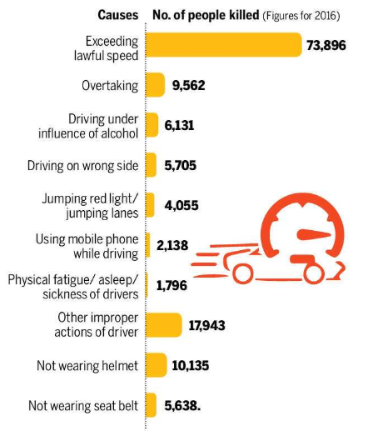

As a solution to this problem of the road safety we are proposing a android app. This app is all about the safety of those traveling on road. The main focus of this app is to provide the driver a safe and a harmless experience. The main features of the app are as follows:

* **Over speeding Challan** – The main reason for the accidents is over speeding. One of our main objective is to prevent over speeding. By using the driver’s GPS location and monitoring the speed of the driver we can give him/her alerts for over speeding by means of a alarm. Now if the person does not control the speed in 5 minutes the driver will be charged a penalty for over speeding and a automatic e-challan will be generated in the name of the owner. The proof of the driver’s overspeeding and breaking the laws will be saved in database as a proof.
* **Parental control** – Parental control is the function by which the parents of the particular younger drivers get alerts if he/she break the law and over speeds the vehicle. If the parental control feature is turned off then again the parent will get a message that the parental control has been disabled.
* **Performance analysis** – We will provide a performance analysis of the driver in terms of a performance score depending on the way in which the riders and drivers drive. Performance analysis will help the driver to drive the car more safely and more accurately by controlling the speed by viewing their performance analysis. By maintaining the good performance score, the user will get the virtual coins.
* **Bot** –Another reason why accidents occur is because people use their mobiles during riding. To prevent this we have added the feature of a BOT. By this feature of a chat BOT when the driver start drive, then after reaching a minimum speed 15km/hr the app will be started automatically and the messages and calls will be silenced. When anyone call the user the call gets cut for the first time and an message is being send to the caller that the user is driving and if there is any emergency then call back again, or we will get back to you after some time. When the caller calls for a second time then call will get connected and the driver would have to stop the vehicle in order to receive the call.
* **Rewards** – Now the only question remains that why people will use our app? To motivate the people to use the app we will give them reward in terms of virtual coins. Can earn the coins by their performance score. Users can redeem these coins at the petrol pump, or service centre.

So, the main objective of our app is to motivate the drivers to drive under the speed limit and reduce the accidents.