Intelligent Examination Trend Analysis Using Semantic Representation and Temporal Forecasting

Sanjay Karthick S  M.Tech Data Science  Department of IT  Rajalakshmi Engineering College  Chennai, Tamil Nadu, India  sanjaykarthick.s.2025.mtechds@rajalakshmi.edu.in | Mr. R. Vinoth Kumar  Assistant Professor (SG),  Department of IT  Rajalakshmi Engineering College  Chennai, Tamil Nadu, India  vinothkumar.r@rajalakshmi.edu.in | Dr. Ganesa Ramachandran Arunachalam  L&T EduTech, Chennai  grcchem@gmail.com

Abstract: This paper introduces a conceptual framework and prediction strategy for intelligent examination trend analysis that fuses historical question knowledge semantic representation with predictive analysis of the temporal recurrence of examination topic. The prediction system is designed for university examination papers with heterogeneous PDF layouts, OCR noise, alternative question types, and mutable examination patterns. A structure-aware ingestion layer captures examination questions, retain examination part and marks information, and separate alternative question type records into groups of questions. SentenceBERT captures the semantic representation of each question and its relation to the syllabus topic set by similarity to emulate and identify subject matter associations, as a semantic interpretation of questions within relevant sets of previously used questions. The conceptual framework then groups question mark occurrences by examination year and derives temporal features, such as frequency, recency, number of years active, recency gap, and trend slope. A learned classifier estimates the probability of a given knowledge topic recurring in the following exam year. It compares semantic-temporal forecast estimates against baseline models of frequency-only and temporal-only models, evaluated via chronological back-testing, and using ranking metrics of precision@k, recall@k, F1@k, MAP@k, and NDCG@k. As well as question type, question part, and question marks, the formal framework records the features of historical evidence on which each forecast is based, leading each forecast to be founded on its own historical lead-up. Rather than enumerate repeated-question detection or generate questions, this study models future recurring knowledge as a quantitatively measurable prediction problem, testing to see if the semantic signal will
improve the forecast accuracy. Currently the paper reports the research design and development-time validation protocol; the final forecast scores are withheld pending parser validation completion.
Keywords: Examination trend analysis, semantic representation, Sentence-BERT, temporal forecasting, question-paper mining, topic recurrence, chronological back-testing.
I. INTRODUCTION
Previous papers provide a valuable record of the topics that teachers have asked questions about, the form they have taken and how marks and the actual forms of questions have varied from year to year. Scanning just a couple of papers is reasonably straightforward, but running the same exercise across a number of years becomes painful and straightforward comparison is compromised. The paper has to be much more than a set of words, matched exactly against one another or the difference in number of words allows little room for any multiple-element questions. The question must have one meaning and one place in the examination paper, hence the analysis must reflect both points.
Previous work. To a limited extent, analysis of exam papers has been successful automatically. Dutta and Mohanty, using document-layout processing, OCR and LDA topic modelling, found key-topic categories in a collection of historical exam papers [1]. Recent work in question-paper analysis has fused OCR with TF-IDF and cosine-similarity to find and rank repeats and semantically similar questions for examination-revision [2]. While all of these are successful at converting historical papers into a structured collection of evidence, their purpose was to find or rank within the existing corpus. This work makes a more precise request: given the history of topics through year t, can a model predict the distribution of topics in year t+1, and improve that prediction with semantics?
Time series topic modelling is a distinct approach. Dynamic Topic Models aim to model change over a series of document collections with a time-varying probabilistic model [4]. Other recent work has shown that these topic embeddings can be interpreted as animated representations in semantic space and that their temporal trajectories can be modelled and interpreted [5]. Sentence-BERT has emerged as a useful means to compare meaning of questions, as it provides an optimal sentence embedding for semantic similarity [6]. The proposed approach uses the second idea in a much more limited context: university examination questions, with the examination year as the temporal unit and topic recurrence as the outcome variable.
This work is motivated by four contributions. First, a structure-aware pipeline is defined for question extraction from heterogeneous exam PDF sources, maintaining part-mark-question-number-answer-number relationships. Second, question meaning is modeled through sentence embedding, not as an exact word overlap. Third, future-topic recurrence is posed as a chronologically ordered forecast problem that leverages combined semantic and temporal features. Fourth, an evaluation design is provided that contrasts semantic-temporal forecasting to naïve, simplistic baselines through rolling historical backtests and ranked-retrieval metrics.
We use the system as a topic-forecasting tool, not as a method to predict the specific words of a future question. A predicted topic is grounded in observable historical evidence: recurrence, recency, semantic similarity, and trend. This is important because a pattern of events in the past can support the prediction of a topic of questions to come, but it cannot predict what an examiner will actually ask. The sections that follow describe the research gap, framework, dataset and preprocessing, experimental design, evaluation protocol, findings during development, limitations, and future work.
II. RELATED WORK
Previous research on automatic paper analysis is broadly divided into: topic identification, question similarity, automatic question generation and temporal topic analysis. Dutta and Mohanty [1] applied document-layout segmentation, optical character recognition (OCR) and LDA to extract and rank important topics from past papers and establish a new, data-driven examination-preparation system. Their approach corresponds to the data-ingestion and topic-discovery phases of our analysis. Their publication's stated goal is to generate and rank key topics from the current corpus, not to examine recurrence of the next year's topics via time-series forecasting.
Shikh et al. published Prep Vision AI, comprising PDF/image extraction, OCR, preprocessing, TFIDF vectorization, cosine similarity, repeated-questions detection, and multi-factor importance ranking [2]. The method shows a promising way from free-paper access to grouped questions of similar topics. Our work differs in that the forecasting is made not by imparting an importance score to questions based largely on their individual attributes, but by constructing a topic-by-year representation, and examining whether semantic evidence, time-series evidence, or both help forecast the next year's observed exam date.
Bloom's-taxonomy question-generation work investigates a different stage of the exam pipeline. Joshi et al. report a NLP tool for question generation and arrangements based on Bloom's cognitive levels [3]. This research is helpful in generating practice content after analysis, but generation is not forward-looking. Within this system, generation is an optional downstream step; the main contribution of the research is the empirical study of future topic recurrence.
Within the general area-modelling literature, Blei and Lafferty proposed Dynamic Topic Models for the analysis of topic evolution within ordered sets of documents [4]. Their work emphasizes that topic information can be modelled as a time-series signal. Huang et al. subsequently designed an architecture for showing, predicting, and interpreting the semantic movement of topic embeddings [5], indicating that language representations learned through natural language processing can be utilized for temporal topic modelling. These works inspire the semantic-temporal formulation, but are focused on academic literature on a larger scale and different variables as targets.
Semantic representation: In this work we will use BERT as the semantic representation layer [4]. Reimers and Gurevych introduced SBERT as an architecture for creating sentence embeddings that are comparable in cosine similarity [6], which is very convenient for our current task where questions with different wording might cover similar syllabus concepts. We initialize the question classifier by training a tree-based classifier, since the feature space has both numerical (concept differences etc.) and semantic (similarity between question and concept) summary features. Random Forests are a good choice for the tabular, nonlinear relationships we're constructing, and also for the feature-importance estimates they give [7]. Finally, ranking metrics like NDCG are helpful, as the system outputs a ranked list of candidate topics, rather than a single binary decision.
They give us part of the story, but leave a more specific question unanswered: we have explored the approaches of automated analysis of text, semantic similarity, question generation, and temporal topic modelling, but combining them at the level of the topic-level future examination forecast is an open experimental challenge. This is our research question – does semantic information provide value above baseline frequency and temporal recency?
III. PROPOSED FRAMEWORK
Our framework converts heterogeneous examination PDFs into a time-ordered topic dataset, and then forecasts topic repetition for an unseen examination year. The entire pipeline may be summarized as six key phases: document ingestion, structure-aware question extraction, semantic representation and topic attribution, temporal feature generation, learned forecasting and evidence-based output.

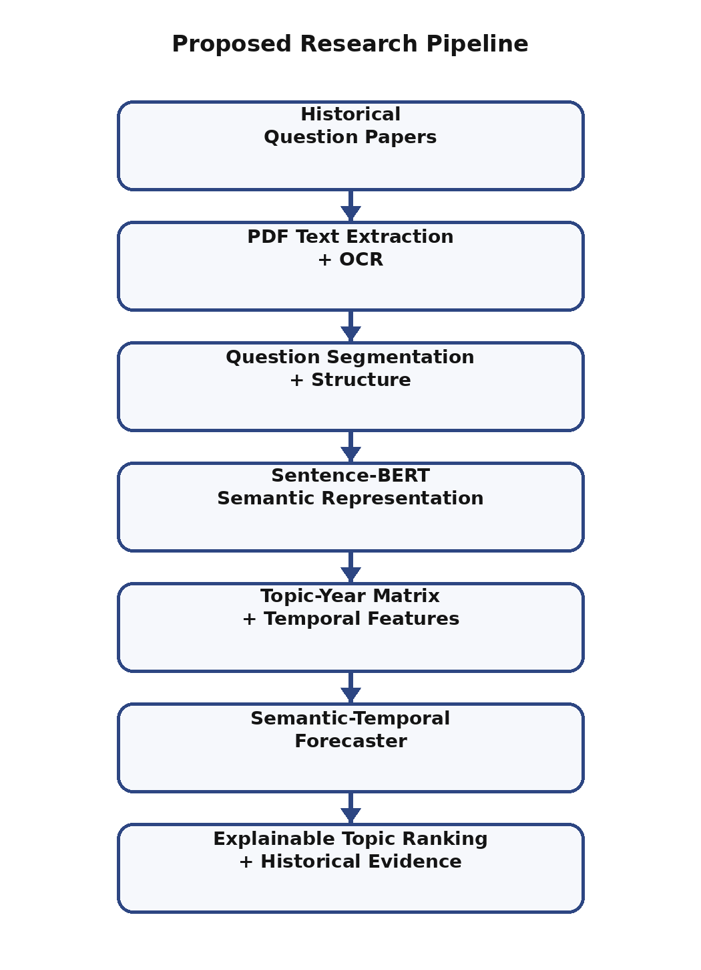
Our initial collection includes the examination PDFs and an attempt to extract the embedded text; scanning the file or acquiring the text in case of an image-based document may happen, leading to an OCR on the pages for the portion of the document that is an image (or text in a non-human-readable form). The parser was constructed based on the structure of an exam paper, instead of based on the PDF as text; the parser detects part of the exam, question numbering, question choices, and marks, and prevents particular silly errors like treating decimal points inside numerals in questions as new question identifiers. Alternative questions remain separate individual records for the purposes of semantic analysis, but share a question group identifier so the system recognizes the difference between observed records and selectable question sites.
Semantic representation stage In this stage, each question extracted during the question extraction stage is encoded with Sentence-BERT. A syllabus-aware topic dictionary allows us to identify candidate topic labels and associations to units. The cosine similarity between an embedding of a question and each topic representation is used to select a best semantic match, with a threshold applied to decide whether the matching is strong enough. Questions that do not reach the threshold are left unassigned, not forced into a random topic label. This conservative rule exists since an incorrect topic label would later show up as a true observation in the year-wise frequency plot.
Once questions are allocated to topics, the observations are laid out in a topic-year matrix. For each topic i in year t, the number of question records assigned to topic i is counted. From the historical sequence, temporal descriptors such as total frequency, recent frequency, active years, recurrence rate, recency gap, and trend slope are obtained. Semantic descriptors such as mean question-to-topic similarity, recent mean similarity, and semantic change across years can be extracted. These variables serve as features for the recurrence prediction.
In the forecasting stage, topic i may occur in the next observed exam year, t+1, which is the prediction target of this topic. We define a binary label y(i, t+1) = 1 if topic i occurs in the next observed exam year t+1, and 0 otherwise. Random Forest classifier is suggested as the initial learned model, as the input features are different, numerical, possibly non-linear, and small size [7]. It will yield a recurrence probability that ranks candidate topics.
Instead of simply returning a ranked list, the system also displays the justification for why the topic received its rank. For each ranked topic, the system displays recent frequency, prior frequency, recency gap, direction of trend, semantic similarity metrics, and a set of sample historical questions associated with the topic. A generative component can later generate practice questions from the historical blueprint, with the generated material clearly dissociating prediction from generation in the experimental design.
IV. RESEARCH METHODOLOGY AND DATA COLLECTION
A. Examination Paper Acquisition
In the development, we used university engineering-physics examination papers drawn from open sources. The current development set has 6 PDF papers from open examination years from 2020 to 2024 with two different paper code.pdf formats and three different paper layouts.pdfs. We intentionally maintained a heterogeneous corpus. The parser must support scanned pages, normal pdfs, OCR text, alternative questions, and paper restructuring.
We include the original filename and the year identified from the paper for each document. The year identification process looks for known examination-year formats in the filename, and has a generic four-digit year fallback. The metadata are attached for each question we extract. The working schema is filename, year, part, question number, options/alternatives indicator, question group, marks, question, semantic topic, similarity, syllabus unit.
B. Document Preprocessing and Question Segmentation
We do question extraction prior to the semantic model execution. Machine-readable PDF text is used where there is enough text; otherwise, pages are rendered and OCR'd. The parser unifies line endings and duplicate whitespace, but maintains line breaks as these are critical for numbering questions and sections.
A key design decision is to interpret the structure of the exam as metadata, rather than attempting to extract it using guesses from the question text in isolation. Part headings can be identified using different forms of PART or SECTION and multiple forms of punctuation and dash. Top level questions can be identified by several common forms including 1., 1), Q1. And 11(a), but require a small amount of punctuation and spacing to distinguish them from decimal values. Alternate questions can be stored as separate questions, but linked to a common question group.
Where possible, marks are allocated from the validated examination-part metadata. This avoids the problem of section totals such as "5×16=80" being misinterpreted as the marks of an individual question. The structure of the design also allows for exam papers which have no part in them. This is practical as the format of an examination paper varies from one year to the next.
C. Semantic Representation and Topic Assignment
Given a question q and a candidate topic z, Sentence-BERT produces the embedding e(q) for the question and e(z) for the topic. The semantic similarity score is then obtained as:
Sim(q, z) = [e(q) · e(z)] / (||e(q)|| ||e(z)||) (1)
The question with the highest similarity is assigned if the score is greater than the validation threshold. If not, the question is kept as Unassigned. This means questions with weak matches are not forced into a topic, but remain visible in the subsequent analysis.
D. Temporal Feature Construction
For each topic i, we compute its features using only the examination history available up to year t. Total frequency indicates the number of observed question records for the given topic. Recent frequency focuses on the most recent years. Active years count how many examination years the topic existed in, and recurrence rate normalizes this number by the total number of available years. Recency gap indicates how recently the topic occurred, while trend slope represents the sum of the growth/decline of topic frequency over time.
Semantic information is summarized, using descriptive scores rather than the individual embedding dimensions. The mean and recent mean semantic similarity measure how closely the history of questions on a topic conform to the topic's semantic representation. By tracking the difference in these figures over the years, they can help signal when a topic is renamed but retains its essence.
E. Forecast Target and Research Hypotheses
For each chronological split, the model only sees the examination years before the prediction year. The label is whether a topic occurs in the next year. Our primary research question in this work is: RQ1: Does using semantic information relative to the temporal information improve how we rank the topics in the future in comparison to frequency-only and temporal-only baselines? Two follow-up questions are RQ2: Which semantic and temporal features contribute most to the accurate ranking of topics?
RQ3: Is it possible to show a warning for each forecast based on pieces of evidence?
The semantic information should be particularly helpful where the wording of the same feature has changed from one year to another. The chronological evaluation should also be more realistic than a random split as the random split may contain information from later years.
V. EXPERIMENTAL SETUP
A. Development Corpus and Data Quality Validation
Development corpus with six papers. In total, there are six PDF exams in the development corpus from 2020 to 2024. Before we show the forecasting output, we do a structural validation of each paper. The validation has the following parameters extracted: question count, part distribution, question-group structure, alternative relations and marks. This validation is very important: one extraction mistake can turn into the wrong count of topics later and again seem like a topic trend.
As a sample validation exercise, consider the PH 8151 Engineering Physics paper for Nov/Dec 2020. The source document has ten Part-A questions and five numbered Part-B question groups, each of which has an OR alternative question. Part-C does not appear in this document. In illustrating why a robust parser would need to differentiate between question records and question groups, and why a section total (say 80 marks) cannot be given to each question.
B. Baselines and Proposed Model
We implement three models to disentangle the effects of the several sources of information. The frequency baseline ranks topics according to frequency during historical time periods. The temporal baseline modifies this by including the recentness and trendingness attributes. The model also includes the semantic similarity attributes and learns the mapping from the concatenated feature vector to the recurrence of a topic.
The first model learned in the implementation is a Random Forest classifier. The number of trees, feature subsampling, class weights, and minimum leaf sizes are all tuned only over the historical training period of each back-test and never make use of information from the test year in the selection process. Feature importance is saved for interpretation later and is used for description, not as evidence of causality.
C. Chronological Back-Testing
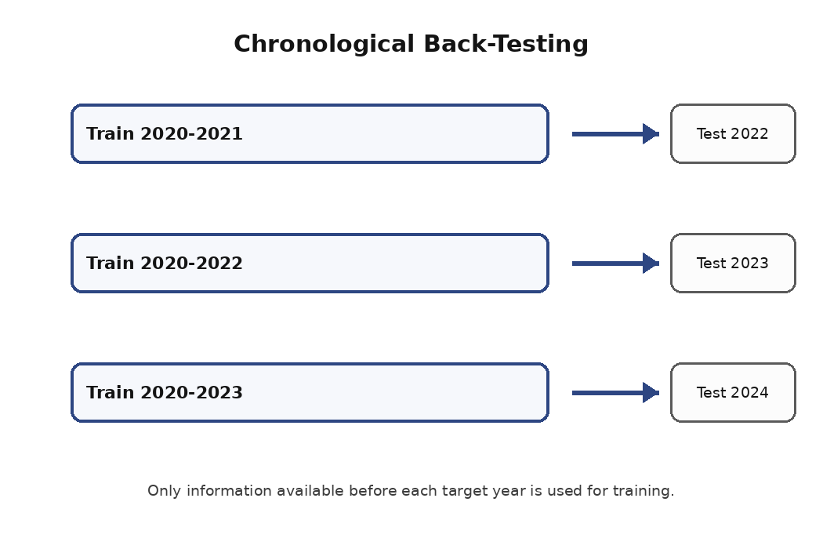
Fig. 2. Rolling chronological back-testing whereby early years are used to predict the following unseen exam year.
Main assessment employs rolling chronological splits in training. For instance, train on 2020-2021, forecast 2022, then train on 2020-2022, forecast 2023, then train on 2020-2023, forecast 2024, etc. We use only the years prior to the target year (before the model is used) to build features. If a topic does not appear in the training window, then the topic can be handled separately, since we are unable to learn the historical feature pattern of a binary recurrence model.
It is especially relevant to test with a chronologically ordered split because the model is meant to predict a year. Randomly splitting the data would let questions from future years shape the training distribution and would thus test interpolation within the body of the data, not prediction into a future year.
D. Evaluation Metrics
Since the output is a ranked list of topics, we want to see how many of the relevant topics appear at the beginning of the list. Precision@K measures what fraction of the topics in the top K actually occur in the target year. Recall@K measures what fraction of the topics in the target year are recovered at K. F1@K combines the above two measures. MAP@K assesses the quality of the ranked list of retrievals while NDCG@K rewards relevant topics to appear near the top of the list [8].
Precision@K = Number of relevant topics within the top K/ K (2)
Recall@K = relevant topics in topK / relevant topics in target year (3)
F1@K = 2 × Precision@K × Recall@K / (Precision@K + Recall@K) (4)
VI. RESULTS AND EVALUATION
The work is currently at the developer and validation stage. The parser which generates the semantic representation, adds the topics, constructs the temporal features, and performs the chronological analysis has been implemented and can be run; however, no final forecasting scores are given in this paper as the examination parser has not been structurally validated for the entire corpus.
While we were testing the parser, two types of error emerged that might decrease the reliability of the trend analysis. The first was that alternative questions can be used to store more records but not add additional question groups to answer. This, in combination with question reuse, affects how reliable the trend analysis can be. The second was that OCR and PDF layouts could cause section headers to be missed, and subsequent questions then seem to be a change in section to the parser; embedded numbers are also mistaken for new questions if a line-based generic parser is used. We adjusted the structure-aware rules to deal with these issues.
Two more validation principles relate to the marking. An exam paper might report a total mark, for example "5×16=80", but that doesn't specify the mark awarded for each question. By analogy, the existing registration layer considers each mark level on an item to be metadata, and won't let any pattern-based analysis on a following layer overwrite the mark metadata with any value found in the item text. The mark metadata must be established beforehand so that mark-pattern evolution can be analyzed and a future blueprint can be constructed.
The final evaluation will compare the three models (frequency-only, temporal-only, semantic-temporal) on the same chronological test splits. The study will evaluate not only the overall top-K metrics but also provide the yearly scores, feature importance, error categories, and successful and failed examples of topic prediction. A formal ablation will first remove the semantic features from our proposed model, then perform an ablation that removes the temporal features.
TABLE I. PLANNED EVALUATION SETUP
Model | Feature set
Frequency-only | Historical topic frequency
Temporal-only | Frequency + recency + trend
Semantic-temporal | Temporal features + semantic similarity

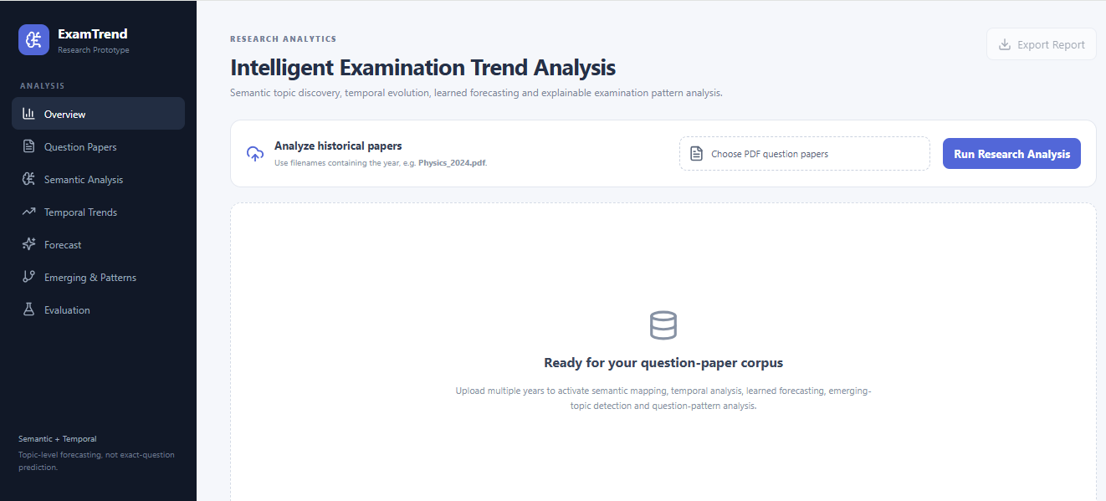
Fig.3. Dashboard

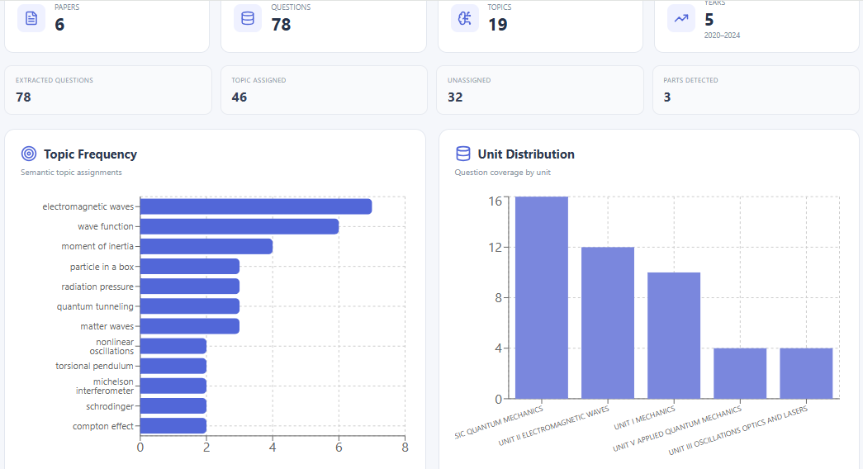
Fig.4. Topic and Unit Graph
VII. DISCUSSION AND LIMITATIONS
Rather than limiting to frequency counts, we interpret the overall problem of future topic recurrence as a forecasting problem. This distinction may matter in practice. A topic may have recurred many times in the past but not recently, and vice versa for a topic with fewer total instances. Semantic representation also handles variation in wording: the same idea expressed
with different words can reduce the accuracy of exact-string matching and may lead to underestimation of recurrence.
The most obvious weakness today is the size of the corpus. University examination corpora are very much smaller than the document collections normally used in topic-modelling research. Small chronological windows limit the number of independent back-test cases and can produce unstable model estimates. These results should be seen as an empirical study of this particular domain-specific corpus, not as a universal predictor for all subjects or institutions.
Constructing topic labels introduces other limitations. The current system employs the syllabus-defined candidate topics and the semantic similarity to classify questions. While this is more resistant than exact lexical matching to modifications in wording, a similarity threshold cannot be used to substitute an expert decision on questions which really straddle multiple topics. Future iterations should have multiple topic labels and/or some human oversight on low confidence questions.
The shortcomings of document extraction are also an issue. OCR might distort symbols, mathematical formulas, subscripts, or the numbering of questions. One mismatch in extraction can influence topic counts and then time features. This work makes parser validation a part of the experiment rather than only an issue of software engineering.
Another thing to be cautious of is the probability itself. The system can only use past evidence to estimate probabilities of recurrence for questions, and so cannot include information about targeted syllabus adjustment, change in question strategy, curriculum modification, or surprise examination design choices. The system should therefore present ranked evidence with uncertainty.
VIII. CONCLUSION AND FUTURE WORK
This paper outlines a semantic-temporal framework for examination trend analysis. Such a framework leverages structure-aware PDF/OCR processing, semantic question representation via Sentence-BERT, syllabus-aware topic assignment, temporal feature construction, learned future-topic prediction, and evidence-based ranking. The core questions of research are whether semantic information yields any quantifiable predictive benefit over frequency and temporal recurrence for the unseen examination year target.
The approach retains extraction, semantic mapping and forecasting so that each step's errors can be checked. It also separates alternative question records from question groups, and maintains marks as exam metadata. This is important because the exam paper has information embedded in it (the information within the questions) that the plain text file would lose.
Future work will include extending the corpus along more subjects and levels, completing the chronology back-tests, and publishing the following metrics per model: Precision@K, Recall@K, F1@K, MAP@K, NDCG@K. Further experiments will include testing different temporal models, with calibrated uncertainty, with newly emerging topics, with topic-drift metrics, with unit-level predictions, and with detected question patterns. Low confidence questions can optionally be screened for human evaluation, and this human-in-the-loop data used to train a new dataset. Further, the suggested predictions for the current estimated topic blueprint can subsequently be used to generate practice questions by the local language model, separately from the scientifically developed forecasting model.
The eventual objective is not to substitute for academic judgement or confidently say what will be in next year's exam. The objective is to produce a method that is both reproducible and interpretable to examine the recurrence, development and prediction of assessed subject matter from previous exams.
REFERENCES
[1] R. Dutta and S. Mohanty, “Enhancing Exam Preparation through Topic Modelling and Key Topic Identification,” Journal on Artificial Intelligence, vol. 6, no. 1, pp. 177–192, 2024, doi: 10.32604/jai.2024.050706.
[2] R. R. Shaikh, S. S. Patil, V. S. Sargar, and K. A. Jagtap, “PrepVision AI: An Intelligent Question Paper Analysis System Using NLP and Semantic Similarity for Exam Preparation,” International Journal of Advanced Multidisciplinary Research and Educational Development, vol. 2, no. 2, pp. 335–339, 2026.
[3] N. Reimers and I. Gurevych, “Sentence-BERT: Sentence Embeddings using Siamese BERT-Networks,” in Proc. EMNLP-IJCNLP, 2019, pp. 3982–3992, doi: 10.18653/v1/D19-1410.
[4] L. Breiman, “Random Forests,” Machine Learning, vol. 45, pp. 5–32, 2001, doi: 10.1023/A:1010933404324.
[5] K. Järvelin and J. Kekäläinen, “Cumulated Gain-Based Evaluation of IR Techniques,” ACM Transactions on Information Systems, vol. 20, no. 4, pp. 422–446, 2002, doi: 10.1145/582415.582418
[6] N. Reimers and I. Gurevych, “Sentence-BERT: Sentence Embeddings using Siamese BERT-Networks,” in Proc. EMNLP-IJCNLP, 2019, pp. 3982–3992, doi: 10.18653/v1/D19-1410.
[7] L. Breiman, “Random Forests,” Machine Learning, vol. 45, pp. 5–32, 2001, doi: 10.1023/A:1010933404324.
[8] K. Järvelin and J. Kekäläinen, “Cumulated Gain-Based Evaluation of IR Techniques,” ACM Transactions on Information Systems, vol. 20, no. 4, pp. 422–446, 2002, doi: 10.1145/582415.582418.

